APPENDIX D

METHOD FOR PREDICTING MEAN PAVEMENT TEMPERATURE (adapted from Ref. 1)

Definition and Purpose:

Mean pavement temperature is an average of the temperatures at the surface, mid-depth, and bottom of the asphalt-bound portion of the pavement, even though it may have been placed in several layers and at different times.

The mean pavement temperature is used to find a Temperature Adjustment Factor, required for adjusting pavement deflection values to a standard temperature of 21°C, as indicated in Step 1 of Appendix B.2 of the manual.

Information Required:

The temperature prediction method requires five items of information:

- Location of test site—for identification of test data to guide in selection of the weather station from which air temperature data must be obtained.

- Date of test—required to indicate the dates on which air temperature will be needed for pavement temperature adjustment.

- Maximum and minimum air temperature—needed for each of the five days immediately prior to the date of deflection testing to provide an air-temperature history at the test site.

- Pavement surface temperature—measured at the time the deflection test is performed.

- Thickness of asphalt-bound portion of the pavement—required for selection of the proper curves on the pavement temperature chart.

All information listed above, except Item 3, is recorded during performance of the Benkelman beam deflection survey.

Item 3, the five days of air temperature history, prior to the date of the deflection measurements, can be obtained in one of three ways.

- Hourly air temperatures may be read and recorded for a period of five days preceding each test location in the general vicinity where deflection measurements are made. From these data the maximum and minimum daily temperatures are determined.

- Obtain from the nearest weather station the maximum and minimum air temperatures for each of the five days proceeding each day of testing. This station should be in a location that records essentially the same temperature readings as at the test site.

- Obtain the maximum and minimum air temperatures for each of the five days proceeding each day of testing from published weather bureau (or similar agency) data. This is the most practical approach if the evaluation of test results is needed immediately.

When the five-day air temperature history has been obtained, the average of the ten values is determined. This average is used, together with pavement surface temperature to estimate the pavement temperature at any depth. Surface temperature is measured and recorded when the deflection test is performed. The date and time of these are also recorded.

Surface temperature may be measured by inserting a thermometer or thermocouple into a small, 6mm± deep hole or indentation in the surface of the pavement. The hole should be filled with water or asphalt, which should be allowed to come to equilibrium before the temperature is read.

Prediction of Mean Pavement Temperature:

Relationships between pavement surface temperature, air-temperature history, and pavement temperature at any depth have been derived and are shown in condensed form in Figure D-1. It should be used for overlay design only. Pavement temperatures at various depths can be estimated by applying the required information to this chart.

The first step is to add the five-day air temperature history (average of maximum and minimum air temperatures for five days preceding the test) and the pavement surface temperature to determine the value with which to enter the chart. Then, the Mean Pavement Temperature is estimated:

- Determine pavement thickness and mid-depth.

- Enter Figure D-1 on the horizontal scale with the pavement surface temperature. Extend a line vertically to intersect the depth lines. Extend lines horizontally from the depth representing the bottom of the layer to intersect the vertical scale. Interpolate between the depth lines as necessary.

- The sum of the surface temperature, mid-depth temperature, and bottom temperature is averaged to provide the Mean Pavement Temperature.

- The Mean Pavement Temperature is used to enter Figure 4.1 in the Manual to obtain a temperature adjustment factor for Benkelman beam deflection readings.

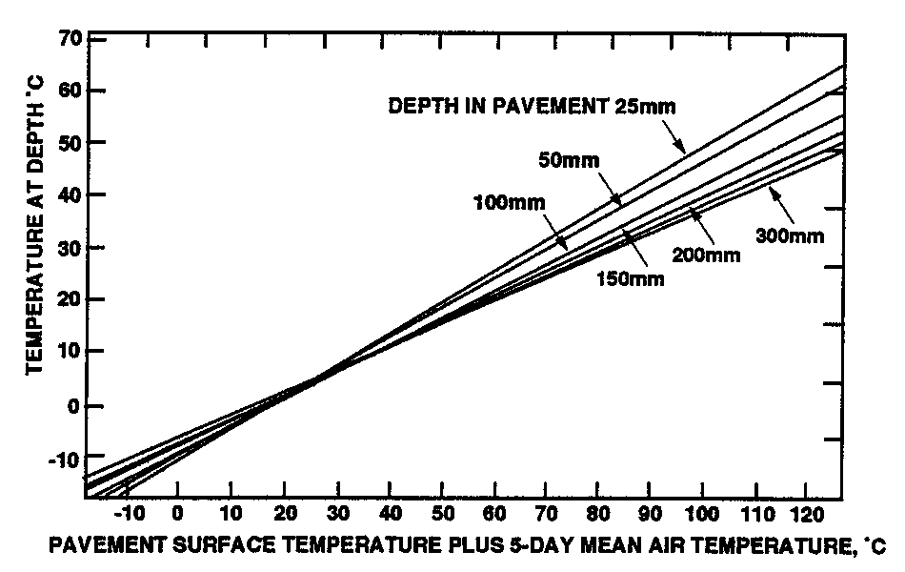

Figure D.1 Predicted Pavement Temperature

Example

Given: Asphalt concrete pavement 10cm thick. Surface temperature is 31°C. Average air temperature for 5 days preceding the test is 22°C. The adjusted surface temperature is 31 + 22 = 53°C (surface temperature plus 5-day average air temperature). Find predicted pavement mean temperature.

- Surface temperature = 31°C

- Temperature at 5cm depth = 30°C (From Figure D-1)

- Temperature at 10cm depth = 27°C (From Figure D-1)

- Pavement mean temperature =

31° + 30° + 27° = 29°
3

(Use this temperature in Figure 4.1 of the manual to find temperature adjustment factor, F.)

