APPENDIX F

DERIVATION OF SN_{eff}, EFFECTIVE STRUCTURAL NUMBER OF AN EXISTING PAVEMENT
(adapted from Ref. 3)

The NDT method of SN_{eff} determination follows an assumption that the structural capacity of the pavement is a function of its total thickness and overall stiffness. The relationship between SN_{eff} and stiffness is:

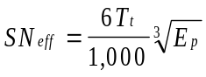 (Equation 1)

where T_{t} = total thickness (in centimeters) of all pavement layers above the subgrade

E_{p} = effective modulus of pavement layers above the subgrade (kPa)

E_{p} may be back-calculated from deflection data as follows.

The data required for the calculations is:

d_{o} = deflection measured at the center of the load plate (and adjusted to a standard temperature of 20° C), cm

P = applied load, kg

D = total thickness of pavement layers above the subgrade, cm

d_{r} = deflection at a distance r from the center of the load, cm

r = distance from center of load, cm

a = NDT load plate radius, cm

With the above data, using Figure F-1, the ratio of E_{p}/M_{R} can be calculated.

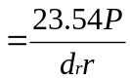Where M_{R} = subgrade resilient modulus, kPa

Based on the ratio of E_{p}/M_{R} and known value of M_{R}, E_{p} can be computed in kPa. SN_{eff} is then calculated using Equation 1.

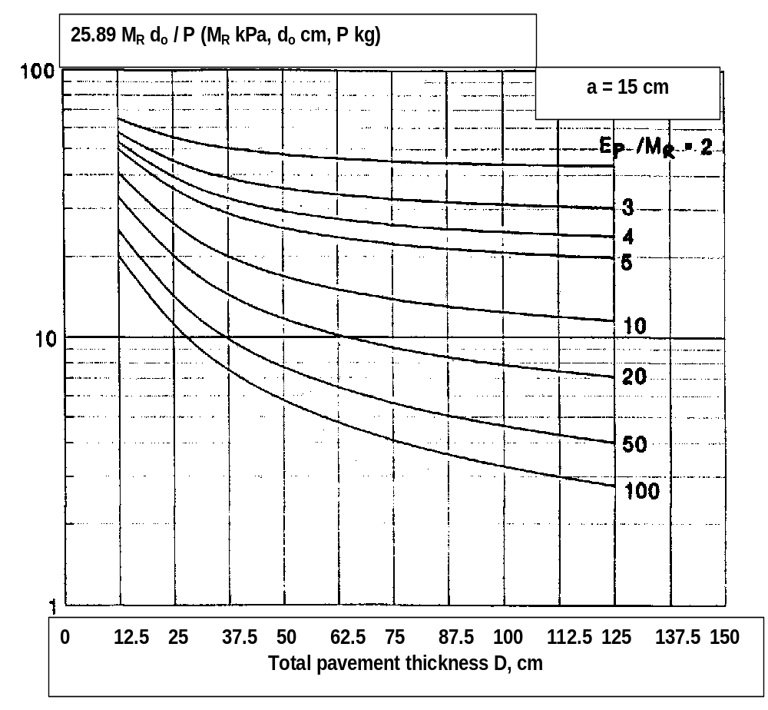

Figure F.1 Determination of E_{p}/M_{R} (Ref. 3)

