R2ROAD AND BRIDGE WORKS


THE REPUBLIC OF UGANDA

MINISTRY OF WORKS, HOUSING AND COMMUNICATIONS

ROAD DESIGN MANUAL

Vol. 3: Pavement Design

Part I: Flexible Pavements

July 2005

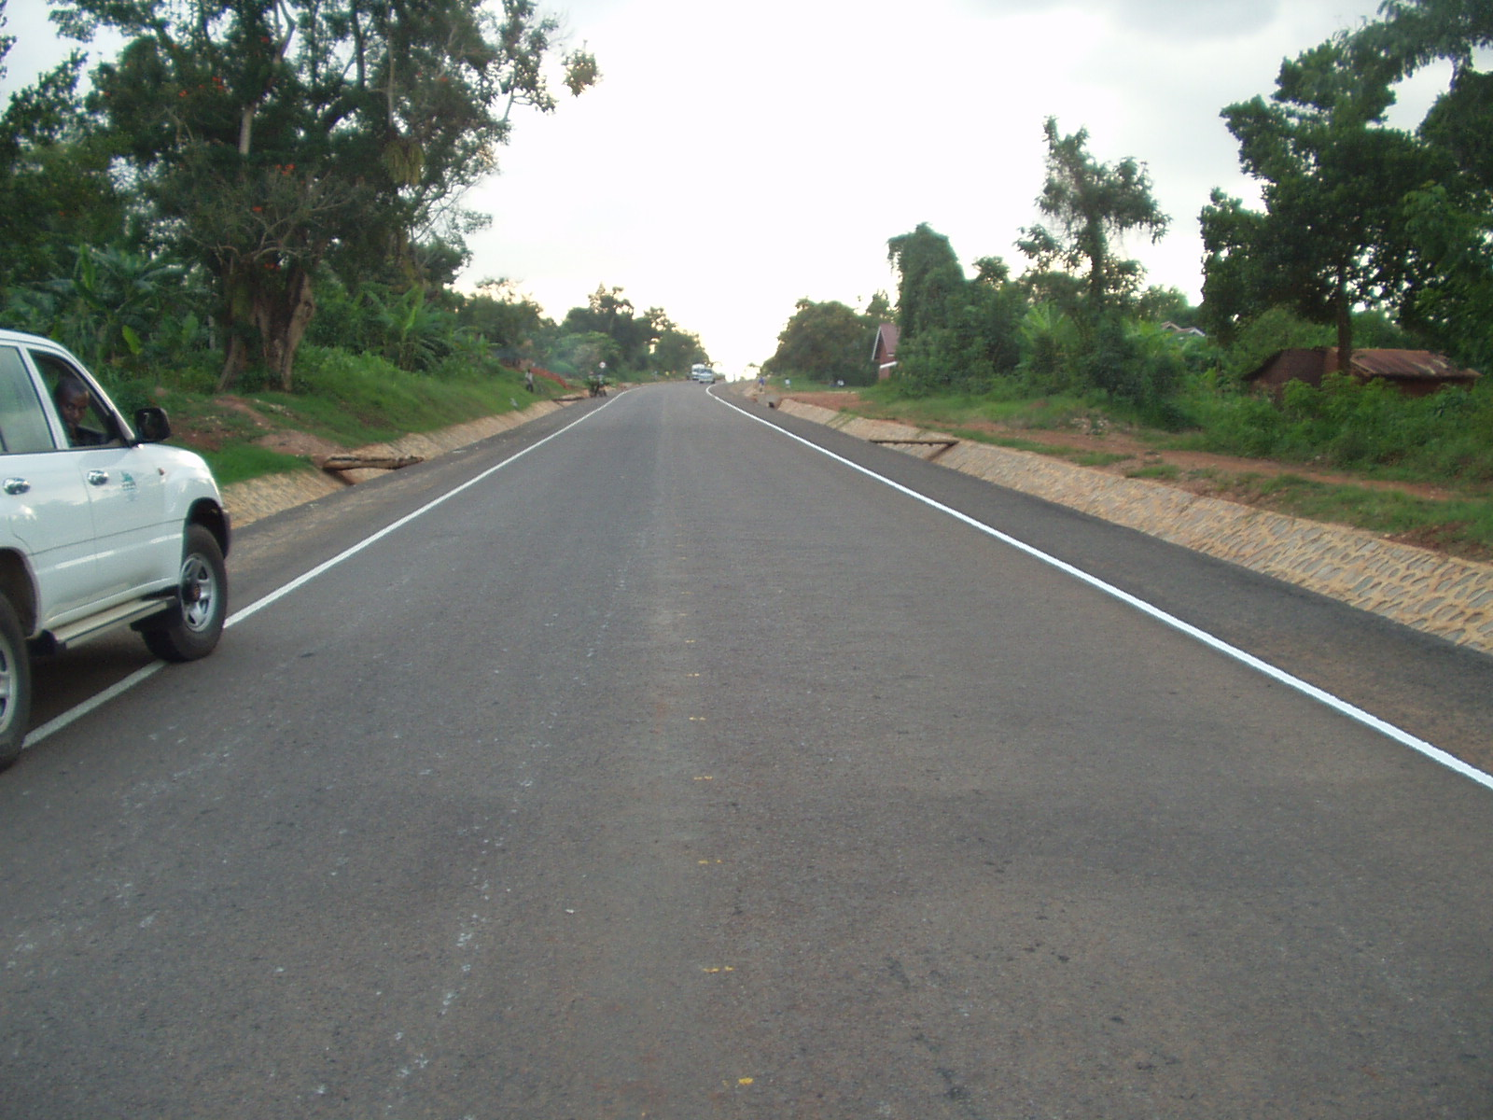
FOREWORD

The Ministry of Works, Housing and Communications (MoWHC) Mission is to promote an adequate, safe and well maintained transport infrastructure, an efficient and effective communication system, safe housing and buildings so as to effectively contribute to the socio-economic development of the country

In exercising this mission and in discharging its responsibilities, the Ministry is issuing a series of Design Manuals, Guidelines, Codes and Standards, of which the “Road Design Manual, Vol. III: Pavement Design Manual” is one part thereof.

The purpose of this manual is to serve as a nationally recognized document, the application of which is deemed to serve as a standard reference and ready source of good practice for the pavement design of roads, and will assist in a cost effective operation and an environmentally sustainable development of the country’s road network.

The major benefits to be gained in applying this document are the harmonization of professional practice and the ensuring of appropriate levels of safety, health and economy with due consideration of the objective conditions and need of the country.

This manual is a technical document, which, by its very nature, requires periodic updating from time to time arising from the dynamic technological development and changes. The Ministry, therefore, welcomes comments and suggestions from any concerned bodies, groups or individuals, as feedback on all aspects of the document during the course of its implementation. All feed backs received will be carefully reviewed by professional experts with a view to possible incorporation of amendments in future editions.

John Nasasira
Minister
Ministry of Works, Housing
and Communications

2005

TABLE OF CONTENTS

ABBREVIATIONS i
BACKGROUND ii
1. INTRODUCTION 1.1
1.1. Background 1.1
1.2. Pavement Structure and Cross-section 1.2
1.3. Design Process 1.2
2. ESTIMATING DESIGN TRAFFIC LOADING 2.1
2.1. General 2.1
2.2. Design Traffic Loading 2.2
2.3. Design Traffic Class 2.7
2.4. Probability Distribution of Traffic 2.7
2.5. Axle and Wheel Load Distribution 2.8
2.6. Lateral Wonder, Directional Factor and Lane Factor 2.8
3. DETERMINING SUBGRADE STRENGTH 3.1
3.1. Background 3.1
3.2. Representative Subgrade Moisture Content 3.2
3.3. Classifying Design Subgrade Strength 3.2
4. DEFINITION OF WET OR DRY CONDITIONS 4.1
4.1. Background 4.1
4.2. Selecting the Appropriate Pavement Design Based on Moisture Influence 4.1
4.2.1. Predominantly Dry Regions 4.1
4.2.2. Predominantly Wet Regions 4.1
5. PRACTICAL CONSIDERATIONS 5.1
5.1. Background 5.1
5.2. Materials Availability 5.1
5.2.1. Natural Gravel/soil Materials not Meeting CBR and/or PI Requirements 5.3
5.2.2. Cohesionless Materials, Sands 5.4
5.2.3. Dense Clays/expansive Materials 5.4
5.2.4. "Collapsible" Sands and Soils 5.4
5.3. Terrain 5.4
5.4. Vehicle Overloading 5.5
5.5. Subgrade CBR less than two per cent 5.5
5.6. Design Trafficking Greater than 30 million ESAs 5.6
5.7. Rehabilitation of Existing Roads 5.6
5.8. Use of the Dynamic Cone Penetrometer (DCP) 5.6
6. SELECTION OF POSSIBLE PAVEMENT STRUCTURES 6.1
7. REFERENCES 7.1

APPENDIX A : MATERIALS A.1
A.1 Introduction A.1
A.2 Unbound Materials A.1
A.2.1 Granular Base Construction A.1
A.2.2 Granular Subbase Construction A.4
A.2.3 For Selected Layer Construction A.5
A.3 Cemented Materials A.5
A.3.1 Treatment or Stabilisation with Portland Cement A.6
A.3.2 Treatment with Lime A.7
A.3.3 Treatment with Bitumen Emulsion A.8
A.4 Bituminous Materials A.8
A.4.1 Asphalt Premix Base and Surfacings A.9
A.4.2 Surface Dressings A.10
APPENDIX B: DRAINAGE AND SHOULDERS B.1
B.1 Introduction B.1
B.2 Drainage B.1
B.3 Shoulders B.2
APPENDIX C: DESIGN CATALOGUE C.1
C.1 Introduction C.1
Chart D1 C.2
Chart D2 C.3
Chart D3 C.4
Chart D4 C.5
Chart D5 C.6
Chart W1 C.7
Chart W2 C.8
Chart W3 C.9
Chart W4 C.10
Chart W5 C.11
APPENDIX D: EXAMPLE OF PAVEMENT DESIGN D.1
Appendix E: Test Standards E.1

LIST OF TABLES

Table 2.1: Pavement design life selection guidance . . . . . . . . . . . . . . . . . . . . . . . . . . . . . . 2-2
Table 2.2: Recommended relative damage exponents, n . . . . . . . . . . . . . . . . . .. . . . . . . . 2-4
Table 2.3: Load equivalency factors for different axle load groups, in ESAs . . .. . . . . . . . . 2-5
Table 2.4: Factors for design traffic loading . . . . . . . . . . . . . . . . . . . . . . . . . . . . . . . . . . . . . 2-6
Table 2.5: Traffic classes . . . . . . . . . . . . . . . . . . . . . . . . . . . . . . . . . . . . . . . . . . . . . . . . . . . 2-7
Table 3.1: Subgrade classification . . . . . . . . . . . . . . . . . . . . . . . . . . . . . . . . . . . . .. . . . . . . .3-1
Table 3.2: Method for classifying subgrade design CBR . . . . . . . . . . . . . . . . . . . .. . . . . . . .3-3
Table 3.3: Recommended minimum subgrade depth meeting design strength . . . . . . . . . .3-5
Table 4.1: Guide to selecting design conditions for predominantly wet regions . . . . . .. . .. .4-2
Table 5.1: Nominal strength classification of materials in the design catalogue . . . . . . . ... .5-2
Table 5.2: Layer Coefficients……………………………………………………………………….5-2
Table 6.1: Classification of structures in the design catalogue . . . . . . . . . . . . . . . . . . . . . . .6-1

LIST OF FIGURES

Figure 1.1: Geometry and nomenclature for the pavement . . . . . . . . . . . . . . . . . . . . . . . . . 1-2
Figure 3.1: Illustration of CBR strength cumulative distribution . . . . . . .. . . . . . . . . . . . . . . . 3-4

ABBREVIATIONS

AADT = Annual Average Daily Traffic

AASHTO = American Association of State Highway and Transportation Officials

CBR = California Bearing Ratio (as described in AASHTO T193)

CEM I = Portland Cement US 310-1 (US = Uganda Standard)

CSIR = Council for Scientific and Industrial Research

DCP = Dynamic Core Penetrometer

ESA = Equivalent Standard Axles

MDD = Maximum Dry Density

MPa = Mega Pascals

OMC = Optimum Moisture Content

PFA = Pulverized Fuel Ash

RN31 = Transport Research Laboratory's Overseas Road Note 31

Sabita = Southern Africa Bitumen Association

SATCC = South African Transport and Communications Commission

TRL = Transport Research Laboratory (UK)

BACKGROUND

The Pavement Design Guide included in and adopted by this Design Manual is “SATCC Draft Code of Practice for the Design of Road Pavements, September 1998 (Reprinted July 2001)”, prepared by the Division of Roads and Transport Technology, CSIR.

Additional important aspects which are widely accepted by current practice in flexible pavement design, and which are believed to complement the manual, are also incorporated.

The guide makes use of a comprehensive design catalogue which enables the pavement designer to rapidly select possible structural configurations that should meet the design criteria.

The catalogue structures have been developed from current practice deemed appropriate to the region, primarily as exemplified by the Transport Research Laboratory’s Overseas Road Note 31 (RN 31) and the South African Pavement Design Guide TRH4. These documents in particular were identified from a broader review, including the previous SATCC guidelines and two Australian approaches, as being most appropriate for the purpose.

INTRODUCTION

Background

This pavement design guide for new trunk roads is intended to provide a simple and easily applied method for determining an appropriate pavement structure for the expected design criteria. It is based on the use of a comprehensive design catalogue which enables the pavement designer to rapidly select possible structural configurations that should meet the design criteria. Suggested designs have been checked against current mechanistic analysis methods for suitability.

It must be noted at the outset that certain limitations apply to the use of this guide and the principal ones are given as follows:

- This guide is not for either concrete or gravel roads.
- This guide does not cover special considerations for urban pavements.
- This guide is not for design trafficking of more than 30 million equivalent standard axles.
- This guide does not specifically cover existing subgrade conditions for which the nominal California Bearing Ratio (CBR) is less than 2 per cent.

Guidance is, however, given on some practical aspects of pavement design and construction which may assist in addressing these other conditions.

The catalogue structures have been developed from current practice deemed appropriate to the region, primarily as exemplified by the Transport Research Laboratory's Overseas Road Note 31 (RN31)1 and the South African pavement design guide TRH42. These documents in particular were identified from a broader review, including the previous SATCC guidelines and two Australian approaches, as being most apt for the purpose.

In order to keep this guide readily usable, much of the information has been pared to essentials. Whilst efforts have been made to ensure that all practical design considerations are addressed, the user is actively encouraged to become familiar with other more comprehensive pavement design documents which may provide additional insight into the process.

Similarly the user should regard the catalogue structures here as sound suggestions for the assumed conditions, but should make use of other design methods as both a check and a means of possibly refining the structure to suit specific conditions. In the same way, the Engineer should draw on local knowledge of materials and techniques which have proven to be satisfactory and substitute these where deemed appropriate for the more generic material classifications used in this guide. The nominal materials details are given in Appendix A, which provides general guidance on their usage.

Pavement Structure and Cross-section

Figure 1.1 shows both a typical pavement cross-section and the nominal pavement structure, in order to define some of the terminology used. The specific geometry of the pavement section is defined separately by applying either SATCC or other acceptable regional standards.

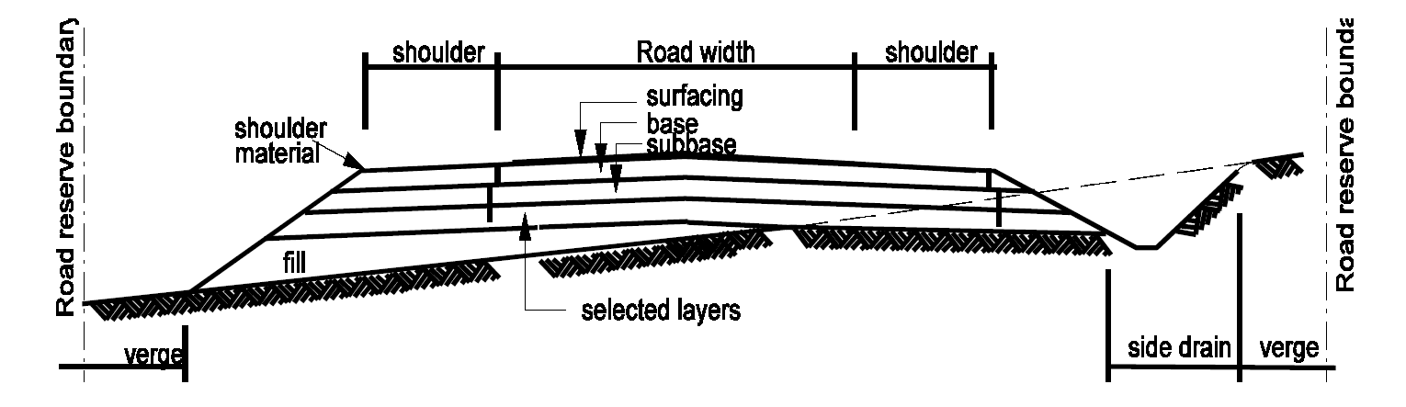

Figure 1.1: Geometry and nomenclature for the pavement

This guide focuses only on deriving the most appropriate layer configuration to form the pavement structure, but the following inherent conditions must be met if the pavement is to function properly:

- The road has an impervious surfacing.
- The road has at least 1m width shoulders.
- The road has a minimum road camber or cross-fall of 2.5 per cent.

Appendix B gives more details on road drainage and shoulders.

Design Process

The design process in this guide is defined in five steps. These are:

- Estimating the cumulative traffic loading expected during the design life.
- Defining the strength of the subgrade (soil) over which the road will be built.
- Defining the nominal operating climate (wet or dry).
- Determining any practical aspects which will influence the design selection.
- Selecting possible pavement structures.

These steps are given in the five sections following.

ESTIMATING DESIGN TRAFFIC LOADING

General

The design life is the period during which the road is expected to carry traffic at a satisfactory level of service, without requiring major rehabilitation or repair work. It is implicit, however, that certain maintenance work will be carried out throughout this period in order to meet the expected design life. This maintenance work is primarily to keep the pavement in a satisfactory serviceable condition, and would include routine maintenance tasks and periodic resealing as necessary.

Absence of this type of maintenance would almost certainly lead to premature failure (earlier than the design life) and significant loss of the initial investment.

Distinctions are usually made between forms of maintenance, based on their required frequency. They are usually grouped into the following four categories:

- Routine maintenance, required continually on every road, whatever its engineering characteristics or traffic volume,
- Recurrent maintenance, required at intervals during the year with a frequency that depends on the volume of traffic using the road,
- Periodic maintenance, required only at intervals of several years,
- Urgent maintenance, needed to deal with emergencies and problems calling for immediate action when a road is blocked.

Examples of activities within these categories are as follows:

Routine:
Grass cutting; drain clearing; recutting ditches; culvert maintenance; road signs maintenance

Recurrent on paved roads:
Repairing potholes; patching; repairing edges; sealing cracks

Periodic on paved roads:
Resealing (surface dressing, slurry sealing, fog spray, etc.); regravelling shoulders; road surface marking

Urgent:
Removal of debris and other obstacles; placement of warning signs and diversion works.”

A maximum design life of 20 years is recommended for these pavements, at which stage the road would be expected to need strengthening but would still have a good residual strength (and value). Conversely, a minimum design life of 10 years is recommended as a practical limit for economic justification in most cases.

The selection of design life will depend on a number of factors and uncertainties, and must be specified by the designer based on all available information, but most times should be either 15 or 20 years. Table 2.1 provides some guidance on selection.

Table 2.1: Pavement design life selection guidance

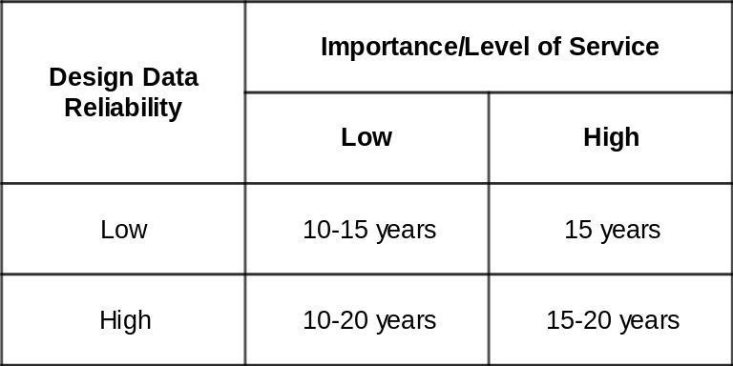

It is important to note that there may be little difference in pavement structure for two distinctly different design periods, and it is always worthwhile to check the estimated design traffic for different periods.

Design Traffic Loading

The pavement design process requires the estimation of the average daily number of ESAs on one lane at the opening of the new road to traffic, which is then projected and cumulated over the design period to give the design traffic loading. There are principally two ways to do this as outlined below in 2.3(a) and (b) respectively. The most important thing is that the data used be checked carefully for reasonableness and accuracy. Where deemed necessary, additional traffic and axle survey data must be obtained. More complete details regarding the processes and factors involved can be obtained from RN31¹ or TRH4².

    - Traffic Count Data and Static Vehicle Axle Load Survey Data

      - Determine the baseline Annual Average Daily Traffic (AADT).
This is defined as the total annual traffic summed for both directions and divided by 365, applicable at time of opening of the new road. This should be derived from available traffic count data, and should take cognisance of the possibility for diverted traffic (existing traffic that changes from another route) and generated traffic (additional traffic generated from the development).

  - Estimate the numbers of vehicles in different categories that comprise the baseline AADT.

Normal categories are cars/small pick-ups; light goods vehicles (including 4-wheel drives, panel vans and minibus/combis); trucks (which normally includes several sub-classifications to differentiate rigid and articulated vehicles, trucks with trailers, and various multi-axle configurations typical to the area), and buses. These classifications will already exist in a particular region and should form the basis for this estimate.

  - Forecast the one-directional cumulative traffic flow for each category expected over the design life.

This means taking half the value in step (ii) and projecting it at a selected growth rate, and cumulating the total over the design period. Growth rates will normally be in the range of 2 to 15 per cent per annum, and selected values should be based on all available indicators including historical data, and socio-economic trends.

The following formula, using the average daily traffic flow for the first year (not the value at opening to traffic, but the projected average for the year), gives the cumulative totals:

DT = T * 365 * [1 + r/100]^{p} - 1 ......Equation 1
r/100

where:

DT is the cumulative design traffic in a vehicle category, for one direction, and

T = average daily traffic in a vehicle category in the first year (one direction)
r = average assumed growth rate, per cent per annum
p = design period in years

  - Use static axle load data to determine average vehicle damage factors (ESAs per vehicle class).

These are determined from converting the surveyed axle loads to ESAs/vehicle classification, and then deriving a representative average value. In some cases, there will be distinct differences in each direction and separate vehicle damage factors for each direction should be derived.

No average vehicle damage factors for different vehicle classes are given in this document, as vehicle classifications, usage, degrees of overloading and legal limits are likely to differ throughout the region. These will all influence the average factors, and it is considered injudicious to propose values in this document which are likely to be inappropriate.

The following formula is used for converting real axle loads to ESAs:

F = [P/8160]^{n} (for loads in kg) or F = [P/80]^{n} (for loads in kN)
......Equation 2
Where:

F = the load equivalency factor in ESAs, and
P = axle load (in kg or kN)
n = relative damage exponent

For vehicles using multi-axle configurations (such as tandems and tridems), some agencies introduce further factors to derive modified load equivalencies on the basis that these axle groupings may be less damaging than the sum of the individual axles as derived above. Within the bounds of current knowledge and data reliability, and to keep the calculation straightforward, it is recommended that no such additional processing be adopted at this stage.

The value of 4 for the exponent n is often used, in line with early findings and the commonly cited "fourth-power damage effects" of heavy axle loads. It is now clear that the value is influenced by various factors, with the most significant being the pavement configuration.

Table 2.2 indicates recommended n values to be used for the pavements in this guide, and Table 2.3 gives load equivalency factors for different axle loads and n values derived from Equation 2. The pavement base/subbase combination of cemented/granular is not used in this guide, nor recommended, based on many examples of poor performance deriving from premature cracking and deterioration of the cemented base.

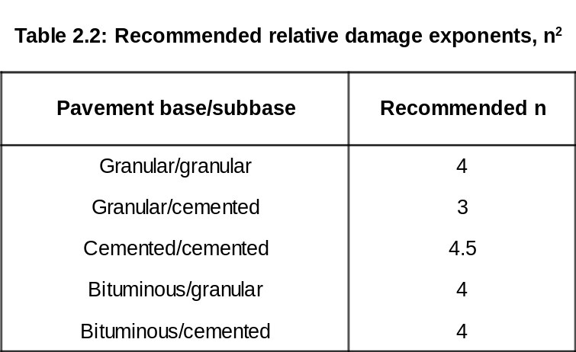

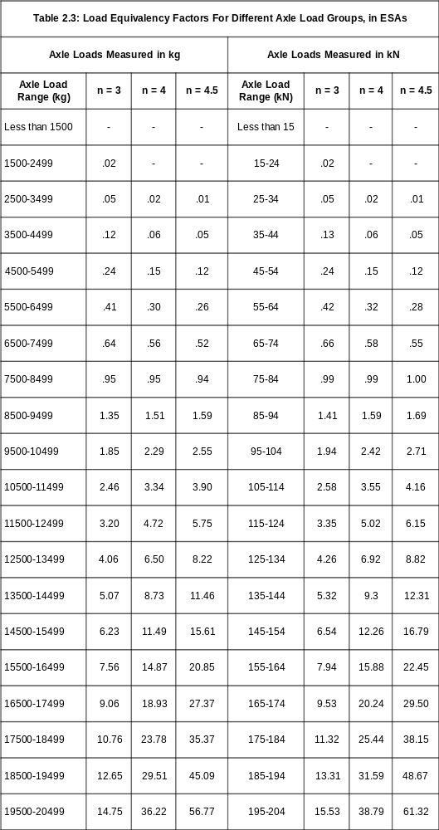

  - Convert one-directional cumulative traffic flows to the cumulative total ESAs in each direction.

The total ESAs in each direction are the sum of the ESAs from each vehicle category, derived from step (iii) above, using the factors from step (iv).

The actual design traffic loading (ESAs) is then calculated from the above, using the design carriageway widths and type of road to finalise the probable design needs. Table 2.4 gives the basis for design traffic loading using the nominal totals for each direction as determined above.

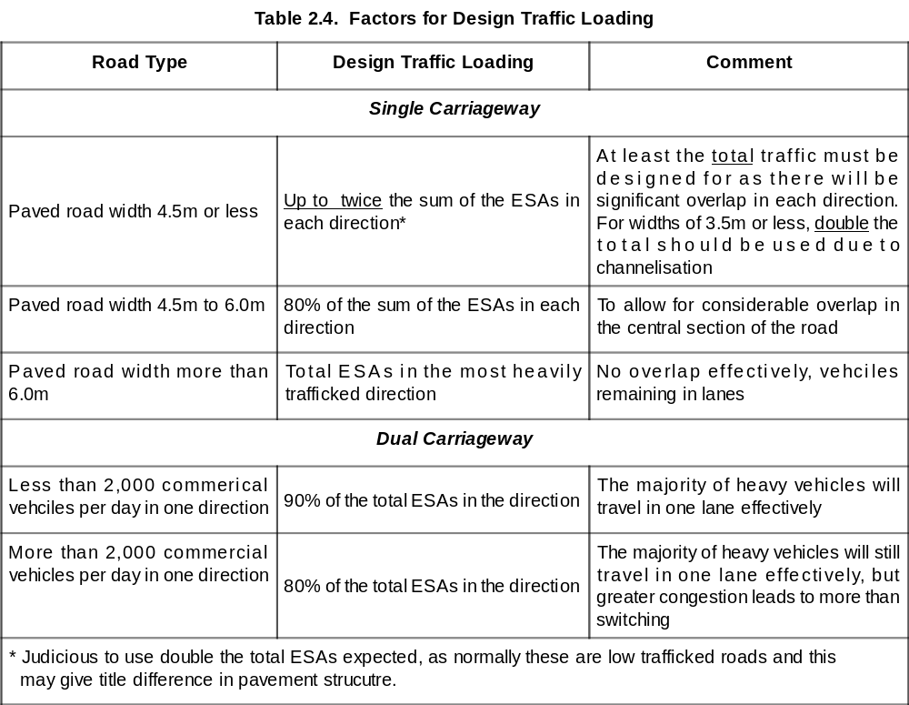

For dual carriageways it is not recommended to adopt different designs for the different lanes for the main reason that, apart from practical issues, there are likely to be occasions when traffic is required to switch to the fast lane or other carriageway due to remedial needs. This could then lead to accelerated deterioration of the fast lanes and any initial cost savings could be heavily outweighed by future expenditure and loss of serviceability.

- Weigh-in-motion (WIM) Axle Load Survey Data

  - Determine the baseline average daily traffic loading, ESAs, in each direction. Reliable WIM survey data provides a direct measurement of axle loads, and these can be converted to ESAs directly as outlined above. In this case, it is not necessary to know the vehicle details.

  - Convert the baseline ESAs to cumulative ESAs in each direction during the design life.

Equation 1 can be used, in which the average daily ESAs expected during the first year from step (i) are used for term T. The result, DT, is then the total cumulative ESAs for the particular direction.

The design traffic loading is then derived from Table 2.4 in the same manner as before.

Design Traffic Class

The pavement structures suggested in this guide are classified in various traffic categories by cumulative ESAs expected. Table 2.5 gives these classifications, and the design traffic determined from Section 2.2 is used to decide which category is applicable.

Table 2.5: Traffic classes¹
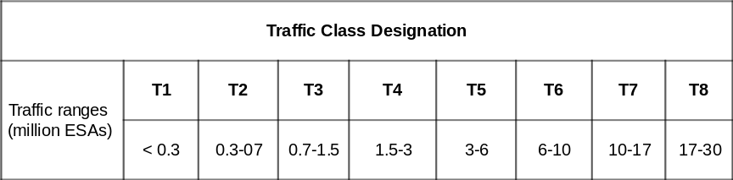

If calculated design values are very close to the boundaries of a traffic class, the values used in the forecasts should be reviewed and sensitivity analyses carried out to determine which category is most appropriate.

The lowest traffic class T1, for design traffic of less than 0.3 million ESAs, is regarded as a practical minimum since realistic layer thicknesses as well as materials specifications tend to preclude lighter structures for lesser traffic. The current level of knowledge on pavement behaviour, in any case, limits the scope for rational design of such lighter structures.

However, in the unlikely case that design traffic is estimated at less than 0.1 million ESAs (that is, traffic significantly less than the lowest class T1), since this guide is aimed primarily at the Regional Trunk Road Network, the Engineer is recommended to also consider alternative designs proven locally for this very light trafficking.

Probability Distribution of Traffic

Probability distribution of traffic is necessary since not all traffic would cruise at the design speed. Normally, a probabilistic analysis is needed to predict the performance of a pavement using a translation from mathematical findings.

In general a pavement design procedure consists of two major processes, which are the analysis of stresses and strains in the pavement structure and the determination of the allowable stresses and strains that can be taken by the pavement materials.

It is obvious that such a procedure involves careful material characterization, proper stress analyses that take into account the complex stress dependent, non-linear visco-elasto-plastic behavior of the material, as well as a translation of the mathematical findings into performance predictions. Normally a probabilistic analysis is needed to make such predictions.

The probability of failure can be reduced by a reduction in stress level (achievable by increasing thickness) or by an increase in strength level (achievable by using better quality materials) or by reducing the amount of variability.

Reducing the amount of variability can be achieved by an effective and appropriate quality control. Reducing the variability in stress and strength seems to be a very attractive way to increase the reliability of pavement structures. In order to design pavement structures properly one must not only take into account the mean strength of the materials used and the mean stresses induced in them, but also the variation in both induced stress and variable strength.

Axle and Wheel Load Distribution

Uneven distribution of axle loads over the wheels of the axle has large effects on damage developments (edge deterioration). Furthermore it is assumed that in case of dual wheels on either side of the axle, each wheel of the dual wheel will carry the same load. This however might also not be true. Assuming equally distributed wheel loads on an axle could be acceptable for design purposes but in any case the final design should be checked on the effect of unevenly distributed wheel loads.

Next to the axle load and wheel load information, information on the wheel configuration is of importance. Rear axles are sometimes equipped with single tires. In that case there is only one wheel on either side of the axle and this change in wheel configuration has definitely its effect on pavement deterioration and performance.

Lateral Wonder, Directional Factor and Lane Factor

Since trucks do not drive in exactly the same wheel path, the number of peak strain repetitions that occur at a given location in the pavement is not the same as the number of wheel passages. This effect is called lateral wonder.

This has a beneficial effect on the pavement life. Studies have been conducted to develop reduction factors that can be applied to the total number of wheel passages and the thickness of the pavement.

The width of the lane does not only have an influence on the lateral wonder but also on the directional factor. On narrow roads (e.g. of 3 m width) the traffic in both directions will travel in the same wheel paths. On a 2 lane road it can be assumed that 50% of the total traffic travels in one direction and 50% in the other direction. Factors given on Table 2.4 are used for designing the traffic loading.

On multilane highways, most of the trucks are supposed to travel on the outer lanes but not all. This implies that the distribution of the trucks over the lanes must be taken into account and more particularly one should know the percentage of the trucks driving on the most heavily trafficked lane.

For heavily trafficked roads it is likely that traffic measures will be taken to keep all trucks in the same lane and in this case the lane factor should not be taken into account.

DETERMINING SUBGRADE STRENGTH

Background

The subgrade strength is the other most important factor, apart from traffic loading, which governs the pavement structural configuration. It is assumed in this guide that the first stages of determining nominally uniform sections in terms of subgrade condition will have been undertaken. This can be based on geological and soil property assessments, in conjunction with other physical assessments such as the Dynamic Cone Penetrometer (DCP) test or in situ bearing tests, or any other means that allows realistic delineation. Section 5.8 discusses the general use of the DCP.

This section therefore focuses on the classification of these sections in terms of the California Bearing Ratio (CBR) to represent realistic conditions for design. In practice this means determining the CBR strength for the wettest moisture condition likely to occur during the design life, at the density expected to be achieved in the field.

The classification of subgrade condition in this guide is similar to RN31 and is shown in Table 3.1.

Table 3.1: Subgrade classification¹

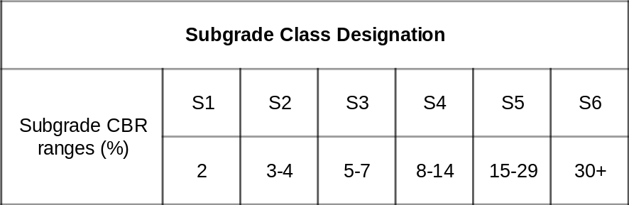

Since the combination of density and moisture content wholly governs the CBR for a given material, it is firstly clear that changes in moisture content will alter the effective CBR in the field, and it is therefore clear that particular effort must be taken to define the design subgrade condition.

The result of incorrect subgrade classification can have significant effects, particularly for poorer subgrade materials with CBR values of 5 per cent and less. If the subgrade strength is seriously overestimated (ie, the support is actually weaker than assumed), there is a high likelihood of local premature failures and unsatisfactory performance. Conversely, if the subgrade strength is underestimated (ie, the support is stronger than assumed), then the pavement structure selected will be thicker, stronger and more expensive than needed.

By the same token, there will always be considerable variation between results from samples, which makes it difficult to decide on a design value. This is further complicated by the requirement that the assumed subgrade strength is available to some depth: a thin, nominally high strength, material layer over a far weaker material will not provide the good support expected.

These guidelines are purposely kept as simple as possible, which means that limited details are provided. If more detailed information is required, RN311 is suggested as a primary reference source.

Representative Subgrade Moisture Content

The estimation of the wettest subgrade condition likely to occur, for design purposes, is the first stage in determining the design subgrade CBR. It is well known that moisture contents in subgrades are prone to variation due to natural effects, including rainfall, evaporation, and proximity of water table, as well as material type.

Any available local knowledge of the subgrade, locale, and prevailing conditions, should be drawn on first in determining the nominal design moisture content. Direct sampling should be undertaken if there is a clear understanding of how the sampled moisture content relates to the probable wettest condition to be encountered. If such specific information is not available, or it is felt necessary to supplement the available information, the following approach is suggested to estimate design moisture content.

- Areas where water-tables are normally high, regular flooding occurs, rainfall exceeds 250 mm per year, conditions are swampy, or other indicators suggest wet conditions occurring regularly during the life of the road leading to possible saturation.

Design moisture content should be the optimum moisture content determined from the AASHTO (Proctor) compaction test T-99 for the design moisture content.

- Areas where water-tables are low, rainfall is low (say less than 250 mm per year), no distinct wet season occurs, or other indicators suggest that little possibility of significant wetting of the subgrade should occur.

Use the moisture content determined from the following formula based on the optimum moisture content (OMC) determined from the AASHTO (Proctor) compaction test T-99:

Design moisture content (%) = 0.67 * OMC (%) + 0.8 .....Equation 3

Where:

OMC is the optimum moisture content from the AASHTO (Proctor) compaction test T-99, and the simple relationship was derived from a comprehensive investigation into compaction characteristics (Semmelink, 1991³).

Classifying Design Subgrade Strength

The subgrade strength for design should reflect the probable lowest representative CBR likely to occur during the life of the road. As noted in Section 3.1, the value will be influenced by both density achieved and moisture content. For practical purposes, it is important that the highest practical level of density (in terms of Maximum Dry Density, or MDD) be achieved from the subgrade upwards in order to minimise subsequent deformations due to further densification under the traffic loading.

Clearly if insufficient compaction is achieved during construction then the longer term performance of the road is likely to be negatively affected, so it is critical to ensure that good compaction is attained. It is also critical to ensure that the subgrade has been compacted to a reasonable depth in order to avoid the possibility of the road deforming due to weakness of the deeper underlying material.

The following guidance (Table 3.2) is suggested for determining subgrade CBR classification according to Table 3.1, for minimum subgrade compaction requirements and for a control check on subgrade compaction during construction.

Table 3.2: Method for classifying subgrade design CBR

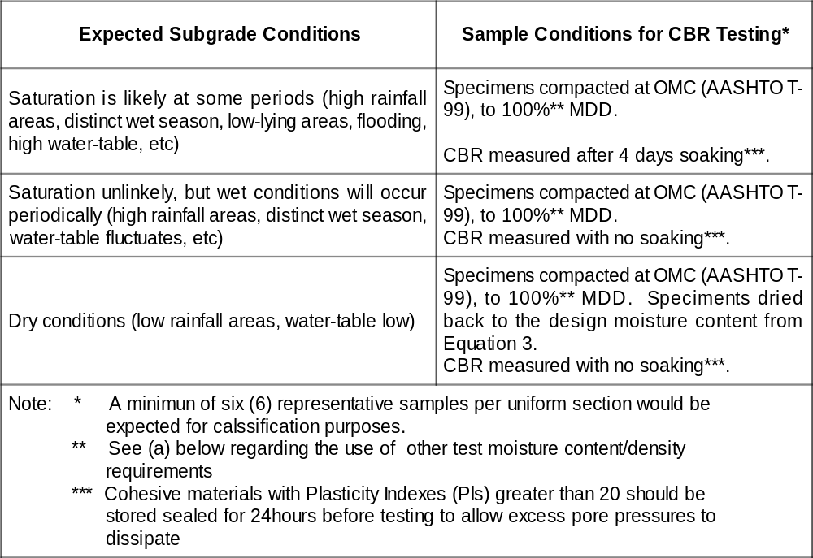

- Minimum subgrade compaction requirements

The method for classification in Table 3.2 assumes that a minimum field compaction density of 100 per cent Proctor MDD (or 95 per cent modified AASHTO MDD) will be attained. In most cases, with current compaction equipment, this minimum should be readily achieved.

Where there is evidence that higher densities can be realistically attained in construction (from field measurements on similar materials, from established information, or from any other source), a higher density should be specified by the Engineer. The higher density should also be used in the CBR classification in Table 3.2 in place of the 100 per cent MDD value.

There may be cases where, because of high field compaction moisture contents (higher than OMC), material deficiencies or other problems, the CBR sample conditions are not realistic. In such cases, the Engineer must specify a lower target density and/or higher moisture content to be substituted for the sample conditions in Table 3.2 to represent probable field conditions more realistically.

- Specifying the design subgrade class
The CBR results obtained in accordance with Table 3.2 are used to determine which subgrade class should be specified for design purposes, from Table 3.1.

In some cases, variation in results may make selection unclear. In such cases it is recommended that, firstly, the laboratory test process is checked to ensure uniformity (to minimise inherent variation arising from, for example, inconsistent drying out of specimens). Secondly, more samples should be tested to build up a more reliable basis
for selection.

Plotting these results as a cumulative distribution curve (S-curve), in which the y-axis is the percentage of samples less than a given CBR value (x-axis), provides a method of determining a design CBR value. This is illustrated in Figure 3.1, from which it is clear that the design CBR class is realistically S2, or 3 - 4 per cent CBR. Choice of class S3 (5 - 7 per cent CBR) would be unjustified as the Figure indicates that between roughly 20 to 90 per cent of the sampled CBRs would be less than the class limits.

A good rule of thumb is to use the 10 per cent cumulative percentage (percentile) as a guide to the subgrade class, on the basis that only 10 per cent of the actual values would be expected to have a lower CBR than the indicated CBR. In this case, the 10 per cent rule indicates a CBR of approximately 4.5 per cent, thus confirming that the subgrade class of S2 is more appropriate than S3.

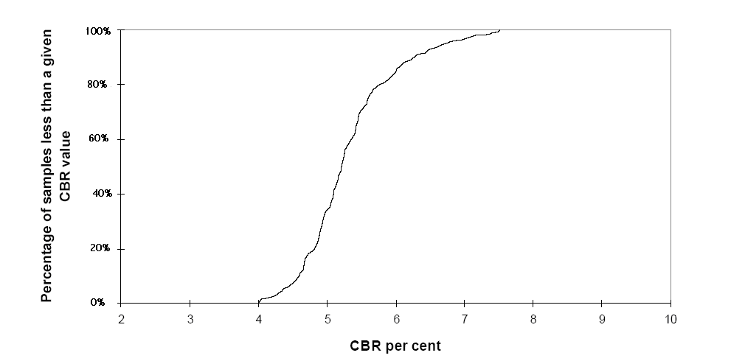
Figure 3.1: Illustration of CBR strength cumulative distribution

- Control check on subgrade strength uniformity during construction
It is critical that the nominal subgrade strength is available to a reasonable depth in order that the pavement structure performs satisfactorily. A general rule is that the total thickness of new pavement layers (derived from the catalogue) plus the depth of subgrade which must be to the design subgrade strength should be 800 to 1 000 mm. Table 3.3 gives recommended depths for subgrade strength uniformity for the design subgrade classifications in Table 3.1.

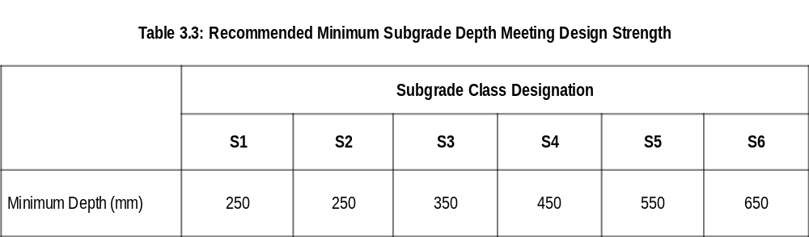
It should be clearly understood that the minimum depths indicated in Table 3.3 are not depths to which recompaction and reworking would be anticipated. Rather, they are the depths to which the Engineer should confirm that the nominal subgrade strength is available. In general unnecessary working of the subgrade should be avoided and limited to rolling prior to constructing overlying layers.

For the stronger subgrades especially (class S4 and higher, CBR 8 - 14 per cent and more), the depth check is to ensure that there is no underlying weaker material which would lead to detrimental performance.

It is strongly recommended that the Dynamic Cone Penetrometer (DCP) be used during
construction to monitor the uniformity of subgrade support to the recommended minimum depths given in Table 3.3 (see Section 5.8).

For designing the thickness of a road pavement, the strength of the subgrade should be taken as that of the soil at a moisture content equal to the wettest moisture condition likely to occur in the subgrade after the road is opened to traffic. According to TRL RN 31, subgrade moisture conditions under impermeable road pavements can be classified into three main categories in the tropics. Category(1) are subgrades where the water table is sufficiently close to the ground surface to control the subgrade moisture content. Category(2) are subgrades with deep water tables and where rainfall is sufficient to produce significant changes in moisture conditions under the road. Category(3) are subgrades in areas with no permanent water table near the ground surface and where the climate is dry throughout most of the year with an annual rainfall of 250 mm or less. It is recommended to refer to TRL, RN 31 for further details regarding the estimation of the subrade moisture content with respect to the location of the water table.

For areas with high water tables the top of the subgrade or improved subgrade must be raised above the level of the local water table to prevent it being soaked by ground water.

DEFINITION OF WET OR DRY CONDITIONS

Background

The design catalogue in this guide includes specific pavement structures for either nominally wet or nominally dry regions, in order to simplify the selection of appropriate pavements. While some consideration to prevailing conditions has already been given in the selection of appropriate subgrade classification, this section provides guidance on which set of structures to select.

Factors which will have an influence on the selection, apart from broad climatic considerations, also include drainage and maintenance regimes that are anticipated for the road. It is a basic fact that, for any road, the frequent ingress of water to the pavement layers will result in unwanted deterioration under trafficking. The rate and degree of such deterioration will also depend therefore on the level of trafficking.

While the underlying requirement for any road is the provision of good drainage and operation of an effective maintenance programme to ensure that water does not penetrate the pavement, real life conditions may not always match these needs.

Although it is implicitly assumed that suitable drainage and maintenance should be effected during the life of the road, and that lack of either of these will undoubtedly have a negative impact on long-term performance, the following guidance acknowledges that deficiencies occur. Such deficiencies should, nevertheless, be addressed in order to retain the investment made in the road. Appendix B provides some discussion on drainage.

Selecting the Appropriate Pavement Design Based on Moisture Influence

Predominantly Dry Regions

Selection of pavement structures from the catalogue for dry regions is appropriate where annual rainfall is less than 250 mm and there is no likelihood of moisture ingress due to factors such as significant flooding (in low-lying flood plain areas, or in tidal basins, for example), underground springs or wells, or any other detrimental conditions.

In regions of higher rainfall, where rainfall is evenly distributed throughout the year and no distinct rainy season conditions apply, the Engineer may deem the dry region catalogue to be appropriate. In such cases, it should be confirmed that there are not periods in which
conditions will lead to significant possibility of moisture ingress to the pavement. It should be noted that long periods of light rain (or heavy fog), with heavy truck traffic, can cause serious damage of thin surfacings especially. It is unlikely that regions with rainfall more than 500 mm per annum would be regarded as dry regions for design purposes.

Predominantly Wet Regions

Any regions which do not comply with (a) above must be regarded as being predominantly wet. In line with the earlier discussion, there are certain other factors which should have an influence on selection of appropriate designs, and Table 4.1 provides some guidance. Depending on the likely maintenance and drainage provisions, Table 4.1 indicates which set of design catalogues might be appropriate. The Engineer must, however, review all the prevailing factors in finalising his selection.

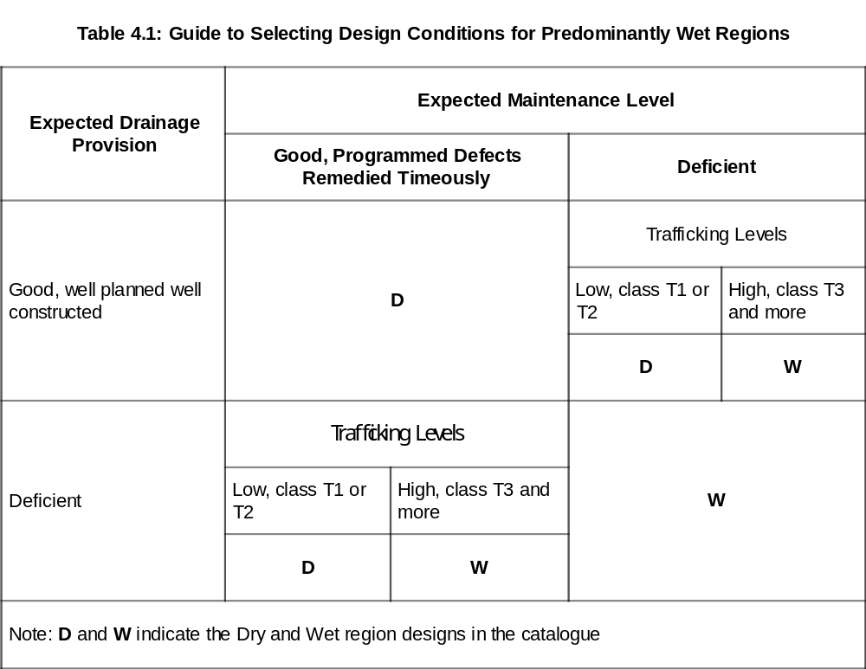

PRACTICAL CONSIDERATIONS

Background

The earlier sections have provided guidance to the designer in selecting the design parameters of traffic class, subgrade support classification and nominal conditions. These are the primary factors used in entering the design catalogue in Appendix C to determine appropriate structures.

Until now, however, no consideration has been given to other factors which will have a practical influence on finalising possible pavement structures. Most significant of these is the availability, in terms of both quantity and quality, of materials for road construction. Other factors include the general topography, and the use of established local methods for road layer construction. Each of these will affect the final selection of a pavement.

While general specification requirements should be met, and some of these are indicated in both Appendix A guidelines and Appendix C, there may be a need for the Engineer to review these in the light of specific local conditions. This section therefore aims to provide some guidance in that respect.

It should be noted, however, that it is implicitly assumed that suitable bituminous surfacing materials will be obtained, whether surface treatments (typically single and double seals, including variations such as Cape or slurry seals) or hot-mix asphalts. This is not, therefore, discussed here.

Materials Availability

The designs given in this guide are based on the nominal material strength classifications given in Table 5.1. For structural purposes, this provides a guide to the probable performance, assuming that no unexpected deterioration (for example, due to water ingress) takes place. The full specifications, given elsewhere, include a number of other indicatory properties to assure that such deterioration ought not take place during the life of the road.

For the granular materials, only a minimum strength requirement is specified since there are usually no disadvantages in attaining higher strengths, and long-term performance is likely to be better in such cases. In line with foregoing discussions, however, it should be noted that density achieved is critically important if deformation under subsequent trafficking is to be minimized.

In contrast to just a minimum strength requirement, distinct upper and lower strength limits are placed on cemented materials (here meaning use of a CEM I binder), due to the propensity of strongly cemented materials to form wide, widely-spaced, cracks which can reflect through overlying layers and open the pavement to moisture ingress, as well as losing structural integrity. The strength bounds are intended to ensure that any detrimental effects from cracking of the layer, which is virtually unavoidable in this type of material, are minimized by ensuring closer-spaced narrow cracks.

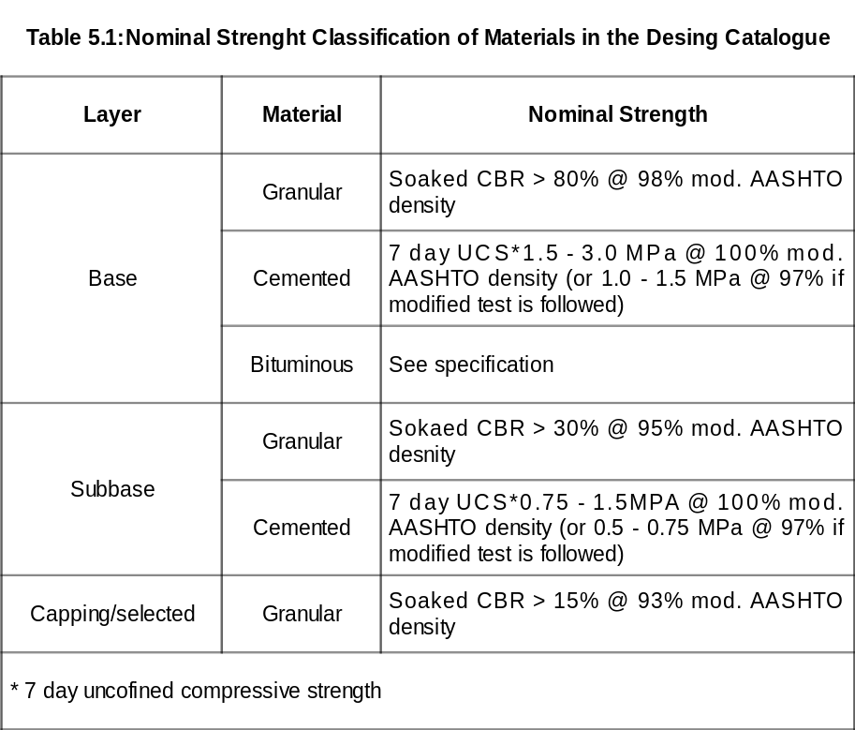

Note: Samples for UCS tests are mixed and left for two hours before being compacted into 150 mm cubes. These samples are then moist cured for 7 days and soaked for 7 days in accordance with BS 1924. (For further details refer to TRL, RN 31). The UCS test shall be conducted according to BS 1924 : Part 2:1990.

Table 5.2: Layer Coefficients

Layer/Material | Layer Coefficient
Surfacing
Surface dressing | a₁ = 0.20
Asphalt concrete | a₁ = 0.35
Base
Bitumen Macadam | a₂ = 0.20
Natural or crushed gravel | a₂ = 0.12
Crushed stone
On natural gravel subbase | a₂ = 0.14
On stabilished subbase | a₂ = 0.18
Cement treated gravel (4)
Type A, 3.5 < UCS (Mpa) < 5.0 | a₂ = 0.18
Type B, 2.0 < UCS (Mpa) < 3.5 | a₂ = 0.14
Subbase
Natural gravel, CBR > 30% | a₃ = 0.11
Cement treated material
Type B, 2.0 < UCS (Mpa) | a₃ = 0.16
Type C, 0.7 < UCS (Mpa) < 2.0 | a₃ = 0.12

The 1989 SATTC Pavement Design Guide can be used if layer coefficients and Structural Number approach is followed for the pavement thickness design.

If layer coefficients are used the structural pavement design shall satisfy the following general equation:

DSN = a₁h₁ + a₂h₂ + a₃h₃
Where:

DSN is the weighed structural number for the entire pavement (multiplied by 25.4 to accommodate the layer thickness to be entered in mm),
a₁,a₂ and a₃ are layer coefficients representative of surfacing, base and subbase respectively,
h_{l},h₂, and h₃ are actual thickness, in mm, of surface, base and subbase courses respectively.
In case of a fourth pavement layer the equation is extended by adding a₄, h₄.

It should be recognised at the outset that the use of cemented layers will only normally be considered if there are not suitable granular materials available locally. The first consideration is therefore to determine what local materials could be feasiblely used, and how these could meet the nominal requirements in Table 5.1 without significant processing (such as crushing, screening and recombining, or mechanical or chemical stabilisation).

Mechanical stabilization (modification) is explained in the General Specification for Road and Bridge Works, MOWHC, January, 2005 on Section 3804 as follows: The modification of soils and gravels, by the addition of a soil binder, hereinafter referred to as mechanical modification, shall consist of the addition of an approved soil binder to the materials, in order to improve the load bearing capacity, plasticity index, grading and other properties of material.

Bearing in mind that the cost of transport of materials becomes a major cost factor if materials must be brought in to the site from a distance, it is usually cost-effective to try to utilise the local materials even if this would then necessitate some form of processing. As indicated above this may take various forms, but the choice is, of course, ostensibly a matter of cost and economy and in most cases the pavement designer must select materials accordingly.

In the case of certain "problem" materials (requiring some form of processing to comply with nominal specification requirements, other than crushing or screening) the following techniques might be considered in order to improve their road-building potential. No specific details are given here, however, and the Engineer should determine the most appropriate method based on local experience, ad hoc trials and/or specialist advice.

Natural Gravel/soil Materials not Meeting CBR and/or PI Requirements

Techniques which have been found to be effective in certain cases include:

- Treatment with lime or any other cementitious material (typically 2 to 5 per cent by weight): normally effective for reducing high PIs; will normally enhance CBR. Carbonation can cause longer term reversion to the original properties, so some caution should be adopted when using such treatment.

- Treatment with both bitumen-emulsion (typically 0.7 to 1.5 per cent residual bitumen by weight) and cement (typically 1.0 per cent by weight): will normally enhance compactibility, strength/CBR.

Cohesionless Materials, Sands

Techniques which have been found to be effective in certain cases include:

- Treatment with bitumen
- Treatment with foamed bitumen

Stability may be a problem in the above cases unless well confined.

Dense Clays/expansive Materials

A technique which has been found to be effective in certain cases is:

- Treatment with lime: It can increase Plastic Limit (PL) and make material friable/more stable; will normally enhance CBR.
- Replacement of expansive soils: Expansive soils shall be removed up to a depth specified by the Engineer and back filled with fill materials meeting the general requirements for fill.

"Collapsible" Sands and Soils

These are materials that are, in effect, uncompacted and in which the existing material skeleton is maintained by relatively weak bonds between particles (usually clayey bonds). In the first instance, they should be compacted to a depth of 1.0 metre to a minimum density of 85 per cent modified AASHTO MDD (test method T-180). The Engineer should then reassess their suitability as a subgrade, and determine the appropriate subgrade classification (Section 3).

Terrain

The performance of a road in otherwise similar conditions can be influenced by terrain, in that rolling or mountainous terrain (in which significant grades are encountered) tends to lead to significantly more traffic-related loading on surfacings and bases. This is fairly commonly observed on relatively heavily trafficked roads (say, class T5 and higher, carrying more than 3 million ESAs) where surface deterioration and rutting deformation occurs. Routes on which overloaded trucks are common (axle loads of 10 tonnes and more) are especially prone.

In such situations, it is imperative that compaction of layers is controlled extremely well and ideally to more than minimum standards. It is also advised that the surfacing layer is resistant to deformation and, of course, well-bonded to the base to avoid early failure due to debonding and traffic-induced slippage at the interface.

A bituminous base combined with a hot mix asphalt surfacing can be (and is often) used to provide a stable, relatively stiff, deformation resistant backbone, which can also mask possible compaction deficiencies in the underlying layers which may occur due to difficult working conditions. There is considerable merit in looking at the use of special bituminous binders which may help inhibit rutting due to heavy vehicles, and the guidance of the bitumen supplier should be sought in the first instance.

An alternative approach, not specifically covered in this guide, is to consider the possibility of a concrete base. This type of construction can be effective for these conditions, and can be laid by labour-enhanced methods where conventional large-scale construction equipment is unsuitable.

It is also commonly observed that moisture-induced problems, leading to possible local premature failures, occur in cuts and on sag curves (dips), emphasising the need for particular attention to drainage provision and maintenance in such locations.

Vehicle Overloading

Incidences of vehicle overloading can have a significant negative impact on the performance of a road, and the effects are observed especially by premature failures of surfacing layers (excessive rutting, bleeding, loss of surface texture, and ravelling being prevalent as early indicators). Naturally, every effort should be made to limit the amount of overloading (illegal loading) but it is recognised that current controls may not always be sufficient.

While the design process should account for the amount of heavy vehicle axle loads in determining the design traffic loading (Section 2), the specific effects of the very heavy abnormal axle loads on the pavement must be considered in finalising the design.

In situations where overloading is likely to occur, special attention must be given to the quality and strength of all the pavement layers during construction. Amongst other measures, there may be justification in increasing the specification CBR requirements for granular layers, in increasing the base and subbase layer thicknesses, and in specifying special bitumen binders and asphalt mixtures, such as stone mastic asphalts, which are more resistant to deformation.

The specific measures that the Engineer may deem necessary should, ideally, be based on either proven local practice or at least specialised advice/analysis in order to maintain a well balanced structure.

Subgrade CBR less than two per cent

In these cases, which must be treated according to the specific situation, some of the possible approaches include:

- In situ treatment with lime (for clayey materials).
- Removal and replacement with better quality material.
- Use of geo-fabrics.
- Construction of a pioneer layer (for highly expansive material and marshy areas) or rock fill.

These conditions are often encountered in low-lying, wet and swampy areas, and treatment should ideally be based on past proven practice for similar conditions. The use of geo-fabrics, usually in accordance with specialist advice from the manufacturer, can be extremely effective in situations where other approaches are inappropriate (for example, where better quality materials are either not readily available, or would tend to displace downwards).

When appropriately treated, the design for the overlying pavement can then be based on the re-evaluated subgrade support condition.

Design Trafficking Greater than 30 million ESAs

For such heavily trafficked roads, other established design methods must be used and the pavement designer is advised to look at UK, US and Australian practices in addition to the South African TRH4² guide.

From reviewing these documents (as well as others deemed appropriate), it will normally be straightforward to derive a design suited to the particular needs.

Rehabilitation of Existing Roads

Various methods exist for determining needs for rehabilitation and strengthening of existing roads, and it is recommended that the SATCC Code of Practice for Pavement Rehabilitation⁴ be used in the first instance. The catalogue in this guide may then be used, amongst others, to review the rehabilitation needs identified and help establish the most effective treatment.

Use of the Dynamic Cone Penetrometer (DCP)

The DCP is probably the single most effective testing device for road construction, being a simple, rapid and direct indicator of material condition that can be used from initial site survey through to construction control. Its use within the region is already established, and this section is intended only to highlight the main aspects of its effective usage.

During initial field survey the DCP can aid in determining the existing subgrade condition, in conjunction with normal indicator and CBR tests, and therefore in delineating uniform sections for design. Similarly, during construction the DCP can be used to monitor uniformity of layers, particularly in terms of in situ density. It can also be used as a design tool in its own right and a method has been developed for such application⁵.

While the DCP is commonly used to estimate in situ CBRs from nominal penetration rates (mm/blow), this technique should only be used when correlations have been specifically developed for the DCP apparatus used. It is known that several different types of DCP are commonly used, having different cone types and dynamic energy input. If used with the wrong CBR correlations, incorrect estimates of CBR will be obtained. Since changes in moisture content will influence the rate of penetration for a given density, the Engineer must ensure that this factor is taken into account if the DCP is used for CBR estimation.

DCP (Dynamic Cone Penetrometer) testing shall be carried out at intervals of 100 meters to directly measure the field CBR strength of the subgrade. Continuous measurements can be made down to a depth of approximately 850mm or when extension shafts are used to a recommended maximum depth of 2 meters. The interval of test pits for CBR shall not be more than 1.0 km. Correlations have been established between measurement with the DCP and CBR so that results can be interpreted and compared with CBR specifications for pavement design.

Alternatively, and especially for control monitoring, the penetration rate can be used in its own right as a compliance check. For example, the Engineer can determine an acceptable maximum DCP penetration rate directly from in situ measurements on areas (of subgrade or constructed granular layers) deemed to meet the required field strength and density requirement. The DCP can then be used as a process control tool to check that the field compaction is satisfactory to the specified depth. Where penetration rates exceed the acceptable specified maximum value, further compaction is indicated.

The DCP should not be used specifically, however, as the basis for determining construction acceptance (ie, for density or strength compliance with the specification requirements): this should still be undertaken using the appropriate standard test methods.

Consequently the use of the DCP during the whole construction process, from initial field survey through to rapid compliance checking, can significantly reduce the need for some of the more onerous testing and its use is strongly recommended.

SELECTION OF POSSIBLE PAVEMENT STRUCTURES

The design catalogue is given as Appendix C, and comprises two distinct sets of structures for nominally dry and nominally wet conditions (Charts D1 to D5, and W1 to W5 respectively). The set of structures deemed most appropriate should be as determined from Section 4. The charts are classified as follows (Table 6.1):

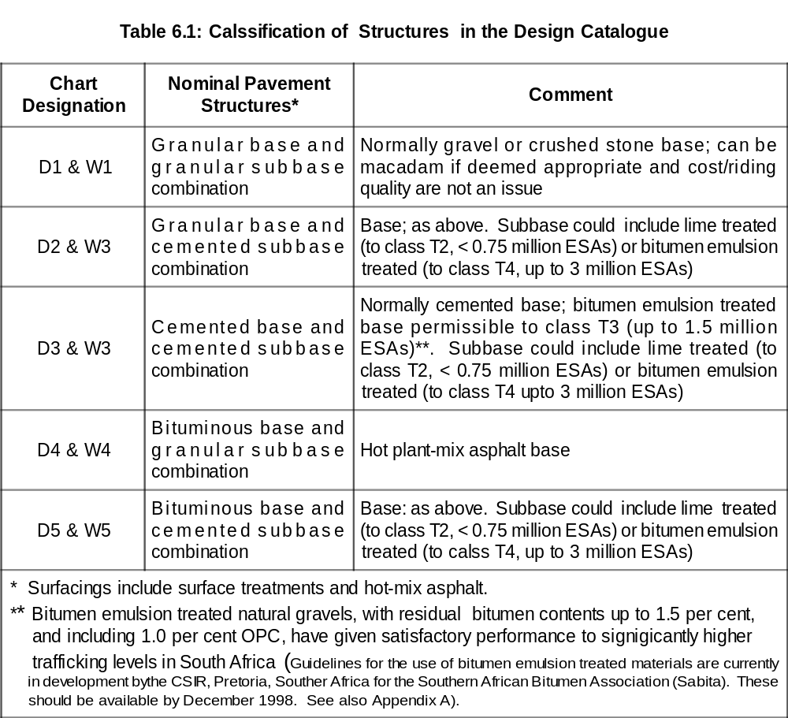
Note: Based on the plasticity and particle size distribution of the material cement treatment can also be used for subbase and base materials. Cement is more difficult to mix intimately with plastic materials. On Appendix A.3.1 of this manual it is stated that material suitable for cement treatment will normally have a low Plasticity Index (less than 10), with a reasonably uniform grading. TRL, Overseas Road Note 31, 1993, is recommended for more complete discussion regarding cement and lime treatments.

The appropriate design set(s) can then be accessed on the basis of design trafficking class (from Section 2) and design subgrade condition (from Section 3), and the designer can review the alternatives to finalise the selection (See Construction note below).

As noted in the introduction, the designer should regard the selected structure as being one of many possibilities that is likely to provide adequate service for the given design conditions. It is therefore recommended that, when possible, the suggested structure be reviewed in terms of the specific conditions and in light of established local (or other appropriate) practices. This might enable judicious refinement of the structure to optimise for prevailing conditions.

Before finalising the structural design, the Engineer should confirm that it provides the most cost-effective solution for the particular application. This will be based primarily on initial costs, but must also take into account probable future periodic maintenance needs (such as resealing during the design life) based on expected performance in the prevailing conditions.

While not addressed in this document, the designer should be aware that the most cost effective, or economic, road would be defined as that which minimises the total cost of the facility during its life time. Factors that would be included in such an analysis are the initial construction cost, the maintenance costs, the road user costs, and any assumed residual value at the end of the design life.

For practical purposes, where details of this nature are unavailable, unreliable, or otherwise deemed unnecessary, it can be assumed that comparison of initial (construction) costs will provide a good basis for final selection for the structures in this guide.

For comparisons between rigid and flexible pavements, it is more appropriate to assess whole life cycle costs than initial costs.

Construction note

In some cases, the catalogue structures have base, subbase or capping layers of substantial
thickness (more than 200 mm). Actual construction lift thicknesses should be defined by the Engineer, and it is recommended that compacted lift thicknesses greater than 200 mm or less than 100 mm should generally be avoided. The underlying principle, however, is that full uniform compaction is achieved within the layer and that a good key between individual lifts/layers is achieved.

Both these factors have a marked effect on subsequent performance of the road, and every effort should be made to achieve the best compaction and bond. Local good practice for specific materials and compaction equipment should be followed where this is deemed appropriate. Monitoring and control checks should be instigated which provide confirmation of satisfactory layer construction.

REFERENCES

- A guide to the structural design of bitumen-surfaced roads in tropical and sub-tropical countries. 1993. Crowthorne, UK: Transport Research Laboratory.
- Code of Practice for Pavement Rehabilitation. 1998. Maputo, Mozambique: Southern Africa Transport and Communications Commission (SATCC).
- DE BEER, M. 1991. Use of the dynamic cone penetrometer in the design of road structures. Proceedings of the 10th Regional Conference for Africa on Soil Mechanics and Foundation Engineering. Maseru, Lesotho.
- Draft guidelines on the use of bitumen emulsion treated materials. 1998. Cape Town, SA. Southern African Bitumen Association (Sabita).
- SEMMELINK, C.J. 1991. The effect of material properties on the compactibiliy of some untreated road building materials. PhD dissertation, University of Pretoria, South Africa.
- Standard specifications for road and bridge works. 1998. Maputo, Mozambique: Southern Africa Transport and Communications Commission (SATCC).
- Structural design of flexible pavements for inter-urban and rural roads. 1996. Pretoria, SA: Department of Transport. (Technical Recommendations for Highways Draft TRH4).
- Subsurface drainage for road. 1994. Pretoria, SA: Department of Transport. (Technical Recommendations for Highways Draft TRH15).
- Surfacing seals for rural and urban roads. 1998. Pretoria, SA: Department of Transport. (Technical Recommendations for Highways Draft TRH3).

APPENDIX A

MATERIALS

APPENDIX A : MATERIALS

A.1 Introduction

The specification of the materials to be used in the pavement are given in detail in the separate SATCC Standard Specifications for Road and Bridge Works documents. This Appendix is not intended to override any of the requirements given in that document, but is given in order to provide the pavement designer with certain insights that may not be readily apparent in the specification. The MoWHC Standard Specs for Road and Bridge Works shall be used in conjunction with the SATCC Standards. Whenever there are discrepancies the MoWHC Standard Specs shall be followed.

The information given here should therefore be regarded as general guidance, which might also provide a basis for considering the use of materials which may not otherwise fully comply with specification requirements.

This Appendix reviews the materials by class in the following sections: unbound, cemented and bituminous.

A.2 Unbound Materials

A.2.1 Granular Base Construction

A wide range of materials can be used for unbound bases. These include crushed rock or stone, naturally occurring as ‘dug’ gravels, and various combinations of crushing and screening, mechanical stabilisation or other modification. Their suitability for use depends primarily on the design traffic class of the pavement, and climate, but all base materials must have a particle size distribution and particle shape which provide high mechanical stability. In particular, they should contain sufficient fines (material passing the 0.425 mm sieve) to produce a dense material when compacted.

In circumstances where several types of base are suitable the final choice should take into account the expected level of future maintenance and the total cost over the expected life of the pavement. The use of locally available materials is encouraged, particularly at low traffic volumes (ie, categories T1 and T2).

In selecting and using natural gravels, their inherent variability must be taken into account in the selection process. This normally requires reasonably comprehensive characterization testing to determine representative properties, and it is recommended that a statistical approach be applied in interpreting test results.

For lightly trafficked roads the specification requirements may be too stringent and reference should be made to specific case studies, preferably for roads under similar conditions, in deciding on suitability of materials which do not fully comply with specification requirements.

- Graded Crushed Stone

Graded crushed stone can be derived from crushing fresh, quarried rock (used either as an all-in product, usually termed a crusher-run, or by screening and recombining to produce a desired particle size distribution), or from crushing and screening natural granular material, rocks or boulders, to which may be added a proportion of natural fine aggregate.

After crushing, the material should be angular but not excessively flaky in order to promote good interlock and performance. If the amount of fine aggregate produced during crushing is insufficient, additional non-plastic sand may be used to make up the deficiency.

In constructing a crushed stone base, the aim should be to achieve maximum density and high stability under traffic. Aggregate durability is normally assessed by standard crushing tests but these are not as discriminating as durability mill testing, which is the preferred method.

The material is usually kept damp during transport and laying to reduce the likelihood of particle segregation. These materials are commonly dumped and spread by grader, rather than the more expensive option of using a paver, which demands greater construction skill to ensure that the completed surface is smooth with a tight finish. The Engineer should pay particular attention to this aspect to guarantee best performance. When properly constructed, however, crushed stone bases will have CBR values well in excess of 100 per cent¹.

Materials for crushed aggregate base course shall meet the requirements given in Section 3900 (Tables 3902/1, 3902/2 and 3903/1) of the General Specifications for Road and Bridge Works, MOWHC, January 2005.

- Naturally-occurring Granular Materials

A wide range of materials including lateritic, calcareous and quartzitic gravels, river gravels and other transported gravels or granular materials resulting from the weathering of rocks have been used successfully for bases.

The over-riding requirement for the use of such materials is the achieval of the minimum design soaked CBR of 80 per cent at the probable in situ density and moisture content conditions, and the maintaining of this strength in service (long-term durability) without undesirable volume changes in the material. Some further discussion is given below, under the sub-section on potential problem materials below.

Guidance on material gradings which ought to meet the performance requirements is given in the form of grading limits in the specification, for various nominal maximum aggregate sizes. It must be noted that all grading analyses should be done on materials that have been compacted, since some material breakdown may occur during the process.

It should also be clearly understood that the gradings are for guidance and not
compliance: material outside the grading limits which is deemed to meet the CBR strength and the long-term durability requirements should be deemed acceptable. In other words, the performance criteria are the critical parameter in selecting materials.

Where the required performance cannot be consistently achieved by a particular as-dug material, mixing of materials from different sources is permissible in order to achieve the required properties, which might include adding fine or coarse materials or combinations of the two.

1 The CBR classification is used in this document as being the most widely adopted regional method for assessing unbound materials. Where other methods are used (such as the Texas Triaxial test), guidance may be needed on correlation for local materials. As a rule-of-thumb, however, local materials already regarded as "base" or "subbase" quality based on previous usage and performance ought to comply with the nominal CBR requirements in this document. The main criterion is then to ensure that a satisfactory degree of compaction is achieved in the field to minimise traffic-induced consolidation and premature rutting/failure.

Where blending of different materials is necessary, it has been found that a high proportion of coarser particles (more than 10 mm diameter) should have angular, irregular or crushed faces, since this aids in particle interlock and stability. By the same token, the amount of smooth, rounded, aggregate particles should be kept as low as possible, and preferably not more than 50 per cent of the coarse particle volume.

The fines should preferably be non plastic but should normally never exceed a PI of 6, or a linear shrinkage of 3. If difficulties are encountered in meeting these criteria, the addition of a low percentage of hydrated lime or cement could be tried.

Naturally occurring granular materials for base construction shall meet the requirements given in Section 3700 (Table 3702/2) of the General Specifications for Road and Bridge Works, MOWHC, January 2005.

- Potential Problem Materials

  - Weathered materials of basic igneous origin, including basalts and dolerites and others (unsound materials).

The state of decomposition or metamorphic alteration can lead to rapid and premature failure with moisture ingress, and affects their long term durability even when stabilised.

Identifying these materials can be difficult with normal aggregate classification tests and other methods must be used (including petrographic analysis, and soundness tests such as soaking in ethylene glycol²).

Where there is any doubt about a material's soundness or suitability, it is advisable to seek expert advice where local knowledge is insufficient.

  - Marginal quality materials

There are many examples where as-dug gravels, which do not conform to normal specifications for bases, have been used successfully. Generally, their use should be confined to the lower traffic categories (ie, T1 and T2) unless local evidence indicates that they could perform satisfactorily at higher levels.

The Engineer is advised to be duly cautious if some extrapolation of performance appears warranted, and to ensure that the basis of the good behaviour is reasonably understood. In most cases, the presence or absence of moisture will alter the in situ behaviour of such materials, which is why the CBR is normally assessed under soaked (worst-case) conditions.

- Wet- and Dry-bound Macadams

This is a traditional form of construction, regarded as comparable in performance with a graded crushed stone, that has been used successfully in the tropics. Two nominal types are used: dry-bound and wet-bound. They are often constructed in a labor-intensive process whereby the large stones are arranged by hand.

2 Chemical soundness tests such as sodium and magnesium sulphate tests are not regarded as such good indicators as the technique of soaking in ethylene glycol

The materials consist of nominal single-sized crushed stone and non-plastic fine aggregate filler (passing the 5.0 mm sieve). The fine material should preferably be well graded and consist of crushed rock fines or natural angular pit sand.

Both processes involve laying single-sized crushed stone (often of either 37.5 mm or 50 mm nominal size) in a series of layers to achieve the design thickness. Each layer of coarse aggregate should be shaped and compacted and then the fine aggregate spread onto the surface. The compacted thickness of each layer should not exceed twice the nominal stone size.

For dry-bound, the fines are vibrated into the voids to produce a dense layer. In wetbound (waterbound macadam), the fines are rolled and washed into the surface to produce a dense material. Any loose material remaining is brushed off and final compaction carried out usually with a heavy smooth wheeled roller.

This sequence (large stone, compaction, void filling) is then repeated until the design thickness is achieved. Production economy can be obtained if layers consisting of 50 mm nominal size stone and layers of 37.5 mm nominal size stone are both used, to allow the required total thickness to be obtained more precisely and to make better overall use of the output from the crushing plant.

Aggregate hardness, durability, particle shape and in situ density should conform to those used for graded crushed stone.

Due to the method of construction for macadams, the finished surface may be relatively bumpy and achieving an acceptable riding quality may require an asphalt leveling course as well as surfacing. Generally it is more economical and "labour friendly" to use a properly specified crusher-run, which will provide a better finished riding surface.

The wet-bound operation should not be even considered where water sensitive, plastic materials are used in the subbase or subgrade, as it is practically impossible to prevent moisture ingress (or even saturation) during construction. If this method of base construction is used, it should therefore be undertaken on a stabilised subbase which will minimise the risk of damage to underlying layers.

A.2.2 Granular Subbase Construction

The subbase may fulfil several requirements apart from its load-spreading capability as part of the pavement structure, including forming a working platform for the construction of the upper pavement layers, and as a separation layer between subgrade and base. The choice of subbase material therefore depends on the design function of the layer as well as the anticipated moisture regime both in service and at construction.

A nominal minimum CBR of 30 per cent is required at 95 per cent modified AASHTO MDD (test method T-180). Where construction traffic loading or climate is severe during construction, the Engineer is advised to specify more stringent requirements. Broadly, the poorer the conditions, the lower should be the limits on PI and linear shrinkage, and the more the need for a wellgraded better-quality material. Conversely for less severe conditions, particularly in drier areas, some relaxation of these requirements may be deemed justifiable.

In wet areas or if saturation of the layer is anticipated at any time during its life (for example, if used as a drainage layer, or if water might penetrate at some stage due to poor surface maintenance and a permeable base) the CBR must be determined from samples soaked in water for four days. In drier areas the Engineer may consider an unsoaked test, but it is strongly advised that the standard soaked test is adhered to whenever possible. This is because, even in nominally dry areas, there may still be some likelihood of wetting or saturation of the subbase during its life, the observed effect of which is to cause marked rapid deterioration of the road.

Naturally occurring granular materials for subbase construction shall meet the requirements given in Section 3700 (Table 3702/5) of the General Specifications for Road and Bridge Works, MOWHC, January 2005.

A.2.3 For Selected Layer Construction

In a number of cases, particularly for the poorer subgrade support conditions (class S1, S2 and S3), selected layers are required to provide sufficient cover on weak subgrades (see Appendix C design catalogue).

The requirements are more relaxed than for subbases, with the main criterion being a minimum CBR strength of 15 per cent at 93 per cent of the modified AASHTO MDD (test method T-180), at the highest anticipated moisture content in service. Estimation of this moisture content must take into account the functions of the overlying subbase layer and its expected moisture condition, and the moisture conditions in the subgrade. If either of these layers is likely to be saturated during the life of the road then the selected layer should also be assessed in this state.

Where possible, selected materials should be homogeneous and relatively insensitive to moisture change on bearing capacity (CBR strength).

A.3 Cemented Materials

This section provides guidance on the use of cemented materials as base and subbase layers in the pavement structure. In this document, the term cemented materials covers the main categories of treatment or stabilisation with Portland cement, treatment with lime, and treatment with bitumen emulsion.

For more complete discussion of these materials, RN311 is recommended as a source for cement and lime treatments. For bitumen emulsion treatment, the Southern African Bitumen Association (Sabita) of South Africa is currently developing guidelines for the use of these materials, which should be available by April 1998.

The use of other materials having natural cementing action (pozzolans), such as pulverised fuel ash (PFA), is not discussed specifically here, although some of the design considerations will be similar to the materials considered here. The Engineer is advised to draw on established local practice and specialist advice if the use of pozzolans might be warranted.

An overriding consideration in the use of cemented materials is that treatments will be applied in situ, with the main intention of enhancing the suitability for pavement construction of locally available materials, and avoiding the need to import other materials. This can usually lead to more cost-effective use of available materials but, as noted in the guidelines, the economic viability of possible alternative approaches should be assessed prior to finalising the pavement design.

Beneficial properties that will normally be sought or attained for these types of materials, compared with the untreated parent material, include:

  - Increased strength or stability,
  - Increased layer stiffness and load-spreading capability,
  - Increased resistance to erosion,
  - Reduced sensitivity to moisture changes,
  - Reduced plasticity.

Potential problems or pitfalls with these types of material, of which the Engineer should be aware in their application, include:

  - Propensity to cracking, through traffic loading or environmental conditions (thermal and shrinkage stresses), particularly with cement treatment.
  - Degradation of the cementing action due to carbonation (carbon dioxide), specifically for cement and lime treatment.
  - Requirement for greater levels of skill and control during construction (compared with untreated materials) to achieve satisfactory results.

Results from pavements using bitumen emulsion treated materials indicate that this type of material is immune to the first two potential problems, but it is more expensive and requires greater levels of skill and control during construction (compared with cement stabilised materials) to achieve satisfactory results.

Construction of satisfactory cemented layers is largely dependent on producing well-mixed homogeneous materials. This, therefore, means that in situ plant mixing is recommended for the best control and results. However, this may be impractical for certain applications and lime treatment is usually only practical by mix-in-place methods. The underlying need to produce a homogeneous mix should, nevertheless, remain the principal requirement.

A.3.1 Treatment or Stabilisation with CEM I

While a range of materials can be treated with cement, the use of high cement contents (say 5 per cent or more) should tend to be avoided both for economic and for performance considerations. In particular higher cement contents can lead to greater cracking potential, which may detract from the overall performance of a pavement.

For this reason it is now common practice to set both upper and lower bounds on the strength of these materials to minimise the detrimental effects of cracking, on the basis that the formation of closer-spaced, narrower cracks (which occur with lower strength material) is more desirable than wider-spaced, wide cracks (which occur for stronger cemented materials).

The latter causes much greater loss of structural integrity of the layer, as well as greater susceptibility to reflection cracking through overlying layers, and the potential for undesirable moisture ingress to the pavement.

As a guide, material suitable for cement treatment will normally have a low Plasticity Index (less than 10), with a reasonably uniform grading. Materials with higher PIs can first be treated with lime (modified), prior to cement treatment. Direct treatment with cement of materials with higher PIs is unlikely to be satisfactory.

Laboratory trial mixes should be made, where such treatment appears to have potential, for a range of cement contents (typically 2, 4 and 6 per cent by weight) at mix moisture contents appropriate to field mixing and to a dry density which reflects probable field compaction.

Seven days moist curing at 25°C should be allowed, where specimens are either wax-sealed or wrapped in plastic cling-film then sealed in plastic bags, and kept out of direct sunlight, to represent on site conditions. This allows the strength gain that should be achieved in practice during site curing.

Strength testing, however, should be after a further four hours soaking of the specimens (again at 25°C) with specimens tested direct from the waterbath to represent worst case operational conditions. In dry regions, where the possibility of saturation of the layer is deemed negligible, it may be more realistic to allow some drying out prior to testing (say 24 hours at 25°C, kept out of direct sunlight).

Strength results should be plotted against cement contents in order to determine the design cement content. A reasonably well-defined relationship between strength and cement content should be obtained, and it is advisable to plot the average strength of each set of specimens as well as the individual results to view the overall correlation. In the case that unexplainable or anomalous results obscure the picture, further testing should be undertaken.

Depending on the layer application, the design cement content should ensure that the strength from the above process should be between 0.75 and 1.5 MPa, or be between 1.5 to 3 MPA, based on specimens of nominal height to width/diameter ratios of 1:1. Generally, this should be based on the average strength relationship and the cement content to achieve the mid-range values (ie, target strengths of 1.1 MPa and 2.2 MPa respectively).

Where specimens of height to width/diameter ratios of 2:1 are used, the corresponding ranges should be 0.6 to 1.2 MPa and 1.2 to 2.4 MPA.

The catalogue (Appendix C) indicates the specific strength range which should be used, depending on the layer application, and for some designs includes a requirement for a 3 to 5 MPA UCS. This should be determined from the same process. Corresponding strength bounds for specimens of height to width/ diameter ratios of 2:1 are 2.4 to 4 MPa respectively.

Long-term durability of the material will normally be satisfactory if the parent material is sound. It should be checked, however, if any doubt at all exists about the mixture and a wet-dry brushing test has been found to be a suitable method.

A.3.2 Treatment with Lime

Addition of lime has been found very effective on many materials with high PIs, normally greater than 10, which will not respond so well to cement treatment. It may be used in order to lower the PI of materials otherwise within specification limits, as a pre-treatment (for the same purpose) of materials that might then be treated with cement or bitumen emulsion to produce a suitable road building material, or as a strengthening agent like cement.

In certain regions lime is produced on a small scale, in local batch kilns, while in others it may be commercially available on a large-scale. The quality control of the products is likely to differ considerably as well, so the Engineer must firstly confirm that both production rate and quality are satisfactory for the need identified. Two main categories of lime can be produced: hydrated and unhydrated (quick) lime. Use of quicklime is strongly cautioned against due to health risks, and its use for roadbuilding is already banned in a number of countries.

Compared with cement, the strength and stiffness gains are less marked and the cementitious reaction is slower so that (depending on the parent material) measurable changes can take place over a number of years. By the same token the initial effect of lime addition, particularly to wet soils, is rapid and the chemical reaction leads to increases in strength and trafficability of such materials.

Lime treatment can be used for both base and subbase construction, adopting the same strength limits for cemented material (as given above), and there are many examples of its successful use throughout the sub-continent.

In selecting design lime content for subbase usage, the same procedure used for Portland cement addition as outlined above should be followed with the major difference in the curing time allowed. For lime, this should be 11 days moist curing instead of 7 days. Testing should then be conducted after a further 4 hours soaking as indicated for the cemented material.

It should be noted that for strength control during construction, the curing regime above is impractical, and the Engineer should determine 7 day minimum strength limits for this purpose.

A.3.3 Treatment with Bitumen Emulsion

As indicated in the introductory comments, treatment with bitumen emulsion has been proven to be very effective for a range of materials, leading to significant improvements in strength and durability. It can be used for both base and subbase layers.

The approach adopted successfully in South Africa is the use of a 60 per cent anionic stable grade emulsion, applied at typically 1 to 3 per cent by weight (corresponding residual bitumen contents, 0.6 to 1.8 per cent), combined with the addition of 1 per cent CEM I.

The exact nature of the reaction is still unclear, but it is conjectured that the emulsion initially aids compaction (leading to higher density and strength than the untreated material), the cement then helps the emulsion to break, and the combined effect of the bitumen and cement contributes to a long-term strength gain.

It is clear, however, that this type of treatment can generally enhance the roadbuilding
characteristics of natural gravels and in situ material, thus allowing the use of lower quality parent material which would otherwise not meet specification requirements. Guidance and details on the approach is given in the Sabita guide⁶.

As indicated in Section 6 of the guide, the use of this type of treated material is currently recommended only up to certain traffic levels, simply because the technique has only a relatively short track record. There are, however, a good number of sections in South Africa which have been in service more than 10 years (and some more than 20), in some instances carrying substantial traffic, and no failures have been reported.

The Engineer is therefore advised to use due discretion, and is encouraged to consider the inclusion of trial sections in order to establish a performance record in a particular region.

A.4 Bituminous Materials

For this discussion, the term bituminous materials covers asphalt base and surfacing materials, and surface dressings. This section is intended to highlight some of the more important considerations in their application, without going into specific detail, because it is assumed that such materials will already form part of established road construction techniques in the region. More complete details of these types of materials can be found in RN311 or other local guides. The guidance on all types of seal applications given in Technical Recommendations for Highways, TRH38 is strongly recommended.

Prime and tack coats are not specifically discussed here, but their correct use is implicitly assumed in bituminous layer applications.

The use of tar as a binder is not specifically excluded in the following discussion, but its use is not encouraged due to acknowledged health hazards as a cancer-causing agent. It is strongly urged that all member States endeavour to phase out the use of tar and substitute an oil-based bituminous binder.

A.4.1 Asphalt Premix Base and Surfacings

Asphalt premixes are plant-produced bituminous mixes using good quality aggregates, hot mixed, transported to the site, and laid and compacted while still hot. Minimum practical thicknesses, depending on the aggregate size, can be as low as 25 mm or so. For the designs in this guide, the minimum asphalt premix surfacing thickness is 40 mm.

The mixes must be designed to provide high deformation (rutting) resistance, high fatigue resistance, good load spreading (high stiffness), and good durability while being sufficiently workable during construction to allow satisfactory compaction.

In particular, the load spreading/deformation resistance requirements (necessitating a high stiffness) can conflict with the need for fatigue resistance (usually necessitating more flexibility). Thus the design of suitable asphalt premixes should be regarded as a specialist function, whereby the asphalt producer should be given a performance-related specification to meet, using his particular expertise to ensure mix compliance.

Commonly used bituminous premixes include asphalt concretes, bitumen macadams, rolled asphalts, and mastic asphalts. These have been developed over the years from different backgrounds, essentially to make use of local aggregates and to provide similar desirable performance characteristics, but differ in composition and design approach. Where possible, therefore, the Engineer should make use of local knowledge of satisfactory performing materials and be guided by the asphalt producer.

Primary practical considerations for asphalt premixes include:

- Bitumen content, } influencing long-term
- Air voids, } durability
- Marshall stability and flow criteria influencing performance.

The exact requirements will differ depending on the application as either base or surfacing. Factors which will influence selection of specific parameter values include design trafficking level, operating temperature, incidence of overloading, channelisation of traffic, and gradient/terrain.

Clearly the harsher the operating environment, particularly related to the above mentioned factors, the more stringent the specification required. The Engineer should therefore draw on specialist advice for the particular application in defining the asphalt premix specification.

Particular attention should be paid to the sealing of any cracks which may develop during the life of the road in order to prevent premature distress, usually from ingress of water to the underlying layers.

Materials for bituminous base course and asphalt concrete surfacing shall meet the requirements given in Section 4200 (Tables 4202/2, and 4202/6) of the General Specifications for Road and Bridge Works, MOWHC, January 2005.

Properties of the mixed materials, especially in relation to traffic classes, shall meet the requirements given in Section 4200 (Tables 4203/2, and 4203/4) of the General Specifications for Road and Bridge Works, MOWHC, January 2005.

A.4.2 Surface Dressings

Surface dressings (or surface treatments or seals) are produced in situ, generally using either penetration grade bitumens, cutbacks, or bitumen emulsions as the binding and sealing agent. Bitumen-rubber binder (in which natural and/or synthetic rubber from old vehicle tyres, mainly, is blended with a bitumen binder) has also been used successfully to provide a resilient, durable, binding agent with greater resistance to deformations and cracking. Its use may be appropriate on more heavily trafficked roads where vehicle overloading is significant, or where there are high deflections.

Hard, durable, single-sized aggregate chippings are normally used to provide a non-skid running surface. More recently, graded aggregate seals (Otta seals) have been shown to be highly successful under light traffic, and result in more cost-effective use of material with a more "forgiving" construction requirement.

Bitumen binders (penetration grades, cutbacks, bitumen-rubbers and polymer modified binders) are normally applied hot, and emulsions may be applied cold, although low water content emulsions (sometimes used on more heavily trafficked roads) can also be gently heated to aid application. The underlying requirement is that the binder, on application, should be sufficiently fluid to spread evenly and have good adhesion with the stones. The other requirement, particularly for remedial sealing, is for the binder to then revert to its harder, stiffer (ambient condition) viscosity within a reasonable time so that trafficking can start as soon as possible.

It is generally advised to use a cutback bitumen, of medium to rapid curing, as this will normally fulfil the requirements indicated above satisfactorily. It should be noted that it is not advisable to use cutback bitumen under hot ambient conditions. The Engineer should, in any case, draw on established local practice for the particular conditions of application.

There are a number of different variations of surface dressings, with single surface treatments (or spray-and-chip) being the cheapest and simplest, ranging through double seals and more sophisticated treatments such as slurry and Cape seals. The Cape seal is a combination of a surface dressing with a slurry seal on top which has been found effective where a surface dressing alone may deteriorate too quickly under heavier trafficking.

Single surface treatments can be extremely effective when used to reseal existing surfaced pavements, while double surface treatments should be used on new construction. Where traffic loading conditions are particularly severe, the use of a bitumen-rubber premix with a single surface treatment has been found particularly effective and long-lived.

Common characteristics of all properly constructed new surface dressings are their ability to keep out moisture, together with their inability to rectify inherent riding quality/ roughness deficiencies from the underlying layer. In other words, surface dressings cannot be used to remedy riding quality problems.

Practical considerations in the use of surface dressings include:

- Aggregates must be clean,
- Aggregates must be sufficiently strong and durable,
- Aggregates must bond with the selected binder. Use of pre-coating may assist the bonding process,
- Binders must be applied uniformly to the specified application rate,
- Stones must be well shaped (not flaky or elongated) and nominally single-sized,
- Rubber-tyred rollers are preferred for good stone embedment without crushing.

The Engineer is advised to use TRH38 for detailed guidance on all aspects of seal selection, design and construction including:

- Factors influencing the performance of surfacing seals,
- Pre-design investigations,
- Selection of appropriate surfacings,
- Criteria for determination of the choice of binder,
- Surface preparation/pre-treatment,
- Design and construction of seals,
- Recommended material specification,

as well as process and acceptance control, maintenance planning and budgeting, construction of seal work using labour-intensive methods, life expectancy of seals, relative cost of surfacings, selection of type of reseal and stone spread rates.

Surface dressings will deteriorate under both the effects of trafficking and time (aging of the binder), and should be expected to require remedial action within the design life of the road. Deterioration will normally take the form of loss of the sealing ability through cracking, and/or the loss of texture through stone loss or smoothing as stone gets pushed in.

Normal remedial action would be application of a new seal, as part of a periodic maintenance programme, and this should be considered a standard requirement which should be taken into account when selecting the pavement structure. Failure to maintain surface dressings is likely, therefore, to lead to a reduced pavement life.

APPENDIX B

DRAINAGE AND SHOULDERS

APPENDIX B: DRAINAGE AND SHOULDERS

B.1 Introduction

The long-term satisfactory performance of a road is influenced by both drainage and the shoulders. Provision of suitable drainage clearly has a direct effect on the likelihood of any of the pavement layers being adversely affected by water and moisture ingress. Shoulders contribute both to the effective drainage of surface water away from the structure, and to the lateral support provided to the structure preventing the layer materials from deteriorating during trafficking.

This Appendix provides some guidance on both these factors in ensuring satisfactory
performance of a road during its life. The pavement designer is nevertheless advised to take full cognisance of the detailed guidance on drainage aspects given in the South African TRH159 document, as well as any local guides on these aspects.

.

B.2 Drainage

Water can enter the road as a result of rain penetrating the surface or as a result of the infiltration of ground water. The road surface must be constructed with a camber so that it sheds rainwater quickly and the top of the subgrade or improved subgrade must be raised above the level of the local water table to prevent it being soaked by ground water. The road designs in this guide are based on the assumption that side drains and culverts associated with the road are properly designed, maintained, and function correctly.

Drainage within the pavement layers themselves is an essential element of structural design because the strength of the subgrade used for design purposes is based on the moisture content during the most likely adverse conditions. Since it is impossible to guarantee that road surfaces will remain waterproof throughout their lives, it is critical to ensure that water is able to drain away quickly from within the pavement.

Crossfall is needed on all roads to assist the shedding of water into the side drains. A suitable value for paved roads is about 3 per cent for the carriageway, with a slope of about 4-6 per cent for the shoulders. An increased crossfall for the carriageway (for example, 4 per cent) is desirable if the quality of the final shaping of the road surface is likely to be low for any reason.

There is evidence that there are also benefits obtained by using steeper crossfalls for layers at successive depths in the pavement.

Thus ideally the top of the subbase should have a crossfall of 3-4 per cent (the minimum being the same as the carriageway) and the top of the subgrade should be 4-5 per cent. These crossfalls not only improve the drainage performance of the various layers but also provide a slightly greater thickness of material at the edge of the pavement where the structure is more vulnerable to damage (note: the design thickness should be that at the centre line of the pavement).

When permeable base materials are used particular attention must be given to the drainage of this layer. Ideally, the base and subbase should extend right across the shoulders to the drainage ditches. Under no circumstances should a ‘trench’ type of cross-section be used in which the pavement layers are confined between continuous impervious shoulders. This will undoubtedly lead to a swimming pool effect whereby water is trapped within the pavement layers, and these rapidly deteriorate under trafficking.

If it is not feasible to extend the base and subbase material across the shoulder, a continuous drainage layer of pervious material (typically 75 to 100 mm thickness) can be laid under the shoulder such that the bottom of the drainage layer is at the level of the top of the subbase. This is very effective and highly recommended.

Alternatively, drainage channels at 3 to 5 m intervals should be cut through the shoulder to a depth of 50 mm below subbase level. These channels should be back-filled with material of base quality but which is more permeable than the base itself, and should be given a fall of 1 in 10 to the side ditch. This is not as effective as the foregoing, but should be used if neither of the other methods can be incorporated.

If the subgrade itself is permeable and can drain freely, it is preferable that vertical drainage can take place. This can be achieved by ensuring that each layer of the pavement is more permeable than the layer above, but is not always feasible.

The most important point, therefore, is that the road structure is designed to allow outflow of water from the layers and that no inadvertently built in barriers prevent free draining. Full consideration of the permeabilities of the various construction materials should be made in order to devise the best drainage method.

B.3 Shoulders

Shoulders are an essential element of the structural design of a road and are especially important when unbound materials are used in the pavement. For this type of construction it is recommended that shoulders should ideally be at least 2.0 m wide.

For bound bases, shoulder widths can be reduced if required, and in some situations where construction widths may be limited (for example, mountainous areas), this may influence the selection of pavement structure.

Where there is a large volume of non-motorised traffic, shoulder width should be increased to a minimum of 3.0 m in order to maintain safe unimpeded flow of motorised traffic.

In order to exclude water from the road, the top of the shoulders should be impermeable and a surface treatment or other impermeable seal is recommended. Sealed shoulders prevent ingress of water at the edge of the pavement, which is an area particularly vulnerable to structural damage. In wet regions, sealing of shoulders (even if these are only one metre width) should be regarded as essential.

Single seals are not generally recommended for shoulder seal since they tend to require traffic moulding to perform well. Without such action, they can deteriorate fairly quickly and become permeable. Two layer treatments (for example, double surface treatments, Cape seals) or asphalt premixes are preferable since these should provide a more durable, better performing, surfacing.

Unsurfaced shoulders are not generally recommended because they require considerable maintenance if satisfactory performance is to be guaranteed. They may be appropriate in dry regions, but seals should be applied in general.

Where the base and subbase cannot be extended to form the shoulders, the shoulder material should be selected using the same criteria as for a gravel-surfaced road or a subbase to carry construction traffic. Thus the material should be strong enough to carry occasional vehicles and should be as cohesive as possible without being too weak when wet.

For sealed shoulders on grades, base-quality shoulder material must be used to avoid early failures from heavy vehicles running on the shoulder if adequate provision (such as passing lanes) cannot be made in the geometric design.

It is also very desirable if at least the outer edge of the shoulder is able to support the growth of grasses which help to bind the surface and prevent erosion. On rural roads where shoulders rarely need to carry traffic, excellent shoulder performance can be obtained if the whole of the shoulder is grassed.

In these circumstances it is necessary for the grass to be cut regularly to prevent the level of the shoulder building up above the level of the carriageway-shoulder interface where it can penetrate the road structure and cause structural weakening.

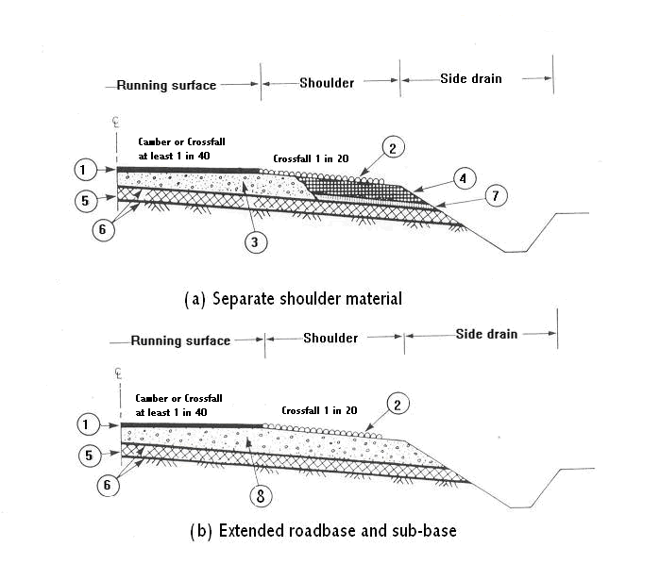

- Impervious surfacing
- Shoulders surface dressed (giving contrasting texture to running surface)
- Roadbase extending under shoulder for at least 500mm
- Shoulder material capable of supporting occasional traffic
- Impervious subbase carried across full width of construction
- Formation and sub-base constructed with crossfall of 1 in 30 (providing drainage path for any water that enters and also a thicker and stronger pavement on the outside wheel track)
- Drainage layer of previous material
- Roadbase extending through shoulder

Fig. B-1 Cross section of road showing drainage arrangements (Adapted from Ref. 1)

APPENDIX C

DESIGN CATALOGUE

APPENDIX C: DESIGN CATALOGUE

C.1 Introduction

The following catalogues are provided:

- Chart D1 - Granular base/granular subbase in dry regions
- Chart D2 - Granular base/cemented subbase in dry regions
- Chart D3 - Cemented base/cemented subbase in dry regions
- Chart D4 - Bituminous base/granular subbase in dry regions
- Chart D5 - Bituminous base/cemented subbase in dry regions
- Chart W1 - Granular base/granular subbase in wet regions
- Chart W2 - Granular base/cemented subbase in wet regions
- Chart W3 - Cemented base/cemented subbase in wet regions
- Chart W4 - Bituminous base/granular subbase in wet regions
- Chart W5 - Bituminous base/cemented subbase in wet regions

Key to Design Catalogue

Traffic Classes (10⁶ esa) |  |  | Subgrade Strength Classes (CBR %)
T1 | = | <0.3 | S1 | = | 2
T2 | = | 0.3-0.7 | S2 | = | 3-4
T3 | = | 0.7-1.5 | S3 | = | 5-7
T4 | = | 1.5-3.0 | S4 | = | 8-14
T5 | = | 3.0-6.0 | S5 | = | 15-29
T6 | = | 6.0-10 | S6 | = | 30+
T7 | = | 10-17 |  | =
T8 | = | 17-30 |  | =

Material Definitions

The key for the material definition is given below each design chart.

Note: Regarding charts D2 and W2, considering the construction time of cemented subbase, specified upper and lower cemented subbase may be merged into one layer and if thickness is more than 250mm, the remaining layer portion may be provided by increasing granular base course.
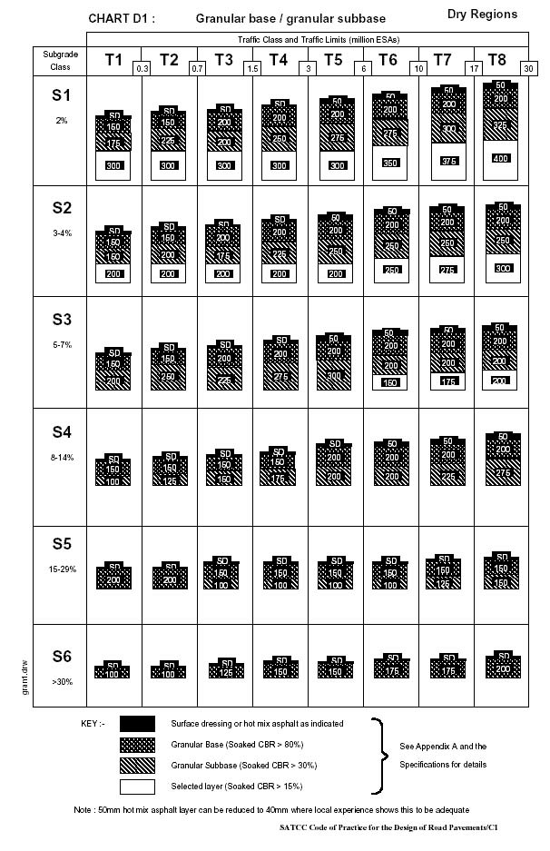
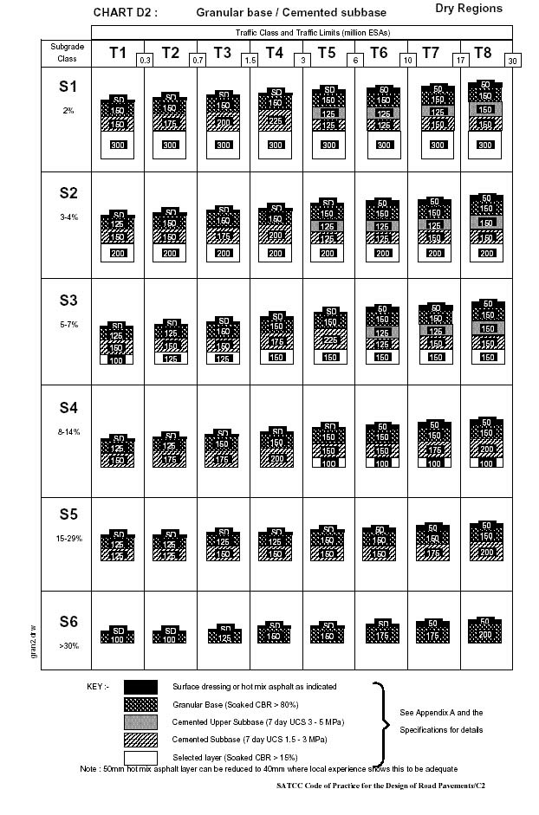
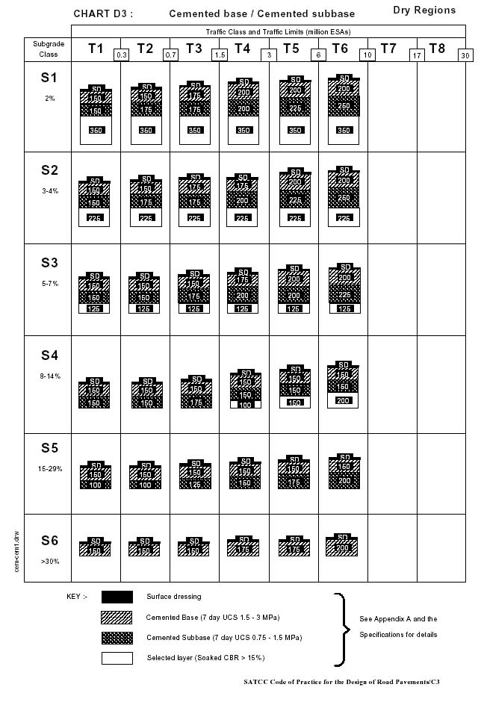
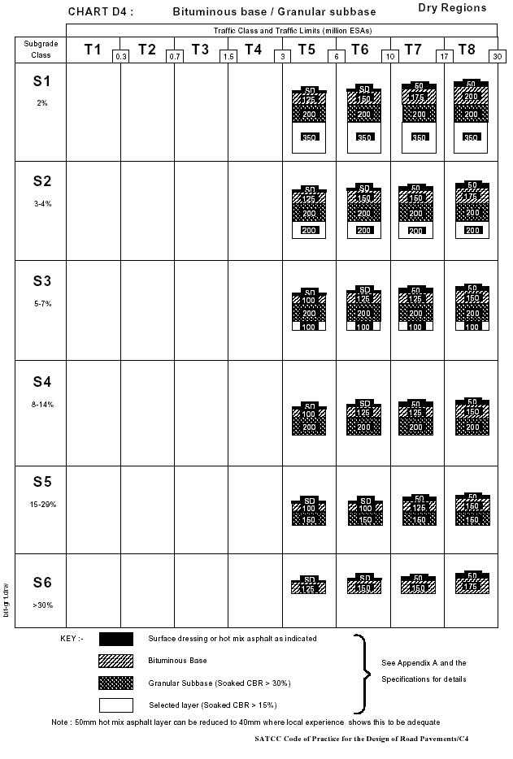
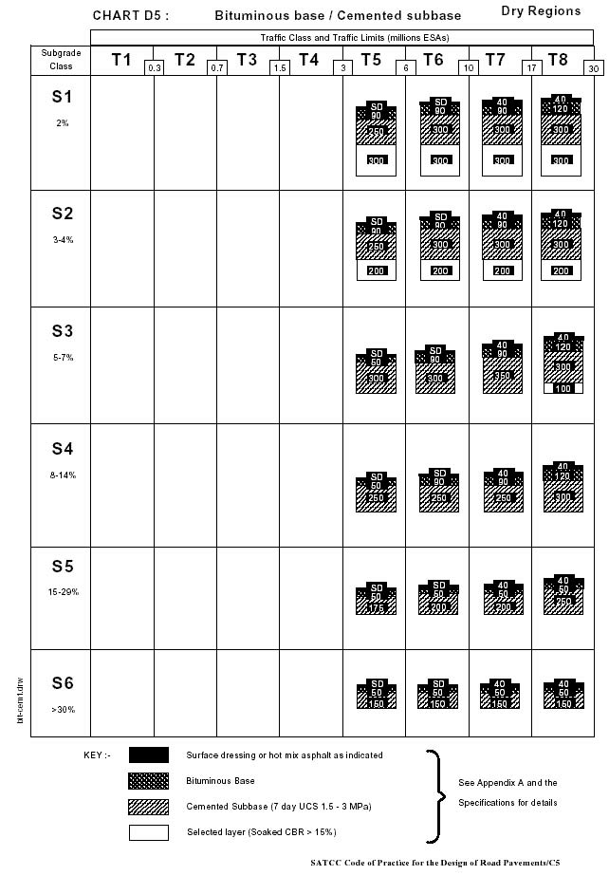
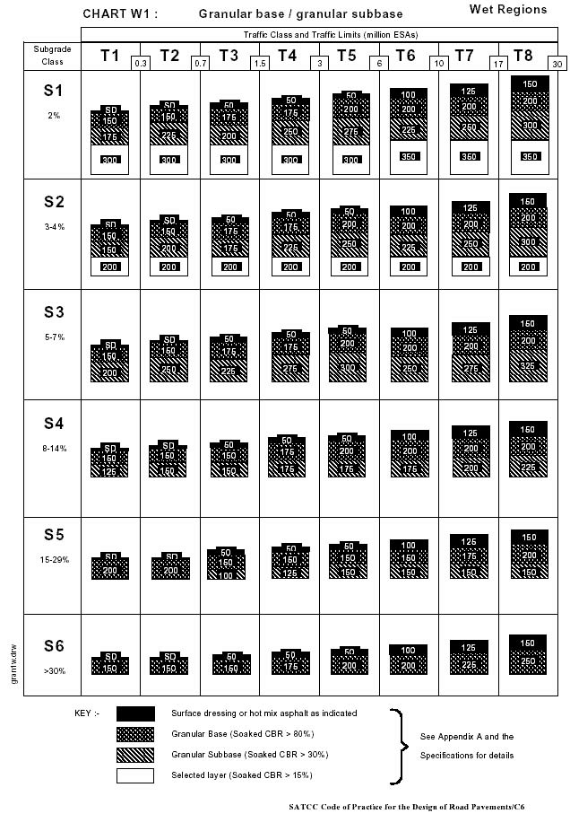
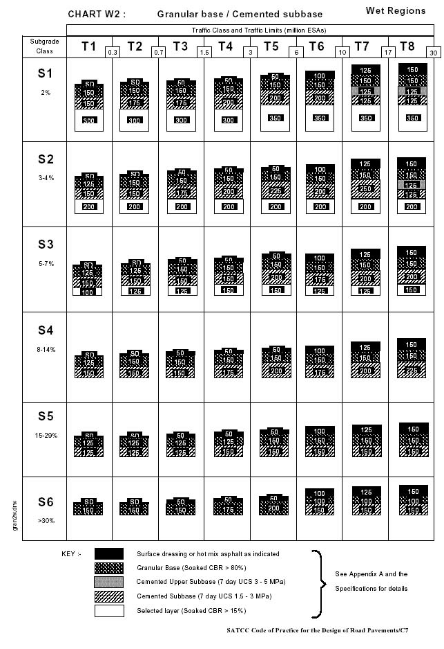
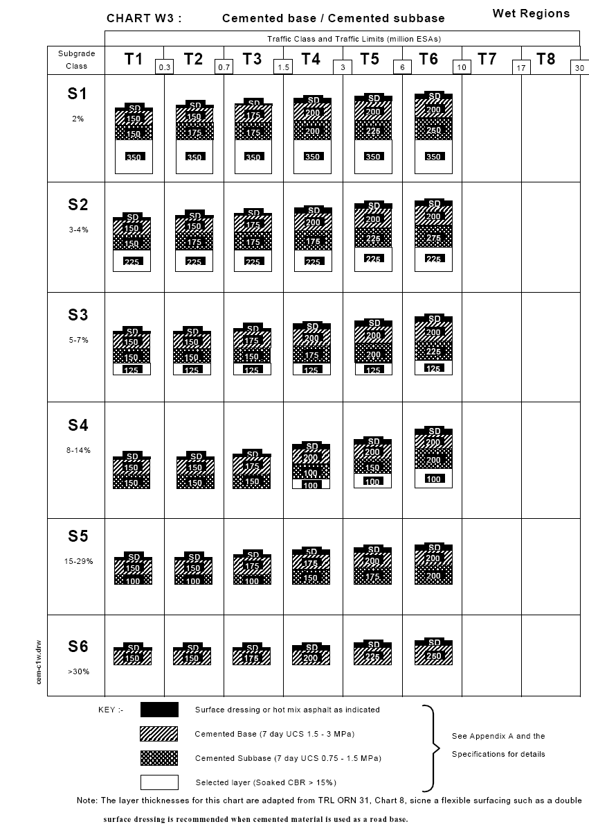

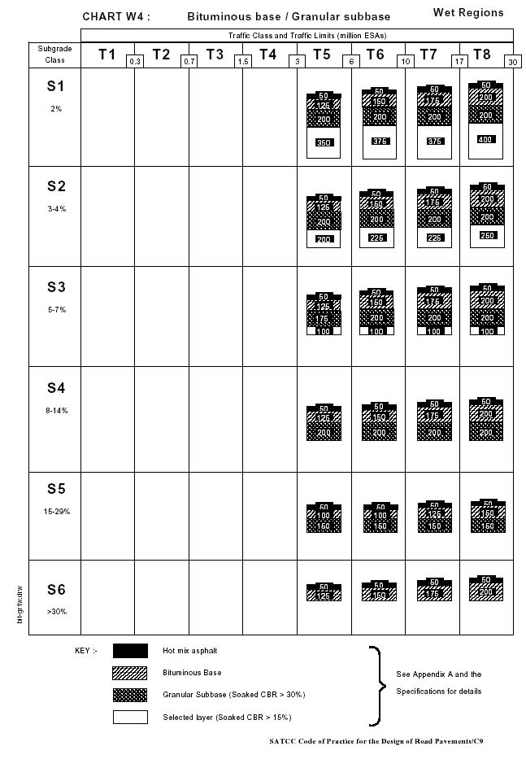
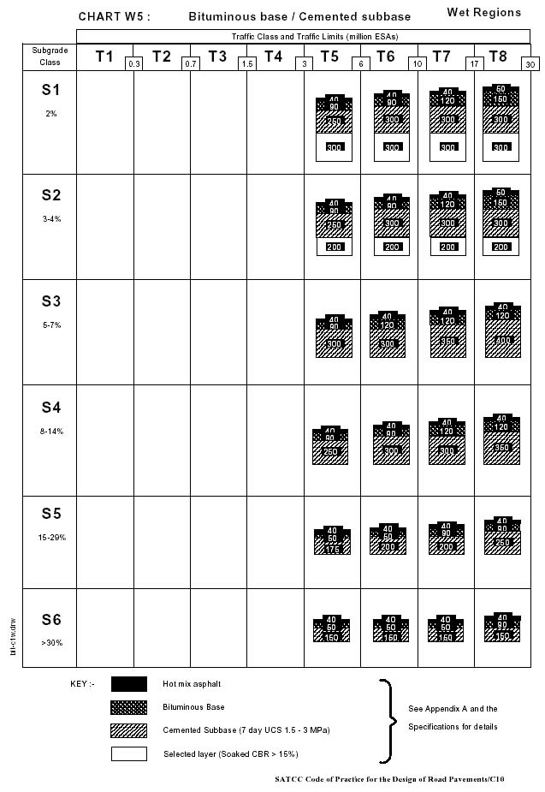

APPENDIX D

EXAMPLE OF PAVEMENT DESIGN

APPENDIX D: EXAMPLE OF PAVEMENT DESIGN

Consider a single carriageway pavement, having a road width of 7.0 meters, to be designed for the following conditions.

Climate. The mean annual rainfall is 1100mm.

Subgrade. The subgrade soil is silty clay. Its design CBR at 100% MDD (standard compaction) and after 4 days soak is 6% (refer to section 3). Thus according to Table 3.1 the soil is classified in S3 subgrade class.

Traffic. Traffic counts and axle load surveys have shown that the initial daily number of commercial vehicles and equivalence factors, EF, will be as follows: [refer to section 2.2 for converting real axle loads to ESAs. The average vehicle damaging factor (equivalent factor) is then obtained for each vehicle class).

2 axle and tandem trucks: 70, EF= 2.0
Trucks with drawbar trailer: 15, EF= 6.0
Articulated units : 8, EF= 6.0
Buses : 20, EF= 1.0

The economic study of the project has recommended a design period of 15 years, and has forecasted a constant annual growth rate of 2.5%.

- Obtain the cumulative design traffic (DT) for one direction for each vehicle category according to equation 1 [section 2.2 (iii)]
- Obtain the cumulative standard axle loads for each vehicle category by multiplying DT with the equivalent factor for each vehicle category.
- Sum up the cumulative standard axles obtained for each vehicle category. The sum of the cumulative number of standard axles is 1.95 x 10⁶ ESA.

The traffic class is thus T4.

Road making materials. Filed investigations and laboratory tests have shown that latteritic gravel occurs in sufficient quantity near the alignment.

The gravel has soaked CBR in the range 20-25%, and PI in the range of 17 – 20. In order to fulfill quality requirements and serve as subbase it should be treated with 5% lime.

A stone source suitable for graded crushed stone, bituminous base and asphalt concrete exists close to the alignment.

The climate shows predominantly wet region. Based on the available materials, traffic class and subgrade strength, Design Chart W2 is the appropriate chart to be considered.

Using Traffic Class T4 and Subgrade Class S3 we obtain the following layer thickness:

Asphlat concrete 50 mm
Granular Base (soaked CBR > 80%) 150 mm
Cemented subbase (7 day UCS 1.5 – 3 Mpa) 150 mm
Selected Layer (soaked CBR > 15%) 150 mm

APPENDIX E

TEST STANDARDS

7502 STANDARDS AND TEST METHODS
(i) Tests on Soils and Gravel
Name of Test | Standard Test Method
Moisture Content | BS 1377: Part 2: 1990
Liquid Limit (Cone Penetrometer) | BS 1377: Part 2: 1990
Plastic Limit & plasticity Index | BS 1377: Part 2: 1990
Linear Shrinkage | BS 1377: Part 2: 1990
Particle Density Determination - Pycnometer | BS 1377: Part 2: 1990
Particle Density Determination | BS 7755-5.3/ISO 11508
Bulk Density for undisturbed samples | BS 1377: Part 2: 1990
Determination of dry bulk density | ISO 11272: 1998
Particle Size Distribution | BS 1377: Part 2: 1990
Particle Size Distribution - Hydrometer Method | BS 1377: Part 2: 1990
Compaction Test - BS Light and BS Heavy | BS 1377: Part 4: 1990
Unsoaked CBR Test - One Point Method | BS 1377: Part 4: 1990
Unsoaked CBR Test - Three Point Method | BS 1377: Part 4: 1990
Soaked CBR Test - One Point method | BS 1377: Part 4: 1990
Soaked CBR Test - Three Point method | BS 1377: Part 4: 1990
Field density | BS 1377: Part 9
In situ tests: sand replacement, CBR testing, vane shear strength, cone penetrometer and plate bearing test | BS 1377: Part 9
Sampling, sample preparation and tests on materials before stabilisation | BS 1924: Part 1
Preparation of stabilised Samples for UCS | BS 1924: Part 2:1990
Compaction Test and UCS of Stabilised Materials | BS 1924: Part 2:1990
Initial Consumption of Lime - ICL | US 288:2001 or BS 1924:Part 2:1990
Quicklime, hydrated lime and natural calcium carbonate-methods of physical testing | BS 6463: Part 103

(ii) Tests on Aggregates
Name of Test | Standard Test Method
Guide to sampling and testing aggregates | BS 812: Part 101 and BS 5835
Methods of sampling | US 145:2000 or BS 812:Part 102
Moisture content of aggregates | BS 812: Part 109:1990 and BS 5835
Relative density | BS EN 1097-3: Part 3:1998
Determination of loose bulk density and air voids | BS EN 1097-3: Part 3:1998
Water absorption | BS EN 1097-3: Part 3:1998
Sieve tests on aggregates | BS 812: Part 103.1:1985
Flakiness Index (FI) | BS EN 933-3: 1997
Elongation Index | BS 812: Section 105.2:1990
Average Least Dimension (ALD) | US 144:2000 or BS EN 933-3: 1997
Particle Shape Index | US 144:2000 or BS EN 933-4: Part 4
Aggregate Crushing Value (ACV) | BS 812: Part 110: 1990
Ten Percent Fines Value (TFV) | BS 812: Part 111: 1990
Aggregate Impact Value (AIV) - Standard | BS 812: Part 112: 1990
Aggregate Impact Value (AIV) - Modified | BS 812: Part 112: 1990
Los Angeles Abrasion Test (LAA) | ASTM C535-89 and BS 812: Part 113
Polished Stone Value | BS 812: Part 114
Determination of percentage of crushed & broken surfaces in coarse aggregate particles | BS EN 933-5: Part 5: 1998
Determination of grading requirements | BS 882
Sodium Soundness Test (SSS) | ASTM C88-90

(iii) Tests on Asphalt and Bituminous Materials
Name of Test | Standard Test Method
Sampling Bituminous mixes | BS 598: Part 100
Density of Bituminous Binders | ASTM D70-97
Flash and Fire Point by Cleveland Open Cup | ASTM D92-90
Thin-Film Oven Test (TFOT) | ASTM D1754-87
Penetration of Bituminous Materials | ASTM D5-86 or BS 2000: Part 49
Softening Point Test | ASTM D36-70 or BS 2000: Part 58
Ductility | ASTM D113-86
Kinematic Viscosity of Asphalts | AASHTO T 201 or ASTM D 2170
Viscosity of Asphalts by Vacuum capillary Viscometer | AASHTO T 202 or ASTM D 2171
Density and Water Absorption of Aggregates Retrieved on a 4.75 mm Sieve | ASTM C127-88
Density and Water Absorption of Aggregates passing the 4.75 mm Sieve | ASTM C128-88
Mixing of Test Specimens; Hot bituminous Mixes | NPRA 014 Test 14.5532
Determination of maximum Theoretical Density of Asphalt Mixes and Absorption of Binder into Aggregates | ASTM D2041-95 and D4469-85
Bulk Density of Saturated Surface Dry Asphalt Mix Samples | ASTM D2726-96
Calculation of Void Content in Bituminous Mixes | ASTM D3203 and AASHTO pp 19-93
Marshall Test | ASTM D1559-89
Marshall Mix Design | ASTM D1559-89
Refusal Density Mix Design | TRL Overseas Road Note 31, Appendix D: 1990
Methods of test of the design of wearing course asphalt | BS 598: Part 107
Methods for the measurement of temperature of bituminous mixtures | BS 598: Part 109
Temperature Measurement | BS EN 12697 - 13: Part 13: 2000
Methods of test for the determination of density and compaction | BS 598: Part 104
Determination of Binder Content and Aggregate Grading by Extraction | ASTM D2172-88, Method B
 | BS EN 12697 - 1: Part 1: 2000
Water Content | BS EN 12697 - 27: Part 14: 2000
Sampling | BS EN 12697 - 27: Part 27: 2001
Distillation of cut back asphalt (bituminous) products | BS 2000: Part 27

