R2ROAD AND BRIDGE WORKS


THE REPUBLIC OF UGANDA

MINISTRY OF WORKS, HOUSING AND COMMUNICATIONS

ROAD DESIGN MANUAL

Vol. 3: Pavement Design

Part III: Gravel Roads

SEPTEMBER 2006

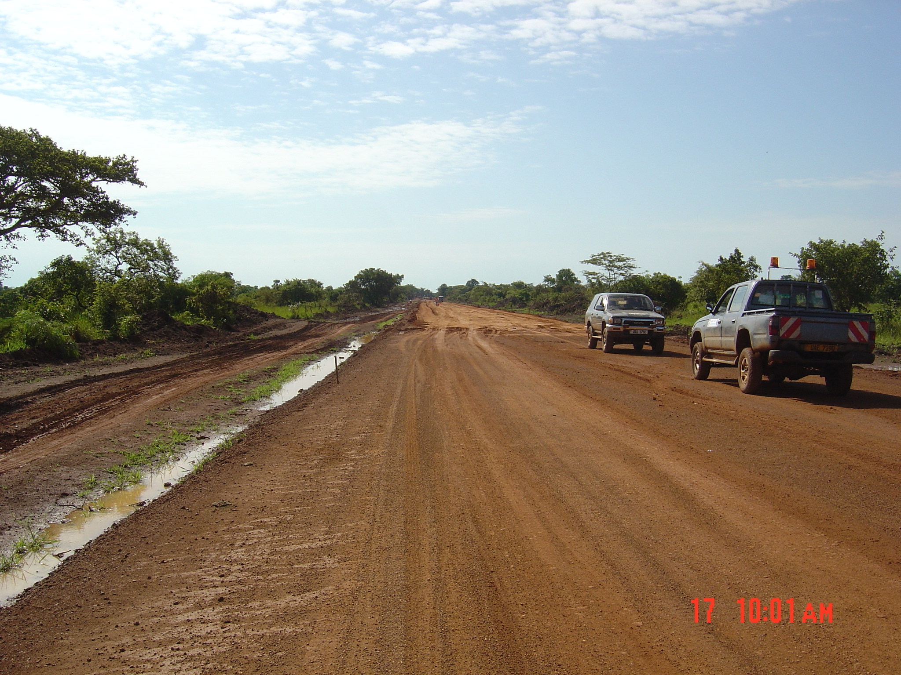
table of Contents

DEFINITIONS i
abbreviations iii
1 Introduction 1.i
1.1 General 1.1
1.2 Design Principles 1.1
1.2.1 Steps to be considered in the Design Process 1.1
1.2.2 All-weather Access 1.1
1.2.3 Surface Performance 1.1
1.2.4 Maintenance 1.2
1.3 The Elements of a Gravel Road 1.2
2 Traffic 2.1
2.1 Design Period 2.1
2.2 Traffic Volumes 2.1
2.2.1 Vehicle Classification 2.1
2.2.2 Initial Traffic Volumes 2.2
2.2.3 Determination of Cumulative Traffic Volumes 2.3
3 Sub-grade 3.1
3.1 General 3.1
3.2 Sub-grade Strength 3.1
3.3 Determination of Design Sub-grade Strength 3.2
3.3.1 Homogenous Sections 3.2
3.3.2 Statistical Analysis 3.2
4 Design Method 4.1
4.1 Minimum Thickness Required 4.1
4.2 Gravel Loss 4.1
4.3 Total Thickness Required 4.2
4.4 Cros-fall and Drainage 4.2
5 CLIMATIC ZONES 5.1
6 Material Requirements 6.1
6.1 Experience with Local Materials 6.1
6.2 Marginal Materials 6.1
6.3 Improved Sub-grade Layer 6.2
6.4 Treatment of Expansive Formations 6.2
6.5 Performance Characteristics of Gravel Wearing Course 6.3
6.6 Gravel Wearing Course Material Specification 6.3
6.7 Major Gravel Roads (AADTdesign = 50 to 300) 6.4
6.8 Minor Gravel Roads (AADTdesign < 50) 6.4
7 REFERENCES 7.1

Appendices

Appendix A: Example of Gravel Road Pavement Design

Definitions

Average Annual Daily Traffic (AADT) | The total yearly traffic volume in both directions divided by the number of days in the year.
Average Daily Traffic (ADT) | The total traffic volume during a given time period in whole days greater than one day and less than one year divided by the number of days in that time period.
Carriageway | That portion of the roadway including the various traffic lanes and auxiliary lanes but excluding shoulders.
Cross-fall | The difference in level measured transversely across the surface of the roadway.
Deformation | A mode of distress, unevenness of the surface profiles.
Design Period | The period of time that an initially constructed or rehabilitated pavement structure will perform before reaching a level of deterioration requiring more than routine or periodic maintenance.
Distress | The visible manifestation of deterioration of the pavement with respect to either the serviceability or the structural capacity.
Fill | Material of which a man-made raised structure or deposit such as an embankment is composed, including soil, soil-aggregate or rock. Material imported to replace unsuitable roadbed material is also classified as fill.
Formation Level | Level at top of sub-grade.
Gravel | A mix of stone, sand and fine-sized particles used as sub-base, base or surfacing on a road.
Gravel Wearing Course | The uppermost layer of a gravel road, which provides the riding surface for vehicles.
Heavy Vehicles | Those having an unloaded weight of 3000 kg or more.
Improved Sub-grade (Capping Layer) | The top of embankment or bottom of excavation prior to construction of the pavement structure. Where very weak soils and/or expansive soils (such as black cotton soils) are encountered, a capping layer is sometimes necessary. This consists of better quality sub-grade material imported from elsewhere or sub-grade material improved by stabilization (usually mechanical), and may also be considered as a lower quality subbase.
Maintenance | Routine work performed to keep a pavement, under normal conditions of traffic and forces of nature, as nearly as possible in its as-constructed condition.
Mountainous (Terrain) | Terrain that is rugged and very hilly with substantial restrictions in both (terrain) horizontal and vertical alignment.
Paved Road | Any road that has a semi-permanent surface placed on it such as asphalt or concrete. Gravel surfaced roads are virtually always referred to as unpaved roads.
Rolling (Terrain) | Terrain with low hills introducing moderate levels of rise and fall with some restrictions on vertical alignment.
Side Drain | Open longitudinal drain situated adjacent to and at the bottom of cut or fill slopes.
Stabilization | The treatment of the materials used in the construction of the road bed material, fill or pavement layers by the addition of a cementitious binder such as lime or Portland Cement or the mechanical modification of the material through the addition of a soil binder or a bituminous binder.
Sub-grade | The surface upon which the pavement structure and shoulders are constructed. It is the top portion of the natural soil, either undisturbed (but recompacted) local material in cut sections, or soil excavated in cut or borrow areas and placed as compacted embankment.
Traffic Volume | Volume of traffic usually expressed in terms of average annual daily traffic (AADT).
Wearing Course | The uppermost layer of construction of the roadway made of specified materials.

1 Introduction

General

Much of the information presented here is based on the "Pavement and Materials Design Manual" prepared by the United Republic of Tanzania Ministry of Works 1999, and on relevant ERA (Ethiopian Roads Authority) and TRL publications. Available information has been modified to provide a simple procedure to design gravel wearing courses.

Gravel road pavements are generally utilized for roads where design traffic flow Annual Average Daily Traffic (AADT) is less than 300 at the time of construction. This guide for design of gravel road sets out the standards for pavement design, and specifies the materials which may be used for gravel roads.

Gravel pavements are designed to a minimum thickness required to avoid excessive strain at the sub-grade level. This in turn ensures that the sub-grade is not subject to significant deformations. At the same time, the gravel materials themselves should not deteriorate to such an extent as to affect the riding quality and functionality of the pavement. These goals must be achieved throughout a specific design period. Deteriorations which affect the riding quality of a gravel road include rutting, potholes, corrugations, and other such distresses.

Gravel wearing courses must also be designed for an additional thickness to compensate for gravel loss under traffic during the period between regravelling operations. Such thicknesses are dependent on the sub-grade strength class and the traffic class.

Design Principles

1.2.1 Steps to be considered in the Design Process

- Traffic (Baseline flow and forecast)
- Material and geotechnical information (Field survey and material properties)
- Sub-grade (Classification, foundation for expansive soils and material strength)
- Thickness design (Gravel wearing course thickness)
- Materials design

1.2.2 All-weather Access

An essential consideration in the design of gravel roads is to ensure all-weather access. This requirement places particular emphasis on the need for sufficient bearing capacity of the pavement structure and provision of drainage and sufficient earthworks in flood or problem soil areas (e.g. black cotton).

1.2.3 Surface Performance

The performance of the gravel surface mainly depends on material quality, the location of the road, and the volume of traffic using the road. Gravel roads passing through populated areas in particular require materials that do not generate excessive dust in dry weather. Steep gradients place particular demands on gravel wearing course materials, which must not become slippery in wet weather or erode easily. Consideration should therefore be given to the type of gravel wearing course material to be used in particular locations such as towns or steep sections. Gravel loss rates of about 25-30mm thickness a year per 100 vehicles per day is expected, depending on rainfall and materials properties (particularly plasticity).

Performance characteristics that will assist in identifying suitable material are shown in Figure 6-1.

1.2.4 Maintenance

The material requirements for the gravel wearing course include provision of a gravel surface that is effectively maintainable. Adherence to the limits on oversize particles in the material is of particular importance in this regard and will normally necessitate the use of crushing or screening equipment during material production activities.

The Elements of a Gravel Road

The elements of a gravel road pavement are illustrated in Figure 1-1, where the simpler form of a pavement provided by the wearing course of a gravel road is shown.
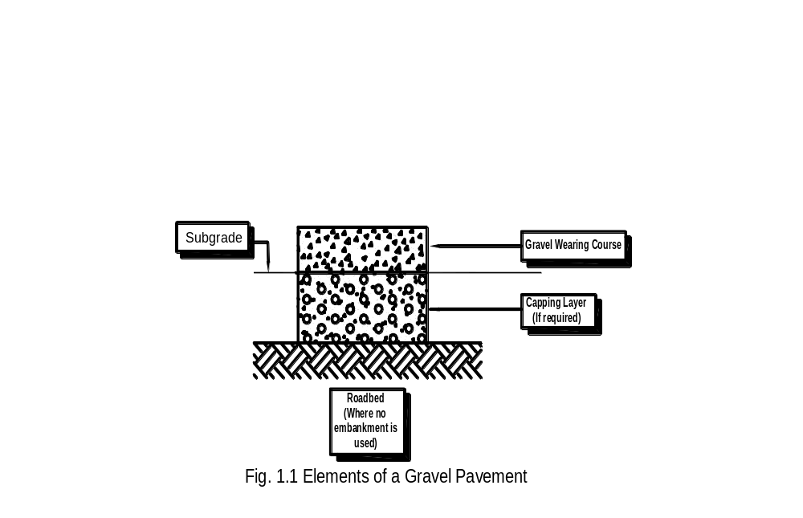

The mechanisms of deterioration of gravel roads differ from those of flexible pavement. While the functions of the wearing course still include the protection of the sub-grade, and the wearing course needs to be designed for that aspect, the potential defects of a gravel road require other considerations in the design.

Typical defects which may affect gravel roads are dustiness, potholes, stoniness, corrugations, ruts, cracks, raveling (formation of loose material), erosion, slipperiness, impassibility and loss of wearing course material. Many of these have a direct effect on the road roughness and safety.

A major problem of unpaved roads built on steep alignments is the efficient removal of surface water to the side drains. As the gradients increase, the problem becomes more acute irrespective of any increase in the cross-fall of the road. The problem of gulley erosion along the center of unpaved roads will be exacerbated as vertical gradients increase above the value of the cross-fall.

A frequent problem on both paved and unpaved roads is the deformation of the shoulder, which often precipitates the structural failure of the pavement. In many cases, this is the result of vehicles, particularly heavy lorries, standing off the road due to breakdown or overnight stop and sometimes as a result of passing vehicles straying off the edge of the road. It can also occur as a result of water leaving the road surface, but staying on the shoulder because of insufficient cros-fall.

Since corrugations are one of the most disturbing defects of gravel roads (and one which still causes much debate), an illustration of the likely mechanism of their formation is worthwhile, and is given in Figure 1-2. In illustration a), localized areas of the gravel wearing course have slightly lesser cohesion than adjacent areas, and a result is that the wheel displaces this material towards the back, at the same time compressing the remaining material at the contact point. Continuing actions as in a) result eventually in the wheel loosing contact with the road, as in b). When the wheel regains road contact, as in c), the result is a magnification of the effects as in a).
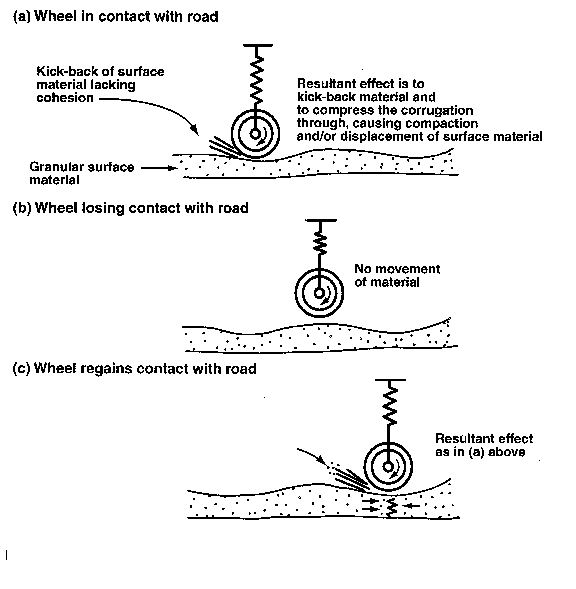
Figure 1-2: The Forced Oscillation Theory for the Formation of Corrugation

A number of the typical defects can be mitigated by an adequate selection of the materials for gravel wearing courses, which should satisfy the following requirements that are often somewhat conflicting:

- They should have sufficient cohesion to prevent raveling and corrugating (especially in dry conditions)
- The amount of fines (particularly plastic fines) should be limited to avoid a slippery surface under wet conditions

These aspects are dealt with in the Particular Project Specifications and are naturally influenced by the availability of materials. In design, the thickness requirements for the gravel wearing course will essentially derive from the combined need to protect the sub-grade and to periodically replace the lost materials.

Traffic

The deterioration of paved roads caused by traffic results from both the magnitude of the individual wheel loads and the number of times these loads are applied. It is necessary to consider not only the total number of vehicles that will use the road but also the wheel loads (or, for convenience, the axle loads) of these vehicles. Equivalency factors are used to convert traffic volumes into cumulative standard axle loads.

The mechanism of deterioration of gravel roads differs from that of paved roads and is directly related to the number of vehicles using the road rather than the number of equivalent standard axles. The traffic volume is therefore used in the design of unpaved roads, as opposed to the paved roads which require the conversion of traffic volumes into the appropriate cumulative number of equivalent standard axles.

2.1 Design Period

Determining an appropriate design period is the first step towards pavement design. Many factors may influence this decision, including budget constraints. However, the designer should follow certain guidelines in choosing an appropriate design period, taking into account the conditions governing the project. Some of the points to consider include:

- Functional importance of the road
- Traffic volume
- Location and terrain of the project
- Financial constraints
- Difficulty in forecasting traffic

Problems in traffic forecasting may also influence the design. When accurate traffic estimates cannot be made, it may be advisable to reduce the design period to avoid costly over design.

2.2 Traffic Volumes

2.2.1 Vehicle Classification

Vehicle classification is an essential aspect of traffic volume evaluation (as well as evaluation of equivalent axle loads). The types of vehicles are usually defined according to the following breakdown: cars; pick-ups and 4-wheel drive vehicles such as Land Rovers and Land Cruisers; small buses; medium and large size buses; small trucks; medium trucks; heavy trucks; and trucks and trailers. This breakdown can be further simplified, for reporting purposes, and expressed in five classes of vehicles (with vehicle codes 1 to 5) listed in Table 2-1.

Table 2-1: Vehicle Classification

Vehicle Code | Type of Vehicle | Description
1  2  3  4  5 | Small car  Bus  Medium Truck  Heavy Truck  Articulated Truck | Passenger cars, minibuses (up to 24-passenger seats), taxis, pick-ups, and Land Cruisers, Land Rovers, etc.  Medium and large size buses above 24 passenger seats  Small and medium sized trucks including tankers up to 7 tons load  Trucks above 7 tons load  Trucks with trailer or semi-trailer and Tanker Trailers

It is most often in terms of volumes (e.g. AADT) in each of these 5 classes that the traffic data will initially be available to the designer. Small cars do not contribute significantly to the structural damage of roads.

2.2.2 Initial Traffic Volumes

The estimate of the initial traffic volume should be the (Annual) Average Daily Traffic (AADT) currently using the route (or, more specifically, the AADT expected to use the route during the first year the road is placed in service), classified into the five classes of vehicles described above. Adjustments will usually be required between the AADT based on the latest traffic counts and the AADT during the first year of service. These adjustments can be made using the growth factors discussed further below.

The AADT is defined as the total annual traffic summed for both directions and divided by 365. It is usually obtained by recording actual traffic volumes over a shorter period from which the AADT is then estimated.

Traffic counts carried out over a short period as a basis for estimating the AADT can produce estimates which are subject to large errors because traffic volumes can have large daily, weekly, monthly and seasonal variations. In order to reduce error, it is recommended that traffic counts to establish AADT at a specific site conform to the following practice:

- The counts are for seven consecutive days.
- The counts on some of the days are for a full 24 hours, with preferably at least one 24-hour count on a weekday and one during a weekend. On the other days 16-hour counts should be sufficient. These should be extrapolated to 24-hour values in the same proportion as the 16-hour/24-hour split on those days when full 24-hour counts have been undertaken.
- Counts are avoided at times when travel activity is abnormal for short periods due to the payment of wages and salaries, public holidays, etc. If abnormal traffic flows persist for extended periods, for example during harvest times, additional counts need to be made to ensure this traffic is properly included.
- If possible, the seven-day counts should be repeated several times throughout the year.

2.2.3 Determination of Cumulative Traffic Volumes

In order to determine the cumulative number of vehicles during the first year the road is placed in service, the following procedure should be followed:

- Determine the initial traffic volume (AADT₀) using the results of the traffic survey and any other recent traffic count information that is available.
- Estimate the annual growth rate “i” expressed as a decimal fraction, and the anticipated number of years “x” between the traffic survey and the opening of the road.
3. Determine AADT₁ the traffic volume in both directions on the year of the road opening by:

AADT₁ = AADT₀ (1+i)^{x}

Sub-grade

3.1 General

The type of sub-grade soil is largely determined by the location of the road. However, where the soils within the possible corridor for the road vary significantly in strength from place to place, it is clearly desirable to locate the pavement on the stronger soils if this does not conflict with other constraints.

The strength of the road sub-grade is commonly assessed in terms of the California Bearing Ratio (CBR) and this is dependent on the type of soil, its density, and its moisture content. Direct assessment of the likely strength or CBR of the sub-grade soil under the completed road pavement is often difficult to make. Its value, however, can be inferred from an estimate of the density and equilibrium (or ultimate) moisture content of the sub-grade together with knowledge of the relationship between strength, density and moisture content for the soil in question. This relationship must be determined in the laboratory. The density of the sub-grade soil can be controlled within limits by compaction at suitable moisture content at the time of construction. The moisture content of the sub-grade soil is governed by the local climate and the depth of the water table below the road surface.

3.2 Sub-grade Strength

To determine the sub-grade strength to use for the design of the road pavement, it is necessary to ascertain the density-moisture content-strength relationship(s) specific to the sub-grade soil(s) encountered along the road under study. It is also necessary to select the density, which will be representative of the sub-grade once compacted.

Estimating the sub-grade moisture content that will ultimately govern the design, i.e. the moisture content following the construction, is also required. It is recommended to determine the moisture content as a first step in the process, as this could influence the subsequent ones. The optimum moisture content can be taken as the moisture condition for design purposes.

After estimating the sub-grade moisture content for design, it is then necessary to determine a representative density at which a design CBR value will be selected.

To specify densities during construction, it is recommended that the top 25 cm of all sub-grades should be compacted to a relative density of at least 93% of the maximum dry density achieved according to BS 1377: Part 4: 1990 (BS Heavy) or AASHTO T 180. With modern compaction equipment, a relative density of 95% of the density obtained in the heavier compaction test should be achieved without difficulty, but tighter control of the moisture content will be necessary.

As a result, it is generally appropriate to base the determination of the design CBR on a density of 95% of the maximum dry density achieved according to BS 1377: Part 4: 1990 (BS Heavy) or AASHTO T 180.

3.3 Determination of Design Sub-grade Strength

3.3.1 Homogenous Sections

Identification of sections deemed to have homogenous sub-grade conditions is carried out by desk studies of appropriate documents such as geological maps, followed by site reconnaissance that includes excavation of inspection pits and initial indicator testing for confirmation of the site observations. Due regard for localized areas that require individual treatment is an essential part of the site reconnaissance. Demarcation of homogenous sections shall be reviewed and changed as required when the CBR test results of the centerline soil survey are available.

It is thus recommended, as a first step, to conduct compaction tests and to measure the CBR on samples molded at 100% MDD and OMC, to guide in the selection of homogeneous sections of a road project. Following this selection, each typical soil is subjected to a more detailed testing involving three levels of compaction. The design CBR is then obtained by interpolation.

Each CBR value is determined by laboratory measurement carried out for a minimum of three density values to give a CBR - Density relationship for the material. The CBR value is determined at the normal field density specified for the respective operation (i.e. a minimum in-situ density of 95% of the maximum dry density determined in accordance with the requirements of AASHTO T 180). This method enables an estimate to be made of the sub-grade CBR at different densities and allows the effects of different levels of compaction control on the structural design to be evaluated.
The design sub-grade strength together with the traffic are then used to determine the pavement layer thicknesses.

3.3.2 Statistical Analysis

The flow chart in Figure 3-1 shows the procedure to determine CBR_{design}.

The CBR_{design} for cuttings is the lowest CBR value encountered for the homogenous section.

The CBR_{design} for sections that do not require special assessment or are not within cuttings are determined by the 90%-ile value of the CBR test results. The 90 percentile value for a section of this type is the CBR value which 10% of the test results fall below. The following example shows how this is calculated.

- CBR values are plotted in ascending order (number of tests on the "x axis" and the CBR test result values on the "y axis");
- Calculate d = 0.1 x (n-1), where n = number of tests;
- d is measured along the "x axis" and the CBR_{design} is determined from the "y axis".

The CBR_{design} is the CBR value of a homogenous section, for which the sub-grade strength is classified into S15, S7 and S3 for the purpose of pavement design. The procedure to determine CBR_{design} is shown in the flow chart in Figure 3-1.

Site
Reconnaissance
Compilation of input data
Demarcation of homogenous sections
Minimum 3 CBR tests per section
Cutting?
Use lowest CBR value
CBR_{design}:
Classify S3, S7, S15
Design improved sub-grade as required
Minimum 5 CBR tests per section
No
Special assessment of the section
Plot values in ascending order
Yes
No
Yes
Determine 90%-ile at the 0.1 X (n-1) point on the curve

Figure 3-1: Flow Chart for Design

The sub-grade shall be classified according to its CBR strength as shown in Table 3.1

Table 3.1 Sub-grade strength classes

Sub-grade Class | CBR_{design} (%) |  |  | Density for determination of CBR_{design} (% of MDD)
Sub-grade Class | Wet or moderate climatic zones  4 days soaked value | Dry climatic zones  (both requirements shall be met) |  | Density for determination of CBR_{design} (% of MDD)
Sub-grade Class | Wet or moderate climatic zones  4 days soaked value | Tested at OMC | 4 days soaked value | Density for determination of CBR_{design} (% of MDD)
S15 | Min 15 | Min 15 | Min 7 | 95 BS-Heavy
S7 | 7 – 14 | 7 – 14 | 3 – 14 | 93 BS-Heavy
S3 | 3 - 6 | 3 - 6 | 2 - 6 | 100 BS-Light
“Soaked” and “OMC” refer to standard 4 days soaking and optimum moisture content

BS-Light compaction effort is used on poor in-situ soils and deep in-situ soils rather than BS-Heavy due to its better correspondence with the actual effect from compaction equipment under conditions with poor support for compaction.

Depending on the CBR_{design} of the sub-grade, improved sub-grade layers shall be constructed as required, on which the gravel wearing course is placed. Soils used in improved sub-grade layers shall be non-expansive, non-dispersive and free from any deleterious matter. Laboratory test results shall meet the requirements in Table 3.2.

Table 3.2 Material requirements for improved sub-grade layers

Material Properties | G15 (Upper Layer) | G7 (Lower Layer)
CBR(%), wet or moderate climatic zones | Min 15 after 4 days soaking | Min 7 after 4 days soaking
CBR(%), dry climatic zones (both requirements shall be met) | Min 15 at OMC | Min 7 at OMC
 | Min 7 after 4 days soaking | Min 3 after 4 days soaking
CBR-swell (%) | Max 1.5 | Max 2.0
PI (%) | Max 25 | Max 30
Max particle size, d_{max} | 2/3 of layer thickness | 2/3 of layer thickness
Compacted layer thickness (mm) | Max 250 | Max 250
CBR-swell is measured at 100% BS-Heavy compaction effort

For existing pavements, test pits represent one of the common methods of investigation to determine the thickness and type of the various pavement layers and to assess the sub-grade. Samples from each pavement layer and sub-grade can be collected for visual inspection and subsequent laboratory testing. As a guideline, one test pit every 1 km, alternating on either side of the roadway is recommended.

Dynamic Cone Penetrometer (DCP) testing is designed for the rapid in-situ measurement of the structural properties of existing road pavements and sub-grades. The DCP test results can be compared with the laboratory test results. DCP testing frequency is usually every 100 meters but a testing interval of 200 meters can be adequate.

Design Method

The required gravel thickness shall be determined as follows:
- Determine the minimum thickness necessary to avoid excessive compressive strain in the sub-grade (D₁).
- Determine the extra thickness needed to compensate for the gravel loss under traffic during the period between regravelling operations (D₂).
- Determine the total gravel thickness required by adding the above two thicknesses (D₁+ D₂).

4.1 Minimum Thickness Required

It is necessary to limit the compressive strain in the sub-grade to prevent excessive permanent deformation at the surface of the road. Figure 6.2 gives the minimum gravel thickness required for each traffic category with the required thickness of improved sub-grade materials for upper and lower sub-grade layers.

4.2 Gravel Loss

According to TRL Laboratory Report 673, an estimate of the annual gravel loss is given by the following equation:

GL = (f T² / ( T² + 50) )* ( 4.2 + 0.092 T + 3.50 R² + 1.88V)
Where:

GL = the annual gravel loss measured in mm
T = the total traffic volume in the first year in both directions, measured in thousands of vehicles
R = the average annual rainfall measured in m
V = the total (rise + fall) as a percentage of the length of the road
f = 0.94 to 1.29 for lateritic gravels
= 1.1 to 1.51 for quartizitic gravels
= 0.7 to 0.96 for volcanic gravels (weathered lava or tuff)
= 1.5 for coral gravels
= 1.38 for sandstone gravels

The predicted annual loss of gravel is evaluated using the relevant values of annual traffic, annual rainfall, vertical gradient and gravel constants in the equation.

The interaction between traffic and rainfall contributes significantly to the loss of material from a gravel-surfaced road. Erosion is frequently manifested in the form of longitudinal gullies along the surface of steep roads with gradients higher than about five percent and this is especially the case in high rainfall areas.

Annual gravel loss on unpaved roads will vary between 10 mm and 30 mm per 100 vehicles per day and will be dependent on climate and road alignment. These rates of gravel loss probably only hold for the first phase of the deterioration cycle lasting possibly for two or three years. They should not be considered to hold over a long period of time. As the wearing course is reduced in thickness, other developments such as the formation of ruts will affect the loss of gravel material. However the rates of loss given above can be used as an aid to the planning for regravelling in the future.

The total loss of gravel from unpaved roads in developing countries is increasing annually because of additions to the road network. This problem will become exacerbated as road networks expand and the sources of good road making gravel continue to dwindle. Already, haulage distances of up to 80 km for gravel exist in Africa, and generally haulage distances for material are lengthening in Africa.

4.3 Total Thickness Required

The wearing course of a new gravel road shall have a thickness D calculated from:

D = D₁ + N. GL
Where:
D₁ is the minimum thickness from Figure 6.2
N is the period between regravelling operations in years
GL is the annual gravel loss
Regravelling operations should be programmed to ensure that the actual gravel thickness never falls below the minimum thickness D₁.

4.4 Cross-fall and Drainage

The cross-fall of carriageway and shoulders for gravel roads shall be 4 - 6%, depending on local conditions. This is to ensure that potholes do not develop by rapidly removing surface water and to ensure that excessive cross-fall does not cause erosion of the surface. Provision of drainage is extremely important for the performance of gravel roads.

CLIMATIC ZONES

The seasonal rainfall distribution patterns over Uganda and many part of East Africa within these latitudes can be generalized into the four broad seasons given by East African Meteorological Department (1963). [Taken from International Journal of Climatology, Vol. 15, 1161-1177 (1995)]

Season 1, a generally dry period, lasts from December of the preceding year to the end of February.

Season 2, the main rainy season throughout Uganda and referred to locally as the ‘long rains’ lasts from March to the end of May.

Season 3, which is dry except in parts of northern Uganda, lasts from June to end of August

Season 4, the second rainy period throughout the country and known locally as the ‘short rains’, lasts from September to the end of November.

For the purpose of gravel wearing course design, Uganda can be considered to have only one climatic zone (wet zone). All places with mean annual rainfall greater than 500mm are considered to be wet zones and all places with mean annual rainfall less than 500mm can be considered to be moderate/dry zones.

The mean annual rainfall for Uganda is shown on a map in figure 5.1

UGANDA RAINFALL ZONES
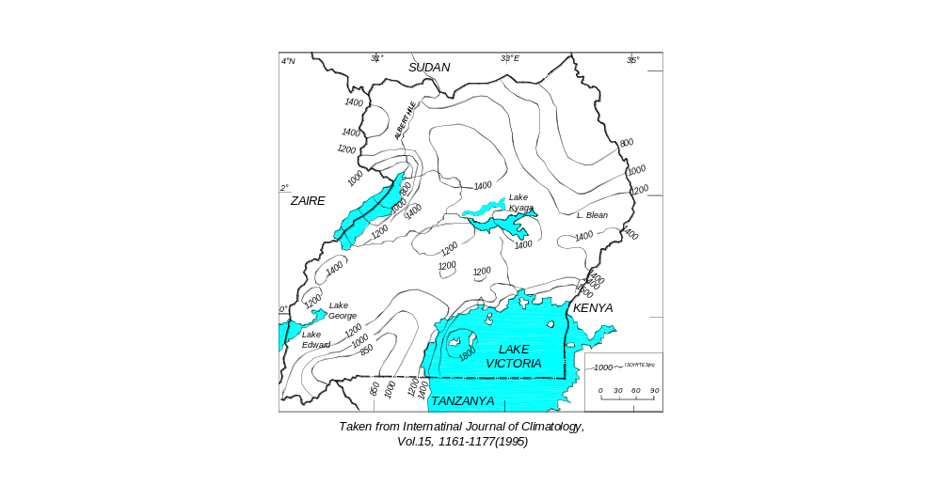
Fig. 5.1 Mean Annual Rainfall Map

Taken from International Journal of Climatology,
Vol. 15, 1161 – 1177 (1995)
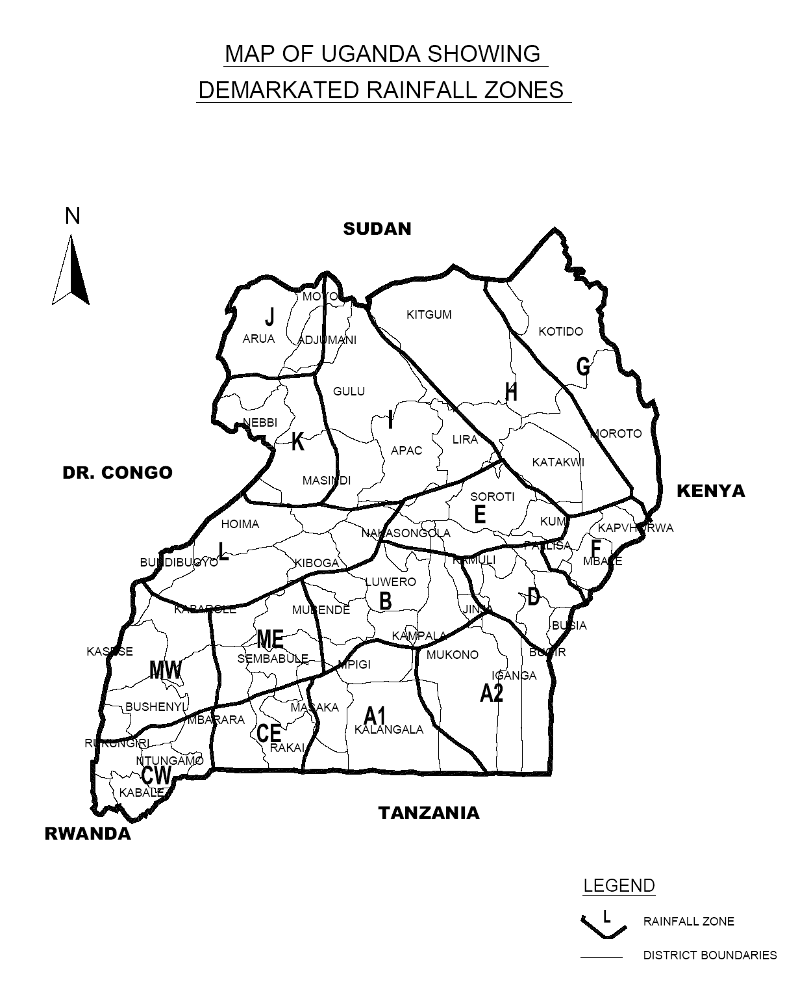
Figure: 5.2 Map of Uganda Showing Demarcated Rainfall Zones (The rainfall zones are prepared by the GIS sub unit of the water Resources Management Department, Entebbe)
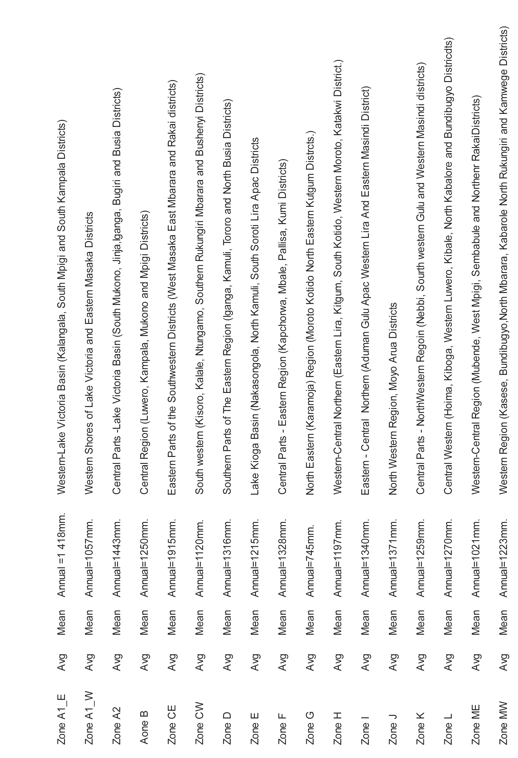

Material Requirements

6.1 Experience with Local Materials

Knowledge of past performance of locally occurring materials for gravel roads is essential. Material standards may be altered to take advantage of available gravel sources provided they have proved to give satisfactory performance under similar conditions. Materials for gravel wearing course shall comply with the requirements given in Table 6.1.

Table 6.1 Material Requirements for Gravel Wearing Course
Material Properties | Requirements
Material Properties | Climatic Zones
Material Properties | Wet | Moderate or Dry
CBR (%) at 95% of MDD (BS Heavy Compaction) | Min 25 after 4 days soaked | Min 25 at OMC
% Passing 37.5 mm | Min 95
Shrinkage Product, SP  SP = LS X (Percent Pass 0.425 mm) | 120 - 400¹
Grading Coefficient GC² | 16 – 34
Field Dry Density (% of MDD)  (BS-Heavy Compaction) | Min 95
- In built up areas a maximum shrinkage product of 270 is desirable to reduce dust problems
- GC = [(% passing 28 mm) – (% passing 0.425 mm)] X (% passing 5 mm)/100

6.2 Marginal Materials

Figure 6-1 illustrates the performance characteristics to be expected of materials that do not meet the requirements for gravel wearing course. Refinements and amendments of the standard material specification may be necessary to overcome problem areas such as towns (dust nuisance) or steep hills (slipperiness).
[
300000000
400000000
500000000
Slippery
Shrinkage Product, SP
Good but may be dusty
Ravels
Erodible materials
Good

100000000
200000000
Ravels and corrugates

10
20
30
40
Grading Coefficient, CG
Note: SP = (Linear Shrinkage) x (% passing 0.425 mm)
GC = ((% passing 28 mm) - (% passing 2 mm)x (% passing 5 mm)/100

Figure 6-1. Expected Performance of Gravel Wearing Course Materials

6.3 Improved Sub-grade Layer

In General the use of improved sub-grade layers has the following advantages:

- Provision of extra protection under heavy axle loads;
- Protection of underlying earthworks;
- Provides running surface for construction traffic;
- Assists compaction of upper pavement layers;
- Provides homogenous sub-grade strength;
- Acts as a drainage filter layer;
- More economical use of available materials.

6.4 Treatment of Expansive Formations

The following treatment operations should be applied on Expansive Formations for higher class roads of AADT_{design} greater than 50 and which are fully engineered gravel roads:

- Removal of Expansive Soil

- Where the finished road level is designed to be less than 2 metres above ground level, remove the expansive soil to a minimum depth specified by the Engineer over the full width of the road, or
- Where the finished road level is designed to be greater than 2 metres above ground level, remove the expansive soil to a depth specified by the Engineer below the ground level under the unsurfaced area of the road structure, or
- Where the expansive soil does not exceed 1 meter in depth, remove it to its full depth.

- Stockpile the excavated material on either side of the excavation for subsequent spreading on the fill slopes so as to produce as flat a slope as possible.
- The excavation formed as directed in paragraph (i) should be backfilled with a plastic non-expansive soil of CBR value 3 - 4 or better, and compacted to a density of 95% modified AASHTO.
- After the excavated material has been replaced with non-expansive material in 150mm lifts and compacted to 95% modified AASHTO density; bring the road to finished level in approved materials, with a side slope of 1:2, and ensure that pavement criteria are complied with. The previously stockpiled expansive soil excavated as directed under (i) should then be spread over the slope.
- Do not construct side drains unless they are absolutely essential to stop ponding. Where side drains are necessary, they should be as shallow as possible and located as far from the toe of the fill as possible.
- Ideally, construction over expansive soil should be done when the in-situ moisture content is at its highest, i.e. at the end of rainy season.

The following treatment operations may be applied on Expansive Formations for light traffic class roads of AADT_{design} less than 50, i.e. gravel roads which are not fully engineered:

- Remove 150mm of expansive topsoil and stockpile conveniently for subsequent use on shoulder slopes
- Shape road bed and compact to 90% modified AASHTO
- The excavation formed as directed in paragraph (i) should be backfilled with a plastic non-expansive soil of CBR value 3 - 4 or better, and compacted to a density of 95% modified AASHTO in each 150mm layer; the sub-grade material may be plastic but non-expansive.

6.5 Performance Characteristics of Gravel Wearing Course

The materials for gravel wearing course should satisfy the following requirements that are often somewhat conflicting:

a) They should have sufficient cohesion to prevent ravelling and corrugating (especially in dry conditions)
b) The amount of fines (particularly plastic fines) should be limited to avoid a slippery surface under wet conditions.

Figure 6-1 shows the effect of the Shrinkage Product (SP) and Grading Coefficient (GC) on the expected performance of gravel wearing course materials. Excessive oversize material in the gravel wearing course affects the riding quality in service and makes effective shaping of the surface difficult at the time of maintenance. For this reason the following two types of gravel wearing course material are recommended. Type 1 gravel wearing course which is one of the best material alternatives which shall be used on all roads which have AADT_{design} greater than 50. Type 1 material shall also be used for all routine and periodic maintenance activities for both major and minor gravel roads. Type 1 gravel wearing course material may be used on new construction of roads having AADT_{design} less than 50. Type 2 gravel weaving course material shall be used for minor gravel roads which are not fully engineered and which have AADT_{design} less than 50.

6.6 Gravel Wearing Course Material Specification

Selected material shall consist of hard durable angular particles of fragments of stone or gravel. The material shall be free from vegetable matter and lumps or balls of clay.

Type 1
The grading of the gravel after placing and compaction shall be a smooth curve within and approximately parallel to the envelopes detailed in Table 6-2.
The material shall have a percentage of wear of not more than 50 at 500 revolutions, as determined by AASHTO T96.
The material shall be compacted to a minimum in-situ density of 95% of the maximum dry density determined in accordance with the requirements of AASHTO T 180.
The plasticity index should be not greater than 15 and not less than 8 for wet climatic zones and should be not greater than 20 and not less than 10 for dry climatic zones.
The linear Shrinkage should be in a range of 3-10%.
Note that the above gradation and plasticity requirements are only to be used with angular particles and that crushing and screening are likely to be required in many instances for this purpose.
Type 2
This material gradation allows for larger size material and corresponds to the gradation of a base course material. The use of this gradation of materials is subject to the local experience and shall be used with PIs in a range of 10-20.

Table 6-2
Test Sieve Size(mm) | Percent(%) by mass of total aggregate passing test sieve
Test Sieve Size(mm) | Type 1 | Type 2
50 | - | 100
37.5 | 100 | 80-100
28 | - | -
20 | 80 - 100 | 60-80
14 | - | -
10 | 55 - 100 | 45-65
5 | 40 - 60 | 30-50
2.36 | 30 - 50 | 20-40
2 | - | -
1 | - | -
0.425 | 15 - 30 | 10-25
0.075 | 5 - 15 | 5-15

6.7 Major Gravel Roads (AADTdesign = 50 to 300)

Major gravel roads are roads which are fully engineered and which have a design AADT greater than 50 and less than 300. It is recommended to use a gravel wearing course material of grading Type 1 in the new construction of roads having an AADT greater than 50 and for all routine and periodic maintenance activities. Type 2 material may be used in the new construction of roads having an AADT less than 50. Pavement and improved sub-grade for major gravel roads shall be constructed in accordance with Figure 6-2.

6.8 Minor Gravel Roads (AADTdesign < 50)

Minor gravel roads are roads which are not fully engineered and which have a design AADT (AADT_{design}) less than 50. They are normally community roads, which are constructed by labor-based methods. Usually these roads are unsurfaced (earth roads). However, for sub-grade CBR values less than 5% and longitudinal gradients of greater than 6%, a gravel wearing course is recommended. Materials for gravel wearing course shall comply with the requirements for Type 2 material for new construction and Type 1 for maintenance activities. Pavement and improved sub-grade for minor gravel roads shall be constructed in accordance with Figure 6-2.

The CBR requirements may be reduced to 20% if other suitable material is not locally available and the LA abrasion value may be increased to 55%.

AADT¹_{design}
<50
50 - 100
100 - 300
150mm
GW
150mm
GW
150mm
GW
S15

150mm
GW

150mm

100mm
GW
G15

150mm

150mm
GW
G15
S7

Dry/Moderate Zones
mm

150

150

150
G7
G15
GW
Wet Zones
mm

150

200

200
G7
G15
GW
Dry/Moderate Zones
mm

150

150

150
G7
G15
GW
Wet Zones
mm

150

200

300
G7
G15
GW
S3
Dry/Moderate Zones

mm

150

150
G7
GW
Wet Zones

mm

150

300
G7

GW

Figure 6-2: Pavement and Improved Sub-grade for Gravel Roads for ADDTs < 300

1) Maximum 50% heavy vehicles is assumed. Heavy vehicles are those having an un-laden weight of more than 3 tonnes, or buses with a seating capacity of 40 or more.

REFERENCES

- ETHIPIAN ROADS AUTHORITY (2000). Pavement Design Manual, Volume 1, Flexible Pavements and Gravel Roads.
- TRANSPORT RESEARCH LABORATORY (1993). Laboratory Report 673.
- THE UNITED REPUBLIC OF TANZANIA MINISTRY OF WORKS (1999). Pavement and Materials Design Manual.
- TRANSPORT AND ROAD RESEARCH LABORATORY (1984). TRRL Laboratory Report 1111.

APPENDICES

APPENDIX A

EXAMPLE OF GRAVEL ROAD PAVEMENT DESIGN

APPENDIX A EXAMPLE OF GRAVEL ROAD PAVEMENT DESIGN

Consider a single carriageway gravel road pavement, having a road width of 6.0 meters, to be designed for the following conditions. The data for the road design is collected in August 2003.

The construction of the gravel road is expected to be completed around the end of year 2005. The traffic volume is expected to grow at a rate of 6.5% per annum for the project area for the next ten years based on the increase in economic activity as represented by GDP forecasts.

Climate. The mean annual rainfall is 1200mm.

Sub-grade. A design CBR of 9% was determined based on the 90th percentile value of the CBRs obtained from the sub-grade soils (refer section 3.3.2). The relevant sub-grade strength class according to Table 3.1 is S7. For wet or moderate climatic zones materials grouped in sub-grade class S7 should have 4 days soaked CBR value ranging from 7% - 14% at 93% BS-Heavy.

Traffic. The initial traffic volume at the end of August 2003 is obtained as 181 vehicles. The AADT in both directions, expected to use the route during the first year when the road is placed in service is obtained as 218 using the growth rate of 6.5% and the formula given in section 2.2.3.

Gravel Wearing Course Thickness

According to the Manual gravel road pavements are designed for roads where AADT is less than 300 at the time of construction. Depending on the design CBR of the sub-grade, improved sub-grade layers shall be constructed as required, on which the gravel wearing course is placed. The requirements for gravel wearing course materials are given in Table 6.1 and 6.2. The requirements for improved sub-grade layers (G15 and G7) are given in Table 3.1

The total pavement thickness (D) required to carry the specific traffic load for the road is the sum of the minimum gravel thickness (D₁) and the total gravel loss (TGL). Refer to Section 4, Design Method.

D = D₁ + TGL

Minimum Gravel Wearing Course Thickness

For sub-grade class S7 (wet climatic zone) and based on and AADT of 218 during the year of opening the road to traffic, 150 mm of gravel wearing course and 150 mm of G15 improved sub-grade layer is required according to Figure 6.2.

Gravel Loss

The gravel loss is calculated using the formula given in section 4.2. The annual gravel loss is calculated as 14 mm. Re-gravelling is assumed to be done every 3 years and the total gravel loss (TGL) in a period of 3 years shall be 42 mm.

Total Pavement Thickness

The total pavement thickness required for carrying the specified load for the road is the sum of the minimum gravel thickness and the total gravel loss [150 + 42 = 192 mm (200 mm is taken)].

