R2ROAD AND BRIDGE WORKS


THE REPUBLIC OF UGANDA

MINISTRY OF WORKS, HOUSING AND COMMUNICATIONS

ROAD DESIGN MANUAL

Vol. 3: Pavement Design

Part II: Rigid Pavements

July 2005

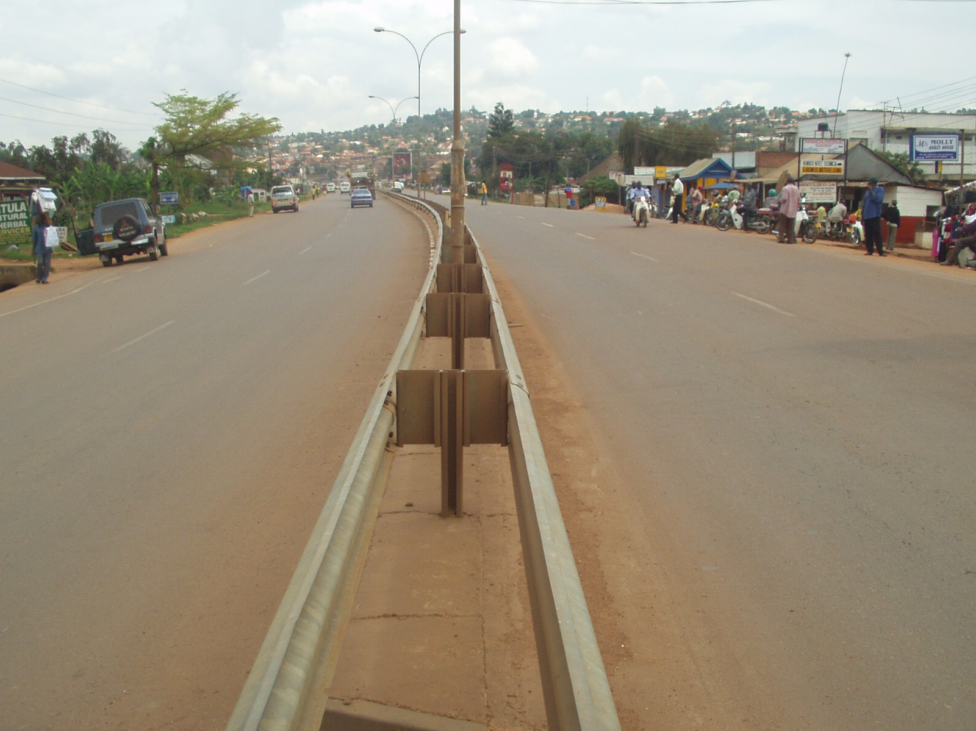
TABLE OF CONTENTS

Definitions i
Abbreviations iv
1. INTRODUCTION 1.1
2. GENERAL CHARACTERISTICS AND TYPES OF RIGID PAVEMENTS 2.1
2.1 GENERAL CHARACTERISTICS 2.1
2.2 TYPES OF RIGID PAVEMENTS 2.1
3. PAVEMENT STRUCTURE, FUNCTION OF PAVEMENT LAYERS AND COMPONENTS 3.1
3.1 PAVEMENT LAYERS 3.1
3.2 REINFORCEMENT STEEL AND LOAD TRANSFER DEVICES 3.2
4. JOINTS 4.1
4.1 GENERAL 4.1
4.2 BROAD CLASSIFICATION OF JOINTS 4.2
4.2.1 Transverse Joints 4.2
4.2.2 Longitudinal Joints 4.4
5. Selection of pavement type 5.1
6. STRESS DEVELOPMENT AND DESIGN CRITERIA 6.1
6.1 STRESS DEVELOPMENT 6.1
6.1.1 Horizontal Tensile Stresses 6.2
6.1.2 Horizontal compressive stresses 6.2
6.1.3 Vertical stresses 6.3
6.2 DESIGN CRITERIA 6.3
7. DESIGN OF RIGID PAVEMENTS 7.1
7.1 INTRODUCTION 7.1
7.2 DESIGN TRAFFIC LOADING 7.1
7.3 THICKNESS DESIGN 7.1
7.3.1 Capping and Subbase 7.1
7.3.2 Concrete Slab Thickness and Reinforcement 7.2
7.4 DESIGN FOR MOVEMENT 7.3
7.4.1 Transverse Joint Spacing 7.3
7.4.2 Longitudinal joint spacing 7.3
7.4.3 Slabs Dimensions 7.3
7.4.4 Joint Layout 7.3
8. References 8.1

Appendices

Appendix – A Design Example
Appendix – B Typical Details
Definitions of Terms and Abbreviations

TERMS

AGGREGATE

Hard mineral elements of construction material mixtures, for example: sand, gravel (crushed or uncrushed) or crushed rock.

AVERAGE ANNUAL DAILY TRAFFIC (AADT)

The total yearly traffic volume in both directions divided by the number of days in the year.

AVERAGE DAILY TRAFFIC (ADT)

The total traffic volume during a given time period in whole days greater than one day and less than one year divided by the number of days in that time period.

CAPPING LAYER

The top of embankment or bottom of excavation prior to construction of the pavement structure.

CARRIAGEWAY

That portion of the roadway including the various traffic lanes and auxiliary lanes but excluding shoulders.

CONSTRUCTION JOINT

A joint made necessary by a prolonged interruption in the placing of concrete.

CONTRACTION JOINT

A joint normally placed at recurrent intervals in a rigid slab to control transverse cracking.

DEFORMED BAR

A reinforcing bar for rigid slabs conforming to “Requirements for Deformations” in AASHTO Designations M 31M.

DESIGN PERIOD

The period of time that an initially constructed or rehabilitated pavement structure will perform before reaching a level of deterioration requiring more than routine or periodic maintenance.

DOWEL

A load transfer device in a rigid slab, usually consisting of a plain round steel bar.

EQUIVALENT STANDARD AXLES (ESAS)

Summation of equivalent 8.2 metric ton single axle loads used to combine mixed traffic to design traffic for the design period (cf. ERA’s Pavement Design Manual, Volume 1).

EXPANSION JOINT

A joint located to provide for expansion of a rigid slab, without damage to itself, adjacent slabs, or structures.

FILL

Material of which a man-made raised structure or deposit such as an embankment is composed, including soil, soil-aggregate or rock. Material imported to replace unsuitable roadbed material is also classified as fill.

LONGITUDINAL JOINT

A joint normally placed between traffic lanes in rigid pavements to control longitudinal cracking.

MAINTENANCE

Routine work performed to keep a pavement, under normal conditions of traffic and forces of nature, as nearly as possible in its as-constructed condition.

PAVEMENT LAYERS

The layers of different materials which comprise the pavement structure.

PROJECT SPECIFICATIONS

The specifications relating to a specific project, which form part of the contract documents for such project, and which contain supplementary and/or amending specifications to the standard specifications.

PUMPING

The ejection of foundation material, either wet or dry, through joints or cracks, or along edges of rigid slabs resulting from vertical movements of the slab under traffic.

REINFORCEMENT

Steel embedded in a rigid slab to resist tensile stresses and detrimental opening of cracks.

RIGID PAVEMENT

A pavement structure which distributes loads to the subgrade, having as one course a Portland cement concrete slab of relatively high-bending resistance.

ROAD BED

The natural in situ material on which the fill, or in the absence of fill, any pavement layers, are to be constructed.

ROAD BED MATERIAL

The material below the subgrade extending to such depth as affects the support of the pavement structure.

ROADWAY

The area normally traveled by vehicles and consisting of one or a number of contiguous traffic lanes, including auxiliary lanes and shoulders.

STABILIZATION

The treatment of the materials used in the construction of the road bed material, fill or pavement layers by the addition of a cementitious binder such as lime or Portland cement or the mechanical modification of the material through the addition of a soil binder or a bituminous binder. Concrete and asphalt shall not be considered as materials that have been stabilized.

SUBBASE

The layer of material of specified dimensions on top of the subgrade and, in the case of rigid pavements, below the concrete slab.

SUBGRADE

The surface upon which the pavement structure and shoulders are constructed.

TIE BAR

A deformed steel bar or connector embedded across a joint in a rigid slab to prevent separation of abutting slabs.

TRAFFIC LANE

Part of a traveled way intended for a single stream of traffic in one direction, which has normally been demarcated as such by road markings.

WELDED WIRE FABRIC

Welded Steel Wire Fabric for Concrete Reinforcement.

ABBREVIATIONS

AADT Average Annual Daily Traffic

ADT Average Daily Traffic

AASHTO American Association of State Highway and Transportation Officials

CBR California Bearing Ratio (as described in AASHTO T 193)

ESA Equivalent Standard Axle

TRL Transport Research Laboratory (UK)

1. INTRODUCTION

The purpose of this Pavement Design Manual - Part 2 is to give specific guidance and recommendations to the engineers responsible for the design of rigid pavements in Uganda.

It is hoped that this Manual will provide all users with both a standard reference and a ready source of good practice for the Rigid Pavement design of roads, and will assist in a cost effective operation, and environmentally sustainable development of the road network.

As this Manual requires periodic updating due to technological development and change, comments and suggestions on all aspects from any concerned body, group or individual as feedback during its implementation is expected and will be highly appreciated.

This volume contains:

- A description of rigid pavements: their characteristics, their components and their function, the different types of slabs and joints, including drawing details.
- A description of the factors influencing the pavement type selection and the design process.
- A design procedure for the different types of pavement, slab reinforcement, joint details and joint layout.

The design method is a directly utilizable one, based mainly on empirical results and full scale experiments. Although an analytical, comprehensive approach to the design is possible, based on the stresses and strains induced in the pavement by an applied wheel loading, it is very complicated, rarely used, leads to minor changes and as such is not covered in these pages.

2. GENERAL CHARACTERISTICS AND TYPES OF RIGID PAVEMENTS

2.1 General Characteristics
Rigid pavements (concrete pavements), as the name implies, are rigid and considerably stronger in compression than in tension. One of the main characteristics of rigid pavements is that a relatively thin pavement slab distributes the load over a wider area due to its high rigidity. Localized low strength roadbed material can be overcome due to this wider distribution area. In concrete pavements, the strength of the pavement is contributed mainly by the concrete slab, unlike flexible pavements where successive layers of the pavement contribute cumulatively. Since the modulus of elasticity of the concrete slab is much greater than that of the foundation material, a major portion of the load carrying capacity is derived from the slab itself. This has often been referred to as beam action.

The main objective in design is to make sure that the stresses imposed by traffic and induced by thermal expansion and contraction are contained within limits that the concrete can accept without fracturing. Concrete can be damaged by deleterious salts, either in the aggregate or entering the concrete in solution from an external source. But in the absence of such deleterious materials, concrete does not deteriorate. Indeed, its strength increases with age over the first few months.

Concrete pavements are subject to thermal stresses due to variation in daily and annual temperatures and hence thermal stresses deserve attention for the design of concrete pavements. Concrete changes in volume with changing temperature and, to a lesser degree, with changes in moisture content. In concrete used as a surfacing, these changes in volume must be accommodated by the use of contraction joints, the spacings of which are determined by the range in diurnal and annual temperature. In some tropical climates, notably in humid low lying areas near the equator, there are only small fluctuations in temperature and joints can be quite widely spaced. In other tropical climatic regimes, notably in deserts, there can be large fluctuations in both diurnal and annual temperatures and special attention is necessary to joint design and spacing.

Skidding resistance of concrete pavement surfaces is also an important functional characteristic. The rugose surface required for an adequate resistance to skidding in wet conditions can be provided by dragging stiff brooms transversely across the newly-laid concrete or by cutting shallow randomly spaced grooves in the surface of the hardened concrete slab.

At present, concrete pavements have not been extensively used in most tropical countries and in Uganda in particular, mainly due to a lack of tradition and experience in design and construction. One characteristic of concrete pavements is that either they prove to be extremely durable, lasting for many years with little attention, or they give trouble from the start, sometimes because of faults in design, but more often because of mistakes in construction.

2.2 Types of Rigid Pavements
Depending on the level of reinforcement, the rigid pavements can be categorized into three basic types:

- Jointed unreinforced concrete pavements (JUCP)
- Jointed reinforced concrete pavements (JRCP)
- Continuously reinforced concrete pavements (CRCP)

In jointed unreinforced concrete pavements (JUCP), the pavement consists in a succession of cast in place unreinforced concrete slabs separated by joints to prevent expansion from developing stresses and to control cracks. The slabs are linked together by tie bars or dowels to transmit the vertical stresses.

In Jointed reinforced concrete pavements (JRCP) the pavement consists in a succession of cast in place reinforced concrete slabs separated by joints to control cracks. The slabs are linked together by tie bars or dowels to transmit the vertical stresses. JRCP are used where a probability exists for transverse cracking during pavement life due to such factors as soil movement and/or temperature/moisture change stresses. The longitudinal reinforcement is the main reinforcement. A transverse reinforcement though not absolutely necessary in most cases is usually added to facilitate the placing of longitudinal bars.

Continuously reinforced concrete pavements (CRCP) are used for rather highly trafficked roads where a good level of comfort is expected. The principal reinforcement, in the form of prefabricated mesh or reinforcing bars installed at mid-depth of the slab, is again the longitudinal steel which is essentially continuous throughout the length of the pavement. This longitudinal reinforcement is used to control cracks which form in the pavement due to volume change in the concrete.




INITIAL CRACKING
(a) Crack Development in Unjointed Unreinfroced Concrete Road Pavements
(b) Effects of Warping in Concrete Pavement
FIG. 2.1 CRACK DEVELOPMENT IN CONCRETE PAVEMENTS

3. PAVEMENT STRUCTURE, FUNCTION OF PAVEMENT LAYERS AND COMPONENTS

3.1 Pavement Layers
Rigid pavements generally consist of, as shown in Figure 3.1, a subbase, and a concrete slab constructed above the subgrade constituted of the roadbed or embankment and a capping layer (if required). The load bearing capacity of the soil subgrade is not important in the design of concrete pavements. The prime requirement is to provide a foundation on which construction traffic can operate without impairing the shape to which the surface of the foundation has been trimmed.

The capping layer consists of selected fill and is provided in cases of low strength roadbed material. It protects the underlying subgrade from construction traffic loading and provides a stronger platform for the subbase layer, which is placed on top of the capping layer.

Base courses are often called subbase courses when used with rigid pavements. These terms are often used interchangeably and it should be noted that either of the terms refers to a prepared layer of material immediately between the concrete slab and subgrade. The base courses (subbases) are utilized under these pavements for several reasons: (1) control of pumping, (2) control of frost action, (3) drainage, (4) control of shrink and swell of the subgrade, and (5) to expedite construction. The subbase of a rigid pavement structure consists of one or more compacted layers of material placed between the subgrade and the rigid concrete slab. In some cases the material can be cement stabilized to increase its quality.

If the roadbed soils are of an acceptable quality and if the design traffic is low (less than one million equivalent standard axles (ESAs)), a subbase layer may not be necessary between the prepared roadbed and the concrete slab. If water accumulates in the pavement under a joint, mud pumping is likely to occur as heavy vehicles pass from one slab to the next. If the subgrade soil is not free draining it is necessary to provide a subbase. This subbase should be free draining and should continue through the road shoulder. As an alternative, the upper 150 mm of the subbase can be stabilized with cement or lime to produce a structured material resistant to mud pumping.
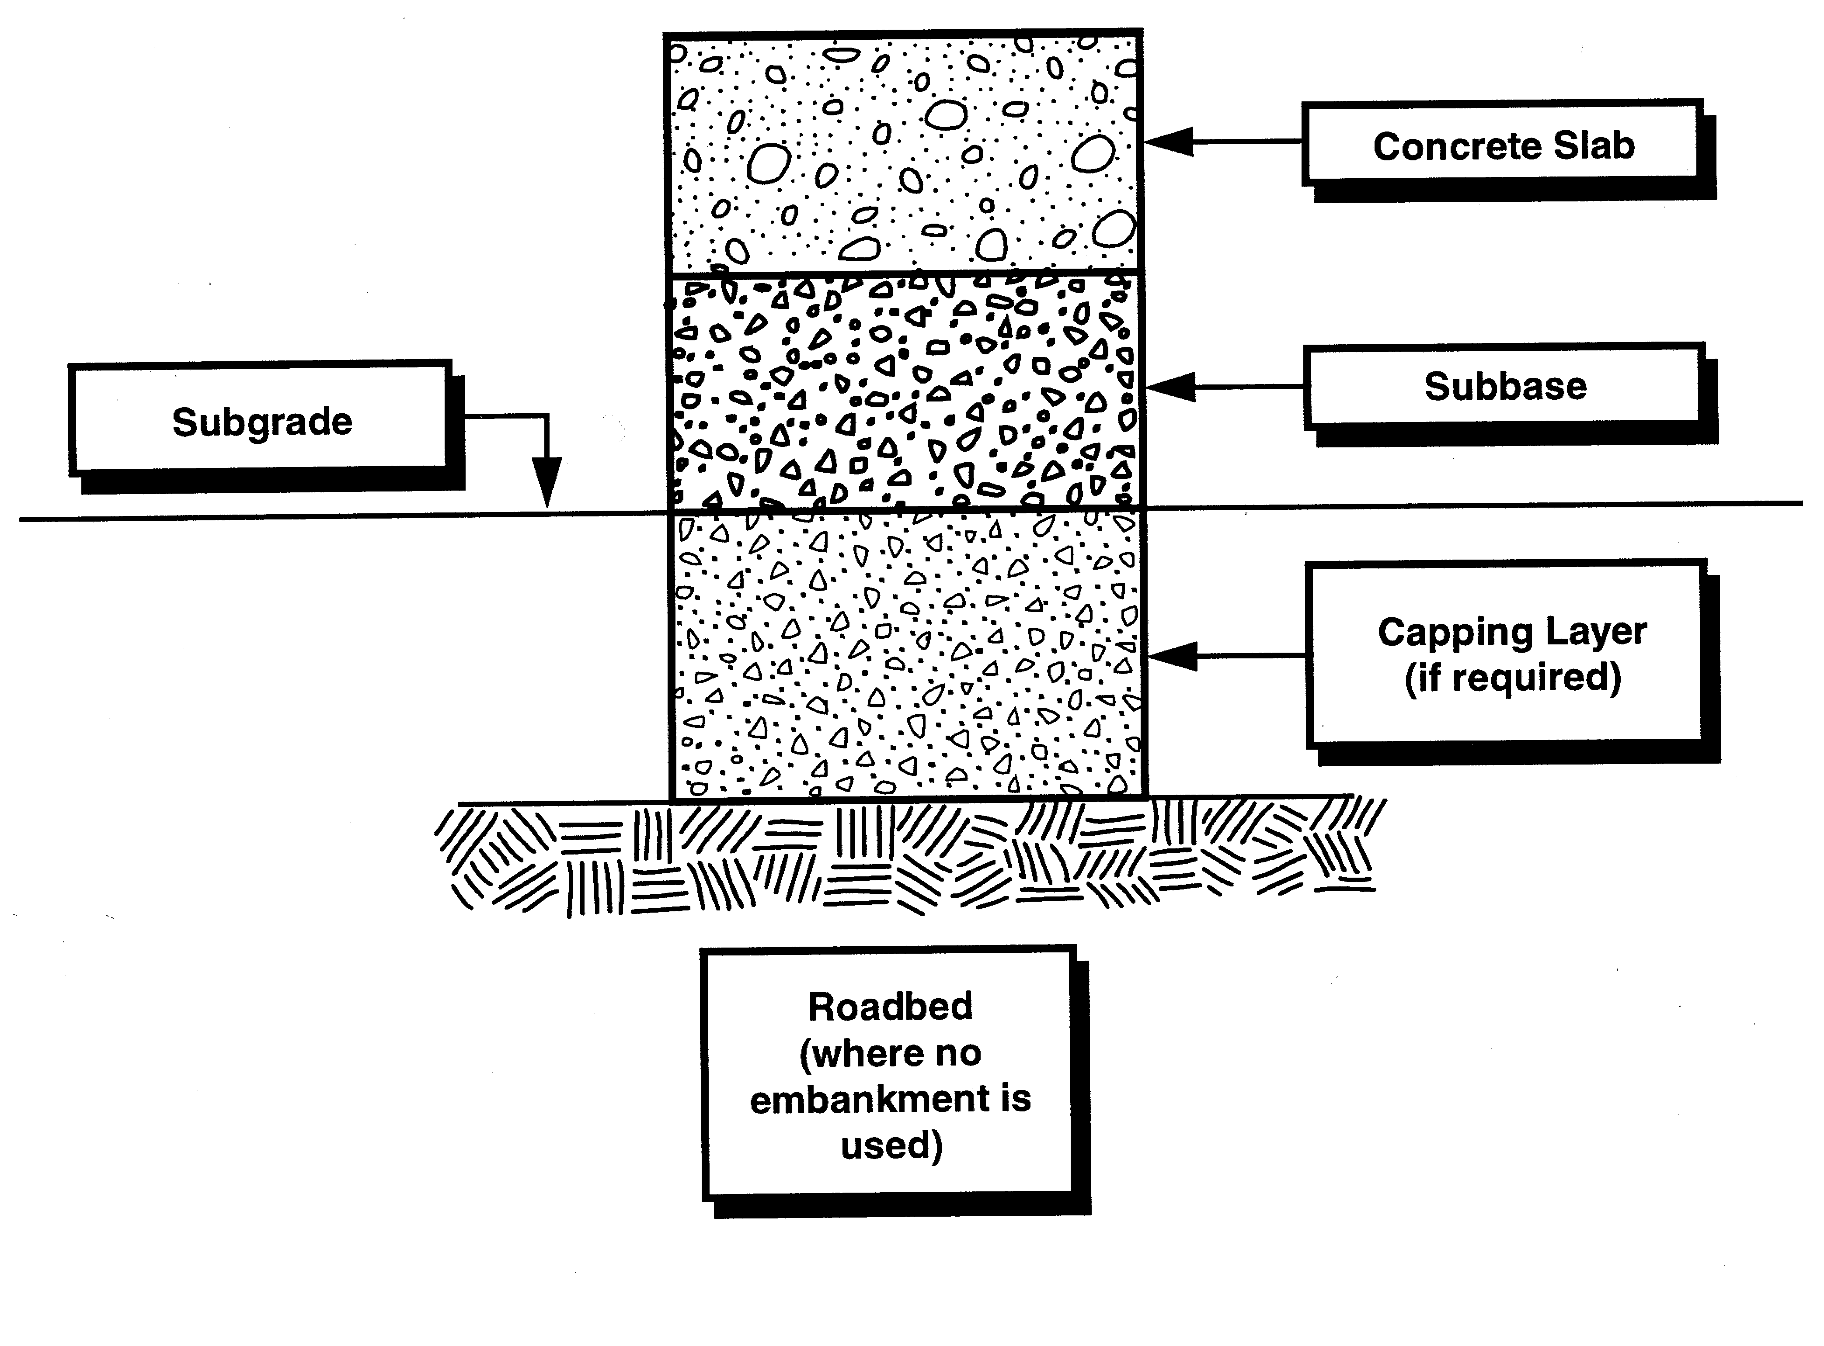
Fig. 3.1 Rigid Pavement

A subbase is provided under a concrete pavement for the following reasons:

- to provide a stable “working platform” for the construction equipment;
- to provide a uniform concrete slab support;
- to help in the control of excessive volume changes in roadbed soils susceptible to such phenomena; and
- to prevent “pumping” at joints and slab edges.

The concrete slab consists of Portland cement concrete, reinforcing steel (when required), load transfer devices and joint sealing materials.

3.2 Reinforcement Steel And Load Transfer Devices
Distributed reinforcement steel.
The purpose of distributed steel or temperature steel is basically one of crack control. Temperature steel will not prohibit the formation of cracks but acts as a tie member, which controls the width of the crack opening. It holds tightly closed any cracks that may form, thus maintaining the pavement as integral structural unit. Transverse reinforcement is provided to ensure that the longitudinal bars remain in the correct position during the construction of the slab. It also helps to control any longitudinal cracking that may develop. Highways with transverse joint spacing ranging between 6 and 30 meters, and with lanes 3.5 meters wide require heavier longitudinal than transverse reinforcement. The transverse reinforcement act primarily as spacers, since longitudinal cracking generally does not take place. Continuous reinforcing refers to relatively high percentage of steel in contrast to ordinary design.

The physical mechanism through which crack develop is affected by (1) temperature and/or moisture-related slab contractions, and (2) frictional resistance from the underlying material. As temperature drops or moisture content decreases, the slabs tend to contract. This contraction is resisted by the underlying material through friction and shear between it and the slab. The restraint of slab contraction results in tensile stresses which reach a maximum at mid-slab. If these tensile stresses exceed the tensile strength of the concrete, a crack will develop and all the stresses are transferred to the steel reinforcement. Thus the reinforcement must be designed to carry these stresses without any appreciable elongation that would result in excessive crack width. In all cases, the amount of reinforcement required is specified as a percentage of the concrete cross-sectional area. Normally, for joint spacing less than 6.0 meters, transverse cracking is not anticipated and steel reinforcement would not be required.

Dowel Bars

The most often encountered and by far the most dramatic failure of concrete roads occur at the transverse joints. It is thus necessary that adequate load transfer across joints limits slab deflections to reduce faulting, spalling and corner breaks.

Load transfer efficiency can be improved by:

a) large (greater than 26,5 mm) durable aggregates
b) dowels
c) Reduced joint opening
d) stiff subbases

A fixed dowel spacing of 300 mm is recommended due to the practicality thereof. The dowels shall be 20 mm in diameter and 400 mm long for slabs up to 239 mm thick, and 25 mm in diameter for slabs 240 mm thick or more.

Dowel bars are load transfer devices, and, thus, they must be fairly heavy and spaced at close intervals to provide resistance to bending, shear, and bearing on the concrete. Dowel bars are used at joints on long slabs or where load transfer by “aggregate interlock” is suspect. Joints without dowels are generally satisfactory if the joint opening is 1 mm or less. For doweled joints the opening should be 6 mm or less. Hence, short slabbed pavements generally do not use dowels. However, many engineers sometimes use dowels regardless of joint spacing.

To allow slabs to move horizontally relative to each other, at least two thirds of the length of the dowel should be coated with a bond-breaking compound as indicated on drawing no. B2(i). The end dowels are to be at least 200 mm away from a free edge. In an aggressive environment such as closer than 5 km to the sea, galvanized dowels should be considered.

Tie Bars.

In contrast to dowel bars, tie bars are not load-transfer devices within themselves but are a means of tying two slabs together. Thus, whereas dowel bars must be smooth and lubricated on one of their ends to maintain freedom of movement of the slab, tie bars must be deformed or hooked and must be firmly anchored into the concrete to function properly. Tie bars are smaller in diameter than dowel bars, relatively long and are spaced at greater intervals.

Tie bars prevent separation of the pavement at longitudinal joints, allowing warping or curling to occur without excessive restraint. Tie-bars at longitudinal joints are provided to hold these joints tightly closed and therefore perform a similar function to steel reinforcement between transverse joints. The purpose of a tie-bar is to hold a joint tightly closed to allow load transfer by aggregate interlock.
If the width of the pavement, being paved in one operation, is wider than 4.5 m, hinge joints should be provided by sawing the concrete to a depth of 0.3 x concrete thickness. These joints should be sealed. Joints should be tied by inserting uncoated deformed steel tie-bars at a depth of 2/3-pavement thickness into the slab (drawing no. B2[ii]). (For slabs less than 200 mm thick, the tie-bar should be inserted at mid depth in the pavement).

Tie bars are deformed steel bars having 12 mm diameter and 750 mm long at 600 mm spacing. Where the pavement is constructed in more than one paved lane, tie-bars should be inserted. The same principle in tie-bar design, as discussed in above, is also applicable in this case.

End of day or construction break joints are formed where construction stops and is resumed after a length of time. The new concrete should be jointed to the old concrete by using uncoated tie bars. The length of these tie bars should be at least 750 mm.

The details regarding the design of the pavement slab thickness and the amount of reinforcement required are discussed in Chapter 7.

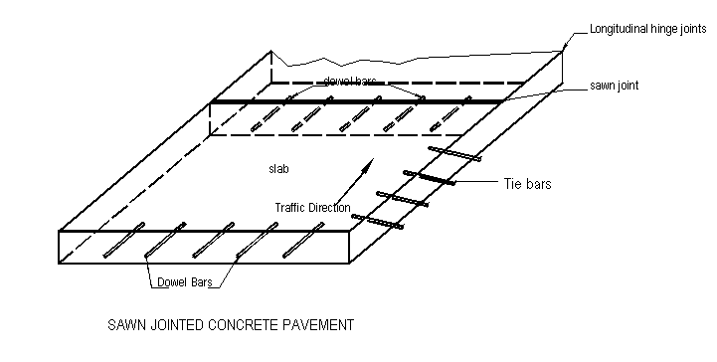

FIG. 3.2 NOMENCLATURE USED FOR CONCRETE PAVEMENTS
(Adapted from Ref. 9)

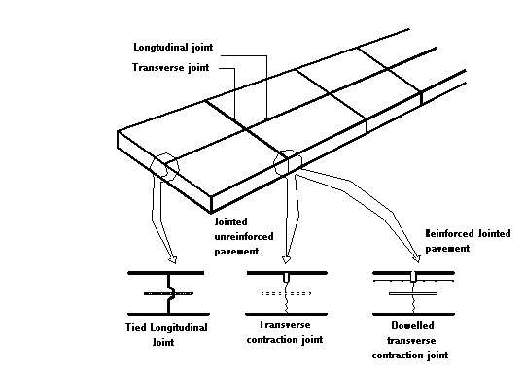

FIG. 3.3 TYPICAL JOINTS IN CONCRETE ROAD PAVEMENT
(Adapted from Ref. 2)



FIG. 3.4 SUGGESTED CONCRETE ROAD PAVEMENT DOWEL ASSEMBLY
(Adapted from Ref. 2)

4. JOINTS

4.1 General
Joints are placed in concrete pavements, whether reinforced or not to permit expansion and contraction of the pavement, thereby relieving stresses due to environmental changes (temperature and moisture), friction, and to facilitate construction. There are four general types of joints: contraction, expansion, warping and construction.

In most cases joints combine several of these functions:

Contraction joints are provided to relieve the tensile stresses due to temperature, moisture and friction, therefore controlling cracking. If contraction joints were not installed, random cracking would occur on the surface of the pavement. Nowadays, special equipment is available to cut slots in the concrete surface as soon as it has hardened sufficiently. The equipment is a power saw fitted with blades suited for sawing concrete. It is self-propelled and manually guided.

The primary function of an expansion joint is to provide space for the expansion of the pavement, thereby preventing the development of compressive stresses, which cause the pavement to buckle. Expansion joints are also contraction joints.

Warping joints allow a slight relative rotation of the slab portions delimited by joints and reduce the strains due to warping. Warping joints are also contraction joints. Longitudinal joints are always warping joints but they can be found also as transverse joints in some cases.

Construction joints are required to facilitate construction, especially when concreting is stopped. For JUCP and JRCP, they shall be coupled with other joints and additional reinforcement shall be placed when dealing with transverse construction joints for CRCP.

Normally the depth of transverse contraction joints should be ¼ of the slab thickness. These joints may be developed by sawing, inserts or forming.

Most joints should be sealed. In pavements with joints spaced not more than 4.5 m apart and which are to be sealed with preformed elastomeric compression seals, joint widths are usually 6 mm. For liquid sealants the required joint width is usually 6 mm for tied longitudinal hinge joints and 8 mm for untied longitudinal hinge joints and transverse contraction joints (Reference 9). The edges of the slots usually have a rounded arris. In general the depth to width of a sealant ratio should be within a range of 1 to 1.5 and the sealant should be placed 3 mm to 13 mm below the surface of the pavement. Specifications for testing commercial sealing compounds are given in BS 2499 and 5212 and in ASTM D 1190 and 1191. As the concrete expands and contracts, these sealing compounds have to accommodate quite large strains. The sealant should be compressed between 20 to 50 percent of its normal width. It is unlikely that they will remain effective in preventing water from entering the joint for more than two or three years. Nevertheless, as long as they remain in place, they fulfill their other important function, which is to prevent loose stones on the road surface from being wedged in the joint. Stones so wedged, can cause spalling of the edges of the joint as the concrete expands.

On roads carrying heavy vehicles it is desirable to provide dowels across joints to limit the vertical movement between slabs as vehicles pass over. Dowels provide load transfer between slabs. It is also desirable to use dowels in roads over unconsolidated soils to prevent differential settlements between adjacent slabs. In transverse joints dowels are bonded into the concrete on one side of the joint. Bonding on the other side is prevented, usually by coating the dowels with bitumen and, for expansion joints, by providing a loose end-cap. It is particularly important that they are accurately aligned perpendicular to the face of transverse joints or parallel to the road if the joints are skewed. All materials required for joints and sealing shall be as per the Standard Specifications.

4.2 Broad Classification Of Joints
Joints can be broadly classified into two categories according to their direction: (1) Transverse Joints and (2) Longitudinal Joints.

Typical details of the joints are presented in Appendix B (adapted from Ref. 2, 7 and 9).

Transverse Joints

Based on their function, the transverse joints can be divided into four types: (i) contraction joints (ii) construction joints (iii) warping joints and (iv) isolation joints.

- Contraction Joints

Contraction joints are the main type of transverse joint. They provide weakened sections between slabs to induce tension cracking at preferred locations in the concrete after it has been placed. They also contribute to limiting the strain due to warping as a result of temperature and moisture changes. Contraction joints shall consist of:

- a sawn or wet formed groove
- dowel bars
- a sealant

The groove and sealant shall be as specified. The dowel bars shall be 20 mm in diameter at 300 mm spacing, 400 mm long for slabs up to 239 mm thick. The dowel bars shall be 25 mm in diameter and 470 mm long for slabs 240 mm thick or more.

The principal requirements of contraction joints in a jointed pavement whether unreinforced or reinforced are:

- To ensure that a crack is induced in the pavement at a predetermined location to control transverse cracking (the crack so formed is to be effectively sealed against the ingress of solids and water)
- To permit the joint to open and close
- To transfer loads across the joint.

Typical details of transverse contraction joints are shown in drawing no.B4.

To control cracking, the proper interval between contraction joints in jointed unreinforced pavements depends on shrinkage properties of the concrete subbase or subgrade friction characteristics and slab thickness (and hence inertia due to its weight). A maximum spacing of 5m is recommended. It is desirable to limit the spacing of joints in reinforced jointed pavements to about 22 meters. A controlled crack is encouraged to occur by reducing the slab cross-section at the joint location. Saw cutting or wet-formed grooves are the two most commonly used methods. A minimum depth reduction of 25 per cent is required to positively induce cracking.

Load transfer across the joint is provided by dowels or by aggregate interlock across the rough crack faces, or a combination of these mechanisms. If the joint opening is greater than 1 mm, load transfer by aggregate interlock may not be fully effective and dowels must be provided. Dowels must not 'lock' the joint; otherwise an uncontrolled crack may occur close to it. Therefore, dowels must be coated with a bond breaker on at least one side of the crack and must be aligned parallel to the longitudinal direction of the pavement and the surface of the pavement to within close tolerances.

Sealing is provided by a joint sealant at the surface of the slab. The dimensions of the sealant reservoir will depend on the slab length, and hence the movement at the joint, and also the properties of the sealant being used.

The relationship between joint spacing and slot details is given in the following tables (Reference 2).

Table 4.1 Joint Sealant Reservoir Dimensions for Field-Moulded Sealants

Joint Spacing (m) | Sealant Reservoir Shape
Joint Spacing (m) | Width (mm) | Depth of Sealant (mm)
5 or less | 6 | 20
6 | 10 | 20
10 | 12 | 20
12 | 15 | 25

Table 4.2 Joint & Sealant Width for Preformed Compression Seals

Joint Spacing (m) | Sealant Dimensions
Joint Spacing (m) | Joint Width (mm) | Sealant Width (mm)
6 or less | 6 | 11
10 | 10 | 16
12 | 11 | 20
15 | 12 | 22

- Construction Joints

Transverse construction joints are required for planned interruptions such as at the end of each day’s run, at block outs for bridges and intersections, and for unplanned (emergency) interruptions where operations are suspended for a period after which the concrete will have begun to set.

Planned construction joints, such as the end of a day’s pour, may be located either in the middle third of the slab (i.e. away from a joint and the possibility of edge over loading), in which cased a keyed and tied joint is used; or at a planned contraction joint, in which case a butt, dowelled joint is used (see drawing no.B4).

In the keyed and tied joint (at the middle third location) the intention is that the joint becomes an integral part of the slab. The key provides load transfer and deformed tie bars are used to hold the joint tightly closed to limit the incidence of sympathetic cracking in adjacent lanes. It will not normally be necessary to seal this type of joint.

With the butt type joint (at the planned contraction joint location), the joint will perform in a similar manner to a contraction joint. Dowels will be necessary as there is no aggregate interlock to provide load transfer. Dowel size and spacing and joint sealing will be as for a normal contraction joint.

The construction joints should be located normally to the longitudinal axis of the pavement.

Emergency (unplanned) joints should be capable of being accommodated within the above requirements, i.e. either in the middle third of the slab, or at a planned contraction joint.

- Warping Joints

Transverse warping joints are used for special cases, such as extra joints at manhole positions, or when unreinforced slabs are alongside reinforced slabs, or in long and narrow or tapered (odd-shaped) JUCP slabs between normal joint positions, to reduce the length/width ratio of the slabs to 2 or less, and in other similar situations.

Warping joints shall consist of

- a sawn or wet formed groove
- tie bars
- a sealant

- Isolation Joints

At pavement intersections an expansion type joint is usually included in the joint layout in the minor leg of the intersection. This joint acts more as an isolation joint than an expansion joint to prevent the development of stresses which may otherwise develop as a result of the intersecting pavements tending to contract or expand in different directions. In most situations either type of expansion joint should give satisfactory performance (drawing no. B8).

Longitudinal Joints

Longitudinal joints are hinge and/or warping joints, required at such a spacing as will reduce the combination of thermal warping stresses and loading stresses to a minimum, and reduce the risk of longitudinal random cracking, and often serve at the same time as construction joints. These joints allow a slight rotation, but differential lateral displacements between adjacent slabs are prevented by tie bars provided at mid-depth of the slab.

Longitudinal joints shall consist of:

- a sawn or wet formed groove
- tie bars
- a sealant

The sealant shall be as per the Specifications. The tie bars for all longitudinal joints, except where transverse reinforcement is permitted in lieu, shall be 12 mm in diameter and 750 mm long at 600 mm spacing.

The purpose of longitudinal joints is to control longitudinal cracking. At the same time they are designed and constructed to remain firmly closed and in general they may be left unsealed.

Longitudinal joints are provided between lanes in pavements to control irregular longitudinal cracks that would otherwise occur (drawing no. B6). Such cracks normally develop due to the combined effects of load and restrained warping after pavements are subjected to traffic.

Under certain conditions, such as rapidly dropping air temperature during the first night, longitudinal cracks may occur early. In such cases, early formation of the longitudinal joint is required in multiple-lane paving.

The following criteria are useful guides for the spacing of longitudinal joints:

- On multiple-lane pavements, a spacing equal to the width of traffic lanes serves the dual purpose of crack control and lane delineation. This would normally be in the range 3 to 4.5m and most commonly about 3.7m. Longitudinal joints on arterial roads can also be spaced to provide traffic and parking lane delineation where parking is permitted. Longitudinal joints should be located away from commercial vehicle wheel-paths to create an interior loading condition, rather than edge loading.
- Longitudinal joints are usually required for crack control on one-way ramps where the slab width is 4.5m or more.

The same requirements for longitudinal joints apply to continuously reinforced pavements. It should be noted that continuously reinforced pavements are jointless only in that no transverse contracting joints are provided.

Longitudinal joints may be either construction joints or weakened plane joints as shown in drawing no. B5.

Tied construction joints should be used in lane-at-a-time construction in multi-lane pavements not paved in one pass, and for ramp connections to the main carriageway.

In order to hold the faces of the abutting slabs in intimate contact, and at the same level, deformed tie bars should generally be provided across all longitudinal joints in heavily trafficked concrete pavements. Shear transfer is achieved by the interlock of the concrete face, which is achieved, in-turn, by a formed corrugated joint or induced (weakened plane) joint.

5. Selection of pavement type

The highway engineer or administrator does not have at his disposal an absolute or indisputable method for determining the type of pavement which should be selected for a given set of conditions.

Unreinforced concrete can be used, but on more heavily trafficked roads it is usual to employ reinforced concrete. This reinforcement is not intended to function as a structural element in the same way as the steel in a reinforced concrete beam or slab in a building. It is provided in the form of prefabricated mesh and is installed at mid-depth of the slab. Its main purpose is to restrain the development of cracking in the concrete. Whilst unreinforced concrete is likely to be satisfactory in countries with small changes in diurnal and annual temperatures, reinforced concrete will be preferred in those countries where diurnal and annual temperature changes exceed some 20°C because of the need to contain the effects of thermal expansion and contraction of the concrete.

First a judgement must be made on many varying factors such as traffic, soil, weather, materials, construction, maintenance and environment. In some cases overriding factors can dictate pavement type. For instance, for heavily traveled facilities in congested locations, the need to minimize the disruptions and hazard to traffic may dictate the selection of CRCP.

Where traffic includes vehicles with axle loads of over 10 tonnes, special treatment is desired to reduce the stresses imposed by this traffic. Such treatment may include: 1) strong load transfer devices across joints, 2) Closer joint spacing, 3) Use of mesh reinforcement in the concrete and 4) Increased slab thickness.

When there is no overriding factor, which may often be the case, it is standard practice to design typical sections of the road using each of the available options and then to compare them on an economical point of view.

Unavoidably, there will be instances where financial circumstances dictate the selection, even though higher maintenance or repair costs may be involved at a later date.

Where circumstances permit, a more realistic economical evaluation has to take into account all expected costs including the initial cost of construction, the cost of subsequent stages or corrective works, anticipated life, maintenance cost and salvage value. Costs to road users during periods of reconstruction or maintenance operations are also appropriate for consideration.

Although pavement structures are based on an initial design period, few are abandoned at the end of this period and continue to serve as part of the future pavement structure. For this reason, the analysis period should be of sufficient duration to include a representative reconstruction of all pavement types.

If the analysis of the above given factors does not show a far higher interest of one option rather than another, a second set of factors can be considered such as the performance of similar pavements in the area or the skills of contractors.

Basically, the use of the different types of rigid pavement is as follows:

- JUCP is suitable for all levels of traffic, whenever the risk of subgrade movement is low and an uncontrolled cracking not very prejudicial.
- JRCP is suitable for all levels of traffic and is used when the risk of settlements of the subgrade can not be neglected.
- CRCP shall basically be considered only for rather high design traffic (>30 msa).

They can also be included for less heavily trafficked schemes where the advantage of lower maintenance throughout the design life may be worthwhile.

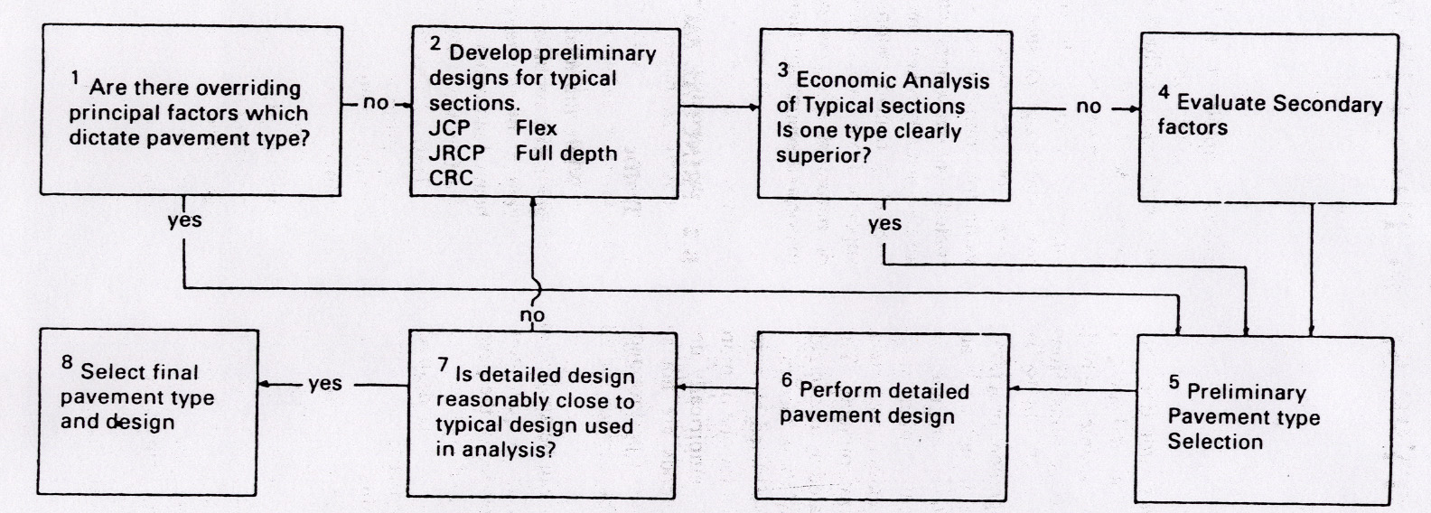

Fig. 5.1 Pavement type selection Process
JCP Jointed Unreinforced Concrete Pavement
JRCP Jointed Reinforced Concrete Pavement
CRCP Continuously Reinforced Concrete Pavement

6. STRESS DEVELOPMENT AND DESIGN CRITERIA

6.1 Stress Development
Stresses in rigid pavements result from a variety of causes, including wheel loads, cyclic changes in temperature (warping and shrinkage or expansion), changes in moisture, and volumetric changes in the subgrade or base course. These changes tend to deform the slab, causing stresses of widely varying intensity. In addition, the magnitude of stresses depends upon continuity of subgrade support. Complete continuity can be destroyed by pumping and plastic deformation of the subgrade.

The concrete slabs in concrete pavement are subjected to two main types of stresses, the stresses developed because of changes of the environment (moisture and temperature) and closely depending on the intrinsic properties of the concrete and the stresses coming from the traffic loads.

If a pavement slab is subjected to a temperature gradient through its depth, the surface will tend to warp. For example, if the top of the slab is cooler than the bottom, the corners will tend to curl upwards, but the weight of the concrete will tend to hold the slab in its original position with the result that stresses are induced in the slab. If the temperature of the top of the slab is higher than the bottom, differential expansion causes the slabs to hog during the heat of the day. In rigid pavements, stresses can also result from uniform temperature changes, which cause the slab to contract or expand. In any case, long slabs nearly always contract at one or more locations between the joints.

These kinds of stresses can not be prevented from developing, but the design of concrete pavement shall take them into account in order to keep them in acceptable ranges of values. Analytical methods have been developed aiming at computing accurately the stresses developed in concrete pavements for a theoretical design. But they are rather complicated and necessitate strong hypothesis on the quality and the evolution of the different layers composing the roadbed. That’s why the approach of this manual is limited to a qualitative description of the phenomena, which justify the pragmatic design procedure exposed in section 7.

Load transfer is lost across a crack if slabs pull apart due to uniform temperature drop. In this case a tie bar can be used across the joint to prevent pulling apart, and load transfer is obtained by “aggregate interlock” as a result of the tie bar holding the two slabs together.

Since, for long slabs, cracking at intermediate points between the joints is almost inevitable, the usual procedure adopted for design is to provide distributed steel throughout the length of long slabs to hold the cracks tightly closed so that load transfer will be provided by aggregate interlock. It should be recognized that this distributed steel is not intended to add to the structural capacity of the slab, but merely to control crack width.

Transverse cracks may occur in rigid pavements as a result of warping stresses, contraction stresses and loading stresses. The cracks themselves may not be detrimental as long as they are not permitted to open appreciably. Cracks caused by warping and contraction are detrimental only as long as load transfer across the crack is lost. Thus a major factor the design engineer must consider is methods of providing load transfer across a crack. This provision can be insured by several means:

1) Short slabs can be designed and load transfer is provided by aggregate interlock.
2) The crack or joint can be tied with tie bars or distributed steel to prevent the crack or joint from opening.
3) Movement at joints can be permitted and a dowel bar placed at the joint.

Horizontal Tensile Stresses

While setting and later depending on external humidity, the moisture rate of the concrete changes, thus inducing tensile stresses in the material.

If the temperature drops after setting, thermal tensile stresses are also induced, depending on the thermal coefficient of the concrete.

The acceleration or slowing down of vehicles also induces horizontal tensile stresses in the pavement, because of the mechanical reaction.

Since the movements of the lower face of the pavement are limited by the friction with the subbase, cracks appear as soon as the sum of these tensile stresses exceeds the concrete tensile strength. When uncontrolled cracks become too wide, they enable water infiltration or slabs and subgrade vertical movements thus accelerating the degradation of the pavement.

Depending on the type of slab this issue is treated differently:

In JUCP and JRCP:

The development of cracks is controlled by placing joints at regular intervals and a separation membrane between the slab and the subbase. The limited lengths of slabs and the increased possibility of horizontal movements limit the tensile stresses and thus prevent the slabs from cracking between joints.

In CRCP:

The continuous reinforcement causes the cracking to occur at regular and little spaced locations thus limiting the width of cracks to acceptable values.

Horizontal Compressive Stresses

If the temperature rises after setting, thermal compressive stresses are also induced, depending on the thermal coefficient of the concrete.

The acceleration or slowing down of vehicles also induces horizontal compressive stresses in the pavement, because of the mechanical reaction.

If the sum of these compressive strengths becomes too high, this may cause the pavement to buckle.

According to the type of slab, this issue is treated as follows:

In JUCP and JRCP:

The placing of expansion joints and the increased possibility of movement through the use of the separation membrane permit the expansion of the concrete and the dissipation of compressive stresses.

In CRCP:

The continuous reinforcement increases the resistance of slabs, eliminates weak sections and prevents any buckling.

Vertical stresses

With a minimum concrete thickness of 150 mm, vertical stresses developed by the traffic loads are prejudicial for rigid pavement only because of their repetitive character causing the progressive degradation of the underlying layers. Indeed, the punctual loss of support and the movements of the subgrade are the main reasons for rigid pavement not to bear vertical stresses.

6.2 Design Criteria
As explained above, the factors which shall intervene in the design of rigid pavements are as follows:

- the roadbed quality
- the quality of the steel and concrete composing the slabs
- the traffic
- the environment. (Moisture and temperature)

Another criterion, which usually intervenes in the design of road pavement, the design period, is not considered here because rigid pavements are deemed suitable for long design periods, usually 20 to 40 years.

The design period, however, is considered when comparing different pavement options with different maintenance costs and design lives. In order to compare different pavement options, a tool called life cycle costing has now become popular. Life cycle costing is used to evaluate different material and construction methods proposed for a project. In preparing a life cycle costing analysis, the required pavement life, several maintenance strategies and an appropriate discount rate should be established.

The principles of life cycle costing is based on adjusting future expenditure and income to a net present value at the start of the project. For the principles and equations used in this economic analysis it is advised to refer to the Australian Interim Concrete Roads Manual, Published by Cement and Concrete Association of Australia, April 1997. The principle elements in the equation are:

- The pavement options are usually compared on a $ per area basis
- The initial construction costs of the project
- Analysis period, noting that some pavement options may have different design lives.
- The long-term discount rate,
- Cost of the maintenance at different periods after initial construction, and
- Cost of the pavement salvage value

For the simplified experience-based design procedure exposed in this manual, the assumption is made that the materials used for construction (cement, aggregate, steel, concrete) meet the standard requirements as defined in the relevant sections of the General Specifications for Road and Bridge Works, (The Republic of Uganda, Ministry of Works, Housing and Communications, January, 2005).

The strength of concrete can be specified in terms of its compressive strength measured by crushing a standard cube. The concrete is required to have a 28-day minimum acceptable characteristic compressive strength of 37.5 MPa (ref. no. 2). A Characteristic yield strength of value of 430 Mpa is assumed for steel reinforcement bars according to the same manual.

The grading and particle shape of the aggregate are important. In the coarse fraction, flaky and elongated particles produce difficulties in compaction and surface finishing. Specifications should require that the proportions of flaky and elongated particles be kept below limits such as those prescribed in BS 812, Part 105 (1990). Concrete is frequently made with coarse and fine aggregate from separate sources, which are recombined in appropriate proportions during mixing. It can also be made with an all-in aggregate e.g. crusher-run stone. Broad grading envelopes for these materials are given in Table 6.1 [Transport Research Laboratory (1993), Road Building in the Tropics. State-of-the-Art Review, No.9]. Within these limits, the grading should be smooth and continuous, avoiding gap graded mixtures. Segregation of the coarse and fine aggregate may occur during spreading of the concrete, with the coarse particles gravitating to the bottom of the slab in the case of thick slabs. Many engineers prefer to use concrete made with aggregate no larger than 20 mm nominal size to minimize the risk of segregation.

To secure concrete of appropriate strength for use in road surfacing, the amount of cement needed will be of the order of 320 kg/m³ of compacted concrete (ref. no.2). The precise cement content will be determined during design by compression testing at 7 and 28 days. These tests will also provide the information needed to specify the grading of the aggregate within close limits. Once the mix proportions have been closely specified and the method of compaction defined, there is normally no need to measure the densities achieved in the completed concrete.

Table 6.1 Broad Limits for Aggregate Grading in Pavement Concrete
(From reference 10)

Sieve Size (mm) | Percentage by Mass of Total Aggregate Passing Sieve
Sieve Size (mm) | Coarse Aggregate |  | Fine Aggregate | All-in Aggregate
Sieve Size (mm) | 40 mm down | 20 mm down |  | 40 mm down | 20 mm down
50 | 100 |  |  | 100 | -
37.5 | 90-100 | 100 |  | 95-100 | 100
20 | 35-70 | 90-100 |  | 45-80 | 95-100
14 | - | 40-80
10 | 10-40 | 30-60 | 100
5 | 0-5 | 0-10 | 30-100 | 25-50 | 35-75
2.36 |  |  | 60-100
1.18 |  |  | 30-100
0.6 |  |  | 15-100 | 5-35 | 10-35
0.3 |  |  | 5-7
0.15 |  |  | 0-10 | 0-8 | 0-8

As stated in the previous section, the accurate computation of the stresses in the concrete is not in the scope of this manual and thus, the proposed thickness design procedure and joint layout for rigid pavement is suitable for the usual natural ranges of temperature and moisture rates.

Consequently, the two parameters to be accounted for in the design procedure are the traffic data and the bearing capacity of the roadbed.

Equivalency Factors – Cumulative Equivalent Standard Axles (ESAs)

Refer to Flexible Pavement Design, Part 1 for details for computing equivalency factors and the cumulative ESAs.

Subgrade Assessment

The strength of the subgrade is assessed in terms of the California Bearing Ratio (CBR). Refer to Flexible Pavement Design, Part 1 for subgrade assessment.

7. DESIGN OF RIGID PAVEMENTS

7.1 Introduction

Design of rigid highway pavements nearly always includes use of a granular base course of varying thickness under the concrete slab. A general methodology of rigid pavement design is presented in Figure 7.2.

One of the decisions the design engineer must make is whether to use a plain or simply reinforced pavement. As a rule, plain pavements without dowel bars are used on highways that will carry low volumes of traffic or if cement treated subbase is placed between the slab and subgrade. If the slab length is less than about 6 meters, the amount of reinforcement required is negligible and this item can be omitted from the design. If the distance between joints is increased up to about 12 meters, it becomes necessary to use some steel for crack control. Therefore, for these cases it is generally the practice to use longitudinal reinforcement along with dowel bars at the joints to assist with load transfer. If the joint spacing is increased to as high as 150 meters the amount of steel required to hold the cracks intact becomes excessive. These pavements then become continuously reinforced pavements and no joints are used except where it is necessary to use construction or expansion joints.

7.2 Design Traffic Loading
Refer to Flexible Pavement Design, Part 1 for the computation of the design Equivalency Axle Load of the road.

7.3 Thickness Design

Capping and Subbase

The capping layer is required only if CBR of the subgrade is less than 15%. The required thickness of a capping layer for a subgrade CBR value less than 15% can be obtained from Figure 7.3.

The subbase layer is required when the subgrade material doesn’t comply with the requirement for a subbase (CBR is less than 30%) or to facilitate the obtaining of the surface levels with the tolerances required. Generally, the thickness of the subbase provided will be a constant 150 mm and can be cement stabilized.

The capping layer shall have a minimum CBR value of 15% at 95% of maximum dry density using modified AASHTO compaction. The subbase shall have a minimum CBR value of 30% at 95% of maximum dry density using modified AASHTO compaction.

Material for fill should have a CBR swell of less than 2% and a minimum CBR value of 5% at 95% of maximum dry density using standard Proctor compaction.

For subgrade CBR values less than 2%, the roadbed material needs to be treated either by replacement or in-situ stabilization.

The analysis of the CBR shall be according to the procedures described in the Flexible Pavement Design, Part 1.

A separation membrane (such as a polythene sheet) is required between subbase and concrete slab, mainly in order to reduce the friction between the slab and the subbase in JUCP and JRCP pavements, and thus inhibits the formation of mid-bay cracks. The minimum thickness of the polythene sheet shall be 2.6 mm. It also reduces the loss of water from the fresh concrete. For CRCP pavements, a bituminous spray should be used on the subbase, instead of polythene, because a degree of restraint is required.

Concrete Slab Thickness and Reinforcement

Based on the design traffic volume and project-specific characteristics, the thickness of pavement is determined. Practical considerations make it undesirable to attempt to construct concrete slabs with a thickness less than 125 mm.

The following represents procedures for determining the thickness and reinforcement for each of the pavement types.

Jointed Unreinforced Concrete Pavement (JUCP)

For a given traffic volume in terms of ESAs, the thickness of JUCP concrete slab can be determined using Figure 7.4.

Figure 7.4 assumes the presence of an effective lateral support to the edge of the most heavily-trafficked lane (i.e., the right lane), such as a shoulder with a pavement structure able to carry occasional loads. In the absence of such a shoulder adjacent to the most heavily trafficked lane, an additional slab thickness is required, and this additional thickness can be determined using Figure 7.6.

JUCP pavements have no reinforcements for crack control. However, the longitudinal and transverse joints are provided with reinforcements. The joint details are discussed in Section 4.

Jointed Reinforced Concrete Pavement (JRCP)

For a given traffic volume in terms of ESAs, the thickness of a JRCP concrete slab can be determined using Figure 7.4. Longitudinal reinforcement steel is used between joints for crack control. The figure can also be used to determine the longitudinal reinforcement in terms of mm2/m for a design thickness of concrete slab. Thus, several alternate combinations of thickness of concrete slab and amount of reinforcement can be compared.

In the absence of an effective lateral support provided by the shoulder adjacent to the most heavily trafficked lane, an additional slab thickness is required and can be determined using Figure 7.6.

In addition to the longitudinal reinforcement, JRCP pavements shall be provided with transverse reinforcement, if required, depending on site conditions. In that case, reinforcement shall be provided at 600 mm spacing and consist of 12 mm diameter steel bars.

Continuously Reinforced Concrete Pavement (CRCP)

CRCP pavement can withstand severe stresses induced by differential movements. CRCP contain relatively high percentages of steel and no joints except for construction and some expansion joints. Since the pavement contains very few joints it is generally smooth riding and, if the steel is properly designed, it is potentially a low-maintenance pavement. The minimum and maximum spacing recommended for longitudinal steel is 100 mm and 220 mm respectively and the minimum steel cover recommended is 65 mm. For a given traffic volume, in terms of ESAs, the thickness of CRCP concrete slab can be obtained from Figure 7.5.

Longitudinal reinforcement in CRCP pavements shall be 0.6% of the concrete slab cross-sectional area. The diameter of the bars should not exceed 20 mm and the center-to-center spacing of the bars should not be greater than 225 mm (From ref. 2). If required, transverse reinforcement shall be provided to control the width of any longitudinal cracks that may form. The diameter of the bars should not be less than 12 mm and the maximum center-to-center spacing of the bars should not be greater than 750 mm (From ref.2). Transverse reinforcement is normally required only for ease of construction. It may be omitted except where there is a risk of differential settlements.

Similarly to JUCP and JRCP pavements, in the absence of effective shoulder support adjacent to the most heavily trafficked lane, the additional slab thickness required can be determined using Figure 7.6.

As is evident from Figure 7.4 and 7.5, the minimum thickness of concrete pavement for JUCP and JRCP pavement is 150 mm and that for CRCP pavement is 200 mm. Hence, the designer should carefully assess the necessity and requirements for such pavements, depending on the design traffic volume, and shall include flexible pavement as an alternate.

A design example of rigid pavement design is presented in Appendix A.

7.4 Design For Movement
Joints shall be designed according to the general considerations of sub section 2.2 and using Drawings B2 to B8.

The general layout of joints shall account for construction consideration and the following limitations concerning joint spacing and slabs dimensions:

Transverse Joint Spacing

Maximum transverse joint spacing for JUCP pavements is 4 m for slab thickness up to 230 mm and is 5 m for slab thickness over 230 mm.

For JRCP, contraction joints are generally at a standard distance of 25m, unless there is 500mm²/m of reinforcement. Then refer to Figure 7.4.

Longitudinal joint spacing

The longitudinal joint spacing shall not be greater than 4.2 m for pavement slabs without transverse reinforcement and 6.0 m for pavement slabs with transverse reinforcement. When required, longitudinal joints shall be placed at the edge of traffic lanes.

7.4.3 Slabs Dimensions

Warping joints shall be added to the general layout in special cases, as described in section 4.2. In general, the length/width ratio of the slabs shall be of 2 or less.

7.4.4 Joint Layout

One of the reasons for joints in concrete pavements is to divide the pavement into suitable lengths and widths for construction purposes. As the geometric alignment of separate, or connecting pavements, will have been previously determined, the joint layout will be controlled by two main factors:

- Construction method-whether the pavement is to be constructed by manually operated equipment or by mechanized means will often determine the width to be paved at one time.
- Pavement Type-the lengths of slabs and also the planning of construction joints will be determined by whether the pavement type is jointed unreinforced, jointed reinforced, or continuously reinforced.

Joint layout, particularly at intersections or at connecting ramps becomes a matter of finding the most suitable pattern of slabs to fit the geometry of the road.

Suggested joint layouts at junctions and crossings are shown schematically in Figures 7.1a and 7.1b. Provided that the principles illustrated in theses joints layout are followed, with particular attention to the avoidance of acute angles in individual slabs and also mismatched joints, good results will be obtained. The actual locations of joints will depend on the actual road geometry and slab lengths.

It is often necessary or unavoidable in concrete pavement joint layout design to resort to odd-shaped slabs, i.e, which do not comply with the requirement for square or rectangular slabs. Unless reinforced, these odd-shaped slabs often crack and eventually spall along the cracks, leading to progressive disintegration of the slab and crack migration. A slab is considered to be odd-shaped if the longer dimension exceeds the shorter one by more than about 30 per cent, or if the joint pattern results in not being essentially square or rectangular. Odd shaped slabs up to 250 mm depth should be reinforced with reinforcing fabric (mesh) of 6.3 mm size.
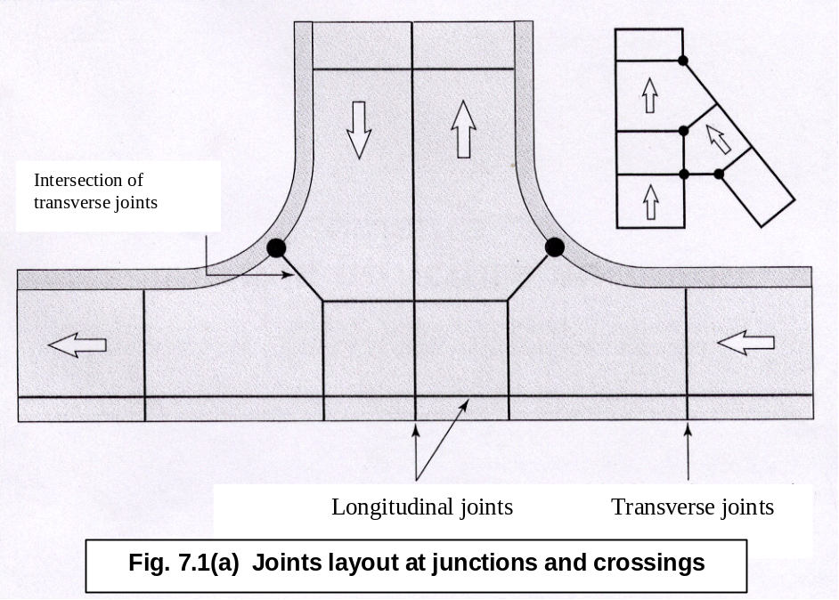
Isolation Joint at Intersection of Transverse Joints

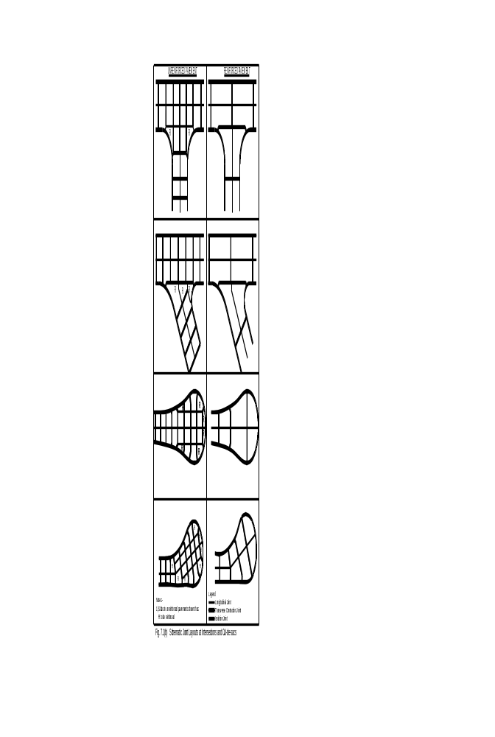

FIG. 7.1(B) Schematic Joint Layouts at Intersections and Cul-de-sacs
(Adapted from Ref. 2)
FIG. 7.1(B) Schematic Joint Layouts at Intersections and Cul-de-sacs
(Adapted from Ref. 2)
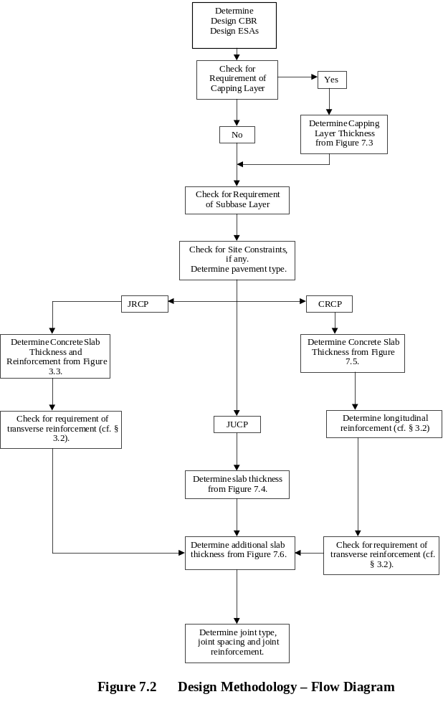Fig. 7.2 Design Methodology – Flow Diagram

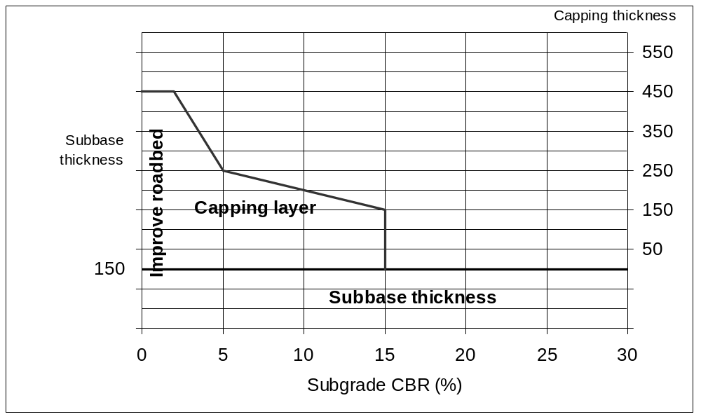
Figure 7.3 Capping Layer and Subbase Thickness design
(Adapted from Ref.8)
mm
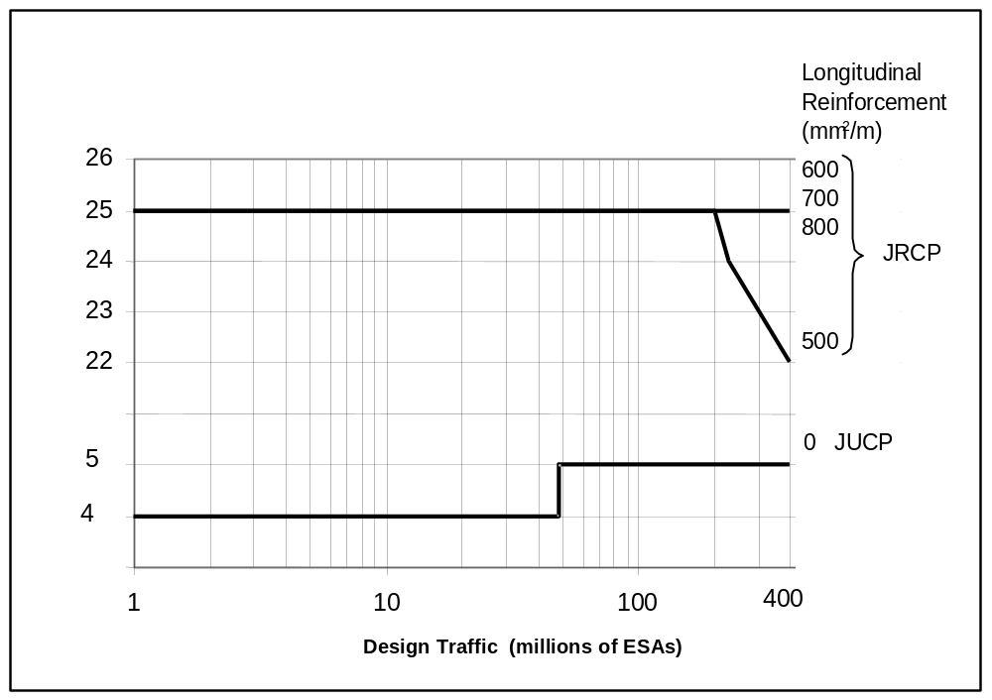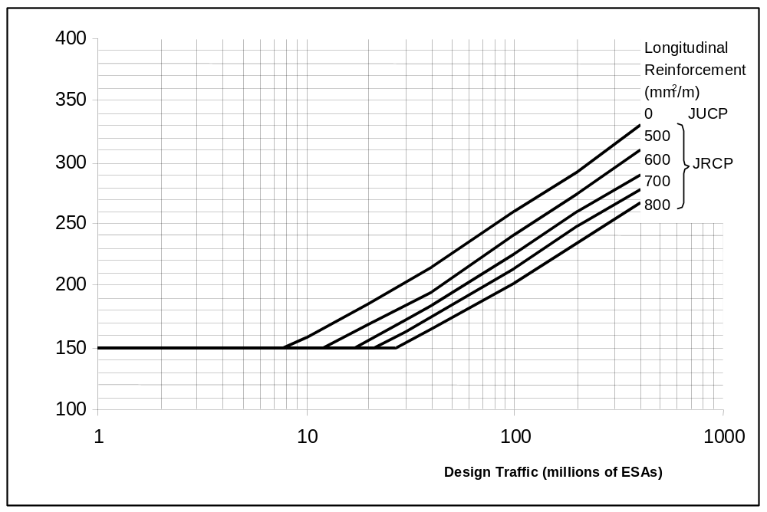
Figure 7.4 Design Thickness and joint spacing for JUCP and JRCP
(Adapted from Ref. 8)
Spacing of Joints (m)
Design tickness of Concrete (mm)
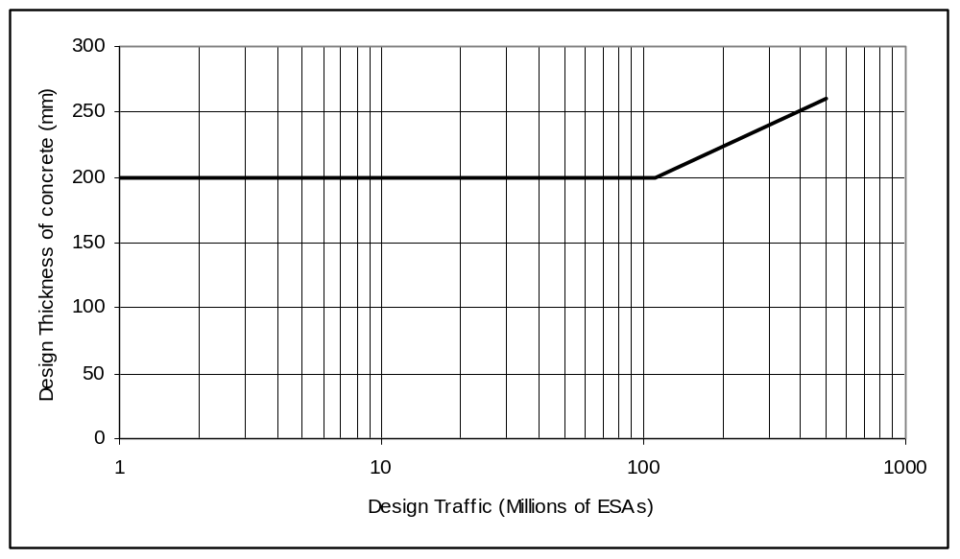
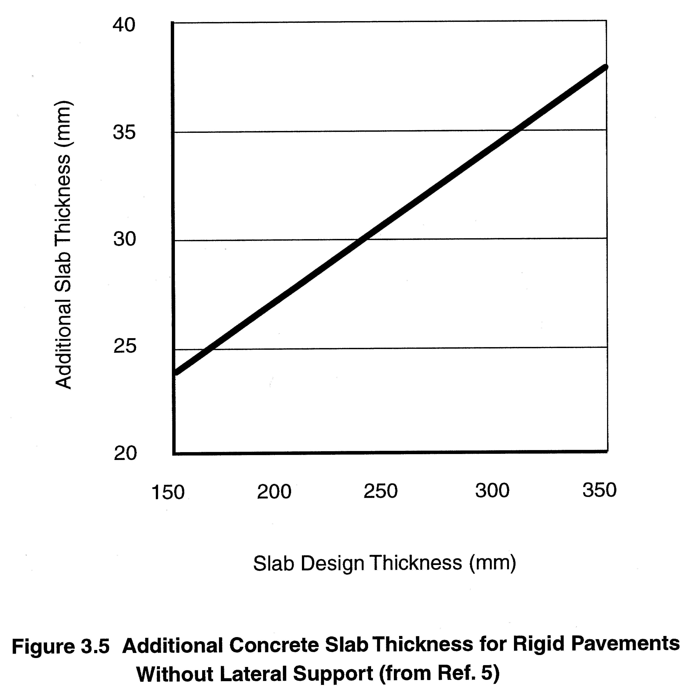
Figure 7.5 Design Thickness for CRCP Pavements
(Adapted from Ref. 8)
Figure 7.6 Additional Concrete Slab Thickness for Rigid Pavements Without Lateral Support
(Adapted from Ref. 8)

8. REFERENCES

- AMERICAN ASSOCIATION OF STATE HIGHWAY and TRANSPORTATION OFFICIALS (1993). AASHTO Guide for Design of Pavement Structures.
- CEMENT AND CONCRETE ASSOCIATION OF AUSTRALIA (1997). Interim Concrete Roads Manual.
- E.J.YODER AND M.W.WITCZAK (1975). Principles of Pavement Design, Second Edition.
- ETHIOPIAN ROADS AUTHORITY (2000). Pavement Design Manual, Volume II, Rigid Pavements.
- HIGHWAYS AGENCY UK (1998). Manual of Contract Documents for Highway Works, Vol. 1: Specification for Highway Works.
- HIGHWAYS AGENCY, UK (1998). Manual of Contract Documents for Highway Works, Vol. 2: Notes for Guidance on the Specification for Highway Works.
- HIGHWAYS AGECY, UK (1998). Manual of Contract Documents for Highway Works, Vol. 3: Highway Construction Details.
- THE DEPARTMENT OF TRANSPORT, London (1997). Design Manual for Roads and Bridges.
- THE DEPARTMENT OF TRANSPORT, PRETORIA (1995). Manual M10, Concrete Pavement Design and Construction.
- TRANSPORT RESEARCH LABORATORY (1993). Road Building in the Tropics. State-of-the- Art Review, No. 9.

Appendix A - Design Example

Design of Rigid Pavement for the following data:

- Design period: 20 years
- Cumulative number of ESAs over the design period (given): 40 x 10⁶
(Refer to Part 1 for details regarding design traffic volume)
- CBR of roadbed material: 8%
- Width of paved carriageway: 7.3 m

Step 1 Check for Capping Layer

Since the CBR value is less than 15%, a capping layer is required.

Referring to Figure 7.3, the required thickness of the capping layer for a subgrade CBR of 8% is 225 mm

Step 2 Subbase

The thickness of the required subbase layer (Cf. § 7.2.1) is 150 mm.

Step 3 Pavement Slab

From Figure 7.4, for a design traffic volume of 40 x 10⁶ ESAs and a longitudinal reinforcement of 500 mm2/m, the thickness of pavement slab required is 200 mm.

Step 4 Joints

From Figure 7.4, the maximum transverse joint spacing is 25 m. Since the thickness of concrete slab is 200 mm [<239 mm, refer to 4.2.1(i)], the dowel bars shall be 20 mm in diameter at 300 mm spacing, 400 mm long.

The conditions are assumed to be such that no transverse reinforcement is deemed necessary. As a result, the maximum longitudinal joint spacing is 4.2 m (7.4.2) and we place one longitudinal joint in the middle of the carriageway, between the two lanes (3.65m each). The tie bars for this slab (<239 mm in thickness) shall be 12 mm in diameter at 600 mm spacing, 750 mm long (4.2.2).

Step 5 Final Design

The pavement cross-section is shown below.

- Longitudinal reinforcement: 500 mm²/m
- Transverse joint spacing: 25 m
- Longitudinal joint spacing: 3.65 m
- Dowels for transverse joints: 20 mm diameter @ 300 mm c/c, 400 mm long
- Tie rods for longitudinal joints: 12 mm diameter @ 600 mm c/c, 750 mm long (4.2.2)

Concrete Slab
200 mm
Subbase
(cement stabilized)

150 mm
Capping layer
225 mm

Roadbed
(CBR 8%)

Rigid Pavement Cross-Section

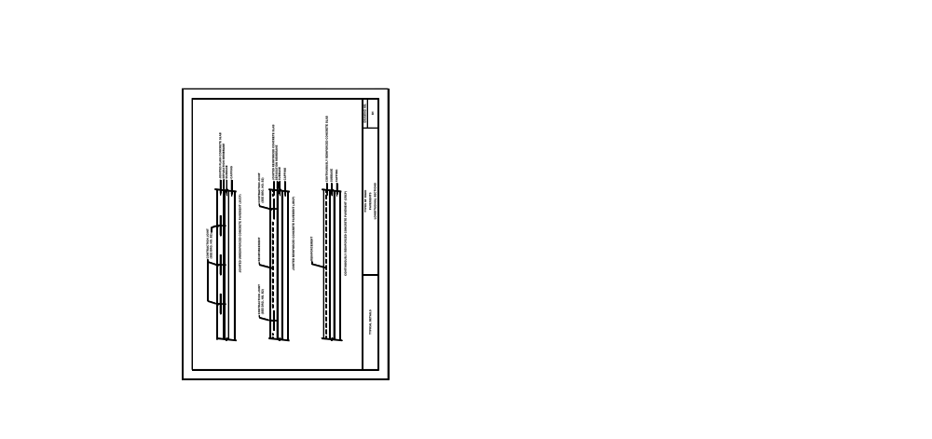
(Adapted from Ref. 7)


(Adapted from Ref. 9)

(Adapted from Ref. 9)
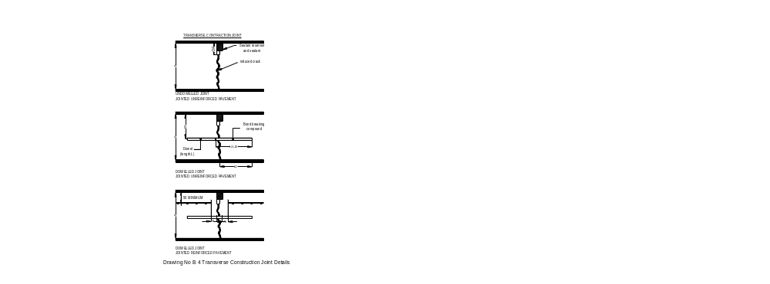
(Adapted from Ref. 2)
Drawing No B 4 Transverse Contraction Joint Details


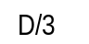
Saw cut or plastic insert
0.2D
in pavements having thickness less than 150mm
Drawing No B 5 Longitudinal Joint Details
(Adapted from Ref. 2)
5R
5R
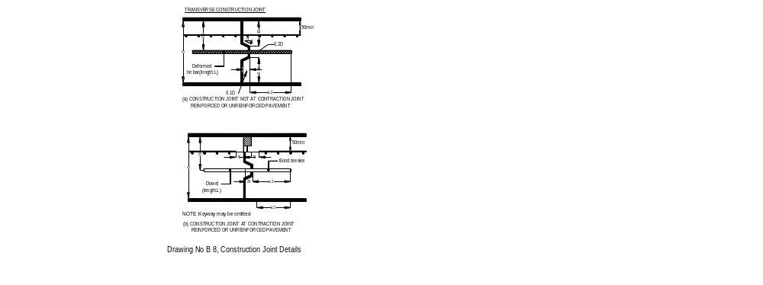

6
2L/3
See drawing B3 (i) or B3 (ii) for detail
in pavements having thickness less than 150mm
(Adapted from Ref. 2)
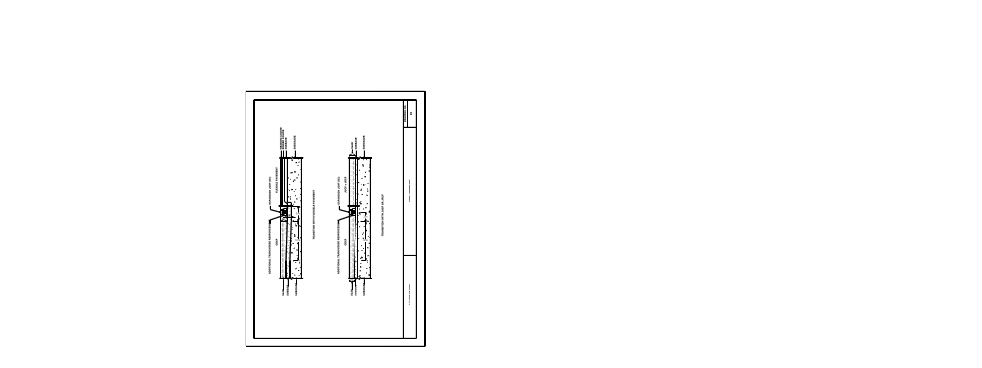

(Adapted from Ref. 7)
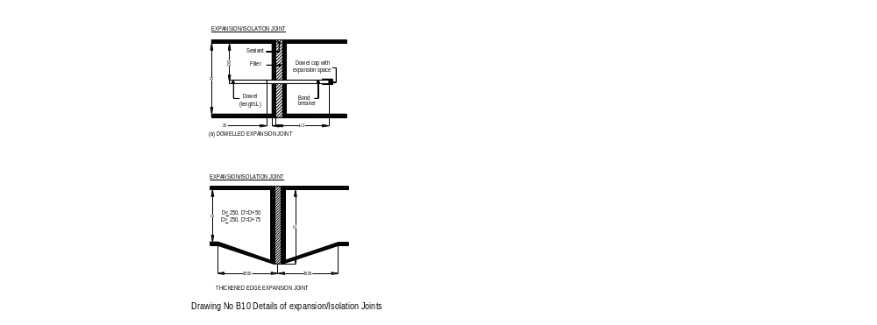

8
Sealant

(Adapted from Ref. 2)
Note: - Expansion joints are normally 20mm wide while isolation joints are normally 10mm wide

