Hybrid Intrusion Detection System Using Supervised and Unsupervised Learning Algorithm

Kalyan Brata Majumder and Karthik Mekala
Supervisor - Professor Anuj Kumar Sirohi
Department of Applied Artificial Intelligence, University of San Diego

Author Note
Data collection was primarily done from CICIDS2017 Kaggle Network Intrusion Data Set. We have no conflict of interest to disclose.

Introduction
In recent years, studies suggest a significant amount of cyber security threats have increased globally specially for systems that keep or process sensitive data/information. With attackers launching an estimated attack every 3 seconds, the maximum number of cyber-attacks happening include large-scale data breaches, critical infrastructure disruption, and sophisticated espionage campaigns. Some alarming issues include data of 815 million Indian citizens stolen and sold on the dark web on 2023; in the very same year 1.5 billion records were exposed due to a non-password-protection. Global cybercrime cost businesses USD 9.22 trillion in 2024, projected to reach USD 13.82 trillion by 2028.
The most common question arises, why firewalls miss threats. Our studies break this into five main reasons- First, Firewalls block traffic, but they cannot stop a user from clicking a malicious link. Second, modern attacks often hide inside HTTPS traffic, unless the firewall is configured with SSL inspection, malicious payloads pass undetected. Third, firewalls monitor external traffic, but internal misuse or access passes through. Fourth, Firewalls rely on known signatures and rules, new exploits can bypass them until patches are applied. Fifth, is a poorly configured firewall, where the gaps are exploited.
To address these limitations, Artificial Intelligence (AI) and machine learning techniques have been introduced into cybersecurity. (Then cite the papers). Criticise them and then tell your part.This allowed systems to detect unknown and evolving attacks, process large volumes of data, and adapt to changing threat landscapes, significantly improving cybersecurity capabilities.
In this project, an ML-based Hybrid Network Intrusion Detection System (IDS) is developed using both supervised and unsupervised learning techniques. Supervised learning algorithms such as Random Forest are used to classify network traffic into benign and malicious categories based on labelled data. Additionally, unsupervised learning techniques such as K-Means clustering are employed to identify anomalous patterns in network traffic, enabling the detection of unknown or emerging threats. This combination of approaches provides a more comprehensive and adaptive solution compared to traditional firewall-based systems.

DATA SUMMARY

This study uses CICIDS2017 dataset obtained from Kaggle, which contains processed network flow features suitable for machine learning analysis. The dataset contains millions of labelled network traffic records with multiple attack types and more than 70 network flow features. Using this dataset, the proposed system will train and evaluate machine learning algorithms to detect and classify network attacks.

- Data Pre-Processing
- Cleaning negative values- Multiple negative data sets (missing, unavailable, or not applicable) were found where few were deleted and rest were set to zero so as to avoid heavy data set loss.
- Column consistency check- Before merging multiple CSV files into a single dataset, it is important to verify that all files share the same column structure. Differences in column names or ordering can lead to incorrect merging and introduce missing values.
- Detection and removal of infinite values- The dataset was examined for the presence of infinite values, which can arise due to division-based feature calculations such as rates (e.g., bytes per second or packets per second). These values typically occur when the denominator in a calculation is zero, leading to undefined or extremely large results. Since infinite values can negatively impact machine learning algorithms and lead to training failures, a preprocessing step is performed to identify and remove them.
- Duplicate column deletion.

- Major challenges in Network Distribution Labels
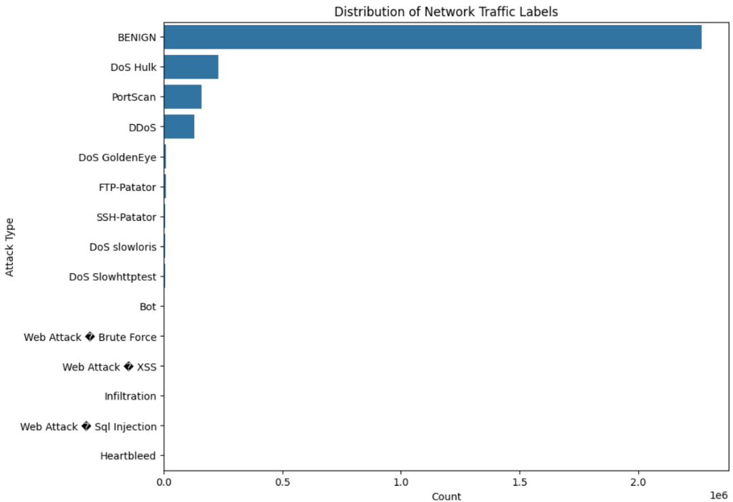
The above figure clearly shows, the dataset is highly imbalanced, with BENIGN traffic dominating the dataset by a very large margin. Among attack types, DoS Hulk, Port Scan, and DDoS have relatively higher occurrences compared to others. Several attack categories such as: Heartbleed, SQL Injection, Infiltration, Web Attacks (XSS, Brute Force)
have extremely low sample counts.

- The imbalance indicates that a model trained directly on this dataset may become biased toward predicting the majority class (BENIGN).
- Rare attack types may be poorly learned or completely ignored by the model.

