Scene look and feel

Scene elements
The scene contains the following elements:
- Items
- Arrange buttons
- Search control (see “Search” spec)
- Playback controls (see “Playback” spec):
- Playback slider
- Playback buttons
- Speed slider
- Volume slider
- View/edit button

Items overview
Along with video item should contain:
- Name
- Basic information (resolution, fps)
- Status icon (online, offline, malfunction etc)
- Recording status icon
- “Take screenshot” button
- “Toggle recording” button
- “Toggle pin” button (edit mode only)
This information should display if hovering with the mouse cursor over an item and hide when the mouse moves out.

Items placement
Scene is divided on cells. Cells have same size and aspect ratio 4:3.
Initially items should be placed in cells. Each cell should contain one item (keeping the item’s AR).
The way items are displayed in cells should fit 4:3 as close as possible.
Ideally it is a rectangle 3x3, 4x4 etc. (4x4 in this case): | If some items are missing, those are subtracted from the bottom row until rectangle (4x3): | Then items are subtracted from the right column until square (3x3):
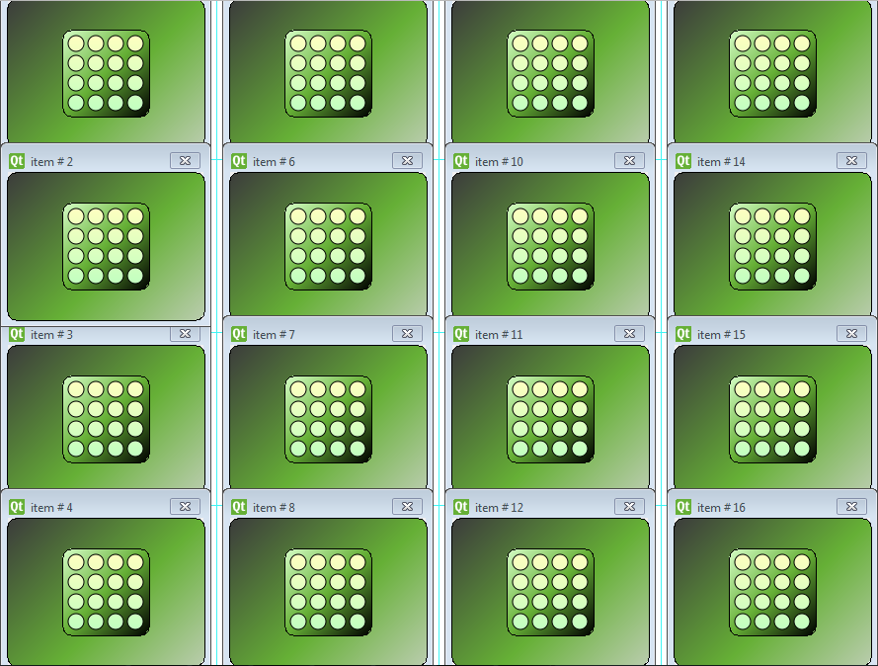 | 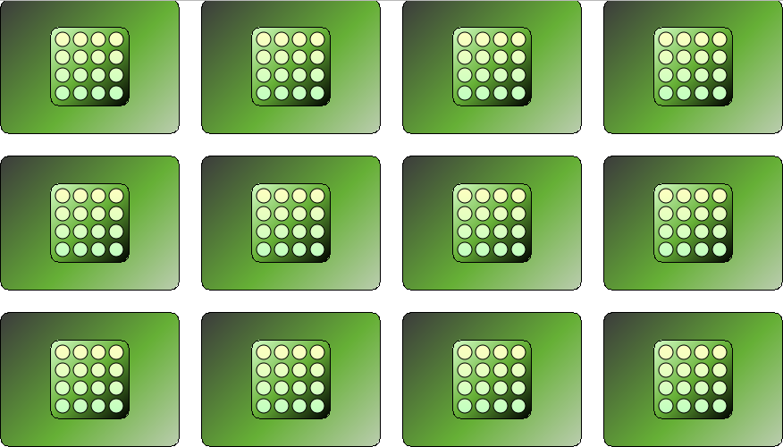 | 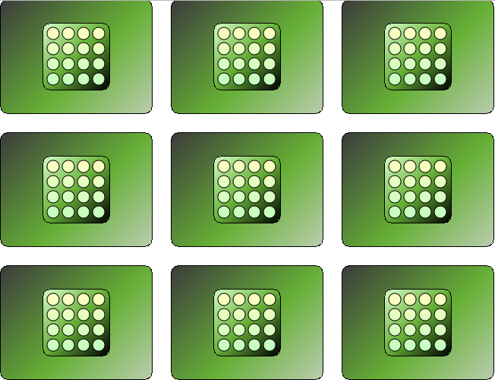
Maximum number of items visible should be specified by system setting. If the number of items exceeds this number, those items are displayed in “preview mode”: the placeholder is displayed however the video is not decoded. Decoding starts if select the video. In this case decoding of the 1st video on the scene is stopped.

Window/fullscreen mode
If switching to window mode and resizing window it is necessary to scale down items in order to display them all. Window can shrink up to XXX x YYY.
This is possible by:
- Context menu item;
- Alt+Enter

Viewing and editing the scene

Toggle view/edit
View mode is designed in order to monitor items on the scene.
Edit mode allows changing the layout.
Modes should be switched by the button or context menu item (T). By default the scene should be in view mode. Mode setting should be stored for each layout.
Operations allowed in view mode:
- Select/unselect an item
- Toggle fullscreen of the selected item
- Rotation (only in fullscreen). If exit to preview mode item must be rotated back to 0 degrees
- Zoom to a position/unzoom
- Save screenshot from a video
- Open a saved layout
- Fit in view
Edit mode provides all possible operations.

Selecting items
Toggle item select/deselect – left click.
If selecting an item it should be resized at n% towards the center of the scene (overriding items near). Next click reverts item’s size and position.
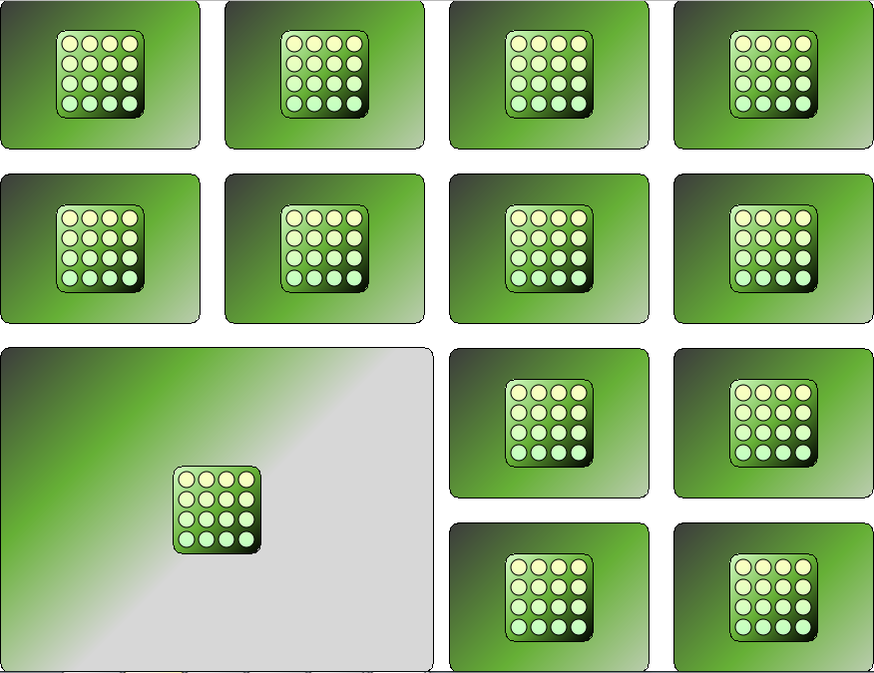
If the item is greater than m% of the screen its size remains the same.
After selecting an item playback is switched to single mode. Deselect reverts playback to group mode (see the “Playback” spec for details).
If item is in “preview mode” (video is not decoding) selection fires decoding video. In this case decoding of the 1st item in the scene is stopped and it turns into “preview mode”.
If an item is selected selection can be moved to closer items using arrow keys (up, down, left, right). If the item is the last in row/column the focus should move to the first item in the next row/column.
Only one item can be selected at a time.

Toggle fullscreen
Fullscreen mode can be applied to any item by double-click or context menu item. Also toggle fullscreen applies to the selected item while pressing Enter.
Fullscreen forces playback to switch to single mode (see the “Playback” spec for details). Arrow keys allows selecting prev/next/upper/lower item for fullscreen viewing (unless zoomed >1x).

Zooming to a position/unzoom and scene dragging
Zoom and scene dragging can be performed both in view and edit mode.
Zoom can be applied to any place of the scene. To zoom in/out mouse wheel up/down or +/- hotkeys are used (zooming to the cursor position).
To revert zoom to 1x:
- “Fit in view” context menu item (Asterisk (*))
- middle mouse button
- double click (only in fullscreen mode).
Initially scene can be dragged by right-clicking and holding right mouse button at any place on the scene and pulling it in any direction. Scene dragging stops if mouse button is released. Dragging should have kinematic effect. If drag N px or less scene does not move and context menu appears when releasing RMB
If dragging a fullscreen zoomed video drag should stop on video’s edges. Also arrow keys can be used to drag fullscreen video.

Adding items to a scene
It is necessary to have the following options:
- Add a single item,
- Add multiple items.
Items can be added by the following ways:
- From the context menu (duplicated by a hotkey)
- Drag and drop (from the tree menu). Multi-selection in tree menu is described in another spec.
- Adding a search criteria
If an item is added to a scene it should appear in cells in order to fit 4:3 as close as possible:
- First items should appear on the left column (until the column is filled);
- Then items should appear on the bottom row (until the row is filled).
If the scene is completely filled (maximum number of items specified in settings is reached) next item should be displayed in “Preview mode”: the placeholder is displayed however the video is not decoded.

Multi-selection
Multi-selection allows performing same operations with different items simultaneously:
- Context menu actions
- Move/switch
- Rotate
- Toggle pin
- Resize
- Close
It can be completed by holding Ctrl and:
- clicking on the desired items
- dragging a selection area
Left click on any place on the scene removes current selection.

Removing single/multiple items from layout
Remove item can be done via context menu (duplicated by a Del hotkey) or “Close” button. If removing an item from a scene its place remains unoccupied.

Toggle pin for an item
Pin applies to a separate item and allows unbinding item from the grid and moving it to any position. Selected item(s) can be pinned/unpinned by:
- Quick button
- Context menu item
- Hotkey (Alt+P)
Pin changes behavior of the following actions:
- Moving
- Rotating
If unpin an item then transform it (move, rotate, resize) and then pin it back pin restrictions should apply and item should move to the free cell near the last one.

Moving items in the grid
View mode – in layout bounds
In order to move an item it is necessary to drag it to desired position and drop there. It is possible to move several items by selecting and then dragging them.
When dragging starts grid cells become visible.
There are two mechanisms of changing items’ position: pinned and unpinned.
- Unpinned: item can be moved to any position (it can override other items).
- Pinned: item can be moved to any position but it fits to the nearest possible cell(s). If the target cell(s) is occupied by pinned items source and target items switch their position. If the target cells contains unpinned items those are overridden.
If trying to switch items with different dimensions (on cells) the following rules apply:
- If dragging a larger item on several small ones:
- If larger item is unpinned it overrides small-ones
- If larger item is pinned it switches with pinned small items and overrides unpinned.
- If dragging a larger item on several small ones:
- If dragging a smaller item on large-one they switch and change their size: larger item becomes smaller, and smaller item becomes larger (pinned). If unpinned source overrides target-one.
- If dragging several smaller items on large-one (all items pinned):
- If the shape of several smaller items is equal to the larger-one, they switch (i.e. larger item occupies 4 cells square and 4 smaller items occupy 4 cells in square)
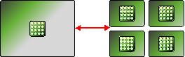
- If not they revert back.
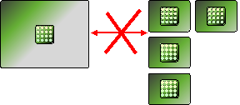
- If dragging several smaller items on large-one (some items unpinned), pinned items revert back, unpinned items override the larger-one.

Rotating Items
Item rotation is performed by Alt+LMB(hold)+mouse drag. Rotation stops if release LMB or Alt.
Rotation is possible both in pinned and unpinned modes:
- Unpinned – item rotates without resizung
- Pinned – if item’s edges are out of bounds of cell Item shrinks in order to fit the cell.
Rotation should have kinematic effect. Item should dock on 0,90,180 and 270 degrees.
In order to rotate video to 0 degrees:
- context menu item can be used (B hotkey)
- middle mouse button.
Rotation of fullscreen video is possible both in view and edit modes. During rotation video’s size doesn’t change. When exit from fullscreen video should revert back to 0 degrees.
Rotation can be applied to several videos using multi-selection. In this case each video is rotated as usual (around its center).

Resizing Items
Resize is done according to item’s proportions in order to save AR. Resize can be done by the following operations:
- dragging item’s corner.
- Selecting items and Ctrl + MwUp/Dn.
Resize algorithm is different in pinned and unpinned mode.
Unpinned mode:
- Resize is done placing the resized item over nearby ones.
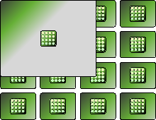
Pinned mode:
- Item should fit in cells after resize.
- Nearby items (pinned) are moved to any free cell. Unpinned items are overridden by resized-one.
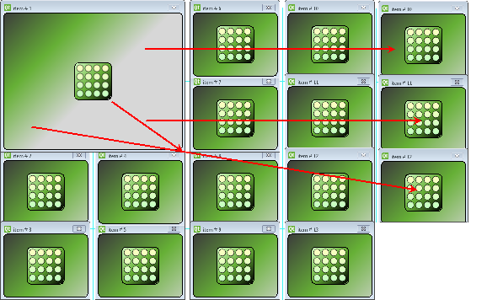

Fit in view
Fit in view applies to all items in order to display them all. Fit in view keeps all position, size and orientation changes made.
Fit in view can be performed by the following ways:
- Context menu item (duplicated by asterisk (*) hotkey),
- Double-click on the empty area on the scene.
If the number of items exceeds maximum number specified in settings, those items are displayed in “preview mode”: the placeholder is displayed however the video is not decoded.

Changing the distance between items
This feature is implemented by shrinking/enlarging cells bounds. All bounds are resized simultaneously keeping aspect ratio. Items’ size remains the same.
This can be done by holding Ctrl (grid appears) and drag cell borders:
- If drag right or down cells are increasing
- If drag left or up cells are decreased

Z-order
Sometimes items overrides each other and lower item is not accessible. For this purpose it is necessary:
Keep Z-order of each item
- Allow to change Z-order of an item:
- “Bring to front” or … hotkey
- Send to back or … hotkey

Arrange modes
Arrange modes allows returning predefined items’ position and default orientation (0 degrees) and size. Each mode displays as a button at top right corner of the scene.
Each mode can be available depending of the number of items and its size.
There is several predefined arrange modes.
- 1 cell – 1 item. This is initial arrange mode and it is described at the beginning of the document. It is always available.
- …

Saving and Restoring layouts

Save
Layout should be saved by the following ways:
- “Save layout as…” context menu item or Ctrl+Shift+S hotkey. The dialog should appear. Dialog contains all available layouts and input box for the layout name.
- “Save layout” context menu item or Ctrl+S hotkey. If layout is saved for the first time it is necessary to open “Save layout as…” dialog. Next saves should be performed without prompt.
The following scene information should be saved on layout:
- Items
- Items’ size
- Items’ position
- Items’ rotation
- Z-order
- Pin status for items
Saved Layouts should be stored on server and be accessible from any client.

Load
Open a saved layout can be performed by “Open Layout” context menu item or Ctrl+L hotkey. If layout is opened all current items on the scene should be erased.

Undo/Redo
Each action with items on the scene should be reverted back and repeated if necessary. History should be stored locally in the temporary subfolder in Eve installation root.
History should be stored for each layout independently. Undo history should be erased when Eve is closed.
Undo/redo is performed via context menu items or Ctrl+Z/Ctrl+Shift+Z.

Saving screenshots from video items
Save screenshot is initiated:
- By context menu item (duplicated by … hotkey)
- By quick button displayed on the item.
Standard “Save as” dialog window opens for screenshot saving.
PNG and JPG file formats should be supported for saving.

