NetXMS
Installation Guide

Table of Contents

Table of Contents 3
1 Preface 5
1.1 Audience 5
1.2 Additional Documentation 5
2 Requirements 7
2.1 Server Requirements 7
2.1.1 Hardware 7
2.1.2 Operating System 7
2.1.3 Database 7
2.2 Console Requirements 7
2.2.1 Hardware 7
2.2.2 Operating System 8
2.3 Agent Requirements 8
2.3.1 Hardware 8
2.3.2 Operating System 8
3 Server Installation and Upgrade 9
3.1 Installing NetXMS Server on UNIX 9
3.2 Upgrading NetXMS Server on UNIX 12
3.3 Installing NetXMS Server on Windows 13
3.4 Upgrading NetXMS Server on Windows 18
4 Console Installation 19
4.1 Installing NetXMS Console 19
4.2 Connecting to the NetXMS Server for the first time 20
5 Agent Installation and Upgrade 21
5.1 Installing NetXMS Agent on UNIX 21
5.2 Upgrading NetXMS Agent on UNIX 22
5.3 Installing NetXMS Agent on Windows 23
5.4 Upgrading NetXMS Agent on Windows 25
5.5 Unattended installation of NetXMS Agent on Windows 26
5.6 Installing NetXMS Agent on NetWare 27
5.7 Upgrading NetXMS Agent on NetWare 28

Preface

This manual provides instructions for installing NetXMS components for UNIX, Windows, and NetWare.

Audience

This manual is intended for network administrators, responsible for NetXMS deployment and maintenance. The person installing NetXMS components must have a working knowledge of the appropriate operating system (UNIX, Windows, or NetWare).

Additional Documentation

For information on topics not covered in this manual, please see NetXMS User's Manual or Documentation section on NetXMS web site (http://www.netxms.org/documentation).

Requirements

Read this chapter and perform a thorough review of the system or systems onto which you are planning to install NetXMS software. The system/s must meet software, hardware, and configuration requirements listed in this chapter.

Server Requirements

Hardware

Minimum requirements: Pentium III 500 MHz, 256MB RAM, 100MB of free disk space.
Recommended: Pentium IV 1 GHz, 512MB RAM, 100MB of free disk space.

For non-Intel platforms, adequate hardware should be used.

Operating System

Server can run on the following operating systems:
- Linux
- FreeBSD
- Windows 2000, Windows XP, Windows Server 2003
- Solaris 8, 9 (Solaris 10 was not tested yet)

If you wish to compile NetXMS server with encryption support on UNIX, you should have OpenSSL package installed.

Database

The following database engines can be used as a backend:
- Microsoft SQL
- Oracle
- MySQL
- PostgreSQL
- SQLite

Database size and load is very hard to predict, because it is dependent on a number of monitored nodes and collected parameters. If you plan to install database engine on the same machine as NetXMS server, increase your hardware requirements accordingly.

Console Requirements

Hardware

Minimum requirements: Pentium III 500, 256 MB RAM, 30 MB of free disk space.
Recommended: Pentium IV 1GHz, 512 MB RAM, 30 MB of free disk space, video adapter capable of at least 1024x768 resolution with 32bit colors.

Operating System

NetXMS Console can run on Windows 2000, Windows XP, and Windows Server 2003. You can also run console on Linux under WINE (see http://www.winehq.com for more information).

Agent Requirements

Hardware

NetXMS agent can run on any hardware supported by target operating system, and requires approximately 1 MB of free disk space (depending on OS).

Operating System

NetXMS agent can be run on the following operating systems:
- Windows 95/98, NT 4.0, Windows 2000, Windows XP, Windows Server 2003
- Linux
- FreeBSD
- OpenBSD
- Solaris
- AIX
- Novell NetWare 5.1 SP3, 6.0, 6.5

Server Installation and Upgrade

Installing NetXMS Server on UNIX

- Download the latest version from http://www.netxms.org/download, if you don't have it. You will need source archive (named netxms-VERSION.tar.gz, for example netxms-0.2.11.tar.gz). Please note that in the following steps VERSION will be used as a substitution for an actual version number.

- Unpack the archive:
$ tar zxvf netxms-VERSION.tar.gz

- Change directory to netxms-version and run configure script:
$ cd netxms-VERSION
$ sh ./configure --with-server --with-mysql --with-agent

Important arguments:
- --prefix=DIRECTORY: installation prefix, all files go to the specified directory;
- --with-server: build server. Don't forget to add at least one DB Driver as well;
- --with-pgsql: build Postgres DB Driver (if you plan to use PostgreSQL as backend database);
- --with-mysql: build MySQL DB Driver (if you plan to use MySQL as backend database);
- --with-odbc: build ODBC DB driver (if you plan to connect to your backend database via ODBC; you will need UNIX ODBC package to do that);
- --with-agent: build monitoring agent. It is strongly recommended to install agent on a server box;
- --with-nxhttpd: build NetXMS web server.

To learn more about possible configure parameters, run it with --help option.

- Run make and make install:
$ make
$ make install

- Copy sample config files to desired locations:
$ cp contrib/netxmsd.conf-dist /etc/netxmsd.conf
$ cp contrib/nxagentd.conf-dist /etc/nxagentd.conf
By default, both server and agent will look for configuration files in /etc directory. If you wish to place configuration files in a different location, don't forget to use –c command line switch for agent and –config-file command-line switch for server to specify an alternate location.

- Create Database and User with access rights to this database. Below is an example for MySQL:
$ mysql -U root -p mysql
mysql> CREATE DATABASE netxms;
mysql> GRANT ALL ON netxms.* TO netxms IDENTIFIED BY 'PaSsWd';
mysql> \q
Please note that database that user you have created should have rights to create new tables.

- Modify server configuration file (default is /etc/netxmsd.conf). It should look the following way:
DBDriver = /usr/local/lib/libnxddr_mysql.so
DBServer = localhost
DBName = netxms
DBLogin = netxms
DBPassword = PaSsWd
LogFile = /var/log/netxmsd
LogFailedSQLQueries = yes

Description of configuration parameters:

DBDriver
Database driver to be used. You can use one of the following drivers:

libnxddr_mysql.so | Driver for MySQL database.
libnxddr_pgsql.so | Driver for PostgreSQL database.
libnxddr_odbc.so | ODBC connectivity driver (you can connect to MySQL, PostgreSQL, MS SQL, and Oracle via ODBC).
libnxddr_sqlite.so | Driver for embedded SQLite database.

If you installed NetXMS with non-default prefix (default is /usr/local), you should change the path to database driver appropriately.

DBServer
Database server to connect to (for ODBC driver, name of ODBC source).

DBName
Database name.

DBLogin
Database user name.

DBPassword
Database user's password.

LogFile
Server's log file. To write a log to syslog (or Event Log on Windows), use {syslog} as file name.

LogFailedSQLQueries
Controls logging of failed SQL queries. Possible values are "yes" (default) or "no". It is recommended to keep this parameter set to "yes" to simplify diagnostics of database-related problems and bugs.

- Modify agent's configuration file (/etc/nxagentd.conf). For detailed description of possible parameters, please consult NetXMS User's Manual. For the normal server's operation, you should add at least the following line to your agent's configuration file:

MasterServers = 127.0.0.1, your_server_IP_address

- Initialise this database using sql-script in sql/dbinit_DBTYPE.sql. DBTYPE can be "mssql", "mysql", "pgsql", "oracle", or "sqlite".

MySQL example:
$ mysql -u netxms -p netxms < /usr/local/share/netxms/sql/dbinit_mysql.sql

You can also use nxdbmgr utility to initialize database:
$ /usr/local/bin/nxdbmgr init /usr/local/share/netxms/sql/dbinit_mysql.sql

Run agent and server:
# /usr/local/bin/nxagentd –d
# /usr/local/bin/netxmsd

Now you have working NetXMS server.

Upgrading NetXMS Server on UNIX

- Download the latest version from http://www.netxms.org/download, if you don't have it. You will need source archive (named netxms-VERSION.tar.gz, for example netxms-0.2.11.tar.gz). Please note that in the following steps VERSION will be used as a substitution for an actual version number.

- Unpack the archive:
$ tar zxvf netxms-VERSION.tar.gz

- Change directory to netxms-version and run configure script:
$ cd netxms-VERSION
$ sh ./configure --with-server --with-mysql --with-agent
Be sure to include all options that were used at installation time.

- Run make:
$ make

- Stop NetXMS server.

- Stop NetXMS agent.

- Check database for possible inconsistencies:
$ nxdbmgr check

Proceed to the next step only if database checker does not report any errors!

- Run make install:
$ make install

- Upgrade database:
$ nxdbmgr upgrade

- Start NetXMS agent.

- Start NetXMS server.

Installing NetXMS Server on Windows

- Download the latest version from http://www.netxms.org/download, if you don't have it. You will need Windows installer (named netxms-VERSION.exe, for example netxms-0.2.11.exe). Please note that in following steps VERSION will be used as a substitution for an actual version number.

- Run the installer package on your server machine. Installation wizard will be shown. Follow the prompts until the Select Components window opens (Figure 1).

- On the Select Components window, select NetXMS Server option and an appropriate database client library. You do not have to install database client library from NetXMS package, if it is already installed on the machine.
Figure 1: Select Components window
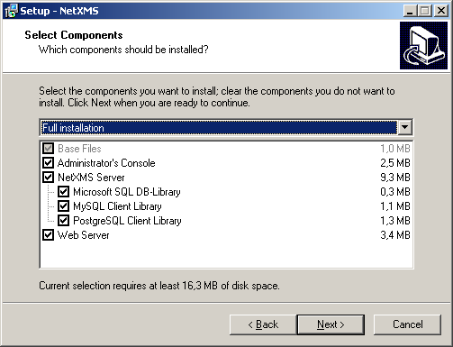

If you plan to use web interface, also select Web Server component, and if you plan to run NetXMS console from the same machine, select Administrator's Console option as well.

- Follow the prompts until Ready to Install window opens. If the Web Server option was selected, you will be prompted for master server address. Set it to localhost (Figure 2):
Figure 2: Master server address set up
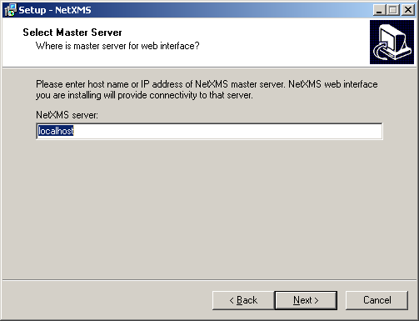

- On Ready to Install window, check whether everything is correct, then press the Install button.

- After copying files, Server Configuration Wizard will open (Figure 3).
Figure 3: Server Configuration Wizard
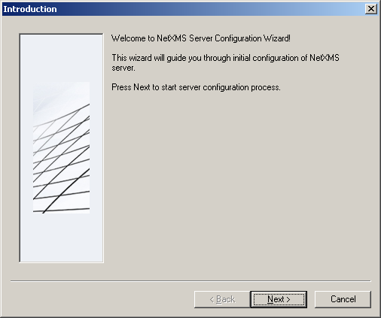

Press the Next button to start NetXMS server configuration.

- Database selection window will open (Figure 4):
Figure 4: Select Database window
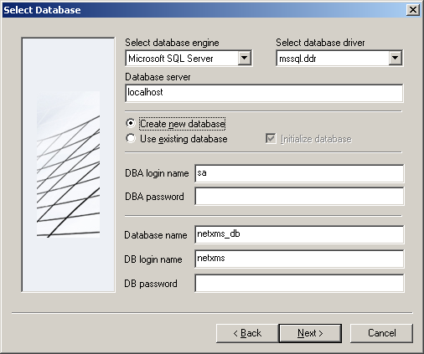

- Select the desired database engine and driver. For most databases, you will have two drivers available – native and ODBC. Please note that if you select ODBC, you will have to manually configure ODBC source.
- Enter the name of database server or ODBC source.
- In DBA login name and DBA password fields, enter database administrator’s login name and password. You have to fill these fields only if you have chosen Create new database option.
- Enter the desired database name, database user name and password. If you are not using ODBC, the wizard will create database and a user for you. If ODBC is used, database and user should be created beforehand.

Microsoft SQL note:
If you wish to use Windows authentication for database connectivity, use * (asterisk) as a login name and leave the password field blank. If you specify asterisk as DBA login, user with which you are logged in to Windows should have administrative rights to the database server. If you use asterisk as DB login, you should run NetXMS Server service as a user with appropriate rights to the database.

- On the next window, you will be prompted for various polling parameters (Figure 5):
Figure 5: Polling Configuration window
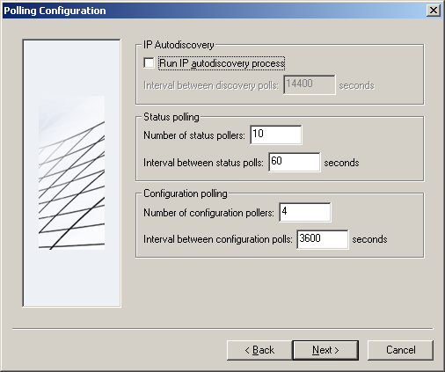

- Check Run IP autodiscovery process check-box, if you wish NetXMS server to automatically discover your IP network.
- Increase number of status and configuration pollers if you plan to monitor large number of nodes.

- On the next window, enter address of your SMTP server. NetXMS will use it to send notification e-mails. If you have mobile phone attached to management server via serial cable or USB, select mobile phone driver and COM port; otherwise, select "<none>".

- Then next window will prompt you for logging method. Either check Event Log or select file, and press the Next button.

- Windows service configuration window will appear (Figure 6):
Figure 6: Windows Service Configuration window
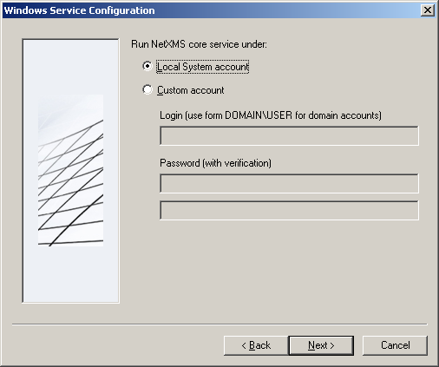

In most situations, you can run NetXMS server as the Local System account. You may need to run it under specific account if you are using Microsoft SQL database and Windows authentication, or for security reasons.

- Follow the prompts until server configuration will be complete. After successful server configuration, installation will be finished, and you will have NetXMS server up and running.

Upgrading NetXMS Server on Windows

- Download the latest version from http://www.netxms.org/download, if you don't have it. You will need Windows installer (named netxms-VERSION.exe, for example netxms-0.2.11.exe).

- Stop NetXMS server.

- Check database for possible inconsistencies:
C:\NetXMS\bin> nxdbmgr check

Proceed to the next step only if database checker does not report any errors!

- Run NetXMS installer and follow the prompts. Normally, you will not need to change any settings on installation wizard windows. Alternatively, you can run the installer with /SILENT option to disable any prompts:
C:\Download> netxms-0.2.11.exe /SILENT

- Check whether NetXMS Server service is running again. If it's not, most likely you have to upgrade your database to newer version. To upgrade database, use nxdbmgr utility:
C:\NetXMS\bin> nxdbmgr upgrade

- Start NetXMS server, if it is not already started.

Console Installation

Installing NetXMS Console

- Download the latest version from http://www.netxms.org/download, if you don't have it. You will need Windows installer (named netxms-VERSION.exe, for example netxms-0.2.11.exe).

- Run the installer package on your workstation. Installation wizard will be shown. Follow the prompts until the Select Components window (Figure 7) opens.

- On the Select Components window, select the Administrator's Console option.
Figure 7: Select Components window
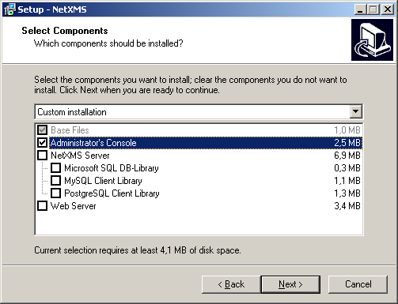

Press the Next button and follow the prompts until installation finishes.

Connecting to the NetXMS Server for the first time

After you have successfully installed NetXMS Server and Management Console, you are ready to start working with NetXMS.

- Run console; login dialog will appear (Figure 8):
Figure 8: Login dialog window
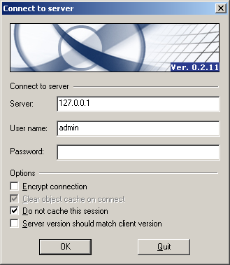

- Enter the address of your NetXMS server, or leave the default address (127.0.0.1), if you are starting console on the server machine. Use admin as login name and netxms as password.

Agent Installation and Upgrade

Installing NetXMS Agent on UNIX

- Download the latest version from http://www.netxms.org/download, if you don't have it. You will need source archive (named netxms-VERSION.tar.gz, for example netxms-0.2.11.tar.gz). Please note that in the following steps VERSION will be used as a substitution for an actual version number.

- Unpack the archive:
$ tar zxvf netxms-VERSION.tar.gz

- Change directory to netxms-version and run configure script:
$ cd netxms-VERSION
$ sh ./configure --with-agent

Important arguments:
- --prefix=DIRECTORY: installation prefix, all files goes to specified directory;
- --with-agent: build monitoring agent.

To learn more about possible configure parameters, run it with --help option.

- Run make and make install:
$ make
$ make install

- Copy sample config file to desired location:
$ cp contrib/nxagentd.conf-dist /etc/nxagentd.conf

By default, an agent will look for configuration file in /etc directory. If you wish to place configuration file in different location, don't forget to use –c command line switch to specify alternate location.

- Modify agent's configuration file (/etc/nxagentd.conf). For detailed description of possible parameters, please refer to NetXMS User's Manual. At least, you should set the following parameters:
MasterServers = your_management_server_IP_address
LogFile = log_file
FileStore = place_for_agent_temporary_files

- Run agent:
# /usr/local/bin/nxagentd –d

- Now you have a working NetXMS agent.

Upgrading NetXMS Agent on UNIX

We highly recommend using centralized agent upgrade feature for agent upgrades. However, if you decide to upgrade an agent manually, it can be done in just a few steps:

- Download the latest version from http://www.netxms.org/download, if you don't have it. You will need source archive (named netxms-VERSION.tar.gz, for example netxms-0.2.11.tar.gz). Please note that in the following steps VERSION will be used as a substitution for an actual version number.

- Unpack the archive:
$ tar zxvf netxms-VERSION.tar.gz

- Change directory to netxms-version and run configure script:
$ cd netxms-VERSION
$ sh ./configure --with-agent

Important arguments:
- --prefix=DIRECTORY: installation prefix, all files go to a specified directory;
- --with-agent: build monitoring agent.

To learn more about possible configure parameters, run it with --help option.

- Run make:
$ make

- Stop NetXMS agent.

- Run make install:
$ make install

- Start NetXMS agent.

Installing NetXMS Agent on Windows

- Download the latest version from http://www.netxms.org/download, if you don't have it. You will need Windows Agent installer (named nxagent-VERSION.exe, for example nxagent-0.2.11.exe).

- Run the installer package on target server. Installation wizard will be shown. Follow the prompts until the NetXMS Server window opens (Figure 9):
Figure 9: NetXMS Server window
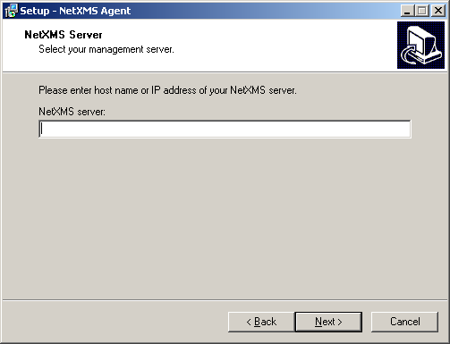

Enter IP address or host name of your NetXMS server. You can specify multiple management servers, separating them by commas. Press the Next button to continue.

- Subagent Selection window will open (Figure 10):
Figure 10: Subagent Selection window
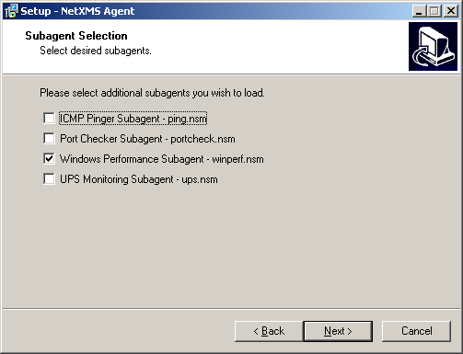

On this window, you can select which subagents you wish to load. Each subagent extends agent's functionality, as described below:

ping.nsm | Adds possibility to send ICMP pings from monitored host. Ping round-trip times can be collected by management server.
portcheck.nsm | Adds possibility to check network services (like FTP or HTTP) from monitored host.
winperf.nsm | Adds access to Windows performance counters. This subagent is required if you need to collect CPU utilization from monitored host.
ups.nsm | Adds support for UPS monitoring. UPS can be attached to host via serial cable or USB.

For more information about subagents, please refer to NetXMS User's Manual.

- Follow the prompts to complete the installation.

Upgrading NetXMS Agent on Windows

We highly recommend using centralized agent upgrade feature for agent upgrades. However, if you decide to upgrade agent manually, it can be done in just a few steps:

- Download the latest version from http://www.netxms.org/download, if you don't have it. You will need Windows Agent installer (named nxagent-VERSION.exe, for example nxagent-0.2.11.exe).

- Run NetXMS agent installer and follow the prompts. Normally, you will not need to change any settings on installation wizard dialog windows. Alternatively, you can run installer with /SILENT option to disable any prompts:
C:\Download> nxagent-0.2.11.exe /SILENT

Unattended installation of NetXMS Agent on Windows

Windows Agent installer (named nxagent-VERSION.exe, for example nxagent-0.2.13.exe), has various command line options for unattended installation. These options are following:

/SILENT |  | Don't show installation wizard, only a progress bar;
/VERYSILENT |  | Don't show anything;
/SUPPRESSMSGBOXES |  | Don't ask user anything;
/DIR=path |  | Set installation directory (default is C:\NetXMS);
 | /SERVER=address |  | Set address of master server (will be written to generated agent's configuration file as value for MasterServers parameter);
 | /SUBAGENT=name |  | Enable subagent name;
 | /NOSUBAGENT=name |  | Disable subagent name;

Valid subagent names are PING, PORTCHECK, WINPERF, and UPS. By default WINPERF is enabled and all others are disabled.
For example, to install agent silently (without any messages or progress bars), use Windows Performance and UPS management subagents, and set NetXMS management server address to 10.0.0.1, run the following command (it should be on one line):

C:\> nxagent-0.2.13.exe /VERYSILENT /SUPPRESSMSGBOXES /SERVER=10.0.0.1 /SUBAGENT=UPS

Installing NetXMS Agent on NetWare

- Download the latest version from http://www.netxms.org/download, if you don't have it. You will need archive with precompiled NetWare binaries (named netxms-VERSION-netware-binaries.tar.gz, for example netxms-0.2.13-netware-binaries.tar.gz).

- Unpack arcive to the desired location on your NetWare server, for example, SYS:NetXMS.

- Copy sample configuration file to desired location. By default, an agent will look for configuration file in SYS:/etc directory. If you wish to place configuration file in different location, don't forget to use –c command line switch to specify alternate location.

- Modify agent's configuration file (by default, SYS:/etc/nxagentd.conf). For detailed description of possible parameters, please refer to NetXMS User's Manual. At least, you should set the following parameters:
MasterServers = your_management_server_IP_address
LogFile = log_file
FileStore = place_for_agent_temporary_files

- Add the following line to your autoexec.ncf:
LOAD install_dir/NXAGENTD.NLM
If you agent's configuration file located in directory other than SYS:/etc, specify it on command line:
LOAD install_dir/NXAGENTD.NLM –c config_file
This will ensure automati agent loading on server startup.

- Load NetXMS agent by typing command used in previous paragraph on server console to load NetXMS agent.

Upgrading NetXMS Agent on NetWare

- Download the latest version from http://www.netxms.org/download, if you don't have it. You will need archive with precompiled NetWare binaries (named netxms-VERSION-netware-binaries.tar.gz, for example netxms-0.2.13-netware-binaries.tar.gz).

- Stop NetXMS agent by entering the following command on server console:
UNLOAD NXAGENTD.NLM

- Unpack arcive to the directory on your NetWare server where NetXMS agent currently installed.

- Start NetXMS agent by entering the following command on server console:
LOAD install_dir/NXAGENTD.NLM
If you agent's configuration file located in directory other than SYS:/etc, specify it on the command line:
LOAD install_dir/NXAGENTD.NLM –c config_file

