Start TYPO3 Responsive!
Start TYPO3 Responsive! (start) extends TYPO3 with the responsive framework Foundation (Zurb), a dozen responsive Backend Layouts and some responsive Grid Elements. It enables editors, to create responsive nested layouts within a few minutes. It extends some backend forms for controlling the display of content elements depending on devices like smartphones, tablets and desktops. It extends TYPO3 content elements and menus with some helpful responsive Foundation features. A template for a responsive newsletter is included.



Version: 2.4.0, 2016-01-04
Extension Key: start
Language: en
Keywords: framework, responsive, foundation, backend, layouts, zurb, grid
Copyright 2014-2016, Dirk Wildt - Die Netzmacher, <http://wildt.at.die-netzmacher.de>

This document is published under the Open Content License available from http://www.opencontent.org/opl.shtml
The content of this document is related to TYPO3 a GNU/GPL CMS/Framework available from www.typo3.org
Table of Contents
Start TYPO3 Responsive! 1
Screen Shots 3
Frontend 3
Backend 4
Introduction 6
What does it do? 6
What do you need? 6
Audience 6
Installation 7
Configuration 8
Foundation Framework (cb_foundation) 8
Start TYPO3 Responsive! (start) 8
Grid Elements 9
First Steps 10
Pages 10
Backend Layout 10
Next Steps 10
Features and Samples 11
Backend Layouts 11
Navigation 12
Grid Layout 14
Panel 15
Callout 15
Modal 16
RTE-Editor 17
Visibility classes 17
Flexible Video 17
Responsive Newsletter 18
Requirements 18
TypoScript 18
Backend Layout 19
Header and Footer 19
Content 19
User Interface: Constant Editor 20
START - COMPRESS CSS AND JSS 20
START – CONFIG* 20
START – FAVICON 21
START - FOUNDATION – BREADCRUMBS 21
START - FOUNDATION – GMENU 21
START - FOUNDATION – ICONBAR 21
START - FOUNDATION – ICONBAR START 22
START - FOUNDATION – TOPBAR 22
START – PAGES* 23
START - SEARCH ENGINE OPTIMISATION 23
START – TEMPLATES* 23
Reference 24
Start [1] 24
Start [1] +Gridelements 29
Start [2] Foundation 30
Start [2] +Foundation Icons 3 38
Start [8] +E-Mail 39
Start [9] Debug 45
Adapt Start to your needs 46
CSS 46
HTML 46
Helpful suggestions and benefits 47
Forum 47
Packages for Sponsors 48
Fun – 50 EUR 48
Logo – 150 EUR 48
Patron – 500 EUR 48
Further Information 49
Website 49
Manual in PDF 49
Development 49
Responsive Framework Foundation 49
Professional Support 49
Credits 49
Other extensions published by Die Netzmacher 50
Known Bugs 51
Change Log 52
Illustration index 55
Alphabetical Index 56

Screen Shots

Frontend

Desktop
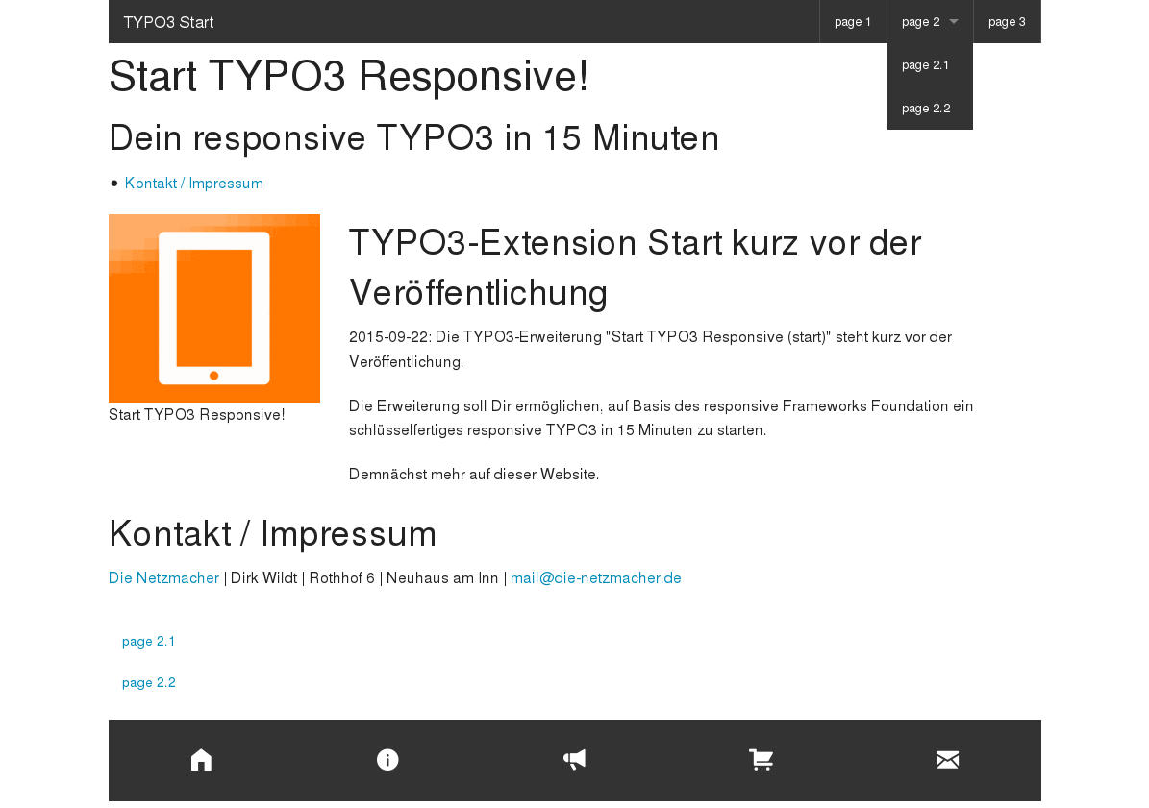Illustration 1: http://start-typo3-responsive.de/
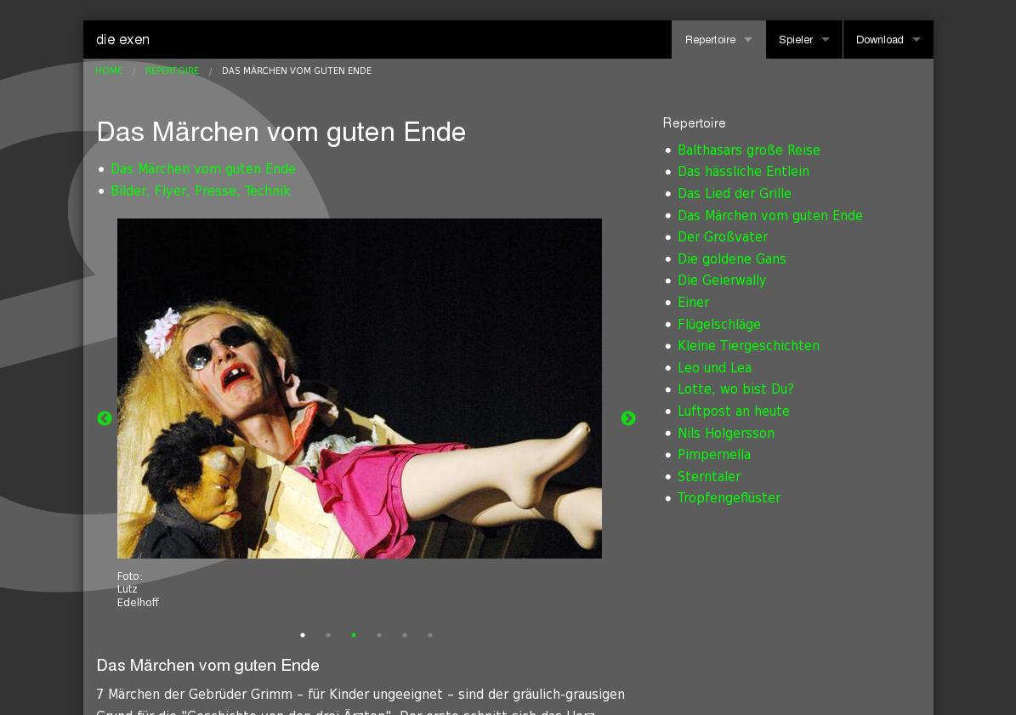Illustration 2: http://die-exen.de/
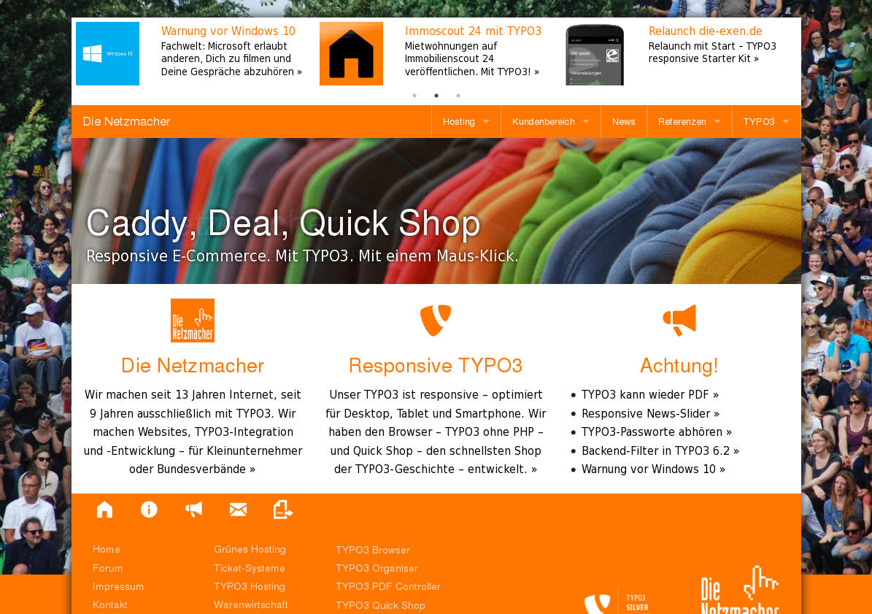Illustration 3: http://die-netzmacher.de/
Illustration 4: http://neukoellner-talente.de/
Samples with the default Foundation CSS only (start-typo3-responsive.de) and with the extension Start TYPO3 Responsive Customer (startcustomer) additionally.

Smartphone
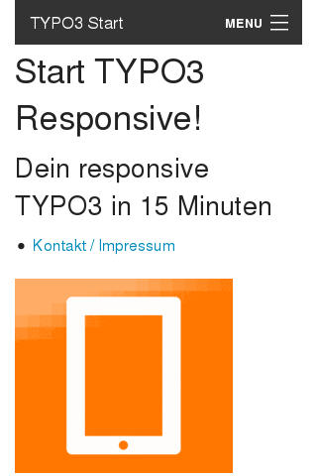Illustration 5: http://start-typo3-responsive.de/
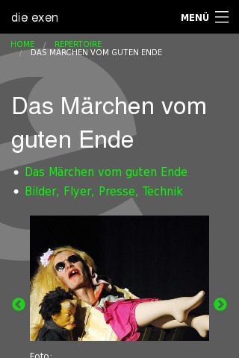Illustration 6: http://die-exen.de/
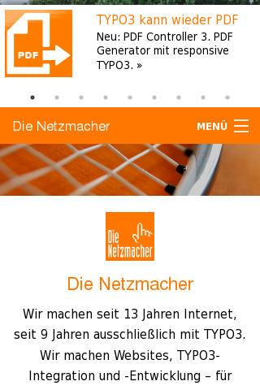Illustration 7: http://die-netzmacher.de/
Illustration 8: http://neukoellner-talente.de/
Samples with the default Foundation CSS only (start-typo3-responsive.de) and with the extension Start TYPO3 Responsive Customer (startcustomer) additionally.

Backend

User Interface
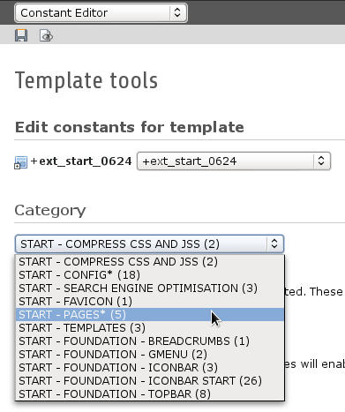Illustration 9: User interface with 11 forms
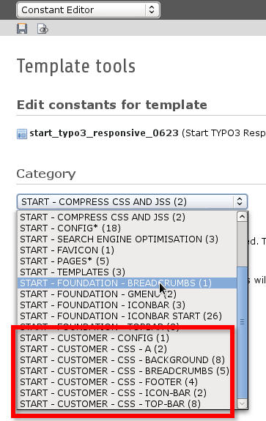Illustration 10: Extended user interface
Start TYPO3 Responsive! (start) adds 11 forms to the TypoScript user interface of TYPO3.
The extension Start TYPO3 Responsive Customer (startcustomer) adds seven forms more.
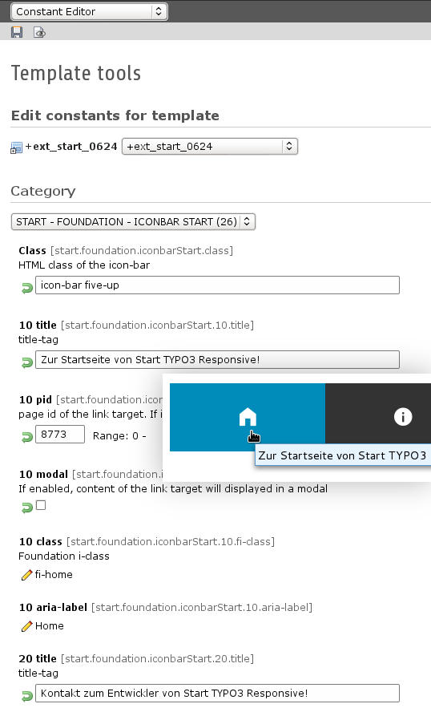Illustration 11: Icon-Bar Start

Backend Layouts
12: Default
13: Simple: Main | Right
14: Bronze: Main
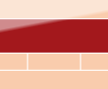15: Silver: Top | Botom
16: Newsletter
Some Backend Layouts. See more at "Backend Layouts" on page 11 below.

Grid Layouts
17: 1 column
18: 2 columns
19: 6 columns
Some Grid Layouts. See more at "Grid Layout" on page 14 below.

Introduction

What does it do?
- Start TYPO3 Responsive! (start) extends TYPO3 with the responsive framework Foundation (Zurb), a dozen responsive Backend Layouts and some responsive Grid Elements.
- It enables editors, to create responsive nested layouts within a few minutes.
- It extends some backend forms for controlling the display and hide of content elements depending on devices like smartphones, tablets and desktops.
- It extends TYPO3 content elements and menus with some helpful responsive Foundation features like
  - Breadcrumbs
  - Clearing Lightbox
  - Flexible Video
  - Icon Bar
  - Side Nav
  - Top Bar
- You can customise a lot of CSS properties – especially colours – by an user interface.
- It provides a template for an extensive responsive newsletter.
- You should need no longer than 15 minutes for a ready-for-use responsive TYPO3.

What do you need?
- A TYPO3-Installation.
- If you want to use the ready-for-use Grid Layouts, an empty table for Grid-Layouts.

Audience
- TYPO3 agencies
- TYPO3 integrators
- TYPO3 developers

Installation
Install and enable
- Foundation Framework (cb_foundation)
- Grid Elements (gridelements)
- Start TYPO3 Responsive! (start)

Configuration

Foundation Framework (cb_foundation)
- Nothing to do.

Start TYPO3 Responsive! (start)

New Website
- Add a TypoScript template to your root page.

Existing Website
- Disable / hide the TypoScript template of your root page.

Both – existing and New Website
Take your TypoScript root template:
- Options
  - Clear: [X] Constants, [X] Setup
  - Rootlevel: [X]
- Include the static templates
  - CSS Styled Content (css_styled_content)
  - Gridelements (gridelements)
  - Foundation framework (cb_foundation)
  - Foundation framework (default CSS) (cb_foundation)
  - Start [1] (start)
  - Start [1] +Gridelements (start)
  - Start [2] Foundation (start)
  - Start [2] +Foundation Icons 3 (start)
  - Start Customer (startcustomer)
- Configure some base properties like the base URL and language properties with the Constant Editor.
See: category [START - CONFIG]
- Configure the pid of your root page with the Constant Editor.
See: category [START - PAGES] > field: Root page: Your root page id

Grid Elements
- Add a folder for grid layouts. For example
  - Grid Layouts
- Create backend layouts (use it only, if your table tx_gridelements_backend_layout is empty!)
  - edit typo3conf/ext/start/ext_tables_static+adt.sql
  - replace 'xyz' with the page id of your folder "backend layouts" from above
  - Copy the SQL statements from the file and paste it into PhpMyAdmin
  - Send the SQL statements
- Create backend layouts icons
  - Copy the icons to the tx_gridelements folder in uploads:
cp -aR typo3conf/ext/start/Resources/Public/uploads/tx_gridelements/* uploads/tx_gridelements/

- Check the content of your folder "backend layouts". It should contain 8 backend layouts.

First Steps

Pages

Existing Website
Nothing to do but adding a page called page 2 for playing with samples.

New Website
Add some pages like
- page 1
- page 2
  - page 2.1
  - page 2.2
- page 3

Backend Layout
- Select your root page.
- Select a layout for the current page and the subpages too.
Here: [Start Bronze 1: | MAIN | ]
20: Bronze: MAIN

Next Steps
Please cross "Features and Samples" on page 11 below for the next steps.

Features and Samples

Backend Layouts
21: Default
22: Simple: MAIN
23: Simple: Left | MAIN
24: Simple: MAIN | Right
25: Left | MAIN | Right
26: Bronze: MAIN
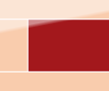27: Bronze: Left | MAIN
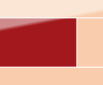28: Bronze: MAIN | Right
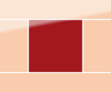29: Left | MAIN | Right
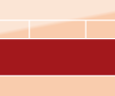30: Silver: Top | MAIN
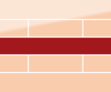31: Top | MAIN | Bottom
32: MAIN | Bottom
33: Newsletter
You are selecting a Backend Layout
- page properties
- tab [Appearance]
- Page Layout

Navigation
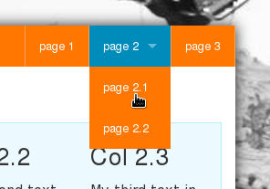Illustration 34: Top-Bar

Top Bar
Add a menu. Here the foundation top bar.
- Select your root page.
- Add to the header area
  - a special element. Here: a special menu
  - Select [Start: Foundation Top Bar]
- Configure the top bar with the Constant Editor.
See: category [START - FOUNDATION - TOPBAR]

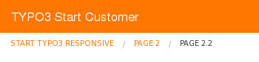Illustration 35: Breadcrumbs

Breadcrumbs
Add a menu. Here the foundation breadcrumbs.
- Select your root page.
- Add to the header area below of the top bar
  - a special element. Here: a special menu
  - Select [Start: Foundation Breadcrumbs]
- Configure the breadcrumbs with the Constant Editor.
See: category [START - FOUNDATION – BREADCRUMBS]

Side Nav
Add a menu. Here the foundation side nav.
- Select your root page.
- Add to the footer area
  - a special element. Here: a special menu
  - Select Menu Type: [Start: Foundation Side Nav from directories]
  - Select page: Page 2
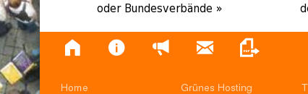Illustration 36: Icon-Bar

Icon Bar
Add a menu. Here the foundation icon bar.
- Select your root page.
- Add to the footer area below of your side nav
  - a special element. Here: a special menu
  - Select Menu Type: [Start: Foundation Icon bar Start]
- Configure the Icon bar Start with the Constant Editor.
  - Category [START - FOUNDATION – ICONBAR START]
  - Class: icon-bar five-up
  - 10 pid: page id of your root page (here:8773)
  - 10 modal: false
How to use a modal is explained in the section "Modal" on page 16 below.

Grid Layout
37: 1 column
38: 2 columns
39: 3 columns
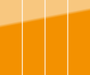40: 4 columns
41: 5 columns
42: 6 columns

Two Columns
Add a two columns grid layout.
- Select your page 2.
- Add to the content area a Grid Element
  - Header: "Grid Layout with two columns"
  - Grid Layout: [Columns 2]
  - Save the form
  - Large columns arrangement: [6 | 6]
  - Medium columns arrangement: [6 | 6]
  - Small columns arrangement: [12 | 12]
- Add to the column 2 of your grid layout a content element TEXT
  - Header: Column 2
  - Text: My second text in the second column of my first grid layout.

Nested Grid Layout
Add a two columns grid layout to the second columns of your first grid layout (see above)
- Add above the TEXT element "Column 2" a Grid Element
  - Header: "Grid Layout with three columns"
  - Grid Layout: [Columns 3]
  - Save the form
  - Large columns arrangement: [4 | 4 | 4]
  - Medium columns arrangement: [12 | 12 | 12]
  - Small columns arrangement: [12 | 12 | 12]
- Add to the column 1 of your second grid layout a content element TEXT
  - Header: Col 2.1
  - Text: My first text in the first column of my second grid layout.
- Repeat the last step for the second and the third column.
  - Adapt the header and the text.
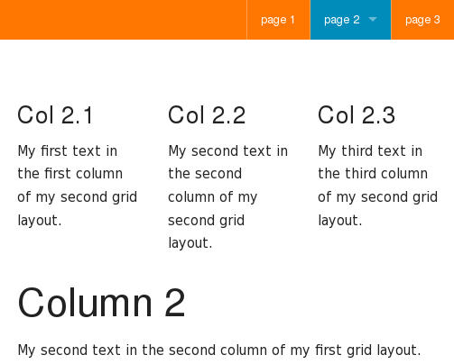Illustration 43: Without any frame
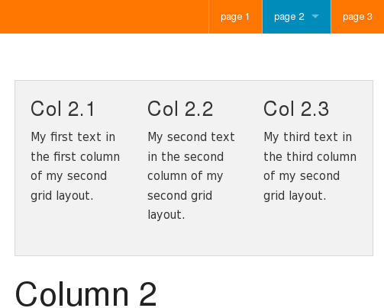Illustration 44: Panel
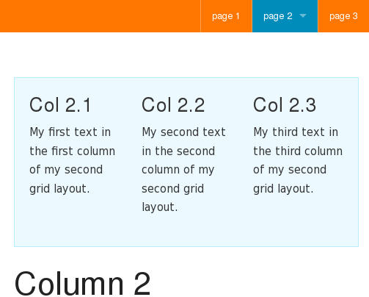Illustration 45: Callout

Panel
Move the second grid layout to a panel.
- Edit the second Grid Element "Grid Layout with three columns"
  - Grid Layout: [Columns 3]
  - Set [Appearance] > Indentation and Frames to [Panel]

Callout
Repeat the step from above, but set Indentation and Frames to [Callout]
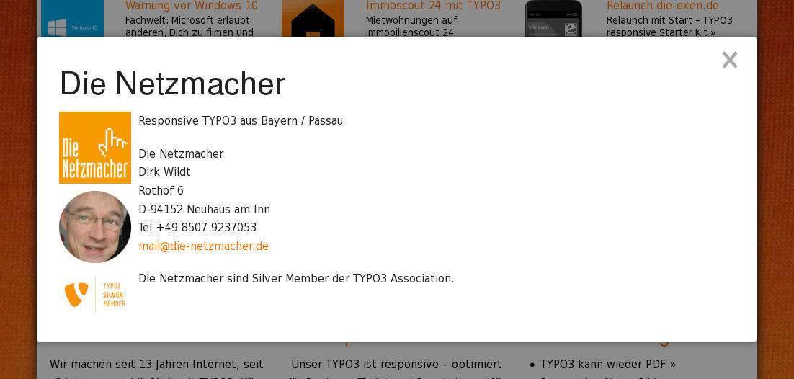Illustration 46: A modal

Modal

Content Element
Add to your root page a page "Modals".
- Set both Backend Layouts – this page and subpages – to [Start Simple 1: | Main | ]
- Move the page type from [Default] to [Folder].
Add to the folder "Modals" the folder "Contact" (in my sample the folder got the page id 8780).
Add to the content area of the folder "Contact" a content element:
- General
  - Type: [Text & Images]
  - Header: Contact
  - Text: Your name, phone number and e-mail-address.
- Images
  - Upload a portrait of you.
- Appearance
  - Image Adjustments: Width: 100
  - Image Alignment: [Beside Text, Left]
  - Number of columns: [1]

Link with the Icon Bar
Link the content with an icon of the Icon Bar Start (see section "Icon Bar" on page 13 above).
- Configure the Icon Bar Start with the Constant Editor.
  - Category [START - FOUNDATION – ICONBAR START]
  - 20 pid: page id of the modal folder contact (here: 8780)

RTE-Editor
cb_foundation provides some custom configurations for the RTE.
See details at
- https://docs.typo3.org/typo3cms/extensions/cb_foundation/UserManual.html#rte

Visibility classes
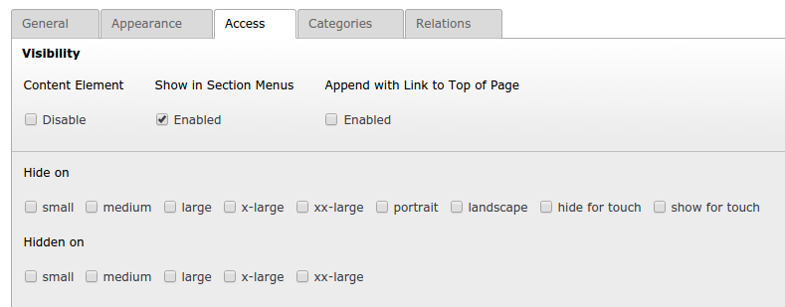Illustration 47: Visibility classes
See details at
- https://docs.typo3.org/typo3cms/extensions/cb_foundation/UserManual.html#visibility

Flexible Video
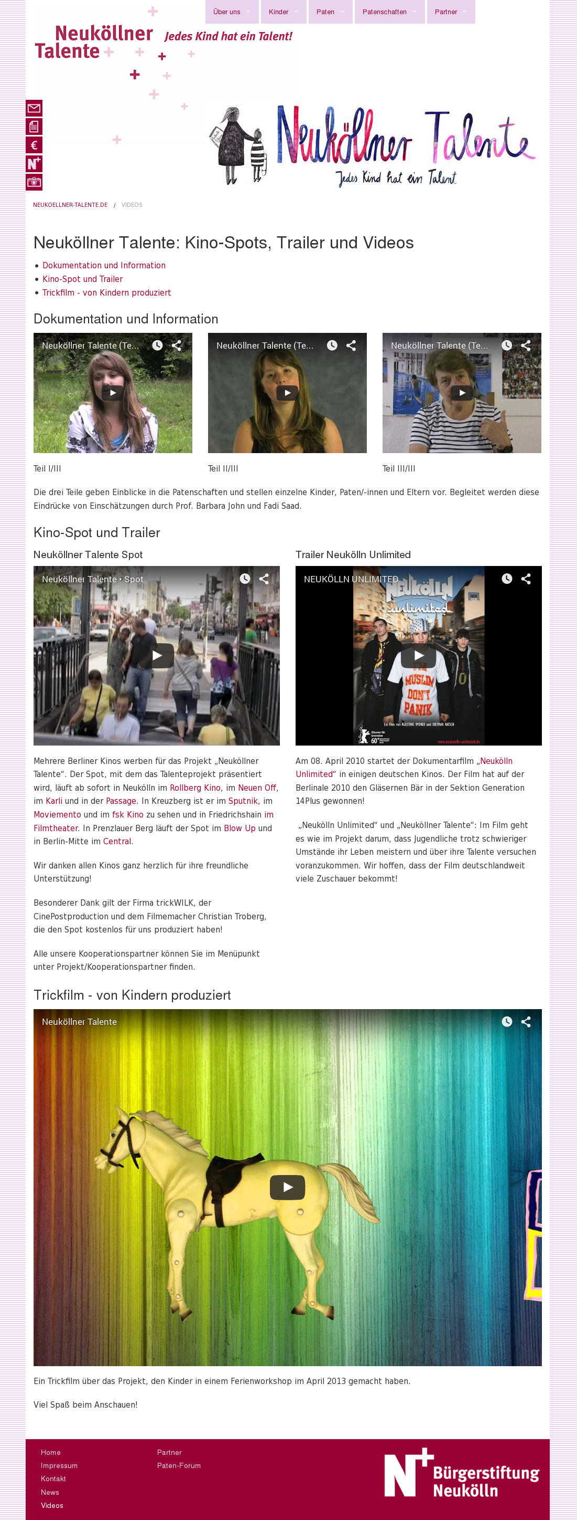48: Desktop
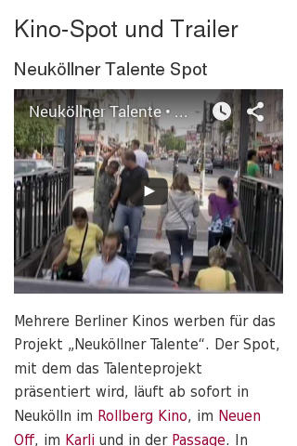49: Smartphone
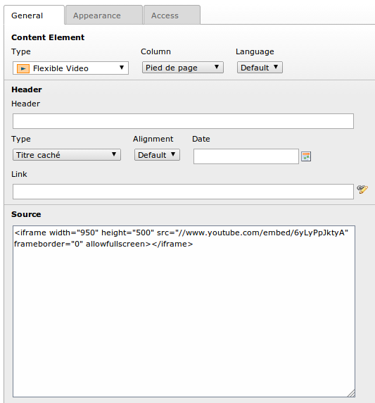Illustration 50: Flexible Video in the Backend
See:
- Details at: https://docs.typo3.org/typo3cms/extensions/cb_foundation/UserManual.html#flexible-video
- Live sample at: http://neukoellner-talente.de/videos/

Responsive Newsletter
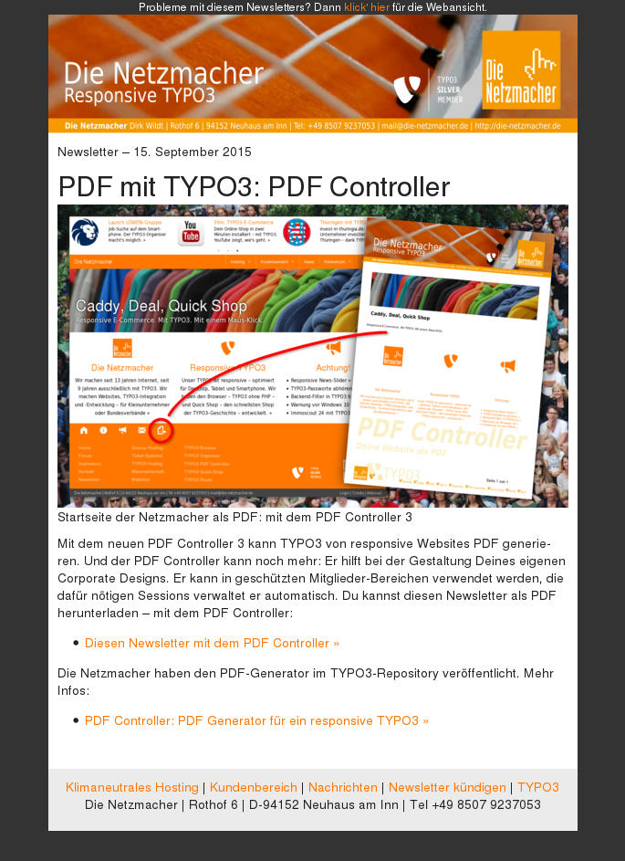Illustration 51: Responsive Newsletter

Requirements
You are using Direct Mail.
You have configured Direct Mail.
You have added a Direct Mail folder to the page tree.

TypoScript
Select the Direct Mail folder.
Disable all TypoScript templates.
Add the TypoScript template:
- page_page-name_id
Configure the template like in the sample below.
[General]
- Constants

// plugin.tx_directmail_pi1
// start.config
// styles.content

plugin.tx_directmail_pi1 {
siteUrl = http://your-domain.com/
}

start {
config {
absRefPrefix = http://your-domain.com/
htmlTag_langKey = de
language = de
locale_all = de_DE.UTF-8
tx_realurl_enable = 1
}
}

styles {
content {
imgtext {
maxWInText = 260
maxW = 580
}
}
}

[Options]
- Clear
  - [X] Constants
  - [X] Setup
- Rootlevel
  - [X]
[Includes]
- Include static (from extensions)
  - CSS Styled Content (css_styled_content)
  - Direct Mail Content Boundaries (direct_mail)
  - Direct Mail Plain text (direct_mail)
  - Start [1] (start)
  - Start [8] +e-mail (start)
  - Start Customer [8] E-Mail (startcustomer)

Backend Layout
52: Newsletter
Select the newsletter backend layout:
- [General]
  - Move the page type from [folder] to [default]
- [Appearance]
  - Backend Layout (this page only): [Start Newsletter Basic: | MAIN |]
  - Backend Layout (subpages of this page): [Start Newsletter Basic: | MAIN |]
- [General]
  - Move the page type from [default] to [folder]

Header and Footer
Your Direct Mail folder has now a header section and a footer section.
Add to the header section your header.
Add to your footer section your footer.
Header and footer will handed down the every subpage, which doesn't have any own heder and footer.

Content
Add to your Direct Mail folder a page.
Add to the content section of this page the content of your newsletter.

User Interface: Constant Editor

START - COMPRESS CSS AND JSS
Prefix: start.compress
Property: | Data type: | Description: | Default
css | boolean | CSS: If set, CSS files will compressed and concatenated. These properties will enabled: config.compressCss, config.concatenateCss. | TRUE
jss | boolean | JSS: If set, JSS files will compressed. These properties will enabled: config.compressJs, config.concatenateJs. | TRUE

START – CONFIG*
Prefix: start.config
Property: | Data type: | Description: | Default
absRefPrefix | boolean | absRefPrefix: If this value is set, then all relative links in TypoScript are prepended with this string. Prefixing all links with a "/" results in absolute link paths: /. Prefixing all links with the path to a subdirectory: /some-subsite/. Prefixing all links with a URI scheme: http://example.com/.
admPanel | boolean | Admin Panel: Display the admin panel in the frontend for a logged in backend user | TRUE
baseURL | string | Base URL*: *Obligate! Your base URL with ending slash. Example: http://die-netzmacher.de/
doctype | string | Document type:  - html5 for the HTML5 doctype.  - none for no doctype at all.  - xhtml_11 for the XHTML 1.1 doctype.  - xhtml_basic for the XHTML basic doctype.  - xhtml_frames for the XHTML 1.0 Frameset doctype.  - xhtml_strict for the XHTML 1.0 Strict doctype.  - xhtml+rdfa_10 for the XHTML+RDFa 1.0 doctype.  - xhtml_trans for the XHTML 1.0 Transitional doctype. | html5
clearAtMidnight | boolean | Clear cache at midnight: Obligated, if your are using calender items. | FALSE
headerComment | string | Header comment: The content is added before the "TYPO3 Content Management Framework" comment in the <head> section of the page. Use this to insert a note like that "Programmed by My-Agency".  Default: Development by http://die-netzmacher.de: responsive TYPO3. | See description
pageTitleFirst | boolean | Pagetitle first: TYPO3 by default prints a HTML title tag in the format "website: page title". If pageTitleFirst is set (and if the page title is printed), then the page title will be printed IN FRONT OF the template title. So it will look like "page title: website". | FALSE
language | string | Language: Example for German: de | en
htmlTag_langKey | string | Language HTML: HTML tag langauge keyExample for German: de | en
locale_all | string | Language local all: Example for German: de_DE.UTF-8 | en_GB.UTF-8
tx_realurl_enable | boolean | Real URL | FALSE
typolinkEnableLinksAcrossDomains | boolean | Enable links across domains: This option enables to create links across domains using current domain's linking scheme. This option implies "config.typolinkCheckRootline=1", which will be activated automatically. Setting value of "config. typolinkCheckRootline" inside TS template will have no effect. | FALSE
prefixLocalAnchors | boolean | Prefix local anchors: Recommended: all. If set to one of the keywords, the content will have all local anchors in links prefixed with the path of the script. Basically this means that <a href="#"> will be transformed to <a href="path/path/script?params#">. This procedure is necessary if the <base> tag is set (e.g. if the "realurl" extension is used to produce speaking URLs). See property "config.baseURL". all: The content is always processed before it is possibly stored in cache (or not stored in cache). cached: The content is only processed, if the page will be put into the cache. output: The content is processed just before it is echoed out. | all
disablePrefixComment | boolean | Disable prefix comment: If set, the stdWrap property "prefixComment" will be disabled, thus preventing any revealing and space-consuming comments in the HTML source code. | TRUE
removeDefaultJS | string | Remove default JS: If set, the default JavaScript in the header will be removed. The default JavaScript is the blurLink function and browser detection variables. Special case: If the value is "external", then the default JavaScript is written to a temporary file and included from that file. See "inlineStyle2TempFile" below. | external
inlineStyle2TempFile | boolean | inlineStyle2TempFile: If set, the inline styles TYPO3 controls in the core are written to a file, typo3temp/stylesheet_[hashstring].css, and the header will only contain the link to the stylesheet. The file hash is based solely on the content of the styles. | TRUE
spamProtectEmailAddresses | integer | Protect e-mail: If set, then all email addresses in typolinks will be encrypted so spam bots cannot detect them. Range from -10 to 10. | -3
spamProtectEmailAddresses_atSubst | string | Substitute @:Substitute label for the at-sign (@).  Default: @<span style="display:none;">remove-this.</span> | See description

START – FAVICON
Prefix: start
Property: | Data type: | Description: | Default
favicon | string | Path: Path to the favicon  Default: typo3conf/ext/start/Resources/Public/Images/favicon.ico | See description

START - FOUNDATION – BREADCRUMBS
Prefix: start.foundation.breadcrumbs
Property: | Data type: | Description: | Default
includeNotInMenu | integer | includeNotInMenu: Display a page title even it isn't visible in the menu | FALSE

START - FOUNDATION – GMENU
Prefix: start.foundation.gmenu
Property: | Data type: | Description: | Default
no.listNum | integer | listNum NO: position of the image in the list of images for the menu in the NO (normal) state | 0
ro.listNum | integer | listNum RO:position of the image in the list of images for the menu in the RO (rollover) state | 1

START - FOUNDATION – ICONBAR
Prefix: start.foundation.iconbar
Property: | Data type: | Description: | Default
class | string | Class: HTML class of the icon-bar  Default: icon-bar vertical five-up | See description
no.listNum | integer | listNum NO: position of the image in the list of images for the menu in the NO (normal) state | 0
ro.listNum | integer | listNum RO:position of the image in the list of images for the menu in the RO (rollover) state | 1

Illustration 53: Foundation Icons

START - FOUNDATION – ICONBAR START
Prefix: start.foundation.iconbarStart
Property: | Data type: | Description: | Default
class | string | Class: HTML class of the icon-bar  Default: icon-bar vertical five-up | See description
10.title | string | 10 title: title-tag | Home
10.pid | integer | 10 pid: page id of the link target. If it is empty or 0, any icon won't displayed. | 10000
10.modal | boolean | 10 modal: If enabled, content of the link target will displayed in a modal | TRUE
10.fi-class | string | 10 class: Foundation i-class. See at http://zurb.com/playground/foundation-icon-fonts-3 | fi-home
10.aria-label | string | 10 aria-label: | Home
20.title | string | 20 title: title-tag | Contact data
20.pid | integer | 20 pid: page id of the link target. If it is empty or 0, any icon won't displayed. | 20000
20.modal | boolean | 20 modal: If enabled, content of the link target will displayed in a modal | TRUE
20.fi-class | string | 20 class: Foundation i-class. See at http://zurb.com/playground/foundation-icon-fonts-3 | fi-info
20.aria-label | string | 20 aria-label: | contact
30.title | string | 30 title: title-tag | News
30.pid | integer | 30 pid: page id of the link target. If it is empty or 0, any icon won't displayed. | 30000
30.modal | boolean | 30 modal: If enabled, content of the link target will displayed in a modal | TRUE
30.fi-class | string | 30 class: Foundation i-class. See at http://zurb.com/playground/foundation-icon-fonts-3 | fi-megaphone
30.aria-label | string | 30 aria-label: | news
40.title | string | 40 title: title-tag | Shop
40.pid | integer | 40 pid: page id of the link target. If it is empty or 0, any icon won't displayed. | 40000
40.modal | boolean | 40 modal: If enabled, content of the link target will displayed in a modal | TRUE
40.fi-class | string | 40 class: Foundation i-class. See at http://zurb.com/playground/foundation-icon-fonts-3 | fi-shopping-cart
40.aria-label | string | 40 aria-label: | shop
50.title | string | 50 title: title-tag | Newsletter
50.pid | integer | 50 pid: page id of the link target. If it is empty or 0, any icon won't displayed. | 50000
50.modal | boolean | 50 modal: If enabled, content of the link target will displayed in a modal | TRUE
50.fi-class | string | 50 class: Foundation i-class. See at http://zurb.com/playground/foundation-icon-fonts-3 | fi-mail
50.aria-label | string | 50 aria-label: | Newsletter

START - FOUNDATION – TOPBAR
Prefix: start.foundation.topbar
Property: | Data type: | Description: | Default
name | string | Name: Your company name. I.e: Die Netzmacher | TYPO3 Start
title | string | Title: Title tag of the top bar name. I.e: TYPO3 agency  Default: Start TYPO3 Responsive! (start) | See description
icon.label.default | string | Icon label: The icon lable is displayed in minimised menus. | Menu
icon.label.de | string | Icon label (German): The icon lable for minimised menus in German language. | Menü
position | string | Top bar position: Full-browser width by default. To make the top bar stay fixed as you scroll, select "fixed". If you want your navigation to be set to your grid width, wrap it with "contain-to-grid". You may use fixed and contain-to-grid together. | contain-to-grid
section.position | string | Main menu position: left or right. | right
is_hover | boolean | Mouse hover:Recommended. Top bar menus will open by a mouse hover, visitor doesn't need to click. | TRUE
mobile_show_parent_link | boolean | Show parent link: Recommended. Will copy parent links into dropdowns for mobile navigation. | TRUE

START – PAGES*
Prefix: start.pages
Property: | Data type: | Description: | Default
root | integer | Home*: *Obligate:Uid of your home page. | 1
contact | integer | Contact data*: *Obligate:Uid of page which contains any contact data.
news | integer | News: Uid of page which contains your news.
shop | integer | Shop: Uid of page which contains your shop.
footer.library | integer | Footer Library: Uid of the footer library folder. | 9999

START - SEARCH ENGINE OPTIMISATION
Prefix: start.page.meta
Property: | Data type: | Description: | Default
author | string | author: Default author.  Default: Start TYPO3 Responsive! | See description
keywords | string | description: Default keywords.  Default: TYPO3, Start, responsive, Foundation | See description
description | string | description: Default description.  Default: Start TYPO3 Responsive! And you'll get a responsive TYPO3 in 15 minutes - based on the responsive framework Foundation (Zurb) | See description

START – TEMPLATES*
Prefix: start.fluid.path
Property: | Data type: | Description: | Default
layouts | string | Layout: Path to the fluid layouts. With ending slash!  Default: EXT:start/Resources/Private/Templates/Layouts/ | See description
partials | string | Partials: Path to the fluid partials. With ending slash!  Default: EXT:start/Resources/Private/Templates/Partials/ | See description
templates | string | Templates: Path to the fluid templates. With ending slash!  Default: EXT:start/Resources/Private/Templates/ | See description

Reference
It is recommended to use the TypoScript user interface – the Constant Editor – for editing TypoScript.

Start [1]
TypoScript template Start [1]. See: Configuration/TypoScript/Base/

config
Property: | Data type: | Description:
config | array | config {  absRefPrefix = {$start.config.absRefPrefix}  admPanel = {$start.config.admPanel}  baseURL = {$start.config.baseURL}  cache_clearAtMidnight = {$start.config.cache_clearAtMidnight}  compressCss = {$start.compress.css}  compressJs = {$start.compress.jss}  concatenateCss = {$start.compress.css}  concatenateJs = {$start.compress.jss}  disablePrefixComment = {$start.config.disablePrefixComment}  doctype = {$start.config.doctype}  headerComment = {$start.config.headerComment}  htmlTag_langKey = {$start.config.htmlTag_langKey}  inlineStyle2TempFile = {$start.config.inlineStyle2TempFile}  language = {$start.config.language}  locale_all = {$start.config.locale_all}  pageTitleFirst = {$start.config.pageTitleFirst}  prefixLocalAnchors = {$start.config.prefixLocalAnchors}  removeDefaultJS = {$start.config.removeDefaultJS}  spamProtectEmailAddresses = {$start.config.spamProtectEmailAddresses}  spamProtectEmailAddresses_atSubst = \  {$start.config.spamProtectEmailAddresses_atSubst}  tx_realurl_enable = {$start.config.tx_realurl_enable}  typolinkEnableLinksAcrossDomains = \  {$start.config.typolinkEnableLinksAcrossDomains}  }

page
Property: | Data type: | Description:
page | array | page = PAGE  page {  bodyTagCObject = TEXT  bodyTagCObject {  insertData = 1  value = <body id="bodyId-{TSFE:id}">  }  meta {  author = {$start.page.meta.author}  keywords {  field = keywords  ifEmpty = {$start.page.meta.keywords}  keywords = 1  }  description {  field = description  ifEmpty = {$start.page.meta.description}  }  viewport = width=device-width, initial-scale=1.0  }  shortcutIcon = {$start.favicon}  typeNum = 0  // start FLUIDTEMPLATES  63148 = CASE  63148 {  ... -> See page.63148 below  }  }

page.63148
Property: | Data type: | Description:
page.63148 | array | page = PAGE  page {  // start FLUIDTEMPLATES  63148 = CASE  63148 {  key {  data = levelfield:-2,backend_layout_next_level,slide  override {  field = backend_layout  }  }  default = TEXT  default {  data = levelfield:-2,backend_layout_next_level,slide  override {  field = backend_layout  }  noTrimWrap {  stdWrap {  cObject = TEXT  cObject {  ... -> Please inspect the code with the TypoScript Object Browser  }  }  }  }  // One column: content  start__bronze_01 = FLUIDTEMPLATE  start__bronze_01 {  file = {$start.fluid.path.templates}bronze_01.html  layoutRootPath = {$start.fluid.path.layouts}  partialRootPaths {  10 = {$start.fluid.path.partials}  }  variables {  }  settings {  classColMainContentMain =  }  stdWrap {  ... -> Please inspect the code with the TypoScript Object Browser  }  }  // Two columns: content | right  start__bronze_02 < .start__bronze_01  start__bronze_02 {  ... -> Please inspect the code with the TypoScript Object Browser  }  // Two columns: left | content  start__bronze_03 < .start__bronze_01  start__bronze_03 {  ... -> Please inspect the code with the TypoScript Object Browser  }  // Three columns: left | content | right  start__bronze_04 < .start__bronze_01  start__bronze_04 {  ... -> Please inspect the code with the TypoScript Object Browser  }  ... -> Please inspect the code with the TypoScript Object Browser  }  }

start.strcuture.content
Prefix: start.strcuture
Property: | Data type: | Description:
content | array | start {  structure {  // bottomLeft (4), bottomCenter (6), bottomRight (5),  // main (0), topLeft (1), topCenter (3), topRight (2)  content =  content {  // CONTENT, stdWrap  bottom = COA  bottom {  ... -> Please inspect the code with the TypoScript Object Browser  }  // CONTENT, stdWrap  bottomLeft = COA  bottomLeft {  ... -> Please inspect the code with the TypoScript Object Browser  }  // CONTENT, stdWrap  bottomCenter < start.structure.content.bottomLeft  bottomCenter {  ... -> Please inspect the code with the TypoScript Object Browser  }  // CONTENT, stdWrap  bottomRight < start.structure.content.bottomLeft  bottomRight {  ... -> Please inspect the code with the TypoScript Object Browser  }  // CONTENT, stdWrap  left = COA  left {  ... -> Please inspect the code with the TypoScript Object Browser  }  // CONTENT, stdWrap  main = COA  main {  ... -> Please inspect the code with the TypoScript Object Browser  }  // CONTENT, stdWrap  right = COA  right {  ... -> Please inspect the code with the TypoScript Object Browser  }  // CONTENT, stdWrap  topLeft = COA  topLeft {  ... -> Please inspect the code with the TypoScript Object Browser  }  // CONTENT, stdWrap  topCenter < start.structure.content.topLeft  topCenter {  ... -> Please inspect the code with the TypoScript Object Browser  }  // CONTENT, stdWrap  topRight < start.structure.content.topLeft  topRight {  ... -> Please inspect the code with the TypoScript Object Browser  }  }  }  }

start.strcuture.footer
Prefix: start.strcuture
Property: | Data type: | Description:
footer | array | start {  structure {  // bottom (22), left (23), main (21), right (24), top (20)  footer =  footer {  // CONTENT, stdWrap  bottom = COA  bottom {  ... -> Please inspect the code with the TypoScript Object Browser  }  left < start.structure.content.bottom  left {  ... -> Please inspect the code with the TypoScript Object Browser  }  // CONTENT, stdWrap  library = COA  library {  ... -> Please inspect the code with the TypoScript Object Browser  }  main < start.structure.content.bottom  main {  ... -> Please inspect the code with the TypoScript Object Browser  }  right < start.structure.content.bottom  right {  ... -> Please inspect the code with the TypoScript Object Browser  }  // CONTENT, stdWrap  top < start.structure.content.bottom  top {  ... -> Please inspect the code with the TypoScript Object Browser  }  }  }  }

start.strcuture.header
Prefix: start.strcuture
Property: | Data type: | Description:
header | array | start {  structure {  // bottom (12), left (13), main (11), right (14), top (10)  header =  header {  // CONTENT, stdWrap  bottom = COA  bottom {  ... -> Please inspect the code with the TypoScript Object Browser  }  // CONTENT, stdWrap  left < start.structure.header.bottom  left {  ... -> Please inspect the code with the TypoScript Object Browser  }  // CONTENT, stdWrap  main < start.structure.header.bottom  main {  ... -> Please inspect the code with the TypoScript Object Browser  }  // CONTENT, stdWrap  right < start.structure.header.bottom  right {  ... -> Please inspect the code with the TypoScript Object Browser  }  // CONTENT, stdWrap  top < start.structure.header.bottom  top {  ... -> Please inspect the code with the TypoScript Object Browser  }  }  }  }

Start [1] +Gridelements
TypoScript template Start [1] +Gridelements. See: Configuration/TypoScript/Base/Start/Gridelements/

start.gridelements.1 to 6
Prefix: start.gridelements
Property: | Data type: | Description:
1 | array | start {  // for proper comments only  gridelements {  }  // 1 column  gridelements =  gridelements {  1 < lib.gridelements.defaultGridSetup  // for proper comments only  1 {  }  // 1 column: wrap, columns  1 =  1 {  wrap {  stdWrap {  cObject = COA  cObject {  // <div ...  10 = TEXT  10 {  value = <div class="row  }  // class  20 = TEXT  20 {  field = flexform_class  noTrimWrap = | ||  required = 1  }  // ... /div>  30 = TEXT  30 {  value = ">|</div>  }  }  }  }  columns {  default {  wrap {  stdWrap {  cObject = COA  cObject {  // class  10 = TEXT  10 {  field = flexform_class  noTrimWrap = | ||  required = 1  }  }  }  noTrimWrap = |<div class="columns|">|  }  wrap2 = |</div>  }  }  }  }  }  tt_content.gridelements_pi1.20.10.setup.1 < start.gridelements.1
2 to 6 | array | See code for start.gridelements.1 above

Start [2] Foundation
TypoScript template Start [2] Foundation. See: Configuration/TypoScript/Foundation/

page
Prefix: page
Description:
page {
includeCSS {
startNormalize = EXT:start/Resources/Public/JavaScript/Libs/Foundation-5.5.1/css/normalize.css
startFoundation = EXT:start/Resources/Public/JavaScript/Libs/Foundation-5.5.1/css/foundation.min.css
}
includeJSlibs {
startModernizr = EXT:start/Resources/Public/JavaScript/Libs/Foundation-5.5.1/js/vendor/modernizr.js
}
includeJSFooter {
startFastclick = EXT:start/Resources/Public/JavaScript/Libs/Foundation-5.5.1/js/vendor/fastclick.js
startFoundation = EXT:start/Resources/Public/JavaScript/Libs/Foundation-5.5.1/js/foundation.min.js
startFoundationClearing = \
EXT:start/Resources/Public/JavaScript/Libs/Foundation-5.5.1/js/foundation/foundation.clearing.js
startFoundationInit = EXT:start/Resources/Public/JavaScript/Libs/foundation.js
}
includeJSFooterlibs {
startJquery = EXT:start/Resources/Public/JavaScript/Libs/Foundation-5.5.1/js/vendor/jquery.js
startJquery {
forceOnTop = 1
}
}
}

start.lib.breadcrumbs
Prefix: start.lib
Property: | Data type: | Description:
breadcrumbs | array | start {  lib {  // Display breadcrumbs, if current page isn't root page  breadcrumbs = HMENU  breadcrumbs {  // if rootpage uid isn't current page uid  if =  if {  value {  // rootpage uid  data = leveluid:0  }  equals {  // current page uid  data = page:uid  }  negate = 1  }  includeNotInMenu = {$start.foundation.breadcrumbs.includeNotInMenu}  special = rootline  special {  range = 0|3  }  wrap = <nav class="breadcrumbs">|</nav>  1 = TMENU  1 {  noBlur = 1  NO = 1  NO {  ATagTitle {  field = description // abstract // subtitle // title  }  allWrap = |  stdWrap {  htmlSpecialChars = 1  }  }  CUR < .NO  CUR = 1  CUR {  ATagParams = class="current"  }  }  }  }  }  tt_content.menu.20 {  startFoundationBreadcrumbs < start.lib.breadcrumbs  }

start.lib.gmenu
Prefix: start.lib
Property: | Data type: | Description:
gmenu | array | start {  lib {  gmenu < tt_content.menu.20.default  gmenu {  stdWrap {  prepend >  outerWrap = <ul class="side-nav" role="navigation" title="Link List">|</ul>  }  1 >  1 = GMENU  1 {  noBlur = 1  wrap = <ul class="inline-list">|</ul>  NO = 1  NO {  ATagTitle {  field = description // abstract // subtitle // title  }  altImgResource {  import = uploads/media/  import {  field = media  listNum = {$start.ntalente.lib.gmenu.no.listNum}  }  }  stdWrap {  htmlSpecialChars = 1  }  wrap = <li role="menuitem">|</li>  }  // 150901, dwildt: RO wird ausgeführt,  // aber in mouseover wird image von NO geschrieben!  RO < .NO  RO {  altImgResource {  import {  listNum = {$start.ntalente.lib.gmenu.ro.listNum}  }  }  }  }  }  gmenuFromDirs < .gmenu  gmenuFromDirs {  special = directory  }  }  }  tt_content.menu.20 {  startGmenu < start.lib.gmenu  startGmenuFromDirs < start.lib.gmenuFromDirs  }

start.lib. iconbar
Prefix: start.lib
Property: | Data type: | Description:
iconbar | array | start {  lib {  iconbar < tt_content.menu.20.default  iconbar {  stdWrap {  prepend >  outerWrap = <div class="{$start.foundation.iconbar.class}" role="navigation">|</div>  }  1 >  1 = GMENU  1 {  noBlur = 1  #wrap = |  NO = 1  NO {  ATagTitle {  field = description // abstract // subtitle // title  }  altImgResource {  import = uploads/media/  import {  field = media  listNum = {$start.foundation.iconbar.no.listNum}  }  }  stdWrap {  htmlSpecialChars = 1  }  #wrap = |  ATagParams {  wrap = class="first item" role="menuitem"|*| class="item" role="menuitem" |*| class="last item" role="menuitem"  }  }  // 150901, dwildt: RO wird ausgeführt,  // aber in mouseover wird image von NO geschrieben!  RO < .NO  RO {  altImgResource {  import {  listNum = {$start.foundation.iconbar.ro.listNum}  }  }  }  }  }  iconbarFromDirs < .iconbar  iconbarFromDirs {  special = directory  }  }  }  tt_content.menu.20 {  startFoundationIconbar < start.lib.iconbar  startFoundationIconbarFromDirs < start.lib.iconbarFromDirs  }

start.lib. iconbarStart
Prefix: start.lib.iconbarStart
Property: | Data type: | Description:
10 | array | start {  lib {  // iconBar, modals  iconbarStart = COA  iconbarStart {  // iconbar: 10, 20, 30, 40, 50  10 = COA  10 {  // isn't modal, is modal,  10 = COA  10 {  if {  isTrue = {$start.foundation.iconbarStart.10.pid}  }  // isn't modal  10 = TEXT  10 {  if {  isFalse = {$start.foundation.iconbarStart.10.modal}  }  value = <i class="{$start.foundation.iconbarStart.10.fi-class}"></i>  typolink {  parameter = {$start.foundation.iconbarStart.10.pid}  title = {$start.foundation.iconbarStart.10.title}  ATagParams = class="item" role="button" tabindex="0" aria-label="{$start.foundation.iconbarStart.10.aria-label}"  }  }  // is modal  20 = TEXT  20 {  if {  isTrue = {$start.foundation.iconbarStart.10.modal}  }  value = {$start.foundation.iconbarStart.10.title}  wrap (  <a class="item" role="button" tabindex="0" aria-label="{$start.foundation.iconbarStart.10.aria-label}" href="#" title="|" data-reveal-id="modal10">  <i class="{$start.foundation.iconbarStart.10.fi-class}"></i>  </a>  )  }  }  20 = COA  20 {  ... -> Please inspect the code with the TypoScript Object Browser  }  30 ...  40 ...  50 ...  wrap = <div class="{$start.foundation.iconbarStart.class}" role="navigation">|</div>  }  // modals: 10, 20, 30, 40, 50  20 = COA  20 {  ... -> See section start.lib.iconbarStart.20 below  }  }  }  }  tt_content.menu.20 {  startFoundationIconbarStart < start.lib.iconbarStart  }

Prefix: start.lib.iconbarStart
Property: | Data type: | Description:
20 | array | start {  lib {  // iconBar, modals  iconbarStart = COA  iconbarStart {  // iconbar: 10, 20, 30, 40, 50  10 = COA  10 {  ... -> See section start.lib.iconbarStart.10 above  }  // modals: 10, 20, 30, 40, 50  20 = COA  20 {  10 = COA  10 {  if {  isTrue = {$start.foundation.iconbarStart.10.modal}  }  10 = TEXT  10 {  value (  <h1>  Missing content  </h1>  <p>  There isn't any proper id for this page.<br />  Or page doesn't have any content in the default column (colPos: 0).<br />  The used page id is #{$start.foundation.iconbarStart.10.pid}.<br />  Please configure [START - FOUNDATION - ICONBAR START].<br />  Please take the TypoScript Constant Editor.  </p>  <p>  This is a prompt by the TYPO3 extension Start.<br />  Sorry for the trouble.  </p>  )  }  stdWrap {  override {  cObject < styles.content.get  cObject {  select {  pidInList = {$start.foundation.iconbarStart.10.pid}  }  }  }  wrap (  <div id="modal10" class="reveal-modal" data-reveal aria-labelledby="modalTitle" aria-hidden="true" role="dialog">  |  <a class="close-reveal-modal" aria-label="Close">&#215;</a>  </div>  )  }  }  20 = COA  20 {  ... -> Please inspect the code with the TypoScript Object Browser  }  30 ...  40 ...  50 ...  }  }  }  }  tt_content.menu.20 {  startFoundationIconbarStart < start.lib.iconbarStart  }

start.lib.sidenav
Prefix: start.lib
Property: | Data type: | Description:
sidenav | array | start {  lib {  sidenav < tt_content.menu.20.default  sidenav {  stdWrap {  prepend >  outerWrap = <ul class="side-nav" role="navigation" title="Link List">|</ul>  }  1 {  NO {  ATagTitle {  field = description // abstract // subtitle // title  }  wrapItemAndSub = <li role="menuitem">|</li>  }  ACT < .NO  ACT = 1  ACT {  wrapItemAndSub = <li role="menuitem" class="active">|</li>  }  ACTIFSUB < .NO  ACTIFSUB = 1  SPC = 1  SPC {  stdWrap {  cObject = TEXT  cObject {  value = <hr />  }  }  wrapItemAndSub = <li class="spc">|</li>  }  }  }  sidenavFromDirs < .sidenav  sidenavFromDirs {  special = directory  }  }  }  tt_content.menu.20 {  startFoundationSideNav < start.lib.sidenav  startFoundationSideNavFromDirs < start.lib.sidenavFromDirs  }

start.lib.topbar
Prefix: start.lib
Property: | Data type: | Description:
topbar | array | start {  lib {  // 1, 2, 3, 4, stdWrap, wrap  topbar = HMENU  topbar {  1 = TMENU  1 {  expAll = 1  collapse = 0  noBlur = 1  stdWrap {  ... -> Please use the TypoScript Object Browser  }  NO = 1  NO {  ... -> Please use the TypoScript Object Browser  }  ACT < .NO  ACT {  ... -> Please use the TypoScript Object Browser  }  ACTIFSUB < .NO  ACTIFSUB {  ... -> Please use the TypoScript Object Browser  }  CUR < .NO  CUR {  ... -> Please use the TypoScript Object Browser  }  CURIFSUB < .NO  CURIFSUB {  ... -> Please use the TypoScript Object Browser  }  IFSUB < .NO  IFSUB {  ... -> Please use the TypoScript Object Browser  }  }  2 ...  3 ...  4 ...  5 ...  6 ...  stdWrap {  if {  isTrue = {$start.foundation.topbar.position}  }  wrap = <div class="{$start.foundation.topbar.position}">|</div>  }  wrap = <nav class="top-bar" data-topbar data-options="custom_back_text:false;is_hover:{$start.foundation.topbar.is_hover};mobile_show_parent_link:{$start.foundation.topbar.mobile_show_parent_link};">|</nav>  }  }  }  tt_content.menu.20 {  startFoundationTopBar < start.lib.topbar  }

Start [2] +Foundation Icons 3
TypoScript template Start [2] +Foundation Icons 3. See: Configuration/TypoScript/FoundationIcons/

page
Prefix: page
Property: | Data type: | Description:
includeCSS | array | page {  includeCSS {  startFoundationIcons = \  EXT:start/Resources/Public/Css/foundation-icons-3/foundation-icons.css  }  }

Start [8] +E-Mail
TypoScript template Start [8] +E-Mail. See: Configuration/TypoScript/EMail/

config

Constants
Prefix: start
Property: | Data type: | Description:
config | array | start {  config {  doctype = xhtml_strict  removeDefaultJS = 1  }  }

Setup
Prefix: -
Property: | Data type: | Description:
config | array | config {  admPanel >  baseURL >  cache_clearAtMidnight >  compressCss >  compressJs >  concatenateCss >  concatenateJs >  inlineStyle2TempFile = 0  spamProtectEmailAddresses >  spamProtectEmailAddresses_atSubst >  }

Page
Prefix: -
Property: | Data type: | Description:
page | array | page >  // OVERRIDEN by: Start [8] +e-mail  page = PAGE  page {  cssInline {  // typo3.css, newsletter_01.css, start.css  10 = COA  10 {  // typo3.css  10 = FILE  10 {  file = typo3conf/ext/start/Resources/Public/Css/EMail/typo3.css  }  // newsletter_01.css  20 = FILE  20 {  file = typo3conf/ext/start/Resources/Public/Css/EMail/newsletter_01.css  }  // start.css  30 = FILE  30 {  file = typo3conf/ext/start/Resources/Public/Css/EMail/start.css  }  }  }  meta {  viewport = width=device-width  }  63148 >  // start FLUIDTEMPLATES - overriden by Start [8] +e-mail  63148 = CASE  63148 {  key {  data = levelfield:-2,backend_layout_next_level,slide  override {  field = backend_layout  }  }  default = TEXT  default {  ... -> Please inspect code with the TypoScript Object Browser  }  // One column: content  start__newsletter_01 = FLUIDTEMPLATE  start__newsletter_01 {  ... -> Please inspect code with the TypoScript Object Browser  }  }  }

start.strcuture.e-mail.content
Prefix: start.strcuture.e-mail
Property: | Data type: | Description:
content | array | // for proper comments only  start {  }  // structure  start =  start {  // for proper comments only  structure {  }  // e-mail  structure =  structure {  // for proper comments only  e-mail {  }  // content  e-mail =  e-mail {  // main (0)  content =  content {  // CONTENT, stdWrap  main = COA  main {  // table, select, stdWrap  20 < styles.content.get  20 {  select {  where = colPos=0  }  stdWrap {  required = 1  wrap (  <table class="row">  <tr>  <td class="wrapper last">  <table class="twelve columns">  <tr>  <td>  |  </td>  <td class="expander"></td>  </tr>  </table>  </td>  </tr>  </table>  )  }  }  }  }  }  }  }

start.strcuture.e-mail.footer
Prefix: start.strcuture.e-mail
Property: | Data type: | Description:
footer | array | // for proper comments only  start {  }  start =  start {  // for proper comments only  structure {  }  // e-mail  structure =  structure {  // for proper comments only  e-mail {  }  // footer  e-mail =  e-mail {  // main (21)  footer =  footer {  main = COA  main {  // table, select, stdWrap  20 < styles.content.get  20 {  select {  where = colPos=21  }  slide = -1  stdWrap {  required = 1  wrap (  <table class="row footer">  <tr>  <td class="wrapper last">  <table class="twelve columns">  <tr>  <td align="center">  <center>  |  </center>  </td>  <td class="expander"></td>  </tr>  </table>  </td>  </tr>  </table>  )  }  }  }  }  }  }  }

start.strcuture.e-mail.header
Prefix: start.strcuture.e-mail
Property: | Data type: | Description:
header | array | start {  structure {  // for proper comments only  e-mail {  }  // header  e-mail =  e-mail {  // main (11)  header =  header {  // table, select, stdWrap  //main < start.structure.header.bottom  main = COA  main {  // header link  10 = TEXT  10 {  value = Click here  lang {  de = klick' hier  en = Click here  }  typolink {  parameter {  data = page:uid  }  #ATagParams = style="color:#2131AD;"  extTarget = _blank  target = _blank  }  noTrimWrap {  stdWrap {  cObject = TEXT  cObject {  value = |<p class="webversion">Trouble with this newsletter? | for the web view.</p>|  lang {  de = |<p class="webversion">Probleme mit diesem Newsletter? Dann | für die Webansicht.</p>|  en = |<p class="webversion">Trouble with this newsletter? | for the web view.</p>|  }  }  }  }  }  // table, select, stdWrap  20 < styles.content.get  20 {  select {  where = colPos=11  }  slide = -1  }  wrap (  <table class="row header">  <tr>  ... -> Please insepct code with the TypoScript Object Browser  </tr>  </table>  )  }  }  }  }  }

tt_content.image.20
Prefix: tt_content.image.20
Property: | Data type: | Description:
layout | array | ## images  tt_content.image {  20 {  layout {  # above-center  default {  value (  <table class="row">  <tr>  <td class="wrapper last">  <table class="twelve columns">  <tr>  <td>  <div class="csc-textpic csc-textpic-center csc-textpic-above###CLASSES###">  ###IMAGES###  ###TEXT###  </div>  </td>  <td class="expander"></td>  </tr>  </table>  </td>  </tr>  </table>  )  override (  <table class="row">  <tr>  <td class="wrapper last">  <table class="twelve columns">  <tr>  <td>  <div class="csc-textpic csc-textpic-responsive csc-textpic-center csc-textpic-above###CLASSES###">  ###IMAGES###  ###TEXT###  </div>  </td>  <td class="expander"></td>  </tr>  </table>  </td>  </tr>  </table>  )  }  # above-right  1 = TEXT  1 {  ... -> Please insepct code with the TypoScript Object Browser  }  # above-left  2 ...  # below-center  8 ...  # below-right  9 ...  # below-left  10 ...  # intext-right  17 ...  # intext-left  18 ...  25 ...  26 ...  }  }  }

Start [9] Debug
TypoScript template Start [9] Debug. See: Configuration/TypoScript/Debug/

page.99999
Prefix: page
Property: | Data type: | Description:
99999 | array | page = PAGE  page {  99999 = TEXT  99999 {  data = levelfield:-2,backend_layout_next_level,slide  override {  field = backend_layout  }  split {  token = start__  1 {  current = 1  wrap = |  }  }  wrap = {$start.fluid.path.templates}|.html  }  }

Adapt Start to your needs

CSS

Recommended: EXT:startcustomer
Controll a lot of CSS properties by the extension Start TYPO3 Responsive Customer (startcustomer):
- Install and enable Start TYPO3 Responsive Customer (startcustomer)
- Include the static template Start Customer [1]
See details at
- TYPO3 repository: http://typo3.org/extensions/repository/view/startcustomer/
- the PDF manual: http://start-typo3-responsive.de/typo3conf/ext/startcustomer/doc/manual.pdf

Own CSS file
Include your CSS file like in the snippet below.
page.includeCSS {
myOwnCSS = fileadmin/myown.css
}

HTML

Backend Layouts and Grid Layouts
Mix Backend Layouts and Grid Layouts like you need it.

Fluid Templates
Use your own fluid templates. See Constant Editor > START – TEMPLATES* on page 23 above.

Helpful suggestions and benefits

Forum
If you have helpful suggestions, feel free to publish any question, bug or code snippet on
- Start TYPO3 Responsive! forum at
http://forum.start-typo3-responsive.de/
Posts are welcome in English and German.

Packages for Sponsors
Your donation and sponsoring is welcome.
Please order a package for sponsors at
- http://start-typo3-responsive.de/sponsoring/

Fun – 50 EUR

You like to treat the Start TYPO3 Responsive! project.
You don't expect any equivalent. No logo. No service.
Throw 50 EUR or any other old sum into the cash box.
You will get a receive. You can set the amount off against tax liability.

Logo – 150 EUR
You are treating the Start TYPO3 Responsive! project and you like to be a guide for others.
Your logo will appear in the manual, at the website and in the extension manager of Start TYPO3 Responsive!
The period of validity is limited to one year.
You will get a receive. You can set the amount off against tax liability.
You can pay more than 150 EUR.

Patron – 500 EUR
You are the patron. You are treating Start TYPO3 Responsive! project and you like to pay the developer more than best for two hours service.
Your logo will appear in the manual, at the website and in the extension manager of Start TYPO3 Responsive!
You can book the developer of the Organiser for two hours.
The period of validity for both – the logo and the two hours – is limited to one year. If you don't use the two hours in this period, you will lost it.
You will get a receive. You can set the amount off against tax liability.
You can pay more than 500 EUR.

Further Information

Website
- http://start-typo3-responsive.de/

Manual in PDF
You find this manual and the tutorial in PDF format at
- http://start-typo3-responsive.de/typo3conf/ext/startcustomer/doc/manual.pdf

Development

Bugtracker
See https://forge.typo3.org/projects/extension-start/issues

SVN Repository

Checkout / Download
Latest version / Specific version
your@server:/path/to/typo3conf/ext# svn co http://die-netzmacher.de/svn/start/tags/x.x.x start

Developer version - not recommended!
your@server:/path/to/typo3conf/ext# svn co http://die-netzmacher.de/svn/start/trunk start

Update
your@server:/path/to/your/typo3conf/ext/start# svn update

Responsive Framework Foundation
- http://foundation.zurb.com/

Professional Support
If you need professional support, please contact the Developer:
- Dirk Wildt
http://wildt.at.die-netzmacher.de/
E-Mails are welcome in English and German.

Credits
Credits to Charles Brunet, who develops the extension "Foundation framework" (cb_foundation).

Other extensions published by Die Netzmacher
- +AOE Linkhandler Configurator: Configure the AOE linkhandler supported by userinterfaces. Out-of-the-box templates for cal, org, tt_news and tt_products. Don't edit page TSconfig any longer.
http://typo3.org/extensions/repository/view/linkhandlerconf/
- autositemap: A smart site-map optimised for the footer. It groups menus in columns. Great menus will get two columns. Configuration is based on TypoScript HMENU.
http://typo3.org/extensions/repository/view/autositemap/
- Browser – TYPO3 without PHP. Develop your TYPO3 extension 8 times faster! You need one line TypoScript for a result list with a search form, a record browser and an index browser. Images are wrapped self-acting. SEO, Search Engine Optimization, is integrated. http://typo3-browser.de/
- Caddy – the TYPO3 shopping cart. You can use it for your own needs. You need a database with products or any other items only. You can install Caddy out of the box with one mouse click – see Quick Shop below.
http://typo3-caddy.de/
- Deal! – TYPO3 Quick Shop interface for the marketplace ebay. Manage all items with TYPO3 and publish it on ebay. Amazon is under construction.
http://typo3-deal.de/
- Duty – collection of helpful scheduler tasks. Here: remove deprecated files from directories.
http://typo3.org/extensions/repository/view/duty/
- Flip it! offers lovely and smooth page flip transitions. It enables you to run over pages in PDF documents like in a real magazine. It is based on flash. Flipt it! can convert PDF documents to swf files automatically.
http://typo3.org/extensions/repository/view/flipit/
- Jobmarket is a catalogue with job offers. Views, the a-z-browser, the page-browser, the search, social bookmarks and a lot of other stuff can configured by the Browser plugin with the mouse.
http://typo3-job-market.de/
- Organiser – TYPO3 for the lobby and the organisers. Handle news, events, staff, headquarters, locations, workshops and a calendar with one extension. Sell online tickets! Install the Organiser with one mouse click!
http://typo3-organiser.de/
- Quick Shop – the fastest shop in the history of TYPO3. Install it with one mouse click! Quick Shop is based on the browser (see above) and powermail.
http://typo3-quick-shop.de/
- PDF Controller: Offer a TYPO3 page for PDF download. Individual layout with background PDF file. TYPO3 sessions are supported. Handling of responsive backend layouts and grid elements possible. PDF engine is TCPDF. http://typo3-pdfcontroller.de/
- Radial Search (Umkreissuche) – Enable the browsing through your data by geo location. 'Your data must have a latitude and a longitude. Address data can geocoded automatically by the Browser - TYPO3 without PHP.
http://typo3.org/extensions/repository/view/radialsearch/
- Route – Publish your routes with GoogleMaps or OpenStreetMap. Routes have points of interest (POI). You can categorise and filter both: routes and POI. Address data can geocoded automatically.
http://typo3-route.de/
- seo_dynamic_tag: Search Engine Optimization for the title tag, the canonical tag and the meta tags author, description and keywords. Configuration by a user interface.
http://typo3.org/extensions/repository/view/seo_dynamic_tag/
- Slick - jQuery Carousel: Fully responsive. Scales with its container. Separate settings per breakpoint. Uses CSS3 when available. Swipe enabled. Desktop mouse dragging. Infinite looping. Fully accessible.
http://typo3-slick.de/
- Start extends TYPO3 with the responsive framework Foundation (Zurb). Provides a dozen ready-to-use backend layouts and some grid-layouts. Template is included for a responsive newsletter. Based on the responsive framework Foundation (Zurb). http://start-typo3-responsive.de/
- TSconfig Pages and Users by extManager (extkey: tsconf): Configure the the eight most commonly used TSconfig porperties with the mouse - like page tree uids, activated extended view, activated clipboard, ...
http://typo3.org/extensions/repository/view/tsconf/

Known Bugs
See https://forge.typo3.org/projects/extension-start/issues

Change Log

2.4.0 Improvement
* #i0063: Update for TYPO3 7.6
2.3.1 New Feature
* #i0062: viewport is configurable by the Constant Editor
2.3.0 New Feature
* #71476: Print Template
Improvement
* #i0061: Backend layouts: theme gold is removed
2.2.1 New Feature
* #i0060: config.htmlTag_setParams
2.2.0 New Feature
* #i0059: Thumbnails Menu
2.1.2 Improvement
* #i0057: Extension description
2.1.1 Publishing
* #i0056: Publishing
2.1.0 New feature
* #i0051: Foundation for e-mails: http://zurb.com/ink/
* Backend layout: newsletter basic
Improvement
* #i0055: state is moved from experimental to beta
* #i0054: Extension icon
* #i0053: New: config.absRefPrefix
* #i0052: Removed: typoscript template for df_foundation5
* #i0050: Grid layouts are set to hidden:
* Foundation Accordion & Tabs
* Foundation Sections
* Foundation Slider-Orbit
* #i0049: New: config.typolinkEnableLinksAcrossDomains
2.0.2 New Feature
* #i0047: Icon Bar Start
Among others:
* New constant: start.foundation.iconbarStart.class
Improvement
* #i0048: New: config.doctype
2.0.1 Improvement
* #i0046: TypoScript file structure. Here: Gridelements
2.0.0 Improvement
* #i0045: Foundation extension is moved
from df_foundation5 to cb_foundation
1.1.6 Improvement
* #i0044: All df_foundation5.enableJs-features are dsiabled
1.1.5 New Feature
* #i0043: Search engine optimisation for pages
* author
* description
* keywords
1.1.4 New Feature
* #i0042: Foundation Icon Bar
* #i0041: Gmenu
* #i0040: New constant: config.cache_clearAtMidnight
* #i0039: 5th and 6th level for top bar
* #i0038: New constant: breadcrumbs.includeNotInMenu
Improvement
* #i0040: config.admPanel = 1
* #i0036: Remove redundant TypoScript
Bugfix
* #i0037: Constant editor: wrong type
1.1.3 Improvement
* #i0035: die-netzmacher.ico added
1.1.2 Bugfix
* #i0034: config: compress* and concatenate* added
1.1.1 Feature
* #i0033: Config properties are configurable by the Constant Editor
* #i0031: Foundation Top Bar (configurable by Constant Editor)
* #i0030: Foundation Side Nav from directories
* #i0029: Foundation Side Nav
* #i0026: Gridelements flexform: individual class: Large. medium ans small are configurabele.
* #i0025: Fluidtemplates settings: classes
* #i0024: CSS netzmacher is added
* #i0022: gridelement with one column
* #i0021: df_foundation5 foundation lib items for tt_content menu
* #i0020: static template for df_foundation5
* #i0019: static template for gridelements
Improvement
* #i0032: Backend layouts are improved
* #i0028: Foundation update from 5.4.7 to 5.5.1
* #i0027: Backend layouts: theme gold is disabled
* #i0023: fluidtemplates got a stdWrap
Bugfix
* #i0032: autoplayspeed is moved to autoplaySpeed
1.1.0 Feature
* #i0018: state is set to experimental
* #i0017: foundation-icons-3 added
1.0.3 Bugfix
* #i0016: Clean up ext_localconf.php
1.0.2 Feature
* #i0015: TYPO3 7.0
1.0.1 Feature
* #i0014: Debug TypoScript 99999
1.0.0 Feature
* #63148: COA id for fluidtemplate
* #i0013: TYPO3 4.x compatibility isn't possible because of backend layout data provider
Development
* #i0012: Clean up
* #i0011: Dataprovider for backend-layouts
0.3.0 Development
* #i0010: Some Foundation Features are integrated as grid elements.
Database records and icons have to install manually for
* backend_layout
* tx_gridelements_backend_layout
0.2.0 Development
* #i0009: ext_tables_static+adt.sql
* Records for
* backend_layouts
* tx_gridelements_backend_layout
* Icons in
* Resources/Public/uploads
* media
* tx_gridelements
* #i0008: Improved Manual
* #i0007: Available for TYPO3 6.2
0.1.0 Development
* #i0006: Update for extbase and fluid
0.0.5 Development
* #i0005: Powermail section: tab -> auto
0.0.4 Feature
* #i0004: Move input-"buttons" to real buttons
0.0.3 Feature
* #54859. Powermail for Foundation
0.0.2 Improvements
* #i0003: manual
* #i0002: lib/icons/start_90x80.gif
0.0.1 Initial Release

Illustration index
Illustration 1: http://start-typo3-responsive.de/ 3
Illustration 2: http://die-exen.de/ 3
Illustration 3: http://die-netzmacher.de/ 3
Illustration 4: http://neukoellner-talente.de/ 3
Illustration 5: http://start-typo3-responsive.de/ 3
Illustration 6: http://die-exen.de/ 3
Illustration 7: http://die-netzmacher.de/ 3
Illustration 8: http://neukoellner-talente.de/ 3
Illustration 9: User interface with 11 forms 4
Illustration 10: Extended user interface 4
Illustration 11: Icon-Bar Start 4
12: Default 5
13: Simple: Main | Right 5
14: Bronze: Main 5
15: Silver: Top | Botom 5
16: Newsletter 5
17: 1 column 5
18: 2 columns 5
19: 6 columns 5
20: Bronze: MAIN 10
21: Default 11
22: Simple: MAIN 11
23: Simple: Left | MAIN 11
24: Simple: MAIN | Right 11
25: Left | MAIN | Right 11
26: Bronze: MAIN 11
27: Bronze: Left | MAIN 11
28: Bronze: MAIN | Right 11
29: Left | MAIN | Right 11
30: Silver: Top | MAIN 11
31: Top | MAIN | Bottom 11
32: MAIN | Bottom 11
33: Newsletter 11
Illustration 34: Top-Bar 12
Illustration 35: Breadcrumbs 12
Illustration 36: Icon-Bar 13
37: 1 column 14
38: 2 columns 14
39: 3 columns 14
40: 4 columns 14
41: 5 columns 14
42: 6 columns 14
Illustration 43: Without any frame 15
Illustration 44: Panel 15
Illustration 45: Callout 15
Illustration 46: A modal 16
Illustration 47: Visibility classes 17
48: Desktop 17
49: Smartphone 17
Illustration 50: Flexible Video in the Backend 17
Illustration 51: Responsive Newsletter 18
52: Newsletter 19
Illustration 53: Foundation Icons 22

Alphabetical Index

Backend Layout 10
Newsletter 19
Breadcrumbs 12
Bugtracker 49
Callout
Sample 15
Config 24
absRefPrefix 20
admPanel 20
baseURL 20
clearAtMidnight 20
disablePrefixComment 21
doctype 20
headerComment 20
htmlTag_langKey 20
htmlTag_setParams 52
inlineStyle2TempFile 21
language 20
locale_all 20
Menu 52
pageTitleFirst 20
prefixLocalAnchors 20
removeDefaultJS 21
spamProtectEmailAddresses 21
spamProtectEmailAddresses_atSubst 21
tx_realurl_enable 20
typolinkEnableLinksAcrossDomains 20
viewport 52
CSS
compress 20
concatenate 20
Customising 46
file 46
inlineStyle2TempFile 21
startcustomer 46
Visibility classes 17
Customising
CSS 46
Fluid Templates 46
HTML 46
startcustomer 46
Development
SVN Repository 49
Documentation
PDF 49
E-mail
spamProtectEmailAddresses 21
spamProtectEmailAddresses_atSubst 21
EXT
startcustomer 8, 46
Fluid 24
Customising 46
layouts 23
partials 23
templates 23
Forum 47
Foundation 49
Breadcrumbs 31
includeNotInMenu 21
Configuration 8
Flexible Video 17
gmenu 21, 32
Home 22
Iconbar 21, 33
Contact data 22
Home 22
News 22
Newsletter 22
Shop 22
IconbarStart 22, 35
icons 38
Modal 22
RTE-Editor 17
Sidenav 36
Topbar 22, 37
Visibility classes 17
Grid Elements 7, 29
Import 9
Installation 7
Nested Grid Layout 14
Sample 14
HTML
Customising 46
Fluid Templates 46
Icon Bar
Modal 16
Iconbar
Sample 13
Installation 7
Foundation 7
Grid Elements 7
Javascript
compress 20
concatenate 20
removeDefaultJS 21
Menu
Thumbnails 52
Modal 22
Icon Bar 16
Sample 16
Navigation
breadcrumbs 21
Breadcrumbs 31
gmenu 21, 32
Iconbar 13, 21, 33
IconbarStart 22, 35
Sidenav 12, 36
Topbar 12, 22, 37
Newsletter 18
Backend Layout 19
Page
63148 25
99999 45
author 24
bodyTagCObject 24
debug 45
description 24
favicon 21
fluid
63148 25
start__bronze_01 25
includeCSS 30, 38
includeJSFooter 30
includeJSFooterlibs 30
includeJSlibs 30
keywords 24
meta 24
Pages 23
contact 23
footer 23
news 23
root 23
shop 23
Panel
Sample 15
Print Template 52
Real URL
tx_realurl_enable 20
SEO
author 23
description 23
keywords 23
Sidenav 12
Sponsoring 48
package 48
Start
Customising 46
Grid Elements 29
startcustomer 8, 46
structure
content 26
footer 27
header 28
Support 49
contact 49
Developer 49
Topbar 12
TypoScript
CSS Styled Content 8
Foundation framework 8
Grid Elements 29
Gridelements 8
Newsletter 18
Start 8
Start Customer 8
startcustomer 8

http://foundation.zurb.com/. start is using the extension "Foundation Framework" (cb_foundation)
dito.
If you need a developer version, please refer to https://forge.typo3.org/projects/extension-start/wiki
Not needed, if you are using a Start Customer template. See "Start Customer" below.
Only in case of a customer extension for Start.
On the top level.
See page properties > Appearance
Direct Mail isn't obligated, but this tutorial refer to Direct Mail only.
Recommended only: page-name is the name or short name of the fiolder. The id is the id of your TypoScript template.
All properties are editable by the Constant Editor
Optional: An additional static template of a Start customer extension
x.x.x: See https://tickets.die-netzmacher.de/projects/start/repository/show/tags
http://typo3.org/extensions/repository/view/cb_foundation/

