Results pack Q2 - Cumulative fluid balance and acute kidney injury
FLUID-ICU is a SIMULATED dataset made for teaching. No real patients. Neudata | Foundations of Clinical Research, Level 2
SIMULATED DATA - NOT REAL PATIENTS. FLUID-ICU was generated by computer for this course. Write your manuscript as a training exercise and state clearly that the data are simulated.
1. The question
In adults with sepsis in the ICU, is a higher cumulative fluid balance by day 3 associated with acute kidney injury?
2. Design and data
• Design: multicentre prospective cohort study (observational).
• Setting: 4 ICUs (ICU A-D), consecutive adults with sepsis, enrolment January 2023 to December 2024.
• Exposure: cumulative fluid balance at day 3 in ml/kg, analysed per 10 ml/kg (continuous); secondary: positive vs negative balance.
• Outcome: acute kidney injury (KDIGO stage >= 1, maximum stage during ICU days 1-7; aki_any). Secondary: AKI stage 2-3; renal replacement therapy (descriptive).
• Analysis sample: 618 patients with a day-3 balance; adjusted models 527 complete cases.
• Pre-specified confounders (SAP): age, SOFA score, lactate, vasopressor, mechanical ventilation, chronic kidney disease.
• Software: R 4.6 (packages gtsummary, survival, mice). Scripts: Course/Data/R/.
Participant flow: 620 patients enrolled -> 2 without a day-3 fluid balance (weight or output missing after cleaning) -> 618 in the exposure analysis -> 91 without lactate (or age) -> 527 in the complete-case adjusted model.
3. Table 1 - who was studied
Table 1. Baseline characteristics by fluid-balance group
Characteristic | Overall  N = 618¹ | Negative balance  N = 245¹ | Positive balance  N = 373¹
Age, years | 62.6 (15.2) | 64.6 (15.0) | 61.4 (15.2)
Missing | 1 | 1 | 0
Sex
Female | 243 (39%) | 102 (42%) | 141 (38%)
Male | 375 (61%) | 143 (58%) | 232 (62%)
Weight, kg | 64.7 (11.9) | 65.1 (12.4) | 64.4 (11.6)
Diabetes | 158 (26%) | 70 (29%) | 88 (24%)
Chronic kidney disease | 64 (10%) | 28 (11%) | 36 (9.7%)
Heart failure | 97 (16%) | 54 (22%) | 43 (12%)
Hypertension | 282 (46%) | 124 (51%) | 158 (42%)
Source of infection
Respiratory | 267 (43%) | 101 (41%) | 166 (45%)
Urinary | 126 (20%) | 54 (22%) | 72 (19%)
Abdominal | 106 (17%) | 46 (19%) | 60 (16%)
Skin/soft tissue | 57 (9.2%) | 18 (7.3%) | 39 (10%)
Other | 62 (10%) | 26 (11%) | 36 (9.7%)
SOFA score | 7 (5, 9) | 6 (4, 8) | 8 (6, 10)
APACHE II score | 19 (15, 24) | 17 (12, 21) | 20 (17, 25)
Missing | 6 | 3 | 3
Lactate, mmol/L | 2.6 (1.7, 3.7) | 2.2 (1.4, 3.0) | 2.9 (1.9, 4.0)
Missing | 91 | 50 | 41
Mean arterial pressure, mmHg | 73 (66, 80) | 76 (70, 84) | 71 (65, 78)
Missing | 4 | 1 | 3
Vasopressor on admission | 266 (43%) | 61 (25%) | 205 (55%)
Mechanical ventilation | 313 (51%) | 97 (40%) | 216 (58%)
¹Mean (SD); n (%); Median (Q1, Q3)
Mean (SD); n (%); median (Q1, Q3). Missing = number of patients without that value.
4. Main results
• AKI (any stage) occurred in 302/620 (48.7%) of all patients; RRT in 79/620 (12.7%).
• AKI: positive balance 230/373 (61.7%) vs negative balance 71/245 (29.0%).
• AKI rose with each balance category: <= 0: 29%; >0 to 20: 54%; >20 to 40: 63%; > 40: 75%.
• Crude OR per 10 ml/kg more balance: 1.37 (95% CI 1.27 to 1.47).
• Adjusted OR per 10 ml/kg: 1.27 (95% CI 1.16 to 1.40), p <0.001.
• Positive vs negative balance: crude OR 3.94 (95% CI 2.80 to 5.60); adjusted OR 2.70 (95% CI 1.76 to 4.15).
Table 2. Maximum KDIGO AKI stage by fluid-balance group
AKI stage | Negative balance | Positive balance
KDIGO stage 0 | 174 (71%) | 143 (38%)
KDIGO stage 1 | 29 (12%) | 68 (18%)
KDIGO stage 2 | 24 (10%) | 54 (14%)
KDIGO stage 3 | 18 (7%) | 108 (29%)
Table 3. AKI by category of cumulative fluid balance at day 3
Cumulative balance day 3, ml/kg | n | Any AKI, n (%) | AKI stage 2-3, % | RRT, %
<= 0 | 245 | 71 (29%) | 17.1 | 4.1
>0 to 20 | 166 | 90 (54%) | 30.7 | 11.4
>20 to 40 | 130 | 82 (63%) | 52.3 | 21.5
> 40 | 77 | 58 (75%) | 55.8 | 28.6
Table 4. Logistic regression for AKI (adjusted for age, SOFA, lactate, vasopressor, ventilation, CKD)
Model | n | OR (95% CI) | p
Balance per 10 ml/kg, crude | 618 | 1.37 (1.27 to 1.47) | <0.001
Balance per 10 ml/kg, adjusted | 527 | 1.27 (1.16 to 1.40) | <0.001
Positive vs negative balance, crude | 618 | 3.94 (2.80 to 5.60) | <0.001
Positive vs negative balance, adjusted | 527 | 2.70 (1.76 to 4.15) | <0.001
Balance per 10 ml/kg, adjusted - outcome AKI stage 2-3 | 527 | 1.23 (1.12 to 1.35) | <0.001
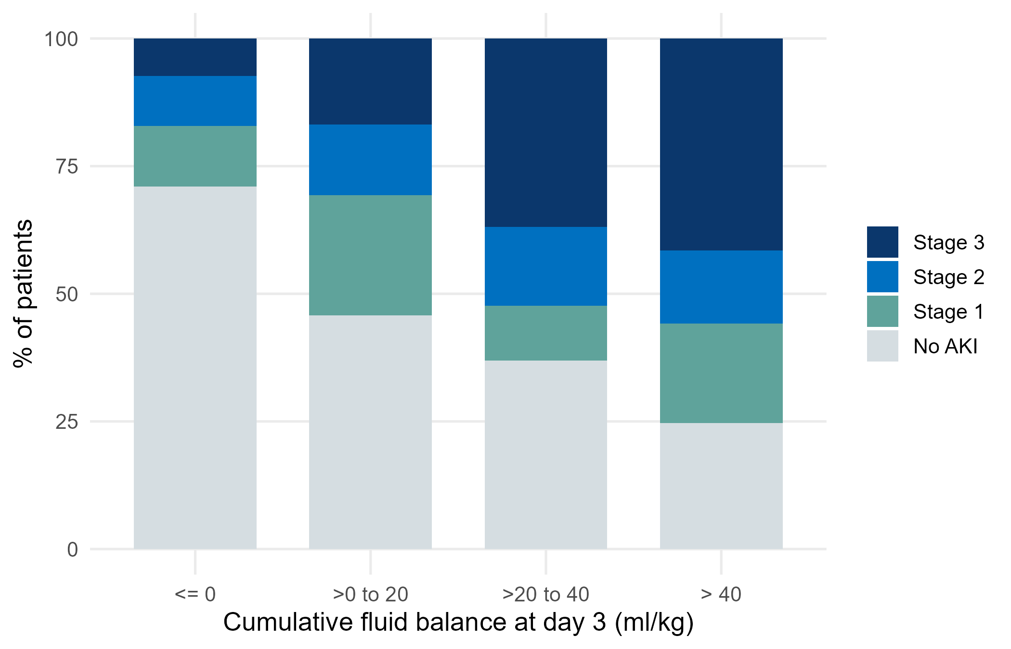
Figure 1. Maximum AKI stage by category of cumulative fluid balance
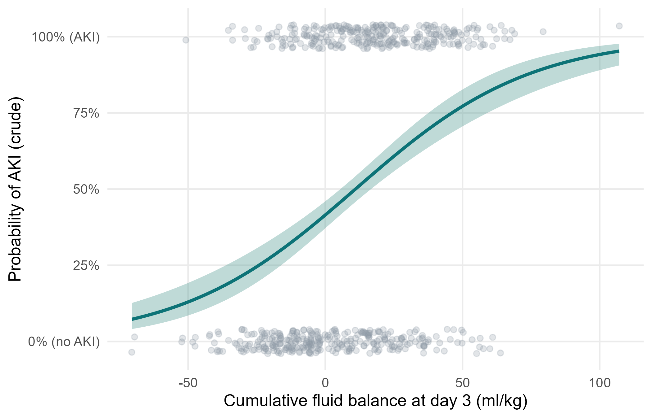
Figure 2. Crude probability of AKI across the range of fluid balance (logistic curve, 95% band)
5. What this means (plain language)
• AKI was more common the more positive the fluid balance: a clear 'dose-response' pattern.
• After adjustment, each extra 10 ml/kg (about 650 ml for a 65 kg adult) was associated with about 27% higher odds of AKI.
• Using the continuous balance keeps more information than positive/negative and shows the gradient.
6. What this does NOT mean
• It does NOT show that fluid damages the kidney. The arrow may point the other way: AKI reduces urine output, and low output makes the balance positive (reverse causation).
• We do not know whether AKI started before or after the fluid accumulated - the data record the maximum stage over days 1-7.
• An OR of 1.27 per 10 ml/kg is not a risk: with AKI this common (about 49%), odds ratios overstate risk ratios.
7. Limitations to discuss (hints)
• Timing: exposure (days 1-3) and outcome (days 1-7) overlap.
• Residual confounding by severity and nephrotoxic drugs (not recorded).
• KDIGO staging may be based on creatinine, which fluid dilutes - AKI may be under-diagnosed in patients with large positive balances.
• Complete-case analysis (lactate missing in 15%).
Which STROBE items this pack helps you write
• Item 6-7: participants and variable definitions (KDIGO)
• Item 12: methods incl. continuous exposure scaling (per 10 ml/kg)
• Item 14: descriptive data (Table 1)
• Item 15: outcome data (Tables 2-3)
• Item 16: crude and adjusted ORs with 95% CI; category boundaries reported (Table 3-4)
• Item 19: limitations - reverse causation and timing
• Item 17: secondary outcome AKI stage 2-3

