Results pack Q3: Cumulative fluid balance and ventilator-free days
FLUID-ICU is a SIMULATED dataset made for teaching. No real patients. Neudata | Foundations of Clinical Research, Level 2
SIMULATED DATA: NOT REAL PATIENTS. FLUID-ICU was generated by computer for this course. Write your manuscript as a training exercise and state clearly that the data are simulated.
1. The question
In adults with sepsis in the ICU, is a higher cumulative fluid balance by day 3 associated with fewer ventilator-free days to day 28?
2. Design and data
• Design: multicentre prospective cohort study (observational).
• Setting: 4 ICUs (ICU A-D), consecutive adults with sepsis, enrolment January 2023 to December 2024.
• Exposure: cumulative fluid balance at day 3 per 10 ml/kg (continuous); secondary: positive vs negative.
• Outcome: ventilator-free days (VFD) to day 28: days alive and free of mechanical ventilation; patients who died = 0; never ventilated and alive = 28 (vent_free_days_28).
• Analysis sample: 618 patients; adjusted models 527 complete cases; 313 were ventilated on admission.
• Pre-specified confounders (SAP): age, SOFA score, lactate, vasopressor, mechanical ventilation, chronic kidney disease.
• Software: R 4.6 (packages gtsummary, survival, mice). Scripts: Course/Data/R/.
Participant flow: 620 patients enrolled -> 2 without a day-3 fluid balance (weight or output missing after cleaning) -> 618 in the exposure analysis -> 91 without lactate (or age) -> 527 in the complete-case adjusted model.
3. Table 1: who was studied
Table 1. Baseline characteristics by fluid-balance group
Characteristic | Overall  N = 618¹ | Negative balance  N = 245¹ | Positive balance  N = 373¹
Age, years | 62.6 (15.2) | 64.6 (15.0) | 61.4 (15.2)
Missing | 1 | 1 | 0
Sex
Female | 243 (39%) | 102 (42%) | 141 (38%)
Male | 375 (61%) | 143 (58%) | 232 (62%)
Weight, kg | 64.7 (11.9) | 65.1 (12.4) | 64.4 (11.6)
Diabetes | 158 (26%) | 70 (29%) | 88 (24%)
Chronic kidney disease | 64 (10%) | 28 (11%) | 36 (9.7%)
Heart failure | 97 (16%) | 54 (22%) | 43 (12%)
Hypertension | 282 (46%) | 124 (51%) | 158 (42%)
Source of infection
Respiratory | 267 (43%) | 101 (41%) | 166 (45%)
Urinary | 126 (20%) | 54 (22%) | 72 (19%)
Abdominal | 106 (17%) | 46 (19%) | 60 (16%)
Skin/soft tissue | 57 (9.2%) | 18 (7.3%) | 39 (10%)
Other | 62 (10%) | 26 (11%) | 36 (9.7%)
SOFA score | 7 (5, 9) | 6 (4, 8) | 8 (6, 10)
APACHE II score | 19 (15, 24) | 17 (12, 21) | 20 (17, 25)
Missing | 6 | 3 | 3
Lactate, mmol/L | 2.6 (1.7, 3.7) | 2.2 (1.4, 3.0) | 2.9 (1.9, 4.0)
Missing | 91 | 50 | 41
Mean arterial pressure, mmHg | 73 (66, 80) | 76 (70, 84) | 71 (65, 78)
Missing | 4 | 1 | 3
Vasopressor on admission | 266 (43%) | 61 (25%) | 205 (55%)
Mechanical ventilation | 313 (51%) | 97 (40%) | 216 (58%)
¹Mean (SD); n (%); Median (Q1, Q3)
Mean (SD); n (%); median (Q1, Q3). Missing = number of patients without that value.
4. Main results
• VFD median (IQR): positive balance 20 (0 to 28) vs negative 28 (22 to 28) days; Mann-Whitney p <0.001.
• Linear regression, crude: -1.48 (95% CI -1.84 to -1.13) days per 10 ml/kg.
• Linear regression, adjusted: -0.61 (95% CI -1.00 to -0.21) days per 10 ml/kg, p 0.003.
• Positive vs negative balance, adjusted difference: -2.78 (95% CI -4.76 to -0.80) days.
Table 2. Ventilator-free days by fluid-balance group
Summary | Negative balance | Positive balance
n | 245 | 373
VFD, median (IQR) | 28 (22 to 28) | 20 (0 to 28)
VFD, mean (SD) | 21.6 (10.5) | 15.2 (12.4)
VFD = 0 (died or ventilated 28 d), n (%) | 45 (18%) | 137 (37%)
VFD = 28 (never ventilated, alive), n (%) | 133 (54%) | 117 (31%)
Ventilated patients: VFD median (IQR) | 23 (0 to 25) | 12 (0 to 22)
Table 3. Association between fluid balance and ventilator-free days
Model | n | Difference in VFD, days (95% CI) | p
Balance per 10 ml/kg, crude (linear) | 618 | -1.48 (-1.84 to -1.13) | <0.001
Balance per 10 ml/kg, adjusted (linear) | 527 | -0.61 (-1.00 to -0.21) | 0.003
Positive vs negative balance, adjusted (linear) | 527 | -2.78 (-4.76 to -0.80) | 0.006
Positive vs negative balance, Mann-Whitney (Hodges-Lehmann) | 618 | -3.0 (-5.0 to 0.0) | <0.001
Negative = fewer ventilator-free days. Adjusted for age, SOFA, lactate, vasopressor, ventilation, CKD.
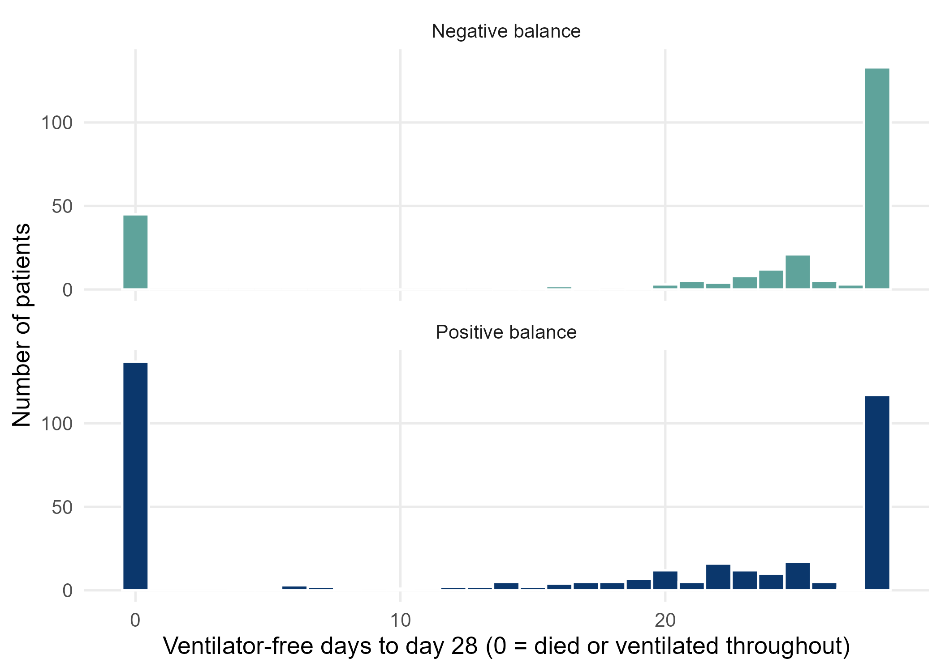
Figure 1. Distribution of ventilator-free days by group (note the two spikes at 0 and 28)
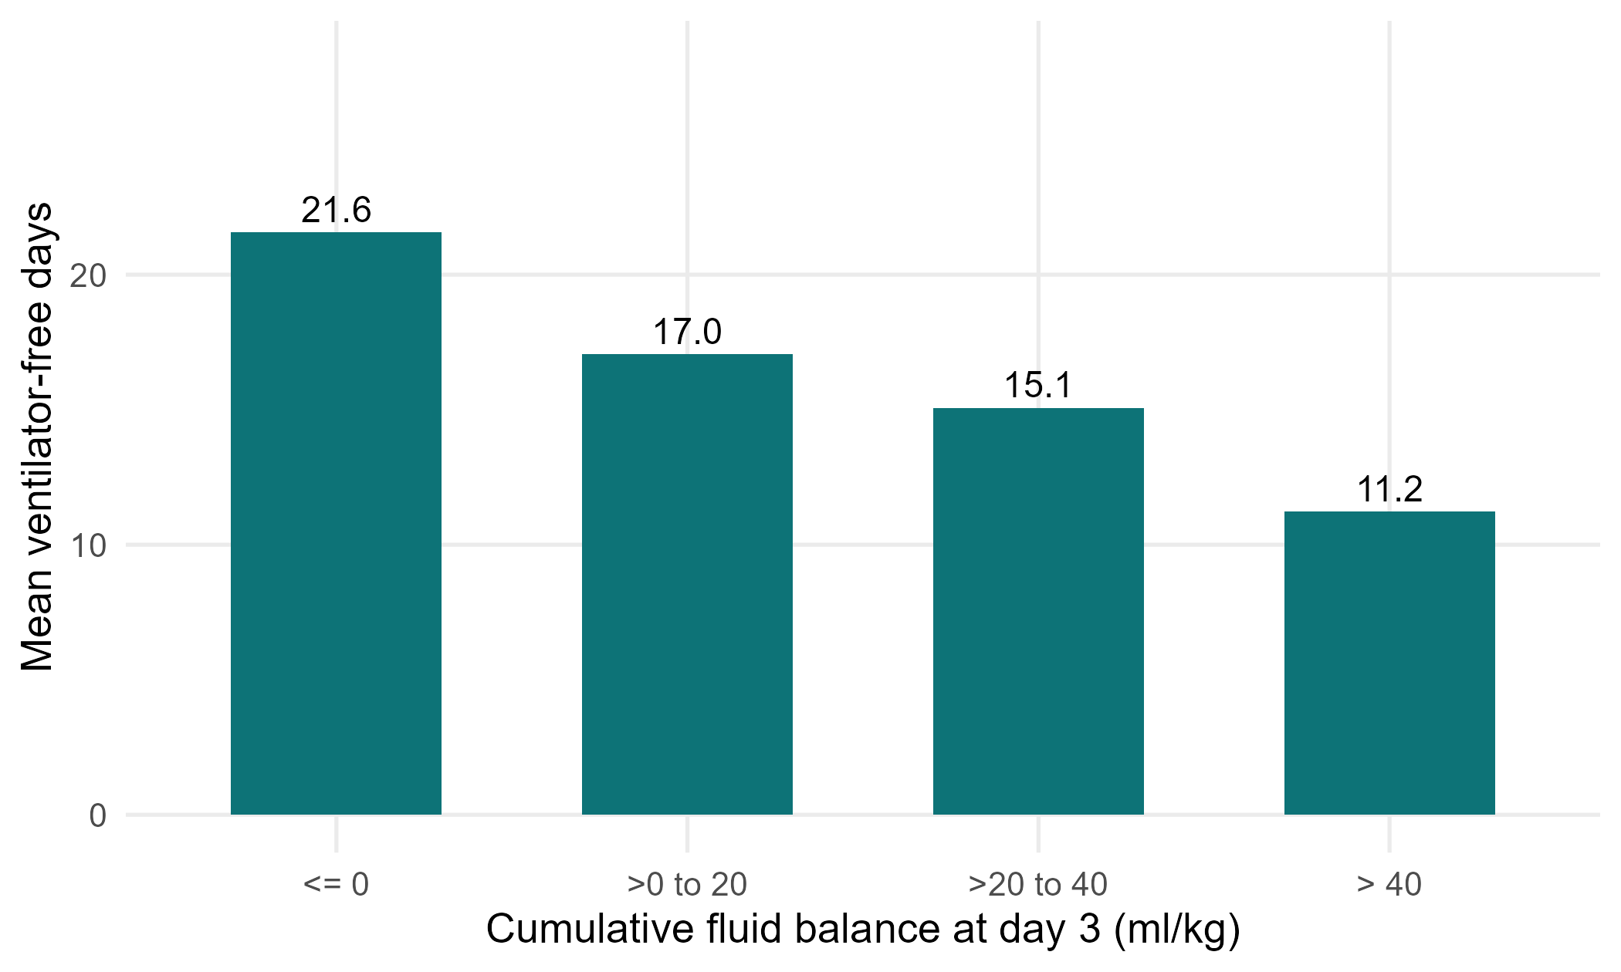
Figure 2. Mean ventilator-free days by category of cumulative fluid balance
5. What this means (plain language)
• Patients with more fluid on board had fewer days alive and off the ventilator.
• After adjustment, each extra 10 ml/kg was associated with about 0.6 fewer ventilator-free days (95% CI 0.2 to 1.0).
• VFD is not a normal-shaped number: many patients are at 0 (died) or 28 (never ventilated). The median and Mann-Whitney test describe it honestly; the linear model gives an easy-to-read average difference but its assumptions are strained.
6. What this does NOT mean
• It does NOT mean fluid keeps patients on the ventilator: VFD mixes death and ventilation time, and sicker patients get more fluid.
• A difference in mean VFD is not the same as 'each patient was ventilated one day longer'.
7. Limitations to discuss (hints)
• Composite outcome: a VFD of 0 can mean early death or 28 days on the ventilator. Say which drives the result.
• Skewed, bounded outcome: linear regression is approximate; consider the Mann-Whitney result or a proportional-odds model as sensitivity.
• Residual confounding by severity; respiratory infections both raise ventilation and may change fluid practice.
• Complete-case analysis (lactate missing).
Which STROBE items this pack helps you write
• Item 7: define the composite outcome VFD precisely
• Item 12: methods (why non-parametric and linear models)
• Item 14: descriptive data (Table 1)
• Item 15-16: outcome summaries and adjusted differences with 95% CI
• Item 19: limitations of a composite, skewed outcome

