Results pack Q5: Fluid balance and ICU length of stay in survivors
FLUID-ICU is a SIMULATED dataset made for teaching. No real patients. Neudata | Foundations of Clinical Research, Level 2
SIMULATED DATA: NOT REAL PATIENTS. FLUID-ICU was generated by computer for this course. Write your manuscript as a training exercise and state clearly that the data are simulated.
1. The question
Among adults with sepsis who survived to day 28, is a positive cumulative fluid balance by day 3 associated with a longer ICU stay?
2. Design and data
• Design: multicentre prospective cohort study (observational); analysis restricted to 28-day survivors.
• Setting: 4 ICUs (ICU A-D), consecutive adults with sepsis, enrolment January 2023 to December 2024.
• Exposure: positive vs negative cumulative fluid balance at day 3; secondary: per 10 ml/kg.
• Outcome: ICU length of stay in days (icu_los_days), right-skewed.
• Analysis sample: 439 survivors with a day-3 balance (239 positive, 200 negative); adjusted model 366 complete cases.
• Pre-specified confounders (SAP): age, SOFA score, lactate, vasopressor, mechanical ventilation, chronic kidney disease.
• Software: R 4.6 (packages gtsummary, survival, mice). Scripts: Course/Data/R/.
3. Table 1: who was studied
Table 1. Baseline characteristics of 28-day survivors by fluid-balance group
Characteristic | Overall  N = 439¹ | Negative balance  N = 200¹ | Positive balance  N = 239¹
Age, years | 61.3 (14.7) | 63.8 (14.6) | 59.1 (14.6)
Missing | 1 | 1 | 0
Sex
Female | 178 (41%) | 85 (43%) | 93 (39%)
Male | 261 (59%) | 115 (58%) | 146 (61%)
Weight, kg | 64.5 (11.8) | 64.7 (12.5) | 64.2 (11.3)
Diabetes | 108 (25%) | 54 (27%) | 54 (23%)
Chronic kidney disease | 33 (7.5%) | 16 (8.0%) | 17 (7.1%)
Heart failure | 60 (14%) | 43 (22%) | 17 (7.1%)
Hypertension | 196 (45%) | 102 (51%) | 94 (39%)
Source of infection
Respiratory | 191 (44%) | 84 (42%) | 107 (45%)
Urinary | 99 (23%) | 45 (23%) | 54 (23%)
Abdominal | 71 (16%) | 37 (19%) | 34 (14%)
Skin/soft tissue | 36 (8.2%) | 15 (7.5%) | 21 (8.8%)
Other | 42 (9.6%) | 19 (9.5%) | 23 (9.6%)
SOFA score | 7 (5, 9) | 6 (4, 7) | 8 (5, 10)
APACHE II score | 18 (13, 22) | 16 (12, 20) | 19 (15, 23)
Missing | 5 | 3 | 2
Lactate, mmol/L | 2.3 (1.6, 3.4) | 2.1 (1.4, 2.9) | 2.6 (1.8, 3.6)
Missing | 73 | 45 | 28
Mean arterial pressure, mmHg | 75 (68, 82) | 78 (71, 85) | 73 (67, 79)
Missing | 3 | 1 | 2
Vasopressor on admission | 152 (35%) | 39 (20%) | 113 (47%)
Mechanical ventilation | 189 (43%) | 67 (34%) | 122 (51%)
¹Mean (SD); n (%); Median (Q1, Q3)
Mean (SD); n (%); median (Q1, Q3). Missing = number of patients without that value.
4. Main results
• ICU stay is right-skewed: in survivors mean 7.5 vs median 6.2 days.
• Median (IQR) ICU stay: positive balance 7.5 (5.2 to 11.2) vs negative 4.8 (3.3 to 7.1) days; Mann-Whitney p <0.001.
• Hodges-Lehmann difference: 2.5 (95% CI 1.8 to 3.2) days.
• Log-linear regression: crude ratio of geometric means 1.50 (95% CI 1.34 to 1.68); adjusted 1.24 (95% CI 1.10 to 1.39), p <0.001 (i.e. about 24% longer stay).
• Per 10 ml/kg more balance: ratio 1.06 (95% CI 1.03 to 1.08).
Table 2. ICU length of stay in survivors by fluid-balance group
Summary | Negative balance | Positive balance
n | 200 | 239
Median (IQR), days | 4.8 (3.3 to 7.1) | 7.5 (5.2 to 11.2)
Mean (SD), days | 6.0 (4.6) | 8.7 (5.0)
Range, days | 1.2 to 41.9 | 1.2 to 27.9
Geometric mean, days | 4.9 | 7.4
Table 3. Association between fluid balance and ICU length of stay (survivors)
Analysis | n | Estimate (95% CI) | p
Mann-Whitney (Hodges-Lehmann difference, days) | 439 | 2.5 (1.8 to 3.2) | <0.001
Log-linear, crude (ratio of geometric means) | 439 | 1.50 (1.34 to 1.68) | <0.001
Log-linear, adjusted (ratio of geometric means) | 366 | 1.24 (1.10 to 1.39) | <0.001
Log-linear, adjusted, per 10 ml/kg (ratio) | 366 | 1.06 (1.03 to 1.08) | <0.001
Ratio of geometric means: 1.24 = 24% longer typical stay. Adjusted for age, SOFA, lactate, vasopressor, ventilation, CKD.
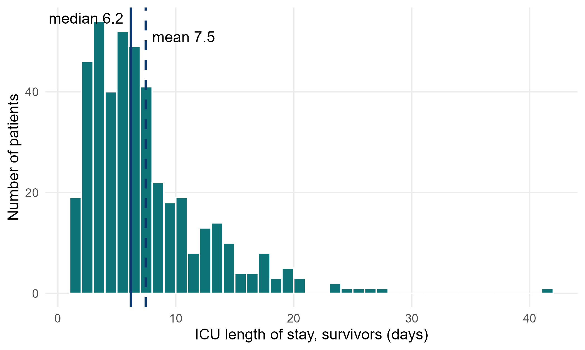
Figure 1. ICU length of stay in survivors: a long right tail pulls the mean above the median
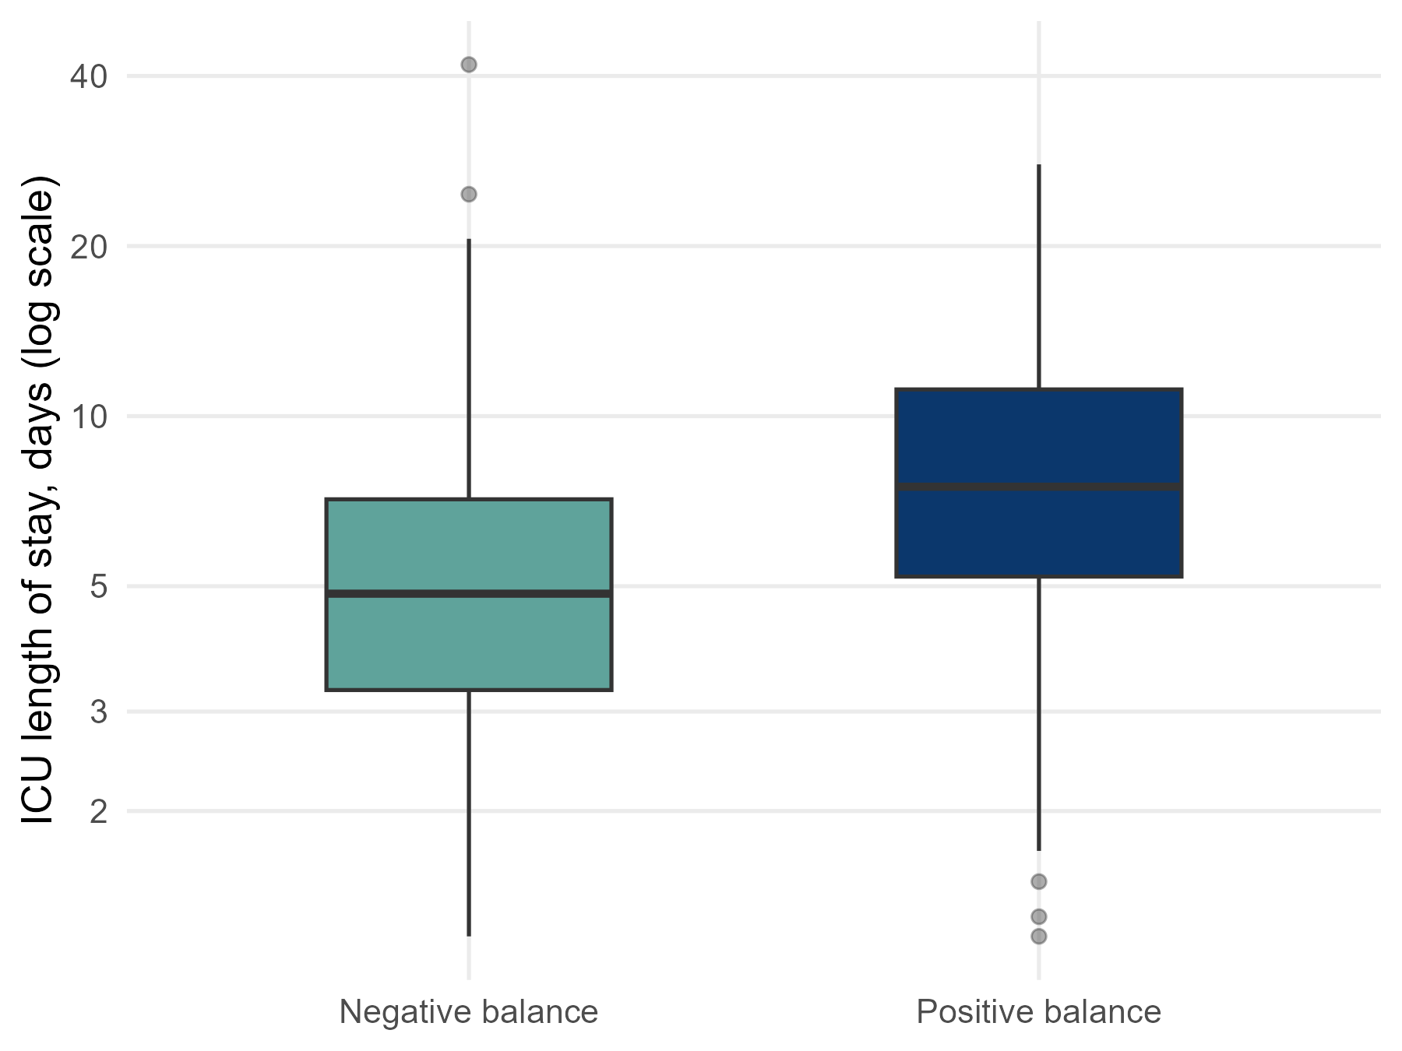
Figure 2. ICU length of stay by fluid-balance group (log scale)
5. What this means (plain language)
• Among survivors, those with a positive balance stayed longer in the ICU, by about 2-3 days in the median.
• After adjustment, the typical (geometric mean) stay was about 24% longer.
• For a skewed outcome, report the median (IQR), use a rank test or analyse the log of the stay, and present a ratio.
6. What this does NOT mean
• It does NOT show that fluid prolongs ICU stay; patients who stay longer have more time and reasons to receive fluid (reverse causation).
• It does NOT describe all patients: deaths were excluded, and death shortens the stay.
7. Limitations to discuss (hints)
• Selection: restricting to survivors conditions on an outcome that is itself related to fluid (survivor bias). An alternative is 'ICU-free days', which counts death as 0.
• ICU discharge depends on bed pressure and local practice, not only on the patient.
• Residual confounding by severity; complete-case adjusted model.
Which STROBE items this pack helps you write
• Item 6: participants (why survivors only)
• Item 12: methods for a skewed outcome (log transformation / non-parametric)
• Item 14: descriptive data (Table 1)
• Item 15-16: medians (IQR) and ratios with 95% CI
• Item 19: limitations (survivor selection)

