Results pack Q1: Positive fluid balance and 28-day mortality
FLUID-ICU is a SIMULATED dataset made for teaching. No real patients. Neudata | Foundations of Clinical Research, Level 2
SIMULATED DATA: NOT REAL PATIENTS. FLUID-ICU was generated by computer for this course. Write your manuscript as a training exercise and state clearly that the data are simulated.
1. The question
In adults with sepsis in the ICU, is a positive cumulative fluid balance by day 3 associated with higher 28-day mortality?
2. Design and data
• Design: multicentre prospective cohort study (observational).
• Setting: 4 ICUs (ICU A-D), consecutive adults with sepsis, enrolment January 2023 to December 2024.
• Exposure: positive cumulative fluid balance at day 3 (fluid in minus fluid out over ICU days 1-3 > 0 ml/kg) vs negative or zero balance.
• Outcome: death from any cause within 28 days of ICU admission (died_28d); time to death for survival analysis (time_to_event_28d, censored at day 28).
• Analysis sample: 618 of 620 patients (2 without a day-3 balance). Adjusted models: 527 complete cases.
• Pre-specified confounders (SAP): age, SOFA score, lactate, vasopressor, mechanical ventilation, chronic kidney disease.
• Software: R 4.6 (packages gtsummary, survival, mice). Scripts: Course/Data/R/.
Participant flow: 620 patients enrolled -> 2 without a day-3 fluid balance (weight or output missing after cleaning) -> 618 in the exposure analysis -> 91 without lactate (or age) -> 527 in the complete-case adjusted model.
3. Table 1: who was studied
Table 1. Baseline characteristics by fluid-balance group
Characteristic | Overall  N = 618¹ | Negative balance  N = 245¹ | Positive balance  N = 373¹
Age, years | 62.6 (15.2) | 64.6 (15.0) | 61.4 (15.2)
Missing | 1 | 1 | 0
Sex
Female | 243 (39%) | 102 (42%) | 141 (38%)
Male | 375 (61%) | 143 (58%) | 232 (62%)
Weight, kg | 64.7 (11.9) | 65.1 (12.4) | 64.4 (11.6)
Diabetes | 158 (26%) | 70 (29%) | 88 (24%)
Chronic kidney disease | 64 (10%) | 28 (11%) | 36 (9.7%)
Heart failure | 97 (16%) | 54 (22%) | 43 (12%)
Hypertension | 282 (46%) | 124 (51%) | 158 (42%)
Source of infection
Respiratory | 267 (43%) | 101 (41%) | 166 (45%)
Urinary | 126 (20%) | 54 (22%) | 72 (19%)
Abdominal | 106 (17%) | 46 (19%) | 60 (16%)
Skin/soft tissue | 57 (9.2%) | 18 (7.3%) | 39 (10%)
Other | 62 (10%) | 26 (11%) | 36 (9.7%)
SOFA score | 7 (5, 9) | 6 (4, 8) | 8 (6, 10)
APACHE II score | 19 (15, 24) | 17 (12, 21) | 20 (17, 25)
Missing | 6 | 3 | 3
Lactate, mmol/L | 2.6 (1.7, 3.7) | 2.2 (1.4, 3.0) | 2.9 (1.9, 4.0)
Missing | 91 | 50 | 41
Mean arterial pressure, mmHg | 73 (66, 80) | 76 (70, 84) | 71 (65, 78)
Missing | 4 | 1 | 3
Vasopressor on admission | 266 (43%) | 61 (25%) | 205 (55%)
Mechanical ventilation | 313 (51%) | 97 (40%) | 216 (58%)
¹Mean (SD); n (%); Median (Q1, Q3)
Mean (SD); n (%); median (Q1, Q3). Missing = number of patients without that value.
Read Table 1 first: the positive-balance group was sicker at baseline: median SOFA 8 (6 to 10) vs 6 (4 to 8), vasopressor 205/373 (55.0%) vs 61/245 (24.9%). This is confounding by indication: sicker patients receive more fluid AND die more.
4. Main results
Table 2. 28-day mortality by fluid-balance group (unadjusted)
Outcome | Negative balance | Positive balance | Effect (95% CI)
Died by day 28, n/N (%) | 45/245 (18.4%) | 134/373 (35.9%) | Risk difference 17.6 (95% CI 10.7 to 24.4); RR 1.96
Survival at day 28 (Kaplan-Meier), % | 81.6 | 64.1 | Log-rank p <0.001
Table 3. Logistic regression for 28-day death: crude and adjusted odds ratios (adjusted model n = 527)
Variable | Crude OR (95% CI) | Crude p | Adjusted OR (95% CI) | Adjusted p
Positive fluid balance (vs negative) | 2.49 (1.70 to 3.70) | <0.001 | 1.62 (1.02 to 2.59) | 0.044
Age, per year | 1.02 (1.01 to 1.03) | <0.001 | 1.02 (1.01 to 1.04) | 0.002
SOFA score, per point | 1.26 (1.18 to 1.35) | <0.001 | 1.10 (1.01 to 1.21) | 0.039
Lactate, per mmol/L | 1.38 (1.23 to 1.55) | <0.001 | 1.15 (1.00 to 1.32) | 0.059
Vasopressor | 3.31 (2.31 to 4.78) | <0.001 | 1.86 (1.20 to 2.88) | 0.005
Mechanical ventilation | 2.98 (2.07 to 4.34) | <0.001 | 1.69 (1.11 to 2.60) | 0.016
Chronic kidney disease | 2.58 (1.52 to 4.36) | <0.001 | 1.85 (1.00 to 3.44) | 0.050
• Crude OR (all 618 patients): 2.49 (95% CI 1.70 to 3.70), p <0.001.
• Crude OR in the same 527 complete cases: 2.22 (95% CI 1.48 to 3.39).
• Adjusted OR (age, SOFA, lactate, vasopressor, ventilation, CKD): 1.62 (95% CI 1.02 to 2.59), p 0.044.
• Kaplan-Meier survival at day 28: 81.6% (negative) vs 64.1% (positive); log-rank p <0.001.
• Cox hazard ratio: crude 2.17 (95% CI 1.55 to 3.05); adjusted 1.46 (95% CI 1.00 to 2.13), p 0.053 (proportional-hazards test, global p = 0.10).
Table 4. Cox regression for time to death within 28 days
Model | n | Events | HR (95% CI) | p
Crude | 618 | 179 | 2.17 (1.55 to 3.05) | <0.001
Adjusted (pre-specified confounders) | 527 | 161 | 1.46 (1.00 to 2.13) | 0.053
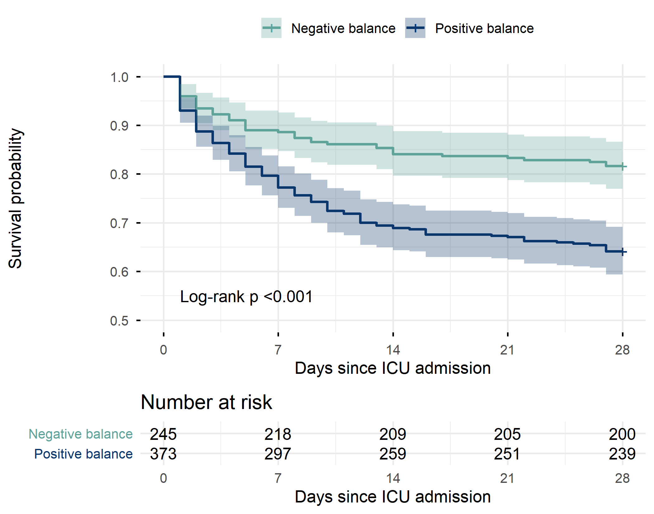
Figure 1. Kaplan-Meier survival to day 28 by fluid-balance group, with numbers at risk
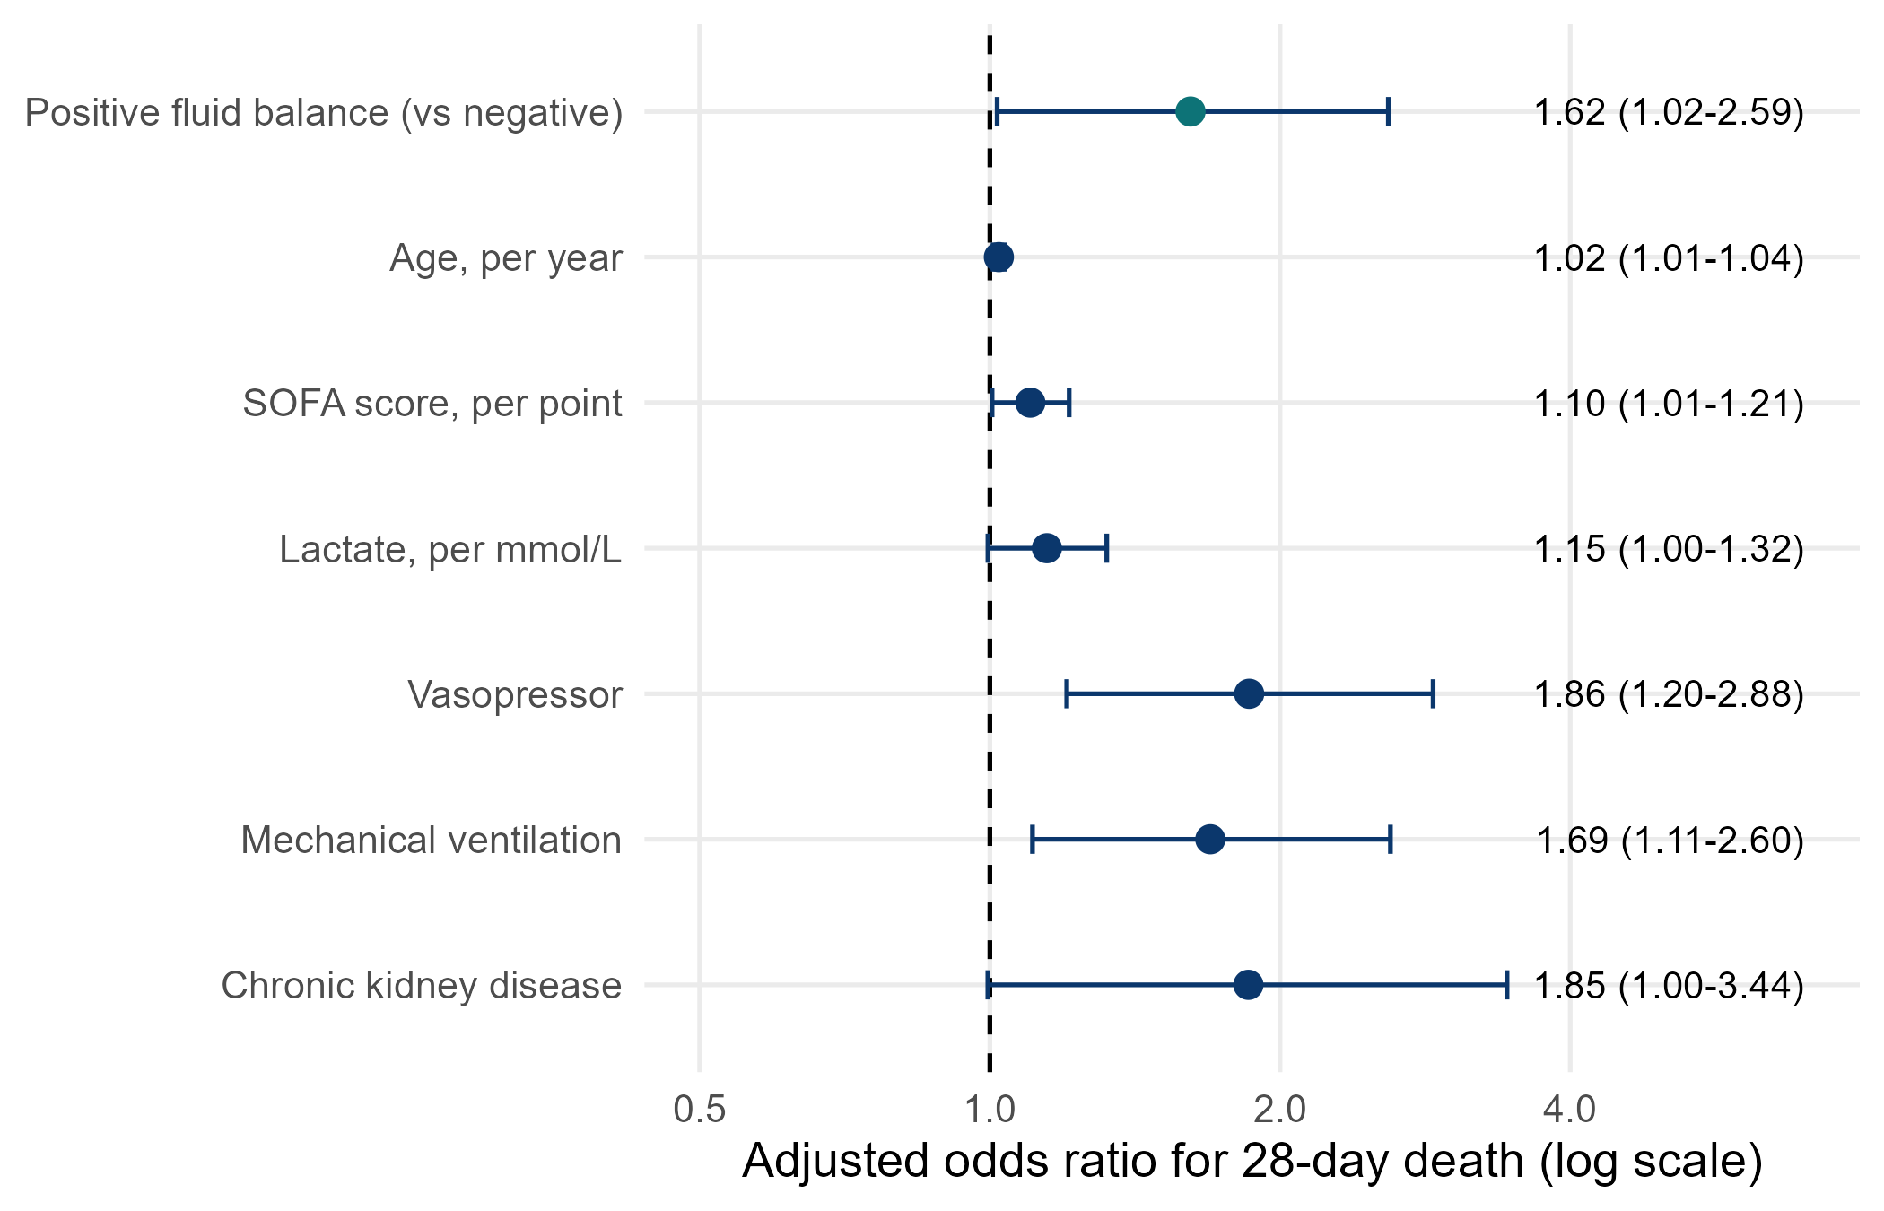
Figure 2. Adjusted odds ratios for 28-day death (forest plot)
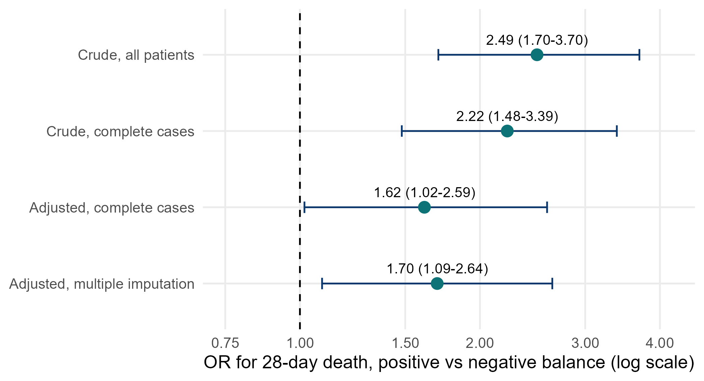
Figure 3. The odds ratio for positive balance before and after adjustment
5. Other analyses
Table 5. Pre-specified effect modification by heart failure
Subgroup | Deaths, negative balance | Deaths, positive balance | Adjusted OR (95% CI) | p for interaction
No heart failure | 34/191 (18%) | 108/330 (33%) | 1.29 (0.77 to 2.19) | 0.031
Heart failure | 11/54 (20%) | 26/43 (60%) | 4.39 (1.65 to 12.38) | 0.031
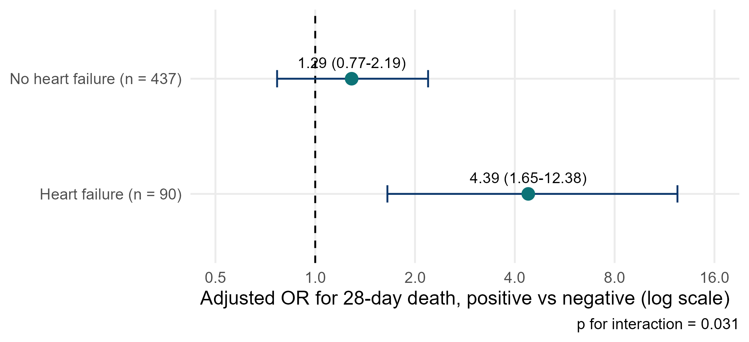
Figure 4. Odds ratio for positive balance in patients with and without heart failure
Table 6. Sensitivity analyses for the primary association
Analysis | n | OR (95% CI) | p
Crude, all patients | 618 | 2.49 (1.70 to 3.70) | <0.001
Crude, complete cases | 527 | 2.22 (1.48 to 3.39) | <0.001
Adjusted, complete cases (main) | 527 | 1.62 (1.02 to 2.59) | 0.044
Adjusted, multiple imputation (m = 20) | 620 | 1.70 (1.09 to 2.64) | 0.020
6. What this means (plain language)
• Patients with a positive fluid balance died more often (36% vs 18%). But they were also sicker.
• After taking severity into account, the association became much smaller (OR fell from 2.49 to 1.62). Much of the crude difference was confounding by indication.
• A modest association remained: the 95% CI only just excludes 1, and the Cox model gives a similar HR whose CI just touches 1. The evidence is weak-to-moderate, not strong.
• The association looked stronger in patients with heart failure (p for interaction 0.031). This was pre-specified but is based on only 90 patients with heart failure, so treat it as a hypothesis.
7. What this does NOT mean
• It does NOT show that fluid CAUSES death. This is an observational study: write 'associated with', not 'caused' or 'increased'.
• It does NOT tell clinicians to restrict fluid. Only a randomised trial (like Paper 1) can test a fluid strategy.
• A p-value of 0.044 is not 'proof'; a CI from 1.02 to 2.59 is compatible with a tiny or a large effect.
8. Limitations to discuss (hints)
• Residual confounding: SOFA and lactate measure severity imperfectly; unmeasured severity may explain the remaining association.
• Reverse causation: patients who do badly (shock, oliguria) accumulate fluid because they are dying, not the other way round.
• Fluid balance is measured over days 1-3; patients who died before day 3 had less time to accumulate fluid (immortal-time issue).
• Missing lactate (15%): the complete-case model lost 91 patients; multiple imputation gave a similar answer (Table 6).
• Insensible losses are not recorded; the dichotomy positive/negative throws away information (see group 2 for the continuous version).
Which STROBE items this pack helps you write
• Item 4-5: design and setting (section 2)
• Item 6: participants and eligibility
• Item 7: variables (exposure, outcome, confounders and the effect modifier, heart failure)
• Item 12a-e: statistical methods incl. confounding, interaction, missing data, sensitivity analyses
• Item 13: participant numbers (flow sentence)
• Item 14: descriptive data (Table 1, missing data)
• Item 15: outcome data (Table 2)
• Item 16: unadjusted and adjusted estimates with 95% CI (Tables 3-4)
• Item 17: other analyses (subgroup/interaction and sensitivity, Tables 5-6)

