Report title
  - Short descriptive subtitle
Analyst Name
2 October 2026
Abstract
One-paragraph executive summary: the question, the data, the approach and the headline finding. Keep it readable by a non-technical decision-maker.
Contents

1. Introduction
Describe the background, the client’s objective and the questions this report answers.
Key findings
- Finding one, stated plainly with its size and uncertainty.
- Finding two.
- Recommendation or implication for the client.

2. Data and methods
Summarise the data sources, inclusion criteria, variables and statistical methods. Refer to the statistical analysis plan for full detail.

3. Results

3.1 Descriptive summary
Table 1 summarises the example data.
Table 1: Mean tooth length by supplement and dose (example data).
Supplement | Dose (mg/day) | Mean length
OJ | 0.5 | 13.2
VC | 0.5 | 8.0
OJ | 1.0 | 22.7
VC | 1.0 | 16.8
OJ | 2.0 | 26.1
VC | 2.0 | 26.1

3.2 Main analysis
Figure 1 shows the relationship using the Neudata palette.
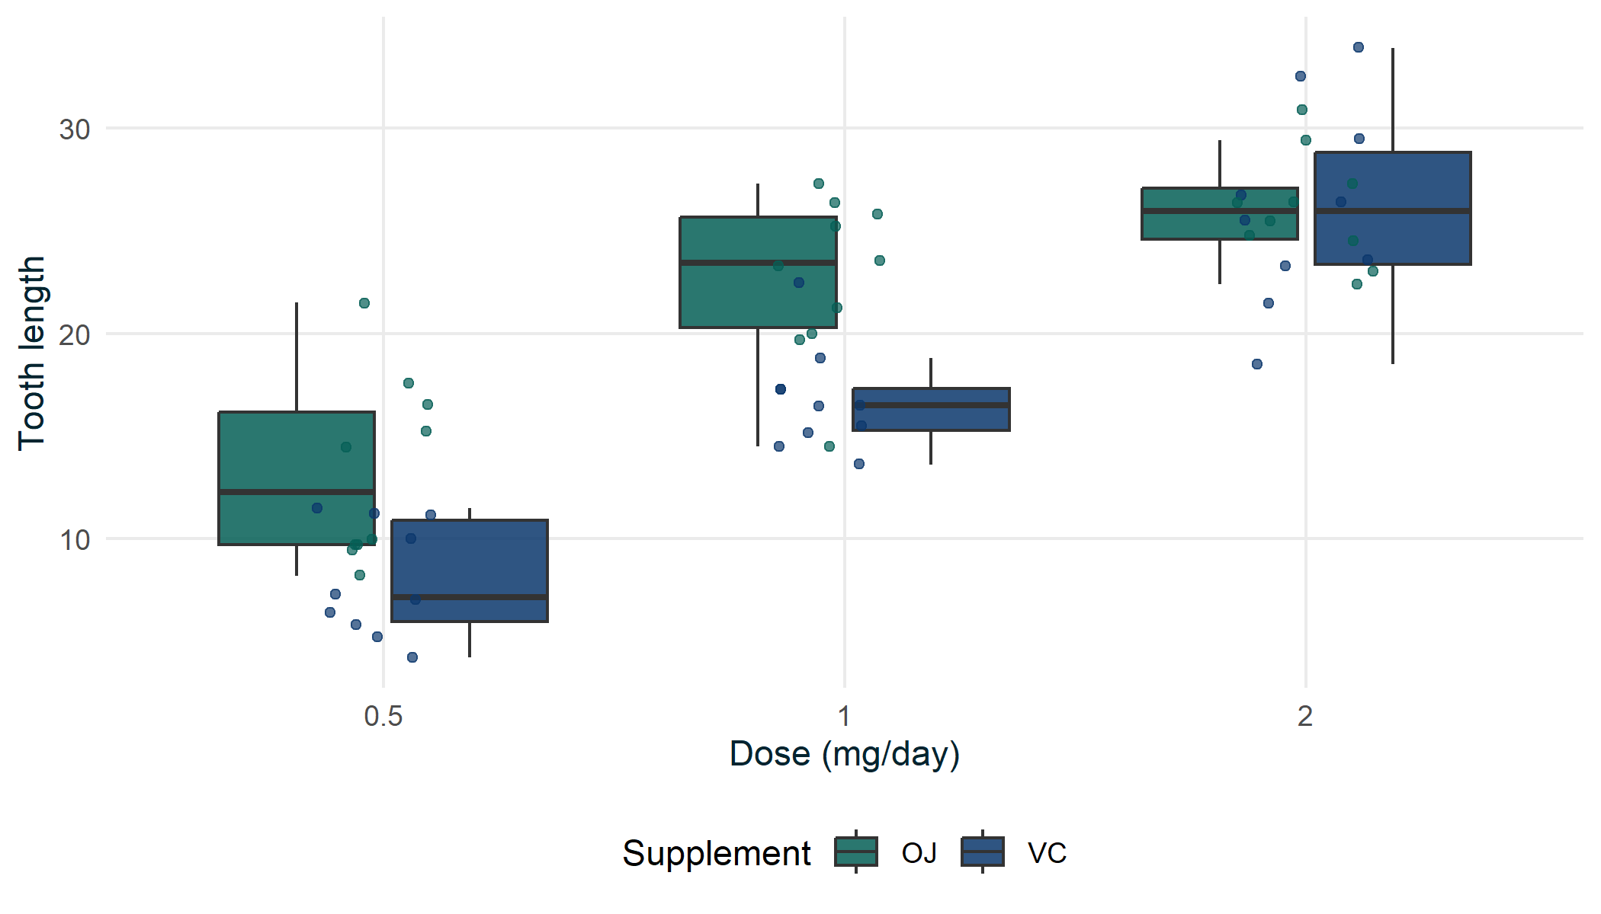
Figure 1: Tooth length by dose and supplement (example data).

4. Discussion
Interpret the results, note limitations and set out recommendations.
 Reproducibility
This report was generated from code. Software versions are listed in the appendix.

5. Appendix
sessionInfo()$R.version$version.string
[1] "R version 4.6.1 (2026-06-24 ucrt)"

