Concepts of Biostatistics and Data Science
  - Participant workbook for the two-day crash course with practical analysis in R
Neudata Consulting Ltd · Version 1.0 · 26-10-2026
Name: ______________________________ Date: ____________________

How to use this workbook
This workbook accompanies the two-day crash course in the concepts of biostatistics and data science, and follows its practical sessions. Each exercise names the R script it belongs to. The scripts contain worked examples with comments; the exercises ask you to adapt that code to a new question and to interpret the result in words. Write your answers in the boxes.
- Core exercises (numbered 1.1, 2.1 ...) form the guided pathway. Everyone should aim to complete them.
- Extensions (E1.1, E2.1 ...) are optional, for participants who finish early or have more experience.
- Always write the interpretation, not only the number. A good answer gives the estimate, its 95% CI, and what it means.
- The reference section at the end contains the cheat sheet, decision diagrams and method-selection guide.
The Healthy Hearts District Study is simulated. Its results are for teaching only and must not be quoted as findings about real people.

Getting started in RStudio
- Open Concepts-of-Biostatistics-and-Data-Science.Rproj (double-click). This sets the working folder.
- Open a script from the Files pane (bottom right), folder R.
- Put the cursor on a line and press Ctrl+Enter (Cmd+Enter on a Mac) to run it. Results appear in the Console (bottom left), plots in the Plots pane.
- Run lines in order from the top. If you get an error, read the message, check spelling and brackets, and check that earlier lines were run.
- Type your own code at the bottom of each script, under "Your turn". Save with Ctrl+S.
Symbol | Meaning | Example
<- | Store a result under a name | fit <- lm(sbp_0 ~ age, data = hearts)
~ | "is modelled by" / "by group" | t.test(sbp_0 ~ sex, data = hearts)
|> | Pass the result on to the next step | hearts |> count(district)
$ | One column of a data frame | hearts$age
na.rm = TRUE | Ignore missing values | mean(hearts$crp, na.rm = TRUE)
?name | Open the help page | ?t.test

The data
480 adults aged 30 to 74 from four districts were measured at baseline and randomly allocated to standard advice or a lifestyle programme. Blood pressure, satisfaction, adverse events and clinic visits were recorded over 12 months. Some participants left early.
Variable | Description | Type | Units or coding | Missing
id | Participant identifier | Identifier | HH001 to HH480 | 0
district | District of residence | Nominal (4 categories) | North; South; East; West | 0
sex | Sex | Binary | Female; Male | 0
age | Age at baseline | Continuous | Years (30 to 74) | 0
education | Highest education level | Ordinal (3 categories) | Primary or less; Secondary; Tertiary | 6
smoker | Current smoker at baseline | Binary | No; Yes | 0
activity_min | Moderate physical activity | Continuous (right-skewed) | Minutes per week | 7
diet_score | Healthy eating score | Discrete score (treated as continuous) | 0 (least healthy) to 10 (most healthy) | 0
bmi | Body mass index at baseline | Continuous | kg/m2 | 10
sbp_0 | Systolic blood pressure at baseline | Continuous | mmHg | 0
high_bp_0 | High blood pressure at baseline | Binary | Yes if sbp_0 >= 140 mmHg; otherwise No | 0
crp | C-reactive protein at baseline | Continuous (right-skewed) | mg/L | 14
programme | Randomised group | Binary | Standard advice; Lifestyle programme | 0
sbp_12 | Systolic blood pressure at 12 months | Continuous | mmHg | 41
high_bp_12 | High blood pressure at 12 months | Binary | Yes if sbp_12 >= 140 mmHg; otherwise No | 41
satisfaction | Satisfaction with care at 12 months | Ordinal (5 levels) | 1 = very dissatisfied to 5 = very satisfied | 41
adverse_event | Minor injury reported during follow-up | Binary | No; Yes | 0
clinic_visits | Unplanned clinic visits during follow-up | Count | Number of visits | 0
followup_months | Months of follow-up | Continuous (exposure time) | Months (2 to 12) | 0

Day 1 practical: understanding data and making comparisons

Part A. Import and inspect (script 01_import_and_inspect.R, 25 minutes)

Exercise 1.1. Import the raw data
Run the first sections of the script to import data/hearts_raw.csv.
a) How many participants (rows) and variables (columns) are there?
Your answer

b) What does one row represent? Which two variables are measurements of the same thing on the same person at different times?
Your answer

Exercise 1.2. Find and fix missing values
Use summary(raw) and colSums(is.na(raw)).
a) Which variables have missing values, and how many?
Your answer

b) What problem do you see in activity_min? How does the script fix it? How many missing values does activity_min have after the fix?
Your answer

c) 41 people have no 12-month blood pressure. Why might this matter for the results?
Your answer

Exercise 1.3. Variable types
Classify each variable. Use: continuous, count, binary, nominal, ordinal.
Variable | Type | Variable | Type
district |  | satisfaction
age |  | clinic_visits
education |  | crp
smoker |  | high_bp_0
sbp_0 |  | followup_months

Part B. Describe and plot (script 02_describe_and_plot.R, 30 minutes)

Exercise 1.4. Counts and proportions
Use count() and mutate() as in the script.
count(hearts, smoker) |> mutate(percent = round(100 * n / sum(n), 1))

a) What number and percentage of participants smoke? Write it as n / N (%).
Your answer

b) What percentage have tertiary education? State your denominator and why.
Your answer

Exercise 1.5. Centre and spread
Calculate the mean, SD, median and IQR of sbp_0 and of crp (remember na.rm = TRUE).
a) Fill in: SBP mean ____ (SD ____), median ____ (IQR ____ to ____). CRP mean ____ (SD ____), median ____ (IQR ____ to ____).
Your answer

b) Which summary would you report for each variable, and why?
Your answer

Exercise 1.6. Plots
Make a histogram of bmi and a boxplot of crp by smoker. Try adding scale_y_log10() to the boxplot.
ggplot(hearts, aes(x = bmi)) + geom_histogram(binwidth = 1)
ggplot(hearts, aes(x = smoker, y = crp)) + geom_boxplot() + scale_y_log10()

Describe the shape of the BMI distribution, and what the boxplot suggests about CRP in smokers and non-smokers. Why is the log scale helpful here?
Your answer

Part C1. Compare groups (script 03_compare_groups.R, 35 minutes)
For each comparison, first write the question, the outcome type, the groups, and whether the data are independent or paired.

Exercise 1.7. Two independent groups
Does mean BMI differ between women and men? Adapt the t-test code from the script.
t.test(bmi ~ sex, data = hearts)

a) Report the mean BMI in each group, the difference and its 95% CI.
Your answer

b) Interpret the result in one or two sentences. Does a p-value above 0.05 show that men and women have the same mean BMI?
Your answer

Exercise 1.8. Paired data
Did systolic blood pressure change between baseline and 12 months in the Standard advice group?
std <- hearts |> filter(programme == "Standard advice", !is.na(sbp_12))
t.test(std$sbp_12, std$sbp_0, paired = TRUE)

a) Report the mean change and 95% CI. How many people does it use?
Your answer

b) Compare with the Lifestyle programme group in the script (-6.0 mmHg). Why can we not judge the programme from the within-group change alone? What comparison does?
Your answer

Exercise 1.9. More than two groups
Does mean BMI differ between the four districts? Summarise by district, then use Welch's ANOVA and Holm-adjusted pairwise comparisons.
oneway.test(bmi ~ district, data = hearts)
pairwise.t.test(hearts$bmi, hearts$district, pool.sd = FALSE, p.adjust.method = "holm")

a) What does the overall test tell you? What does it not tell you?
Your answer

b) Which districts appear to differ? Why adjust the pairwise p-values?
Your answer

Part C2. Categorical associations (script 04_categorical.R, 20 minutes)

Exercise 1.10. A 2 x 2 table
Is high blood pressure at baseline (high_bp_0) associated with sex?
tab_sex <- table(hearts$sex, hearts$high_bp_0)
addmargins(tab_sex)
prop.table(tab_sex, margin = 1)
chisq.test(tab_sex)

a) Write the proportion with high BP in each sex as n / N (%).
Your answer

b) Calculate the prevalence ratio and the odds ratio (men compared with women). Why are they different? Which word should you use: risk or prevalence? Why?
Your answer

c) Interpret the chi-square test.
Your answer

Exercise 1.11. A larger table
Does the prevalence of high BP differ between districts? Make a 4 x 2 table, row proportions and a chi-square test.
Which districts have the highest and lowest prevalence? What does the chi-square test tell you, and what does it not tell you?
Your answer

Day 1 extensions (optional)

Extension E1.1. Kruskal-Wallis
Compare activity_min across education levels with medians (IQR) and kruskal.test(). What does the test compare? Is it a test of medians?

Extension E1.2. An ordinal outcome
Compare satisfaction between women and men. Show the percentage at each level, then use wilcox.test(). Why is a mean less suitable here?

Extension E1.3. Student or Welch?
Compare summary(aov(sbp_0 ~ district, data = hearts)) with oneway.test(sbp_0 ~ district, data = hearts). When would the two disagree?

Extension E1.4. McNemar's test
In the Standard advice group, cross-tabulate high_bp_0 and high_bp_12 and run mcnemar.test(). Which cells matter? Compare with the Lifestyle group in the script.

Extension E1.5. Confounding by age
Create age_group (30-49, 50-74) with cut(age, c(29, 49, 74)). Estimate the smoking-high BP OR in each age group and the Mantel-Haenszel OR (mantelhaen.test()). Compare with the crude OR of 3.39. What do you conclude?

Extension E1.6. Small counts
In the script, look at adverse events among participants aged 65 and over. Why is Fisher's exact test preferred here, and how would you describe the result?

Day 2 practical: regression and an introduction to data science

Part A. Correlation and linear regression (script 05_correlation_regression.R, 50 minutes)

Exercise 2.1. Scatterplot and correlation
Plot sbp_0 against bmi and calculate Pearson's and Spearman's correlations.
ggplot(hearts, aes(x = bmi, y = sbp_0)) + geom_point(alpha = 0.4)
cor.test(~ sbp_0 + bmi, data = hearts)
cor.test(~ sbp_0 + bmi, data = hearts, method = "spearman", exact = FALSE)

Describe the relationship (direction, form, strength). Report r with its 95% CI. Does this show that BMI raises blood pressure?
Your answer

Exercise 2.2. Simple linear regression
Fit lm(sbp_0 ~ bmi, data = hearts). Then create bmi5 = bmi / 5 and refit.
hearts <- hearts |> mutate(bmi5 = bmi / 5)
fit_bmi <- lm(sbp_0 ~ bmi, data = hearts)
tidy(fit_bmi, conf.int = TRUE); glance(fit_bmi)
par(mfrow = c(2, 2)); plot(fit_bmi); par(mfrow = c(1, 1))

a) Interpret the slope per 1 kg/m2 and per 5 kg/m2, with 95% CIs.
Your answer

b) What is R-squared and what does it mean here?
Your answer

c) What do the residual plots show? Are the assumptions reasonable?
Your answer

Exercise 2.3. Confounding
Is smoking associated with SBP? Fit a crude model and one adjusted for age and sex.
fit_s0 <- lm(sbp_0 ~ smoker, data = hearts)
fit_s1 <- lm(sbp_0 ~ smoker + age + sex, data = hearts)
tidy(fit_s0, conf.int = TRUE); tidy(fit_s1, conf.int = TRUE)

a) Report the crude and adjusted differences in SBP for smokers. Why did the estimate change?
Your answer

b) Interpret the adjusted coefficient in one sentence starting "Among people of the same ...".
Your answer

c) A colleague suggests also adjusting for CRP, which smoking raises. Is CRP a confounder or more like a mediator here? What would adjusting for it do? Draw a small diagram.
Your answer

Exercise 2.4. Plot a fitted relationship
Fit lm(sbp_0 ~ bmi + age + sex, data = hearts) and plot predicted SBP against BMI for women and men aged 50, following section E of the script.
What does the plot show? What does the model assume about the BMI slope in women and men?
Your answer

Part B. Logistic and Poisson regression (script 06_logistic_poisson.R, 20 minutes, guided)

Exercise 2.5. Logistic regression
Model high BP at baseline using BMI (per 5 kg/m2), age (per 10 years) and sex.
hearts <- hearts |> mutate(age10 = age / 10, bmi5 = bmi / 5)
fit_lb <- glm(high_bp_0 ~ bmi5 + age10 + sex, family = binomial, data = hearts)
tidy(fit_lb, conf.int = TRUE, exponentiate = TRUE)

a) Interpret the aOR for bmi5 with its 95% CI.
Your answer

b) Why should this aOR not be described as "times the risk"?
Your answer

Exercise 2.6. Poisson regression
Compare the rate of unplanned clinic visits between smokers and non-smokers, adjusting for age, using an offset for follow-up time.
fit_ps <- glm(clinic_visits ~ smoker + age10 + offset(log(followup_months)),
family = poisson, data = hearts)
tidy(fit_ps, conf.int = TRUE, exponentiate = TRUE)
sum(residuals(fit_ps, type = "pearson")^2) / df.residual(fit_ps)
tidy(update(fit_ps, family = quasipoisson), conf.int = TRUE, exponentiate = TRUE)

a) Interpret the IRR for smoking. Why is the offset needed?
Your answer

b) What does the dispersion ratio show, and how does the quasi-Poisson CI differ?
Your answer

Part C. Clustering (script 07_clustering.R, 20 minutes, guided)

Exercise 2.7. k-means: two or three clusters?
Run the script, then fit k-means with k = 2 on the same scaled variables and describe both solutions.
set.seed(2024)
km2 <- kmeans(life_scaled, centers = 2, nstart = 25)
life$k2 <- factor(km2$cluster)
life |> group_by(k2) |> summarise(n = n(), act = median(activity_min),
diet = mean(diet_score), bmi = mean(bmi))
table(life$k2, life$cluster)

a) Give each cluster a short descriptive name (k = 2 and k = 3).
Your answer

b) Why were the variables scaled? What happened without scaling?
Your answer

c) Give two reasons to be cautious before reporting these clusters as real groups.
Your answer

Day 2 extensions (optional)

Extension E2.1. Analysing a randomised trial
Compare the programme effect estimated from change scores (Welch t-test on sbp_12 - sbp_0) with the baseline-adjusted estimate lm(sbp_12 ~ programme + sbp_0). Which CI is narrower?

Extension E2.2. Train and test
Using the split in section G of script 05, fit lm(sbp_0 ~ age + sex + bmi) on the training data and compare training and test RMSE. Why is test error the honest measure? Give one example of data leakage.

Extension E2.3. Negative binomial
Fit the clinic visits model with MASS::glm.nb() (script 06). Compare the IRR and CI with Poisson and quasi-Poisson.

Extension E2.4. Linkage methods
Repeat the hierarchical clustering with method = "average" and cut at 3 groups. Compare the group sizes with Ward's method. What does this tell you?

Final exercise: choose, plot, conclude (25 minutes)
Work alone or in pairs. Pick ONE question. Use the cheat sheet and decision diagrams, and the template script R/08_final_exercise.R. There is more than one defensible analysis for each question; what matters is that you can justify yours.
 | Question
F1 | Were participants in the lifestyle programme more satisfied with their care at 12 months than those given standard advice?
F2 | Do men and women differ in C-reactive protein (CRP) at baseline?
F3 | Is a healthier diet score associated with lower baseline systolic blood pressure, after allowing for age and sex?
F4 | Was high blood pressure at 12 months less common in the lifestyle programme group than in the standard advice group?

Step 1. Write your question and the outcome, its type, the groups or exposure, and the design (independent or paired; any confounders).
Your answer

Step 2. Which analysis did you choose, and why? Name one alternative and say why you did not choose it.
Your answer

Step 3. Describe the data: give the numbers you will report (with denominators or n).
Your answer

Step 4. Produce one plot that shows the answer. Paste it here or sketch it.
Plot

Step 5. Results: the effect estimate with its 95% CI (and p-value if you wish). What did you check?
Your answer

Step 6. Conclusion in plain language (3 to 5 sentences) for a reader with no statistical training. Include the size of the effect, the uncertainty, whether it matters in practice, and one limitation.
Conclusion

Reference section
The pages below are the same as the stand-alone reference pack in the reference folder (cheat sheet, decision diagrams and method-selection guide). Keep them for use after the course.

Statistics and R cheat sheet
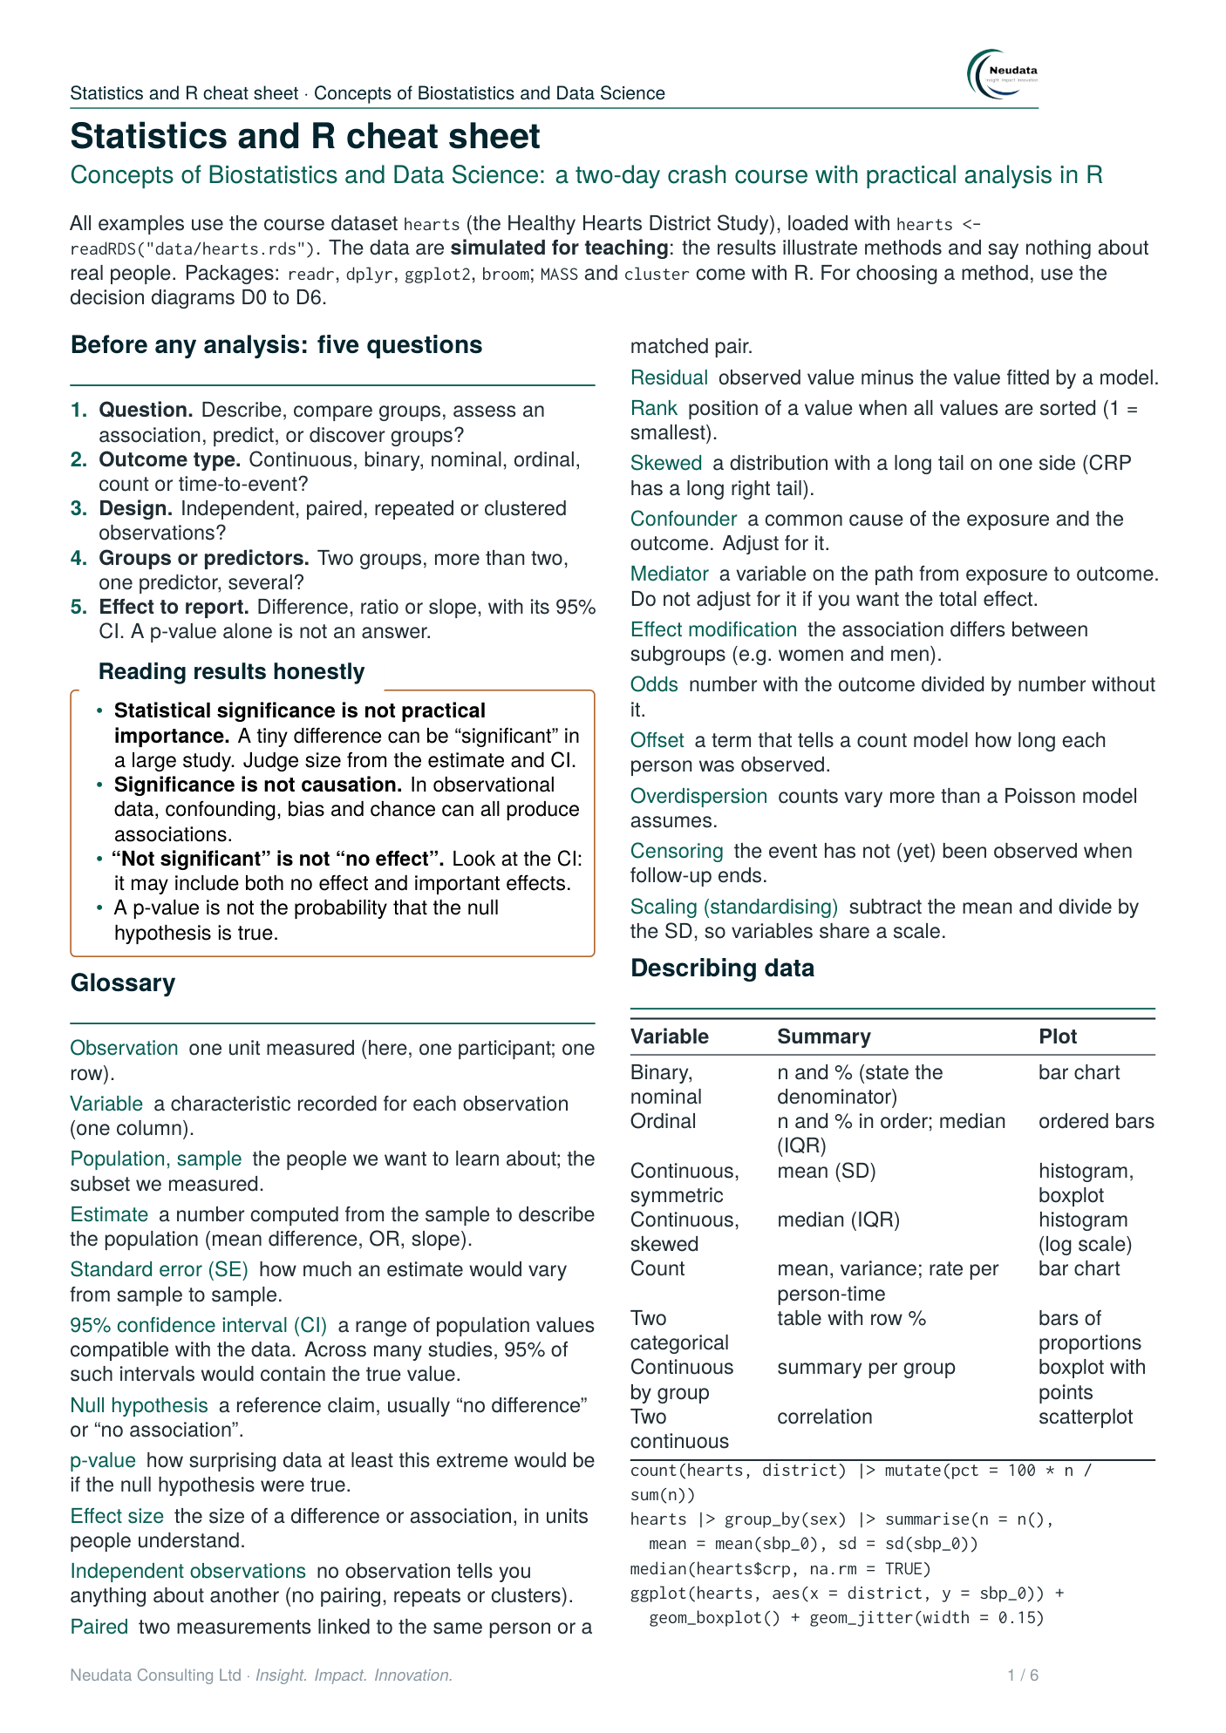

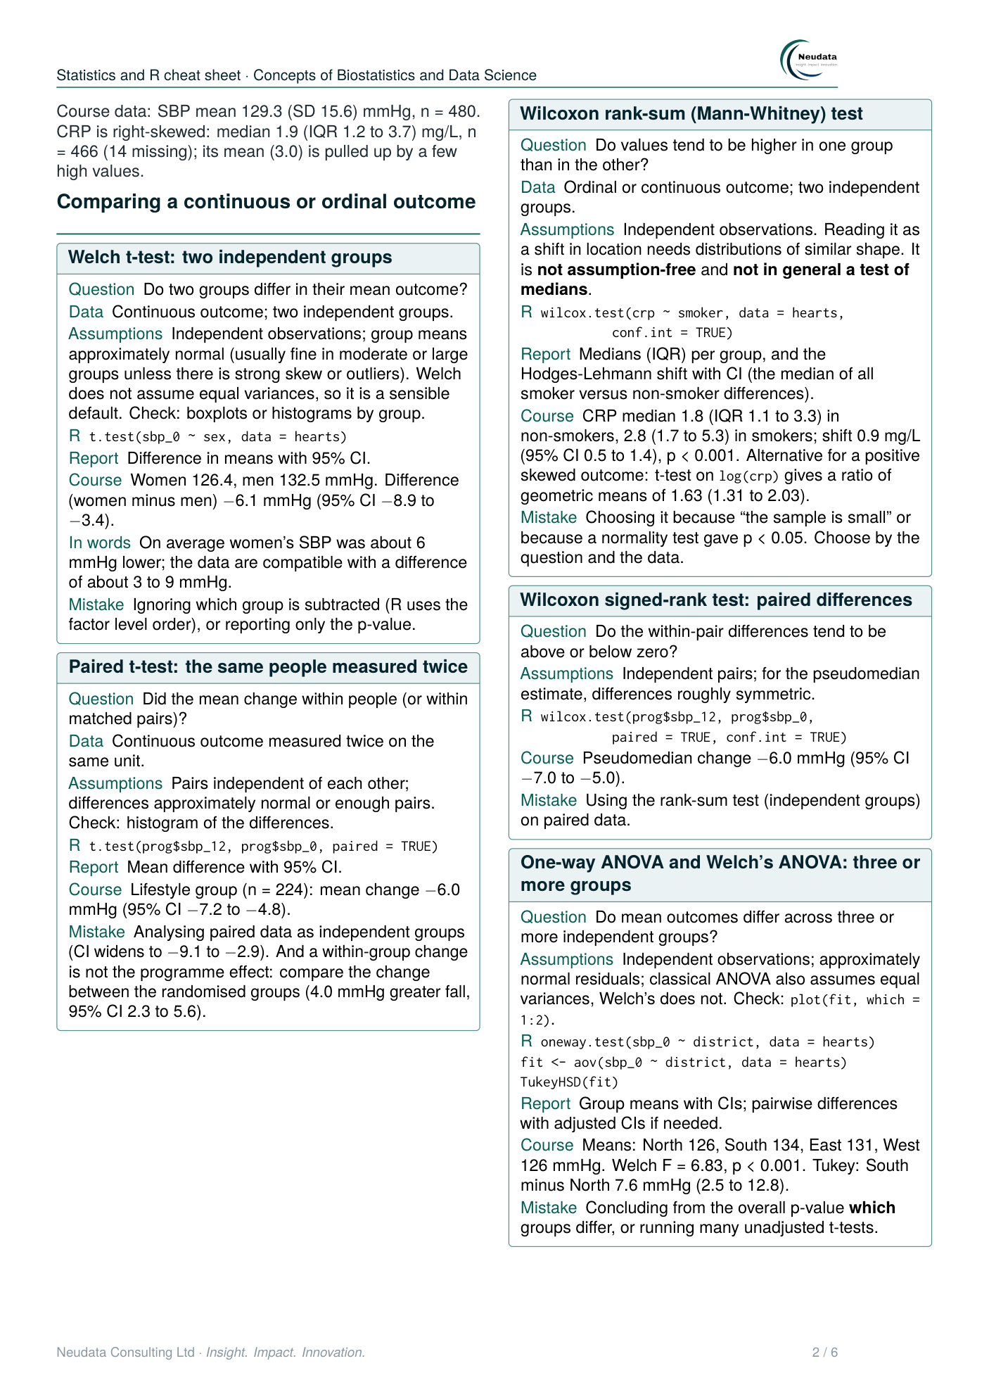

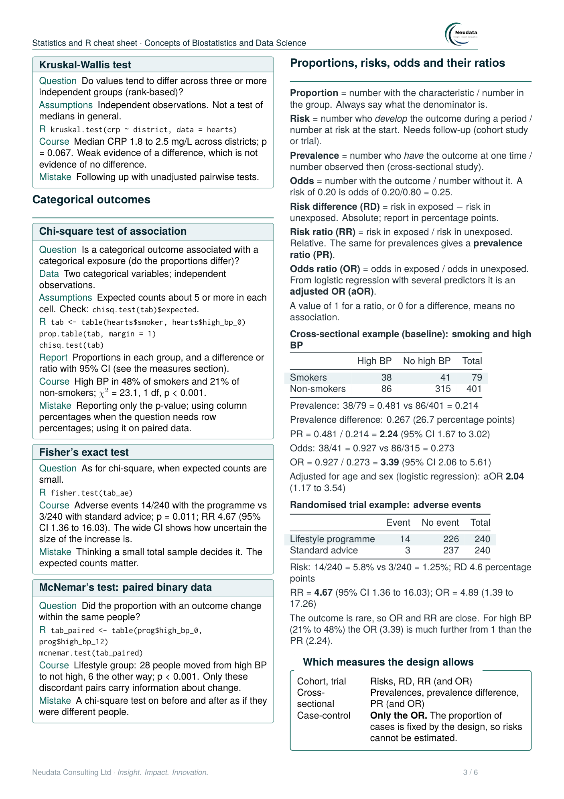

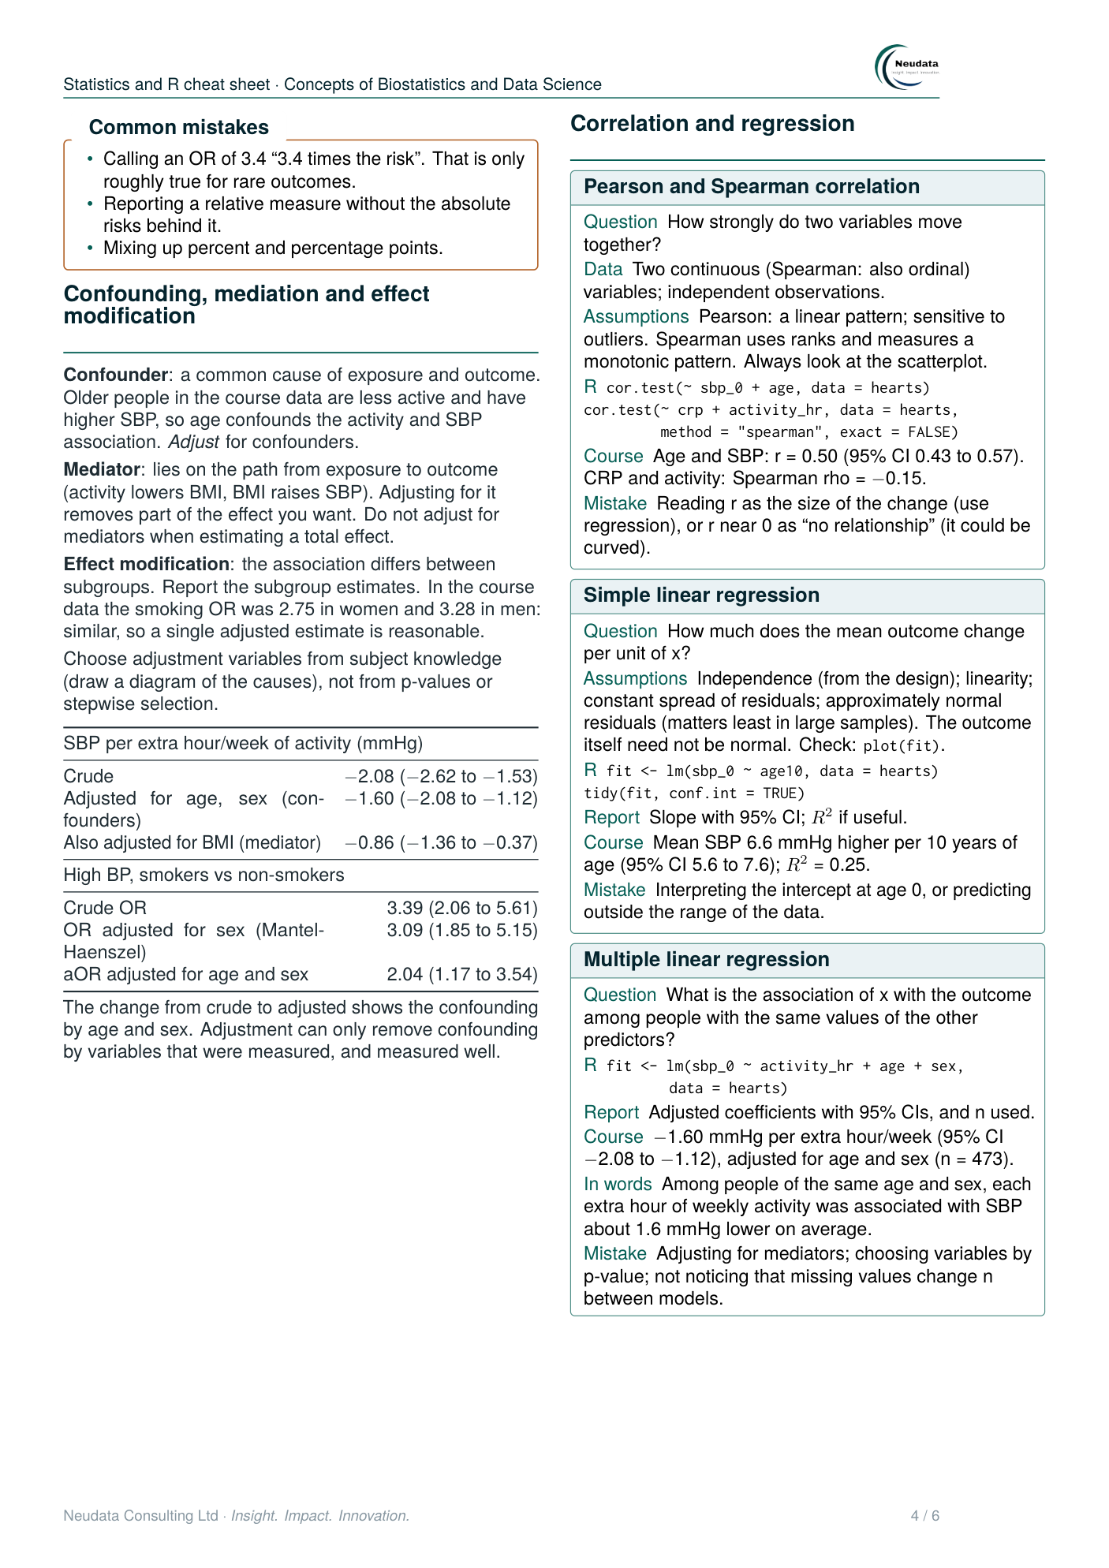

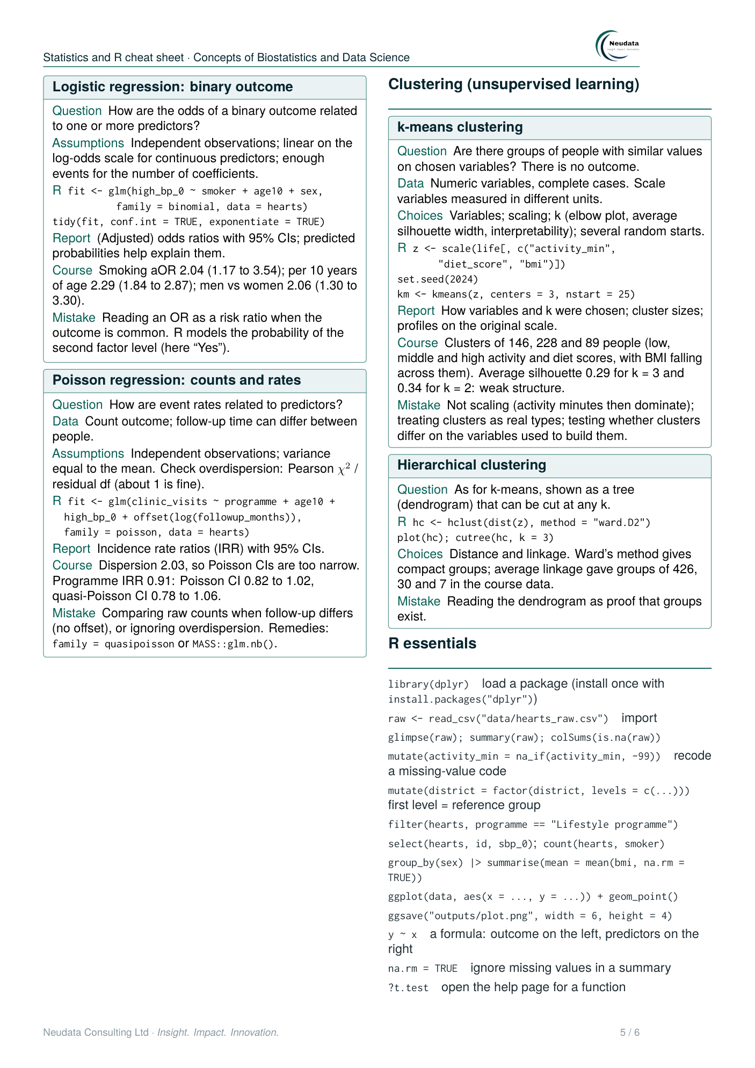

Choosing an analysis: decision diagrams
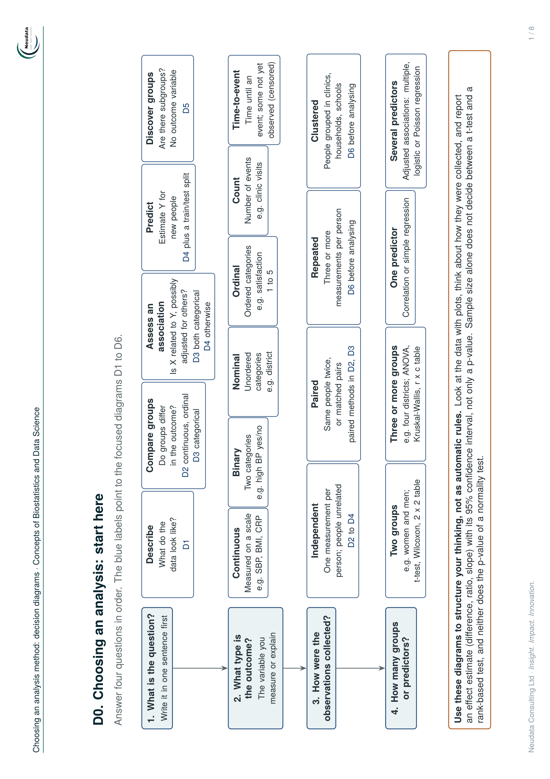

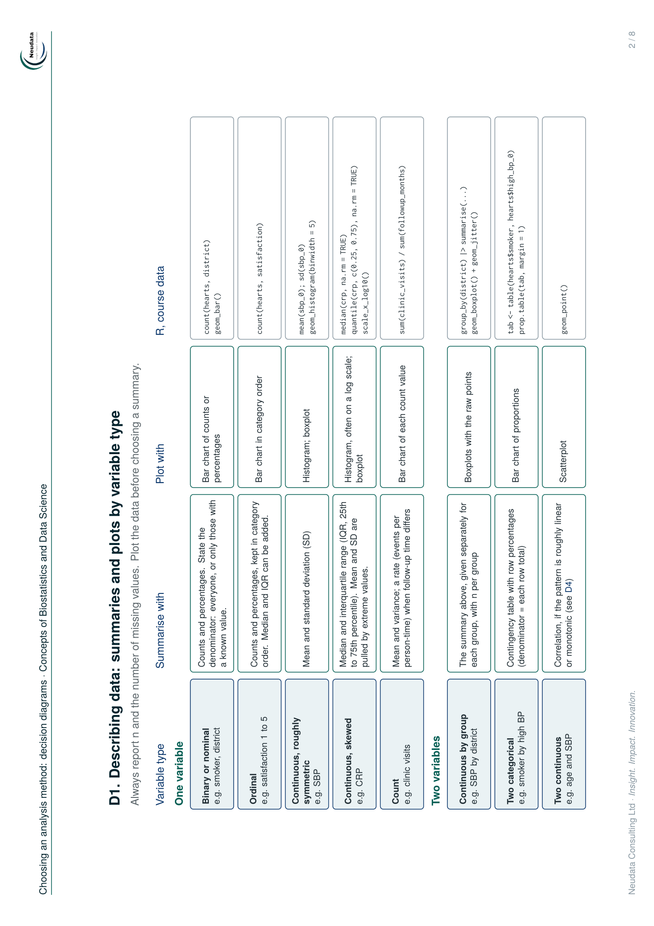

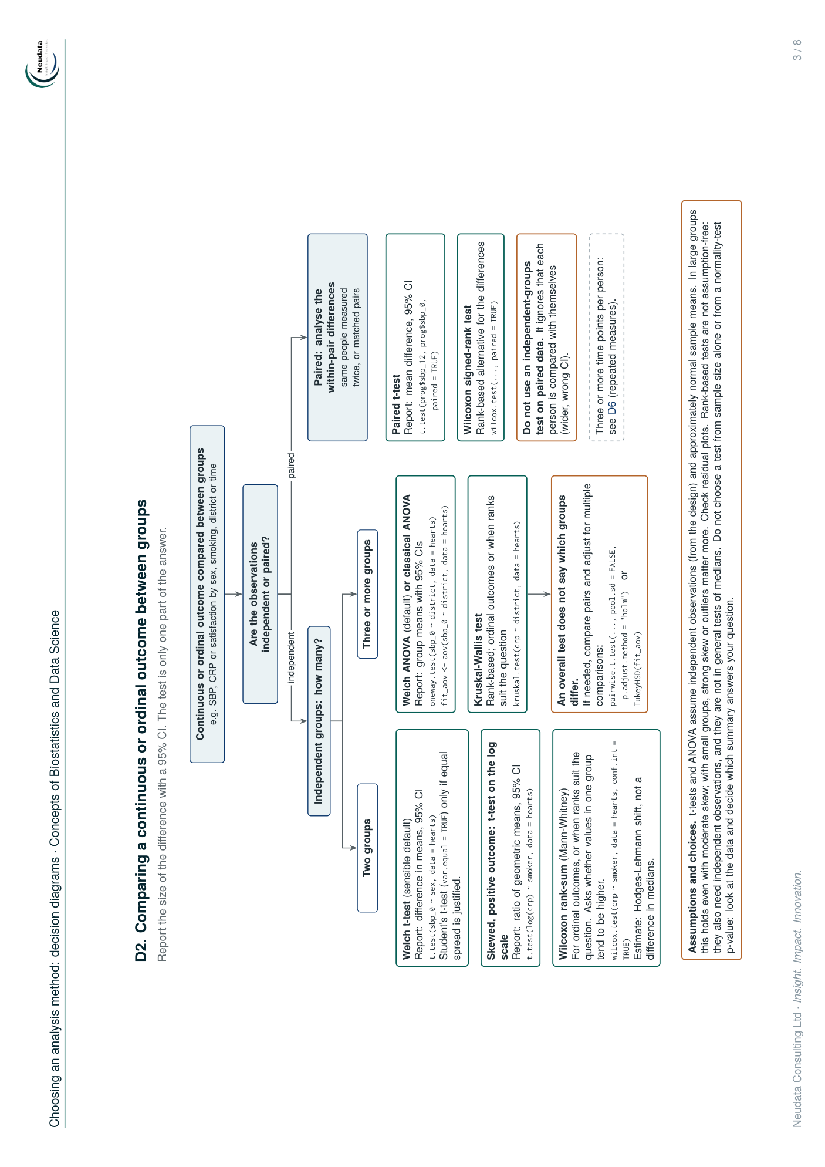

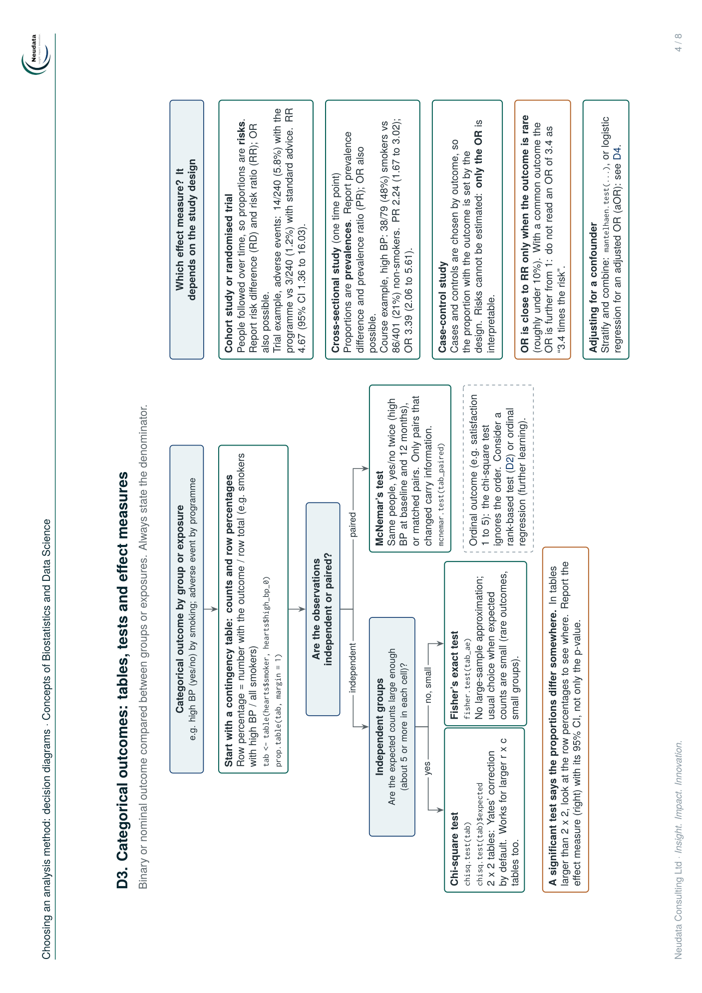

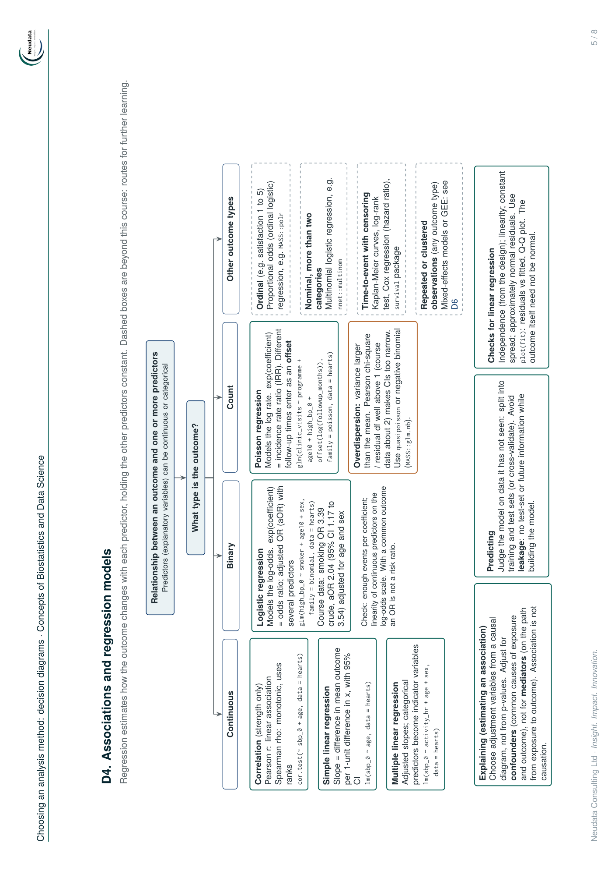

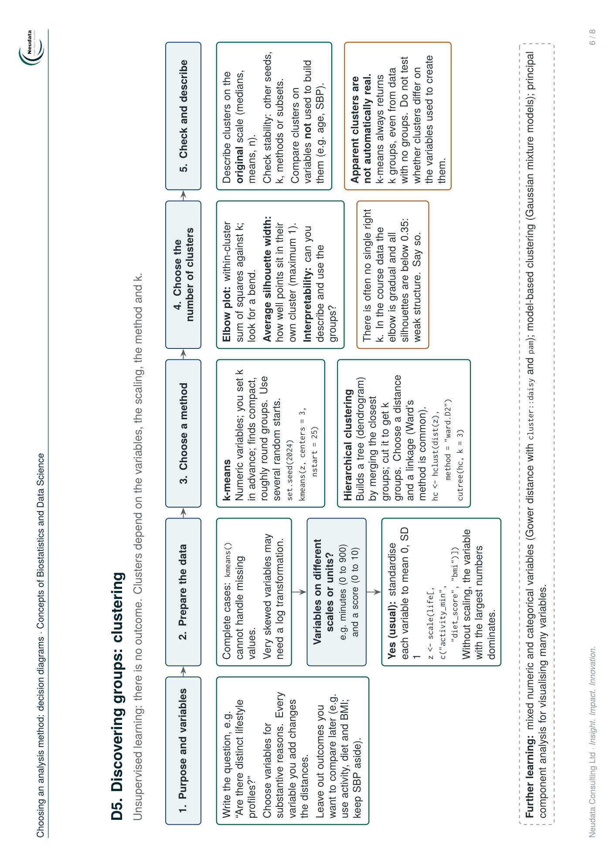

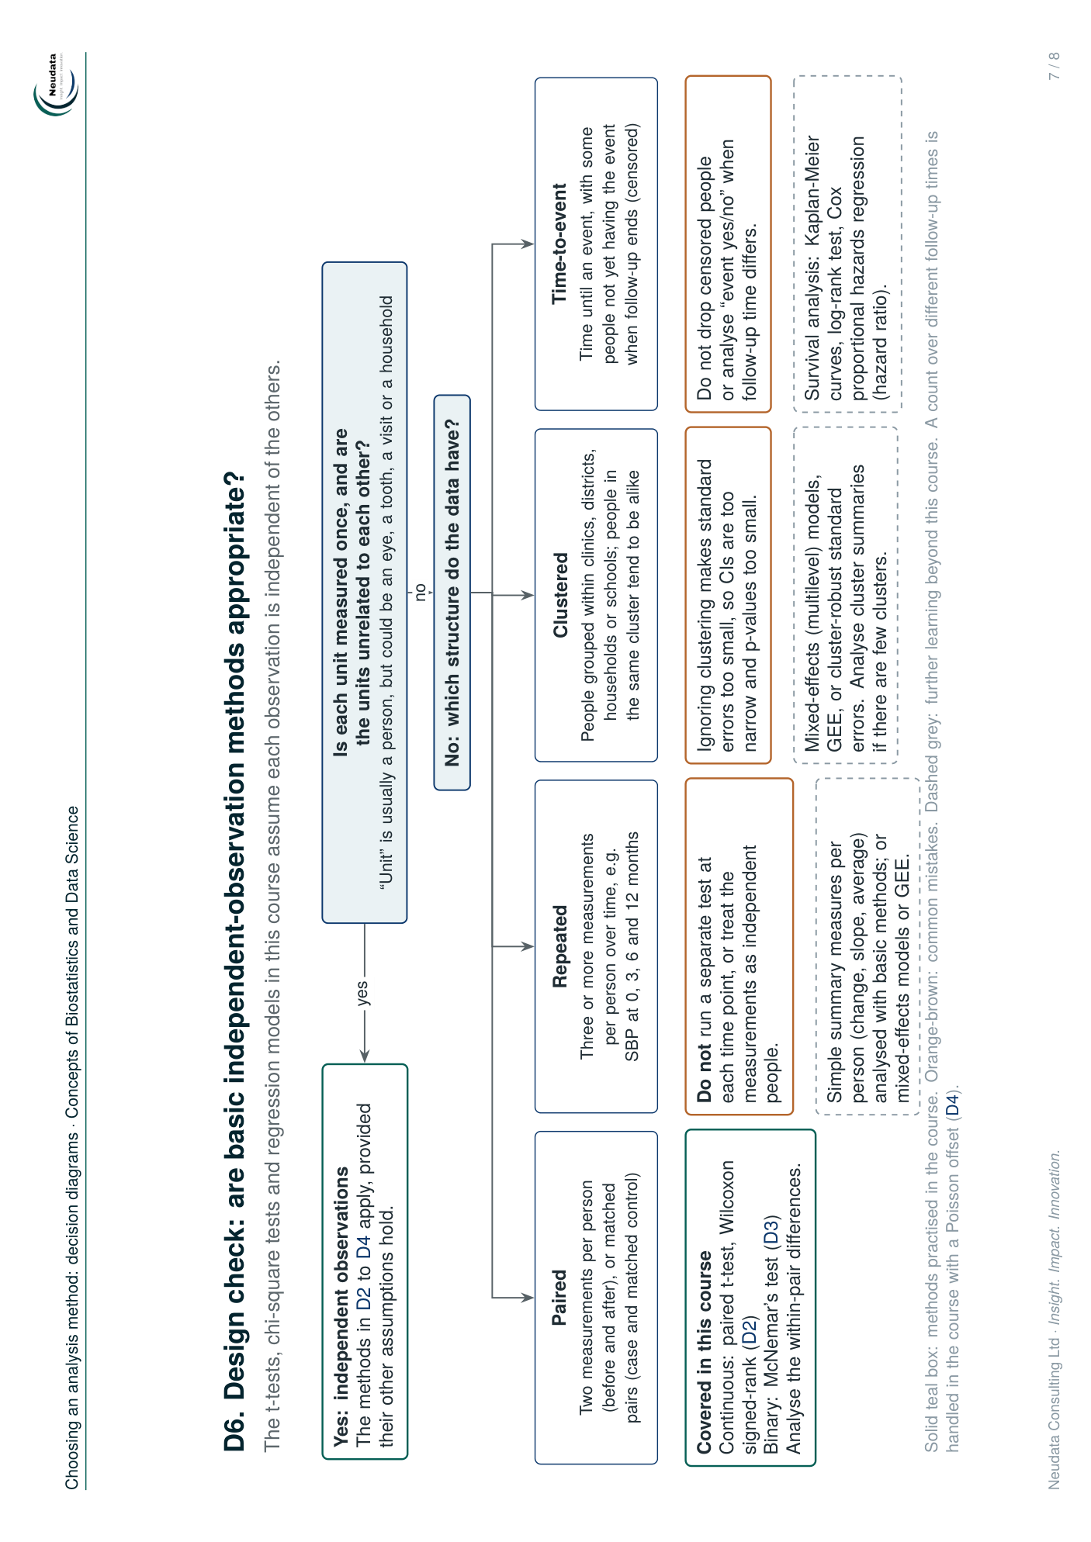

Method-selection guide
