**Self-Image Design Doc**

Feb 4, 2021

Revision 0

## **Introduction**

### Problem Statement

Due to COVID-19, in-person experiments are not feasible which prompted researchers to look for a solution where participants could complete experiments from their homes.

## Goals and Vision

Researchers would like to have a web application that will create, host, and maintain multiple experiments with specific requirements and features.

### Scope

Our priority is to create a web application that satisfies the defined user stories of our current use case, which is the self-image experiment. If time allows, we will continue working on building a more robust experiment platform for running multiple experiments.

## **Design Overview**

### Problem Description

We identified a few problems with the current existing code such as slow image processing, lacking UI/UX and weak security. Therefore, we decided to start everything from scratch with extensibility/maintainability in mind. Our goal is to produce a production-ready web application that will go live. However, if that’s not the case, we would like our code to be continually worked on and we will design our code to make that possible.

### Interface Design

One of the project’s scope is to improve upon the current implementation’s user experience and interface, as well as integrate a handful of new functionalities specific to our defined users such as administrators, researchers and participants.

#### Design System

To optimize our budget and timeline we are developing a Design Guide and System based on modular design and reusable components; the goal is to provide users with a seamless, intuitive interface and to establish brand recognition and better experience.

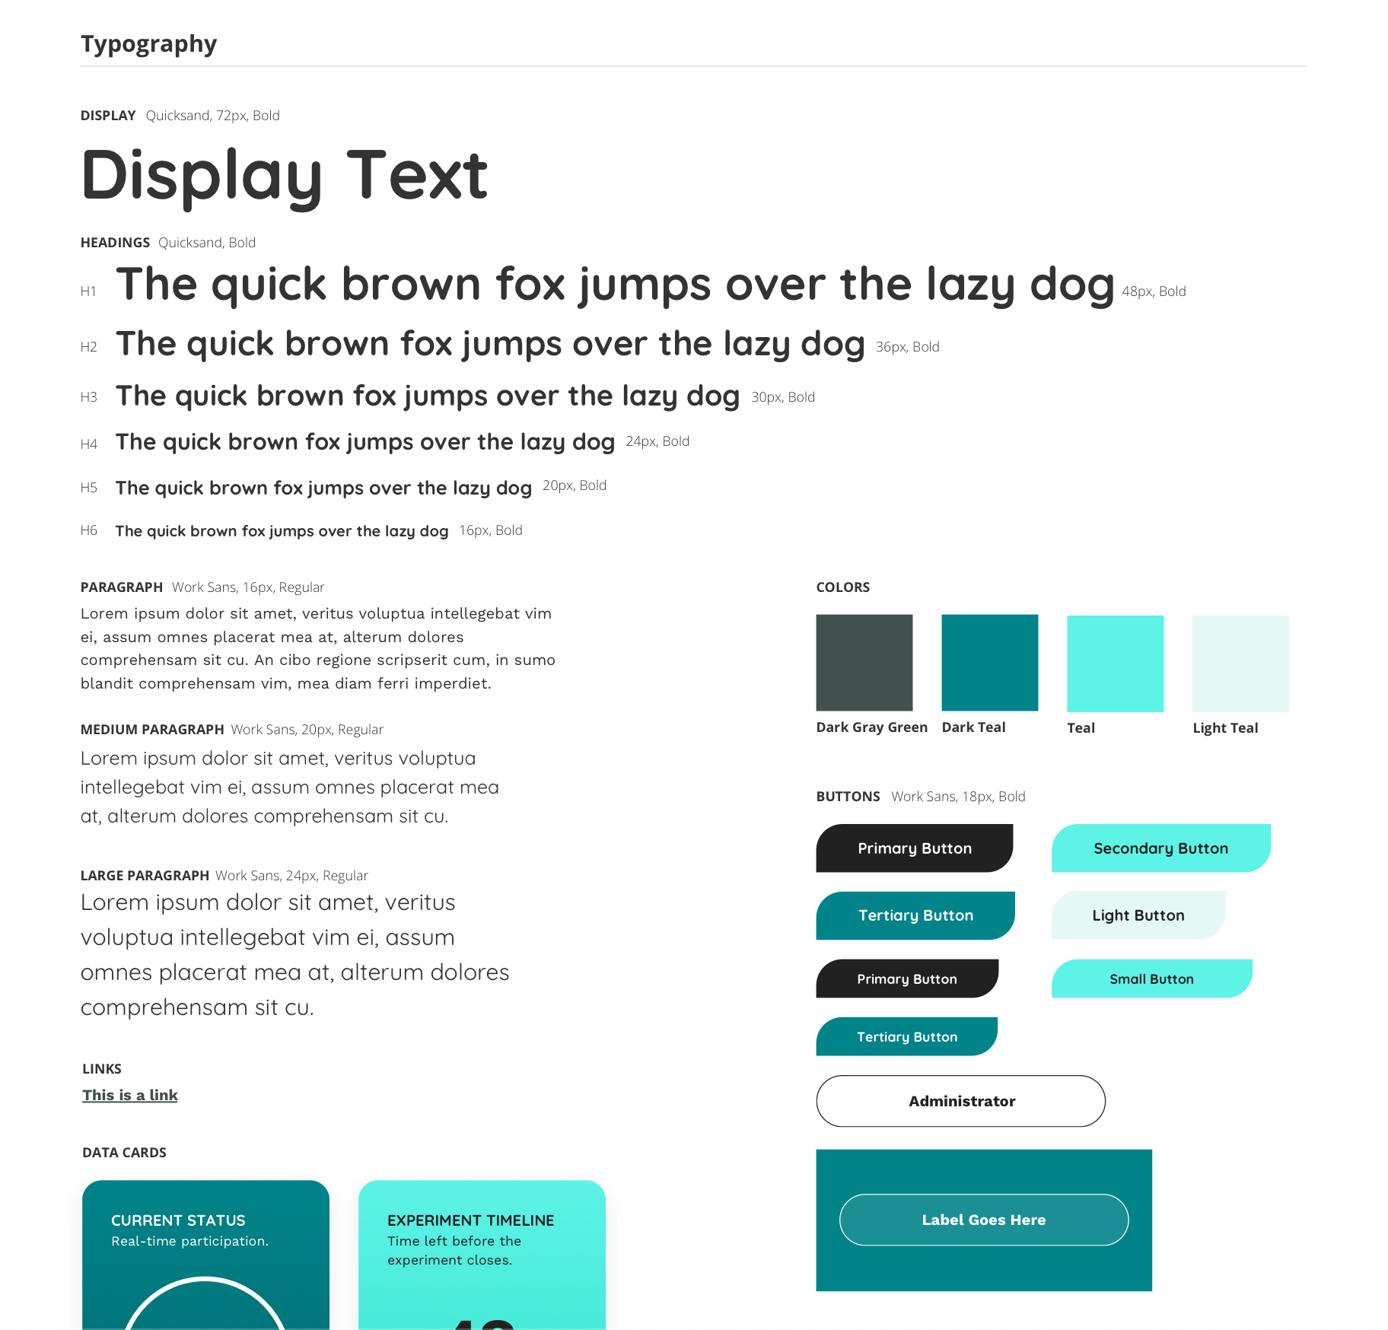

#### User Interface

Building upon the established guidelines and components, we are developing a set of user interfaces:

1. [Login Page - Dark Version](https://www.sketch.com/s/3e6b9c91-118c-471e-98ad-8676d41d1435/a/WKdK9Qy)
2. [Login Page - Light Version](https://www.sketch.com/s/3e6b9c91-118c-471e-98ad-8676d41d1435/a/jg4OEm0)
3. [Signup Page](https://www.sketch.com/s/3e6b9c91-118c-471e-98ad-8676d41d1435/a/dlgZnJZ)
4. [Participant Home Screen](https://www.sketch.com/s/3e6b9c91-118c-471e-98ad-8676d41d1435/a/zxyGnLW)
5. [Participant Account Page](https://www.sketch.com/s/3e6b9c91-118c-471e-98ad-8676d41d1435/a/ZOVyoP7)
6. [Experiment](https://www.sketch.com/s/3e6b9c91-118c-471e-98ad-8676d41d1435/a/JnADd05)
7. [Sample Dashboard](https://www.sketch.com/s/3e6b9c91-118c-471e-98ad-8676d41d1435/a/zxyyxba)

### 

### Technologies

#### Backend

* + - 1. Firebase to serve our website
      2. Google Vision API to do facial detection and image preprocessing
      3. Google Cloud Functions to run R script for image processing
      4. Google Storage to store all images

#### Frontend

* + - 1. Firebase
      2. React
      3. Storybook
      4. Jest

### Requirements

#### User requirements

This application accommodates three user types, provided by the client:

1. *Researchers* - individuals associated with the University of British Columbia who manage, track and oversee ongoing experiments.
2. *Administrators* - individuals with higher privileges than researchers who can create new experiments and assign them to researchers, as well as manage, track and oversee ongoing experiments.
3. *Participants* - individuals who volunteer to participate in a given experiment and are not associated with the organization running the experiment.

Below, we define stories for each user and attempt to identify various features the application is expected to support to help users attain their goals. Due to budget and time constraints, we differentiate features as follows:

1. *CORE* - core features are essential to the success of this project and must be integrated into the product in order for the application to launch
2. *NICE-TO-HAVE* - additional features which would bring more value to the product, that, however, are not integral to the success of the project. They may be built and integrated once *all* core features have been completed.

User stories are presented below.

### **Researchers**

|  |  |
| --- | --- |
| As a researcher... | Feature |
| I want to create an account. | CORE |
| I want to login into my account, view and/or update my personal information. | CORE |
| I want to be able to delete my account. | CORE |
| I want to see a list of all existing experiments assigned to me. | CORE |
| I want to view details about each experiment (i.e. how many participants have completed the survey, participant-related data such as gender distribution, etc) | NICE-TO-HAVE |
| I want to have some tools for analysing and do some statistics. | NICE-TO-HAVE |
| I want to share an experiment with participants. | CORE |

### **Administrator**

|  |  |
| --- | --- |
| As an administrator... | Feature |
| I want to create an account. | CORE |
| I want to login into my account, view and/or update my personal information. | CORE |
| I want to be able to delete my account. | CORE |
| I want to see a list of all existing experiments. | CORE |
| I want to create, update or delete an experiment. | CORE |
| I want to assign experiments to certain researchers. | CORE |
| I want to manage user roles. | NICE-TO-HAVE |
| I want to be able to do everything a researcher can. | CORE |

### **Participants**

|  |  |
| --- | --- |
| As a participant... | Feature |
| I want to create an account. | CORE |
| I want to login into my account, view and/or update my personal information. | CORE |
| I want to see a list of all available experiments. | CORE |
| I want to select and complete an experiment. | CORE |
| I want to save progress on an experiment and come back to it later. | NICE-TO-HAVE |
| I want access to information such as research departments, researchers and their contact information. | NICE-TO-HAVE |
| I want to know the brief description and flow of the experiment. | NICE-TO-HAVE |
| I want to be able to do everything a researcher can. | CORE |

#### Functional requirements

* + - 1. Better UI/UX
      2. Faster image processing
      3. Security

## **System Architecture**

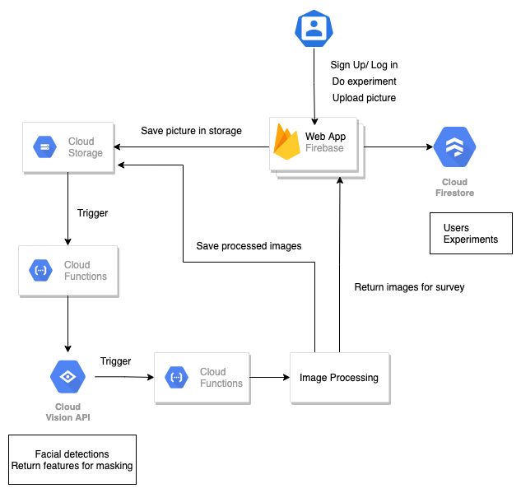

* Users (administrators/researchers/participants) sign up or log in to our system where authentication is handled by firebase.
* Participants will be presented with surveys
* Upon uploading their images, firebase will put the image into a cloud storage bucket (*sie-raw-images*).
* Once an image is uploaded to cloud storage, it will trigger a cloud function to locate the image and pass it as an argument to Cloud Vision API for facial detections and to return necessary features for masking.
* The returned features will be used as arguments to an R script which is then run in the same or another cloud function to generate processed images for the survey.
* This cloud function will then put the new processed images in another cloud storage bucket (*sie-processed-images*) and send a confirmation to firebase notifying users that the images have been processed.
* Firebase must handle all logic pertaining to user information and state using cloud firestore.

**Updated image processing pipeline:**

<https://lucid.app/lucidchart/invitations/accept/645c34c0-4e71-4c04-a0a6-f2a46c869e1d>

<https://drive.google.com/file/d/1pr7JKNi3cALEHlFEMv0UK6JErnBfDAkh/view?usp=sharing>

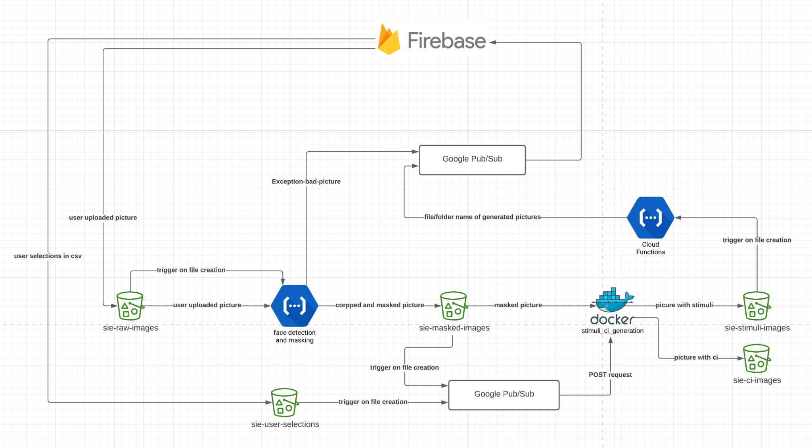

**Format for folder names and messages:**

[participant-id]-[experiment-id]-[status]

Status: “complete”, “face_missing”, “failed”

Example: “001-001-complete”

Files in sie-raw-images: [participant-id]-[experiment-id].jpg

Files in sie-masked-images: [participant-id]-[experiment-id]/neutral.jpg

Files in sie-stimuli-images: [participant-id]-[experiment-id]/***.jpg

Files in sie-user-selections: [participant-id]-[experiment-id]/user_selection.csv

Files in sie-ci-images: [participant-id]-[experiment-id]/***.jpg

## **Milestones and Prioritization**

### [Milestone #1](https://docs.google.com/presentation/d/1QNl0KEYa7itAg0ZToPiGD-1tanL4Ex9b6trLex4nLIU/edit#slide=id.p)

### Milestone #2

### Milestone #3

### Milestone #4

### Milestone #5

### 