Azure Kubernetes Modernization
Design and Build Documentation

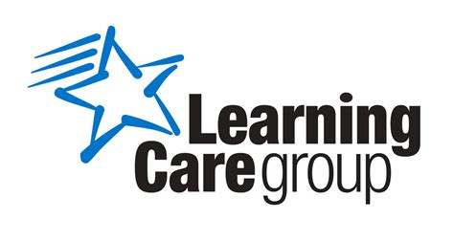

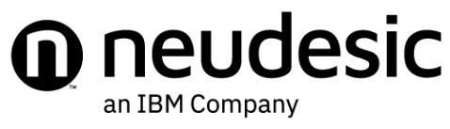

Neudesic, LLC. - (800) 805-1805 – info@neudesic.com - www.neudesic.com

Contents
1 Document Purpose and Conventions 7
1.1 Document Conventions 7
1.2 Document Revision History 7
2 Executive Summary 7
2.1 Business Direction of Cloud 7
2.2 Management Groups 9
2.3 Subscriptions 9
2.4 Security Considerations 9
2.5 Network design 9
2.6 Naming Scheme 9
2.7 Cost Management 9
2.8 Monitoring 10
2.9 Business Continuity Services (BCS) 10
3 Cloud adoption and Business Strategy 10
3.1 Strategy 10
3.2 Cost Savings 11
3.3 Agility and Innovation 11
3.4 Security and Compliance 12
3.5 Recommendations 12
3.6 Cloud Adoption Plan 13
3.6.1 Cloud Adoption Plan for Implementation 13
3.7 Skilling Gaps Assessments 14
4 Core Deployment 17
4.1 Core Azure Services for Workloads 17
4.2 Well-Architected Reviews 19
4.2.1 How to Conduct a Well-Architected Review for Azure 19
5 Azure Configuration 21
5.1 Entra Id 21
5.1.1 Entra ID Tenant 21
5.1.2 AD Connect 22
5.2 Resource Quotas 22
5.3 Resource Tags 22
5.4 Management Groups 24
5.5 Subscriptions 25
5.5.1 Management Subscription 25
5.5.2 Network Subscription 26
5.5.3 Sandbox Subscription 26
5.5.4 Production Subscription 27
5.5.5 Test Subscription 27
5.5.6 Developer Subscription 27
5.6 Access Control 27
5.7 Governance 28
5.7.1 Governance in the Microsoft Cloud Adoption Framework for Azure 28
5.7.2 Policies 29
5.8 Regional Deployment 31
5.9 Naming Conventions 32
5.9.1 Management Group Naming 32
5.9.2 Resource Naming Patterns 32
5.9.3 Virtual Machine Naming Patterns 35
5.9.4 Tagging 36
5.9.5 Resource Lock Naming Patterns 36
5.9.6 Service Account/App Registration Naming Conventions 37
5.9.7 Network Security Group Rule Naming Patterns 37
5.10 Resource Groups 37
5.11 Resource Providers 38
6 Network Configuration 39
6.1 Proposed Azure Architecture 40
6.2 VNET Definitions 41
6.3 IP Zones 41
6.4 ExpressRoute and Virtual Private Networks and Virtual WAN 41
6.5 Net Peering 41
6.6 Domain Controllers and DNS 42
6.7 Firewall Whitelists 42
6.8 Kubernetes Networking 43
6.9 Perimeter Security 45
7 Application Configuration 46
7.1 Core Application 46
7.2 Azure Kubernetes Configuration 46
7.3 Nodes and Node Pools 48
7.4 Pods 50
8 DevOps and Automation 53
8.1 Overview 53
8.2 Source Control 54
8.3 Infrastructure 56
8.4 Azure Pipelines 57
8.5 Azure Container Registry 57
8.6 Implementation 57
9 Observability 58
9.1 Operational Reports 59
9.1.1 E-Mail Distribution 59
9.2 Alerts and Notifications 59
9.2.1 Log Analytics Workspaces 59
9.2.2 Alert Action Groups 59
9.2.3 Alert Action Groups 59
9.2.4 Alerts 60
9.3 Logging and Audit Configuration 60
9.4 Logging/Audit Configuration – Virtual Networks 61
9.5 Logging/Audit Configuration – Network Security Groups 61
9.6 Logging/Audit Configuration – Storage Accounts 62
9.7 Logging/Audit Configuration – Kubernetes Service (AKS 63
9.7.1 Application Health Monitoring 63
9.7.2 Monitoring Cluster Objects and Workloads 63
9.7.3 Monitoring Managed Cluster Components 63
9.7.4 Monitoring Cluster-Level Components 64
9.7.5 Network Monitoring 64
9.7.6 Additional Best Practices 64
9.8 Logging/Audit Configuration – SQL Server (PaaS) 65
9.8.1 Advanced Data Security 65
9.8.2 Auditing 65
9.9 Logging/Audit Configuration – Key Vault 66
9.10 Logging/Audit Configuration – Azure Automation 66
9.11 Design for monitoring using Azure logs and MicroFocus OBM 67
9.12 Cost monitoring budgets 67
9.13 management Dashboards 67
10 Security 68
10.1 Education 68
10.2 Identity 69
10.3 Cloud Security 69
10.4 Governance 70
10.5 Networking 71
10.6 Logging and Monitoring 71
10.7 Steering Committee 72
10.8 Security Center 72
10.9 Security-Center Enabled Subscriptions 73
10.10 Azure Sentinel 73
11 Availability, Backup, and Business Continuity 74
11.1 Azure Platform 74
11.1.1 Azure Regions 75
11.1.2 Regional Pairs 75
11.1.3 Recommendations 75
11.2 Azure Key Vault 75
11.2.1 Availability: 75
11.2.2 Backup: 75
11.2.3 Business Continuity: 76
11.3 Storage Accounts 76
11.3.1 Availability: 76
11.3.2 Soft Delete 76
11.3.3 Backup: 76
11.3.4 Business Continuity: 76
11.4 Azure SQL Database 77
11.4.1 Availability: 77
11.4.2 Backup: 77
11.4.3 Business Continuity: 77
11.5 Virtual Machines 77
11.5.1 Availability: 77
11.5.2 Backup: 78
11.5.3 Design: 78
11.5.4 Azure Site Recovery 78
11.5.5 Azure Site Recovery (high availability) for Learning Care Group 79
12 Service Validation and Testing Process 80
12.1 Process 80
12.2 Test Scope 80
12.2.1 Sanity / Smoke Testing Scenarios / Scope 80
12.2.2 Functional Testing Scenarios / Scope 81
12.2.3 UAT Scenarios / Scope 81
12.2.4 Performance Testing Scenarios / Scope 81
12.2.5 Load Testing Scenarios / Scope 81
12.3 Testing Approach 81
12.3.1 Deployment 82
12.3.2 Storage 82
12.3.3 Network 82
12.4 Testing 82
12.4.1 Deployment 83
12.4.2 Storage 83
12.4.3 Network 83
12.5 Performance test PASS/FAIL criteria 83
12.5.1 Single node performance test 83
12.5.2 Peak load performance test: 84
12.6 Production Service Levels – Incident Response and Resolution 84
12.7 Quality Management - Defect Severity Definitions 86
12.8 List of servers 86
Appendix A – RACI Matrix and Stakeholders 87

Document Purpose and Conventions
This document provides guidance, standards, and ‘as-built’ documentation for Learning Care Group’s Azure Kubernetes Modernization. This is a living document and will be updated regularly as ‘as-built-and-deployed’ reference material.

Document Conventions
- Content presented in Consolas font indicates specific resource naming, conventions or sample code.
- Important notes or follow-up items are shown in red.
- Placeholders for later project phases or additional projects are in blue.

Document Revision History
Version | Date | Description | Author
1.0 | 01/15/2024 | Initial release | Sam Morton, Ryan Wilson
1.1 | 02/27/2024 | Updated design details based on discovery phase | Sam Morton, Ryan Wilson

Executive Summary
The following section will detail an overall picture for Learning Care Group’s Azure Kubernetes Modernization initiative. This section highlights some of the key requirements for executives.

Business Direction of Cloud
The business value of cloud adoption can be categorized into several key areas, including cost optimization, revenue generation, agility and flexibility, and competitive advantage. It is crucial to note that these categories must align with and support Learning Care Group’s overarching business goals and objectives. Therefore, the initial step in driving cloud adoption is to align Learning Care Group's business objectives with the diverse capabilities offered by cloud solutions.

Business Goals & Objectives | Supporting Cloud Capabilities
Zero Downtime | Resiliency, Scalability
Zero Breaches | Security, Operational Excellence
Zero Data Centres | General

This application's objective is to assist Learning Care Group, a leading provider of early education and care services, in transitioning its existing on-premises applications to the Azure cloud platform. This migration is driven by the need to enhance the scalability, performance, security, and cost efficiency of its IT infrastructure. Key requirements for this migration include minimizing downtime, ensuring compliance with industry standards, and employing best practices for cloud architecture and governance.
Learning Care Group aims to migrate their legacy applications to the Azure cloud platform to achieve superior business outcomes. The primary goals of this migration are to improve the availability, reliability, and agility of their applications, while also decreasing operational costs and mitigating risks. Migration requirements involve adhering to the Azure Well-Architected Framework, complying with relevant regulations and policies, and minimizing business operations and user disruptions.
This application is designed to facilitate Learning Care Group's transition of their current applications from on-premises servers to the Azure cloud platform. The motivation behind this initiative is to modernize their IT infrastructure and optimize service delivery. The migration requirements include ensuring high availability, security, and performance of the applications, adhering to industry best practices and standards, and preventing unnecessary downtime or data loss.

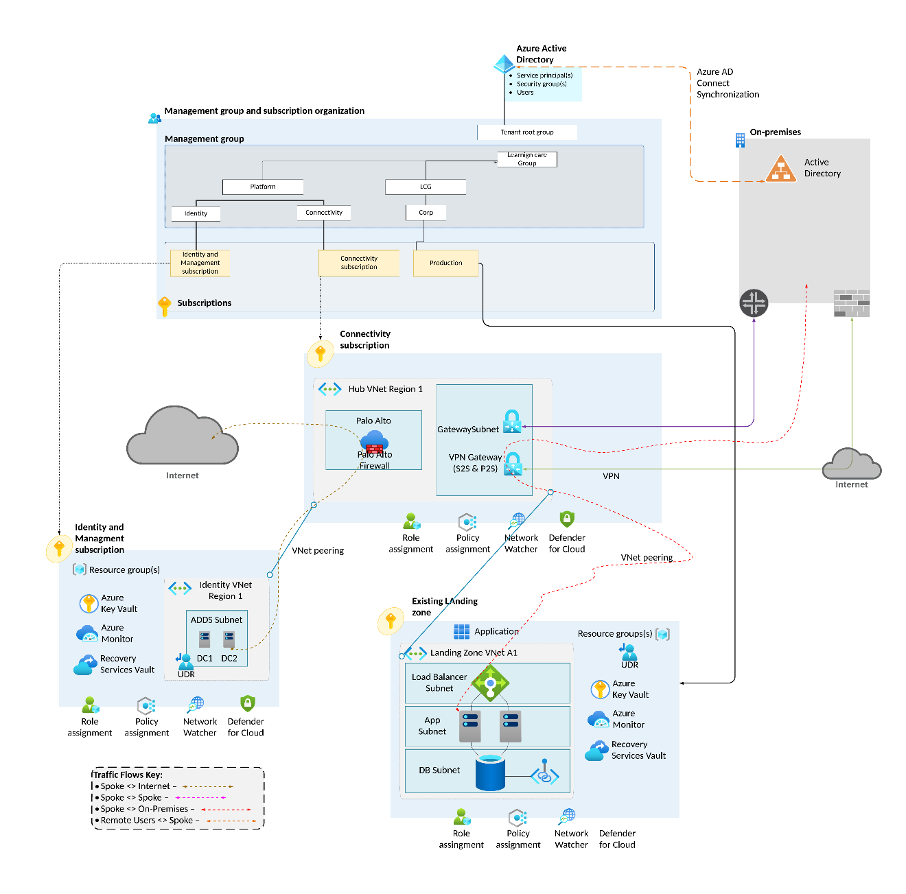

Management Groups
Management groups provide oversight and control for subscriptions. They traverse subscriptions, so they are critical to define at the start of an Azure project. Neudesic recommends that Learning Care Group defines a core management group to control access to all subscriptions. This management group's membership will be controlled by an Azure group.
Subsequent management groups will be created for each subscription, defining access to the relevant subscriptions.

Subscriptions
Subscriptions isolate and control virtual network boundaries. All resources within a subscription can be policies and controlled for management. At this stage Neudesic recommends that seven (7) subscriptions be created and used. The optimal locations for resources (based on traffic and costs ) are East US 2 and Central US. Therefore, all services could be moved to these 2 locations. For a comprehensive cost breakdown, see here. However, the Azure pair matching means that East US 2 and Central US are a pair.

Security Considerations
Security groups should control all access. No permissions should be assigned to individual user accounts. Azure Privileged Identity Management (PIM) should be used to control user accounts' access to contribute /write permissions. However, PIM does require an Azure P2 license for every user utilizing the service.

Network design
Currently, multiple VNETs are being defined in Azure. Neudesic recommends that each subscription contain at least 1 class B VNET. These VNETs need to be broken down into Class C subnets that are clearly defined and consistent across all subscriptions.
These are all defined here.

Naming Scheme
The Appendix A contains a comprehensive list of the naming scheme recommendations from Microsoft. Additionally see here for examples and definitions of the services. Some of the existing resources within the subscriptions do not match the standard. Neudesic recommends that all new resources are defined correctly, and any existing resources are renamed (where possible) to match the standard.

Cost Management
Costs will be reduced by controlling subscription access for staff. Development and Test subscriptions will have resources set to shutdown automatically after hours and start up at the beginning of the day. This will ensure costs for those resources are kept to a minimum. In addition, production resources will be evaluated and only deployed by IT management team after analysis and requirements are determined.

Monitoring
Currently Learning Care Group have a comprehensive well maintained monitoring solution (Site Scope) for servers. Learning Care Group can continue using existing monitoring setup. Neudesic recommends that Learning Care Group to use Log Analytics as primary data capture, and then existing Splunk and SiteScope will pull monitoring data from Log Analytics.
In addition, diagnostic logging needs to be configured for all resources in Azure to ensure that troubleshooting is configured from the outset. Network Watcher needs to be configured to enable traffic analytics to monitor the Azure network for performance and security parameters.

Business Continuity Services (BCS)
Learning Care Group currently does not have a cloud BCS strategy in place. Neudesic recommends a Central US location as a BCS site with applications and/ or servers either backed up to this Azure site or replicated through Azure Site Recovery services.
Within a site any server that may require high availability should be configured within an Availability Set from the outset.
Any services requiring 24x7 uptime and site resilience should be configured with global load balancing (through Azure Traffic Manager) from West US 2 to West Central US.

Cloud adoption and Business Strategy

Strategy
Faster deployment, scaling, and innovation of applications and services that support our learning care goals, while ensuring security and reliability. This means we can deliver value to our customers and stakeholders faster, respond to changing needs and demands more agilely, and leverage the latest technologies and best practices in the cloud.
Access to the global reach, performance, and availability of Microsoft Azure's infrastructure and platform services, which can help us optimize our costs and performance. This means we can reduce our capital and operational expenses, scale our resources up or down as needed, and benefit from the high availability, redundancy, and resilience of Azure's data centres and networks.
To achieve our cloud migration objectives, we will transform our current LCG applications into cloud-native applications that can run on any platform. We will use Docker to containerize our applications, which will enable us to package them with their dependencies and configurations. This will deploy them faster and more consistently. We will use Azure Kubernetes Service (AKS) to orchestrate and manage our containers, which will allow us to scale them dynamically, load balance them efficiently, and monitor their health and performance. We will migrate all our data to Azure SQL Database, which will provide us with a fully managed and secure relational database service that can handle high volumes of transactions and queries. We will also leverage Entra ID and B2C connectors to provide identity and access management for our applications and users, which will ensure security and compliance across our cloud environment.
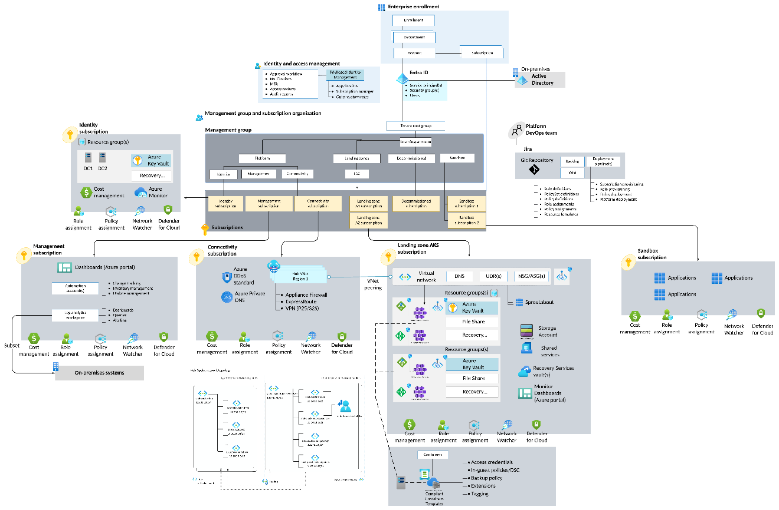
Figure 1Microsoft Azure Landing Zone with Azure Kubernetes

Cost Savings
Cloud services can help the business reduce costs in several ways:
- Eliminate the need for upfront capital expenditure, hardware maintenance, and software licensing, and instead pay only for the resources and services used.
- By optimizing resource utilization and efficiency and avoiding overprovisioning or underutilizing the infrastructure.
- By automating the updates and patches reducing the operational overhead and labor costs.
To achieve cost savings, the business should use the following cloud services:
- Azure Virtual Machines, which provide flexible and scalable compute power on demand, and can be configured with different sizes, operating systems, and pricing options.
- Azure Storage, which provides durable and secure storage for data and files, and can be accessed from anywhere and any device.
- Azure Functions, which provide serverless computing that can run code without managing servers, and can be triggered by events or requests.

Agility and Innovation
Cloud services can help the business improve agility and innovation in several ways:
- By enabling faster development and deployment of new products and features, and reducing the time to market and customer feedback.
- By providing access to cutting-edge technologies and tools, such as artificial intelligence, machine learning, and analytics, that can enhance the user experience and customer satisfaction.
- By fostering a culture of experimentation and innovation, and allowing the business to test and iterate new ideas and solutions quickly and easily.
To achieve agility and innovation, the business should use the following cloud services:
- Azure DevOps, which provides a set of tools and services that can support the entire development lifecycle, from planning to delivery, and enable collaboration and automation.
- Azure Cognitive Services, which provide a suite of APIs and SDKs that can add intelligence and functionality to the applications, such as vision, speech, language, and decision.
- Azure App Service, which provide a platform for building and hosting web and mobile applications, and support multiple languages, frameworks, and integrations.

Security and Compliance
Cloud services can help the business enhance security and compliance in several ways:
- Offering built-in security features, such as encryption, firewall, identity and access management, and backup and recovery, can protect the data and applications from cyberattacks and disasters.
- By providing certifications and audits that can demonstrate compliance with various regulations and standards, such as GDPR, HIPAA, and PCI DSS.
- By enabling the business to monitor and control the security posture and compliance status and to respond to incidents and issues promptly and effectively.
To achieve security and compliance, the business should use the following cloud services:
- Azure Security Center, which provides a unified view of the security and compliance across the cloud and on-premises environments, and provides recommendations and alerts.
- Azure Key Vault, which provides a secure and centralized store for managing secrets, keys, and certificates, and prevents unauthorized access and leakage.
- Azure Backup, which provides a simple and reliable way to backup and restore the data and applications and supports different recovery points and retention policies.

Recommendations
To adopt cloud services, the business should follow a structured and phased approach consisting of the following steps:
- Assess the current state and needs of the business and identify the goals and benefits of cloud adoption.
- Plan the cloud migration and adoption strategy, and select the appropriate cloud services and providers.
- Implement the cloud migration and adoption plan and test and validate the functionality and performance of the cloud services and applications.
- Optimize and manage the cloud services and applications and monitor and measure the outcomes and benefits of cloud adoption.
The following table summarizes the proposed cloud services and their benefits for the business:
Cloud Service | Benefit
Azure Virtual Machines | Cost savings, scalability, performance
Azure Storage | Cost savings, security, availability
Azure Functions | Cost savings, agility, performance
Azure DevOps | Agility, innovation, collaboration
Azure Cognitive Services | Innovation, user experience, customer satisfaction
Azure App Service | Agility, innovation, performance
Azure Security Center | Security, compliance, visibility
Azure Key Vault | Security, compliance, management
Azure Backup | Security, compliance, recovery

Cloud Adoption Plan

Cloud Adoption Plan for Implementation
Task | Start Date | End Date | Duration
Assess | 02/09/2024 | 02/13/2024 | 5 days
Plan | 02/14/2024 | 02/20/2024 | 7 days
Design | 02/21/2024 | 02/27/2024 | 7 days
Implementation | 02/28/2024 | 03/03/2024 | 7 days
Manage | 03/04/2024 | ongoing
The following are the main activities and deliverables for each phase:

Assess

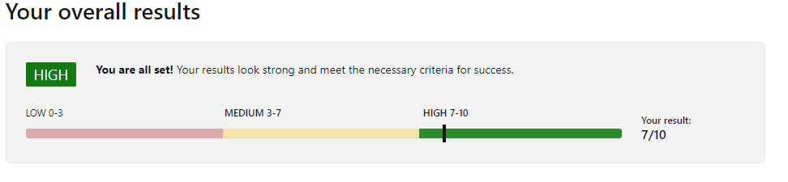
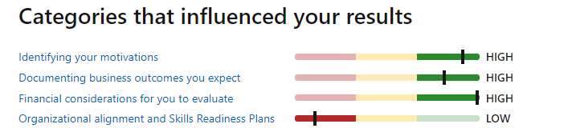

The assessment phase aims to review the current state of the application and the business needs for the cloud adoption project. The main deliverables of this phase are:
- A report on the current application architecture, performance, security, scalability, reliability, and costs.
- A list of the business requirements, risks, and dependencies for the cloud adoption project.
- A scope and objective statement for the cloud adoption project.

Plan
The planning phase aims to develop a comprehensive project plan and select the appropriate Azure services and tools for the AKS implementation. The main deliverables of this phase are:
- A project plan with milestones, tasks, resources, and timelines.
- A role and responsibility matrix for the project team.
- A selection of the Azure services and tools for the AKS implementation.
- A cost-benefit analysis of the cloud adoption project.

Design
The design phase aims to design the target AKS architecture and create the helm templates and scripts for the deployments and version control. The main deliverables of this phase are:
- A design document for the target AKS architecture, including the cluster configuration, node pool size, network connectivity, ingress controller, container registry, logging, monitoring, scaling, and security.
- A set of helm templates and scripts for the deployments and version control.
- A validation report of the design against the business requirements and best practices.

Implementation
The implementation phase aims to deploy the AKS cluster and the application backend and test the functionality, performance, security, and scalability of the AKS implementation. The main deliverables of this phase are:
- A deployed AKS cluster and application backend using the helm templates and scripts.
- A configured Azure application gateway ingress controller, Azure container registry, Azure log analytics, Dynatrace, Keda, and Black duck.
- A testing report of the functionality, performance, security, and scalability of the AKS implementation.
- A resolution report of any issues or errors that arise during the deployment.

Manage
The manage phase aims to monitor and manage the AKS implementation and provide support and training to the end users and stakeholders. The main deliverables of this phase are:
- A monitoring and management dashboard using the Azure portal, Azure log analytics, Dynatrace, and Black duck.
- A backup, update, patch, and audit schedule and procedure.
- A cost and performance optimization strategy and action plan.
- A support and training plan and material for the end users and stakeholders.

Skilling Gaps Assessments

Addin Skills Chart
 | Role | Sub Category | Skill mapping | Azure Certification
1 | Developer | Software Engineer, Full Stack Developer, Cloud Developer, DevOps Engineer, QA Engineer, | Architecture, Delivery | Azure Fundamentals (AZ-900)  Azure Developer Associate (AZ-204)  Azure DevOps Engineer Expert (AZ-400)
2 | Consultant | Cloud Consultant, Infrastructure Consultant | Architecture, Soln/Estimation, Delivery | Azure Administrator Associate (AZ-104)  Azure Solutions Architect Expert (AZ-305)
3 | Architect | Cloud Architect, Infra Arch, NW Arch, Security Arch, EUC Arch, DR Arch, Automation Arch, Hybrid Cloud Arch | Architecture, Soln/Estimation, Delivery, Pre-sales/GTM support | Azure Solutions Architect Expert (AZ-305)
4 | Infrastructure Specialist | Virtualization Specialist, NW Virtualization Specialist,Storage Specialist, Tech Supp Engineer | Architecture, Delivery | Azure Fundamentals (AZ-900)  Azure Administrator Associate (AZ-104)
5 | Cloud Specialist(Migration & Modernization) | Cloud Migration Specialist, Cloud Soln Arch, Appln Migration engineer,Cloud Security Specialist | Architecture, Soln/Estimation, Delivery, Pre-sales/GTM support | Azure Fundamentals (AZ-900)  Azure Administrator Associate (AZ-104)
6 | Platform SME | Cloud Ops Engineer, DevSecOps Engineer, SRE, Automation Arch | Architecture, Soln/Estimation, Delivery, Pre-sales/GTM support | Azure Fundamentals (AZ-900)  Azure Administrator Associate (AZ-104)  Azure DevOps Engineer Expert (AZ-400)  Azure Security Associate (AZ-500)
7 | Backup & Recovery | Backup Admin, Backup SME | Architecture, Delivery | Azure Fundamentals (AZ-900)  Azure Administrator Associate (AZ-104)
8 | Disaster Recovery /Cyberrecovery SME | DR Sepcialist, Business Continuity Mgr(BCM), Infra Arch, Virtualization Admin, NW Speialist, Security Specialist | Architecture, Delivery | Azure Fundamentals (AZ-900)  Azure Administrator Associate (AZ-104)  Azure Security Associate (AZ-500)
9 | Sellers/GTM | Sales Engineer, Cloud Sales Specialist, Account Partners, Soln Architect, Product Manager | License re-sell/co-sell, Soln/Estimation, Pre-sales/GTM support | Azure Fundamentals (AZ-900)

Team Azure Skills Review:
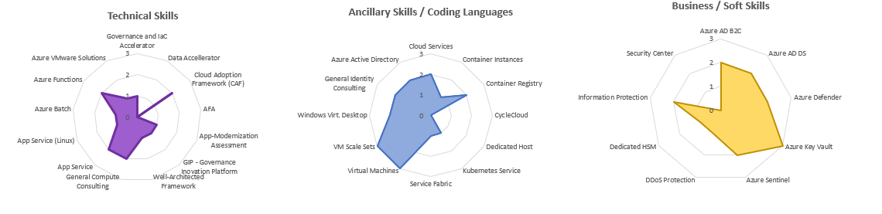

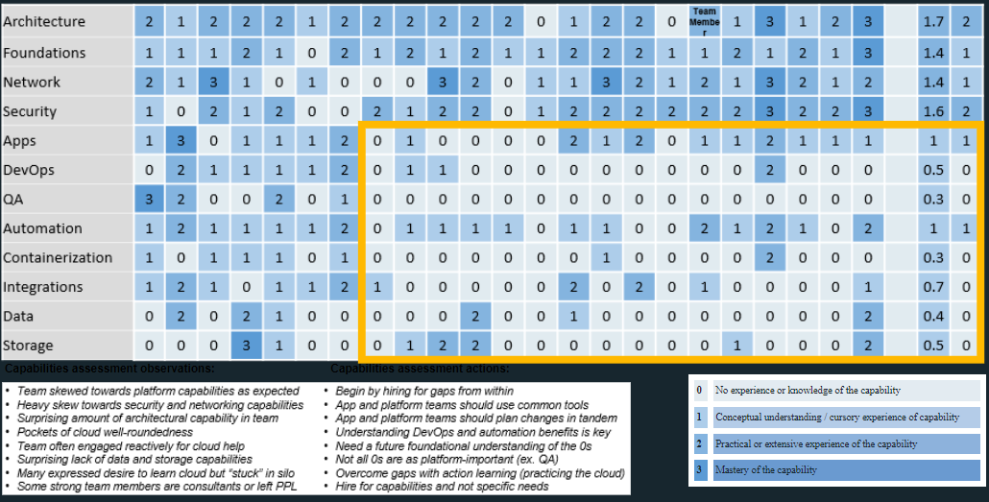

Core Deployment
One of the benefits of adopting Azure as your cloud platform is the ability to leverage various Azure services that can enhance and optimize your workloads. For example, you can use Azure Synapse Analytics to integrate data from different sources and perform advanced analytics and machine learning on it. You can also use Azure Purview to discover, catalog, and classify your data assets, and apply governance policies and compliance standards across your data estate. Additionally, you can use Azure Monitor to collect, analyze, and visualize metrics and logs from your resources and applications, and set up alerts and notifications for any issues or anomalies. By using these Azure services, you can unlock new insights, improve operational efficiency, and ensure data security and compliance for your workloads on Azure.

Core Azure Services for Workloads
To build a scalable, secure, and resilient cloud environment for your workloads, you need to deploy some core Azure services that provide the foundation for your cloud architecture. These services are based on the Azure Cloud Adoption Framework (CAF) and the Enterprise-scale landing zone design principles, which offer best practices and guidance for creating and operating your cloud environment.
The core Azure services for workloads include the following:
- Security: Azure provides comprehensive security tools and capabilities that help you protect your data, identity, and resources from cyber threats. Some of the key security services for workloads are:
- Entra ID: A cloud-based identity and access management service that enables single sign-on, multi-factor authentication, and role-based access control for your resources and applications. To deploy Entra ID, you must create an Entra ID tenant, register your applications, and configure your users and groups.
- Azure Security Center: A unified security management and threat protection service that monitors and assesses the security posture of your Azure resources and provides recommendations and alerts for any vulnerabilities or threats. To deploy Azure Security Center, you need to enable the service on your Azure subscription, select the pricing tier, and configure the security policies and settings.
- Azure Sentinel: A cloud-native security information and event management (SIEM) service that collects and analyses data from various sources and uses artificial intelligence and machine learning to detect and respond to security incidents. To deploy Azure Sentinel, you need to create a Log Analytics workspace, connect your data sources, and create analytics rules and playbooks.
- Networking: Azure offers a range of networking services and features that enable you to connect your workloads to the cloud and to each other, and to optimize their performance and availability. Some of the key networking services for workloads are:
- Azure Virtual Network (VNet): A logical isolation of your Azure resources that allows you to create and manage your own private network space in the cloud, and to configure network settings, such as IP addresses, subnets, and routing. To deploy a VNet, you need to create a VNet resource, specify the address space and location, and add subnets and network interfaces.
- Azure ExpressRoute: A dedicated private connection between your on-premises network and Azure, that offers higher bandwidth, lower latency, and more reliability than public internet connections. To deploy ExpressRoute, you need to create an ExpressRoute circuit, select the service provider and peering location, and configure the routing and connectivity.
- Azure Load Balancer: A network load balancing service that distributes traffic among your servers and applications, and provides high availability and scalability. To deploy a load balancer, you need to create a load balancer resource, specify the frontend and backend pools, and add load balancing rules and health probes.
- Azure VPN Gateway: A virtual network gateway that enables secure and encrypted communication between your Azure VNet and your on-premises or other cloud networks. To deploy a VPN gateway, you need to create a gateway subnet, a public IP address, and a VPN gateway resource, and configure the connection settings and policies.
- Subscription management: Azure provides a flexible and granular way of organizing and managing your cloud resources, based on your business needs and governance requirements. Some of the key subscription management services for workloads are:
- Azure Management Groups: A logical container that groups your Azure subscriptions and allows you to apply governance policies and access controls at a higher level. To deploy management groups, you need to create a management group hierarchy, assign your subscriptions to the appropriate management groups, and apply policies and roles at the management group level.
- Azure Resource Groups: A logical container that groups your Azure resources that share a common lifecycle and allows you to manage them as a unit. To deploy resource groups, you need to create a resource group resource, specify the location and tags, and add resources to the resource group.
- Azure Policy: A service that enables you to create and assign policies that enforce rules and effects on your Azure resources, and to audit and remediate any non-compliant resources. To deploy Azure Policy, you need to create or use an existing policy definition, assign the policy to a scope (such as a subscription, a resource group, or a management group), and evaluate the policy compliance state.
- Azure Bicep: A domain-specific language (DSL) that simplifies the creation and deployment of Azure resources, using a declarative and modular syntax that is easier to read and write than JSON. To deploy Azure Bicep, you need to install the Bicep CLI and the Bicep extension for Visual Studio Code, create or use an existing Bicep file, and compile and deploy the Bicep file using the Azure CLI or PowerShell.

Well-Architected Reviews
A well-architected review for Azure is a beneficial process that aims to ensure the compliance and alignment of the cloud solution with the industry standards and best practices, as well as the specific requirements and goals of the organization. It also helps to identify and mitigate the potential risks and issues that may affect the availability, scalability, performance, security, and cost-effectiveness of the cloud solution. Furthermore, it optimizes the utilization and efficiency of the cloud resources and services, and reduces the unnecessary waste and expenses. Additionally, it enhances the agility and innovation of the cloud solution, and enables faster and easier deployment, integration, and modification of the cloud components. Lastly, it improves the customer satisfaction and trust, and delivers a high-quality and reliable cloud solution that meets or exceeds the expectations and needs of the end-users.

How to Conduct a Well-Architected Review for Azure
A well-architected review is a systematic process to evaluate the design and implementation of a cloud solution against the best practices and principles of the Azure Well-Architected Framework. The framework consists of five pillars: cost optimization, operational excellence, performance efficiency, reliability, and security. The goal of a well-architected review is to identify and prioritize the gaps and risks in the cloud solution and provide recommendations and guidance to improve its quality and alignment with the business objectives.
To conduct a well-architected review, you need to follow these steps:
- Define the scope and objectives of the review. You need to identify the cloud solution or workload that you want to assess, the stakeholders and roles involved, the business and technical requirements, the expected outcomes and benefits, and the timeline and resources for the review.
- Collect and analyze the data and evidence of the cloud solution. You need to gather the relevant information and documentation about the cloud solution, such as the architecture diagrams, the resource inventory, the configuration settings, the performance metrics, the operational logs, the cost reports, the security policies, and the compliance status. You also need to interview the stakeholders and users of the cloud solution to understand their perspectives and experiences.
- Evaluate the cloud solution against the five pillars of the Azure Well-Architected Framework. You need to use the questions and criteria provided by the framework to assess the strengths and weaknesses of the cloud solution in each pillar. You need to rate the cloud solution on a scale of 1 to 5, where 1 means the cloud solution does not meet the pillar requirements, and 5 means the cloud solution fully meets the pillar requirements. You also need to identify the critical issues and risks that need to be addressed urgently.
- Generate and prioritize the improvement actions and recommendations. You need to use the best practices and guidance provided by the framework to suggest the possible solutions and alternatives to improve the cloud solution in each pillar. You need to prioritize the improvement actions based on the impact and urgency, and assign the responsibilities and timelines for each action. You also need to estimate the costs and benefits of each action and evaluate the trade-offs and dependencies among the pillars.
- Report and communicate the findings and results of the review. You need to prepare a comprehensive and concise report that summarizes the key findings and results of the review, such as the scores and ratings of the cloud solution in each pillar, the gaps and risks identified, the improvement actions and recommendations proposed, and the next steps and follow-ups planned. You also need to communicate the report to the stakeholders and users of the cloud solution and solicit their feedback and inputs.

An example of a checklist to walk through the key checks for an Azure deployment is:
Pillar | Key Check | Completed
Cost Optimization | Have you defined and tracked the budget and spending of the cloud solution? | Yes
Cost Optimization | Have you optimized the size and scale of the cloud resources to match the demand and performance? | Yes
Cost Optimization | Have you used the appropriate pricing and purchasing options to reduce the costs of the cloud resources? | Yes
Cost Optimization | Have you implemented the cost management and governance tools and policies to monitor and control the costs of the cloud solution? | Yes
Operational Excellence | Have you defined and documented the operational processes and procedures for the cloud solution? | Yes
Operational Excellence | Have you automated and standardized the deployment and configuration of the cloud resources? | Yes
Operational Excellence | Have you implemented the monitoring and logging tools and metrics to measure and improve the operational performance and health of the cloud solution? | Yes
Operational Excellence | Have you established the backup and recovery strategies and practices to ensure the availability and durability of the cloud solution? | Yes
Performance Efficiency | Have you designed and implemented the cloud solution to meet the functional and non-functional requirements of the workload? | Yes
Performance Efficiency | Have you optimized the network and storage performance and throughput of the cloud solution? | Yes
Performance Efficiency | Have you leveraged the scalability and elasticity features and services of Azure to adapt to the changes in demand and workload? | Yes
Performance Efficiency | Have you evaluated and adopted the latest technologies and innovations of Azure to enhance the performance and efficiency of the cloud solution? | Yes
Reliability | Have you designed and implemented the cloud solution to prevent and mitigate the failures and faults of the cloud resources? | Yes
Reliability | Have you tested and verified the reliability and resiliency of the cloud solution under different scenarios and conditions? | Yes
Reliability | Have you applied the redundancy and fault tolerance techniques and services of Azure to ensure the continuity and availability of the cloud solution? | Yes
Reliability | Have you implemented the incident and problem management processes and tools to detect and resolve the issues and errors of the cloud solution? | Yes
Security | Have you identified and classified the assets and data of the cloud solution and their security and compliance requirements? | Yes
Security | Have you implemented the identity and access management tools and policies to secure and control the access to the cloud resources and data? | Yes
Security | Have you implemented the encryption and key management tools and practices to protect the confidentiality and integrity of the cloud data? | Yes
Security | Have you implemented the security and compliance monitoring and auditing tools and practices to prevent and respond to the threats and vulnerabilities of the cloud solution? | Yes

Azure Configuration

Entra Id

Entra ID Tenant
Entra ID Tenant is the highest level of account and management abstraction for Microsoft Cloud. Many of Microsoft’s cloud services require a tenant to manage resources. In many cases, only one Tenant is required for the enterprise, and it is synonymous with Directories (which map to AD).
Some enterprises have more than one tenant to partition all user security information. At this level, we manage Entra ID and all Authorization and Authentication across Microsoft Cloud resources, our Office365 and Dynamics environments, and multiple Azure resource Subscriptions.
Companies may have one or more tenants, depending on their needs. Tenants may support the management of Azure subscriptions and other Microsoft cloud services or be dedicated to application identity stores for custom solutions. Learning Care Group is already housing the users in their Entra tenant, and the AAD and on-premises active directory infrastructure was determined to be healthy using built-in tools and PowerShell reports.
Current State:
Primary Domain: learningcaregroup.com
Plan: Azure AD Premium P2
Recommendation:
Neudesic recommends that Learning Care Group remain with the current tenant to manage access control to Azure subscriptions for the internal Sprout About identities.

Recommendation:
Neudesic recommends that Sprout About use the existing healthy active directory in use by other tenants for this new tenant.

AD Connect
Active Directory Connect is a tool used to synchronize on-premises Active Directory users and groups into Azure AD, and to enable extended authentication support for Azure services. This is a useful and effective way to leverage existing user directories in the cloud. This deployment is referred to as a hybrid directory deployment and will provide a unified account managed process across on-premises and cloud identities.
Current State:
Sprout About runs an Azure AD Connect server on-premises for this tenant.

Future state Recommendation:

Migrated to Entra ID and upgrade the connector to the new version.

Resource Quotas
While Azure provides for very large-scale deployments, basic protections against unplanned resource consumption are in place in many areas, including resource quotas. In most cases, quota increases beyond the defaults are available through automated service requests. In some cases, soft limits are increased in coordination with the Microsoft Azure operations teams to ensure resource availability in the desired Regions.

Resource Tags
Resource tags are user-defined name-value pairs that provide additional information about a resource. Each Azure resource allows for 15 tag attribute assignments. Tags support requirements for reporting and automation, management, support and privacy. Of note is that tags are simply free form text values that are easily updated.

Tag Name | Resource Type | Allowed Values | Req’d? | Examples | Description
author | All | Email address  Terraform | Yes | John.Doe@company.com | Person who performed the deployment or final release approver if automated
owner | All | Team Alias | Yes | Collaboration services | Organization responsible for the solution
costgroup | All | Text  App + Env | Yes | MSDNSPROD  IVNTIPROD | Name of the department to which resource belongs
costcenter | All | Numeric | Yes | 60002 | Department to which bills go
terraform | All | Yes / No | No | Yes | Did this resource get created by terraform?
environment | All | Text | Yes | Prod  Dev | Environment short name
location | All | Text | Yes | azw2  azwc | Azure region short name
app | All | Text | Yes | MSDNS  IVNTI | Application short name
approle | All | Text | No |  | Application role
backup | VM, DB | Text | Yes | None  Daily  Monthly | Backup status
resourcetype | All | Text | Yes | Virtual_Machine,  Resource_Group,  Virtual_WAN | Resource long name, space need to replace with underscore
utilizationhour | VM | Text | Yes | 8-20 | Utilization hours in 0-24 format.
utilizationday | VM | Text | Yes | Mon-Fri | Utilization days in DDD format
powerontime | VM | Text | Yes | 00:15  20:45 | HH:mm. Power on minutes are restricted to 15 minute interval.
name | All | Text | Yes | vwan-nethub-prod-azw2-01 | Name of the resource. We are doing this to match with multi cloud structure
purpose | All | Text | Yes | Virtual_Machine-Microsoft_DNS-Forwarder-Production | Concatenation of resource type, application long name, application role and environment. Use – (dash) for concatenation and _ (underscore) for space.
Additional Solution-specific tags may be defined as required.

Management Groups
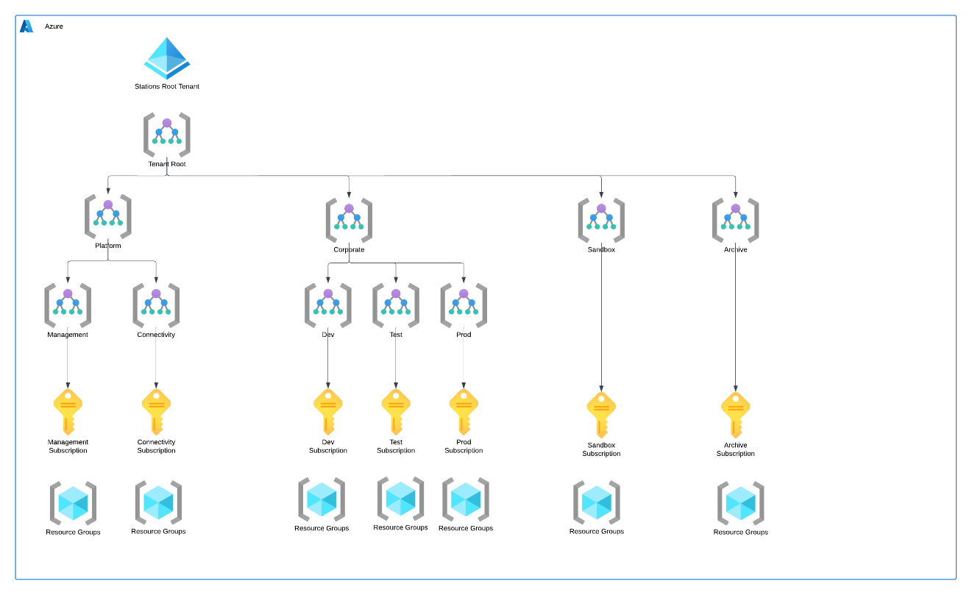
Neudesic recommends the following management groups to be created:

Management Group Description | Mgmt Group Name | Scope
Root Management Group | mg-root | All subscriptions
Platform Management Group | mg-platform | Management and Networking management groups
Management Management Group | mg-management | Management Subscription
Network Management Group | mg-network | Network Subscription
LCG (Production) Management Group | mg-corporate | Dev, Test, and Prod management groups
Prod Management Group | mg-prod | Production management group
Test Management Group | mg-test | Test management group
Dev Management Group | mg-dev | Development management group
Sandbox Management Group | mg-sandbox | Sandbox Subscription
Decommissioned Management Group | mg-archive | Archive Subscription

Subscriptions
Azure Subscriptions are logical containers of Azure resources. They provide an administrative and performance boundary. A single-parent AAD tenant manages each subscription.
Learning Care Group currently have one subscription in the Learning Care Group Working tenant.
Controlled use of a subscription can also reduce the overall cost of the required infrastructure and platform services. Development can be done in a lower-cost Cloud Service Provider (GLSP) model with partner approval or in a pay-as-you-go, model. Additionally, a special subscription type called Dev/Test can be used to reduce licensing costs. This allows additional costs such as VPN, application gateways, or certificates to be added into infrastructure and applications only as needed at each layer.
The following Azure platform components provide core services required for Sprout About Azure projects and establishes a foundation for additional solutions.
Azure Subscriptions provide the highest level of security, billing and policy abstraction. A recommended best practice for Subscription provisioning is to partition based on environment – and implicitly the appropriate level of governance and control.
The table below provides a summary of the current and future Azure subscriptions Neudesic recommends for Sprout About.

Subscription | Purpose | Location
Management Subscription | Management and Identity Tools | East US 2
Network Subscription | Support VWAN and connectivity | East US 2
Sandbox Subscription | Dev environments for QA and Testing | Central US
Prod Management Group | Production management group | East US 2
Test Management Group | Test management group | East US 2
Dev Management Group | Development management group | East US 2
* Both the Development and Testing subscriptions need to be flagged as such in the Microsoft Enterprise Agreement portal to ensure the subscriptions costs are reduced.
The Subscription Name above includes an indication of where it is managed within the overall Learning Care Group deployment topology. At a high level, the Learning Care Group Services Subscription provides a central and highly managed environment with shared resources such as Domain Controllers, Security Reporting, and VPN/ExpressRoute connectivity to on-premises resources.
Note: Subscription names are free-form text and should be reviewed for support of multiple businesses. Naming conventions align directly with other enterprise workloads.

Management Subscription
The management subscription is designed to facilitate an enterprise-scale landing zone architecture in Azure, aligning with the principles of governance, security, and scalability required for large and complex organizations. This subscription serves as the cornerstone for centralized management and orchestration of the various workloads and environments within the Learning Care Group's Azure deployment.
Key features of the management subscription include:
- Security and Monitoring: Centralized security management integrated with Learning Care Group’s security and monitoring infrastructure, providing advanced threat detection and response capabilities. Continuous monitoring and auditing of activities within the subscription are conducted to maintain a secure posture.
- Resource Management: Utilization of Terraform templates and Infrastructure as Code (IaC) practices to automate the deployment and management of resources, ensuring consistency and repeatability across environments.
- Cost Management: Comprehensive cost management and optimization strategies, leveraging Azure Cost Management + Billing, to monitor and control expenditure across subscriptions, ensuring financial accountability and efficiency.
This management subscription framework supports the scalability and operational efficiency required for the Learning Care Group's growing digital landscape, ensuring robust governance, enhanced security, and streamlined management processes across all Azure deployments.
An Identity Subscription within the environment is foundational for managing identity and access across a large and complex organizational landscape. This subscription leverages Entra ID to provide a unified identity and access management system, ensuring secure, scalable, and efficient governance over identity resources.
Key components of this Identity Subscription include Single Sign-On (SSO), Multi-Factor Authentication (MFA), and conditional access policies. SSO allows users to access multiple applications with a single set of credentials, simplifying the user experience and reducing the risk of password fatigue. MFA adds an extra layer of security by requiring two or more verification methods, protecting against unauthorized access. Conditional access policies enable dynamic control over access to resources based on user, location, device, and risk level, ensuring that only legitimate requests are granted.

Network Subscription
The Network Subscription is designed to provide essential ingress and egress capabilities for peered virtual networks. This subscription serves as the backbone for network traffic management, ensuring secure and efficient data flow between various virtual networks and external environments.
Key components of this Connectivity Subscription include ExpressRoute and VPN connections, which facilitate secure and reliable connectivity between on-premises data centers and Azure environments. These connections support hybrid cloud scenarios, enabling seamless workload migration and integration with existing infrastructure. Additionally, the Connectivity Subscription leverages a Palo Alto firewall and Network Security Groups (NSGs) to enforce security policies and protect against unauthorized access.
Peered virtual networks within the Connectivity Subscription benefit from enhanced network performance and reduced latency, as traffic between them does not traverse the public internet. This setup ensures a more secure and efficient communication channel, critical for maintaining the integrity and performance of the interconnected resources.

Sandbox Subscription
The Sandbox Subscription is used to create or configure new resources/capabilities for the project. It is accessible by any developer on the team and is generally supported by operations for core functionality and otherwise at best effort. Changes to this environment are expected on a regular basis – both in the Azure configuration and in the solution itself. These changes may be either manual or through automation.

Production Subscription
The Production Subscription is a specialized production environment designed to efficiently deploy and manage containerized Sprout About applications. This subscription is tailored to support both web app and mobile app endpoints, providing a robust and scalable infrastructure that meets the dynamic demands of modern application development.
Key components of the Production Subscription include managed Kubernetes clusters that orchestrate the deployment, scaling, and management of containerized applications. By leveraging AKS, developers can focus on building features rather than managing the underlying infrastructure, as Azure handles critical aspects like health monitoring, auto-scaling, and updates.
Web app endpoints within the AKS environment benefit from Azure's global load balancing and traffic management, ensuring high availability and performance. The integration with Azure Container Registry simplifies the process of storing and managing container images, facilitating continuous integration and continuous deployment (CI/CD) workflows.
For mobile app endpoints, AKS provides seamless backend services that can handle varying loads and connect with other Azure services, such as data storage components.

Test Subscription
The purpose of the Test Subscription is to contain all test environments used for validating applications. This plays a crucial role in the CI/CD process, ensuring that every aspect of the applications is thoroughly tested before deployment.

Developer Subscription
The purpose of the Dev Subscription is to support development teams in the development process, providing them with the necessary resources and environments to build, test, and iterate on their software projects efficiently. This dedicated subscription ensures that developers have isolated environments to work on new features and bug fixes without impacting the production systems.

Access Control
Access control is another critical component of maintaining a stable and secure cloud environment. Azure provides granular control over all aspects of Azure resources and operations within the cloud environment. Microsoft has developed an extensive selection of pre-defined roles along with the ability to create custom roles that can be leveraged throughout the environment.
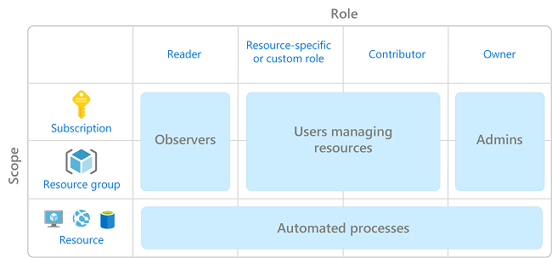

Current State:
There are no current role based access control groups in the Learning Care Group Azure tenant outside proof of concept development that may be happening in other tenants.
Learning Care Group should limit the number of users granted access to administrative roles and should limit the global administrator roles to two accounts, with a fallback emergency account which is highly secured using additional password or FIDO type protections. Operational support should be initially limited in the production environment to only those personnel building and deploying new resources. These recommendations are in accordance with cloud and infrastructure best practices.
Access control gathering and auditing will be needed and it must meet compliance and regulatory requirements for organizations dealing in financial transactions or services. Specific standard are mentioned in the Governance section of this document. Learning Care Group will need to build out these capabilities to ensure the cloud based solution meet the required industry standards.
Recommendation:
Learning Care Group should deploy RBAC roles and policies for administrative functions initially, and further refine role based access control groups for application owners and delegated operational support as applications are redeployed to Azure. Learning Care Group should create top-level Active Directory groups to minimize user sprawl inside of the RBAC controls, and to ensure role management is backed by active directory group management rather than individual assignments.

Recommendation:
Learning Care Group should limit the number of users with global administrator, or similar roles to two or fewer people, and a fallback break glass account. Additional administrative roles in Azure should be provided with a minimum required permissions approach.

Recommendation:
Learning Care Group needs to establish a fully integrated compliance collection methodology for auditing and access which will need to integrate on premises allocation using Auze Automation and Desired State configuration of active directory controllers, AAD authentication, Cloud App Security Broker (CASB), AAD logging, Azure Monitor, Azure Log Analytics, and Azure Sentinel to have the complete audit log in the initial phase of these deployments. This can later be extended with additional automation and third party integration and retention, and Azure long term storage retention to ensure compliance throughout the retention period which is covered in further depth with compliance components.

Governance

Governance in the Microsoft Cloud Adoption Framework for Azure
The cloud creates new paradigms for the technologies that support the Learning Care Group business. These new paradigms also change how those technologies are adopted, managed, and governed. When entire datacenters can be virtually torn down and rebuilt with one line of code executed by an unattended process, traditional approaches need to encompass these changes. This is especially true for governance.
Cloud governance is an iterative process. Learning Care Group has existing policies that govern on-premises IT environments; thus, cloud governance should complement those policies. The level of corporate policy integration between on-premises and the cloud varies depending on cloud governance maturity and Learning Care Group’s digital estate in the cloud. As the cloud estate changes over time, so do cloud governance processes and policies. The following exercises help Learning Care Group start building the initial governance foundation.
- Methodology: Establish a basic understanding of the methodology that drives cloud governance in the Cloud Adoption Framework to provide Learning Care Group with vision of the end state solution.
- Benchmark: Assess Learning Care Group current state and future state to establish a vision for applying the framework.
- Initial governance foundation: Begin the Learning Care Group governance journey with a small, easily implemented set of governance tools. This initial governance foundation is called a minimum viable product (MVP).
- Improve the initial governance foundation: Throughout implementation of the cloud adoption plan, Learning Care Group will iteratively add governance controls to address tangible risks as Learning Care Group progresses toward the end state.

Policies
Azure Policy Service is a tool to apply and enforce controls to Azure resources. They can be applied at scopes from Management Groups, subscription, and resource groups.
Current State:
The current Learning Care Group subscription has no policies in place for Security Center in the new tenant. Existing tenants may provide a template for policies. The key factors in determining what policies should be used with Azure are the compliance requirements which Learning Care Group is accountable to in their audit and compliance processes. Learning Care Group can use a combination of blueprints, initiatives, policies, and best practices baselines available in Azure to meet these needs.
The Learning Care Group organization identified that they are accountable for following.
- CIS Microsoft Azure Foundations Benchmark v1.1.0
Learning Care Group can use existing blueprints of approved and certified solutions in Azure, along with custom initiatives of policies to meet their security and compliance requirements in a policy driven solution. The solutions integrate with the built-in tools of Azure Monitor and Azure Security Center to add in additional best practices monitoring and baselines for IaaS and PaaS solutions security and policy driven compliance.
On top of CIS Microsoft Azure Foundations Benchmark v1.1.0 blueprint, following policies are identified for Learning Care Group governance
- Allowed Locations – East US 2 and Central US only
- Allowed resource types
- Required tag on resource group – Audit Only
- Required tag on resource – Audit Only
- Azure backup should be enabled for Virtual Machines
- Add a tag to subscriptions – Environment tag
- Add a tag to resource group
- Audit VMs that do not use managed disks
- There should be more than one owner assigned to your subscription
- Audit resource location matches resource group location
- Automation account variables should be encrypted
- Azure Automation account should have local authentication method disabled
- Entra ID Domain Services managed domains should use TLS 1.2 only mode
- Allowed virtual machine size SKUs
  - Following SKUs are identified as allowed for LCG
    - General Purpose
      - Standard_D2s_v3
      - Standard_D4s_v3
      - Standard_D8s_v3
      - Standard_D16s_v3
      - Standard_D32s_v3
    - Compute Optimized
      - Standard_F4s_v2
      - Standard_F8s_v2
      - Standard_F16s_v2
      - Standard_F32s_v2
    - Memory Optimized
      - Standard_E2s_v3
      - Standard_E4s_v3
      - Standard_E8s_v3
      - Standard_E16s_v3
- Managed disks should disable public network access
- Audit usage of custom RBAC rules
- Custom subscription owner roles should not exist
- Activity log should be retained for at least three months – custom policy
- Audit diagnostic setting
- A custom IPsec/IKE policy must be applied to all Azure virtual network gateway connections
- Flow logs should be configured for every network security group
- Network Watcher flow logs should have traffic analytics enabled
- RDP access from the Internet should be blocked
- SSH access from the Internet should be blocked
- Deprecated accounts should be removed from your subscription
- IP Forwarding on your virtual machine should be disabled
- Non-internet-facing virtual machines should be protected with network security groups
- Azure SQL Managed Instance should have Entra ID Only Authentication enabled
- Public network access on Azure SQL Database should be disabled
- SQL Managed Instance should have the minimal TLS version of 1.2
- Vulnerability assessment should be enabled on SQL Managed Instance
- Vulnerability Assessment settings for SQL server should contain an email address to receive scan reports
- Public network access should be disabled for Azure File Sync
- Storage account keys should not be expired
- Storage accounts should be limited by allowed SKUs
- Inherit a tag from the resource group if missing
- Inherit a tag from the subscription

Recommendation:
Neudesic recommends Learning Care Group leverage existing blueprints for compliance requirements where they exist. Learning Care Group will have to complete additional development for custom initiatives to support additional standards which are not pre-existing.

Recommendation:
Neudesic recommends Learning Care Group enable Security Center for all resources deployed in Azure, and ensure those devices are also enabled for support in Azure Monitor wherever supported. This will help improve policy driven compliance reporting, and lead to improved mapping of next step tasks for continuous improvement of Azure hosted resources.

Regional Deployment
The Learning Care Group Azure resource deployment currently uses single Azure Region: East US 2. Not all Azure services are available in each location to care needs to be taken as to what services are leveraged. Azure Products by Region | Microsoft Azure
Azure Regions are configured in pairs for business continuity and disaster recovery (BCDR) during an entire data center outage. The Azure platform internally configures East US 2 and Central US for redundancy. The current regional pairing may be reviewed in the reference below.
Ensure business continuity & Business Continuity using Azure Paired Regions | Microsoft Docs

Azure Regions | Location
East US 2 - primary | Virginia
Central US - secondary | Iowa
Azure cost comparison is located here.
Note: Some Azure services are available only in a subset of regions. Depending on requirements, a large deployment typically spans multiple regions. With the speed of the underlying Azure network fabric, this is typically not an issue at the management plane. Still, care should be taken to deploy high-affinity resources (databases and their consumers) to the same location.
The current list of Azure products available in each region are available from the Azure web site referenced here.
Benefits of paired regions:
- Physical isolation – When possible, Azure prefers at least 300 miles of separation between data centers in a regional pair, although this is not practical or possible in all geographies. Physical data center separation reduces the likelihood of natural disasters, civil unrest, power outages, or physical network outages affecting both regions at once. Isolation is subject to the constraints within the geography (geography size, power/network infrastructure availability, regulations, etc.).
- Platform-provided replication - Some services such as Geo-Redundant Storage provide automatic replication to the paired region.
- Region recovery order – In the event of a broad outage, recovery of one region is prioritized out of every pair. Applications that are deployed across paired regions are guaranteed to have one of the regions recovered with priority. If an application is deployed across regions that are not paired, recovery may be delayed – in the worst case the chosen regions may be the last two to be recovered.
- Sequential updates – Planned Azure system updates are rolled out to paired regions sequentially (not at the same time) to minimize downtime, the effect of bugs, and logical failures in the rare event of a bad update.
- Data residency – A region resides within the same geography as its pair (with the exception of Brazil South) in order to meet data residency requirements for tax and law enforcement jurisdiction purposes.

Naming Conventions
Azure deployments comprise an expanding set of resources, each with a specific role. While a first project may only require a small set, this typically evolves rapidly. Identifying resources – either through automation code or by staff – is essential.
Note: Azure imposes some restrictions for the naming of certain types of resources, such as storage accounts and virtual machines. Use of special characters and name lengths also have differing constraints depending on the resource type.
- Virtual Machine name lengths are limited to 15 characters for legacy compatibility
- Storage account names do now allow dashes (‘-‘) and must be globally unique
- Other resources, particularly PaaS services, that may be globally accessible have unique requirements as well.

Management Group Naming
At least 4 management groups will be required to correctly control permissions within the Azure environment.
- mg-prod
- mg-sandbox
- mg-archived

Resource Naming Patterns
As an overall guideline, each resource is identified by its organization, environment, location and resource type – largest scope decreasing to the smallest.
<resourcetype>-<workload/application>-<subscription>-<environment>-<region>-<instance>
(Note the dashes)
- Resource Type
- Workload/Application
- Environment
- Subscription
- Region
- Instance
Each segment is specified with a short but recognizable acronym. Resource tagging will also be useful to further classify services and helps to segment billing costs.

Resource Type
The type of service is identified in the name. The following services are identified for platform foundations.
Note: Virtual Machines and Storage Accounts have distinct naming conventions that deviate from the general conventions due to underling technical restrictions. Specifically, Virtual Machine names are limited to 15 characters, and Storage Account names (including Data Lake) do not allow for the hyphenated convention, must be globally unique and are limited to 24 characters.
Service | Segment Code
Analysis Services | ax
Data Bricks | bk
Data Factory | df
Data Lake | dl
Data Warehouse | dw
Machine Learning Workspace | ml
MS SQL Database (PaaS) | db
MS SQL Database Server (PaaS) | dbs
Postgres Database Server (PaaS) | pds
Postgres Database (PaaS) | pd
Virtual Machine | vm
Availability Set | as
Managed Disk | md
Storage Account | sa
Backup/ASR Vault | vlt
Function Apps | fa
Logic Apps | la
Web Apps | wa
Key Vault | kv
Automation Account | aa
Automation Schedule | scd
Log Analytics Workspace | ws
Internal Load Balancer | ilb
Public Load Balancer | plb
Application Gateway | agw
Virtual Network | vnet
Subnet | sn
Network Security Group | nsg
Virtual Network Peer | peer
Virtual Network Gateway | vng
Public IP Address | pip
ExpressRoute | er
Bastion | bstn
Firewall | fw

Workload/Application
Resources are further segmented based on their use. While migration is the core use case at this time, supporting platform resources for management and connectivity are also required. The solution segments identified below are planned for deployment - either as core infrastructure or specific to an application initiative.
Solution | Segment Code
vWAN Hub | nethub
vWAN Spoke | netspoke

Environment
The following segments names are assigned as a part of naming conventions for each environment.
Environment | Segment Code
Production | prod
QA | qa
Development | dev
Staging | stg

Subscription
The following segments names are assigned as a part of naming conventions for each subscription.
Subscription | Segment Code
Production | prod
QA | stg
Development | dev
Staging | stg
Services | svcs
Bubble | bub

Region/Data Center
Solutions may be deployed across multiple environments and regions. West US is identified as the primary Azure Region, with West Central US as the secondary for Business Continuity requirements.
Note: Some Azure Services are not available in all Regions, and management services may be hosted in Regions serving an entire geography.
Environment | Segment Code
Azure West US2 | azw2
Azure West Central US | azcu

Instance
The instance code is a sequence number for multiple like resource deployments, such as a Virtual Machine Scale Set or multiple Data Bricks. This index is appended to the resource name when appropriate.
Note: Azure Resource Manager iterators are zero-based. Minor additional scripting is included in automation to adjust the index.
Resource Type | Index Code
Virtual Machines | 01-99
Data Bricks | 01-999
Worked Examples
Resource Type | Workload | Subscription | Environment | Region | Instance | Example
rg | hubspoke | svcs | prod | azw2 | 01 | rg-hubspoke-svcs-prod-azw2-01
vwan | nethub | prod | prod | azw2 | 01 | vwan-nethub-prod-prod-azw2-01

Virtual Machine Naming Patterns
Virtual Machines have unique naming requirements, which differ based on the OS (Windows or Linux). Specifically, Windows VM names are limited to 15 characters, while Linux VM names allow up to 64 characters.
Note: Azure VMs have two distinct identifiers – the VM resource name and the host name. Generally, these are the same when the VM is created. The resource name length can be 64 characters, but the host name is where the limitation is a factor – and what is typically used by management tools and the Azure portal.
Working with these constraints, the Sprout About Azure deployment differentiates between VMs in the enterprise/prod environment and those in the spokes just as Data and Analytics (DA) specifically for Windows-based VMs.

Linux VMs:
Linux VM names follow the general conventions in the previous section but omit the ‘vm-’ resource type prefix and subscription.
<workload/application>-<environment>-<region>-<instance>
Examples:
rdp-dev-azw2-01

Windows VMs:
Windows VMs in the spoke Subscriptions generally follow the same conventions as Linux VMs. In order to align with on-premises naming conventions for Windows, as well as conserve characters in the name.
<workload/application>-<environment>-<region>-<instance>
Examples:
mgt-dev-azw2-01

Tagging
Tagging of all resources in an Azure environment helps to provide consistency, query, and automation of services in a mature state. The Microsoft guidelines provide for tags that are organizational focused, but this model is not the best fit for Learning Care Group initially. There are no current tagging policies in place today as resources are not tagged or present in a cloud provider at this point.
Current State:
Learning Care Group does not have tagging in place. Neudesic recommends Learning Care Group keep tagging conventions short and consistent in alignment with the Azure recommended conventions for simplicity.

Kubernetes Resources

Naming Patterns for Kubernetes Resources
- Namespaces: --
- Pods: ---
- Services: svc---
- Deployments: deploy---
- ConfigMaps: cm---
- Secrets: sec---
- PersistentVolumeClaims (PVCs): pvc---
- Ingress: ing---
- DaemonSets: ds---
- StatefulSets: ss---
- Jobs: job----
- CronJobs: cj----

Resource Lock Naming Patterns
Azure provides two types of Resource Locks, which are assigned at the resource, Resource Group or Subscription level. These locks offer an additional layer of protection against unplanned changes to key services. Best practice is to combine both lock types on for the same Resource Group and consider what locks are appropriate for either an entire Subscription or a particularly sensitive resource.
Note: Only a Global Administrator or Resource Owner has permissions to remove Resource Locks. Contributors or other roles do not have this permission.
Two lock types are supported – Read Only and Delete. The convention provided below is composed from the Resource Group name and Resource Lock type.
<resource name>-<lock type>
lock type: read-lock | delete-lock
For example:
rg-nethub-svcs-prod-azw2-01-read-lock (Resource Group)
rg-nethub-svcs-prod-azw2-01-delete-lock (Resource Group)

Service Account/App Registration Naming Conventions
Service accounts are used for application connections between resources, such as from Azure Data Factory to Data Lake storage. These accounts are managed in Entra ID .
Accounts are configured for two different functions – named resources and application roles.
For named resources, application names simply match the resource name itself.
<functionality>-<resource name>
Example: terraform-mg-prod

Network Security Group Rule Naming Patterns
Network Security Groups (NSGs) help control network traffic as lightweight firewalls assigned to entire Virtual Networks, Subnets, or Virtual Machine NICs. Common templates can be applied to multiple resources, but they do not nest.
When created, the Azure platform evaluates each packet against the NSG rules (in order) until there is a match and then either allows or denies traffic. This is done at the NIC level, even if the rules are defined for a broader scope, such as a Subnet or VNet.
NSG rules are a combination of inbound and outbound addresses, ports, protocols and whether to allow or deny traffic.
Rule names are defined as follows:
<action>-<network>-<port>-<direction>
action: allow | deny
network: shorthand for address space, protocol, subnet/vnet/etc.
port: port number | all
direction: in | out
Examples:
- allow-it-prod-all-out: All outbound traffic to the IT Hub subnet
- deny-10-80-out: Deny outbound traffic to the entire 10.x.x.x private address space
- deny-internet-all-out: Prohibit direct connections to Internet resources

Resource Groups
Resource groups in Azure are containers of resources which operate to organize, act as security boundaries, and segment resources by support organizations. Resource Groups are foundational collections of resources that server as a management and security container. In practice, they represent a complete functional solution, or a set of resources with strong affinity. Resource groups are used for a few different purposes and may vary depending on what resources are contained within, and the support function they back.
Additional uses cases may also generate the need for resource groups such as administration access control, delegating fine grained permissions to resources contained with the group. It is recommended for most scenarios that security be applied at the resource group level and let resource contain inherit access controls. Lifecycle of resources, resources that are dedicated and or related to each other for a specific service or application can deployed and removed as group providing efficiency in lifecycle management, and to allow for reorganization as organizations change and grow.
For example, a solution-specific Resource Group may contain its collection of Web Servers, Databases, Storage Accounts and applications required for an entire deployment. Operational Resource Groups, such as a network Resource Group, would contain the Virtual Network, Network Security Groups, VNet Gateways and NVAs.
- Every Azure Resource is contained in exactly one Resource Group
- RBAC permissions may be assigned at the Resource Group level (this is typical).
- Billing reports may be generated for the Resource Group; providing information about the overall cost of each solution within the Learning Care Group environment.
Current State:
Learning Care Group Azure resource groups generally fall into 2 types, organized by service names or environment types. Resource groups should also be used to set permission boundaries, support boundaries, and development team permissions.
Here are some specific examples of what that would look like in accordance with the defined standards and incorporating the naming standards recommendations.
Example: rg-nethub-lcg-prod-prod-azw2-01
Example: rg-netspoke-dev-dev-azw2-01

Recommendation:
Neudesic recommends that as part of the migration process that Learning Care Group identify an application owner and RBAC roles to support those applications during the migration processes. In addition, Learning Care Group should identify how those permissions should be applied in the development and production environments to deploy permissions by appliciation owner or application support team. This will lead to better security boundaries and should result in application oriented resource groups as boundaries.

Resource Providers
Each Azure resource type has supporting Resource Providers that are registered to support specific services. As the Azure platform includes a broad array of services, only those required for a given Subscription are registered and available for applications.
The table below provides the list of Resource Providers registered for the Sprout About Azure deployment.
Note: When fully deployed, the Learning Care Group Production, QA and Development Subscriptions are expected to have the same provider registrations. Over time, some deployments may not require all environments and the reference list may vary across Subscriptions.

Provider – Default Registrations
Microsoft.ADHybridHealthService
Microsoft.Authorization
Microsoft.Advisor
Microsoft.Billing
Microsoft.ClassicSubscription
Microsoft.Commerce
Microsoft.Consumption
Microsoft.CostManagement
Microsoft.Features
Microsoft.MarketplaceOrdering
Microsoft.Network
Microsoft.PolicyInsights
Microsoft.Portal
Microsoft.ResourceGraph
Microsoft.Resources
Microsoft.Security
Microsoft.SerialConsole
microsoft.support
Microsoft.WorkloadMonitor

Provider – Error! Unknown document property name. Other Registrations
Microsoft.AlertsManagement
Microsoft.Automation
Microsoft.Compute
Microsoft.insights
Microsoft.KeyVault
Microsoft.ManagedIdentity
Microsoft.OperationalInsights
Microsoft.Storage
Microsoft.Sql

Network Configuration
Virtual Networks and supporting resources such as DNS, Network Security Groups, and Domain Controllers are fundamental to the CLA IaaS infrastructure. The configuration settings provided in this section are shared across each environment.

Proposed Azure Architecture
This is a proposed architecture for Learning Care Group. All infrastructure will be deployed via pipeline and defined in Terraform.
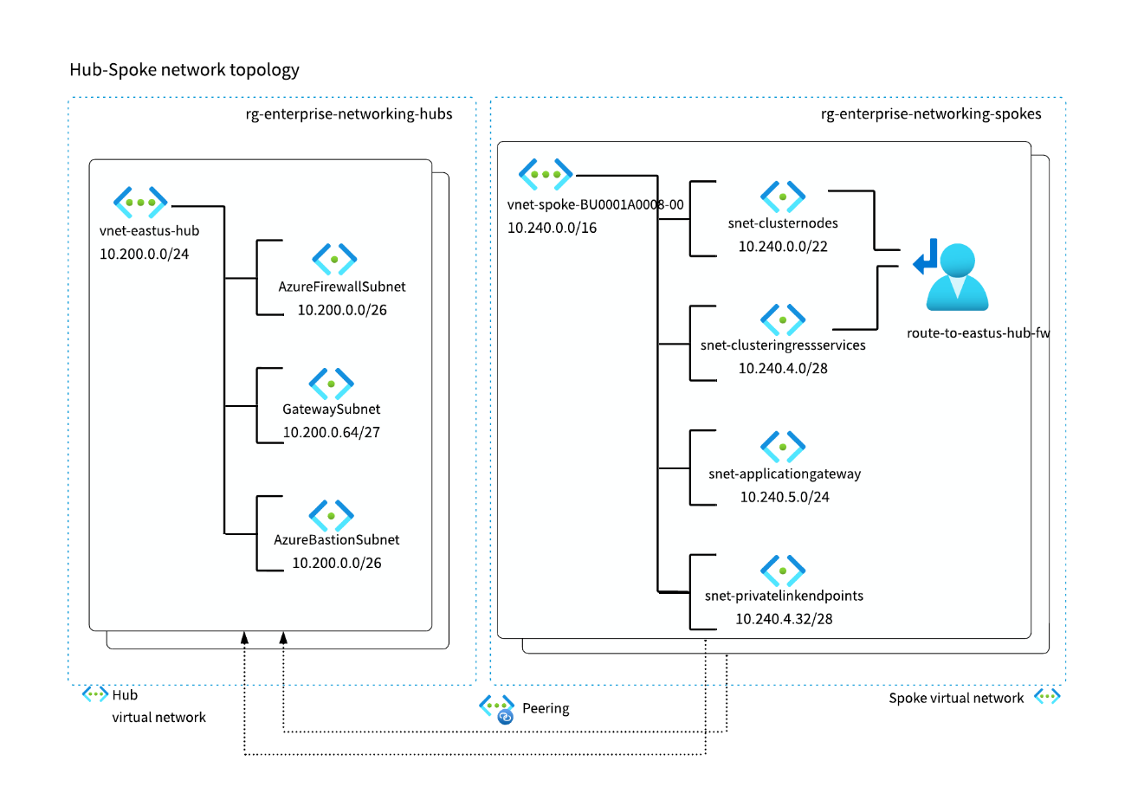

VNET Definitions
Virtual Network | IP Range | Subscription
hub-azw2 (vWAN managed VNET) | 10.200.14.0/24 | Services
vnet-netspoke-svcs-prod-azw2-01 | 10.240.0.0/16 | Services
vnet- netspoke-dev-dev-azw2-01 | 10.220.0.0/24 | Development
vnet- netspoke-test -azw2-01 | 10.230.0.0/24 | Test
vnet- netspoke-prod-prod-azw2-01 | 10.241.0.0/24 | Production

IP Zones
Each of the above address spaces will be divided into a single subnet/Zone called default, and each will have an NSG assigned.
Default subnet IP range will be first /24 range of VNET IP range.

ExpressRoute and Virtual Private Networks and Virtual WAN
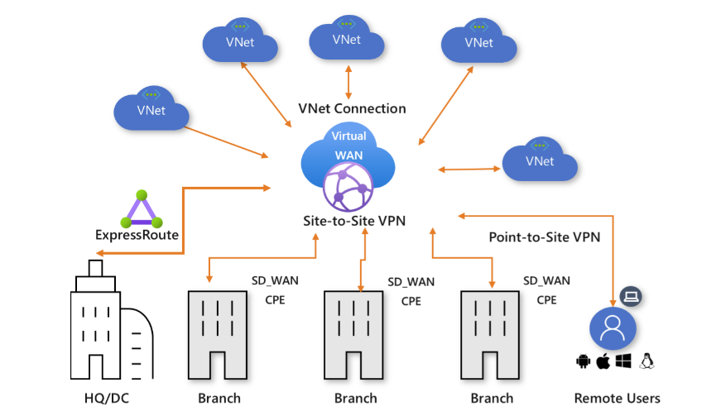
Recommended connectivity from Learning Care Group data centers to Azure is over VPN connections until ExpressRoute is planned and implemented. ExpressRoute provisioning should be planned from head office to the Azure Virtual WAN environment. Each subsequent branch of required location can then connect into the virtual WAN.

Net Peering
Learning Care Group should implement VNET peering between each of the VNETs to ensure connectivity within Azure.
Connecting the connectivity subscription to the spoke AKS (Azure Kubernetes Service) subscription is a crucial step in ensuring seamless integration and efficient management of resources. This can be effectively achieved through the use of Azure VNET peering and Virtual WAN, which facilitate robust communication between different environments.
Initially, the connectivity subscription should be configured to establish VNET peering with the spoke AKS subscription. This involves creating peering links between the VNETs in both subscriptions, allowing for high-speed, low-latency connectivity. The configuration process can be carried out using the Azure portal, Azure CLI, or PowerShell, ensuring that routing is appropriately set up and permissions are granted for seamless data flow. By implementing VNET peering, you enable the AKS clusters in the spoke subscription to securely communicate with resources in the connectivity subscription, thereby optimizing resource utilization and enhancing overall network performance.
Additionally, integrating the connectivity subscription with the Azure Virtual WAN environment further strengthens this setup. The Virtual WAN acts as a centralized hub, connecting multiple branches and VNETs. By connecting the spoke AKS subscription to this hub, you ensure a scalable and efficient network architecture that supports dynamic workloads and simplifies management. This comprehensive approach provides Learning Care Group with a resilient and flexible infrastructure, capable of meeting current demands and accommodating future growth.

Domain Controllers and DNS
While the Azure platform provides native DNS functionality, the Learning Care Group deployment is a direct extension of the internal infrastructure. As such, the Domain Controllers deployed to both the Production environment as well as on-premises provide this service and are configured as a part of Virtual Network configuration. These servers also provide DNS support.
Note: Azure Hub domain controllers have not been deployed and are recommended for support of any future IaaS/VM solutions in Azure.
Server | IP Address
vm-trtcproazw1wp01 | 10.200.0.11
vm-trtcproazw1wp02 | 10.200.0.12
vm-trtcproazw1wp03 | 10.200.0.13

Firewall Whitelists
Many Azure PaaS services use internal firewalls for additional network security. This includes SQL Database and Storage Accounts.
Note: Individual IP addresses listed below are temporary until VPN connectivity is established. Once complete, resource access will be through private connections only.
Following firewall rules were identified as part of preliminary analysis.

Name | Protocol | Source | Destination | Ports | FQDN
DNS Outbound | UDP, TCP | Azure IP Group | 10.101.175.28, 10.0.175.27 | 53, 49152-65535
VDI | Any | Entire Company with DMZ | Azure IP Group | *
Ping Outbound | ICMP | Entire Company with DMZ | Entire Company with DMZ | *
VDI | Any | Azure IP Group | Entire Company with DMZ | *
Ping Inbound | ICMP | Entire Company with DMZ | Azure IP Group | *
HTTPS Outbound | TCP | Azure IP Group | Azure IP Group | 443
Remote Access Outbound | TCP | Azure IP Group | Entire Company with DMZ | 22, 1433, 5985, 3389, 5986
DNS Inbound | UDP, TCP | 10.103.30.216, 10.101.175.28, 10.0.175.27, 10.103.31.18 | Azure IP Group | 53, 49152-65535
Movere Inbound | TCP | 10.0.175.228 | Azure IP Group | 445
Internet Outbound | TCP | Azure IP Group | * | 80, 443
KMS Outbound | TCP | Azure IP Group | 23.102.135.246, 40.83.235.53, 10.0.175.5, 20.118.99.224 | 1688
Remote Access Inbound | TCP | Entire Company with DMZ | Azure IP Group | 22, 1433, 5985, 3389, 5986
HTTPS Inbound | TCP | 10.0.146.0/24 | Azure IP Group | 443
SMTP Outbound | TCP | Azure IP Group |  | 25 | rivendell.trtc.com
GIT Outbound | TCP | Azure IP Group |  | 22 | bitbucket.org, github.com

Kubernetes Networking
Kubernetes adds an additional networking layer and complexity on top of the existing Azure Networking components and configurations. For Learning Care Group, we want to achieve the following goals:
- Network Topology
- The Kubernetes cluster is deployed in a Hub and Spoke network topology:
  - Hub VNet contains centralized networking components such as Azure Firewall, Traffic Manager, Bastion, and Application Gateway.
  - Spoke VNet contains the Kubernetes cluster, which includes nodes, ingress controllers, and internal load balancers.
  - Pod Overlay Network is used within the Kubernetes cluster for internal pod communication, separate from the Azure Virtual Network (VNet) IP address space.
- Ingress and Egress Traffic Flow
- Ingress Traffic Flow:
  - Public-facing traffic enters through the Application Gateway in the Hub VNet, which uses the Application Gateway WAF (Web Application Firewall) for security.
  - The Application Gateway Ingress Controller manages the ingress traffic flow to the Kubernetes cluster, directing it to the appropriate services and pods.
  - Internal traffic is handled by an Internal Load Balancer (ILB) within the Spoke VNet to manage service-to-service communication inside the cluster.
- Egress Traffic Flow:
  - All outbound traffic from the Kubernetes cluster is routed through the Azure Firewall in the Hub VNet for secure inspection and policy enforcement.
- Security Components
- Application Gateway WAF protects ingress traffic against common threats and vulnerabilities.
- Azure Firewall acts as a centralized security control for egress traffic, monitoring and filtering outbound communications.
- Private Endpoints are used for secure access to Azure services (e.g., Key Vault, Storage, Azure Container Registry) from within the Kubernetes cluster, ensuring that traffic does not leave the Azure network.
- Azure Bastion is deployed in the Hub VNet to provide secure and managed access to the Kubernetes cluster for administrators.
- DNS Resolution and Routing
- Azure Traffic Manager is used for DNS resolution and routing across multiple Azure regions, providing global load balancing and failover capabilities.
- Peering with Other VNets
- The Hub VNet is peered with several other VNets hosting additional Azure services:
  - Cosmos DB and Azure SQL for database services.
  - Azure Monitor for monitoring and logging.
  - Azure Sentinel for security information and event management (SIEM).
  - Azure DevOps for CI/CD pipelines and integration.
  - Other applications and resources
- Secure Access to the Cluster
- Secure access to the Kubernetes cluster is achieved using Azure Bastion, which provides a secure and managed connection without exposing any public IP addresses.
- Private Endpoints ensure that access to Azure resources (like Key Vault, Storage, and Container Registry) is secure and stays within the Azure network boundaries.
- Azure Services Used by the Cluster
- Application Gateway (with WAF) for managing and securing ingress traffic.
- Azure Firewall for egress traffic inspection and control.
- Azure Bastion for secure administrative access to the cluster.
- Azure Key Vault, Azure Container Registry, and Azure Storage Accounts for secrets management, container images, and data storage, respectively, accessed securely through Private Endpoints.
- Azure Services in Other VNets
- Azure Cosmos DB: NoSQL database service for managing distributed data.
- Azure SQL Database: Managed relational database service for transactional workloads.
- Azure Monitor: Comprehensive monitoring service for collecting, analyzing, and acting on telemetry data.
- Azure Sentinel: Cloud-native SIEM for intelligent security analytics and threat intelligence.
- Azure DevOps: Platform for DevOps services such as code repositories, CI/CD pipelines, and artifact management.
- Azure Services Peered with the Hub VNet
- Cosmos DB, Azure SQL, Azure Monitor, Azure Sentinel, and Azure DevOps are hosted in different VNets that are peered with the Hub VNet to enable seamless communication and integration with the Kubernetes cluster.
This architecture provides a robust, secure, and scalable environment for deploying and managing Kubernetes workloads, focusing on efficient traffic management, security, and integration with Azure services.

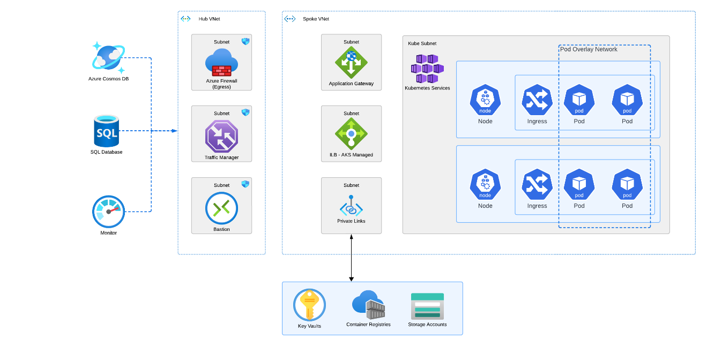
Figure 2 Kubernetes Networking with Azure CNI Overlay

Perimeter Security
A network perimeter is a boundary that separates the public internet and our private virtual networks in Azure. Securing the network perimeter aims to keep out bad traffic, such as DDoS attacks, and protect our network from unauthorized access and threats coming from an external network.
Azure offers several services to help with this, including the DDoS Protection service, Azure Firewall, Azure Web Application Firewall, and third-party security Network Virtual Appliance options.
The following sample architecture diagram shows how we can implement a network perimeter.

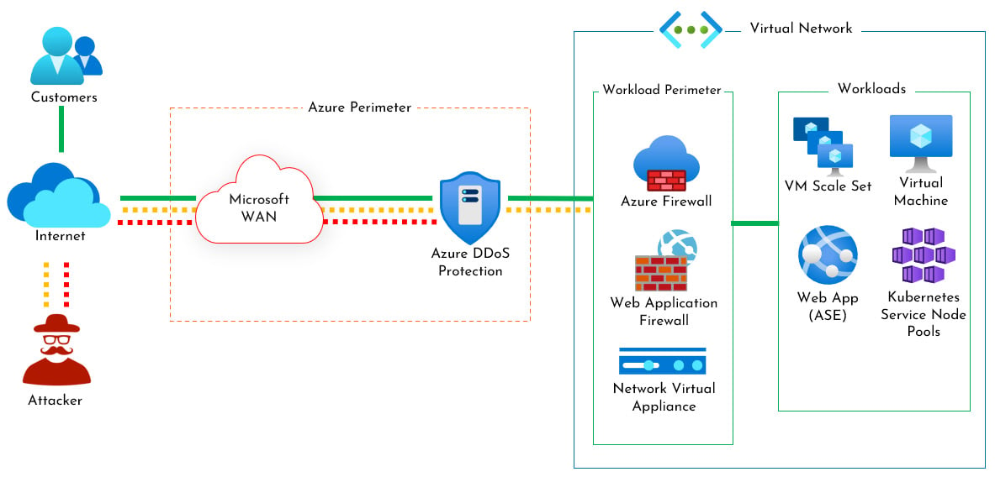

Application Configuration

Core Application
The Learning Care Group’s Sprout About application platform is a mission-critical asset that supports the organization’s growth and expansion goals. It is a portal that connects teachers, parents, and students so that every child can grow and thrive. The portal is divided into three core business domains:
Students Domain: manages all aspects concerning its student users. It provides tools for profile setup, course enrolment, accessing educational content, communication with instructors and classmates, monitoring personal progress and accomplishments, and offering feedback. The Students Domain is designed to meet the specific needs and expectations of the students as the primary end users of Sprout About.
Teachers Domain: manages all aspects concerning its teacher users. It provides tools for creating and delivering educational content, assessing student performance, providing feedback and guidance, collaborating with other teachers and parents, and managing their own professional development. The Teachers Domain is designed to meet the specific needs and expectations of the teachers as the primary facilitators of learning and growth for the students.
Parents Domain: manages all aspects concerning its parent users. It provides tools for profile setup, course selection, payment processing, communication with teachers and administrators, accessing educational content, viewing student progress and achievements, and providing feedback and ratings. The Parent's Domain is designed to meet the specific needs and expectations of the parents as the primary stakeholders and decision-makers for the students.

Azure Kubernetes Configuration
Multi-regional clusters are Kubernetes clusters that span multiple Azure geographic regions. They are important for achieving high availability, disaster recovery, and global load balancing. By distributing the cluster nodes across different regions, multi-regional clusters can ensure that the applications running on them are resilient to regional failures, can serve traffic from the nearest region, and can balance the workload across different regions based on demand and cost.
Azure Kubernetes deployment stamps are a scalable deployment pattern used to achieve high availability, redundancy, and isolation in Kubernetes environments on Azure. Deployment stamps involve creating multiple, independent instances (or "stamps") of an application or service, each running in its own Azure Kubernetes Service (AKS) cluster. These stamps can be deployed across different regions or within the same region, providing fault tolerance and disaster recovery capabilities. By using deployment stamps, organizations can cater to diverse workloads, environments, and compliance requirements while enabling seamless scaling, maintaining consistent performance, and reducing the impact of outages. This approach is particularly beneficial for applications requiring multi-tenant isolation, geo-redundancy, or bespoke configurations for different customer segments.
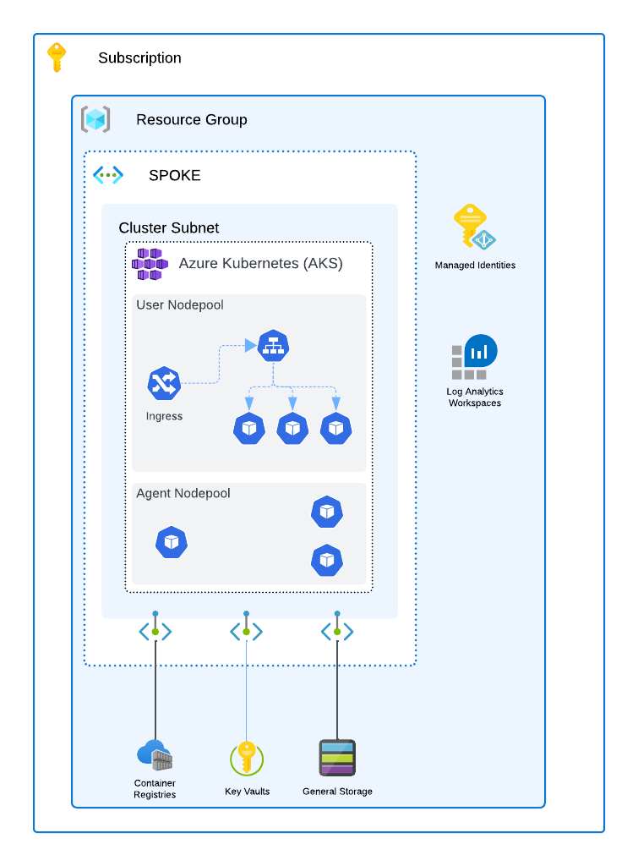
Figure 3 Azure Kubernetes Deployment Stamp

Sprout About is deployed as a multi-regional cluster to East US 2 and Central US regions. Each region has three availability zones, which are physically separate locations within the same region that have independent power, cooling, and networking. By deploying the cluster nodes across different availability zones, Sprout About can achieve higher availability and fault tolerance within each region, as well as lower latency and network costs for the users accessing the platform from those regions.
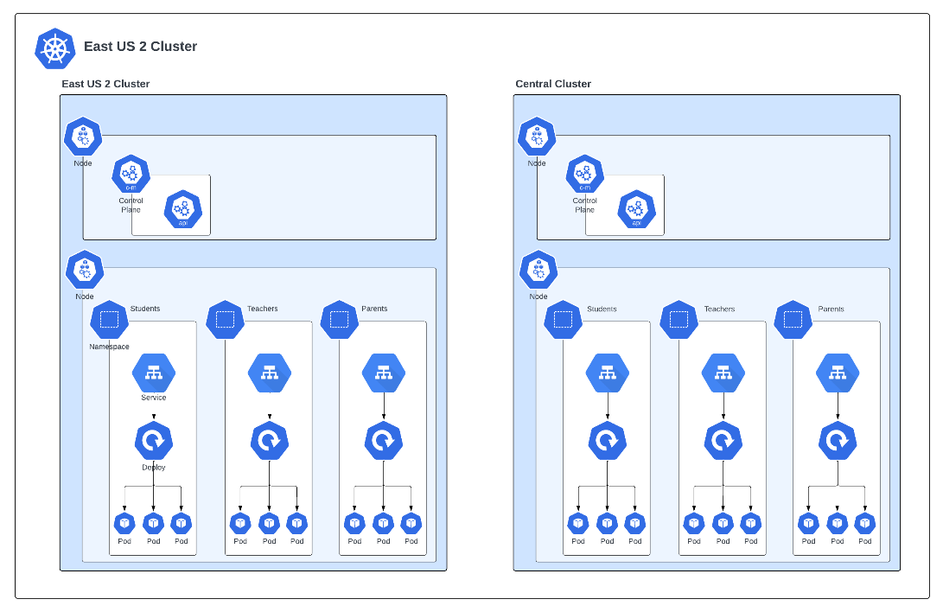
Namespaces are logical units that provide scope for names, access control, and resource quotas. Sprout About uses Kubernetes namespaces to isolate and organize the resources within its multi-regional cluster. It has three main namespaces: Students, Teachers, and Parents, corresponding to the bounded contexts of its microservices architecture. Each namespace contains a collection of APIs that serve the specific needs and functionalities of each user group. These APIs are deployed as Pods behind Kubernetes services, which abstract away the details of the underlying network and provide a stable endpoint for communication. Kubernetes services also enable load balancing, service discovery, and health checking for the Pods within each namespace.

Nodes and Node Pools
In Azure Kubernetes Service (AKS), a node represents a virtual machine (VM) responsible for running containerized applications within a Kubernetes cluster. Nodes serve as the worker machines executing Pods, the smallest deployable units in Kubernetes. The Azure platform manages them as part of a cluster overseen by the Kubernetes control plane. Nodes are assigned to a node pool, a set of nodes within a Kubernetes cluster that share a common configuration. Node pools enable the segmentation of the Kubernetes cluster into distinct sets of nodes based on their roles, performance characteristics, or workload requirements. This allows each node pool to have its own VM size, operating system, and scaling settings, providing a flexible approach to resource management and optimization within the cluster.
Benefits
- Scalability: Nodes can be easily scaled up or down based on workload requirements, ensuring optimal resource utilization. Each node pool can be scaled independently, enabling precise control over resource allocation and cost management.
- Resilience: By distributing workloads across multiple nodes, AKS provides high availability and fault tolerance.
- Cost-Effectiveness: Node pools can be scaled to match demand, helping to optimize costs by only using the necessary resources. Node pools allow different VM sizes and configurations within the same cluster, optimizing resource allocation based on specific workload needs.
- Automation: AKS automatically manages node upgrades and scaling, reducing the operational burden on DevOps teams. Node pools make managing and updating nodes with similar configurations easier, reducing operational complexity.
- Workload Isolation: Different workloads can be run on different node pools, ensuring that resource-intensive applications do not impact the performance of others.
Use Cases
- Microservices Architecture: Deploying microservices across multiple nodes to ensure isolation and scalability.
- High-Performance Computing: Running compute-intensive workloads distributed across many nodes.
- Dev/Test Environments: Quickly provisioning and scaling nodes to match the requirements of development and testing workloads.
- Disaster Recovery: Distributing nodes across different availability zones for fault tolerance and disaster recovery.
Best Practices
- Right-Sizing Nodes: Based on workload requirements, select the appropriate VM size for node pools to ensure cost efficiency and performance.
- Use Multiple Node Pools: Separate workloads into different node pools for better resource management and isolation.
- Enable Autoscaling: Use Cluster Autoscaler to adjust the number of nodes based on demand automatically.
- Monitor Node Health: Regularly monitor node performance and health to address potential issues pre-emptively.
- Monitor and Optimize: Regularly monitor the performance and usage of each node pool to optimize resource allocation and cost.
Limitations
- Resource Constraints: Each node has finite CPU, memory, and storage resources, which may limit the scalability of workloads on a single node.
- Complexity in Management: Managing multiple node pools, especially in large clusters, can become complex and require careful planning.
- Downtime During Upgrades: While AKS automates node upgrades, there might be temporary disruptions during the upgrade process.
- Cost Implications: Improperly configured node pools or over-provisioning nodes can lead to higher costs without corresponding performance benefits.
- Complexity in Management: Managing multiple node pools requires careful planning and oversight to ensure they are correctly configured and optimized.
- Upgrade Considerations: Node pools need to be upgraded independently, which can introduce complexity during cluster upgrades or maintenance windows
The Learning Care Group’s Azure Kubernetes Modernization initiative initially focuses on the Sprout About application platform. In the future, other applications will be migrated to the Azure Kubernetes environment. These applications will have different load characteristics, specifically the Virtual Classroom, and rightsizing the nodes will be extremely important.
The following node pools are proposed for Learning Care Group when Virtual Classroom launches:

Node Pool Name | VM Size | vCPU | RAM | Nodes | Autoscale | OS
sprout-node-pool | D4 v5 | 4 | 16 | 3 Min 10 Max; | Yes | Linux
classroom-node-pool | D8 v5 | 8 | 32 | 10 | No | Linux

Pods
In Azure Kubernetes Service (AKS), a pod is the smallest and simplest unit in the Kubernetes ecosystem. A Pod encapsulates one or more containers that share the same network namespace and storage resources. Pods are the entities that Kubernetes manages and deploys, and they serve as the building blocks for running applications within a cluster. Each Pod is designed to run a single instance of a given application or component, although multiple Pods can work together to form a complete application.
Pods are fundamental to the Kubernetes architecture because they represent the basic execution environment for containerized applications. They provide a level of abstraction that simplifies the deployment, scaling, and management of containers in a Kubernetes cluster. Understanding and effectively managing Pods is crucial for optimizing application performance, resource utilization, and availability in AKS.
Benefits
- Simplified Management: Pods simplify container management by grouping them into logical units that can be scaled, monitored, and managed as a single entity.
- Resource Sharing: Containers within a Pod share the same network and storage resources, enabling efficient communication and data sharing.
- Resilience: Kubernetes can automatically restart or replace Pods that fail, ensuring high availability and fault tolerance.
- Scalability: Pods can be easily scaled up or down to handle varying workloads, providing flexibility in resource allocation.
Use Cases
- Microservices Deployment: Deploying individual microservices as separate Pods, each running its own containerized application or component.
- Batch Processing: Running data processing jobs where each Pod handles a portion of the data, allowing for parallel processing and improved performance.
- Stateful Applications: Managing stateful workloads by leveraging StatefulSets, which ensure that Pods maintain their identity and persistent storage.
- Web Applications: Hosting web servers or API endpoints in Pods, allowing them to be easily scaled to handle varying traffic levels.
Best Practices
- Design Pods for Single Responsibility: Each pod should be focused on a single task or application component to maintain clarity and ease of management.
- Leverage Labels and Selectors: Use labels and selectors to organize and manage Pods, making it easier to scale and monitor them as groups.
- Ensure Proper Resource Allocation: Define resource limits and requests for Pods to ensure they have the necessary CPU and memory while avoiding resource contention.
- Monitor Pod Health: Implement liveness and readiness probes to monitor pod health and ensure they function as expected.
- Use Pod Disruption Budgets: Set up Pod Disruption Budgets to control the number of Pods that can be taken down during maintenance or upgrades, ensuring application availability.
Limitations
- Ephemeral Nature: Pods are designed to be ephemeral, meaning they can be terminated and replaced at any time, which requires careful management of stateful applications.
- Single Network Namespace: All containers within a Pod share the same network namespace, which can complicate networking for complex applications requiring isolated networks.
- Resource Constraints: Improper resource allocation in Pods can lead to performance bottlenecks or resource exhaustion, impacting the application's stability.
- Scaling Overhead: Scaling many Pods can introduce overhead, particularly in managing network connections and storage resources.

Bounded Context | Pod Name | Replicas | CPU Requests/ Limits | Memory Requests / Limits | Labels
Learning | learning-api | 3 | 500m / 1 CPU | 512Mi / 1Gi | app=learning-api, tier=backend
Learning | learning-web | 2 | 300m / 600m | 256Mi / 512Mi | app=learning-web, tier=frontend
Learning | content-service | 2 | 400m / 800m | 512Mi / 1Gi | app=content-service, tier=backend
Learning | progress-tracker | 3 | 300m / 700m | 256Mi / 512Mi | app=progress-tracker, tier=backend
Learning | recommendation-engine | 1 | 600m / 1.2 CPU | 1Gi / 2Gi | app=recommendation-engine, tier=backend
Child | child-api | 2 | 200m / 500m | 256Mi / 512Mi | app=child-api, tier=backend
Child | child-web | 2 | 200m / 500m | 256Mi / 512Mi | app=child-web, tier=frontend
Child | profile-manager | 2 | 300m / 600m | 256Mi / 512Mi | app=profile-manager, tier=backend
Child | history-service | 2 | 300m / 600m | 256Mi / 512Mi | app=history-service, tier=backend
Parent | parent-api | 2 | 300m / 600m | 256Mi / 512Mi | app=parent-api, tier=backend
Parent | parent-web | 2 | 300m / 500m | 256Mi / 512Mi | app=parent-web, tier=frontend
Parent | report-generator | 2 | 400m / 800m | 512Mi / 1Gi | app=report-generator, tier=backend
Parent | notification-service | 2 | 200m / 400m | 128Mi / 256Mi | app=notification-service, tier=backend
Teacher | teacher-api | 2 | 300m / 600m | 256Mi / 512Mi | app=teacher-api, tier=backend
Teacher | teacher-web | 2 | 300m / 500m | 256Mi / 512Mi | app=teacher-web, tier=frontend
Teacher | classroom-manager | 2 | 300m / 600m | 256Mi / 512Mi | app=classroom-manager, tier=backend
Teacher | analytics-service | 2 | 500m / 1 CPU | 1Gi / 2Gi | app=analytics-service, tier=backend
Shared | auth-service | 3 | 400m / 800m | 512Mi / 1Gi | app=auth-service, tier=backend
Shared | gateway-service | 2 | 300m / 600m | 256Mi / 512Mi | app=gateway-service, tier=backend
Shared | logging-service | 2 | 200m / 400m | 128Mi / 256Mi | app=logging-service, tier=backend
Shared | metrics-service | 2 | 200m / 500m | 256Mi / 512Mi | app=metrics-service, tier=backend
Shared | config-service | 1 | 200m / 400m | 128Mi / 256Mi | app=config-service, tier=backend
Shared | event-bus | 3 | 500m / 1 CPU | 512Mi / 1Gi | app=event-bus, tier=backend
Shared | cache-service | 2 | 200m / 400m | 256Mi / 512Mi | app=cache-service, tier=backend
Shared | database-pods | 2 | 600m / 1.2 CPU | 1Gi / 2Gi | app=database-pods, tier=backend

DevOps and Automation

Overview
DevOps is a set of practices that combines software development (Dev) and IT operations (Ops) to shorten the development lifecycle and continuously deliver high-quality software. GitOps, an extension of DevOps, is a methodology that uses Git as the single source of truth for infrastructure and application deployment. Azure DevOps is a suite of tools provided by Microsoft that supports DevOps practices, including version control (via Git-based Azure Repos), CI/CD pipelines, and infrastructure automation, making it an ideal platform for implementing GitOps.
DevOps and GitOps are critical for modern software development as they enable rapid, reliable, and scalable application delivery. By adopting these practices, organizations can achieve faster time-to-market, improve collaboration between development and operations teams, and ensure that infrastructure changes are managed as code, leading to more consistent and secure deployments.
Benefits
- Increased Deployment Frequency: DevOps practices enable continuous integration and continuous delivery (CI/CD), allowing teams to deploy changes more frequently and confidently.
- Improved Collaboration: DevOps fosters a culture of collaboration between development and operations teams, breaking down silos and improving communication.
- Enhanced Stability: GitOps ensures that infrastructure and application states are version-controlled, auditable, and reproducible, reducing the risk of errors during deployment.
- Automated Rollbacks: With Git as the source of truth, GitOps allows for easy rollbacks to previous stable states in case of issues.
- Scalability: Azure DevOps provides scalable infrastructure and tools to manage projects of any size, from small teams to large enterprises.
Use Cases
- Continuous Integration/Continuous Delivery (CI/CD): Automating application build, test, and deployment using Azure Pipelines.
- Infrastructure as Code (IaC): Managing infrastructure using GitOps practices with tools like Terraform or Azure Resource Manager templates.
- Version-Controlled Deployments: Implementing GitOps to ensure all changes to infrastructure and applications are tracked and versioned in Git.
- Multi-Environment Deployments: Using Azure DevOps to manage deployments across different environments (e.g., dev, test, prod) with automated approval workflows.
Best Practices
- Use Git as the Single Source of Truth: Ensure all application code, infrastructure definitions, and configuration files are stored in Git repositories.
- Implement Automated CI/CD Pipelines: Set up automated pipelines in Azure DevOps for building, testing, and deploying code to ensure consistent and reliable delivery.
- Leverage Infrastructure as Code (IaC): Define infrastructure using code (e.g., ARM templates, Terraform) and manage it through GitOps practices to ensure consistency across environments.
- Monitor and Validate Changes: Implement automated validation and monitoring tools to ensure that changes are thoroughly tested before they are deployed to production.
- Secure Access: Use Azure DevOps security features like role-based access control (RBAC) and secure pipeline secrets to protect sensitive information and restrict access to critical operations.

Limitations
- Learning Curve: Implementing DevOps and GitOps practices requires a cultural shift and can have a steep learning curve for teams unfamiliar with these methodologies.
- Tooling Complexity: Managing multiple tools and integrations within Azure DevOps can be complex, especially in large-scale environments.
- Initial Setup and Configuration: Setting up robust CI/CD pipelines and GitOps workflows in Azure DevOps can require a significant upfront investment in time and resources.
- Dependency on Git: GitOps heavily relies on Git as the source of truth, which may be limiting in scenarios where Git is not the preferred or optimal solution.

Source Control
One key aspect of source control is keeping all the artifacts related to the project in a centralized and accessible location. This includes not only the code but also the infrastructure, pipelines, and configuration files that define the environment and deployment process. For this reason, we use Azure DevOps as the main platform for storing and managing all the source control items. Azure DevOps provides a secure and scalable service that integrates with various tools and frameworks for automation.
Branching and Merging
We follow the Trunk-based development methodology for branching and merging to ensure code quality and consistency. This means that all developers work on short-lived feature branches that are frequently merged into the main. Pull requests and code reviews are mandatory to merge into the main. This is to prevent any errors or conflicts that could compromise the stability and functionality of the main branch. The main branch is considered the source of truth and represents the deployable state of the code. Therefore, any changes in the main branch could trigger the continuous integration and continuous delivery pipelines that automate the deployment process to different environments, including production.
Source Layout
In our implementation, we adopted a multi-repo approach to ensure modularity, scalability, and clear team ownership. We separated the configuration of Kubernetes from the application code, placing each in its own repository. The application code was further divided into multiple repositories, with each module, such as services, databases, and frontend components, residing in its own repo. This separation allowed different teams to work independently without conflicts, facilitating parallel development and reducing merge issues.
The core framework, known as the "Kernel," which provided shared utilities, services, and foundational components, also had its own dedicated repository. This approach promoted reusability and consistency across different modules, ensuring that the solution could scale efficiently as new features and services were added.
Directory Structure Example
Each repository followed a consistent structure, ensuring that teams could easily navigate and manage their code. Below is an example directory structure for a service module:
/
└── pipelines
└── scripts
└── application
└── database
└── powershell
└── sql
└── frontend
└── web-app
└── web-app source code
└── module
└── tests
└── unit tests
└── integration tests
└── functional tests
└── smoke tests
└── services
└── service
└── service host
└── managers
└── engines
└── resource access
└── tests
└── unit tests
└── integration tests
└── functional tests
└── performance tests
└── smoke tests

└── databases
└── database
└── programmability
└── functions
└── stored procedures
└── schema
└── tables
└── types
└── views
└── migrations
├── sql-scripts
└── seed-data
The Kernel repository had its own structure, focused on providing reusable components and services:
/
└── framework
└── utilities
└── logging
└── messaging
└── queueing
└── pubsub
└── security
└── authentication
└── authorization
This structure supported modular development, allowing teams to focus on specific areas without overlapping.

Infrastructure
Our infrastructure implementation was based on Kubernetes on Azure Kubernetes Service (AKS), leveraging a multi-repo strategy for defining and managing infrastructure. We used Infrastructure as Code (IaC) principles with Terraform for Azure-specific resources, ensuring the infrastructure was consistent and repeatable across environments.
The infrastructure was divided into separate repositories, with one repository dedicated to the Kubernetes configuration (deployments, services, ingress), and another for managing the core infrastructure (networking, storage, security). This division allowed for clear ownership and version control, making it easier to manage changes and collaborate across teams.

Azure Pipelines
We are leveraging Azure Pipelines to streamline our deployment processes to Azure Kubernetes Service (AKS). Through continuous integration and continuous deployment (CI/CD) practices, Azure Pipelines automates the entire workflow, ensuring that our applications are consistently built, tested, and deployed with minimal manual intervention. This not only improves efficiency but also enhances the reliability of our deployments. By integrating cluster autoscaling and horizontal pod autoscaling, we ensure that our infrastructure can dynamically adjust to varying loads, maintaining optimal performance and resource utilization.

Azure Container Registry
Azure Container Registry plays a pivotal role in our CI/CD pipeline by providing a secure and scalable environment for storing and managing container images. Upon a successful build in Azure Pipelines, the images are automatically pushed to the Azure Container Registry, where they are versioned and stored until deployment. This seamless integration allows for easy retrieval and deployment of the images to Azure Kubernetes Service, enabling consistent and reliable rollouts. By leveraging Azure Container Registry, we ensure that our deployment process remains efficient and secure, with minimal manual intervention.

Implementation
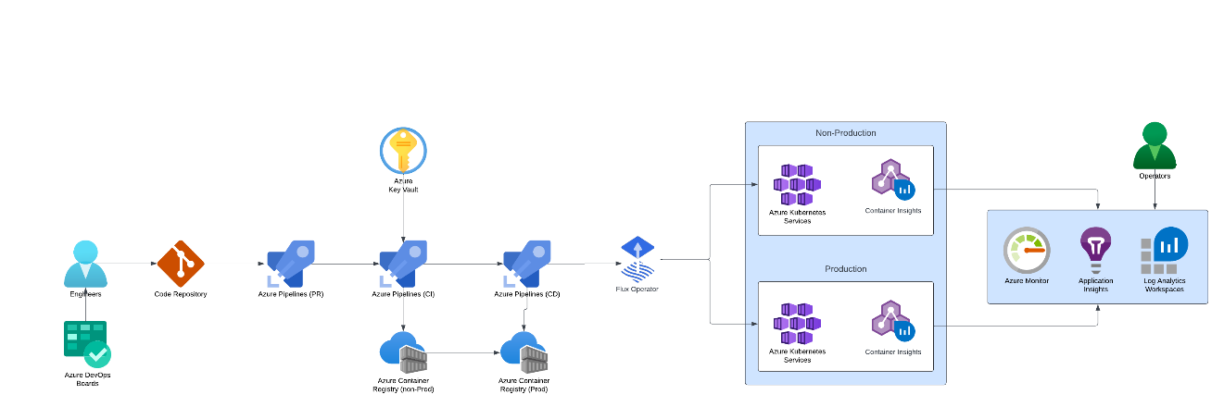

The DevOps process is as follows:
- Code Management and Version Control
  - Engineers commit and push code changes to the Code Repository in Azure Repos.
  - All code changes trigger a Pull Request (PR for code review and approval by peers.
- Continuous Integration (CI) - After the PR is merged, the Azure Pipelines CI process starts:
  - Use Azure Pipelines (PR) to validate the code changes by running unit tests, linting, and static code analysis.
  - Store any required secrets or sensitive data in Azure Key Vault, and securely retrieve them within your CI pipeline.
- Build and Package
  - Azure Pipelines (CI) builds the application container images using Docker or another containerization tool.
  - Push the resulting images to the Azure Container Registry (non-Prod) for non-production environments.

- Continuous Delivery (CD) for Non-Production
  - Use Azure Pipelines (CD) to deploy the application images from the Azure Container Registry (non-Prod) to the Azure Kubernetes Service (AKS) in the Non-Production environment.
  - The Flux Operator watches the Git repository and reconciles the desired state defined in the Kubernetes manifests with the current state in the Non-Production AKS cluster.
- Monitor and Validate
  - Use Azure Monitor and Application Insights to monitor the application's performance and health.
  - Store logs and metrics in Log Analytics Workspaces for further analysis and debugging.
  - Operators check these insights and ensure that the application is performing as expected in the non-production environment.
- Promotion to Production
  - Upon successful validation in the non-production environment, a new CD Pipeline is triggered for production deployment:
  - Azure Pipelines (CD) pulls images from the Azure Container Registry (Prod) and deploys them to the AKS Production cluster
  - Again, the Flux Operator synchronizes the desired state by applying the updated manifests to the Production environment.
- Continuous Monitoring in Production
  - Continuously monitor the Production environment using Azure Monitor, Application Insights, and Log Analytics Workspaces.
  - Operators use these tools to maintain the application's reliability, performance, and availability.
Key Components in the CI/CD Pipeline
- Azure Repos: Source control repository for managing and storing code.
- Azure Pipelines: To automate the deployment to both Non-Production and Production environments.
- Azure Key Vault: Secure storage for secrets, tokens, and sensitive configuration data.
- Azure Container Registry: Centralized registry to store container images for different environments.
- Azure Kubernetes Service (AKS): Managed Kubernetes service to host microservices in both Non-Production and Production environments.
- Flux Operator: GitOps tool to ensure the desired state is maintained in AKS clusters
- Azure Monitor, Application Insights, Log Analytics Workspaces: Monitoring tools to observe the application's health, performance, and reliability.

This pipeline ensures a streamlined and secure deployment process from development to production, incorporating best practices like automated testing, continuous integration, continuous delivery, and observability.

Observability
The Azure platform provides a rich set of metrics for each resource type. These metrics include performance and utilization, audit and configuration, billing, and administrative activities. When configured, metrics can flow into any combination of Blob Storage, Log Analytics, and Event Hub for subsequent processing or actions.
Azure Monitor is a comprehensive solution for collecting, analyzing, and acting on telemetry from various Azure resources. It provides a unified view of the Azure platform's performance and utilization, audit and configuration, billing, and administrative activities. Azure Monitor can send metrics to Blob Storage, Log Analytics, and Event Hub for further processing or actions.

Operational Reports
Regular operational reports provide a summary of overall health for the Azure environment. These include aggregate views of topics such as alerts and scheduled maintenance actions.
Daily Backup: Summary of backup jobs for all vaults in all subscriptions.

E-Mail Distribution
Scheduled reports are sent to the following distribution lists.
E-Mail
All Azure scheduled monitoring reports

Alerts and Notifications
An action group is defined for each Azure alert. These Action Groups are used to configure the notification or logging flow across multiple resources. They may be defined for specific roles, such as DBA alerts vs. Networking Alerts, and also for a given production or test environment.
Multiple methods will be implemented for alert distribution. During initial phases of the Azure deployment, E-Mail will be the primary target. Subsequent project phases will incorporate Event Hub and internal management tool Webhooks.

Log Analytics Workspaces
All Learning Care Group Subscriptions are configured to send logging and diagnostics information to a shared Log Analytics Workspace in Production. This allows for alerts and reports to be generated from a single source and visibility across the entire environment. A single shared workspace also simplifies the set of alerts to be created, as a single alerts can work across all Subscriptions.
Workspace: log-diag-prod-prod-azw2-01

Alert Action Groups
Action Group | Action
AzureAlerts | AzureAlerts  Email: <alerts>@Learning Care Group.com

Alert Action Groups
Action Group | Action
AzureAlerts | AzureAlerts  Email: <alerts>@learningcaregroup.com

Alerts
Action Group | Action
 | Automation runbook job failure
 | Status of Analysis Services has changed – start/pause
 | SQL Server firewall configuration has changed
 | Status of SQL Data Warehouse has changed – start/pause
 | Network Security Group configuration change
 | A resource lock has changed
 | Resource was created or configuration changed. Databricks are excluded.
 | Resource was deleted. Databricks are excluded
 | RBAC role assignments were changed

Logging and Audit Configuration
Each Azure resource type collects comprehensive telemetry, supporting both metric and activity alerts as well as debugging and auditing.
The diagram below provides an overview of the available telemetry flow.
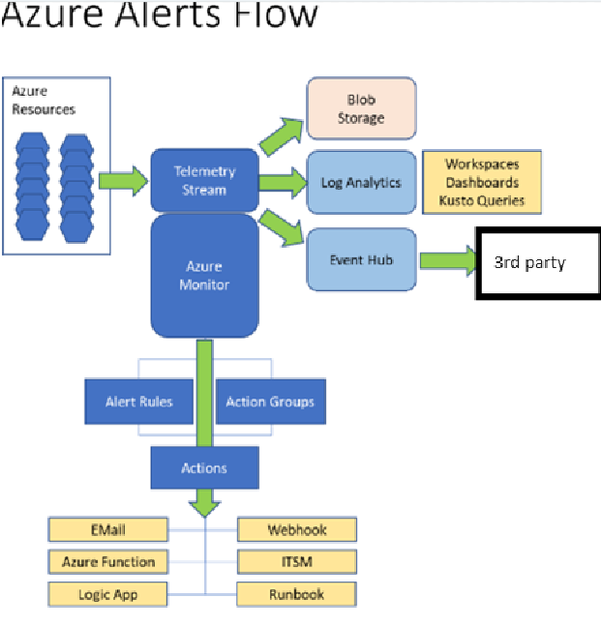
The sections below provide an overview of the settings available the preliminary base configuration for each resource type in the Azure deployment.
>> Logging and auditing is focused on activities/events related to a given resource. This is distinct from metrics, which are collected for all resources and may be used to trigger alerts based on utilization.
Note: Current logging is comprehensive to support initial deployment activity and necessarily more detailed than will be required for either development or production long term. Once in production, the configuration should be reviewed to remove informational logs and focus on warnings and errors.
The Azure platform automatically collects logs for any administrative activity and resource consumption. These are available through the portal and can be downloaded as a CSV file by default. Additionally, each Subscription is integrated with Log Analytics to support alerting, reporting and visualization.
Diagnostics | State
Diagnostics Settings
Status | Off
log\Administrative | Off
log\Security | Off
log\ServiceHealth | Off
log\Alert | Off
log\Recommendation | Off
log\Policy | Off
log\Autoscale | Off
log\ResourceHealth | Off

Logging/Audit Configuration – Virtual Networks
Virtual Network diagnostics and logging supports all metrics, as well as VMProtectionAlerts, which are enabled with DDos detection services.
Note: Due to cost and no direct access to Virtual Machines enabled, the DDos protection service is not currently enabled.
Virtual Network Diagnostics | State
Diagnostics Settings
Status | Off
log\VNetProtectionAlerts | Off
metric\AllMetrics | Off

Logging/Audit Configuration – Network Security Groups
NSG diagnostics and logging tracks specific actions separately from each NSG. Two settings are available.
- NetworkSecurityGroupEvent: Logs each time communication occurs between endpoints within scope of an NSG. This is highly verbose for active networks and should be considered for troubleshooting if required beyond capabilities provided by other resources such as NetworkWatcher.
- NetworkSecuirtyGroupRuleCounter: This log aggregates use of each NSG rule at 60 second intervals.
NetworkWatcher is not specific to NSGs are provisioned separately.
Network Security Group Diagnostics | State
Diagnostics Settings
Status | Off
log\NetworkSecurityGroupEvent | Off
log\NetworkSecurityGroupRuleCounter | Off

Logging/Audit Configuration – Storage Accounts
Storage Accounts may be configured to log to a blob container, and also through Storage Analytics (in Preview as of this note). Enabling Advanced Security configures integration with Azure Security Center.
Storage Account Diagnostics (classic) | State
Diagnostics Settings
Status | On
Blob properties\Hour Metrics | Enable = True  Include API Metrics = True  Delete Data = True  Retention Time = 7 Days
Blob properties\Minute Metrics | Off
Blob properties\Logging | Off
File properties\Hour Metrics | Enable = True  Include API Metrics = True  Delete Data = True  Retention Time = 7 Days
File properties\Minute Metrics | Off
Table properties\Hour Metrics | Enable = True  Include API Metrics = True  Delete Data = True  Retention Time = 7 Days
Table properties\Minute Metrics | Off
Table properties\Logging | Off
Queue properties\Hour Metrics | Enable = True  Include API Metrics = True  Delete Data = True  Retention Time = 7 Days
Queue properties\Minute Metrics | Off
Queue properties\Logging | Off
Advanced Security | On

Logging/Audit Configuration – Kubernetes Service (AKS
AKS needs to be monitored from a few different angles.

Application Health Monitoring
To ensure the health of applications running on AKS:
- Application Insights Integration: Use Azure Application Insights to monitor the performance and health of your microservices. It provides insights into application requests, response times, and failures.
- Custom Metrics and Alerts: Define custom metrics for critical application components. Set up alerts for key performance indicators such as error rates, latency, and throughput.
- Distributed Tracing: Enable distributed tracing using OpenTelemetry or Application Insights SDK to trace requests across microservices, which helps identify bottlenecks or failures in service interactions.
- Health Probes: Implement liveness and readiness probes in your Kubernetes deployments. These probes help Kubernetes automatically manage the lifecycle of your pods based on the application's health status.

Monitoring Cluster Objects and Workloads
For effective monitoring of Kubernetes objects like deployments, containers, and replicasets:
- Azure Monitor for Containers: Enable Azure Monitor for Containers to collect telemetry data from your AKS clusters. It provides out-of-the-box insights for cluster health, node performance, and workload status.
- Prometheus Metrics: Use Prometheus for detailed metrics collection. Azure Monitor for Containers natively supports scraping Prometheus metrics, allowing you to visualize them in Azure Monitor.
- Log Analytics Workspace: Set up a Log Analytics workspace to collect logs from your cluster. Use Kusto Query Language (KQL) to query and analyze logs for detailed insights into workload performance and issues.
- Alerts and Dashboards: Configure alerts based on metrics and logs for key Kubernetes objects. Create dashboards in Azure Monitor to visualize the health and performance of your cluster and workloads.

Monitoring Managed Cluster Components
To monitor critical AKS control plane components:
- Azure Monitor Metrics: Monitor metrics like API server request rates, etcd latency, and kubelet performance. Azure Monitor provides native integration for capturing these metrics.
- AKS Control Plane Logs: Enable diagnostic settings on your AKS cluster to capture control plane logs, including audit logs and kubelet logs, for in-depth analysis of cluster operations and security auditing.
- Control Plane Alerts: Set up alerts for anomalies in control plane performance, such as high API server request latencies or unhealthy etcd states, to proactively manage cluster health.

Monitoring Cluster-Level Components
To ensure the health of VM Scale Sets, nodes, and node pools:
- Node Monitoring: Use Azure Monitor to collect node-level metrics like CPU, memory usage, disk I/O, and network performance. Monitor node conditions to detect issues like node pressure or unresponsive nodes.
- Node Pool Management: Monitor node pool scaling events, node readiness, and failures. Ensure auto-scaling is optimized for workload demand.
- Node Logs: Collect and analyze logs from the kubelet and container runtime to troubleshoot node-level issues. These logs can be ingested into Azure Monitor’s Log Analytics.

Network Monitoring
To monitor the network components supporting your AKS cluster:
- Azure Network Watcher: Use Azure Network Watcher to monitor and diagnose network issues. It provides features like connection troubleshooting, packet capture, and Network Performance Monitor.
- Network Policies: Monitor network policies to ensure compliance and security best practices. Use Azure Monitor to track allowed and denied traffic flows as defined by Kubernetes network policies.
- Virtual Network (VNet) Monitoring: Monitor VNet peering, gateway performance, and subnet utilization to ensure optimal network connectivity and performance.
- Load Balancer and Ingress Monitoring: Monitor the performance of Azure Load Balancers and Ingress controllers managing traffic to your cluster. Use metrics like load balancer health, connection counts, and response times.

Additional Best Practices
- Role-Based Access Control (RBAC: Implement RBAC in Azure Monitor and Kubernetes to restrict access to monitoring data and dashboards, ensuring only authorized personnel can view or manage sensitive information.
- Automation: Use Azure Monitor alerts to trigger automated actions such as scaling, restarting services, or notifying on-call engineers, to reduce response times to incidents
- Regular Reviews and Optimization: Review your monitoring setup regularly and optimize it based on evolving needs and workloads. Leverage Azure’s recommendation tools for proactive management.
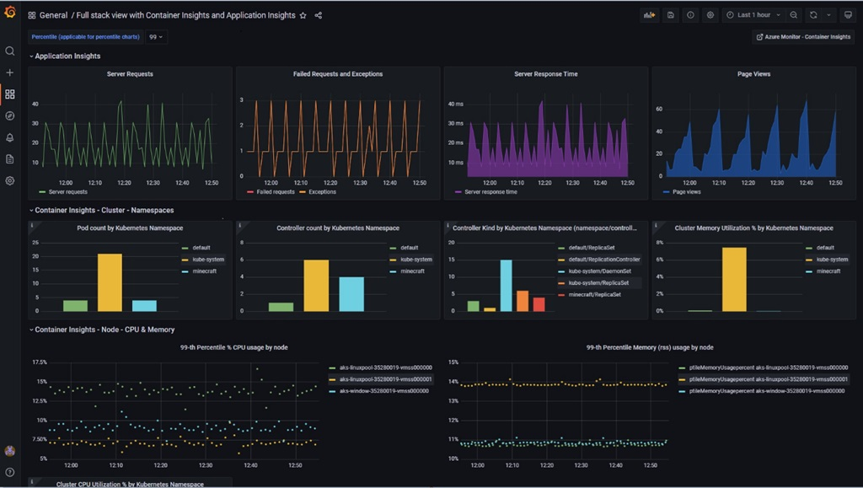
Figure 4 Azure Managed Grafana
Implementing these best practices will help maintain a healthy and performant AKS environment while providing the necessary insights to promptly identify and address any issues.

Logging/Audit Configuration – SQL Server (PaaS)
Azure SQL Server and SQL Database provide comprehensive security, data masking, logging, auditing and diagnostics capabilities as distinct feature configurations. Many of these settings may be configured at the server or database.

Advanced Data Security
Advanced Data Security can provide regular vulnerability assessments and Advanced Threat Protection, saving results to blob storage and/or sending notification emails.
SQL Server Advanced Data Security | State
Advanced Data Security | On
Vulnerability Assessment Storage | e.g., dadevdc01analtyicsdiags
Periodic Recurring Scans | On
Send scan reports to | Admins and Subscription Owners
Send alerts to | Admins and Subscription Owners

Auditing
SQL Server Auditing | State
Auditing | On
Destination\Storage | Off
Destination\Log Analytics | e.g. dev-dc01-mgt-ws
Dynamic Data Masking (Database Only)
This security feature is not currently configured.
Diagnostics (Database Only)
This feature is not currently configured.
Azure SQL Database Diagnostics | State
Diagnostics Settings
Status | Off
log\SQLInsights | Off
log\AutomaticTuning | Off
log\QueryStoreRuntimeStatistics | Off
log\QueryStroeWaitStatistics | Off
log\Errors | Off
log\DatabaseWaitStatistics | Off
log\Timeouts | Off
log\Blocks | Off
log\Deadlocks | Off
metric\Basic | Off
metric\InstanceAndAppAdvanced | Off

Logging/Audit Configuration – Key Vault
Key Vault Diagnostics | State
Diagnostics Settings
Status | On
destination\storage | Off
destination\event hub | Off
destination\log analytics | <log analytics>
log\AuditEvent | On
Metric\AllMetrics | On

Logging/Audit Configuration – Azure Automation
Azure Automation Diagnostics | State
Diagnostics Settings
Status | Off
destination\storage | Off
destination\event hub | Off
destination\log analytics | Off
log\JobLogs | Off
log\JobStreams | Off
log\DscNodeStatus | Off
metric\AllMetrics | Off

Design for monitoring using Azure logs and MicroFocus OBM
Learning Care Group already uses MicroFocus OBM (Operations Bridge Manager) for their existing On-Premises and AWS infrastructure monitoring. We suggest using the Microsoft Azure log analytics integration, where we can view the alert data forwarded from Azure Log Analytics environment in Operations Bridge Manager (OBM).

Cost monitoring budgets
The following monthly budgets are recommended for Learning Care Group . It is also recommended to configure alerts to trigger when budget allocation reaches around 90%

Subscription Name | Budget allocation
Development | $4000
Production | $8000
QA | $4000
Shared Services | $25000

management Dashboards
The following custom dashboard was created for Learning Care Group part of foundations/cost management.
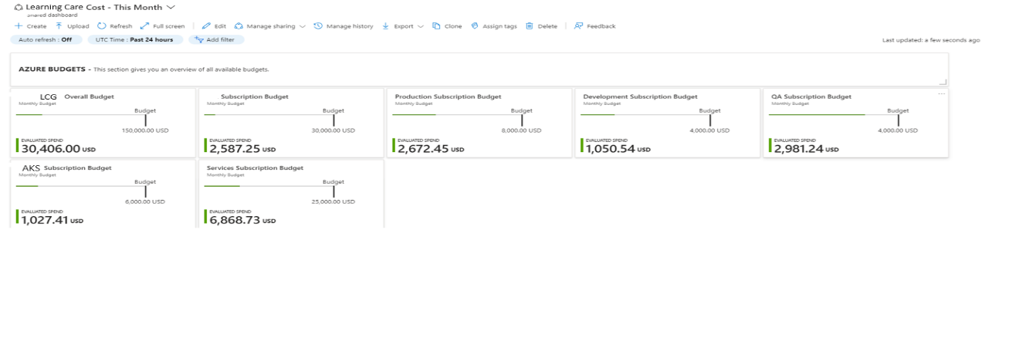

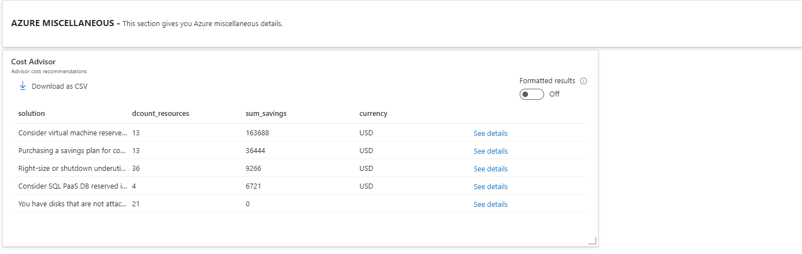

Security
This section outlines the major components of the security and compliance strategy which will be used to support and maintain the planned Azure identity and infrastructure framework. In addition, this section covers how security touches on other components of the Cloud Adoption Framework, the target and start for security management and compliance for the target Learning Care Group’s busines and technical requirements.

Education
Establish education for all team members who are part of the information technology solutions to ensure all departments who provide IT services are aware of the best practices and security policies. While Learning Care Group has already started down this path the introduction of additional tenants and security boundaries to these solutions will represent some additional challenges and changes in process and workflow. All members of IT need a solid foundation in the new processes, security standards, and expectation as new cloud services are integrated. Security services in the cloud such as Office 365 Threat Detection can also be used to generate on going security testing to measure the success of these education programs.

Plan for training for new administrators for both technology and core cloud technologies which include the use of IaaS, PaaS, and SaaS for solutions based on best practices. This will help drive efficiency, cost management, and correct product selection which can represent some significant delays and experience boundaries when moving to the cloud. Initial effort should be focused on service selection, cost management, and identity management to help drive the successful and secure adoption of cloud technologies. Additional third-party training libraries exist which can add to the existing capabilities to quickly and easily have the customer base trained on the platform during deployment.

Recommendations for Education:
- Ensure a process and procedure library is established for the new cloud workflows.
- Ensure all personnel affected by cloud implementation are trained on these processes and workflows.
- Ensure security is a key component of the training as the locations and access control points for security are changing.
- Ensure the best practices and use of Platform as a Service offerings are understood and leveraged.
- Ensure a Security Committee is created and established for the organization to monitor ongoing security risk, publish security guidance and compliance, to identify target security remediation, coordinate security requirements and changes to the organization, and to prioritize service critical security remediation.

Identity
Identity needs to be treated as the edge security barrier in a Cloud centric solution stack and should always be considered the primary security boundary. While this does not remove the more traditional model of network and edge security, the identity itself endures a much greater number of attacks in a cloud driven security model. Identities with administrative privileges in the cloud should be generated separately from user’s traditional user accounts just as they are in an on-premises model. In addition, it is recommended that user identities and fallback administrative accounts be moved to a no permissions-based model. Learning Care Group should rely on a just-in-time security model where permissions are used on a temporary basis to provide access, but normal accounts are not provided administrative access to any resource.

In addition, key vault and identity driven access should be used for application, code, and deployment pipelines wherever possible. This allows Learning Care Group to build application and automation driven solutions that are not reliant on intervention or human interaction to complete. Policies and standards should be written to support automation not only for IT, but also for application developers to integrate solutions with keys and policy driven access. This should include just-in-time or on request permissions driven access for supported tasks and vaults including API URIs, connection strings, variable applications and storage access.

Recommendations for Identity
- Each user should have only a single identity in the system to ease the risk and security management of the organization for the production environment.
- Security in-depth should be used to protect the identity as the new edge and as the primary security boundary for access in the cloud.
- Azure Identities should be used to access and secure key security features such as storage vaults, storage-based backups, and virtual machine access for encryption keys.
- Administrative identities should be separate accounts as well for managing Azure resources and deployments and this should be transitioned to point in time access as deployment is matured.
- Data logging and auditing for authentication and authorization should be integrated into Log Analytics and Azure Sentinel for security automation and operations.
- Access request and management policies should be well defined and stored in a centralized document and process repository.
- All user authentication requests should be backed by multi-factor authentication (MFA) for Learning Care Group and Advisors organizations when authenticating to cloud-based resources.
- Use integrated single sign-on when possible to ensure the minimal number of authentication risks are exposed and fewer credentials to protect.
- Move to password independent resources such as Windows Hello or Authenticators when possible to reduce password driven risks and compromises.
- Limit access to secure resources with conditional access policies to ensure only appropriate users can access more secure data and application access.
- Move all application and service credentials to Azure Key Vaults and make access operational or code based to reduce access from service credentials, connections, and API keys risks or service area of attack.

Cloud Security
Learning Care Group needs to ensure that their integrated Security Operations Center (SoC) or Security team develop in-depth security to provide and monitor security for the cloud solutions in each of the integration Microsoft clouds. Learning Care Group should leverage integrated solutions as the first tier for support, and third-party solutions if gaps in the product series for security. The security monitoring and cloud strategy should include the integrated monitoring, Azure Security Center, Cloud App Security as the Cloud Security Broker (CASB), and Advanced Threat protection to integrate this monitoring closely with all the deployed resources and access controls. This should also be further extended with Azure Automation accounts and agents on domain controllers with desired state configuration to forward active directory authorization into Log Analytics and Sentinel for AD authentication tracking and integration. Azure Log Analytics should be integrated into the solution, as well, to coordinate and centralize log collection from all cloud resources into a searchable and addressable log space.

In a future phase Learning Care Group can also focus on developing their own reporting and statistics with customer view and automation flows using their Sentinel or Splunk, Power BI, and Power Automate to streamline detection and notification. However, the integration of AD logs connectors should be done in Sentinel rather than in Log Analytics and DSC as that generates unfiltered logs which can generate excessive logs size and consumption.

Recommendations for Cloud Security
- In alignment with security governance committee develop RACI Matrix and charts for key areas of security and ownership.
- Update security incident response workflows and tools documentation for cloud-based incidents and tooling.
- Plan and evaluate the security posture management guidelines to help build on specific monitoring policies and guidelines to grow monitoring and security footprint.
- Require Multi-Factor Authentication for all logins to the Learning Care Group clouds.
- Integrate the Native Azure Firewall for integrated network security and monitoring.
- Integrate Azure Security Center for best practices inherited knowledge for all Azure service offerings.
- Integrate web application gateway and load balancing services to secure Platform as a Service (PaaS) offerings.
- Use Managed Instances and SQL Firewall rules to protect SQL data running in PaaS offerings in Azure.
- Disable access to legacy protocols and reduce support for legacy devices to secure cloud resources with a more secure baseline.
- Use privileged access workstations in Azure or Windows Virtual Desktop for all administrative access rather than workstation to reduce the risk to the organization of credentials and information being stored on personal workstations.
- Set Azure AD and Active Directory Password policies to prevent insecure passwords being set as the default building block of a transition to password less authentication.
- Monitor attempts to gain access using deactivated credentials.
- Use compliance based DLP, and AIP policies from the existing infrastructure, along with any other existing policies for continued compliance reporting to ensure goals for Office 365 compliance reporting continue to be met.

Governance
Learning Care Group needs to work to refine and develop specific initiatives which meet the definitions for policy compliance and blueprints. Learning Care Group should use the existing Blueprints which match the need for financial Industries and NIST (for example) compliance, and then continue to build on these policies with additional initiatives to close out the governance compliance enforcement method. Pairing this with the integrated security and AI driving monitoring in Azure Security Center for compliance. In addition, and architectural review and approval board for managing change control and application approval needs to be established for process and change governance for Learning Care Group.

Recommendations for Governance
- Establish Architectural review Board for managing architectural design points and standards across the IT organization.
- Develop a change control process and review board for configuration management and approvals to control risk to the organizations.
- Track the monthly tasks and compliance for industries through the Azure Compliance Manager panel.
- Use blueprints for compliance requirements where available.
- Create Initiatives for industry compliance standards to enforce security (IRS, SOX, NFA, etc.).
- Assign responsible remediation tasks based on ongoing opportunity for improvement guided by secure score and CISO priority of work.

Networking
Networking security is one of the key factors in securing cloud-based platform and infrastructure services. In-depth security is key in developing secure assets in a cloud first infrastructure. By focusing on the key areas of enforcement and standards, Learning Care Group can ensure networks are secure by default and only required access is available for specified assets, users, or Azure services. Service access should be limited and not given free access to all resources on-premises or in the cloud by default.
Recommendations for Networking
- Protect all resources in the network using network security groups, private links, and service endpoints.
- Monitor and log the configuration of vNets, subnets, and NICS with logging, analytics, flow, and traffic analytics.
- Deploy Web Application firewall policies using application gateways and front door services to protect all web facing assets.
- Enable DDOS standard service to help protect assets from known attackers and known attacks for denial of service and transient attacks.
- Enable Network Watcher for packet logging and event forensic investigation.
- Deploy IDPS/IDP solution such as Azure Firewall to front-end security and technology to help detect potential attacks and payload inspection.
- Manage access to web application using application gateways to help secure traffic and reduce surface area of attack.
- Keep network layers simple to manage and rely on application groups and service tags for security rather than network complexity.
- Document traffic configuration rules for the environment so network support and events are easier to troubleshoot.
- Use Azure monitor and logs to monitor and detect potential changes and risks to cloud networks.
- Ensure virtual machines with key business applications are protected with availability zones for failover protection.

Logging and Monitoring
Logging and monitoring are key elements to securing and protecting cloud-based deployments. Cloud monitoring logs should be centralized and maintained for compliance and forensic operations. All resources in azure should have diagnostic logging enabled and gathered using Azure monitor, Monitoring Agents, and resource diagnostic logging, and unless restricted cloud application security broker (CASB) records should also be captured and maintained as part of the system of record.

Recommendations for Logging and Monitoring
- Use only approved time synchronization sources for time feeds for devices in the Learning Care Group environment for consistency of time stamps.
- Centralize the protection of resource with Azure Monitor and built-in analytics as the first line of monitoring with other third party monitoring integrated into the solution to close any remaining gaps.
- Configure central logging through Azure Sentinel or a third party SEIM product.
- Enable audit logging for all Azure resources by default.
- Use the Monitoring Agent on virtual machines to collect audit logs into Sentinel and Azure monitor for centralized logging.
- Configure a retention policy in Log Analytics for compliance requirements for automatic remediation and removal of logs.
- Monitor and review logs monthly and extend that reporting with Power BI as needed.
- Enable alerts for anomalous login events.
- Centralize reporting for malware events.
- Enable DNS query logging.
- Enable Azure command line logging.

Steering Committee
A steering committee is a group lead by senior managers intended to set strategic direction for the organization, to clarify any confusion for priority or project decision points, and to ensure the completion of projects in accordance with organization’s goals. Steering Committees generally meet quarterly to track the progress of existing project and to derive the next phase of projects which need to be planned.

Recommendation committees generally tasked with the four key goals of:
- Set the strategic vision and business objectives for programs and projects.
- Develop communication and assurance to build top-down strategy and consensus.
- Dispel confusion on project objectives and priorities when conflicts cannot be resolved at a lower level.
- Act for a specific functional area impartially to ensure all areas of the business are protected fully (Security, Infrastructure, Operations, Governance, Applications).
- Ensure completion of projects and business objects for programs and projects.

Recommendation General actions of the Steering Committee for each quarter are characterized by:
- Program Status and Challenges Updates for strategic initiatives.
- Program Direction Clarification for strategic initiatives.
- Strategic Planning for next 4 quarters programs.
- Review of strategic challenges and communication requirements from an executive action level.

Security Center
Azure Security Center provides advanced policy and compliance checks for Azure resources. The solution continuously audits configuration settings and provides recommended remediations for known security issues. Aggregate recommendation compliance is provided through the a ‘Security Score’ which rates the severity or impact of each remediation, as well as the specific resource requiring an update.
Additional capabilities for threat protection are also provided with alert tracking according to severity and ongoing trending.
In addition to general guidance, Azure Security Center can be used to check for regulatory compliance controls (SOC TSP, ISO 27001, PCI DSS 3.2.1 and others).

Security-Center Enabled Subscriptions
Security Center is enabled for all Error! Unknown document property name. Subscriptions that have connectivity with corporate networks. Where appropriate, they are applied for their parent Management Groups.

Management Groups and Subscriptions
Tenant Root Group [Management Group]
Tenant Root Management Group [Management Group]
Production Management Group [Management Group]
Production [Subscription]
Development Management Group [Management Group]
Development [Subscription]
QA Management Group [Management Group]
QA [Subscription]
Services Management Group [Management Group]
Services [Subscription]
Stage Management Group [Management Group]
Stage [Subscription]

Recommendation Exceptions
While Azure Security Center provides a default set of recommendations, other enterprise solutions provide protection that is not directly detected.
Default Recommendations from Azure Security Center are overridden as shown below. Unless otherwise indicated, these changes are applied to all Learning Care Group Subscriptions.

Recommendation | Scope | Setting

Azure Sentinel
Azure Sentinel provides intelligent security analytics at cloud scale for your entire enterprise. Azure Sentinel makes it easy to collect security data across your entire hybrid organization from devices, to users, to apps, to servers on any cloud. It uses the power of artificial intelligence to ensure you are identifying real threats quickly and unleashes you from the burden of traditional SIEMs by eliminating the need to spend time on setting up, maintaining, and scaling infrastructure. Since it is built on Azure, it offers nearly limitless cloud scale and speed to address your security needs. Traditional SIEMs have also proven to be expensive to own and operate, often requiring you to commit upfront and incur high cost for infrastructure maintenance and data ingestion. With Azure Sentinel there are no upfront costs, you pay for what you use.
Collect data across your enterprise easily – With Azure Sentinel you can aggregate all security data with built-in connectors, native integration of Microsoft signals, and support for industry standard log formats like common event format and syslog. In just a few clicks you can import your Microsoft Office 365 data for free and combine it with other security data for analysis. Azure Sentinel uses Azure Monitor which is built on a proven and scalable log analytics database that ingests more than 10 petabytes every day and provides a very fast query engine that can sort through millions of records in seconds.
Analyze and detect threats quickly with AI on your side – Security analysts face a huge burden from triaging as they sift through a sea of alerts, and correlate alerts from different products manually or using a traditional correlation engine. That’s why Azure Sentinel uses state of the art, scalable machine learning algorithms to correlate millions of low fidelity anomalies to present a few high fidelity security incidents to the analyst. ML technologies will help you quickly get value from large amounts of security data you are ingesting and connect the dots for you. For example, you can quickly see a compromised account that was used to deploy ransomware in a cloud application.
Azure Sentinel connects to many third-party data sources see https://docs.microsoft.com/en-us/azure/sentinel/connect-data-sources

Availability, Backup, and Business Continuity
A viable backup and business continuity approach considers both the requirements of each workload and all its components, as well as the techniques appropriate to the type of resource. Each Azure Resource Type has different features or capabilities for redundancy and recovery.
For the resource types currently within Learning Care Group current Azure deployment scope, the approach for HA, Backup and business continuity are defined in this section.
Cost is a significant consideration. As increased levels of redundancy and fault tolerance are required, the amount of supporting infrastructure required (and related costs), increase as well. As a part of deployment planning, the appropriate level of redundancy for a given resource should be determined.
Note: The Governance Foundations reference document will include related security information by resource type.

Azure Platform
From its inception, the Azure resource platform and supporting physical infrastructure has been architected for the most demanding enterprise requirements. The supporting data centers leverage industry best practices and decades of experience running some of the largest web applications in the world – all applied to Azure. The resulting infrastructure is hardened sufficiently to meet the most secret government requirements, global availability, and extreme scale.
For Learning Care Group planning, key features of the Azure global data center deployment are integral to the deployment architecture and part of current deployments.

Azure Regions
Microsoft Azure has built data centers across the globe, each identified by a Region and within a Geography.
Learning Care Group deploys to North America Regions: West US is the primary, and West US 2 is the secondary/backup Region.
In the event of a major outage in the primary region, resources will be failed over or redeployed to the secondary region. The specific approach for failover is determined by the specific resource type and capabilities as outlined in sections below.

Regional Pairs
In order to provide high availability for essential Azure platform resources, such as Storage, Key Vault, Active Directory and others, Azure Regions are configured in pairs – with each sufficiently distant from each other to protect against issues such as natural disasters or other localized issues. In this respect, Learning Care Group use of West US and West US 2 do not align with this pairing by convention.
Key services may then be deployed with geo-redundancy, ensuring that they are still available in the event of a data center outage. As indicated below, Azure Storage allows for this as a configuration option. Many other services simply include this as the only option to meet the expected high SLAs. The Azure platform manages failover to the secondary region natively.
Availability Zones
Azure offers further physical diversity within a Region through Availability Zones. Within a Region where this capability is available (not all Regions support this as of writing), multiple data centers are in place and physically separate – each with independent connectivity, power, and related resources.
Certain services, such as Virtual Machine clusters can be explicitly provisioned across zones in order to protect against a failure at any one facility.

Recommendations
Note: While resources deployed to Azure can be configured to meet very high availability requirements, this also requires additional resources. As a result, some approaches may become quite expensive. For each environment and resource, the team must determine the appropriate balance between redundancy and cost that is appropriate for the business. This may vary by solution.

Azure Key Vault

Availability:
High availability and scaling are intrinsic features of this resource type, with keys and secrets automatically to the secondary region. No additional configuration is required.
Note: In the event of a region failover within the Azure platform, the Key Vault will be in read-only mode under the service fails back.

Backup:
Key Vaults can be exported to offline file stores through automation scripts or manually.
Through a PowerShell script executed from on premises management servers <reference>, each Key Vault is synchronized to a secondary vault in the backup datacenter (Central US/cus) <frequency>. In addition, an export of the vault is added to on-prem <service> at <time> and retained for <duration>.
The export is written to '\\path' where TSM then performs a backup.
Initial deployment is scripted through PowerShell ARM templates and maintained in the operations source repository.

Business Continuity:
The Azure platform provides native fault tolerance for Key Vault, including a readable backup vault that is available in the event of a major data center outage.
In addition, the daily backup process includes synchronization with a secondary Key Vault in Sprout About backup region (Central US) and on the schedule indicated above.

Storage Accounts

Availability:
Azure Storage Accounts support multiple levels of redundancy across Regions. Local, Zone (some Regions) and Geographic redundancy approaches are available. By default, locally redundant storage writes three copies of each blob/file within a Storage Account. This is transparent to the user. When Geo-Redundancy is enabled, an additional three copies are written to the secondary Region.
For Production storage, geo-redundancy will be configured for applications, while non-critical resources may be locally redundant.

Soft Delete
Each Storage Account may be enabled for soft deletes. As a configuration setting, a deleted file may be retained for a short period of time before finally committing and reallocating the storage space (and thus unrecoverable).
Note: Use of this feature will be determined by resource, as there are implications in terms of retention and related policies. This is only available for Blobs, not Data Lake services.

Backup:
Azure does not provide a separate backup facility for blob storage. However, it is available for Azure Files as a feature of Azure Backup and Site Recovery. Regular backup schedules and retention periods are configured through that service.
For critical storage accounts, it may be appropriate to schedule external automation to copy specific containers or accounts to entirely separate storage. These ‘shadow’ Storage Accounts can be configured at a lower-cost archive access tier.
Initial deployment is scripted through PowerShell ARM templates and maintained in the operations source repository.

Business Continuity:
In the event of a Data Center outage, the secondary Geo-BCS replica is brought online natively by the Azure platform with no changes required to keys or resource names.
Should a Storage Account be unintentionally deleted, an Azure Operations request may be able to recover the account for a short time period. Once the storage is reallocated, secondary backups or ‘shadow’ accounts are required.

Azure SQL Database

Availability:
Azure SQL Database is a PaaS service. As such, it is deployed as a part of the Azure Fabric to highly available server clusters.
Best practice Production deployments leverage geo-replication features and include a readable secondary in another region. (Azure supports up to five regional replicas). The primary and secondary databases have a Failover Group front-end that manages connections to each. In the event of a failure of the primary, the secondary can be promoted to master with no changes to client configurations – they share the same connection string.

Backup:
Database backup is a native feature of Azure SQL database and supports Point in Time Restore (PITR) with no additional configuration required. Databases can be restored or cloned into other databases with timestamps to the second. This is not a scheduled job and does not require any additional configuration.
Point in time retention can be maintained for up to 35 days. In addition, long term retention can be configured at weekly, monthly and annual intervals – up to 10 years.
Initial deployment is scripted through PowerShell ARM templates and maintained in the operations source repository.

Business Continuity:
Support for Business Continuity is provided through geo-replication and failover groups as described above. In the event of a major data center outage, the Azure Fabric fails over from the primary to the secondary database. This failover can be controlled manually or automated and is transparent to the client.

Virtual Machines

Availability:
Azure Virtual Machines can be clustered in two different high availability configurations - Availability Sets and Availability Zones - at deployment.
Availability Sets separate Virtual Machines into Fault Domains and Update Domains. With VMs in separate Fault Domains, they are deployed to separate locations within the data center physically; protecting against physical issues such as a wire cut or power issue for a tranche. As a compliment, VMs deployed to separate Update Domains indicate to the Azure Fabric that any updates impacting availability such as a reboot may only be applied within one domain at a time. While updates are applied to one set of VMs, the others are not impacted.
Availability Zones are used to deploy VMs in physically separate data centers within an Azure Region. In the event of an outage that impacts an entire building, the other is expected to remain available.
Both Availability Set and Availability Zone deployments are supported by Load Balancers to manage traffic and VM health. Sprout About deployments should leverage Availability Sets, as Availability Zones are relatively new, not available in all Regions and are not yet fully supported by other Azure tools and monitoring solutions.

Backup:
Virtual Machine backup services are provided through Azure Backup and Site Recovery. When enabled, each VM is backed up into a local vault on a regular schedule. These backups are available directly after a snapshot is taken and can be used for recovery back to any point in time during the retention period or used to clone a VM for testing or other purposes.
Initial deployment is scripted through PowerShell ARM templates and maintained in the operations source repository.

Design:
Currently there are no plans to implement Azure Backup or Azure Site Recovery. However, Neudesic recommends that critical machines are replicated to the BCS subscription in the designated regional pair using ASR and any other machines are backed up to the BCS subscription.

Azure Site Recovery
Azure Backup and Site Recovery also provides services for failover into a secondary Region. Instead of maintaining backups in the same Data Center, ASR logs disk operations to a vault in the secondary region. In the event of a failure, this log can be replayed to recreate the VM as it was last updated.
In addition to recreating the VM, ASR supports scripting to support a failover – which may include notifications to operations that a failover has occurred, configuration changes such as DNS required for the new data center and other updates as required for underlying solutions.
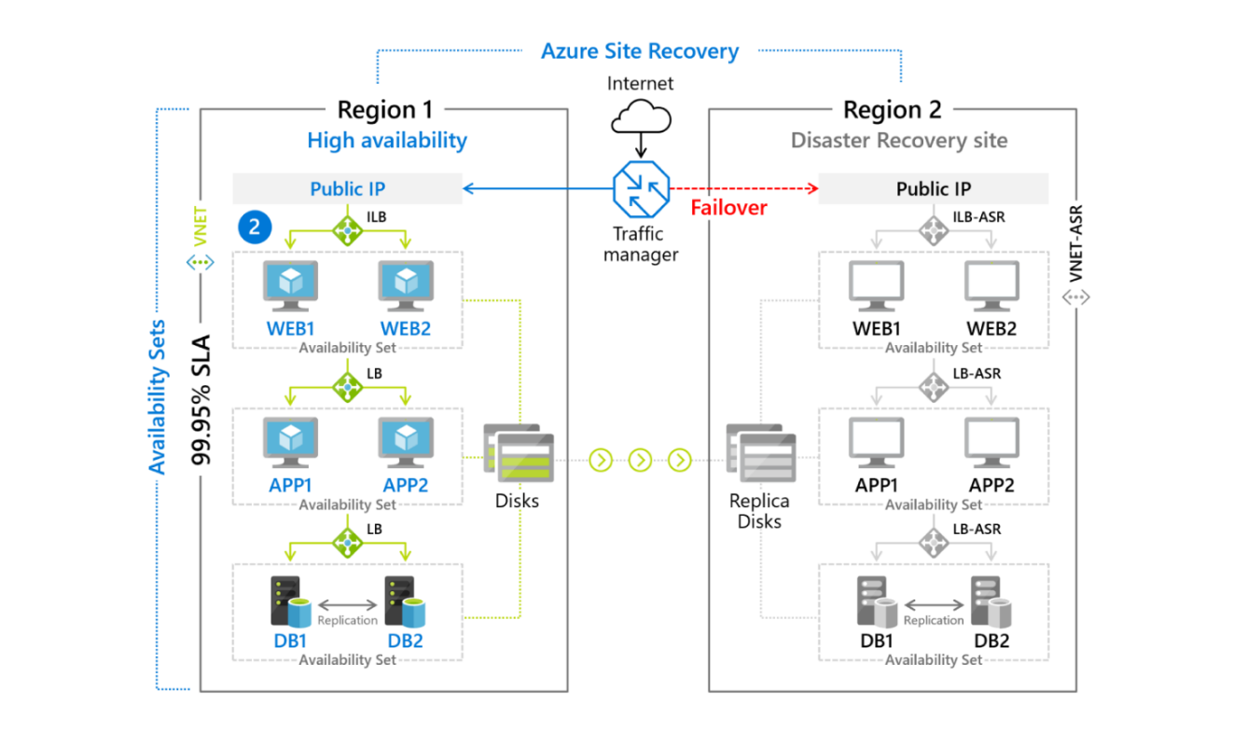

Azure Site Recovery (high availability) for Learning Care Group
The following options for high availability exist:
- On-premise to Azure (failover windows not less than 5 minutes)
- Azure site to Azure site (failover windows not less than 5 minutes)
- RTO and RPO targets. Keep recovery time objectives (RTO) and recovery point objectives (RPO) within organizational limits. Site Recovery provides continuous replication for Azure VMs and VMware VMs, and replication frequency as low as 30 seconds for Hyper-V. You can reduce RTO further by integrating with Azure Traffic Manager.
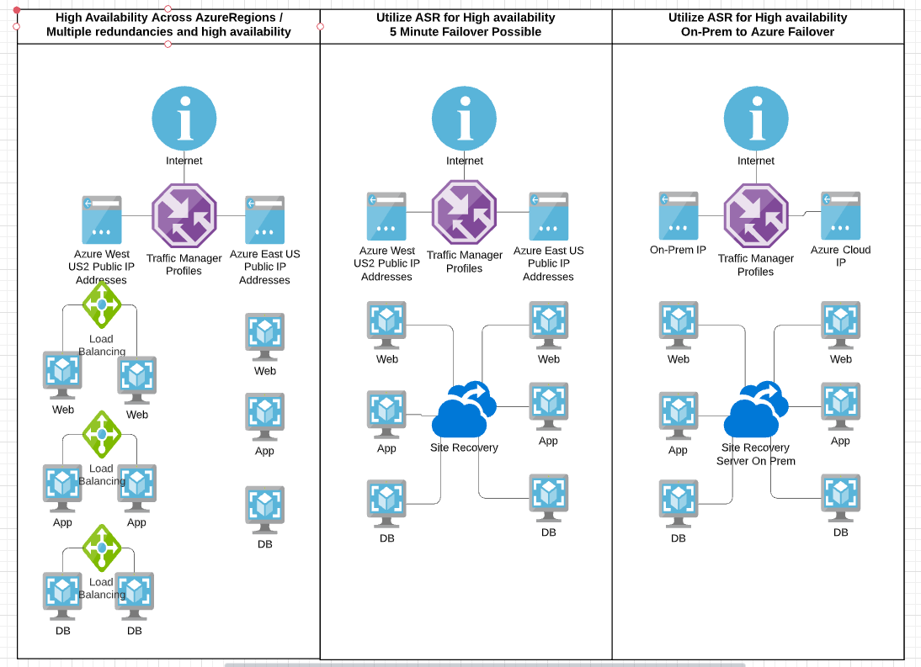

Service Validation and Testing Process

Process
Testing is the systematic search for defects in all project deliverables. It is the process of examining an output of a process under consideration, comparing the results against a set of pre-determined expectations, and dealing with the variances.
Testing is conducted to ensure that a product is developed that will prove useful to the end user.
The primary objectives of testing are to assure that:
- The system meets the users' needs ... has 'the right system been built'
- The user requirements are built as specified ... has 'the system been built right'
Other secondary objectives of testing are to:
- Instil confidence in the system, through user involvement
- Ensure the system will work from a functional viewpoint
- Establish exactly what the system does (and does not do) so that the user does not receive any "surprises" at implementation time
- Identify problem areas where the system deliverables do not meet the agreed to specifications

Test Scope

S.no | Test Scope | Responsible Team
1 | Sanity/Smoke Testing - Systems | Neudesic Team
2 | Functional Testing | LCG Team
3 | UAT Testing | LCG Team
4 | Performance Testing | LCG Team
5 | Load Testing | LCG Team

Sanity / Smoke Testing Scenarios / Scope
TEST ID | TEST SCENARIO DESCRIPTION
T001 | Verify connectivity of system from Azure to on prem and from on prem to Azure and check for high response ping
T002 | Verify the naming standards of the systems and resources (NIC,Disk, containers and VM)
T003 | Verify the host name and Azure name
T004 | Check the disk details and number of disks allocated to the systems and size of the disk
T005 | Verify whether the server belongs to the domain or cluster
T006 | Verify the Windows License of the server if applicable
T007 | Check for Microsoft software installation in the server
T008 | Check for Application software running in the container or on system
T009 | Verify the OS version of the image
T010 | Check whether users can access the system

Functional Testing Scenarios / Scope
DT QA team to update the details of Test scenarios that they plan to cover as part of Functional testing

UAT Scenarios / Scope
DT QA team to update the details of Test scenarios that they plan to cover as part of UAT testing

Performance Testing Scenarios / Scope
DT QA team to update the details of Test scenarios that they plan to cover as part of Performance testing

Load Testing Scenarios / Scope
DT QA team to update the details of Test scenarios that they plan to cover as part of Load testing

Testing Approach
Smoke/Sanity Testing - The Neudesic QA team is involved in the smoke/sanity testing process which is usually taken up in the QA environment which smoke/sanity tests whenever a new build is deployed. It tests whether all the test environment aspects are running successfully and whether the build is stable or not and justifies if the build can be used for further testing process. This testing method is designed to test core functionality of a new build and if the smoke test fails then it is very likely the build is immediately rejected by the Neudesic QA team.

Deployment
deployment processes were used for Learning Care Group using Jenkins pipelines and bitbucket repository. Terraform as mentioned before was used to deploy the Azure environment and used as the primary IaC (infrastructure as code) model.

Windows
Windows systems that were deployed into Azure were often manually validated. Services running on the VMs were known and were validated after the Windows VMs were moved from other datacenters to Azure. Services were validated simply by connecting to management consoles for the given service or if it was a service without a management console port connectivity would be tested using Test-NetConnection cmdlet in PowerShell.

Linux
Linux systems that were deployed into Azure where often manually validated. SSH logins were often completed against Linux systems to ensure they could respond on the network and process simple requests. Linux was further validated by checking management consoles for services that were running and we also used Test-NetConnection before as mentioned if management console was unavailable.

SQL
SQL systems once migrated into Azure were validated by testing the front-end applications that depended on SQL for their backend. Web services that relied on SQL were thoroughly tested by the applications team. The applications team would run manual UI tests within the web applications to ensure the applications were in optimal state.

Storage
Azure Storage, vSAN storage and Azure NetApp Files (ANF) were validated in Azure by running non-production VMs on this storage. Once storage was deemed to perform well and was considered reliable production VMs were then also moved to this storage.

Network
After VMs were moved from the other datacentres to Azure, servers were first pinged using command line from on-premises workstations. Ping replies were carefully reviewed to determine if network latency existed. The network was also validated by running the VM migrations to Azure this process of VM migrations were network intensive. The migrations helped to validate that the network was performing well and was reliable.

Testing

Deployment
After Azure cloud was deployed using Terraform through Jenkins pipelines, test VMs were manually created in the environment. The test VMs ran for a few days in the Azure cloud to ensure the platform was reliable and provided enough performance.

Windows
Windows VMs after being moved into Azure were often tested manually. The services running on the Windows VMs that were moved were manually tested by connecting to the appropriate web applications or services running on the VMs. The DISCOUNT applications team was responsible for manually testing the UI for their web applications that were migrated.

Linux
Linux VMs after being moved into Azure were often tested manually. The services running on the Linux VMs that were moved were manually tested by connecting to the appropriate web applications or services running on the VMs. The DISCOUNT applications team was responsible for manually testing the UI for their web applications that were migrated.

AKS
AKS deployments in Azure should involve initial validation by ensuring cluster creation and node provisioning are successful. Follow up with deploying sample applications to verify that pods are running as expected. Conduct network connectivity tests between services within the cluster. Finally, perform load tests to ensure the cluster can handle expected traffic loads efficiently.

SQL
Windows VMs that ran SQL that were moved to the Azure cloud were validated by connecting to the frontend applications that were connected to the SQL instances that were moved. SQL server were also reviewed.

Storage
The storage performance evaluation was conducted using IOMeter: Iometer project - Downloads. Initially, the performance of Azure’s vSAN was assessed to compare the throughput of NVMe storage against the supplementary Azure NetApp Files storage. The results indicated that Azure NetApp Files storage consistently provided the guaranteed and necessary throughput for running the workloads.

Network
Network performance was consistently tested during VM migrations. VM workloads were moved from on-premises and AWS Cloud to Azure using Azure Site Recovery and Rebuild models. Network throughput was carefully monitored using the Azure Services. The network was more than capable of moving file and SQL servers from other data centers to Azure that had TB of data.

Performance test PASS/FAIL criteria

Single node performance test
- Pass/Fail criteria:
- We are considering only TTFB for sign-off.
- KPI% for DTC & DTD TTFB should be GREEN to pass the build, unless the Performance Baseline is below 88%, in which case the application will be within 3% of the Performance Baseline.
- An exception will be made if 3rd party functionality is introduced which degrades the application’s performance outside of the control of the deliverables of this SOW, such as the deliverables being produced in the Adobe Experience Manager which are being integrated to the application.
- Response times:
- GREEN: >= 85% Pages meet SLA
- YELLOW: < 85% & >= 50% Pages meet SLA
- RED: < 50% Pages meet SL
- Server Health: Utilization for all the servers involved should be within thresholds (80% CPU) or be within 10% of the Performance Baseline.
- UI transaction response times and UI KPI% are out of scope for the build pass/fail criteria however the KPI% is reported and trend will be maintained.

Peak load performance test:
- Pass/Fail criteria:
- Server health is the only thing that is considered for pass/fail criteria for peak load test. The release delivered to the application must be within pass/fail criteria below or be within 10% of the Performance Baseline to pass.
- Server Health:
- Web Scaling: the number of servers needed to sustain an acceptable users interface experience needs to be 40% back from the current high-water mark of 24 nodes.
- Database Scaling: The database needs to run “one click” back from the high-water mark with acceptable and performant CPU load – 8X CPUs with < 80% CPU Load.
- All other servers: Average CPU utilization should be less than 80%
- TTFB and UI response times are not in scope for pass/fail peak load test.
- UI response times for Top 3 Business critical pages (Home page, PLP, PDP) will be reported, and trend will be maintained in the reports but not considering UI response times for pass/fail criteria.

Production Service Levels – Incident Response and Resolution
Category | Priority | Classification | Description | Expected Target
Incident Response | Priority 1 | Critical | A major and/or critical impact to the business functions of Learning Care Group or a group requiring immediate attention and a viable work around is unavailable and/or impractical (e.g. issues that negatively impact the fundamental ability of the business operate) | 100% within 15 minutes
Incident Response | Priority 2 | High | A significant impact to a business function of Learning Care Group , which occurs during any business or operations cycle requiring prompt attention and response and an immediate work around for resolution is unavailable or impractical | 100% within 30 minutes
Incident Resolution | Priority 1 | Critical | A major and/or critical impact to the business functions of Learning Care Group or a group requiring immediate attention and a viable work around is unavailable and/or impractical (e.g. issues that negatively impact the fundamental ability of the business operate) | 90% within 4 hours
Incident Resolution | Priority 2 | High | A significant impact to a business function of Learning Care Group , which occurs during any business or operations cycle requiring prompt attention and response and an immediate work around for resolution is unavailable or impractical | 90% within 8 hours

Quality Management - Defect Severity Definitions
Severity
Impact is a classification of software defect (bug) to indicate the degree of negative impact on the quality of software
Severity Level | Severity Definition | Examples
S1 - Blocker | Prevents function from being used, no work-around, blocking progress | Application crashes or fails to initialize; database connectivity issue where system is unable to fetch data or fetches wrong data;  Data loss taking place; memory leakages are identified;
S2- Critical | Prevents function or data from being used, no work-around | Important primary feature test fails  i.e. sales transactional data; master data; wrong functionality implemented; performance issues; major cosmetic issues; important typo errors to be fixed
S3- Major | The defect impacts secondary functionality or data. It has a workaround but very difficult; impacts productivity and efficiency | Secondary feature in test is not operating as expected  i.e. emails not being sent; scheduler is not performing as expected
S4- Minor | The defect does not affect functionality or data. It does not even need a workaround. It does not impact productivity or efficiency. It is merely an inconvenience. | Feature in test has some not so important issues.  i.e. minor UI or cosmetic issues
S5- Enhancement | Any modification in the existing product, which is not covered in requirements, but the stated modification shall be essential for look and feel or for business

List of servers
Migration Order | Name | AD Domain | App/Role | Location | Env. | Notes

Appendix A – RACI Matrix and Stakeholders

Responsible | Accountable | Consulted | Informed
Has the duty and the obligation to work. Has a duty to exercise independent judgement and raise necessary issues | Has the authority to decide and is the recipient of any consequences (There is only 1 'A' per process step | Must be given the opportunity to influence plans and decisions prior to finalization by the "Responsible" Party | Is informed of progress on key decisions and deliverables by the "Responsible" party

