IELTS Writing
Complete Example Bank & Template System
Task 1: 7 Chart Types × 2 Examples | Task 2: 10 Topics × 2 Examples
Structure for every chart type / topic:
① Two worked examples with full model answers
② Generalized templates: universal logic, structure, and sentence patterns
③ Specialized toolkit: topic-specific vocabulary, collocations, and sentence frames

Target: Band 6.5 – 7.0 | April 2026

PART ONE: TASK 1
Task 1 requires 150+ words in 20 minutes. You describe visual data objectively — no opinions. The key to a high score is a clear overview + selective detail + varied language.

Task 1 Universal Skills (通用技巧)
Master these five cross-cutting skills and you can handle ANY Task 1 chart type.

Skill 1: Paraphrase — Rewriting the Question (同义改写)
The first sentence of your report MUST paraphrase the chart description. Never copy it word for word — the examiner checks this specifically.

Technique A: Synonym Replacement (同义词替换)
Original Word | Paraphrase Options
shows | illustrates / depicts / presents / provides information about / gives data on
the number of | the figure for / the proportion of / the quantity of / how many
from 1990 to 2020 | over a thirty-year period (1990–2020) / between 1990 and 2020 / during the period 1990–2020
in five countries | across five nations / in five different countries / among five countries worldwide
increased | rose / grew / climbed / went up / experienced growth
percentage | proportion / share / ratio / fraction
men and women | males and females / both genders / people of both sexes
different age groups | various age brackets / people in several age categories
spending | expenditure / outlay / consumption / how much was spent
information about | data on / details regarding / figures relating to

Technique B: Grammar Restructuring (语法重组)
Change the sentence structure entirely — this is more powerful than just swapping words.

Original | Paraphrased (restructured)
The bar chart below shows the number of students enrolled in three universities from 2005 to 2015. | The bar chart compares student enrolment figures at three universities over a ten-year period starting from 2005.
The pie charts show the percentage of energy generated from different sources in Country X in 1990 and 2010. | The two pie charts compare the proportion of electricity produced by various energy sources in Country X between 1990 and 2010.
The table below gives information about the underground railway systems in six cities. | The table provides data on the metro networks of six major cities around the world.
The line graph shows changes in the amount of waste produced in three countries between 1990 and 2020. | The line graph illustrates how waste output varied across three nations over a thirty-year period from 1990 to 2020.
The diagram below shows how chocolate is produced. | The diagram illustrates the various stages involved in the manufacture of chocolate.
The maps below show a town in 1980 and at present. | The two maps compare the layout of a town as it was in 1980 with its current form.

Technique C: Active ↔ Passive Voice Swap (主被动转换)
Active | Passive / Restructured
The chart shows how people spent their money. | The way in which people spent their money is shown in the chart.
Three countries produced the most steel. | The most steel was produced by three countries.
People consumed more electricity after 2000. | More electricity was consumed after 2000.

Technique D: Noun ↔ Verb Conversion (名词/动词转换)
Verb Form | Noun Form
The population grew rapidly. | There was rapid growth in population.
Sales increased by 20%. | There was a 20% increase in sales.
Prices fell sharply. | There was a sharp fall in prices.
The number fluctuated. | There was a fluctuation in numbers.
Consumption declined gradually. | There was a gradual decline in consumption.

⚠️ Paraphrase Checklist (before you write):
1. Did I change at least 3–4 key words to synonyms?
2. Did I restructure the grammar (not just swap words)?
3. Did I add useful info: time span in words (e.g., “over a 20-year period”), units, context?
4. Did I use a different verb from “shows”? (illustrates / compares / provides data on)

Skill 2: Sentence Templates by Function (分功能句式库)
Each template is tagged with its best-fit scenario. Memorise 2–3 from each category.

① Opening Sentence (开头句 — paraphrase of question)
Template | Best For
The [chart type] compares [what] in/across [where] over a [timespan] period. | Any dynamic chart (line, bar with time axis)
The [chart type] illustrates [what] in [where/when]. | Any static chart (single-year bar, pie, table)
The [chart type] provides a breakdown of [what] by [category]. | Pie chart, table with categories
The two [chart types] compare [what] in [year] and [year]. | Paired charts (two pies, two maps)
The diagram illustrates the process by which [product] is [manufactured/produced]. | Process diagram
The diagram illustrates the various stages involved in [the production of X]. | Process diagram (alternative)
The two maps compare [place] as it was in [year] with its current layout. | Map comparison
The [line graph] shows how [what] changed in [where] between [year] and [year]. | Line graph / dynamic bar

② Overview Sentences (总览句 — THE most important part for scoring)
Rule: Always start with “Overall,” and mention 2 key features. Never include specific numbers here.

Template | Best For
Overall, [X] experienced the most significant growth, while [Y] remained relatively stable. | Line/bar with diverging trends
Overall, [X] was the dominant category throughout, whereas [Y] was consistently the smallest. | Bar/pie showing clear dominance
Overall, all [categories] saw an upward / downward trend, with [X] showing the steepest change. | All-rising or all-falling data
Overall, [X] and [Y] showed contrasting trends: [X] rose steadily while [Y] declined. | Two opposite trends
Overall, the most striking change was in [X], which [rose/fell] from [rough figure] to [rough figure]. | One dominant change stands out
Overall, the process involves [N] main stages, beginning with [X] and culminating in [Y]. | Process diagram
Overall, the area has undergone significant transformation, particularly in the [north/south]. | Map comparison
Overall, the proportions changed considerably between [year] and [year], with [X] overtaking [Y]. | Paired pie charts

③ Describing Specific Data (描述具体数据)
Template | Best For
Starting at [figure] in [year], [subject] rose steadily to reach [figure] by [year]. | Line chart — describing a starting point + trend
[Subject] stood at approximately [figure] in [year], before climbing to around [figure]. | Bar chart — giving a specific data point
The figure for [X] was roughly [N] times that of [Y]. | Any chart — making a multiplier comparison
[X] accounted for the largest share at [figure], followed by [Y] at [figure]. | Pie chart / table — ranking segments
Between [year] and [year], [subject] saw a [adj] [increase/decrease] of approximately [figure]. | Any dynamic chart — describing change magnitude
By [year], [X] had overtaken [Y], reaching [figure] compared to [Y]’s [figure]. | Line/bar — describing a crossover point
[X] peaked at [figure] in [year], before declining to [figure] by [year]. | Line chart — peak then fall
After remaining stable at around [figure] for [period], [subject] then [rose/fell] sharply. | Line chart — plateau then change
[X] and [Y] followed a similar trajectory, both rising from around [figure] to [figure]. | Line/bar — two items with parallel trends
While [X] experienced a sharp increase, [Y] showed the opposite pattern, falling from [A] to [B]. | Any chart — contrasting two items in one sentence

④ Comparing Data (对比句式)
Template | Best For
[X] far exceeded / significantly outweighed [Y] in [category]. | Large gap between two items
The gap between [X] and [Y] widened / narrowed / remained constant over the period. | Changing relationship between two items
[X] was roughly comparable to / on a par with [Y], both standing at around [figure]. | Two similar values
In contrast to [X], which [rose/fell], [Y] [did the opposite]. | Opposing trends
[X] was nearly double / triple / half that of [Y]. | Proportional comparison
Compared to / Unlike [X], [Y] experienced only a marginal change. | Big change vs. small change

⑤ Closing the Last Paragraph (收束句)
Template | Best For
By the end of the period, [X] had become the [largest/smallest], while [Y] had [fallen to / remained at]... | Summarising final state
The data clearly indicates that [main finding from the chart]. | Strong concluding observation
By [final year], the difference between [X] and [Y] had [widened to / narrowed to] [figure]. | Final comparison

Skill 3: How to Write the Overview (如何写总览)
The overview is worth more marks than all your detail paragraphs combined.
Missing an overview = maximum Band 5 for Task Achievement, regardless of everything else.

The 3-Step Method:
Step 1: Scan the chart for 10 seconds and ask: What is the BIGGEST / MOST OBVIOUS feature? (e.g., “China’s line rises the most steeply”)
Step 2: Find a SECOND key feature that is different from the first (e.g., “Russia is the only country that declined”)
Step 3: Write 2 sentences starting with “Overall,” combining these two features. Do NOT include numbers.

What counts as a “key feature”?
Chart Type | Look For
Line graph | Biggest rise / fall, crossover points (one overtakes another), overall direction
Bar chart (static) | Which category is largest / smallest, any surprising ranking
Bar chart (dynamic) | Which grew / shrank most, any reversals between time points
Pie chart (single) | Dominant segment, very small segments
Pie chart (paired) | What changed the most between the two time periods
Table | Highest / lowest values, biggest change across time, unexpected patterns
Process | How many stages, linear or cyclical, what goes in and what comes out
Map | How much changed overall, which area changed most, what was preserved

Skill 4: Tense Selection (时态选择)
Getting the tense wrong is a common mistake that directly affects your Grammar score.

Scenario | Tense | Example
Past time period (e.g., 1980–2010) | Simple past | Sales rose from 50 to 120 between 1990 and 2000.
Period ending “at present” or “now” | Past + present | Production increased steadily and currently stands at 500 units.
Future projection (e.g., 2030 est.) | Future / is expected to | The population is projected to reach 10 million by 2050.
Process diagram (how something works) | Present passive | The beans are roasted at 350°C.
Map with two dates (both past) | Past / past perfect | The factory was demolished and replaced by a shopping mall.
Map: past vs. present | Past + present perfect | The park has been converted into a car park.
Describing what the chart shows (meta) | Present simple | The chart illustrates / compares / shows...

Skill 5: Data Selection Strategy (数据筛选策略)
You have 20 minutes and 150–180 words. You CANNOT describe every data point. Here is how to choose wisely:

The 4 Priorities (in order):
1. Extremes: Highest and lowest values — always mention these.
2. Trends: Biggest rise, biggest fall, anything that doubled/halved.
3. Turning points: Peaks, troughs, crossover moments (one overtakes another).
4. Exceptions: Anything that goes against the general trend (e.g., “All rose except Russia, which fell”).

What to SKIP:
• Middle-range values that follow the general trend
• Small fluctuations that don’t change the overall picture
• Repeating similar descriptions for items that behave the same — group them instead: “Both X and Y rose steadily, reaching approximately [figure].”

Grouping Strategy:
Instead of describing each line / bar individually, group similar items and contrast them with different items.

Weak (listing) | Strong (grouping + contrasting)
The US rose. China rose. India rose. Russia fell. Japan fell. | The US, China, and India all experienced growth over the period, whereas Russia and Japan saw a decline.
Food was 35%. Housing was 18%. Transport was 15%... | Food was the dominant category at 35%, followed by housing and transport at 18% and 15% respectively. The remaining 32% was shared among clothing, leisure, and other items.

Bonus: Approximation Language (约数表达)
You can’t read exact numbers from most charts. Using approximation language shows confidence and accuracy.

Level of Precision | Expressions | Example
Very close to a number | almost / nearly / just under / just over / marginally above | just under 50%
Rough estimate | approximately / roughly / around / about / in the region of | approximately 3.5 million
Rounding | close to / approaching / not far from | close to one-third of the total
Range | between X and Y / ranging from X to Y | between 20% and 25%
Vague large amount | well over / far more than / considerably above | well over half of all respondents
Vague small amount | fewer than / under / a mere / barely / a negligible | a mere 3% of the total

1. Line Chart (折线图)

Example 1: Energy consumption in three countries (1980–2010)
Prompt: The line graph shows energy consumption (in quadrillion BTUs) in the US, China, and Russia from 1980 to 2010.
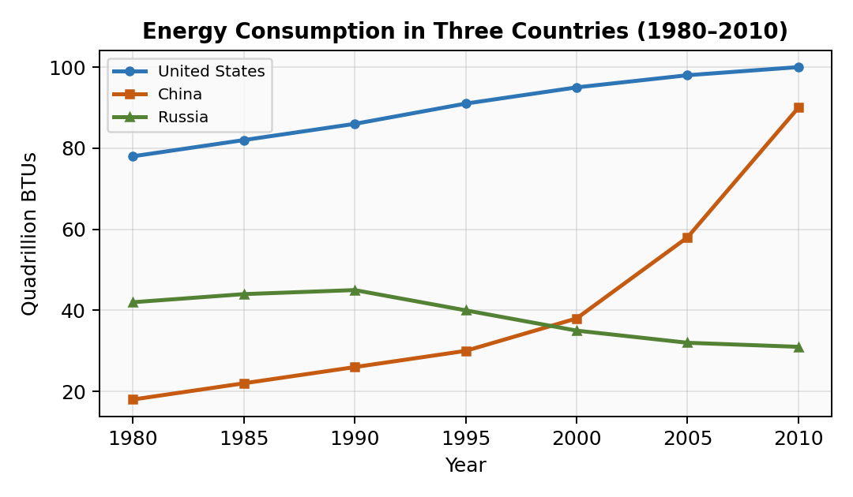

The line graph compares energy consumption in the United States, China, and Russia over a thirty-year period from 1980 to 2010, measured in quadrillion BTUs.
Overall, the US remained the largest energy consumer throughout the period, although China experienced the most dramatic growth and was approaching American levels by 2010. Russia's consumption, by contrast, showed a gradual decline after an initial peak.
In 1980, the US consumed approximately 78 quadrillion BTUs, which rose steadily to around 100 by 2010. China started at a considerably lower figure of roughly 18 quadrillion BTUs in 1980 but saw a sharp acceleration from 2000 onwards, surging to approximately 90 quadrillion BTUs by the end of the period.
Russia's energy use hovered around 42 quadrillion BTUs in 1980, peaked at about 45 in 1990, and then fell markedly to just over 30 by 2010, likely reflecting economic restructuring. By 2010, the gap between US and Chinese consumption had narrowed significantly, while Russia had fallen well behind both nations.

Example 2: Internet users per 100 people in four regions (2000–2020)
Prompt: The line graph shows the number of internet users per 100 people in North America, Europe, Latin America, and Africa between 2000 and 2020.
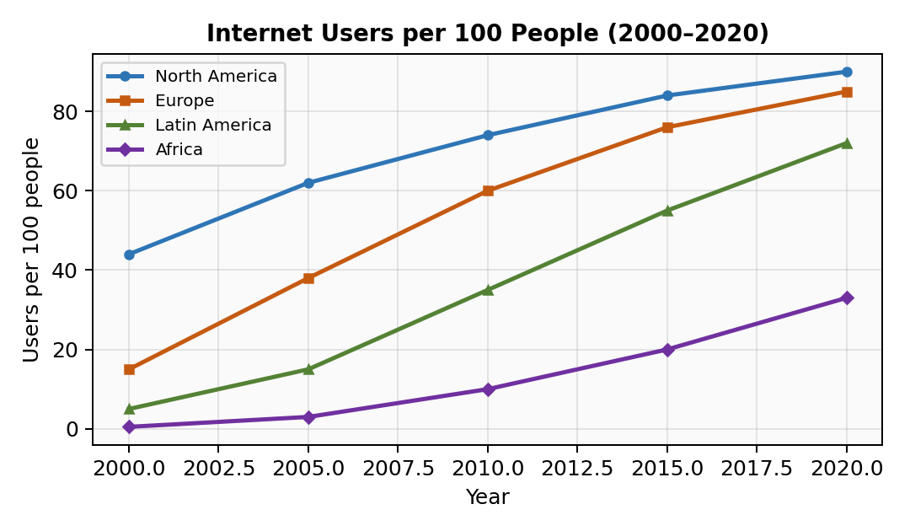

The line graph illustrates changes in internet penetration across four regions — North America, Europe, Latin America, and Africa — over a twenty-year period from 2000 to 2020.
Overall, all four regions experienced growth in internet usage, but North America and Europe consistently led, while Africa remained significantly behind despite notable improvement.
North America started with the highest penetration at roughly 44 users per 100 people in 2000, climbing steadily to approximately 90 by 2020. Europe followed a similar upward trajectory, rising from around 15 to just under 85 over the same period. The gap between these two regions narrowed considerably after 2010.
Latin America saw moderate growth, increasing from about 5 to 72 users per 100 people. Africa, although starting at fewer than 1 user per 100, rose to approximately 33 by 2020, representing the steepest percentage increase of all four regions, yet remaining the lowest in absolute terms.

① Generalized: Universal Logic, Structure & Templates

Universal Structure:
P1: Paraphrase (what + where + when + unit). P2: Overview with “Overall” — identify the biggest trend and a secondary pattern. P3: Detail Group A (usually the lines that rose / the top performers). P4: Detail Group B (the remaining lines, with comparisons to Group A).

Key Logic:
• Always group lines that behave similarly; contrast them with lines that diverge.
• Mention starting points, ending points, and any turning points (peaks, troughs, overtaking moments).
• Use approximate data — never try to read exact figures from a graph.

Sentence Templates:
• The line graph compares [what] in [where] over a [timespan] period from [year] to [year].
• Overall, [subject] experienced the most significant growth, while [subject] remained relatively stable / saw a decline.
• Starting at [figure], [subject] rose / fell [adverb] to reach [figure] by [year].
• The gap between X and Y widened / narrowed / remained constant throughout the period.
• From [year] onwards, there was a marked acceleration / deceleration in [subject].

② Specialized: Vocabulary & Collocations

Function | Expressions
Describing upward movement | rose / climbed / increased / surged / soared / experienced a sharp rise / grew markedly / picked up
Describing downward movement | fell / declined / dropped / plummeted / decreased / saw a gradual decline / slipped to
Describing stability | remained stable / levelled off / plateaued / hovered around / stayed relatively constant / held steady at
Describing fluctuation | fluctuated between X and Y / experienced periodic variation / oscillated around
Describing pace | steadily / gradually / sharply / dramatically / slightly / moderately / rapidly / marginally
Approximation | approximately / roughly / just under / just over / in the region of / slightly above / around
Time references | over the period shown / between X and Y / during the first/latter half / from X onwards / by the end of the period
Comparing lines | whereas / while / in contrast / by comparison / unlike X, Y... / similarly / followed a comparable trend

2. Bar Chart (柱状图)

Example 1: Water use by sector in six countries
Prompt: The bar chart shows the percentage of water used for agriculture, industry, and domestic purposes in six countries.
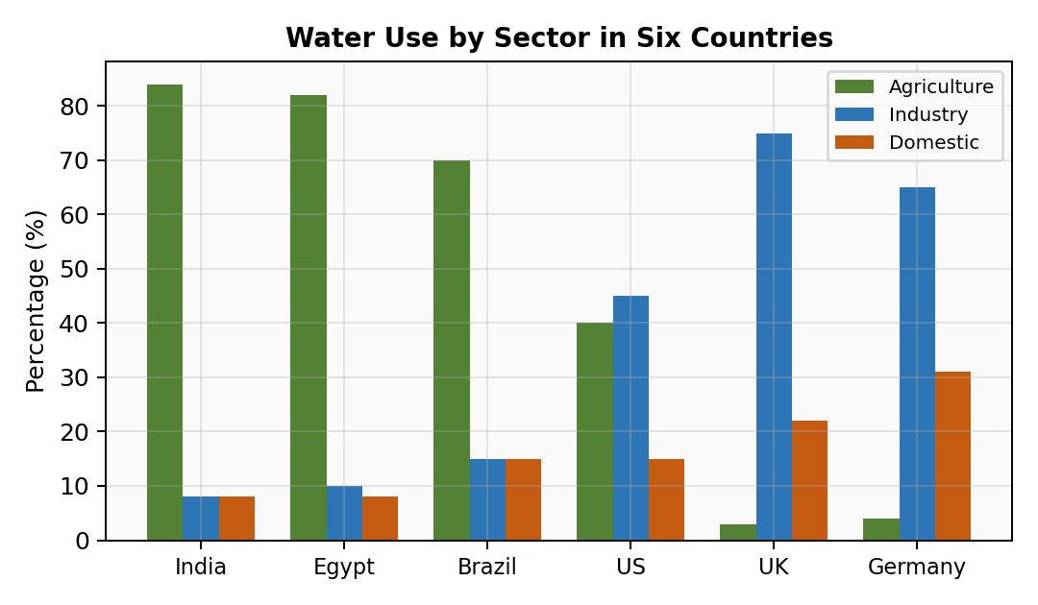

The bar chart compares the proportions of water consumed by three sectors — agriculture, industry, and domestic use — across six countries.
Overall, agricultural use dominated water consumption in most countries, particularly in developing nations. Industrial use, however, was the leading category in more developed economies such as the UK and Germany.
In India and Egypt, agriculture accounted for over 80% of total water use, with industry and domestic consumption each making up less than 10%. Brazil showed a similar pattern, with farming consuming approximately 70% of its water resources.
By contrast, the UK and Germany devoted the largest share of their water to industry, at roughly 75% and 65% respectively. Agricultural use in these countries was minimal, at under 5%. The US displayed a more balanced distribution, with agriculture at around 40%, industry at 45%, and domestic use at 15%.

Example 2: Tourist arrivals in five Asian cities (2015 vs 2020)
Prompt: The bar chart compares the number of international tourist arrivals (in millions) in Bangkok, Singapore, Kuala Lumpur, Tokyo, and Seoul in 2015 and 2020.
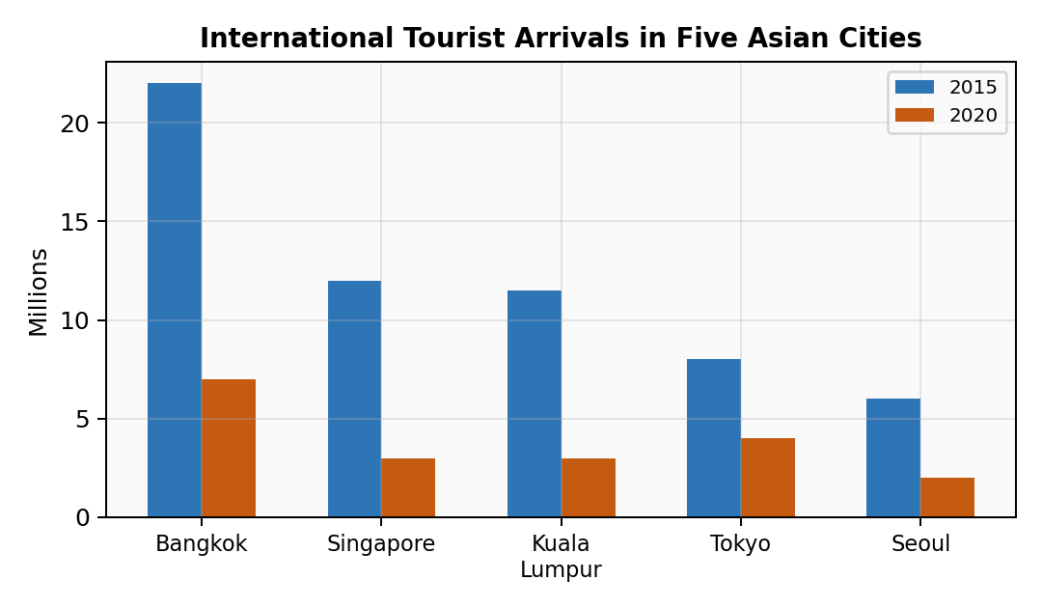

The bar chart compares international tourist arrivals in five Asian cities for the years 2015 and 2020, measured in millions.
Overall, all five cities experienced a significant decline in tourist numbers between 2015 and 2020. Bangkok received the most visitors in both years, while Seoul attracted the fewest.
In 2015, Bangkok led with approximately 22 million international arrivals, followed by Singapore at around 12 million and Kuala Lumpur at just under 12 million. Tokyo and Seoul recorded roughly 8 million and 6 million visitors respectively.
By 2020, tourist arrivals had fallen sharply across all cities, most likely due to global travel restrictions. Bangkok's figure dropped to approximately 7 million, representing a decline of nearly 70%. Singapore and Kuala Lumpur saw similarly dramatic reductions, falling to around 3 million each. Tokyo and Seoul recorded roughly 4 million and 2 million arrivals, with Tokyo showing the smallest proportional decrease among the five cities.

① Generalized: Universal Logic, Structure & Templates

Universal Structure:
P1: Paraphrase. P2: Overview — which category/country is highest/lowest? Any striking pattern? P3: Detail Group A (top 2–3 bars with specific data). P4: Detail Group B (remaining bars + comparisons).

Key Logic:
• For static bars (one time point): compare sizes. For dynamic bars (two+ time points): compare change over time.
• Group bars by similarity (e.g., “developing countries” vs “developed countries”).
• Never describe every single bar — select the most significant ones and summarize the rest.

Sentence Templates:
• The bar chart compares / illustrates [what] across [where/categories].
• [Category] accounted for the largest / smallest share / proportion of [what] in [where].
• [Country A] and [Country B] showed a similar pattern, with [sector] dominating at over X%.
• In contrast, [Country C] displayed a more balanced / uneven distribution.
• The figure for [X] was roughly [number] times that of [Y].

② Specialized: Vocabulary & Collocations

Function | Expressions
Proportions | accounted for / comprised / represented / constituted / made up / took up
Dominance | dominated / was the leading category / was by far the largest / far outweighed / dwarfed
Ranking | followed closely by / came in second at / ranked last with / trailed behind at
Comparisons | was roughly double / triple / half that of / exceeded X by a factor of / stood at X, compared to Y's figure of...
Distribution | displayed a balanced / uneven distribution / was fairly evenly spread / showed a stark contrast
Change (dynamic bars) | increased from X to Y / saw a decline of Z% / fell by nearly half / more than doubled

3. Pie Chart (饼图)

Example 1: Household expenditure in the UK (1970 vs 2010)
Prompt: The two pie charts compare how British households spent their income in 1970 and 2010.
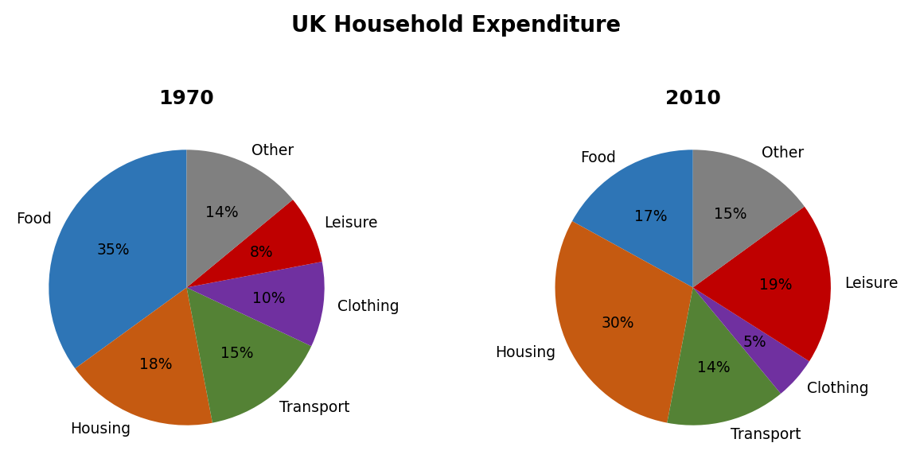

The two pie charts illustrate the breakdown of household expenditure in the United Kingdom in 1970 and 2010.
Overall, housing became the single largest expense by 2010, overtaking food, which had dominated spending in 1970. The share devoted to leisure and entertainment also rose markedly over the forty-year period.
In 1970, food was the biggest category, accounting for 35% of household spending. Housing and transport came next, at 18% and 15% respectively. Clothing represented 10%, while leisure and entertainment made up just 8%. The remaining 14% was spent on other items.
By 2010, housing had risen to 30%, becoming the top category. Food, conversely, dropped sharply to 17%. Transport stayed relatively stable at 14%. The most notable change was in leisure, which more than doubled to 19%. Clothing shrank to 5%, and other expenditure fell to 15%.

Example 2: Energy sources for electricity generation in Country X (2000)
Prompt: The pie chart shows the sources used to generate electricity in Country X in the year 2000.
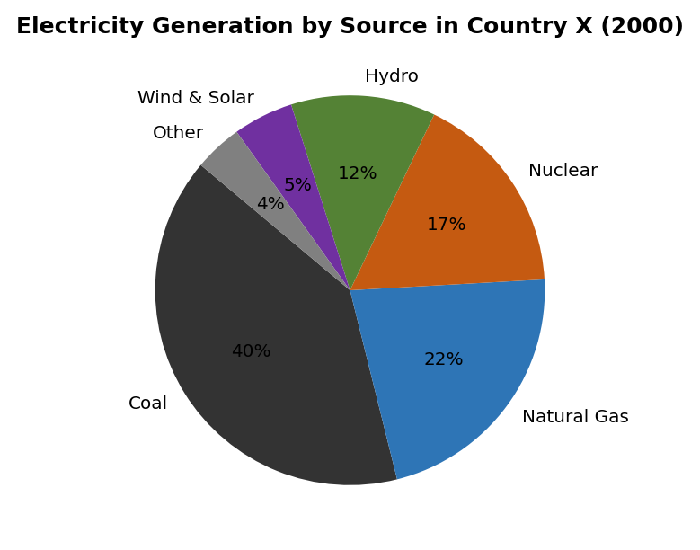

The pie chart provides a breakdown of the sources used for electricity generation in Country X in 2000.
Overall, fossil fuels dominated the energy mix, collectively accounting for nearly three-quarters of total electricity production. Renewable sources contributed a relatively small share.
Coal was the single largest source, making up 40% of electricity generation. Natural gas was the second most significant contributor at 22%, followed by nuclear energy at 17%. Together, these three sources represented almost 80% of the total.
Among renewable sources, hydroelectric power accounted for 12%, making it the most important clean energy source. Wind and solar combined contributed just 5%, while the remaining 4% came from other sources such as biomass. The chart clearly indicates that Country X relied heavily on non-renewable energy in 2000.

① Generalized: Universal Logic, Structure & Templates

Universal Structure:
P1: Paraphrase. P2: Overview — what dominated? What was smallest? (For two pies: what changed most?) P3: Largest segments with exact figures. P4: Smaller segments, grouped if possible.

Key Logic:
• For single pie: describe from largest to smallest, grouping similar-sized slices.
• For two pies: focus on what CHANGED (grew/shrank) rather than listing every number twice.
• Combine small slices: “Wind and solar combined contributed just 5%.”

Sentence Templates:
• The pie chart provides a breakdown of [what] in [where/when].
• [Category] was the largest/dominant segment, accounting for X% of the total.
• [A] and [B] collectively / combined made up roughly X%.
• The share of [X] more than doubled / halved from X% to Y%.
• The remaining X% was divided among [list].

② Specialized: Vocabulary & Collocations

Function | Expressions
Proportion language | accounted for / represented / constituted / comprised / made up / took up X% of the total
Combining segments | collectively / combined / taken together / when grouped, these categories...
Dominance | was the dominant / leading / principal category / was by far the largest segment
Small segments | a mere / a negligible / a marginal X% / contributed only a fraction of...
Change between pies | rose/fell from X% to Y% / saw a notable increase/decrease / overtook [category]
Remainder | the remaining X% was shared among / was attributed to / consisted of

4. Table (表格)

Example 1: Poverty rates in five regions (1990 and 2010)
Prompt: The table shows the percentage of the population living below the poverty line in five world regions in 1990 and 2010.
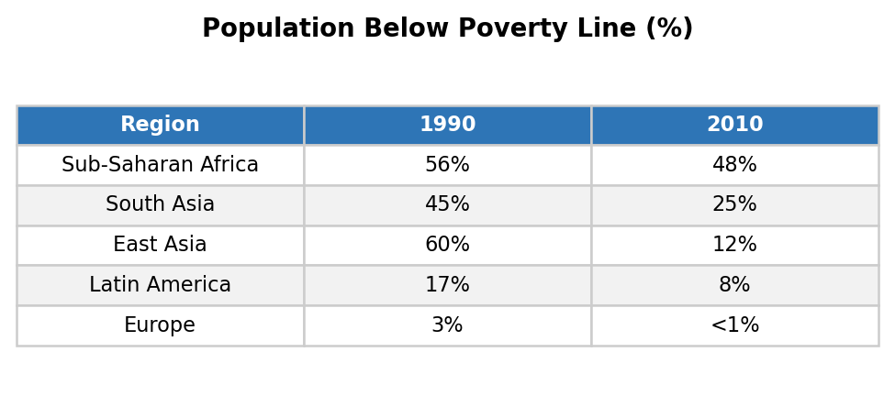

The table compares poverty rates across five world regions — Sub-Saharan Africa, South Asia, East Asia, Latin America, and Europe — in 1990 and 2010.
Overall, poverty declined in all five regions over the twenty-year period, with East Asia recording the most dramatic improvement. Sub-Saharan Africa, despite some progress, remained the poorest region by a considerable margin.
In 1990, Sub-Saharan Africa had the highest poverty rate at 56%, followed by South Asia at 45% and East Asia at 60%. Latin America and Europe had significantly lower rates, at 17% and 3% respectively.
By 2010, East Asia had achieved the most striking reduction, with its poverty rate plummeting from 60% to just 12%. South Asia also saw a notable decline, falling to 25%. Sub-Saharan Africa, however, remained high at 48%, representing only a modest 8-percentage-point drop. Latin America decreased to 8%, while Europe fell to below 1%.

Example 2: Average daily time spent on activities by teenagers (UK, 2022)
Prompt: The table below shows the average number of hours per day that UK teenagers (aged 13–18) spent on different activities in 2022.
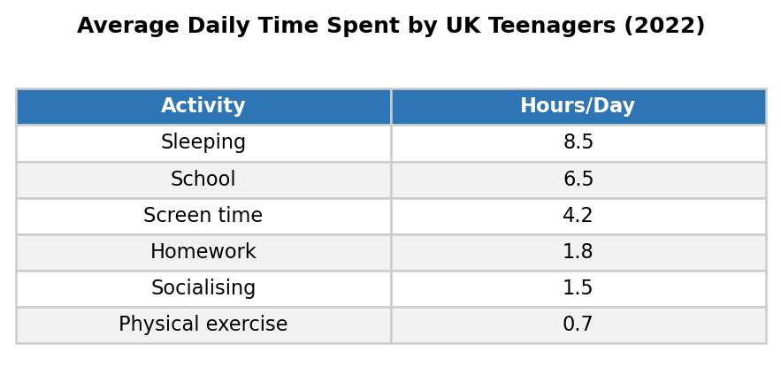

The table provides information on how UK teenagers aged 13 to 18 allocated their time across six daily activities in 2022, measured in hours per day.
Overall, sleeping and school occupied the greatest proportion of teenagers' time, while physical exercise received the least attention. Screen-based leisure was notably higher than outdoor or social activities.
Sleeping was the most time-consuming activity, averaging 8.5 hours per day, followed by school at 6.5 hours. These two essential activities together accounted for 15 of the 24 hours available.
Among discretionary activities, screen time (including social media, gaming, and streaming) averaged 4.2 hours, making it by far the dominant leisure pursuit. Homework occupied 1.8 hours, while socialising with friends took up 1.5 hours. Physical exercise was allocated just 0.7 hours on average, highlighting a relatively sedentary lifestyle among British teenagers.

① Generalized: Universal Logic, Structure & Templates

Universal Structure:
P1: Paraphrase the table description. P2: Overview — identify the highest/lowest values and the main trend. P3: The most significant rows/columns with data. P4: Remaining data with comparisons.

Key Logic:
• Tables have MORE data than charts — you must be selective. Pick the most interesting contrasts.
• Compare across rows (regions/countries) AND across columns (time periods/categories).
• Calculate simple differences or multipliers mentally: “almost halved”, “roughly tripled”.

Sentence Templates:
• The table provides / presents / compares information on [what] in [where/when].
• [X] recorded the highest / lowest figure at [number], followed by [Y] at [number].
• The most striking change was in [X], which fell/rose from [A] to [B].
• [X] and [Y] together accounted for / made up [proportion] of the total.
• By contrast, [X] saw only a marginal / modest change, moving from [A] to [B].

② Specialized: Vocabulary & Collocations

Function | Expressions
Ranking | recorded the highest figure / came in first / topped the list / ranked lowest at / was the least significant
Change magnitude | plummeted from X to Y / saw a modest decline / experienced a marginal increase / nearly halved / more than tripled
Comparison | was roughly X times higher than / exceeded Y by Z / lagged behind at / was comparable to / on a par with
Summarizing groups | among [group], X was the most/least... / within this category / of the five regions surveyed
Precise data | stood at / was recorded at / reached / amounted to / totalled

5. Process Diagram (流程图)

Example 1: How cement is manufactured and used to produce concrete
Prompt: The diagrams illustrate the process of cement manufacturing and how cement is then used to produce concrete.
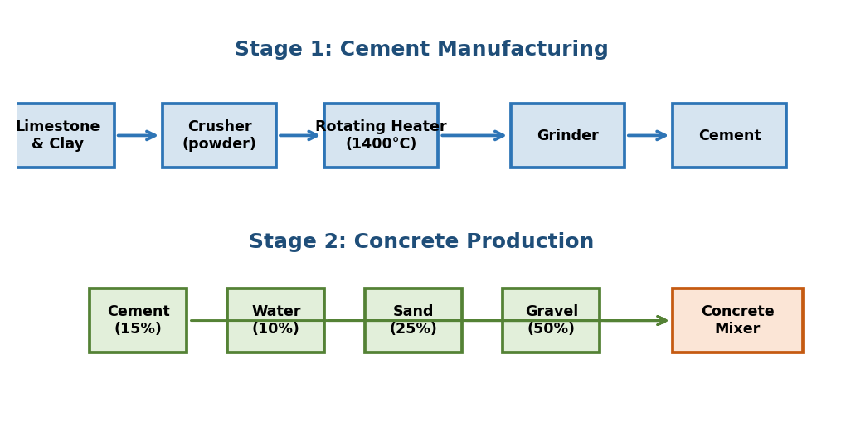

The two diagrams show the stages involved in manufacturing cement and how this cement is subsequently combined with other materials to produce concrete.
Overall, cement production is a linear process involving crushing, heating, and grinding raw materials, while concrete production is a simpler mixing process that uses cement as one of four ingredients.
In the first stage of cement manufacture, limestone and clay are extracted and fed into a crusher, which breaks them into a powder. This powder is then passed through a rotating heater at approximately 1400°C. The intense heat transforms the powder into calcium silicate clinite. Finally, the clinite is ground in a grinder to produce the fine powder known as cement.
To make concrete, cement is combined with water, sand, and gravel in a concrete mixer. The proportions are roughly 15% cement, 10% water, 25% sand, and 50% gravel. These four ingredients are rotated in the mixer until a uniform consistency is achieved, at which point the concrete is ready for use.

Example 2: How chocolate is produced from cacao beans
Prompt: The diagram shows the process by which chocolate is made from cacao beans.
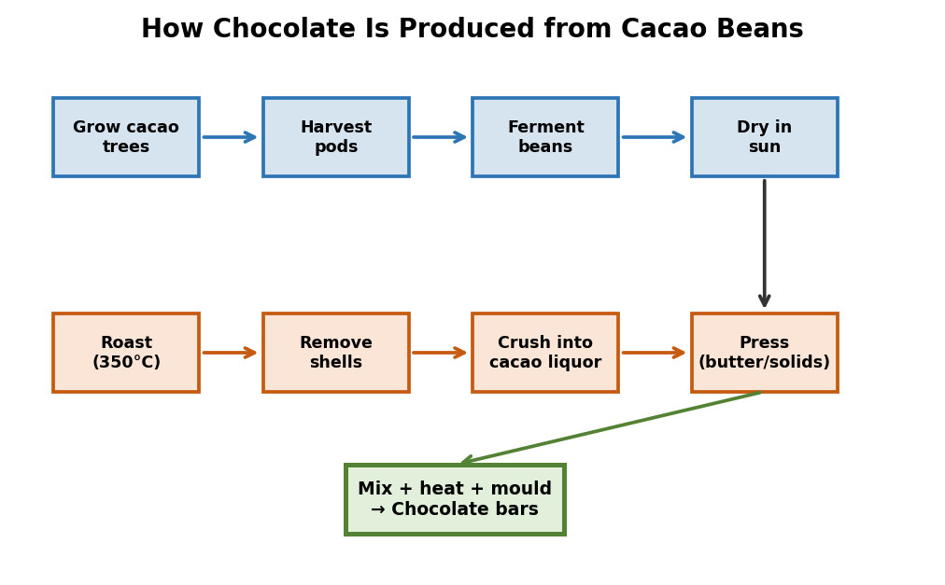

The diagram illustrates the various stages in the production of chocolate, beginning with the harvesting of cacao beans and ending with the finished product.
Overall, the process involves eight distinct stages, moving from agricultural cultivation through industrial processing. The transformation from raw bean to finished chocolate requires both heat treatment and mechanical processing.
The process begins with cacao trees being grown in South America, Africa, or Indonesia. Once the pods are ripe, they are harvested and the beans are removed. These beans are then fermented for several days before being spread out to dry in the sun.
Following this, the dried beans are transported to a factory, where they are roasted at approximately 350°C. After roasting, the outer shells are removed and the inner nibs are crushed into a paste known as cacao liquor. This liquor is then pressed to separate cacao butter from the solids. In the final stage, the butter, solids, sugar, and milk are combined and heated, then poured into moulds and cooled to form chocolate bars.

① Generalized: Universal Logic, Structure & Templates

Universal Structure:
P1: Paraphrase (what is being made/done, from start to end). P2: Overview — how many stages? Is it linear or cyclical? What is the starting point and endpoint? P3: First half of the process. P4: Second half of the process.

Key Logic:
• Use PASSIVE VOICE extensively: “The beans are roasted” not “Workers roast the beans.”
• Use sequence markers naturally — don’t start every sentence with “Then”.
• Include any temperatures, durations, or quantities shown in the diagram.
• Do NOT add information not shown in the diagram.

Sentence Templates:
• The diagram illustrates the process by which [product] is [made/produced/manufactured].
• Overall, the process involves [number] distinct stages, beginning with [X] and culminating in [Y].
• In the first / initial stage, [raw material] is [extracted / collected / harvested].
• Following this / Subsequently / Once this is complete, [next step].
• In the final stage, [product] is [packaged / distributed / ready for use].

② Specialized: Vocabulary & Collocations

Function | Expressions
Sequencing | first / to begin with / initially / in the first stage / at the outset
Continuing | then / next / subsequently / following this / after that / once complete
Simultaneous | at the same time / meanwhile / during this stage / concurrently
Result/purpose | in order to / so that / which results in / thereby producing / this yields
Final stage | in the final stage / lastly / the process culminates in / the end product is
Passive structures | is extracted / is fed into / is heated to / is combined with / is transported to / is processed into

6. Map (地图)

Example 1: Changes to an island before and after tourism development
Prompt: The two maps show an island before and after the construction of tourist facilities.
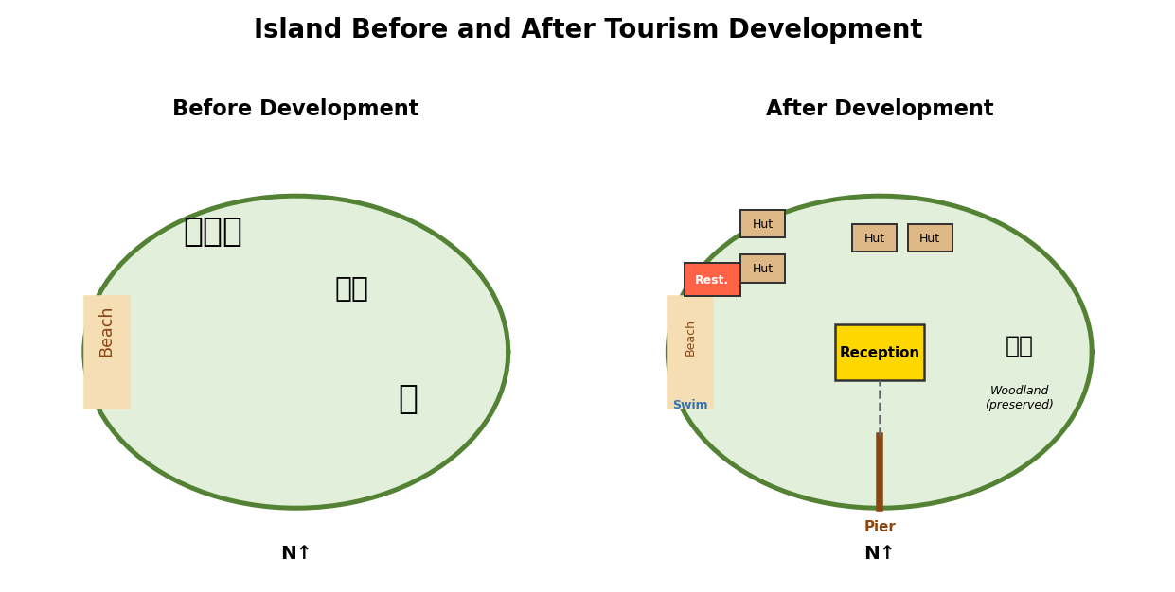

The two maps illustrate changes to a small island following the development of tourist infrastructure.
Overall, the island has been significantly transformed from its natural state, with the addition of accommodation, recreational facilities, and transport links. The western half of the island has undergone the most extensive development.
Before construction, the island contained only a small beach on the western shore, surrounded by palm trees, with no buildings or paths. The eastern half was largely covered by vegetation and woodland.
After development, a reception building was constructed at the centre of the island, connected to a pier on the southern coast by a vehicle track. Accommodation huts were built in two clusters — to the west and north of the reception — linked by footpaths. A restaurant was added near the western beach, and a swimming area was created alongside the natural beach. The eastern woodland, however, was left largely undisturbed.

Example 2: A town centre in 1980 and 2020
Prompt: The maps show the town centre of Bridgeton in 1980 and 2020.
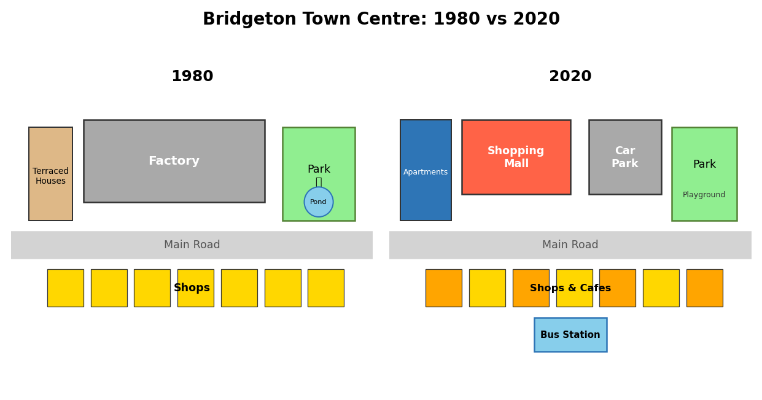

The two maps compare the town centre of Bridgeton in 1980 and in 2020, showing how the area was redeveloped over forty years.
Overall, the town centre underwent substantial modernisation, with several older buildings replaced by commercial and residential developments. The most significant change was the disappearance of industrial land in the north.
In 1980, the town centre featured a main road running east to west, with a row of shops along its southern side. North of the road was a large factory, and to the east stood a park with a small pond. The western section contained several terraced houses.
By 2020, the factory had been demolished and replaced by a shopping mall and a multi-storey car park. The terraced houses in the west were replaced by a block of apartments. The shops along the main road were largely retained, though some were converted into restaurants and cafes. The park in the east remained, but the pond was replaced by a children’s playground. A new bus station was added near the centre, improving public transport access.

① Generalized: Universal Logic, Structure & Templates

Universal Structure:
P1: Paraphrase (what area, what time period). P2: Overview — extent of change + which area changed most/least. P3: Describe major changes (demolished, built, replaced). P4: Remaining changes + what stayed the same.

Key Logic:
• Use compass directions (north, south, east, west) and relative positions (adjacent to, opposite, to the left of).
• Describe CHANGES, not just two static pictures. Say “was replaced by” not “in 1980 there was X; in 2020 there is Y.”
• Always note what was PRESERVED — examiners reward this.

Sentence Templates:
• The two maps compare [place] in [year] and [year] / before and after [event].
• Overall, the area has undergone / experienced significant / substantial transformation.
• The [factory/houses] in the [north/south] was/were demolished and replaced by [X].
• A new [facility] was constructed / added to the [east/west] of [landmark].
• The [park/river], however, remained unchanged / was left intact / was largely preserved.

② Specialized: Vocabulary & Collocations

Function | Expressions
Location | to the north/south of / in the northeast corner / adjacent to / on the opposite side / along the coast / at the centre
Change | was replaced by / was converted into / was demolished / was expanded / was extended / was redeveloped into
Addition | was constructed / was built / was added / was established / a new X appeared
Preservation | remained unchanged / was retained / was left intact / was largely preserved / still stands
Scale of change | underwent significant transformation / saw minor alterations / was substantially redeveloped / remained largely untouched

7. Mixed / Combination Chart (混合图)

Example 1: A bar chart + a pie chart on transport in a city
Prompt: The bar chart shows the number of commuters using four modes of transport in City X (2010–2020). The pie chart shows reasons for choosing public transport in 2020.
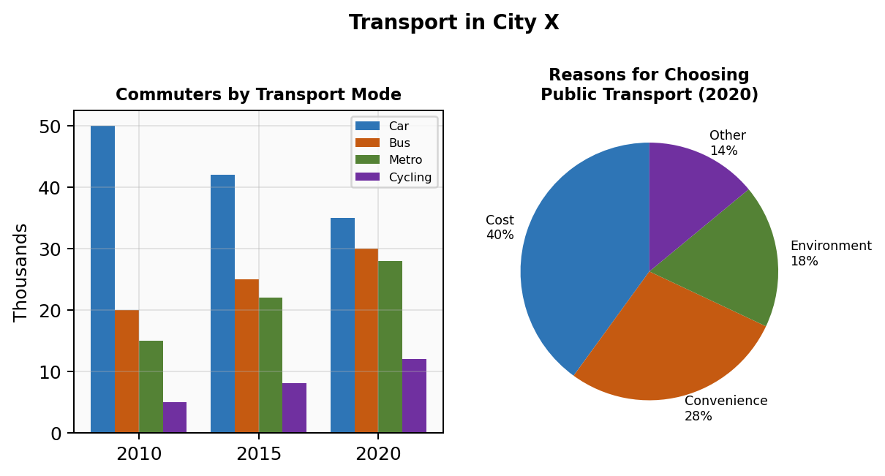

The bar chart illustrates changes in commuter numbers across four transport modes in City X between 2010 and 2020, while the pie chart shows why people chose public transport in 2020.
Overall, public transport usage grew substantially over the decade, while private car use declined. Among public transport users, cost was cited as the primary reason for their choice.
According to the bar chart, the number of private car commuters fell from approximately 50,000 in 2010 to 35,000 in 2020. By contrast, bus and metro users increased steadily, from 20,000 and 15,000 respectively in 2010 to 30,000 and 28,000 by 2020. Cycling also saw modest growth, rising from 5,000 to 12,000.
The pie chart reveals that 40% of public transport users chose this mode primarily for its lower cost. Convenience accounted for 28%, while environmental concerns motivated 18% of respondents. The remaining 14% cited other reasons, such as not owning a car or health benefits.

Example 2: A line graph + a table on university enrolment
Prompt: The line graph shows total university enrolment in Country Y from 2000 to 2020. The table gives a breakdown by field of study for selected years.
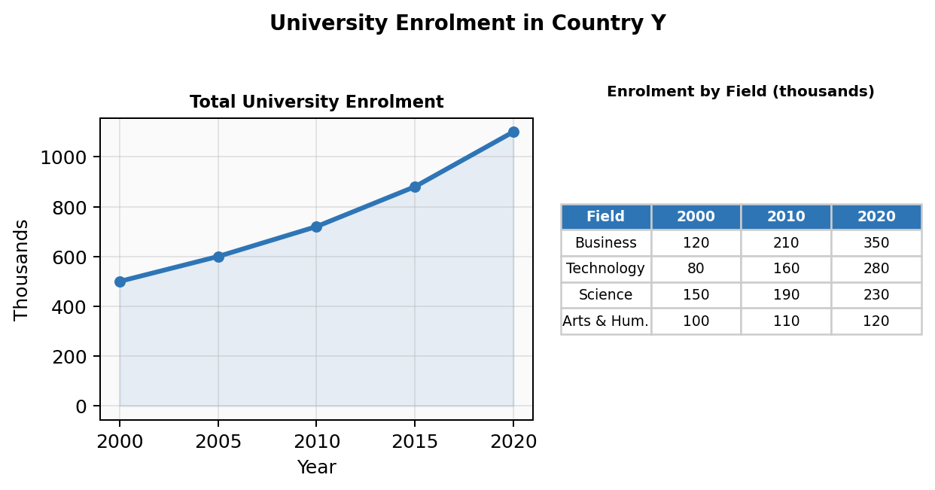

The line graph shows the trend in overall university enrolment in Country Y over a twenty-year period, while the table provides a breakdown of student numbers by field of study in 2000, 2010, and 2020.
Overall, total enrolment more than doubled during this period. The growth was concentrated in business and technology fields, while arts and humanities saw only marginal increases.
The line graph shows that total enrolment rose steadily from approximately 500,000 in 2000 to just over 1.1 million by 2020. The rate of growth was particularly steep between 2010 and 2020.
Turning to the table, business studies grew from 120,000 students in 2000 to 350,000 in 2020, making it the largest field by the end of the period. Technology-related subjects experienced a similar surge, increasing from 80,000 to 280,000. Science enrolment rose moderately from 150,000 to 230,000. By contrast, arts and humanities grew only slightly, from 100,000 to 120,000, and its share of total enrolment actually declined.

① Generalized: Universal Logic, Structure & Templates

Universal Structure:
P1: Paraphrase BOTH visuals in one sentence, connected by “while” or “and.” P2: Overview covering the key finding from EACH visual. P3: Detail from Visual 1. P4: Detail from Visual 2 (start with “Turning to the [pie chart/table]...”).

Key Logic:
• Treat each visual as a separate body paragraph — do NOT mix data from both in one paragraph.
• The overview MUST cover both visuals.
• If the visuals are related, make one linking observation: “The growth in public transport, shown in the bar chart, is further explained by the pie chart.”

Sentence Templates:
• The [chart type 1] illustrates [X], while the [chart type 2] shows [Y].
• Turning to the [second visual], ...
• The information in the [table] provides further insight into / a more detailed picture of...
• When considered together, the two visuals suggest that...

② Specialized: Vocabulary & Collocations

Function | Expressions
Introducing second visual | Turning to / Looking at / As for / With regard to / The accompanying [chart] shows
Linking two visuals | This is consistent with / corroborated by / further illustrated by / helps explain why
Contrasting visuals | While the [bar chart] shows the overall trend, the [table] reveals the underlying composition
Transitional phrases | In more detail / More specifically / Breaking this down further / A closer look at

PART TWO: TASK 2
Task 2 requires 250+ words in 40 minutes. You write an argumentative essay. Do Task 2 FIRST in the exam — it is worth twice the marks of Task 1.

Topic 1: Education (教育)

Example 1: Agree/Disagree
Prompt: Some people think that the main purpose of education is to make individuals useful to society. Others say education should help people achieve personal ambitions. Discuss both views and give your own opinion.

Education has long been the subject of debate regarding its primary purpose. While some argue that it should serve society by producing a skilled workforce, others believe its fundamental aim is to empower individuals to fulfil their personal goals. This essay will examine both perspectives before presenting my own view.
On the one hand, there is a strong case for viewing education as a tool for social development. Governments invest heavily in public schooling with the expectation that graduates will contribute to economic productivity, scientific progress, and social stability. For instance, countries that have prioritised science and engineering education, such as South Korea and Germany, have built highly competitive economies. From this perspective, education is an investment in collective prosperity.
On the other hand, I am more inclined to support the view that education should primarily serve the individual. When students are encouraged to pursue subjects they are passionate about, they tend to develop deeper expertise and greater motivation. A student who studies philosophy because they love it is likely to become a more creative and critical thinker than one forced into a vocational track. Moreover, personal fulfilment and intellectual growth are valuable in their own right, not merely as means to economic ends.
In conclusion, while education undeniably benefits society, I believe its core mission should be to help individuals develop their potential and pursue meaningful lives. A society composed of fulfilled, self-directed learners will, in any case, naturally produce collective benefits.

Example 2: Problem/Solution
Prompt: In many countries, students are losing interest in studying science subjects. What are the causes of this? What solutions can you suggest?

A growing number of students in many parts of the world appear reluctant to study science subjects. This essay will examine the main reasons behind this trend and propose some practical solutions.
One of the principal causes is that science education is often perceived as overly theoretical and disconnected from real life. When students spend years memorising formulae without understanding their practical applications, motivation inevitably declines. Furthermore, the teaching methods in many schools remain outdated, relying on rote learning rather than hands-on experimentation and inquiry-based approaches.
Another contributing factor is the influence of career perceptions. Many young people observe that careers in business, finance, and social media appear more glamorous and financially rewarding than those in scientific research, which is often seen as demanding but poorly paid. This discourages students from choosing science-related paths.
To address this issue, schools could adopt more engaging pedagogies, such as project-based learning and laboratory work, to demonstrate the real-world relevance of science. For example, teaching physics through robotics or biology through environmental fieldwork can spark genuine curiosity. Additionally, governments and media could do more to celebrate scientific achievements and highlight the diverse career opportunities available to science graduates, from healthcare to artificial intelligence.
In summary, declining interest in science stems from uninspiring teaching methods and unfavourable career perceptions. By modernising science education and raising the public profile of scientific careers, this trend can be reversed.

① Generalized: Sentence Templates for This Topic

Sentence Templates:
• Education has long been the subject of debate regarding...
• There is a strong case for viewing education as...
• When students are encouraged to pursue [X], they tend to develop...
• One of the principal causes is that [X] is often perceived as...
• Schools could adopt more engaging pedagogies, such as...

② Specialized: Topic Vocabulary

Chinese | English Expression
学校教育 | schooling / formal education / institutional learning
家庭教育 | upbringing / parenting / home education
素质教育 | quality-oriented education / holistic education
死记硬背 | learn things by rote / rote memorisation
传授知识 | impart knowledge / inculcate knowledge
塑造性格 | shape (mould) one's character
创造力 | creativity / creative thinking / innovative capacity
学业成绩 | academic performance / scholastic achievement
远程教育 | tele-education / distance learning / online education
理论知识 vs 实践 | theoretical knowledge vs practical skills / hands-on experience

Topic 2: Technology & Media (科技与媒体)

Example 1: Agree/Disagree
Prompt: Some people say that the internet has made people more isolated. To what extent do you agree or disagree?

It is frequently argued that the internet, despite connecting billions of people virtually, has paradoxically increased social isolation. While I acknowledge that excessive internet use can lead to withdrawal from face-to-face interaction, I largely disagree with this claim, as digital connectivity has overwhelmingly enhanced human connection.
The primary reason for my position is that the internet enables people to maintain relationships across vast distances. Before email and video calling, emigrating to another country often meant losing daily contact with family and friends. Today, a grandparent can watch a grandchild's first steps in real time from thousands of kilometres away. These technologies have strengthened, not weakened, family ties for millions of people.
Admittedly, there is some merit in the argument that social media can create a superficial sense of connection while undermining deeper relationships. Studies have shown that heavy social media users sometimes experience greater loneliness, possibly because curated online personas replace authentic interaction. For teenagers in particular, the pressure to maintain an online image can be psychologically harmful.
Nevertheless, this is a problem of misuse rather than an inherent flaw of the technology itself. When used mindfully, the internet provides unprecedented opportunities for community building, knowledge sharing, and social support. Online forums have connected people with rare medical conditions, niche hobbies, and minority identities who might otherwise feel profoundly isolated.
In conclusion, while excessive or superficial internet use can contribute to isolation, the technology itself has been a powerful force for human connection. The solution lies in promoting digital literacy, not in rejecting digital communication.

Example 2: Discuss Both Views
Prompt: Some believe that the media should be free to publish any news without government interference. Others think that media freedom should have limits. Discuss both views and give your own opinion.

The question of how much freedom the media should enjoy remains one of the most contentious issues in modern democracies. While some advocate for unrestricted press freedom, others argue that certain limits are necessary to protect individuals and society. This essay will consider both perspectives.
Proponents of unrestricted media freedom contend that a free press is essential for holding governments and powerful institutions accountable. History demonstrates that censorship often serves the interests of those in power rather than the public good. Investigative journalism has exposed corruption, human rights abuses, and corporate fraud that might otherwise have remained hidden. Any restriction, they argue, creates a dangerous precedent.
On the other hand, those who favour some regulation point to the real harm that unrestrained media can cause. False reporting can destroy innocent reputations, sensationalist coverage of tragedies can exploit victims, and the spread of misinformation can undermine public health and democratic processes. The rise of social media has amplified these concerns, as unverified content can reach millions within minutes.
In my view, media freedom is a fundamental right that should be robustly protected, but it must be balanced with accountability. This balance is best achieved not through government censorship but through independent regulatory bodies, strong defamation laws, and industry codes of ethics. The goal should be to ensure accuracy and responsibility without giving any government the power to silence inconvenient truths.

① Generalized: Sentence Templates for This Topic

Sentence Templates:
• It is frequently argued that [X], despite [benefit], has paradoxically [negative outcome].
• These technologies have strengthened, not weakened, [aspect] for millions of people.
• This is a problem of misuse rather than an inherent flaw of the technology itself.
• The question of [X] remains one of the most contentious issues in...
• This balance is best achieved not through [A] but through [B].

② Specialized: Topic Vocabulary

Chinese | English Expression
大众媒体 | mass media / mainstream media / the press
信息爆炸 | information explosion / information overload
新闻审查 | news censorship / media regulation / press control
舆论的晴雨表 | the barometer of public opinion
侵犯隐私 | invade / violate / infringe on one's privacy
误导性的 | misleading / misrepresented / distorted
批判性思维 | critical thinking / media literacy
双刃剑 | a double-edged sword / a mixed blessing
深远影响 | exert a far-reaching impact on / have profound implications for
彻底改变了 | revolutionise the way we... / fundamentally transform

Topic 3: Globalisation (全球化)

Example 1: Discuss Both Views
Prompt: Some people think that globalisation is a positive development, while others believe it mainly benefits rich countries at the expense of poorer ones. Discuss both views and give your opinion.

Globalisation has generated intense debate about whether it benefits all nations equally or primarily serves the interests of wealthy economies. This essay will examine both sides of this argument.
Supporters of globalisation argue that it has lifted hundreds of millions of people out of poverty by opening global markets. Countries like China and Vietnam have achieved rapid economic growth by participating in international trade, attracting foreign investment, and absorbing new technologies. Moreover, cultural exchange through travel, media, and the internet has broadened people's horizons and fostered greater mutual understanding.
Critics, however, contend that globalisation has widened the gap between rich and poor nations. Multinational corporations often exploit cheap labour in developing countries while repatriating profits to their home nations. Local industries may be unable to compete with powerful foreign companies, leading to economic dependency. Furthermore, cultural homogenisation threatens the survival of indigenous traditions and languages.
In my view, globalisation is neither wholly positive nor entirely negative. Its benefits are real but unevenly distributed. The solution is not to reverse globalisation but to manage it more equitably through fair trade agreements, technology transfer programmes, and policies that protect cultural diversity while encouraging economic integration. When these safeguards are in place, globalisation can serve as a rising tide that lifts all boats.

Example 2: Agree/Disagree
Prompt: The spread of multinational companies and the increase in globalisation produce positive effects for everyone. To what extent do you agree or disagree?

It is often claimed that the expansion of multinational corporations and the advance of globalisation bring universal benefits. While I accept that these trends have generated significant economic growth, I partly disagree with the assertion that the effects are positive for everyone.
On the positive side, multinational companies create employment opportunities in developing nations, often providing wages and working conditions superior to those of local firms. They also transfer technology, management expertise, and skills training to host countries. For consumers globally, competition among international brands has led to better products at lower prices.
However, the benefits are far from evenly distributed. Small local businesses frequently cannot compete with the marketing budgets and economies of scale of multinational corporations, leading to closures and job losses in traditional sectors. In many developing countries, the profits generated by foreign companies flow back to shareholders in wealthy nations rather than being reinvested locally. Workers at the bottom of global supply chains often endure poor conditions despite corporate pledges of responsibility.
Furthermore, globalisation can erode cultural identity. When global brands and Western entertainment dominate, local customs and traditions may fade. Young people in developing countries sometimes reject their heritage in favour of an imported consumer culture.
In conclusion, while globalisation and multinational expansion have brought undeniable benefits, claiming these effects are positive for everyone is an oversimplification. Without deliberate policies to ensure fair distribution of gains, globalisation risks deepening inequality.

① Generalized: Sentence Templates for This Topic

Sentence Templates:
• Globalisation has generated intense debate about whether...
• Countries like X and Y have achieved rapid growth by participating in...
• The benefits are real but unevenly distributed.
• The solution is not to reverse [X] but to manage it more equitably through...
• Without deliberate policies to ensure [X], [trend] risks deepening [problem].

② Specialized: Topic Vocabulary

Chinese | English Expression
经济全球化 | economic globalisation / global economic integration
文化多元化 | cultural diversity / multiculturalism
文化同一化 | cultural uniformity / homogenisation
双赢局面 | a win-win situation / mutually beneficial outcome
吸引外资 | attract foreign capital / foreign direct investment
加大贫富差距 | widen the gap between the rich and the poor
融入新文化 | merge into / assimilate into a new culture
对国内企业构成威胁 | pose threats to domestic enterprises
取其精华去其糟粕 | absorb the essence and discard the dross
促进文化融合 | promote cultural integration / foster cultural exchange

Topic 4: Culture & Customs (文化与习俗)

Example 1: Agree/Disagree
Prompt: It is inevitable that traditional cultures will be lost as technology develops. To what extent do you agree or disagree?

Some commentators predict that technological development will inevitably lead to the disappearance of traditional cultures. While I accept that technology poses challenges to cultural preservation, I strongly disagree that the loss is inevitable, as technology can also serve as a powerful tool for protecting heritage.
It is true that rapid modernisation has endangered many traditions. As younger generations become immersed in globalised digital culture, they may show less interest in traditional crafts, rituals, and languages. The convenience of mass-produced goods can undermine local artisanship, and streaming platforms may crowd out folk music and regional storytelling traditions.
However, the same technology that threatens traditions can also preserve them. Digital archives can record endangered languages and oral histories before they vanish. Social media enables communities to share their cultural practices with global audiences, generating both awareness and economic value. Platforms like YouTube have turned obscure folk musicians into international stars, reviving interest in traditions that were fading.
Moreover, many societies have demonstrated that modernity and tradition can coexist. Japan, for example, maintains a thriving technology sector alongside deeply cherished customs such as tea ceremonies and seasonal festivals. The key factor is not technology itself but whether communities actively choose to preserve their heritage.
In conclusion, while technology accelerates cultural change, it does not doom traditions to extinction. With conscious effort and creative use of digital tools, societies can embrace innovation while preserving the cultural practices that define their identity.

Example 2: Problem/Solution
Prompt: Nowadays, international tourism has become a big industry. Some people think it damages local culture. What can be done to minimise the negative impact of tourism on local traditions?

International tourism has grown into one of the world's largest industries, bringing economic benefits but also raising concerns about its impact on local cultures. This essay will discuss practical measures to minimise the cultural damage caused by mass tourism.
One significant problem is the commercialisation of tradition. When sacred rituals or traditional crafts are performed primarily for tourists, they can lose their authentic meaning and become mere entertainment. Local people may abandon genuine customs in favour of exaggerated performances that appeal to foreign visitors.
To counter this, governments could establish cultural protection zones where traditional practices are supported but not commercialised. For example, funding local artisans to continue their craft for its own sake, rather than solely for the tourist market, helps maintain authenticity. Education programmes for tourists, such as guided cultural experiences led by community members, can foster respectful engagement rather than superficial consumption.
Another approach is to promote sustainable and community-based tourism, where local residents control how their culture is presented and shared. Revenue from tourism should be directed back into the community to fund cultural preservation initiatives, language programmes, and heritage site maintenance.
Finally, tourist numbers at sensitive cultural sites should be managed through booking systems and capacity limits, as already practised at locations like Machu Picchu and the Taj Mahal.
In summary, minimising tourism's cultural impact requires a combination of regulation, community empowerment, and visitor education. When tourism is managed thoughtfully, it can actually strengthen rather than erode local traditions.

① Generalized: Sentence Templates for This Topic

Sentence Templates:
• While I accept that [X] poses challenges to [Y], I strongly disagree that the loss is inevitable.
• The same technology that threatens [X] can also preserve it.
• Many societies have demonstrated that modernity and tradition can coexist.
• The key factor is not [X] itself but whether communities actively choose to...
• When [X] is managed thoughtfully, it can actually strengthen rather than erode [Y].

② Specialized: Topic Vocabulary

Chinese | English Expression
文化遗产 | cultural heritage / cultural legacy
跨文化交流 | cross-cultural communication / intercultural dialogue
民族特性 | national identity / cultural identity
风土人情 | local customs and practices / folk traditions
代代相传 | pass down from generation to generation / be handed down through the ages
弘扬文化 | carry forward / promote / preserve cultural traditions
文化同化 | cultural assimilation / cultural absorption
缩小文化差距 | bridge cultural gaps / narrow the cultural divide
文化冲击 | cultural shock / cultural displacement
本土语言消失 | indigenous languages fade / die out / become extinct

Topic 5: Government (政府责任)

Example 1: Discuss Both Views
Prompt: Some think governments should spend money on public services rather than wasting money on arts such as music and painting. To what extent do you agree or disagree?

It is sometimes argued that government funding should be directed exclusively toward essential public services such as healthcare and education, rather than being spent on the arts. While I understand the priority given to basic services, I believe that arts funding is also a necessary investment.
There is a compelling case for prioritising public services. In many countries, hospitals are underfunded, schools lack resources, and infrastructure is deteriorating. When citizens struggle to access basic healthcare or clean water, spending public money on art exhibitions or orchestras can seem irresponsible. Governments have a primary obligation to ensure the well-being of their citizens.
However, cutting arts funding entirely would be short-sighted. The arts contribute significantly to the economy through tourism, creative industries, and cultural exports. Cities known for their cultural offerings — such as Vienna for classical music or Florence for Renaissance art — generate enormous revenue from visitors drawn by their artistic heritage. Furthermore, the arts play a vital role in mental health, community cohesion, and national identity.
A pragmatic approach is to maintain a modest but consistent level of arts funding while ensuring that the bulk of public spending addresses essential services. Government support for the arts can also be leveraged through public-private partnerships and sponsorship models that reduce the burden on taxpayers.
In conclusion, while public services must take priority, a society that neglects the arts risks losing not only cultural richness but also significant economic and social benefits.

Example 2: Problem/Solution
Prompt: In many countries, the gap between the rich and the poor is increasing. What problems does this cause? What solutions can governments implement?

The widening disparity between wealthy and disadvantaged citizens is one of the most pressing challenges facing modern societies. This essay will examine the key problems arising from income inequality and suggest measures that governments can take.
Growing inequality creates several serious social problems. First, it limits access to quality education and healthcare for lower-income families, perpetuating a cycle of poverty across generations. Children from disadvantaged backgrounds are far less likely to attend university or receive preventive medical care. Second, extreme inequality erodes social cohesion, breeding resentment and distrust between different social classes, which can ultimately lead to higher crime rates and political instability.
To address these issues, governments should pursue a multi-pronged strategy. Progressive taxation, where higher earners pay a larger proportion of their income in tax, can fund social programmes that benefit the poorest members of society. Investment in free or affordable education and vocational training is equally crucial, as it provides individuals with the skills needed to improve their economic prospects.
Additionally, governments can implement minimum wage legislation and strengthen labour protections to ensure that economic growth translates into higher living standards for all workers, not merely increased profits for corporations. Social safety nets, including unemployment benefits and housing assistance, should be maintained and expanded where needed.
In summary, income inequality undermines education, health, and social harmony. Through progressive taxation, investment in human capital, and robust social protections, governments can work toward a more equitable distribution of wealth.

① Generalized: Sentence Templates for This Topic

Sentence Templates:
• There is a compelling case for prioritising...
• Cutting [X] funding entirely would be short-sighted.
• A pragmatic approach is to... while ensuring that...
• The widening disparity between [A] and [B] is one of the most pressing challenges facing...
• Governments should pursue a multi-pronged strategy.

② Specialized: Topic Vocabulary

Chinese | English Expression
政府投资 | government investment / public expenditure / state funding
减少预算 | cut budget / reduce expenditure / curtail spending on
基础设施 | infrastructure / public facilities / civic amenities
社会福利 | social welfare / the social safety net / public assistance
税收 | taxation / revenue / fiscal policy
公共交通 | public transport / mass transit / the transport network
医疗保健制度 | healthcare system / public health services
脱贫 | shake off / alleviate / eradicate poverty
人道主义援助 | humanitarian aid / foreign assistance
空间探索 | space exploration / aerospace research

Topic 6: Crime (犯罪)

Example 1: Causes/Effects
Prompt: In many countries, the rate of crime among young people is increasing. What are the causes? What effects does this have on society?

Youth crime rates have risen in numerous countries in recent years, prompting concern among both policymakers and the general public. This essay will explore the primary causes of this trend and its broader social consequences.
Several factors contribute to rising juvenile delinquency. Family breakdown is a significant driver: children from single-parent households or those who experience domestic violence are statistically more likely to engage in criminal behaviour. A lack of parental supervision, combined with the influence of violent media content, can lead impressionable young people astray. Additionally, socioeconomic disadvantage plays a crucial role, as young people in deprived areas with limited educational and employment opportunities may turn to crime out of frustration or financial desperation.
The effects on society are wide-ranging. Most directly, youth crime threatens public safety and creates an atmosphere of fear in affected neighbourhoods. It also places a heavy burden on the criminal justice system, including police resources, courts, and detention centres. In the longer term, young offenders who are not rehabilitated often continue criminal activity into adulthood, perpetuating a vicious cycle. Communities with high youth crime rates may suffer from reduced property values, lower business investment, and social fragmentation.
In conclusion, youth crime is driven primarily by family instability, socioeconomic deprivation, and harmful media influences. Its consequences extend beyond individual victims to undermine the fabric of entire communities, making prevention and early intervention essential.

Example 2: Agree/Disagree
Prompt: Some people think that the best way to reduce crime is to give longer prison sentences. Others believe there are better methods. Discuss both views and give your opinion.

The most effective approach to reducing crime is a matter of ongoing debate. While longer prison sentences are favoured by some as a strong deterrent, others argue that alternative strategies are more effective in the long run.
Proponents of harsher sentencing argue that the threat of extended imprisonment discourages potential offenders from committing crimes. When people know they face severe consequences, they are more likely to think twice before breaking the law. Furthermore, keeping repeat offenders incarcerated for longer periods protects the public by removing dangerous individuals from society.
However, research suggests that longer sentences alone are insufficient to reduce crime rates. Many inmates reoffend upon release because prison fails to address the root causes of their behaviour, such as addiction, mental health issues, or lack of employment skills. In fact, lengthy imprisonment can be counterproductive, as it exposes young offenders to hardened criminals and makes reintegration into society more difficult.
I believe that a combination of appropriate sentencing and preventive measures offers the best solution. Investment in education and job training within prisons can reduce recidivism rates significantly. Community-based rehabilitation programmes, restorative justice initiatives, and early intervention for at-risk youth address the underlying causes of crime rather than merely punishing its symptoms.
In conclusion, while prison sentences serve a purpose in protecting the public, they should be complemented by rehabilitation and prevention strategies to achieve lasting reductions in crime.

① Generalized: Sentence Templates for This Topic

Sentence Templates:
• Youth crime rates have risen in numerous countries, prompting concern among...
• Children from [background] are statistically more likely to...
• Research suggests that [approach] alone is insufficient to...
• A combination of [A] and [B] offers the best solution.
• [Approach] addresses the underlying causes of [problem] rather than merely punishing its symptoms.

② Specialized: Topic Vocabulary

Chinese | English Expression
青少年犯罪 | juvenile delinquency / youth crime / offending among young people
犯罪率上升 | a rising crime rate / an increase in criminal activity
误入歧途 | go astray / be led astray / fall into a life of crime
家庭暴力 | domestic violence / family abuse
监管不严 | slack supervision / inadequate parental oversight
分辨是非 | distinguish right from wrong / develop moral judgement
惩罚 | punishment / sentencing / penalisation
改造归正 | rehabilitation / reform / reintegration into society
恶性循环 | a vicious cycle / a downward spiral
净化社会环境 | purify the social environment / create a safer community

Topic 7: Animals (动物)

Example 1: Discuss Both Views
Prompt: Some people think that experimenting on animals is acceptable for the benefit of humans. Others believe it is wrong. Discuss both views and give your opinion.

The ethics of animal experimentation remain fiercely debated. While some regard it as a necessary sacrifice for medical progress, others view it as morally indefensible. This essay will consider both sides before presenting my position.
Those who support animal testing argue that it has been instrumental in developing life-saving medicines, vaccines, and surgical techniques. Many treatments for cancer, diabetes, and heart disease were first tested on animals before being administered to humans. Without this step, they contend, medical progress would be severely hampered, and human lives would be lost unnecessarily.
Opponents, however, argue that animals have an inherent right to life free from suffering. They point out that the physiological differences between humans and animals mean that test results are not always reliable when applied to people. Furthermore, with advances in technology, alternative methods such as computer simulation, cell culture testing, and artificial tissue models are becoming increasingly viable, reducing the need for animal subjects.
I believe that while a complete and immediate ban on animal testing is impractical, the scientific community has a moral obligation to adopt alternatives wherever possible and to minimise animal suffering in cases where testing remains necessary. Strict regulatory oversight and the continued development of non-animal testing methods should be priorities.
In conclusion, animal experimentation occupies a difficult ethical space between scientific necessity and moral responsibility. The goal should be progressive reduction rather than outright elimination.

Example 2: Problem/Solution
Prompt: Many species of plants and animals are becoming extinct. What are the causes? What can be done to solve this problem?

The accelerating loss of plant and animal species is one of the most alarming environmental trends of our time. This essay will examine the principal causes of this crisis and propose potential solutions.
The primary driver of species extinction is habitat destruction. As human populations grow, forests are cleared for agriculture, wetlands are drained for urban development, and oceans are polluted by industrial waste. Climate change compounds these problems by altering ecosystems faster than many species can adapt. Additionally, illegal hunting and poaching continue to threaten iconic species such as elephants, tigers, and rhinoceroses, despite international prohibitions.
To combat this crisis, governments must strengthen and enforce environmental protection laws. Expanding protected natural areas, such as national parks and marine reserves, can provide safe habitats for endangered species. International cooperation is essential, as species do not respect national borders; migratory birds and marine creatures, for instance, require coordinated conservation efforts.
At the individual level, consumers can make a difference by supporting sustainable products and reducing their ecological footprint. Education campaigns can raise awareness about biodiversity and the interconnectedness of ecosystems, fostering a sense of responsibility toward the natural world.
In summary, habitat destruction, climate change, and poaching are driving mass extinction. Through stronger legislation, international cooperation, and public awareness, humanity can slow and eventually reverse this devastating trend.

① Generalized: Sentence Templates for This Topic

Sentence Templates:
• The ethics of [X] remain fiercely debated.
• [X] has been instrumental in developing...
• The scientific community has a moral obligation to...
• The goal should be progressive reduction rather than outright elimination.
• The accelerating loss of [X] is one of the most alarming [Y] trends of our time.

② Specialized: Topic Vocabulary

Chinese | English Expression
活体解剖 | vivisection / animal experimentation / animal testing
满危动物 | endangered species / animals on the brink of extinction
生物多样性 | biological diversity / biodiversity
生态平衡 | ecological balance / the equilibrium of the ecosystem
栖息地 | habitat / natural habitat / breeding ground
电脑模拟 | computer simulation / in-vitro testing / non-animal alternatives
食物链 | food chain / ecological chain
满临灭绝 | on the verge of extinction / border on extinction
共存 | coexistence / coexist in harmony / live and let live
自然选择 | natural selection / survival of the fittest

Topic 8: Environment (环境保护)

Example 1: Agree/Disagree
Prompt: Environmental problems are too big for individuals to solve. Only governments and large companies can make a real difference. To what extent do you agree or disagree?

It is sometimes argued that environmental challenges are so vast in scale that only governments and corporations have the power to address them effectively. While I agree that institutional action is indispensable, I believe that individual contributions also play a meaningful and complementary role.
Government intervention is clearly essential for tackling systemic environmental issues. Only national authorities can enact legislation to limit carbon emissions, ban single-use plastics, or establish protected natural areas. Similarly, large corporations, which are responsible for a disproportionate share of global pollution, must be held accountable through regulation and incentivised to adopt cleaner technologies. The transition to renewable energy, for example, requires infrastructure investment that is beyond the capacity of any individual.
However, dismissing individual action as insignificant is both factually inaccurate and psychologically harmful. Consumer choices collectively shape markets: the rapid growth of the organic food industry and the shift toward electric vehicles were driven in large part by individual demand. Furthermore, grassroots movements have repeatedly pressured governments and companies into adopting greener policies. When millions of individuals make small changes — reducing waste, conserving energy, choosing sustainable products — the cumulative impact is substantial.
In conclusion, while governments and corporations bear the greatest responsibility for environmental protection, individual action is not merely symbolic. The most effective approach combines top-down regulation with bottom-up behavioural change, as neither alone is sufficient.

Example 2: Causes/Solutions
Prompt: Global warming is one of the biggest threats facing the world today. What are the causes of global warming? What solutions can be implemented?

Global warming presents an existential threat to human civilisation, ecosystems, and future generations. This essay will explore the primary causes and propose actionable solutions.
The dominant cause of global warming is the burning of fossil fuels — coal, oil, and natural gas — for energy, transportation, and industry. This releases vast quantities of carbon dioxide into the atmosphere, trapping heat and raising global temperatures. Deforestation exacerbates the problem by reducing the planet’s capacity to absorb CO2. Industrial agriculture, particularly livestock farming, also contributes significantly through methane emissions.
To address global warming, the most urgent step is transitioning from fossil fuels to renewable energy sources such as solar, wind, and hydroelectric power. Governments should set binding emission reduction targets and provide subsidies for clean energy development. Carbon pricing mechanisms, such as cap-and-trade systems, can create financial incentives for businesses to reduce their emissions.
Equally important is reforestation and the protection of existing forests, which serve as vital carbon sinks. International agreements, building on the framework of the Paris Accord, must be strengthened and enforced, with particular attention to holding major emitters accountable.
At the individual level, adopting energy-efficient practices, reducing meat consumption, and minimising unnecessary travel can contribute to emission reductions. Education and awareness campaigns are crucial for building public support for the lifestyle changes that a sustainable future demands.
In summary, global warming is primarily driven by fossil fuel combustion and deforestation. A combination of government regulation, technological innovation, and individual responsibility offers the best path forward.

① Generalized: Sentence Templates for This Topic

Sentence Templates:
• While I agree that [X] is indispensable, I believe that [Y] also plays a meaningful role.
• Consumer choices collectively shape markets.
• The most effective approach combines top-down [X] with bottom-up [Y].
• [X] presents an existential threat to...
• The most urgent step is transitioning from [A] to [B].

② Specialized: Topic Vocabulary

Chinese | English Expression
环境污染 | environmental pollution / ecological degradation
废气/废液 | waste gas / emissions / effluent / toxic discharge
不可再生资源 | non-renewable resources / finite resources / fossil fuels
可持续发展 | sustainable development / green growth
回收利用 | recycle / reuse / repurpose / circular economy
毁林 | deforestation / forest clearance / logging
水资源短缺 | water scarcity / the depletion of freshwater resources
生态灾难 | ecological disaster / environmental catastrophe
温室气体 | greenhouse gases / carbon emissions / CO2 output
无污染燃料 | pollution-free fuel / clean energy / zero-emission technology

Topic 9: Equality (平等)

Example 1: Discuss Both Views
Prompt: In some countries, women are encouraged to work and are given the same career opportunities as men. Some people believe this is positive, while others think it has negative consequences for family life. Discuss both views.

The increasing participation of women in the workforce is widely regarded as a landmark social achievement. However, some argue that it has come at the cost of family stability. This essay will consider both perspectives.
Those who view women’s workforce participation positively point to several benefits. Gender equality in the workplace allows women to achieve financial independence, develop professional skills, and contribute to economic growth. Dual-income families enjoy a higher standard of living and greater economic security. Moreover, children who see their mothers pursuing careers may develop more progressive attitudes toward gender roles.
On the other hand, critics argue that when both parents work full time, childcare and family relationships may suffer. Young children, they contend, benefit from having a parent available at home during their formative years, and the outsourcing of childcare to nurseries or nannies cannot fully replace parental attention and bonding.
In my view, the solution lies not in discouraging women from working but in creating policies that allow both parents to balance career and family responsibilities. Flexible working arrangements, affordable childcare, generous parental leave for both mothers and fathers, and a cultural shift away from the expectation that women alone bear domestic duties are all essential components.
In conclusion, women’s equal participation in the workforce is overwhelmingly positive, but societies must invest in support systems that allow families to thrive alongside professional ambitions.

Example 2: Agree/Disagree
Prompt: In many countries, the difference in pay between men and women doing the same job is still significant. Why does this happen? What can be done about it?

Despite decades of progress toward gender equality, a significant pay gap between men and women persists in most countries. This essay will analyse the causes of this disparity and suggest remedies.
One major cause is occupational segregation. Women are disproportionately represented in lower-paying sectors such as education, healthcare, and social work, while men dominate higher-paying fields like technology, finance, and engineering. Even within the same industry, women are less likely to hold senior management positions, partly due to unconscious bias in hiring and promotion decisions.
Another contributing factor is the career interruption that many women experience due to maternity leave and childcare responsibilities. Taking time away from work can slow career progression and reduce lifetime earnings, even in countries with legal protections against discrimination. The expectation that women will be the primary caregivers remains deeply embedded in many cultures.
To address this, governments should enforce equal pay legislation rigorously, requiring companies to publish gender pay audits and penalising non-compliance. Encouraging women to enter STEM fields through scholarships and mentoring programmes can help break down occupational barriers. Equally important is promoting shared parental leave policies that encourage fathers to take an active role in childcare, thereby reducing the career penalty that falls disproportionately on women.
In summary, the gender pay gap stems from occupational segregation and unequal caregiving expectations. Legislative enforcement, educational encouragement, and cultural change are all necessary to close this persistent divide.

① Generalized: Sentence Templates for This Topic

Sentence Templates:
• The increasing participation of [X] is widely regarded as a landmark social achievement.
• The solution lies not in [discouraging X] but in [creating Y].
• Despite decades of progress toward [X], [gap/problem] persists.
• Even within the same [field], [group] is less likely to...
• Legislative enforcement, educational encouragement, and cultural change are all necessary to...

② Specialized: Topic Vocabulary

Chinese | English Expression
男女平等 | gender equality / equality between the sexes
性别歧视 | sexual discrimination / gender bias / glass ceiling
经济独立 | be financially independent / achieve economic autonomy
工资差距 | pay gap / salary differential / wage disparity
职业隔离 | occupational segregation / gender-based career division
产假/育儿假 | maternity leave / parental leave / shared parental leave
无意识偏见 | unconscious bias / implicit bias / systemic prejudice
追求事业 | pursue a career / seek professional development
特权 | privilege / preferential treatment / unearned advantage
自尊 | self-respect / self-esteem / dignity

Topic 10: Social Life (社会生活)

Example 1: Agree/Disagree
Prompt: In modern society, many people feel lonely and isolated. What are the causes? What measures can be taken to tackle this problem?

Loneliness and social isolation have become increasingly prevalent in modern societies, affecting people of all ages. This essay will examine the root causes and suggest practical countermeasures.
One primary cause is the changing nature of work and living arrangements. Urbanisation has drawn people away from tight-knit rural communities into cities where neighbours rarely interact. Long working hours and the rise of remote work further reduce opportunities for meaningful social contact. Additionally, the proliferation of digital communication, while keeping people virtually connected, often substitutes shallow online interactions for deeper face-to-face relationships.
Another significant factor is demographic change. The growing number of single-person households, delayed marriage, and ageing populations all contribute to isolation. Elderly people who have lost spouses and whose children live far away are particularly vulnerable.
To address this issue, local governments could invest in community infrastructure such as parks, libraries, and neighbourhood centres that encourage social interaction. Employers should promote work-life balance and team-based activities. For the elderly, volunteer visiting programmes and community lunch clubs can provide regular human contact.
At a broader level, urban planning should prioritise walkable neighbourhoods with shared spaces rather than car-dependent suburbs that physically isolate residents. Schools can also play a role by teaching social and emotional skills that help young people build and maintain meaningful relationships.
In conclusion, modern loneliness stems from urbanisation, overwork, and digital disconnection. Combating it requires intentional investment in community life, workplace culture, and urban design.

Example 2: Discuss Both Views
Prompt: Some people think that competitive sports are good for bringing different people and nations together. Others think that they cause more problems. Discuss both views and give your opinion.

International sporting events are often celebrated as occasions that unite diverse peoples and promote peace. However, some argue that competitive sports can generate division and conflict. This essay will discuss both perspectives.
Supporters of competitive sports highlight their power to bring people together. Major events such as the Olympic Games and the FIFA World Cup create shared experiences that transcend national, cultural, and linguistic boundaries. Athletes from rival nations competing with mutual respect can serve as powerful symbols of cooperation. Domestically, supporting a national team fosters a sense of collective identity and pride.
On the other hand, critics point to the darker side of sports competition. Intense national rivalries can spill over into hostility, as evidenced by instances of fan violence and politically charged boycotts. The enormous financial investment required to host mega-events often diverts resources from social programmes, and the benefits rarely reach ordinary citizens. Furthermore, doping scandals and corruption within governing bodies undermine the noble ideals that sports are supposed to represent.
In my view, the unifying potential of competitive sports outweighs the problems, provided that events are managed responsibly. Strong governance, fair distribution of economic benefits, and zero tolerance for violence and corruption are essential safeguards. When these conditions are met, sports remain one of the most effective vehicles for promoting international understanding and goodwill.

① Generalized: Sentence Templates for This Topic

Sentence Templates:
• [Problem] has/have become increasingly prevalent in modern societies.
• The changing nature of [X] has drawn people away from [A] into [B] where...
• Local governments could invest in community infrastructure such as...
• Urban planning should prioritise [X] rather than [Y] that physically isolate residents.
• The unifying potential of [X] outweighs the problems, provided that...

② Specialized: Topic Vocabulary

Chinese | English Expression
城市化 | urbanisation / urban expansion / rural-to-urban migration
交通拥堵 | traffic congestion / gridlock / rush-hour bottleneck
人才流动 | brain drain / personnel flow / talent mobility
工作生活平衡 | work-life balance / maintaining equilibrium between career and personal life
贫富差距 | the wealth gap / income inequality / socioeconomic disparity
社会福利 | social welfare / the social safety net / public assistance
人口激增 | population explosion / rapid population growth / demographic pressure
快节奏生活 | a rapid pace of life / the fast-paced urban lifestyle
压力相关疾病 | stress-related illnesses / burnout / mental health problems
社区凝聚力 | community cohesion / social bonding / a sense of belonging

