IELTS Writing Task 1
Complete Method + 7 Chart Types with Annotated Examples
Target: Band 6.5 – 7.0 | 20 minutes | 150+ words
This document answers three questions:
① What universal skills apply to ALL Task 1 reports?
② How do I build each paragraph, sentence by sentence?
③ How do I practise and improve week by week?

April 2026

SECTION 1: UNIVERSAL SKILLS
These 7 skills apply to every Task 1 chart type. Master them and you can handle anything.

Skill 1: The Universal 4-Part Structure (四段式结构)
Every Task 1 report — no matter the chart type — follows this structure:

Part | Content | Sentences | Target Words | What the Examiner Checks
P1: Opening | Paraphrase the question | 1 | 20–30 | Did you rewrite (not copy) the chart description?
P2: Overview | 2 key features, NO numbers | 2–3 | 25–35 | THE most important part. Missing = max Band 5.
P3: Detail A | First group of data with figures | 3–4 | 45–55 | Did you select key data? Use precise language?
P4: Detail B | Second group + comparisons | 3–4 | 45–55 | Did you compare and contrast? Use varied vocabulary?

Time allocation (20 minutes total):
• 2 min: Look at the chart, identify key features, plan your 4 parts
• 3 min: Write P1 (opening) + P2 (overview)
• 12 min: Write P3 + P4 (detail paragraphs)
• 3 min: Proofread for articles, tenses, and spelling

Skill 2: Paraphrase the Question (同义改写)
Your first sentence MUST rewrite the chart description. Copying it word-for-word costs you marks.

Technique A: Synonym Replacement
Original | Paraphrase Options
shows | illustrates / depicts / presents / provides information about / compares
the number of | the figure for / how many / the quantity of / the proportion of
from 1990 to 2020 | over a 30-year period (1990–2020) / between 1990 and 2020 / during the period 1990–2020
in five countries | across five nations / in five different countries
percentage | proportion / share / ratio / fraction
men and women | males and females / both genders
spending | expenditure / outlay / consumption
different age groups | various age brackets / several age categories
information about | data on / details regarding / figures relating to
increased / decreased | rose / climbed / grew | fell / declined / dropped

Technique B: Grammar Restructuring
Original | Restructured Paraphrase
The bar chart shows the number of students enrolled in three universities from 2005 to 2015. | The bar chart compares student enrolment figures at three universities over a ten-year period starting from 2005.
The pie charts show the percentage of energy from different sources in 1990 and 2010. | The two pie charts compare the proportion of electricity produced by various energy sources in Country X between 1990 and 2010.
The diagram below shows how chocolate is produced. | The diagram illustrates the various stages involved in the manufacture of chocolate.
The maps below show a town in 1980 and at present. | The two maps compare the layout of a town as it was in 1980 with its current form.
The table gives information about underground railway systems in six cities. | The table provides data on the metro networks of six major cities worldwide.

Technique C: Noun ↔ Verb Conversion
Verb Form | Noun Form
Sales increased by 20%. | There was a 20% increase in sales.
The population grew rapidly. | There was rapid growth in population.
Prices fell sharply. | There was a sharp fall in prices.
Consumption declined gradually. | There was a gradual decline in consumption.
Numbers fluctuated. | There was a fluctuation in numbers.

✔ Paraphrase Checklist:
1. Changed at least 3–4 key words to synonyms?
2. Restructured the grammar (not just swapped words)?
3. Added useful info: time span in words, units, context?
4. Used a different verb from “shows”?

Skill 3: How to Write the Overview (总览写法)
The overview is worth more marks than all your detail paragraphs combined.
Missing an overview = maximum Band 5 for Task Achievement.

The 3-Step Method:
Step 1 (5 sec): What is the BIGGEST / MOST OBVIOUS feature? (e.g., “China’s line rises most steeply”)
Step 2 (5 sec): Find a SECOND key feature DIFFERENT from the first (e.g., “Russia is the only country that declined”)
Step 3: Write 2 sentences starting with “Overall,” combining these. Do NOT include specific numbers.

What counts as a key feature per chart type:
Chart Type | Look For These Key Features
Line graph | Biggest rise / fall, crossover points, overall direction (all up? mixed?)
Bar chart (static) | Largest / smallest category, any surprising ranking
Bar chart (dynamic) | Which grew / shrank most, any reversals over time
Pie chart (single) | Dominant segment, very small segments
Pie chart (paired) | What changed most between the two time periods, any overtaking
Table | Highest / lowest values, biggest change, unexpected patterns
Process diagram | How many stages, linear or cyclical, what is input vs output
Map | Extent of change, which area changed most, what was preserved
Mixed / Combination | One key finding from EACH visual

Overview Sentence Templates (memorise 3–4):
Template | Best For
Overall, [X] experienced the most significant growth, while [Y] remained relatively stable. | Diverging trends
Overall, [X] was the dominant category throughout, whereas [Y] was consistently the smallest. | Clear dominance
Overall, all [categories] saw an upward / downward trend, with [X] showing the steepest change. | All-rising or all-falling
Overall, [X] and [Y] showed contrasting trends: [X] rose steadily while [Y] declined. | Opposite trends
Overall, the most striking change was in [X], which [rose/fell] from [rough] to [rough]. | One dominant change
Overall, the process involves [N] main stages, beginning with [X] and culminating in [Y]. | Process diagram
Overall, the area underwent significant transformation, particularly in the [direction]. | Map
Overall, the proportions changed considerably, with [X] overtaking [Y] by [year]. | Paired pies

Skill 4: Sentence Templates by Function (分功能句式库)
Each template is tagged with its best-fit scenario. Memorise 2–3 from each category.

① Opening Sentence Templates
Template | Best For
The [chart type] compares [what] in/across [where] over a [timespan] period. | Any dynamic chart
The [chart type] illustrates / provides a breakdown of [what] in [where/when]. | Any static chart
The two [chart types] compare [what] in [year] and [year]. | Paired charts
The diagram illustrates the process by which [product] is [produced]. | Process
The diagram illustrates the stages involved in [the production of X]. | Process (alt.)
The two maps compare [place] as it was in [year] with its current layout. | Map

② Describing Specific Data
Template | Best For
Starting at [figure] in [year], [subject] rose steadily to reach [figure] by [year]. | Line: start + trend
[Subject] stood at approximately [figure] in [year], before climbing to around [figure]. | Bar: specific data point
The figure for [X] was roughly [N] times that of [Y]. | Any: multiplier comparison
[X] accounted for the largest share at [figure], followed by [Y] at [figure]. | Pie/table: ranking
Between [year] and [year], [subject] saw a [adj] [increase/decrease] of approximately [figure]. | Any: change magnitude
By [year], [X] had overtaken [Y], reaching [figure] compared to [Y]’s [figure]. | Line/bar: crossover
[X] peaked at [figure] in [year], before declining to [figure] by [year]. | Line: peak then fall
After remaining stable at around [figure] for [period], [subject] then [rose/fell] sharply. | Line: plateau then change
[X] and [Y] followed a similar trajectory, both rising from around [figure] to [figure]. | Line/bar: parallel trends
While [X] experienced a sharp increase, [Y] showed the opposite, falling from [A] to [B]. | Any: contrasting two items

③ Comparing Data
Template | Best For
[X] far exceeded / significantly outweighed [Y] in [category]. | Large gap
The gap between [X] and [Y] widened / narrowed / remained constant over the period. | Changing relationship
[X] was roughly comparable to / on a par with [Y], both at around [figure]. | Two similar values
[X] was nearly double / triple / half that of [Y]. | Proportional comparison
In contrast to [X], which [rose], [Y] [fell]. | Opposite trends
Compared to [X], [Y] experienced only a marginal change. | Big vs small change

④ Process & Map Specific
Template | Best For
In the first / initial stage, [raw material] is [extracted / collected]. | Process: opening
Following this / Subsequently, [next step with passive voice]. | Process: continuation
In the final stage, [product] is [packaged / ready for use]. | Process: closing
The [building] in the [north] was demolished and replaced by [X]. | Map: replacement
A new [facility] was constructed to the [east] of [landmark]. | Map: addition
The [park], however, remained unchanged / was largely preserved. | Map: preservation

Skill 5: Tense Selection (时态)
Scenario | Tense | Example
Past dates (1980–2010) | Simple past | Sales rose from 50 to 120.
Period ending “now” | Past + present | Production increased and currently stands at 500.
Future projection (2050 est.) | is expected to / is projected to | The population is projected to reach 10 million.
Process diagram | Present passive | The beans are roasted at 350°C.
Map: both dates past | Past / past perfect | The factory was demolished.
Map: past vs present | Past + present perfect | The park has been converted into a car park.
Describing the chart itself | Present simple | The chart illustrates / compares / shows...

Skill 6: Data Selection Strategy (数据筛选)
You have 150–180 words. You CANNOT describe every data point.

The 4 Priorities (in order):
1. Extremes: Highest and lowest values.
2. Trends: Biggest rise, biggest fall, anything that doubled/halved.
3. Turning points: Peaks, troughs, crossovers.
4. Exceptions: Anything against the general trend.

Grouping beats listing:
✘ Weak (listing one by one) | ✔ Strong (grouping + contrasting)
The US rose. China rose. India rose. Russia fell. | The US, China, and India all experienced growth, whereas Russia saw a decline.
Food 35%. Housing 18%. Transport 15%... | Food dominated at 35%, followed by housing and transport at 18% and 15%. The remaining 32% was shared among three smaller categories.

Skill 7: Approximation Language (约数表达)
Precision Level | Expressions | Example
Very close | almost / nearly / just under / just over / marginally above | just under 50%
Rough estimate | approximately / roughly / around / about / in the region of | approximately 3.5 million
Rounding | close to / approaching / not far from | close to one-third
Range | between X and Y / ranging from X to Y | between 20% and 25%
Large vague | well over / far more than / considerably above | well over half
Small vague | fewer than / a mere / barely / a negligible | a mere 3%

SECTION 2: PARAGRAPH-BY-PARAGRAPH METHOD
This section shows you exactly what to write in each paragraph, sentence by sentence, for every chart type.

Annotation key: [Para] = Paraphrase [OV] = Overview [Data] = Specific data [Comp] = Comparison [Seq] = Sequence [Chg] = Change [Pres] = Preservation

Line Chart: Annotated Model
Prompt: The line graph shows energy consumption (quadrillion BTUs) in the US, China, and Russia from 1980 to 2010.
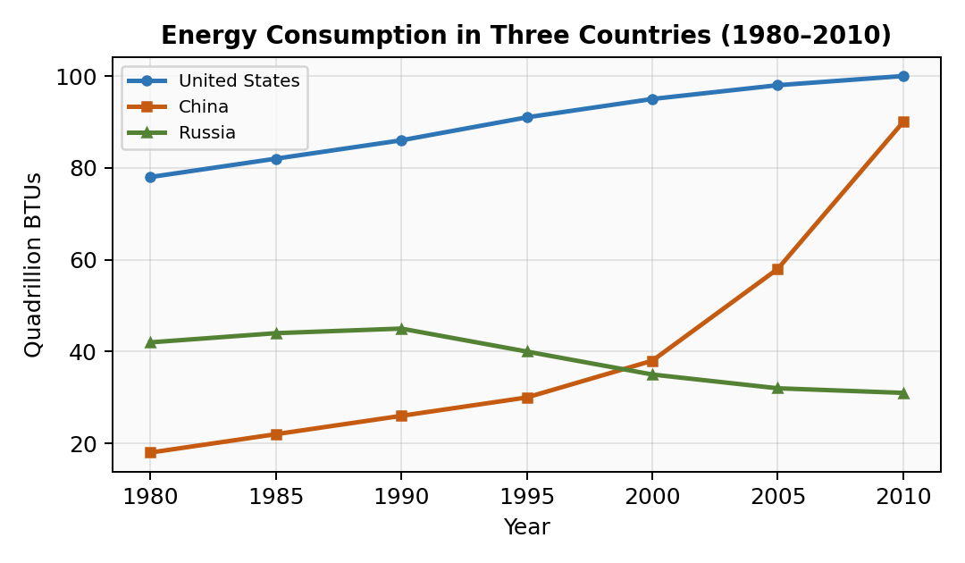

[Para] The line graph compares energy consumption in the United States, China, and Russia over a thirty-year period from 1980 to 2010, measured in quadrillion BTUs.
[OV-1] Overall, the US remained the largest energy consumer throughout the period, although China experienced the most dramatic growth and was approaching American levels by 2010.
[OV-2] Russia’s consumption, by contrast, showed a gradual decline after an initial peak.
[Data] In 1980, the US consumed approximately 78 quadrillion BTUs, which rose steadily to around 100 by 2010.
[Data+Comp] China started at a considerably lower figure of roughly 18 quadrillion BTUs in 1980 but saw a sharp acceleration from 2000 onwards, surging to approximately 90 by the end of the period.
[Data] Russia’s energy use hovered around 42 quadrillion BTUs in 1980, peaked at about 45 in 1990, and then fell markedly to just over 30 by 2010.
[Comp] By 2010, the gap between US and Chinese consumption had narrowed significantly, while Russia had fallen well behind both nations.

Bar Chart: Annotated Model
Prompt: The bar chart shows the percentage of water used for agriculture, industry, and domestic purposes in six countries.
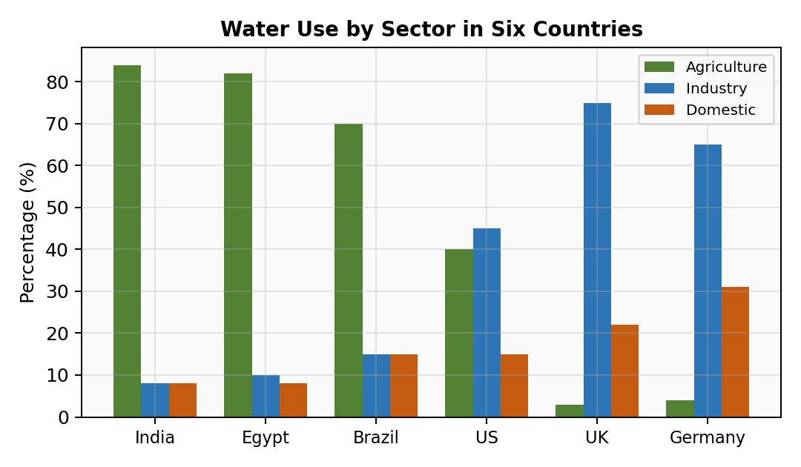

[Para] The bar chart compares the proportions of water consumed by three sectors — agriculture, industry, and domestic use — across six countries.
[OV] Overall, agricultural use dominated water consumption in most countries, particularly developing ones. Industrial use, however, led in more developed economies.
[Data+Group] In India and Egypt, agriculture accounted for over 80% of total water use, with industry and domestic consumption each under 10%. Brazil showed a similar pattern, with farming at approximately 70%.
[Data+Comp] By contrast, the UK and Germany devoted the largest share to industry, at roughly 75% and 65% respectively. Agricultural use was minimal, at under 5%.
[Data+Exception] The US displayed a more balanced distribution, with agriculture at around 40%, industry at 45%, and domestic use at 15%.

Process Diagram: Annotated Model
Prompt: The diagrams illustrate how cement is manufactured and how cement is used to produce concrete.
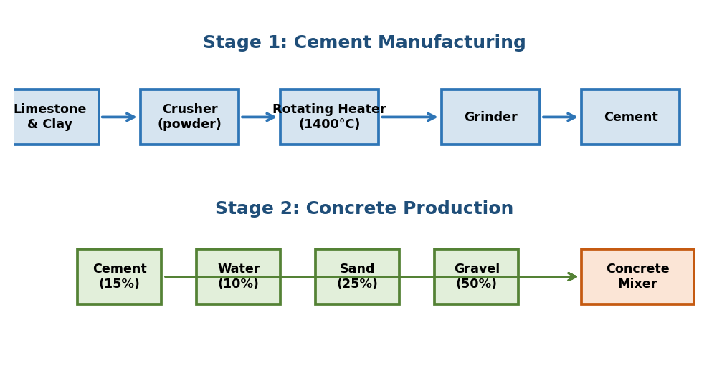

[Para] The two diagrams show the stages involved in manufacturing cement and how cement is subsequently combined with other materials to produce concrete.
[OV] Overall, cement production is a linear process involving crushing, heating, and grinding, while concrete production is a simpler mixing process using cement as one of four ingredients.
[Seq-1] In the first stage, limestone and clay are extracted and fed into a crusher, which breaks them into a powder.
[Seq-2] This powder is then passed through a rotating heater at approximately 1400°C, transforming it into calcium silicate clinite.
[Seq-3] Finally, the clinite is ground in a grinder to produce fine cement powder.
[Seq-4] To make concrete, cement is combined with water (10%), sand (25%), and gravel (50%) in a mixer until a uniform consistency is achieved.

Map: Annotated Model
Prompt: The two maps show a town centre in 1980 and 2020.
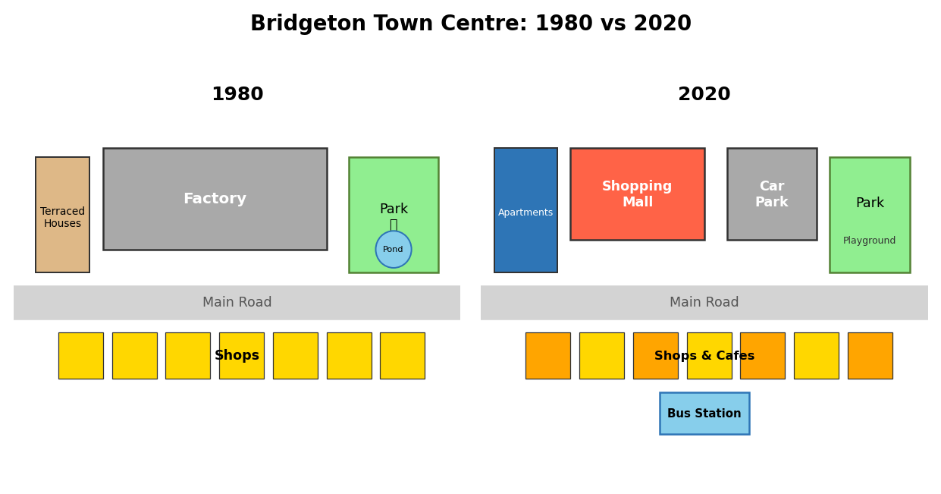

[Para] The two maps compare the town centre of Bridgeton in 1980 and 2020, showing how the area was redeveloped over forty years.
[OV] Overall, the town underwent substantial modernisation, with several older buildings replaced by commercial and residential developments. The most significant change was the disappearance of industrial land.
[Data-Before] In 1980, the centre featured a main road running east to west, with shops along the south. North of the road was a large factory, and to the east stood a park with a pond.
[Chg] By 2020, the factory had been demolished and replaced by a shopping mall and car park. The terraced houses were replaced by apartments.
[Chg+Pres] The park in the east remained, but the pond was replaced by a playground. A new bus station was added near the centre.

SECTION 3: 7 CHART TYPES × 2 EXAMPLES
Each chart type has: chart image → model answer → generalised templates → specialised vocabulary.

1. Line Chart

Example 1:

Example 2:
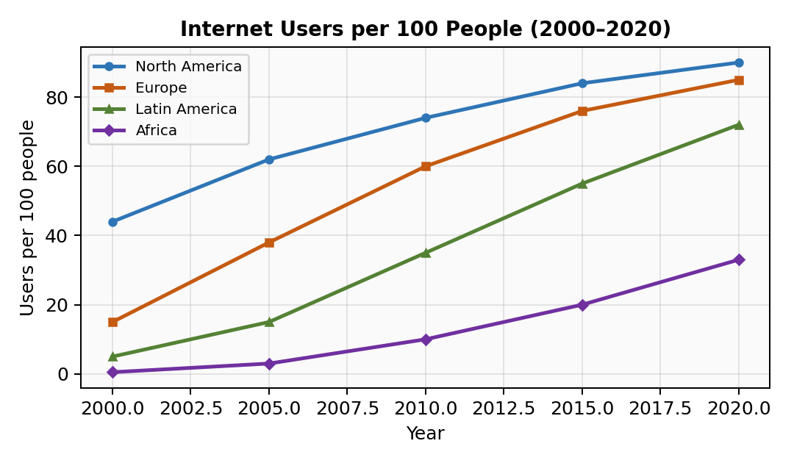

Specialised Vocabulary:
Function | Expressions
Upward | rose / climbed / surged / soared / increased steadily / experienced a sharp rise
Downward | fell / declined / dropped / plummeted / saw a gradual decrease
Stable | remained stable / levelled off / plateaued / hovered around / held steady at
Fluctuation | fluctuated between X and Y / oscillated / experienced periodic variation
Speed | steadily / gradually / sharply / dramatically / slightly / rapidly / marginally
Approximation | approximately / roughly / just under / just over / around / in the region of
Time phrases | over the period / from X onwards / during the latter half / by the end of
Comparing lines | whereas / while / in contrast / by comparison / unlike X, Y... / similarly

2. Bar Chart

Example 1:

Example 2:
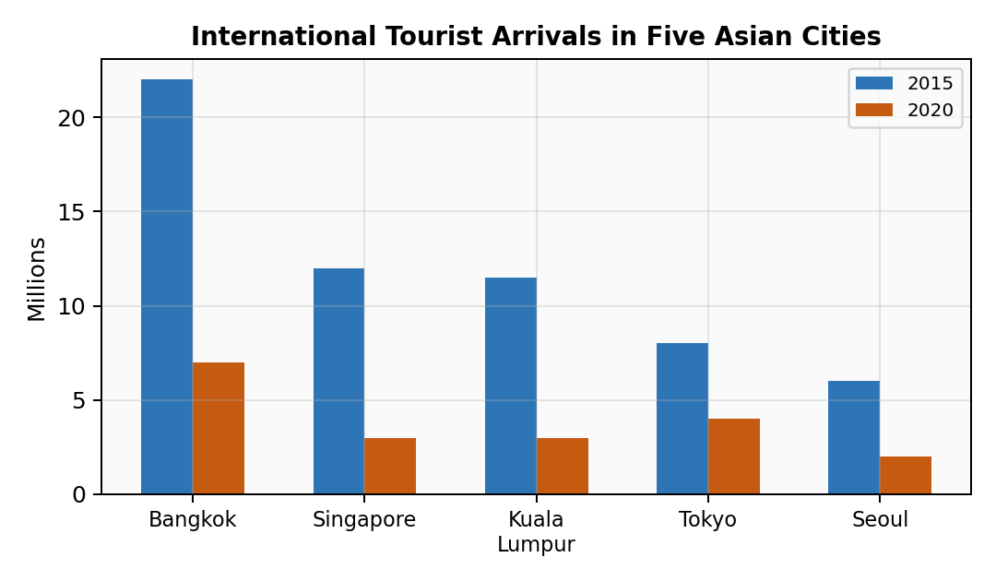

Specialised Vocabulary:
Function | Expressions
Proportions | accounted for / comprised / represented / constituted / made up
Dominance | dominated / was the leading category / far outweighed / dwarfed
Ranking | followed closely by / came in second / ranked last / trailed behind
Comparison | was roughly double / exceeded X by / stood at X, compared to Y’s figure of
Distribution | displayed a balanced / uneven distribution / was fairly evenly spread
Change | increased from X to Y / saw a decline of Z% / fell by nearly half / more than doubled

3. Pie Chart

Example 1:
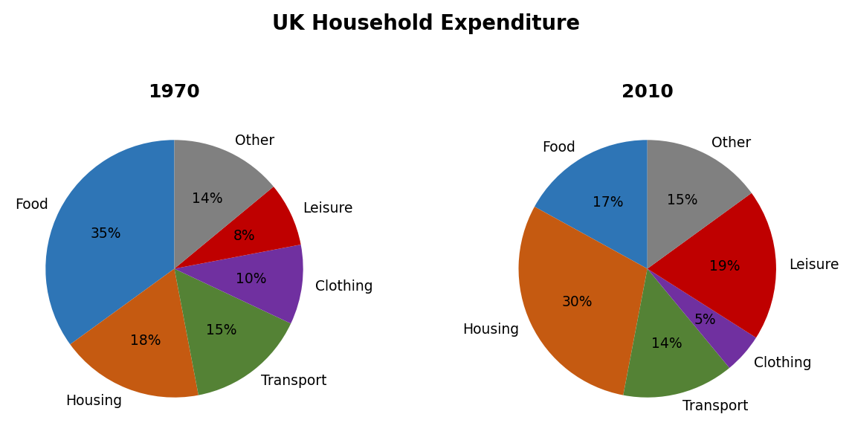

Example 2:
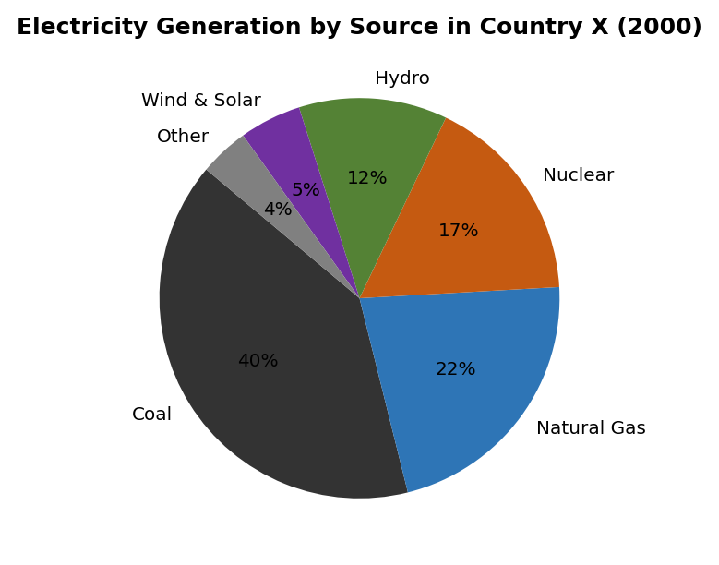

Specialised Vocabulary:
Function | Expressions
Proportion | accounted for / represented / constituted X% of the total / made up
Combining | collectively / combined / taken together / when grouped
Dominance | was the dominant / principal segment / by far the largest
Small segments | a mere / negligible / marginal X% / only a fraction of
Change (paired) | rose/fell from X% to Y% / overtook / more than doubled to
Remainder | the remaining X% was shared among / was attributed to

4. Table

Example 1:
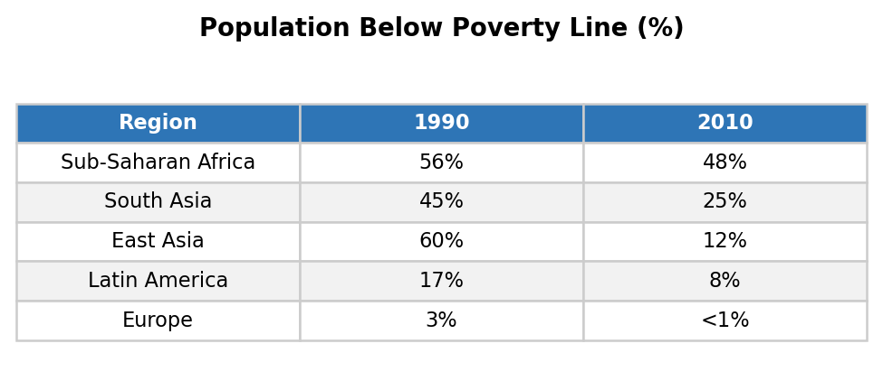

Example 2:
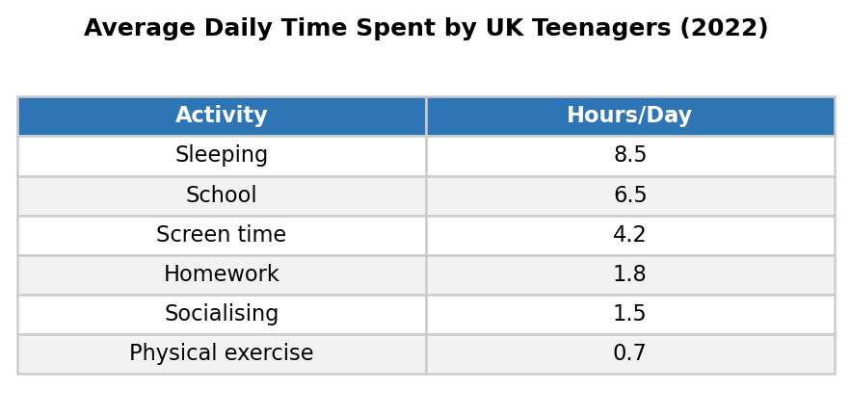

Specialised Vocabulary:
Function | Expressions
Ranking | recorded the highest figure / topped the list / ranked lowest / was the least significant
Change | plummeted / saw a modest decline / experienced a marginal increase / nearly halved
Comparison | was roughly X times higher / exceeded Y by Z / on a par with / lagged behind
Groups | among [group], X was the most... / within this category / of the five regions surveyed
Precision | stood at / was recorded at / reached / amounted to / totalled

5. Process Diagram

Example 1:

Example 2:
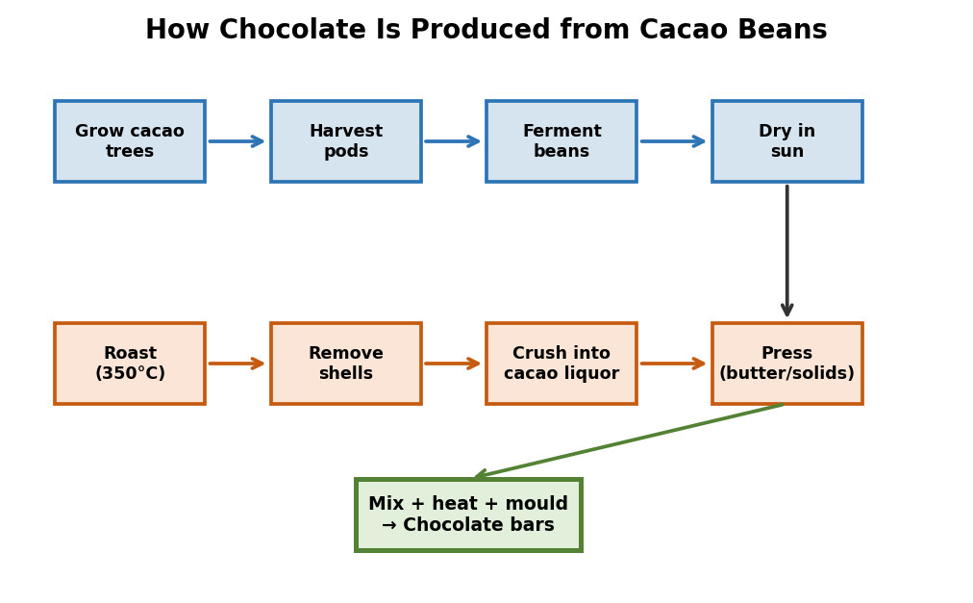

Specialised Vocabulary:
Function | Expressions
Sequencing | first / to begin with / initially / at the outset / in the first stage
Continuing | then / next / subsequently / following this / after that / once complete
Simultaneous | at the same time / meanwhile / during this stage / concurrently
Result | in order to / which results in / thereby producing / this yields
Final | in the final stage / lastly / the process culminates in
Passive | is extracted / is fed into / is heated to / is combined with / is processed into

6. Map

Example 1:
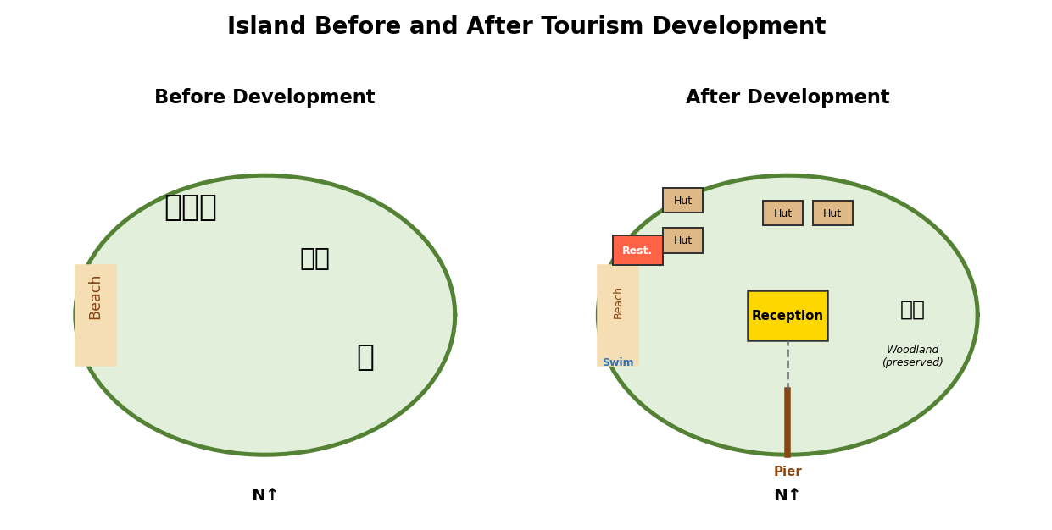

Example 2:

Specialised Vocabulary:
Function | Expressions
Location | to the north of / in the NE corner / adjacent to / on the opposite side / along the coast
Change | was replaced by / was converted into / was demolished / was expanded / was redeveloped
Addition | was constructed / was built / was added / was established / a new X appeared
Preservation | remained unchanged / was retained / was left intact / was largely preserved
Scale | underwent significant transformation / saw minor alterations / remained largely untouched

7. Mixed / Combination

Example 1:
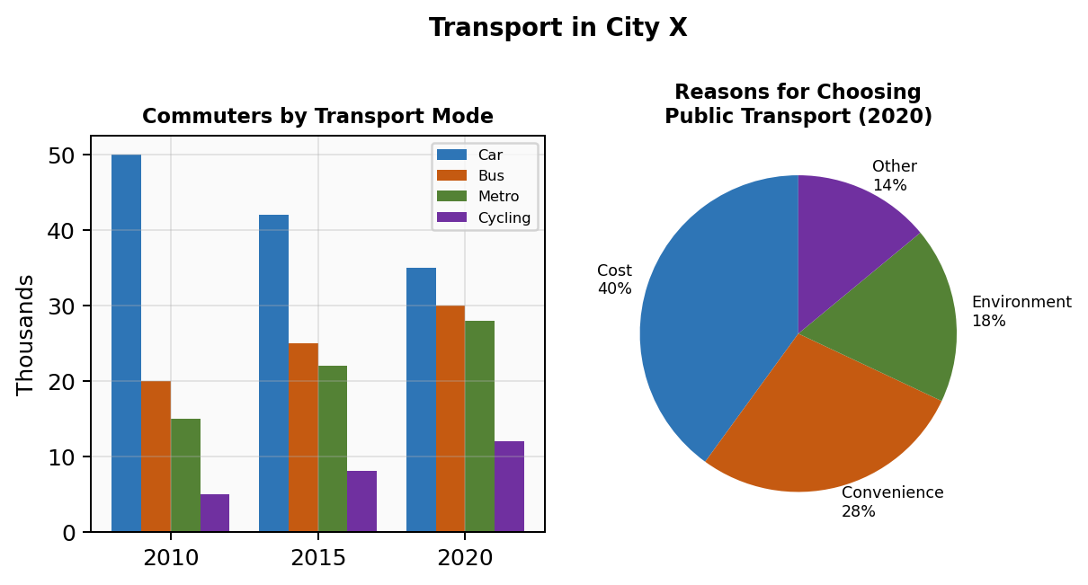

Example 2:
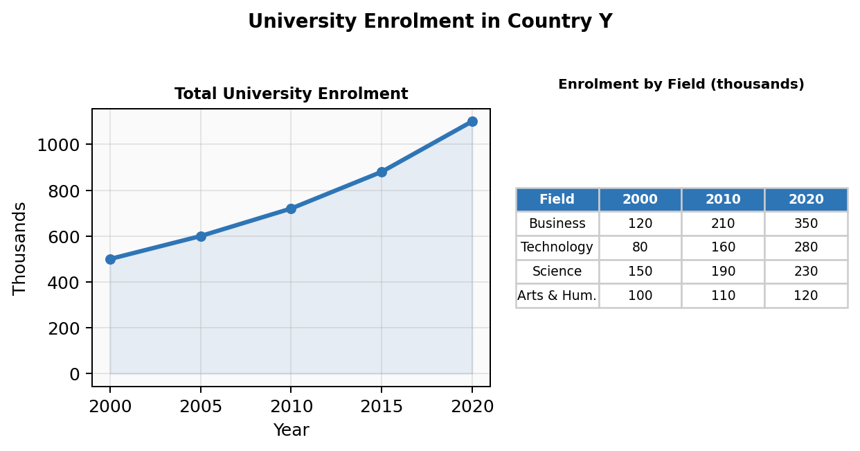

Specialised Vocabulary:
Function | Expressions
Introducing 2nd visual | Turning to / Looking at / As for / The accompanying [chart] shows
Linking visuals | This is consistent with / corroborated by / further illustrated by / helps explain
Contrasting visuals | While the [bar chart] shows the overall trend, the [table] reveals the composition
Transition | In more detail / More specifically / Breaking this down further / A closer look at

SECTION 4: YOUR LEARNING ROADMAP
Follow this 6-week plan. Each week has a clear goal and specific exercises.

Week | Focus | Goal | Daily Exercise (30 min)
Week 1 | Paraphrase + Overview | Write the opening + overview for any chart in under 5 minutes. | Pick 1 chart from Section 3. Write ONLY P1 + P2 (paraphrase + overview). Compare with the annotated model. Repeat with a different chart type each day (7 days = 7 chart types covered).
Week 2 | Detail paragraphs | Write detail paragraphs with varied vocabulary and data selection. | Pick 1 chart. Write ONLY P3 + P4. Focus on: (a) did I select the right data? (b) did I group rather than list? (c) did I use at least 3 different trend words? Compare with model.
Week 3 | Full reports under time | Complete a full 4-part report in 20 minutes. | Set a timer for 20 minutes. Write a complete report. After finishing, check: (a) is my overview present and strong? (b) did I avoid opinions? (c) word count 150–180? Do 1 report per day.
Week 4 | Process + Map focus | Handle the two “unusual” chart types confidently. | Day 1–3: Write process diagram reports (use passive voice, check sequencing words). Day 4–6: Write map reports (use location language, describe changes not static positions). Day 7: Mixed chart.
Week 5 | Vocabulary upgrade | Replace Band 5–6 words with Band 7 equivalents. | Review the vocabulary tables in Section 3. Make flashcards for any expressions you don’t know. Rewrite one of your Week 3 reports using upgraded vocabulary. Compare before and after.
Week 6 | Speed + accuracy | Consistently write 160–170 word reports in 18 minutes with no grammar errors. | Write 1 timed report. Then spend 10 minutes proofreading for: articles (a/the), tenses, subject-verb agreement, spelling. Track your most common errors and target them specifically.

Self-Diagnosis Checklist (每篇自检)
After writing every practice report, check these 10 items:

# | Check Item | If No, Fix By...
1 | Did I paraphrase the question (not copy it)? | Rewrite using Skill 2 techniques
2 | Is there a clear overview starting with “Overall”? | Add 2 sentences identifying the biggest trends
3 | Does the overview avoid specific numbers? | Remove any exact figures from overview
4 | Did I select the most important data (not list everything)? | Apply the 4 Priorities from Skill 6
5 | Did I group similar items instead of listing one by one? | Combine: “X, Y, and Z all rose, whereas...”
6 | Did I include at least 3 comparisons between data points? | Add sentences using comparison templates from Skill 4
7 | Did I use at least 5 different “trend” words (not just “increased”)? | Replace with synonyms from the vocabulary tables
8 | Is my tense correct and consistent? | Check against Skill 5 tense table
9 | Did I use approximation language (not fake precision)? | Replace exact-sounding numbers with “approximately” etc.
10 | Is my word count between 150 and 180? | If under: add one more data point. If over: cut a less important detail.

Common Error Tracker (错误追踪表)
Print this and tick each time you make the error. Focus on your top 3 most frequent mistakes.

Error Type | Example | Tally (mark each occurrence)
Missing article (the/a) | ✘ "number of students" → ✔ "the number of students"
Wrong tense | ✘ "The chart is showing" → ✔ "The chart shows"
Uncountable noun + plural | ✘ "informations" → ✔ "information"
Copying question words | ✘ Identical opening sentence → ✔ Paraphrased
Missing overview | ✘ No “Overall” paragraph → ✔ Add 2-sentence overview
Giving opinions in Task 1 | ✘ "I think this is because" → ✔ Just describe data
Listing instead of grouping | ✘ "X rose. Y rose. Z rose." → ✔ "X, Y, and Z all rose."
Fake precision | ✘ "exactly 47.3%" → ✔ "approximately 47%" or "just under half"
Only using “increased / decreased” | ✘ Same verb 5 times → ✔ rose, climbed, surged, grew...
Run-on sentences | ✘ "X rose, Y fell, Z stayed the same" → ✔ Split into 2–3 sentences

