SIX MONTHS INDUSTRIAL TRAINING

TRAINING REPORT
UNDERTAKEN AT
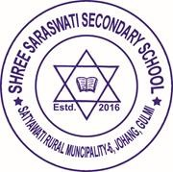
“SHREE SARASWATI SECONDARY SCHOOL”
IN

“DEPARTMENT OF COMPUTER ENGINEERING”

ON
“Transportation Management System using C# in Visual Studio”
SUBMITTED IN PARTIAL FULFILLMENT OF THE DEGREE IN
COMPUTER ENGINEERING

DEPARTMENT OF COMPUTER ENGINEERING
National Examination Board, Sanothimi, Bhaktapur
OCT, 2023

