INTRODUCTION

1.1 OUTLINE OF THE PROJECT

A Transportation Management System (TMS) is like super-smart software designed to make handling transportation and logistics a breeze. It's all about making sure everything runs smoothly, from planning and doing tasks to keeping a close eye on things. The main goal is to boost efficiency in how transportation works, covering everything from figuring out schedules to handling cargo in the best way possible. TMS plays a crucial role by fine-tuning stuff like figuring out the best routes and keeping tabs on things in real-time, making sure everything happens just right.

What's really cool about TMS is that it's like having a superhero for logistics. It's awesome at automating tasks, so there are fewer mistakes, and it keeps detailed records of everything. This not only makes transportation services more reliable but also ensures that deliveries happen on time. And you know how important that is for the smooth running of complicated supply chains and logistics operations.

But TMS goes beyond just making things work better day-to-day. It becomes a strategic partner for logistics companies, fitting right into their mission. By being part of their operations, TMS helps deliver transportation services that are not just efficient but also punctual and super secure. In a nutshell, TMS is the secret sauce in the big recipe of transportation, making things work better and helping logistics companies achieve even more in the ever-changing world of transportation management.

LITERATURE SURVEY

A literature survey on transportation management systems unveils a dynamic and essential field within the logistics and transportation sector. Examining the existing body of knowledge reveals a spectrum of topics, including route optimization, vehicle scheduling, cargo handling, and the integration of technology for streamlined processes. Noteworthy studies emphasize the importance of optimized logistics management, the integration of innovative technologies, and the growing role of automation to enhance operational efficiency. Additionally, ethical considerations, safety protocols, and regulatory compliance in transportation systems emerge as critical areas of focus. This literature survey underscores the ongoing evolution of transportation management, highlighting the need for innovative solutions to address challenges and ensure the smooth flow of goods and services.

With technological advancements, transportation management systems have experienced significant improvements. Automation and advanced technologies are reshaping logistics processes, minimizing errors, and enhancing overall efficiency. Integration with broader supply chain systems, coupled with user-friendly applications, has simplified logistics coordination, and improved the transportation experience. However, challenges such as route optimization, resource allocation, and ethical data use remain areas of active research. The literature survey emphasizes the ever-evolving nature of transportation management, signaling a future where technology-driven solutions, data security, and ethical considerations will continue to play a central role.

AIM AND SCOPE OF PROJECT

  - PURPOSE OF THE PROJECT

The Transportation Management System (TMS) is designed with the objective of enhancing efficiency and reliability in transportation operations. It serves the fundamental purpose of optimizing the management and coordination of various transportation activities. The system provides a centralized platform for users to access comprehensive information related to transportation services. Individuals seeking transportation assistance can easily find suitable options, making the process of commuting more convenient.

Pre-requisite:

    - Basic understanding of C# programming language.
    - Basic understanding of .NET Framework.
    - Have Visual Studio installed on your machine.
    - Have Visual Studio Code installed on your machine.

  - ER Diagram:

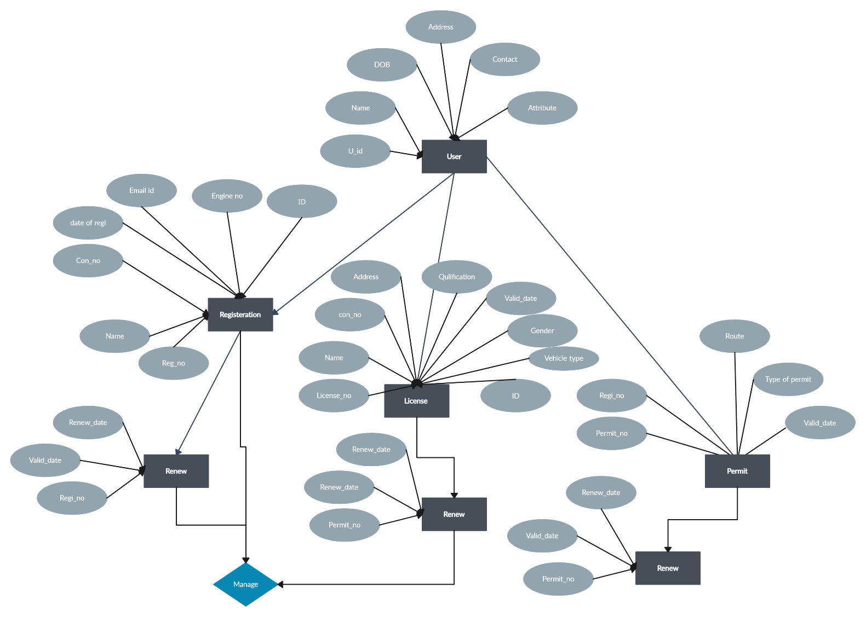

Figure 3.2.1 ER Diagram

PERFORMANCE REQUIREMENT AND MATERIALS USED

  - Performance Requirement

Only when the requirement specification is properly given, it is possible to design a system. Which will fit into the required environment. It rests largely requirement with the users of the existing system to give the requirement specification because they are the people who finally use the system. This is because the requirement must be known during the initial stages so that the system can be designed according to those requirements. It is very difficult to change the system once it has been designed and on the other hand designing a system which does not cater to the requirements of the requirements of the user is of no use.
The requirement specification for any system can be broadly stated as given below:

Minimum Hardware Requirement:
    - System: Pentium I3 Processor
    - Hard Disk: 500GB
    - RAM: 4/8 GB (Recommended)
    - Input Devices: Keyboard and Mouse

Software Requirements:
    - Operating system: Window 8/10/11
    - Available Coding Language: VB.Net
    - Database: MYSQL

WORKING EXPLANATION:

4.2.1 User Authentication
Users, including administrators, drivers, and passengers, should have secure login and authentication mechanisms.

4.2.2 Fleet Registration

Fleet Registration in the Transportation Management System involves capturing essential details, such as vehicle make, model, and registration numbers. This process establishes a comprehensive record for efficient fleet management, enabling tracking and maintenance scheduling.

4.2.3 Route Planning Management

Route Planning Management in the Transportation Management System focuses on optimizing travel routes for efficiency and cost-effectiveness. It involves strategic planning to determine the most practical paths, considering factors like distance, traffic conditions, and delivery priorities. The system enables administrators to organize and adjust routes dynamically, enhancing overall logistics performance and ensuring timely transportation operations.

4.2.4 Inventory Management

Inventory Management in the Transportation Management System oversees the tracking and control of transportation assets and resources. It includes monitoring vehicle availability, maintenance schedules, and ensuring adequate supplies. This system optimizes efficiency by preventing shortages, reducing downtime, and facilitating timely transportation operations. Through centralized control, Inventory Management enhances overall logistical coordination, promoting a streamlined and effective transportation network.

4.2.5 Security and Access Control

Security and Access Control in the Transportation Management System are crucial components ensuring the protection of sensitive data and system functionalities. It involves implementing robust authentication mechanisms, authorization protocols, and encryption methods. This ensures that only authorized personnel can access specific features, safeguarding the integrity and confidentiality of transportation-related information.

MYSQL

MySQL is an open-source relational database management system (RDBMS) known for its efficiency, reliability, and ease of use. It allows users to organize and store data in structured tables with rows and columns, using SQL (Structured Query Language) for data manipulation. MySQL is a popular choice for various applications, particularly web development, where it serves as a backend database for websites and web applications. Its open-source nature makes it cost-effective and widely adopted, with a robust community of users and developers continually improving and extending its functionality. MySQL supports scalability, data security, and replication, making it suitable for both small-scale projects and large, high-traffic applications. It is available on multiple platforms and is compatible with various programming languages, cementing its status as a versatile and powerful database solution.

MySQL's performance optimization and ability to handle a substantial volume of queries and transactions make it a top choice for businesses and developers seeking a reliable and efficient data storage solution. Its flexibility and support for replication enable data redundancy for backup and fault tolerance, ensuring data integrity and availability.

RESULT AND DISCUSSION

Login Page:

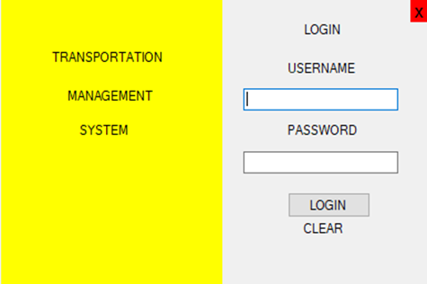
Figure 4.1 Login page

Home Page:
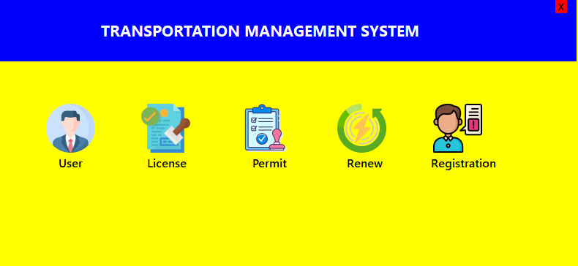

Figure 4.2 Home page

User Page:
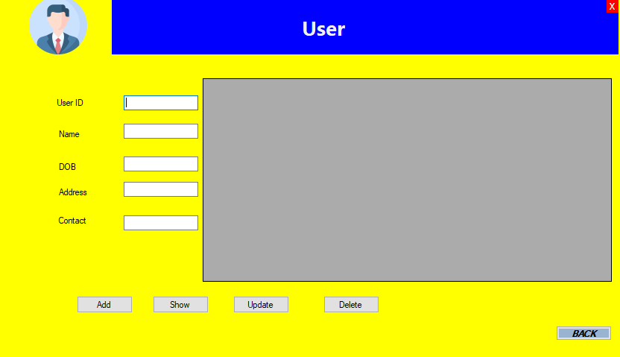

Figure 4.3 User page

License Page:
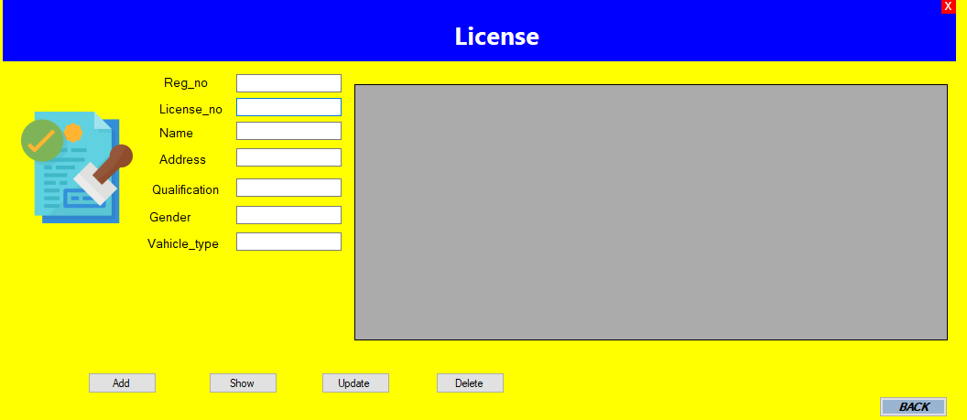

Figure 4.4 License page

Renew Page:
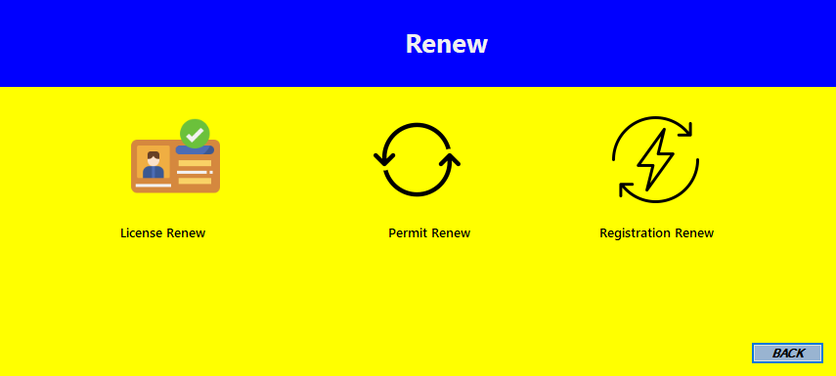

Figure 4.5 Renew page

License Renew Page:
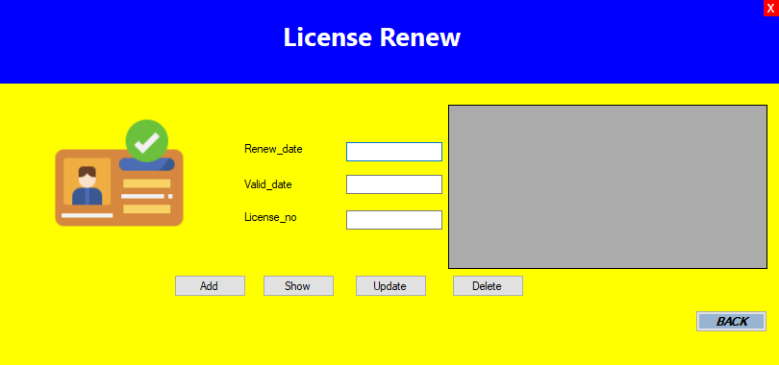

Figure 4.6 License Renew page

Permit Page:
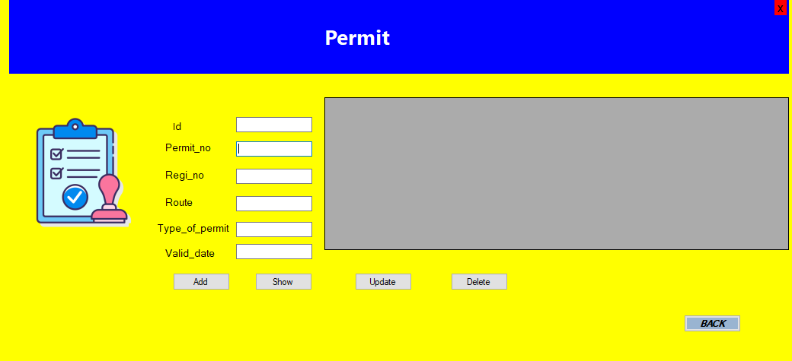

Figure 4.7 Permit page

Permit Renew Page:

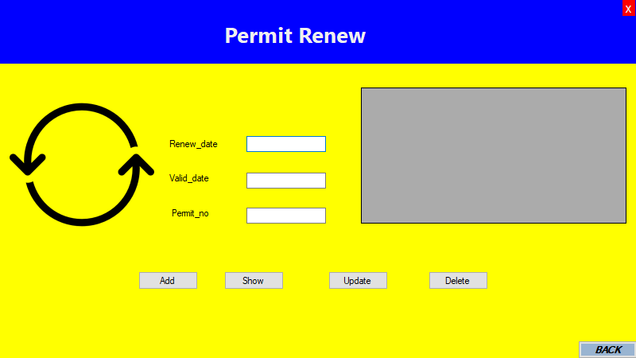

Figure 4.8 Permit Renew page

Registration Page:

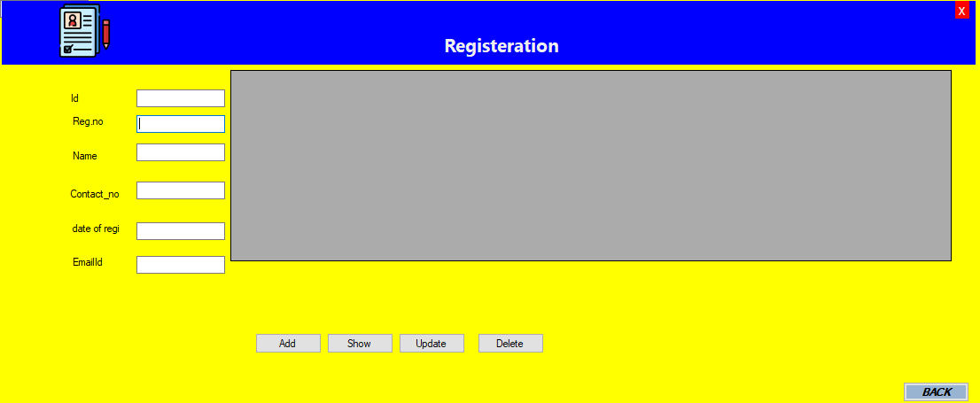

Figure 4.9 Registration page

User Update Page:
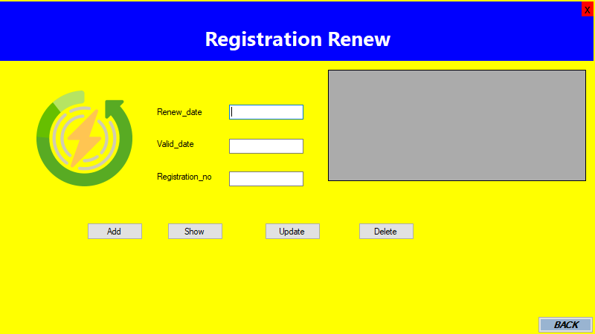

Figure 4.10 Registration Renew page

Database Table:
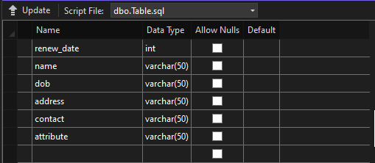

Figure 5.1 Table

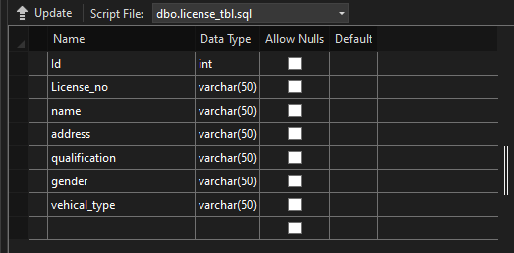

Figure 5.2 License Table
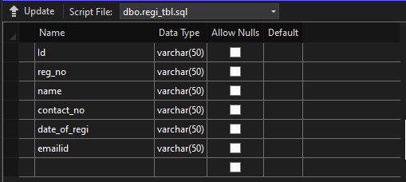

Figure 5.3 Registration Table

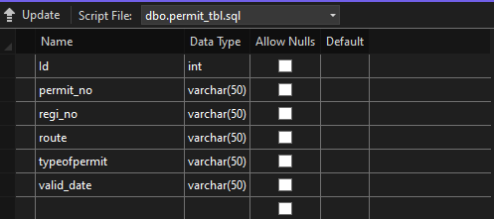

Figure 5.4 Permit Table

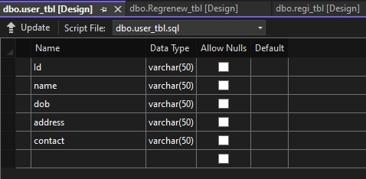

Figure 5.5 User Table

SUMMARY AND CONCLUSION

The researchers conducted this applied research to assess the effectiveness of the Transportation Management System (TMS) in enhancing the efficiency and safety of transportation processes. The study involved designing and implementing the TMS, employing both descriptive and experimental research methods. Questionnaires were distributed to stakeholders, including administrators and staff in transportation departments. Data analysis included computing means, standard deviations, and t-values, leading to insightful conclusions and recommendations.

The study demonstrated that the Transportation Management System significantly outperforms manual systems, with respondents favoring its adoption due to numerous advantages and increased effectiveness. The TMS instills confidence in users by providing superior management capabilities, contributing to heightened safety in transportation processes. The findings underscore TMS’s positive impact on enhancing transportation safety through streamlined management processes.

The study also looked at how the TMS helps the environment. Turns out, it makes transportation use less fuel and pollute less. So, it's not just good for saving money but also for being kinder to the planet. People who used the TMS really liked it because it was easy to use and made sense. They found it simple to navigate and were happy with how it worked. This means that the TMS is not just good for the job, but also for the people using it.

Lastly, the researchers checked if the TMS can handle changes and grow as things get more complicated. It turns out it can! The TMS is flexible and can adjust to different needs, which is important because transportation is always changing. In the end, the study showed that the Transportation Management System is a great choice for making transportation better in many ways – it's efficient, saves money, helps the environment, makes people happy, and can adapt to changes.

APPENDIX

SOURCE CODE:
Program.cs

namespace Transportation_management_system
{
internal static class Program
{
[STAThread]
static void Main()
{
Application.EnableVisualStyles();
Application.SetCompatibleTextRenderingDefault(false);
Application.Run(new login());
}
}
}

Login Designer:
namespace Transportation_management_system
{
partial class login
{
private System.ComponentModel.IContainer components = null;
protected override void Dispose(bool disposing)
{
if (disposing && (components != null))
{
components.Dispose();
}
base.Dispose(disposing);
}
#region Windows Form Designer generated code
private void InitializeComponent()
{
this.panel1 = new System.Windows.Forms.Panel();
this.label3 = new System.Windows.Forms.Label();
this.label2 = new System.Windows.Forms.Label();
this.label1 = new System.Windows.Forms.Label();
this.label4 = new System.Windows.Forms.Label();
this.label5 = new System.Windows.Forms.Label();
this.textBox1 = new System.Windows.Forms.TextBox();
this.textBox2 = new System.Windows.Forms.TextBox();
this.label6 = new System.Windows.Forms.Label();
this.button1 = new System.Windows.Forms.Button();
this.label7 = new System.Windows.Forms.Label();
this.label8 = new System.Windows.Forms.Label();
this.panel1.SuspendLayout();
this.SuspendLayout();
this.panel1.BackColor = System.Drawing.Color.Yellow;
this.panel1.Controls.Add(this.label3);
this.panel1.Controls.Add(this.label2);
this.panel1.Controls.Add(this.label1);
this.panel1.Location = new System.Drawing.Point(1, 0);
this.panel1.Name = "panel1";
this.panel1.Size = new System.Drawing.Size(200, 260);
this.panel1.TabIndex = 0;
this.label3.AutoSize = true;
this.label3.Location = new System.Drawing.Point(68, 111);
this.label3.Name = "label3";
this.label3.Size = new System.Drawing.Size(51, 13);
this.label3.TabIndex = 2;
this.label3.Text = "SYSTEM";
this.label2.AutoSize = true;
this.label2.Location = new System.Drawing.Point(57, 80);
this.label2.Name = "label2";
this.label2.Size = new System.Drawing.Size(84, 13);
this.label2.TabIndex = 1;
this.label2.Text = "MANAGEMENT";
this.label1.AutoSize = true;
this.label1.Location = new System.Drawing.Point(43, 45);
this.label1.Name = "label1";
this.label1.Size = new System.Drawing.Size(107, 13);
this.label1.TabIndex = 0;
this.label1.Text = "TRANSPORTATION";
this.label4.AutoSize = true;
this.label4.Location = new System.Drawing.Point(272, 20);
this.label4.Name = "label4";
this.label4.Size = new System.Drawing.Size(40, 13);
this.label4.TabIndex = 1;
this.label4.Text = "LOGIN";
this.label5.AutoSize = true;
this.label5.Location = new System.Drawing.Point(257, 55);
this.label5.Name = "label5";
this.label5.Size = new System.Drawing.Size(68, 13);
this.label5.TabIndex = 2;
this.label5.Text = "USERNAME";
this.label5.Click += new System.EventHandler(this.label5_Click);
this.textBox1.Location = new System.Drawing.Point(220, 80);
this.textBox1.Name = "textBox1";
this.textBox1.Size = new System.Drawing.Size(140, 20);
this.textBox1.TabIndex = 3;
this.textBox2.Location = new System.Drawing.Point(220, 137);
this.textBox2.Name = "textBox2";
this.textBox2.Size = new System.Drawing.Size(140, 20);
this.textBox2.TabIndex = 5;
this.label6.AutoSize = true;
this.label6.Location = new System.Drawing.Point(257, 111);
this.label6.Name = "label6";
this.label6.Size = new System.Drawing.Size(70, 13);
this.label6.TabIndex = 4;
this.label6.Text = "PASSWORD";
this.button1.Location = new System.Drawing.Point(260, 174);
this.button1.Name = "button1";
this.button1.Size = new System.Drawing.Size(75, 23);
this.button1.TabIndex = 6;
this.button1.Text = "LOGIN";
this.button1.UseVisualStyleBackColor = true;
this.button1.Click += new System.EventHandler(this.button1_Click);
this.label7.AutoSize = true;
this.label7.Location = new System.Drawing.Point(272, 200);
this.label7.Name = "label7";
this.label7.Size = new System.Drawing.Size(42, 13);
this.label7.TabIndex = 7;
this.label7.Text = "CLEAR";
this.label7.Click += new System.EventHandler(this.label7_Click);
this.label8.AutoSize = true;
this.label8.BackColor = System.Drawing.Color.Red;this.label8.Font = new System.Drawing.Font("Microsoft Sans Serif", 12F, System.Drawing.FontStyle.Regular, System.Drawing.GraphicsUnit.Point, ((byte)(0)));
this.label8.Location = new System.Drawing.Point(371, 0);
this.label8.Name = "label8";
this.label8.Size = new System.Drawing.Size(16, 20);
this.label8.TabIndex = 8;
this.label8.Text = "x";
this.label8.Click += new System.EventHandler(this.label8_Click);
this.AutoScaleDimensions = new System.Drawing.SizeF(6F, 13F);
this.AutoScaleMode = System.Windows.Forms.AutoScaleMode.Font;
this.ClientSize = new System.Drawing.Size(386, 257);
this.Controls.Add(this.label8);
this.Controls.Add(this.label7);
this.Controls.Add(this.button1);
this.Controls.Add(this.textBox2);
this.Controls.Add(this.label6);
this.Controls.Add(this.textBox1);
this.Controls.Add(this.label5);
this.Controls.Add(this.label4);
this.Controls.Add(this.panel1);
this.FormBorderStyle = System.Windows.Forms.FormBorderStyle.None;
this.Name = "login";
this.Text = "Form1";
this.Load += new System.EventHandler(this.Form1_Load);
this.panel1.ResumeLayout(false);
this.panel1.PerformLayout();
this.ResumeLayout(false);
this.PerformLayout();
}
#endregion
private System.Windows.Forms.Panel panel1;
private System.Windows.Forms.Label label3;
private System.Windows.Forms.Label label2;
private System.Windows.Forms.Label label1;
private System.Windows.Forms.Label label4;
private System.Windows.Forms.Label label5;
private System.Windows.Forms.TextBox textBox1;
private System.Windows.Forms.TextBox textBox2;
private System.Windows.Forms.Label label6;
private System.Windows.Forms.Button button1;
private System.Windows.Forms.Label label7;
private System.Windows.Forms.Label label8;
}
}

Login Page:

namespace Transportation_management_system
{
public partial class login : Form
{

public login()
{
InitializeComponent();
}

private void Form1_Load(object sender, EventArgs e)
{

}

private void button1_Click(object sender, EventArgs e)
{
SqlConnection conn = new SqlConnection(@"Data Source=(LocalDB)\MSSQLLocalDB;AttachDbFilename=""C:\Users\Dell-Pc\source\repos\Transportation management system\Transportation management system\Transport.mdf"";Integrated Security=True ");
conn.Open();

if ((this.textBox1.Text=="shristi")&&(this.textBox2.Text=="1234"))
{
HOME h= new HOME();
h.Show();
this.Hide();
}
else
{
MessageBox.Show("username or passwod doesnot match");
}
conn.Close();
}

private void label5_Click(object sender, EventArgs e)
{

}

private void label8_Click(object sender, EventArgs e)
{
Application.Exit();
}

private void label7_Click(object sender, EventArgs e)
{
textBox1.Text = " ";
textBox2.Text= " ";
}

private void panel1_Paint(object sender, PaintEventArgs e)
{

}
}
}

HOME Designer:
namespace Transportation_management_system
{
partial class HOME
{

private System.ComponentModel.IContainer components = null;

protected override void Dispose(bool disposing)
{
if (disposing && (components != null))
{
components.Dispose();
}
base.Dispose(disposing);
}
#region Windows Form Designer generated code

private void InitializeComponent()
{
System.ComponentModel.ComponentResourceManager resources = new System.ComponentModel.ComponentResourceManager(typeof(HOME));
this.pictureBox1 = new System.Windows.Forms.PictureBox();
this.panel1 = new System.Windows.Forms.Panel();
this.label9 = new System.Windows.Forms.Label();
this.label1 = new System.Windows.Forms.Label();
this.pictureBox2 = new System.Windows.Forms.PictureBox();
this.pictureBox3 = new System.Windows.Forms.PictureBox();
this.pictureBox4 = new System.Windows.Forms.PictureBox();
this.label2 = new System.Windows.Forms.Label();
this.label3 = new System.Windows.Forms.Label();
this.label4 = new System.Windows.Forms.Label();
this.label5 = new System.Windows.Forms.Label();
this.label6 = new System.Windows.Forms.Label();
this.label7 = new System.Windows.Forms.Label();
this.pictureBox5 = new System.Windows.Forms.PictureBox();
((System.ComponentModel.ISupportInitialize)(this.pictureBox1)).BeginInit();
this.panel1.SuspendLayout();
((System.ComponentModel.ISupportInitialize)(this.pictureBox2)).BeginInit();
((System.ComponentModel.ISupportInitialize)(this.pictureBox3)).BeginInit();
((System.ComponentModel.ISupportInitialize)(this.pictureBox4)).BeginInit();
((System.ComponentModel.ISupportInitialize)(this.pictureBox5)).BeginInit();
this.SuspendLayout();
this.pictureBox1.Image = ((System.Drawing.Image)(resources.GetObject("pictureBox1.Image")));
this.pictureBox1.Location = new System.Drawing.Point(63, 142);
this.pictureBox1.Name = "pictureBox1";
this.pictureBox1.Size = new System.Drawing.Size(68, 67);
this.pictureBox1.SizeMode = System.Windows.Forms.PictureBoxSizeMode.Zoom;
this.pictureBox1.TabIndex = 1;
this.pictureBox1.TabStop = false;
this.pictureBox1.Click += new System.EventHandler(this.pictureBox1_Click);
this.pictureBox1.MouseDoubleClick += new System.Windows.Forms.MouseEventHandler(this.pictureBox1_MouseDoubleClick);
this.panel1.BackColor = System.Drawing.Color.Blue;
this.panel1.Controls.Add(this.label9);
this.panel1.Controls.Add(this.label1);
this.panel1.Location = new System.Drawing.Point(0, -2);
this.panel1.Name = "panel1";
this.panel1.Size = new System.Drawing.Size(788, 86);
this.panel1.TabIndex = 2;
this.label9.AutoSize = true;
this.label9.BackColor = System.Drawing.Color.Red;
this.label9.Font = new System.Drawing.Font("Microsoft Sans Serif", 12F, System.Drawing.FontStyle.Regular, System.Drawing.GraphicsUnit.Point, ((byte)(0)));
this.label9.Location = new System.Drawing.Point(759, 0);
this.label9.Name = "label9";
this.label9.Size = new System.Drawing.Size(16, 20);
this.label9.TabIndex = 2;
this.label9.Text = "x";
this.label9.Click += new System.EventHandler(this.label9_Click);
this.label1.AutoSize = true;
this.label1.BackColor = System.Drawing.Color.Blue;
this.label1.Font = new System.Drawing.Font("Segoe UI", 15.75F, System.Drawing.FontStyle.Bold, System.Drawing.GraphicsUnit.Point, ((byte)(0)));
this.label1.ForeColor = System.Drawing.Color.White;
this.label1.Location = new System.Drawing.Point(133, 28);
this.label1.Name = "label1";
this.label1.Size = new System.Drawing.Size(448, 30);
this.label1.TabIndex = 0;
this.label1.Text = "TRANSPORTATION MANAGEMENT SYSTEM";
this.pictureBox2.Image = ((System.Drawing.Image)(resources.GetObject("pictureBox2.Image")));
this.pictureBox2.Location = new System.Drawing.Point(193, 142);
this.pictureBox2.Name = "pictureBox2";
this.pictureBox2.Size = new System.Drawing.Size(68, 67);
this.pictureBox2.SizeMode = System.Windows.Forms.PictureBoxSizeMode.Zoom;
this.pictureBox2.TabIndex = 3;
this.pictureBox2.TabStop = false;
this.pictureBox2.Click += new System.EventHandler(this.pictureBox2_Click);
this.pictureBox2.MouseClick += new System.Windows.Forms.MouseEventHandler(this.pictureBox2_MouseClick);
this.pictureBox2.MouseDoubleClick += new `System.Windows.Forms.MouseEventHandler(this.pictureBox2_MouseDoubleClick);
this.pictureBox3.Image = ((System.Drawing.Image)(resources.GetObject("pictureBox3.Image")));
this.pictureBox3.Location = new System.Drawing.Point(330, 142);
this.pictureBox3.Name = "pictureBox3";
this.pictureBox3.Size = new System.Drawing.Size(68, 67);
this.pictureBox3.SizeMode = System.Windows.Forms.PictureBoxSizeMode.Zoom;
this.pictureBox3.TabIndex = 4;
this.pictureBox3.TabStop = false;
this.pictureBox3.Click += new System.EventHandler(this.pictureBox3_Click);
this.pictureBox4.Image = ((System.Drawing.Image)(resources.GetObject("pictureBox4.Image")));
this.pictureBox4.Location = new System.Drawing.Point(461, 142);
this.pictureBox4.Name = "pictureBox4";
this.pictureBox4.Size = new System.Drawing.Size(68, 67);
this.pictureBox4.SizeMode = System.Windows.Forms.PictureBoxSizeMode.Zoom;
this.pictureBox4.TabIndex = 5;
this.pictureBox4.TabStop = false;
this.pictureBox4.Click += new System.EventHandler(this.pictureBox4_Click);
this.label2.AutoSize = true;
this.label2.Font = new System.Drawing.Font("Segoe UI Semibold", 12F, System.Drawing.FontStyle.Bold, System.Drawing.GraphicsUnit.Point, ((byte)(0)));
this.label2.ForeColor = System.Drawing.Color.Black;
this.label2.Location = new System.Drawing.Point(76, 212);
this.label2.Name = "label2";
this.label2.Size = new System.Drawing.Size(43, 21);
this.label2.TabIndex = 7;
this.label2.Text = "User";
this.label3.AutoSize = true;
this.label3.Font = new System.Drawing.Font("Segoe UI Semibold", 12F, System.Drawing.FontStyle.Bold, System.Drawing.GraphicsUnit.Point, ((byte)(0)));
this.label3.ForeColor = System.Drawing.Color.Black;
this.label3.Location = new System.Drawing.Point(197, 212);
this.label3.Name = "label3";
this.label3.Size = new System.Drawing.Size(64, 21);
this.label3.TabIndex = 8;
this.label3.Text = "License";
this.label3.Click += new System.EventHandler(this.label3_Click);
this.label4.AutoSize = true;
this.label4.Font = new System.Drawing.Font("Segoe UI Semibold", 12F, System.Drawing.FontStyle.Bold, System.Drawing.GraphicsUnit.Point, ((byte)(0)));
this.label4.ForeColor = System.Drawing.Color.Black;
this.label4.Location = new System.Drawing.Point(346, 230);
this.label4.Name = "label4";
this.label4.Size = new System.Drawing.Size(0, 21);
this.label4.TabIndex = 9;
this.label5.AutoSize = true;
this.label5.Font = new System.Drawing.Font("Segoe UI Semibold", 12F, System.Drawing.FontStyle.Bold, System.Drawing.GraphicsUnit.Point, ((byte)(0)));
this.label5.ForeColor = System.Drawing.Color.Black;
this.label5.Location = new System.Drawing.Point(470, 212);
this.label5.Name = "label5";
this.label5.Size = new System.Drawing.Size(59, 21);
this.label5.TabIndex = 10;
this.label5.Text = "Renew";
this.label5.Click += new System.EventHandler(this.label5_Click);
this.label6.AutoSize = true;
this.label6.Font = new System.Drawing.Font("Segoe UI Semibold", 12F, System.Drawing.FontStyle.Bold, System.Drawing.GraphicsUnit.Point, ((byte)(0)));
this.label6.ForeColor = System.Drawing.Color.Black;
this.label6.Location = new System.Drawing.Point(585, 212);
this.label6.Name = "label6";
this.label6.Size = new System.Drawing.Size(99, 21);
this.label6.TabIndex = 11;
this.label6.Text = "Registration";
this.label6.Click += new System.EventHandler(this.label6_Click);
this.label7.AutoSize = true;
this.label7.Font = new System.Drawing.Font("Segoe UI Semibold", 12F, System.Drawing.FontStyle.Bold, System.Drawing.GraphicsUnit.Point, ((byte)(0)));
this.label7.ForeColor = System.Drawing.Color.Black;
this.label7.Location = new System.Drawing.Point(341, 212);
this.label7.Name = "label7";
this.label7.Size = new System.Drawing.Size(57, 21);
this.label7.TabIndex = 12;
this.label7.Text = "Permit";
this.label7.Click += new System.EventHandler(this.label7_Click);
this.pictureBox5.Image = ((System.Drawing.Image)(resources.GetObject("pictureBox5.Image")));
this.pictureBox5.Location = new System.Drawing.Point(589, 142);
this.pictureBox5.Name = "pictureBox5";
this.pictureBox5.Size = new System.Drawing.Size(73, 67);
this.pictureBox5.SizeMode = System.Windows.Forms.PictureBoxSizeMode.Zoom;
this.pictureBox5.TabIndex = 13;
this.pictureBox5.TabStop = false;
this.pictureBox5.Click += new System.EventHandler(this.pictureBox5_Click);
this.AutoScaleDimensions = new System.Drawing.SizeF(6F, 13F);
this.AutoScaleMode = System.Windows.Forms.AutoScaleMode.Font;
this.BackColor = System.Drawing.Color.Yellow;
this.ClientSize = new System.Drawing.Size(790, 364);
this.Controls.Add(this.pictureBox5);
this.Controls.Add(this.label7);
this.Controls.Add(this.label6);
this.Controls.Add(this.label5);
this.Controls.Add(this.label4);
this.Controls.Add(this.label3);
this.Controls.Add(this.label2);
this.Controls.Add(this.pictureBox4);
this.Controls.Add(this.pictureBox3);
this.Controls.Add(this.pictureBox2);
this.Controls.Add(this.panel1);
this.Controls.Add(this.pictureBox1);
this.FormBorderStyle = System.Windows.Forms.FormBorderStyle.None;
this.Name = "HOME";
this.Text = "-------------------------------------------***************";
this.MouseClick += new System.Windows.Forms.MouseEventHandler(this.HOME_MouseClick);0
((System.ComponentModel.ISupportInitialize)(this.pictureBox1)).EndInit();
this.panel1.ResumeLayout(false);
this.panel1.PerformLayout();
((System.ComponentModel.ISupportInitialize)(this.pictureBox2)).EndInit();
((System.ComponentModel.ISupportInitialize)(this.pictureBox3)).EndInit();
((System.ComponentModel.ISupportInitialize)(this.pictureBox4)).EndInit();
((System.ComponentModel.ISupportInitialize)(this.pictureBox5)).EndInit();
this.ResumeLayout(false);
this.PerformLayout();
}
#endregion
private System.Windows.Forms.PictureBox pictureBox1;
private System.Windows.Forms.Panel panel1;
private System.Windows.Forms.Label label1;
private System.Windows.Forms.PictureBox pictureBox2;
private System.Windows.Forms.PictureBox pictureBox3;
private System.Windows.Forms.PictureBox pictureBox4;
private System.Windows.Forms.Label label2;
private System.Windows.Forms.Label label3;
private System.Windows.Forms.Label label4;
private System.Windows.Forms.Label label5;
private System.Windows.Forms.Label label6;
private System.Windows.Forms.Label label7;
private System.Windows.Forms.PictureBox pictureBox5;
private System.Windows.Forms.Label label9;
}
}
HOME.cs

namespace Transportation_management_system
{
public partial class HOME : Form
{
public HOME()
{
InitializeComponent();
}

private void label6_Click(object sender, EventArgs e)
{

}

private void label5_Click(object sender, EventArgs e)
{

}

private void label7_Click(object sender, EventArgs e)
{

}

private void label3_Click(object sender, EventArgs e)
{

}

private void pictureBox1_MouseDoubleClick(object sender, MouseEventArgs e)
{
user us= new user();
this.Hide();
us.Show();
}

private void pictureBox1_Click(object sender, EventArgs e)
{

}

private void pictureBox2_MouseDoubleClick(object sender, MouseEventArgs e)
{

}

private void pictureBox2_MouseClick(object sender, MouseEventArgs e)
{

}

private void pictureBox3_Click(object sender, EventArgs e)
{
Permit p=new Permit();
this.Hide();
p.Show();
}

private void HOME_MouseClick(object sender, MouseEventArgs e)
{

}

private void pictureBox4_Click(object sender, EventArgs e)
{
Renew r = new Renew();
this.Hide();
r.Show();
}

private void pictureBox2_Click(object sender, EventArgs e)
{
License l = new License();
this.Hide();
l.Show();
}

private void label9_Click(object sender, EventArgs e)
{
Application.Exit();
}
private void button1_Click(object sender, EventArgs e)
{

}

private void pictureBox5_Click(object sender, EventArgs e)
{
registration re= new registration();
re.Show();
this.Hide();
}

private void HOME_Load(object sender, EventArgs e)
{
}
}
}

user.Designer.cs
namespace Transportation_management_system
{
partial class user
{

private System.ComponentModel.IContainer components = null;

protected override void Dispose(bool disposing)
{
if (disposing && (components != null))
{
components.Dispose();
}
base.Dispose(disposing);
}

#region Windows Form Designer generated code
private void InitializeComponent()
{
System.ComponentModel.ComponentResourceManager resources = new System.ComponentModel.ComponentResourceManager(typeof(user));
this.label1 = new System.Windows.Forms.Label();
this.user_id = new System.Windows.Forms.TextBox();
this.user_name = new System.Windows.Forms.TextBox();
this.label2 = new System.Windows.Forms.Label();
this.user_dob = new System.Windows.Forms.TextBox();
this.label3 = new System.Windows.Forms.Label();
this.user_address = new System.Windows.Forms.TextBox();
this.label4 = new System.Windows.Forms.Label();
this.user_contact = new System.Windows.Forms.TextBox();
this.label5 = new System.Windows.Forms.Label();
this.button1 = new System.Windows.Forms.Button();
this.button2 = new System.Windows.Forms.Button();
this.button3 = new System.Windows.Forms.Button();
this.button4 = new System.Windows.Forms.Button();
this.dataGridView1 = new System.Windows.Forms.DataGridView();
this.panel1 = new System.Windows.Forms.Panel();
this.label9 = new System.Windows.Forms.Label();
this.label7 = new System.Windows.Forms.Label();
this.pictureBox1 = new System.Windows.Forms.PictureBox();
this.button5 = new System.Windows.Forms.Button();
((System.ComponentModel.ISupportInitialize)(this.dataGridView1)).BeginInit();
this.panel1.SuspendLayout();
((System.ComponentModel.ISupportInitialize)(this.pictureBox1)).BeginInit();
this.SuspendLayout();
this.label1.AutoSize = true;
this.label1.Location = new System.Drawing.Point(73, 131);
this.label1.Name = "label1";
this.label1.Size = new System.Drawing.Size(43, 13);
this.label1.TabIndex = 0;
this.label1.Text = "User ID";
this.label1.Click += new System.EventHandler(this.label1_Click);
this.user_id.Location = new System.Drawing.Point(166, 128);
this.user_id.Name = "user_id";
this.user_id.Size = new System.Drawing.Size(100, 20);
this.user_id.TabIndex = 1;
this.user_id.TextChanged += new System.EventHandler(this.user_id_TextChanged);
this.user_name.Location = new System.Drawing.Point(166, 166);
this.user_name.Name = "user_name";
this.user_name.Size = new System.Drawing.Size(100, 20);
this.user_name.TabIndex = 3;
this.user_name.TextChanged += new System.EventHandler(this.user_name_TextChanged);
this.label2.AutoSize = true;
this.label2.Location = new System.Drawing.Point(76, 173);
this.label2.Name = "label2";
this.label2.Size = new System.Drawing.Size(35, 13);
this.label2.TabIndex = 2;
this.label2.Text = "Name";
this.user_dob.Location = new System.Drawing.Point(166, 210);
this.user_dob.Name = "user_dob";
this.user_dob.Size = new System.Drawing.Size(100, 20);
this.user_dob.TabIndex = 5;
this.user_dob.TextChanged += new System.EventHandler(this.textBox3_TextChanged);
this.label3.AutoSize = true;
this.label3.Location = new System.Drawing.Point(76, 217);
this.label3.Name = "label3";
this.label3.Size = new System.Drawing.Size(30, 13);
this.label3.TabIndex = 4;
this.label3.Text = "DOB";

this.user_address.Location = new System.Drawing.Point(166, 244);
this.user_address.Name = "user_address";
this.user_address.Size = new System.Drawing.Size(100, 20);
this.user_address.TabIndex = 11;
this.label4.AutoSize = true;
this.label4.Location = new System.Drawing.Point(76, 251);
this.label4.Name = "label4";
this.label4.Size = new System.Drawing.Size(45, 13);
this.label4.TabIndex = 10;
this.label4.Text = "Address";
this.user_contact.Location = new System.Drawing.Point(166, 289);
this.user_contact.Name = "user_contact";
this.user_contact.Size = new System.Drawing.Size(100, 20);
this.user_contact.TabIndex = 9;
this.label5.AutoSize = true;
this.label5.Location = new System.Drawing.Point(76, 289);
this.label5.Name = "label5";
this.label5.Size = new System.Drawing.Size(44, 13);
this.label5.TabIndex = 8;
this.label5.Text = "Contact";
this.button1.Location = new System.Drawing.Point(103, 397);
this.button1.Name = "button1";
this.button1.Size = new System.Drawing.Size(75, 23);
this.button1.TabIndex = 12;
this.button1.Text = "Add";
this.button1.UseVisualStyleBackColor = true;
this.button1.Click += new System.EventHandler(this.button1_Click);
//
// button2
//
this.button2.Location = new System.Drawing.Point(205, 397);
this.button2.Name = "button2";
this.button2.Size = new System.Drawing.Size(75, 23);
this.button2.TabIndex = 13;
this.button2.Text = "Show";
this.button2.UseVisualStyleBackColor = true;
this.button2.Click += new System.EventHandler(this.button2_Click);
//
// button3
//
this.button3.Location = new System.Drawing.Point(313, 397);
this.button3.Name = "button3";
this.button3.Size = new System.Drawing.Size(75, 23);
this.button3.TabIndex = 14;
this.button3.Text = "Update";
this.button3.UseVisualStyleBackColor = true;
this.button4.Location = new System.Drawing.Point(434, 397);
this.button4.Name = "button4";
this.button4.Size = new System.Drawing.Size(75, 23);
this.button4.TabIndex = 15;
this.button4.Text = "Delete";
this.button4.UseVisualStyleBackColor = true;
this.button4.Click += new System.EventHandler(this.button4_Click);
this.dataGridView1.ColumnHeadersHeightSizeMode = System.Windows.Forms.DataGridViewColumnHeadersHeightSizeMode.AutoSize;
this.dataGridView1.Location = new System.Drawing.Point(272, 105);
this.dataGridView1.Name = "dataGridView1";
this.dataGridView1.Size = new System.Drawing.Size(549, 273);
this.dataGridView1.TabIndex = 16;
this.dataGridView1.CellContentClick += new System.Windows.Forms.DataGridViewCellEventHandler(this.dataGridView1_CellContentClick);
this.panel1.BackColor = System.Drawing.Color.Blue;
this.panel1.Controls.Add(this.label9);
this.panel1.Controls.Add(this.label7);
this.panel1.ForeColor = System.Drawing.SystemColors.ButtonFace;
this.panel1.Location = new System.Drawing.Point(150, -3);
this.panel1.Name = "panel1";
this.panel1.Size = new System.Drawing.Size(680, 76);
this.label9.AutoSize = true;
this.label9.BackColor = System.Drawing.Color.Red;
this.label9.Font = new System.Drawing.Font("Microsoft Sans Serif", 12F, System.Drawing.FontStyle.Regular, System.Drawing.GraphicsUnit.Point, ((byte)(0)));
this.label9.Location = new System.Drawing.Point(664, 0);
this.label9.Name = "label9";
this.label9.Size = new System.Drawing.Size(16, 20);
this.label9.TabIndex = 3;
this.label9.Text = "x";
this.label7.AutoSize = true;
this.label7.Font = new System.Drawing.Font("Segoe UI", 20.25F, System.Drawing.FontStyle.Bold, System.Drawing.GraphicsUnit.Point, ((byte)(0)));
this.label7.Location = new System.Drawing.Point(248, 21);
this.label7.Name = "label7";
this.label7.Size = new System.Drawing.Size(82, 37);
this.label7.TabIndex = 0;
this.label7.Text = "User ";
this.label7.Click += new System.EventHandler(this.label7_Click);
this.pictureBox1.Image = ((System.Drawing.Image)(resources.GetObject("pictureBox1.Image")));
this.pictureBox1.Location = new System.Drawing.Point(12, -5);
this.pictureBox1.Name = "pictureBox1";
this.pictureBox1.Size = new System.Drawing.Size(132, 78);
this.pictureBox1.SizeMode = System.Windows.Forms.PictureBoxSizeMode.Zoom;
this.pictureBox1.TabIndex = 18;
this.pictureBox1.TabStop = false;
this.pictureBox1.Click += new System.EventHandler(this.pictureBox1_Click);
this.button5.BackColor = System.Drawing.SystemColors.ActiveCaption;
this.button5.Font = new System.Drawing.Font("Microsoft Sans Serif", 8.25F, ((System.Drawing.FontStyle)((System.Drawing.FontStyle.Bold | System.Drawing.FontStyle.Italic))), System.Drawing.GraphicsUnit.Point, ((byte)(0)));
this.button5.Location = new System.Drawing.Point(746, 437);
this.button5.Name = "button5";
this.button5.Size = new System.Drawing.Size(75, 20);
this.button5.TabIndex = 19;
this.button5.Text = "BACK";
this.button5.UseVisualStyleBackColor = false;
this.button5.Click += new System.EventHandler(this.button5_Click);
this.AutoScaleDimensions = new System.Drawing.SizeF(6F, 13F);
this.AutoScaleMode = System.Windows.Forms.AutoScaleMode.Font;
this.BackColor = System.Drawing.Color.Yellow;
this.ClientSize = new System.Drawing.Size(832, 479);
this.Controls.Add(this.button5);
this.Controls.Add(this.pictureBox1);
this.Controls.Add(this.panel1);
this.Controls.Add(this.dataGridView1);
this.Controls.Add(this.button4);
this.Controls.Add(this.button3);
this.Controls.Add(this.button2);
this.Controls.Add(this.button1);
this.Controls.Add(this.user_address);
this.Controls.Add(this.label4);
this.Controls.Add(this.user_contact);
this.Controls.Add(this.label5);
this.Controls.Add(this.user_dob);
this.Controls.Add(this.label3);
this.Controls.Add(this.user_name);
this.Controls.Add(this.label2);
this.Controls.Add(this.user_id);
this.Controls.Add(this.label1);
this.FormBorderStyle = System.Windows.Forms.FormBorderStyle.None;
this.Name = "user";
this.Text = "user";
this.Load += new System.EventHandler(this.user_Load);
((System.ComponentModel.ISupportInitialize)(this.dataGridView1)).EndInit();
this.panel1.ResumeLayout(false);
this.panel1.PerformLayout();
((System.ComponentModel.ISupportInitialize)(this.pictureBox1)).EndInit();
this.ResumeLayout(false);
this.PerformLayout();
}
#endregion
private System.Windows.Forms.Label label1;
private System.Windows.Forms.TextBox user_id;
private System.Windows.Forms.TextBox user_name;
private System.Windows.Forms.Label label2;
private System.Windows.Forms.TextBox user_dob;
private System.Windows.Forms.Label label3;
private System.Windows.Forms.TextBox user_address;
private System.Windows.Forms.Label label4;
private System.Windows.Forms.TextBox user_contact;
private System.Windows.Forms.Label label5;
private System.Windows.Forms.Button button1;
private System.Windows.Forms.Button button2;
private System.Windows.Forms.Button button3;
private System.Windows.Forms.Button button4;
private System.Windows.Forms.DataGridView dataGridView1;
private System.Windows.Forms.Panel panel1;
private System.Windows.Forms.Label label7;
private System.Windows.Forms.PictureBox pictureBox1;
private System.Windows.Forms.Label label9;
private System.Windows.Forms.Button button5;
}
}

User.cs:

namespace Transportation_management_system
{
public partial class user : Form
{
SqlConnection conn = new SqlConnection(@"Data Source=(LocalDB)\MSSQLLocalDB;AttachDbFilename=""C:\Users\Dell-Pc\source\repos\Transportation management system\Transportation management system\Transport.mdf"";Integrated Security=True");
public user()
{
InitializeComponent();
}

private void button1_Click(object sender, EventArgs e)
{
conn.Open();
string query = "insert into user_tbl values ( @id,@name,@dob,@address,@contact)";
SqlCommand cmd = new SqlCommand(query, conn);
cmd.Parameters.AddWithValue("@id", user_id.Text);
cmd.Parameters.AddWithValue("@name", user_name.Text);
cmd.Parameters.AddWithValue("@dob", user_dob.Text);
cmd.Parameters.AddWithValue("@address", user_address.Text);
cmd.Parameters.AddWithValue("@contact", user_contact.Text);
cmd.ExecuteNonQuery();
MessageBox.Show("Data has ben inserted");
conn.Close();
user_id.Text = "";
user_name.Text = "";
user_dob.Text = "";
user_address.Text = "";
user_contact.Text = "";

}

private void textBox3_TextChanged(object sender, EventArgs e)
{

}

private void user_Load(object sender, EventArgs e)
{

}

private void user_id_TextChanged(object sender, EventArgs e)
{

}

private void label1_Click(object sender, EventArgs e)
{

}

private void label7_Click(object sender, EventArgs e)
{

}

private void pictureBox1_Click(object sender, EventArgs e)
{

}

private void button2_Click(object sender, EventArgs e)
{
conn.Open();
string query = "select * from user_tbl";
SqlCommand sqlcommand = new SqlCommand(query, conn);
var reader = sqlcommand.ExecuteReader();
DataTable dt = new DataTable();
dt.Load(reader);
dataGridView1.DataSource = dt;
conn.Close();
}

private void button3_Click(object sender, EventArgs e)
{
conn.Open();
string id = user_id.Text;
string name = user_name.Text;
string dob = user_dob.Text;
string address = user_address.Text;
string contact = user_contact.Text;
string query =" update user_tbl set name='" + user_name.Text + "',dob= '" + user_dob.Text + "' , address='" + user_address.Text + "' , contact='" + user_contact.Text + "' where id='" + user_id.Text + "'";
SqlCommand cmd = new SqlCommand(query, conn);
cmd.ExecuteNonQuery();
conn.Close();
MessageBox.Show("Data has been successfully updated");
user_id.Text = "";
user_name.Text = "";
user_address.Text = "";
user_contact.Text = "";
}

private void button4_Click(object sender, EventArgs e)
{
conn.Open();
string id = user_id.Text;
string name = user_name.Text;
string dob = user_dob.Text;
string address = user_address.Text;
string contact = user_contact.Text;
string query = "delete from user_tbl where Id='"+id+"'";
SqlCommand cmd = new SqlCommand(query, conn);
cmd.ExecuteNonQuery();
conn.Close();
MessageBox.Show("Data has been deleted ");
user_id.Text = "";
user_name.Text = "";
user_address.Text = "";
user_contact.Text = "";
}

private void label9_Click(object sender, EventArgs e)
{
Application.Exit();
}

private void button5_Click(object sender, EventArgs e)
{
HOME hOME = new HOME();
this.Hide();
hOME.Show();
}

License.Designer.cs

namespace Transportation_management_system
{
partial class License
{
private System.ComponentModel.IContainer components = null;
protected override void Dispose(bool disposing)
{
if (disposing && (components != null))
{
components.Dispose();
}
base.Dispose(disposing);
}

#region Windows Form Designer generated code

private void InitializeComponent()
{
System.ComponentModel.ComponentResourceManager resources = new System.ComponentModel.ComponentResourceManager(typeof(License));
this.panel1 = new System.Windows.Forms.Panel();
this.label3 = new System.Windows.Forms.Label();
this.label1 = new System.Windows.Forms.Label();
this.pictureBox1 = new System.Windows.Forms.PictureBox();
this.label2 = new System.Windows.Forms.Label();
this.textBox1 = new System.Windows.Forms.TextBox();
this.textBox2 = new System.Windows.Forms.TextBox();
this.label5 = new System.Windows.Forms.Label();
this.textBox3 = new System.Windows.Forms.TextBox();
this.label6 = new System.Windows.Forms.Label();
this.textBox4 = new System.Windows.Forms.TextBox();
this.label7 = new System.Windows.Forms.Label();
this.textBox5 = new System.Windows.Forms.TextBox();
this.label8 = new System.Windows.Forms.Label();
this.textBox6 = new System.Windows.Forms.TextBox();
this.label9 = new System.Windows.Forms.Label();
this.button1 = new System.Windows.Forms.Button();
this.button2 = new System.Windows.Forms.Button();
this.button3 = new System.Windows.Forms.Button();
this.button4 = new System.Windows.Forms.Button();
this.dataGridView1 = new System.Windows.Forms.DataGridView();
this.button5 = new System.Windows.Forms.Button();
this.textBox7 = new System.Windows.Forms.TextBox();
this.label4 = new System.Windows.Forms.Label();
this.panel1.SuspendLayout();
((System.ComponentModel.ISupportInitialize)(this.pictureBox1)).BeginInit();
((System.ComponentModel.ISupportInitialize)(this.dataGridView1)).BeginInit();
this.SuspendLayout();
this.panel1.BackColor = System.Drawing.Color.Blue;
this.panel1.Controls.Add(this.label3);
this.panel1.Controls.Add(this.label1);
this.panel1.ForeColor = System.Drawing.SystemColors.ButtonHighlight;
this.panel1.Location = new System.Drawing.Point(3, -5);
this.panel1.Name = "panel1";
this.panel1.Size = new System.Drawing.Size(1041, 72);
this.panel1.TabIndex = 0;
this.label3.AutoSize = true;
this.label3.BackColor = System.Drawing.Color.Red;
this.label3.Font = new System.Drawing.Font("Microsoft Sans Serif", 12F, System.Drawing.FontStyle.Regular, System.Drawing.GraphicsUnit.Point, ((byte)(0)));
this.label3.Location = new System.Drawing.Point(1025, 0);
this.label3.Name = "label3";
this.label3.Size = new System.Drawing.Size(16, 20);
this.label3.TabIndex = 3;
this.label3.Text = "x";
this.label3.Click += new System.EventHandler(this.label3_Click);
this.label1.AutoSize = true;
this.label1.Font = new System.Drawing.Font("Segoe UI", 20.25F, System.Drawing.FontStyle.Bold, System.Drawing.GraphicsUnit.Point, ((byte)(0)));
this.label1.Location = new System.Drawing.Point(486, 24);
this.label1.Name = "label1";
this.label1.Size = new System.Drawing.Size(110, 37);
this.label1.TabIndex = 0;
this.label1.Text = "License";
this.pictureBox1.Image = ((System.Drawing.Image)(resources.GetObject("pictureBox1.Image")));
this.pictureBox1.Location = new System.Drawing.Point(23, 93);
this.pictureBox1.Name = "pictureBox1";
this.pictureBox1.Size = new System.Drawing.Size(122, 181);
this.pictureBox1.SizeMode = System.Windows.Forms.PictureBoxSizeMode.Zoom;
this.pictureBox1.TabIndex = 1;
this.pictureBox1.TabStop = false;
this.label2.AutoSize = true;
this.label2.Font = new System.Drawing.Font("Microsoft Sans Serif", 9.75F, System.Drawing.FontStyle.Regular, System.Drawing.GraphicsUnit.Point, ((byte)(0)));
this.label2.Location = new System.Drawing.Point(171, 111);
this.label2.Name = "label2";
this.label2.Size = new System.Drawing.Size(76, 16);
this.label2.TabIndex = 2;
this.label2.Text = "License_no";
this.label2.Click += new System.EventHandler(this.label2_Click);
this.textBox1.Location = new System.Drawing.Point(258, 107);
this.textBox1.Name = "textBox1";
this.textBox1.Size = new System.Drawing.Size(115, 20);
this.textBox1.TabIndex = 3;
this.textBox2.Location = new System.Drawing.Point(258, 133);
this.textBox2.Name = "textBox2";
this.textBox2.Size = new System.Drawing.Size(115, 20);
this.textBox2.TabIndex = 9;
this.label5.AutoSize = true;
this.label5.Font = new System.Drawing.Font("Microsoft Sans Serif", 9.75F, System.Drawing.FontStyle.Regular, System.Drawing.GraphicsUnit.Point, ((byte)(0)));
this.label5.Location = new System.Drawing.Point(171, 137);
this.label5.Name = "label5";
this.label5.Size = new System.Drawing.Size(44, 16);
this.label5.TabIndex = 8;
this.label5.Text = "Name";
this.textBox3.Location = new System.Drawing.Point(258, 162);
this.textBox3.Name = "textBox3";
this.textBox3.Size = new System.Drawing.Size(115, 20);
this.textBox3.TabIndex = 11;
this.label6.AutoSize = true;
this.label6.Font = new System.Drawing.Font("Microsoft Sans Serif", 9.75F, System.Drawing.FontStyle.Regular, System.Drawing.GraphicsUnit.Point, ((byte)(0)));
this.label6.Location = new System.Drawing.Point(171, 166);
this.label6.Name = "label6";
this.label6.Size = new System.Drawing.Size(58, 16);
this.label6.TabIndex = 10;
this.label6.Text = "Address";
this.textBox4.Location = new System.Drawing.Point(258, 195);
this.textBox4.Name = "textBox4";
this.textBox4.Size = new System.Drawing.Size(115, 20);
this.textBox4.TabIndex = 13;
this.label7.AutoSize = true;
this.label7.Font = new System.Drawing.Font("Microsoft Sans Serif", 9.75F, System.Drawing.FontStyle.Regular, System.Drawing.GraphicsUnit.Point, ((byte)(0)));
this.label7.Location = new System.Drawing.Point(163, 199);
this.label7.Name = "label7";
this.label7.Size = new System.Drawing.Size(80, 16);
this.label7.TabIndex = 12;
this.textBox5.Location = new System.Drawing.Point(258, 225);
this.textBox5.Name = "textBox5";
this.textBox5.Size = new System.Drawing.Size(115, 20);
this.textBox5.TabIndex = 15;
this.label8.AutoSize = true;
this.label8.Font = new System.Drawing.Font("Microsoft Sans Serif", 9.75F, System.Drawing.FontStyle.Regular, System.Drawing.GraphicsUnit.Point, ((byte)(0)));
this.label8.Location = new System.Drawing.Point(160, 229);
this.label8.Name = "label8";
this.label8.Size = new System.Drawing.Size(52, 16);
this.label8.TabIndex = 14;
this.label8.Text = "Gender";
this.textBox6.Location = new System.Drawing.Point(258, 254);
this.textBox6.Name = "textBox6";
this.textBox6.Size = new System.Drawing.Size(115, 20);
this.textBox6.TabIndex = 17;
this.label9.AutoSize = true;
this.label9.Font = new System.Drawing.Font("Microsoft Sans Serif", 9.75F, System.Drawing.FontStyle.Regular, System.Drawing.GraphicsUnit.Point, ((byte)(0)));
this.label9.Location = new System.Drawing.Point(158, 258);
this.label9.Name = "label9";
this.label9.Size = new System.Drawing.Size(85, 16);
this.label9.TabIndex = 16;
this.label9.Text = "Vahicle_type";
this.button1.Location = new System.Drawing.Point(96, 407);
this.button1.Name = "button1";
this.button1.Size = new System.Drawing.Size(75, 23);
this.button1.TabIndex = 18;
this.button1.Text = "Add";
this.button1.UseVisualStyleBackColor = true;
this.button1.Click += new System.EventHandler(this.button1_Click);
this.button2.Location = new System.Drawing.Point(228, 407);
this.button2.Name = "button2";
this.button2.Size = new System.Drawing.Size(75, 23);
this.button2.TabIndex = 19;
this.button2.Text = "Show";
this.button2.UseVisualStyleBackColor = true;
this.button2.Click += new System.EventHandler(this.button2_Click);
this.button3.Location = new System.Drawing.Point(351, 407);
this.button3.Name = "button3";
this.button3.Size = new System.Drawing.Size(75, 23);
this.button3.TabIndex = 20;
this.button3.Text = "Update ";
this.button3.UseVisualStyleBackColor = true;
this.button3.Click += new System.EventHandler(this.button3_Click);
this.button4.Location = new System.Drawing.Point(476, 407);
this.button4.Name = "button4";
this.button4.Size = new System.Drawing.Size(75, 23);
this.button4.TabIndex = 21;
this.button4.Text = "Delete";
this.button4.UseVisualStyleBackColor = true;
this.button4.Click += new System.EventHandler(this.button4_Click);
this.dataGridView1.ColumnHeadersHeightSizeMode = System.Windows.Forms.DataGridViewColumnHeadersHeightSizeMode.AutoSize;
this.dataGridView1.Location = new System.Drawing.Point(387, 92);
this.dataGridView1.Name = "dataGridView1";
this.dataGridView1.Size = new System.Drawing.Size(648, 280);
this.button5.BackColor = System.Drawing.SystemColors.ActiveCaption;
this.button5.Font = new System.Drawing.Font("Microsoft Sans Serif", 8.25F, ((System.Drawing.FontStyle)((System.Drawing.FontStyle.Bold | System.Drawing.FontStyle.Italic))), System.Drawing.GraphicsUnit.Point, ((byte)(0)));
this.button5.Location = new System.Drawing.Point(960, 433);
this.button5.Name = "button5";
this.button5.Size = new System.Drawing.Size(75, 23);
this.button5.TabIndex = 23;
this.button5.Text = "BACK";
this.button5.UseVisualStyleBackColor = false;
this.button5.Click += new System.EventHandler(this.button5_Click);
this.textBox7.Location = new System.Drawing.Point(258, 81);
this.textBox7.Name = "textBox7";
this.textBox7.Size = new System.Drawing.Size(115, 20);
this.textBox7.TabIndex = 25;
this.label4.AutoSize = true;
this.label4.Font = new System.Drawing.Font("Microsoft Sans Serif", 9.75F, System.Drawing.FontStyle.Regular, System.Drawing.GraphicsUnit.Point, ((byte)(0)));
this.label4.Location = new System.Drawing.Point(176, 82);
this.label4.Name = "label4";
this.label4.Size = new System.Drawing.Size(55, 16);
this.label4.TabIndex = 24;
this.label4.Text = "Reg_no";
this.AutoScaleDimensions = new System.Drawing.SizeF(6F, 13F);
this.AutoScaleMode = System.Windows.Forms.AutoScaleMode.Font;
this.BackColor = System.Drawing.Color.Yellow;
this.ClientSize = new System.Drawing.Size(1056, 459);
this.Controls.Add(this.textBox7);
this.Controls.Add(this.label4);
this.Controls.Add(this.button5);
this.Controls.Add(this.dataGridView1);
this.Controls.Add(this.button4);
this.Controls.Add(this.button3);
this.Controls.Add(this.button2);
this.Controls.Add(this.button1);
this.Controls.Add(this.textBox6);
this.Controls.Add(this.label9);
this.Controls.Add(this.textBox5);
this.Controls.Add(this.label8);
this.Controls.Add(this.textBox4);
this.Controls.Add(this.label7);
this.Controls.Add(this.textBox3);
this.Controls.Add(this.label6);
this.Controls.Add(this.textBox2);
this.Controls.Add(this.label5);
this.Controls.Add(this.textBox1);
this.Controls.Add(this.label2);
this.Controls.Add(this.pictureBox1);
this.Controls.Add(this.panel1);
this.FormBorderStyle = System.Windows.Forms.FormBorderStyle.None;
this.Name = "License";
this.Text = "v";
this.panel1.ResumeLayout(false);
this.panel1.PerformLayout();
((System.ComponentModel.ISupportInitialize)(this.pictureBox1)).EndInit();
((System.ComponentModel.ISupportInitialize)(this.dataGridView1)).EndInit();
this.ResumeLayout(false);
this.PerformLayout();
}

#endregion
private System.Windows.Forms.Panel panel1;
private System.Windows.Forms.Label label1;
private System.Windows.Forms.PictureBox pictureBox1;
private System.Windows.Forms.Label label2;
private System.Windows.Forms.TextBox textBox1;
private System.Windows.Forms.TextBox textBox2;
private System.Windows.Forms.Label label5;
private System.Windows.Forms.TextBox textBox3;
private System.Windows.Forms.Label label6;
private System.Windows.Forms.TextBox textBox4;
private System.Windows.Forms.Label label7;
private System.Windows.Forms.TextBox textBox5;
private System.Windows.Forms.Label label8;
private System.Windows.Forms.TextBox textBox6;
private System.Windows.Forms.Label label9;
private System.Windows.Forms.Button button1;
private System.Windows.Forms.Button button2;
private System.Windows.Forms.Button button3;
private System.Windows.Forms.Button button4;
private System.Windows.Forms.DataGridView dataGridView1;
private System.Windows.Forms.Label label3;
private System.Windows.Forms.Button button5;
private System.Windows.Forms.TextBox textBox7;
private System.Windows.Forms.Label label4;
}
}
License.cs

namespace Transportation_management_system
{
public partial class License : Form
{
public License()
{
InitializeComponent();
}

private void label2_Click(object sender, EventArgs e)
{

}

private void button1_Click(object sender, EventArgs e)
{
SqlConnection conn = new SqlConnection(@"Data Source=(LocalDB)\MSSQLLocalDB;AttachDbFilename=""C:\Users\Dell-Pc\source\repos\Transportation management system\Transportation management system\Transport.mdf"";Integrated Security=True");
conn.Open();
string query ="insert into license_tbl values ( @Id,@License_no,@name,@address,@qualification,@gender,@vehicle_type)";
SqlCommand cmd = new SqlCommand(query, conn);
cmd.Parameters.AddWithValue("@Id", textBox7.Text);
cmd.Parameters.AddWithValue("@License_no", textBox1.Text);
cmd.Parameters.AddWithValue("@name", textBox2.Text);
cmd.Parameters.AddWithValue("@address", textBox3.Text);
cmd.Parameters.AddWithValue("@qualification", textBox4.Text);
cmd.Parameters.AddWithValue("@gender", textBox5.Text);
cmd.Parameters.AddWithValue("@vehicle_type", textBox6.Text);
cmd.ExecuteNonQuery();
MessageBox.Show("Data has ben inserted");
conn.Close();
textBox1.Text = "";
textBox2.Text = "";
textBox3.Text = "";
textBox4.Text = "";
textBox5.Text = "";
textBox6.Text = "";

}

private void button2_Click(object sender, EventArgs e)
{
SqlConnection conn = new SqlConnection(@"Data Source=(LocalDB)\MSSQLLocalDB;AttachDbFilename=""C:\Users\Dell-Pc\source\repos\Transportation management system\Transportation management system\Transport.mdf"";Integrated Security=True");
conn.Open();
string query = "select * from license_tbl";
SqlCommand sqlcommand = new SqlCommand(query, conn);
var reader = sqlcommand.ExecuteReader();
DataTable dt = new DataTable();
dt.Load(reader);
dataGridView1.DataSource = dt;
conn.Close();
}

private void label3_Click(object sender, EventArgs e)
{
Application.Exit();
}

private void button5_Click(object sender, EventArgs e)
{
HOME h = new HOME();
h.Show();
this.Hide();
}

private void button4_Click(object sender, EventArgs e)
{
SqlConnection conn = new SqlConnection(@"Data Source=(LocalDB)\MSSQLLocalDB;AttachDbFilename=""C:\Users\Dell-Pc\source\repos\Transportation management system\Transportation management system\Transport.mdf"";Integrated Security=True");
conn.Open();
string Id = textBox7.Text;
string License_no = textBox1.Text;
string name = textBox2.Text;
string address = textBox3.Text;
string qualification = textBox4.Text;
string gender = textBox5.Text;
string vehicle_type = textBox6.Text;
string query = "delete from license_tbl where Id='" + textBox7.Text + "'";
SqlCommand cmd = new SqlCommand(query, conn);
cmd.ExecuteNonQuery();
conn.Close();
MessageBox.Show("Data has been deleted ");
textBox7.Text = "";
}

private void button3_Click(object sender, EventArgs e)
{
SqlConnection conn = new SqlConnection(@"Data Source=(LocalDB)\MSSQLLocalDB;AttachDbFilename=""C:\Users\Dell-Pc\source\repos\Transportation management system\Transportation management system\Transport.mdf"";Integrated Security=True");

conn.Open();
string Id = textBox7.Text;
string License_no = textBox1.Text;
string name = textBox2.Text;
string address = textBox3.Text;
string qualification = textBox4.Text;
string gender = textBox5.Text;
string vehicle_type = textBox6.Text;
string query = " update license_tbl set License_no='"+ textBox1+"',name= '" + textBox2.Text + "' , address='" + textBox3.Text + "' , qualification='" + textBox4.Text + "', gender='" + textBox5.Text + "' , vehical_type='" + textBox6.Text + "' where Id='" + textBox7.Text + "'";
SqlCommand cmd = new SqlCommand(query, conn);
cmd.ExecuteNonQuery();
conn.Close();
MessageBox.Show("Data has been successfully updated");
textBox7.Text = "";

}

private void License_Load(object sender, EventArgs e)
{

}
}
}

Licrenew.Designer.cs

namespace Transportation_management_system
{
partial class License
{
private System.ComponentModel.IContainer components = null;
protected override void Dispose(bool disposing)
{
if (disposing && (components != null))
{
components.Dispose();
}
base.Dispose(disposing);
}

#region Windows Form Designer generated code

private void InitializeComponent()
{
System.ComponentModel.ComponentResourceManager resources = new System.ComponentModel.ComponentResourceManager(typeof(License));
this.panel1 = new System.Windows.Forms.Panel();
this.label3 = new System.Windows.Forms.Label();
this.label1 = new System.Windows.Forms.Label();
this.pictureBox1 = new System.Windows.Forms.PictureBox();
this.label2 = new System.Windows.Forms.Label();
this.textBox1 = new System.Windows.Forms.TextBox();
this.textBox2 = new System.Windows.Forms.TextBox();
this.label5 = new System.Windows.Forms.Label();
this.textBox3 = new System.Windows.Forms.TextBox();
this.label6 = new System.Windows.Forms.Label();
this.textBox4 = new System.Windows.Forms.TextBox();
this.label7 = new System.Windows.Forms.Label();
this.textBox5 = new System.Windows.Forms.TextBox();
this.label8 = new System.Windows.Forms.Label();
this.textBox6 = new System.Windows.Forms.TextBox();
this.label9 = new System.Windows.Forms.Label();
this.button1 = new System.Windows.Forms.Button();
this.button2 = new System.Windows.Forms.Button();
this.button3 = new System.Windows.Forms.Button();
this.button4 = new System.Windows.Forms.Button();
this.dataGridView1 = new System.Windows.Forms.DataGridView();
this.button5 = new System.Windows.Forms.Button();
this.textBox7 = new System.Windows.Forms.TextBox();
this.label4 = new System.Windows.Forms.Label();
this.panel1.SuspendLayout();
((System.ComponentModel.ISupportInitialize)(this.pictureBox1)).BeginInit();
((System.ComponentModel.ISupportInitialize)(this.dataGridView1)).BeginInit();
this.SuspendLayout();
this.panel1.BackColor = System.Drawing.Color.Blue;
this.panel1.Controls.Add(this.label3);
this.panel1.Controls.Add(this.label1);
this.panel1.ForeColor = System.Drawing.SystemColors.ButtonHighlight;
this.panel1.Location = new System.Drawing.Point(3, -5);
this.panel1.Name = "panel1";
this.panel1.Size = new System.Drawing.Size(1041, 72);
this.panel1.TabIndex = 0;
this.label3.AutoSize = true;
this.label3.BackColor = System.Drawing.Color.Red;
this.label3.Font = new System.Drawing.Font("Microsoft Sans Serif", 12F, System.Drawing.FontStyle.Regular, System.Drawing.GraphicsUnit.Point, ((byte)(0)));
this.label3.Location = new System.Drawing.Point(1025, 0);
this.label3.Name = "label3";
this.label3.Size = new System.Drawing.Size(16, 20);
this.label3.TabIndex = 3;
this.label3.Text = "x";
this.label3.Click += new System.EventHandler(this.label3_Click);
this.label1.AutoSize = true;
this.label1.Font = new System.Drawing.Font("Segoe UI", 20.25F, System.Drawing.FontStyle.Bold, System.Drawing.GraphicsUnit.Point, ((byte)(0)));
this.label1.Location = new System.Drawing.Point(486, 24);
this.label1.Name = "label1";
this.label1.Size = new System.Drawing.Size(110, 37);
this.label1.TabIndex = 0;
this.label1.Text = "License";
this.pictureBox1.Image = ((System.Drawing.Image)(resources.GetObject("pictureBox1.Image")));
this.pictureBox1.Location = new System.Drawing.Point(23, 93);
this.pictureBox1.Name = "pictureBox1";
this.pictureBox1.Size = new System.Drawing.Size(122, 181);
this.pictureBox1.SizeMode = System.Windows.Forms.PictureBoxSizeMode.Zoom;
this.pictureBox1.TabIndex = 1;
this.pictureBox1.TabStop = false;
this.label2.AutoSize = true;
this.label2.Font = new System.Drawing.Font("Microsoft Sans Serif", 9.75F, System.Drawing.FontStyle.Regular, System.Drawing.GraphicsUnit.Point, ((byte)(0)));
this.label2.Location = new System.Drawing.Point(171, 111);
this.label2.Name = "label2";
this.label2.Size = new System.Drawing.Size(76, 16);
this.label2.TabIndex = 2;
this.label2.Text = "License_no";
this.label2.Click += new System.EventHandler(this.label2_Click);
this.textBox1.Location = new System.Drawing.Point(258, 107);
this.textBox1.Name = "textBox1";
this.textBox1.Size = new System.Drawing.Size(115, 20);
this.textBox1.TabIndex = 3;
this.textBox2.Location = new System.Drawing.Point(258, 133);
this.textBox2.Name = "textBox2";
this.textBox2.Size = new System.Drawing.Size(115, 20);
this.textBox2.TabIndex = 9;
this.label5.AutoSize = true;
this.label5.Font = new System.Drawing.Font("Microsoft Sans Serif", 9.75F, System.Drawing.FontStyle.Regular, System.Drawing.GraphicsUnit.Point, ((byte)(0)));
this.label5.Location = new System.Drawing.Point(171, 137);
this.label5.Name = "label5";
this.label5.Size = new System.Drawing.Size(44, 16);
this.label5.TabIndex = 8;
this.label5.Text = "Name";
this.textBox3.Location = new System.Drawing.Point(258, 162);
this.textBox3.Name = "textBox3";
this.textBox3.Size = new System.Drawing.Size(115, 20);
this.textBox3.TabIndex = 11;
this.label6.AutoSize = true;
this.label6.Font = new System.Drawing.Font("Microsoft Sans Serif", 9.75F, System.Drawing.FontStyle.Regular, System.Drawing.GraphicsUnit.Point, ((byte)(0)));
this.label6.Location = new System.Drawing.Point(171, 166);
this.label6.Name = "label6";
this.label6.Size = new System.Drawing.Size(58, 16);
this.label6.TabIndex = 10;
this.label6.Text = "Address";
this.textBox4.Location = new System.Drawing.Point(258, 195);
this.textBox4.Name = "textBox4";
this.textBox4.Size = new System.Drawing.Size(115, 20);
this.textBox4.TabIndex = 13;
this.label7.AutoSize = true;
this.label7.Font = new System.Drawing.Font("Microsoft Sans Serif", 9.75F, System.Drawing.FontStyle.Regular, System.Drawing.GraphicsUnit.Point, ((byte)(0)));
this.label7.Location = new System.Drawing.Point(163, 199);
this.label7.Name = "label7";
this.label7.Size = new System.Drawing.Size(80, 16);
this.label7.TabIndex = 12;
this.label7.Text = "Qualification";
this.textBox5.Location = new System.Drawing.Point(258, 225);
this.textBox5.Name = "textBox5";
this.textBox5.Size = new System.Drawing.Size(115, 20);
this.textBox5.TabIndex = 15;
this.label8.AutoSize = true;
this.label8.Font = new System.Drawing.Font("Microsoft Sans Serif", 9.75F, System.Drawing.FontStyle.Regular, System.Drawing.GraphicsUnit.Point, ((byte)(0)));
this.label8.Location = new System.Drawing.Point(160, 229);
this.label8.Name = "label8";
this.label8.Size = new System.Drawing.Size(52, 16);
this.label8.TabIndex = 14;
this.label8.Text = "Gender";
this.textBox6.Location = new System.Drawing.Point(258, 254);
this.textBox6.Name = "textBox6";
this.textBox6.Size = new System.Drawing.Size(115, 20);
this.textBox6.TabIndex = 17;
this.label9.AutoSize = true;
this.label9.Font = new System.Drawing.Font("Microsoft Sans Serif", 9.75F, System.Drawing.FontStyle.Regular, System.Drawing.GraphicsUnit.Point, ((byte)(0)));
this.label9.Location = new System.Drawing.Point(158, 258);
this.label9.Name = "label9";
this.label9.Size = new System.Drawing.Size(85, 16);
this.label9.TabIndex = 16;
this.label9.Text = "Vahicle_type";
this.button1.Location = new System.Drawing.Point(96, 407);
this.button1.Name = "button1";
this.button1.Size = new System.Drawing.Size(75, 23);
this.button1.TabIndex = 18;
this.button1.Text = "Add";
this.button1.UseVisualStyleBackColor = true;
this.button1.Click += new System.EventHandler(this.button1_Click);
this.button2.Location = new System.Drawing.Point(228, 407);
this.button2.Name = "button2";
this.button2.Size = new System.Drawing.Size(75, 23);
this.button2.TabIndex = 19;
this.button2.Text = "Show";
this.button2.UseVisualStyleBackColor = true;
this.button2.Click += new System.EventHandler(this.button2_Click);
this.button3.Location = new System.Drawing.Point(351, 407);
this.button3.Name = "button3";
this.button3.Size = new System.Drawing.Size(75, 23);
this.button3.TabIndex = 20;
this.button3.Text = "Update ";
this.button3.UseVisualStyleBackColor = true;
this.button3.Click += new System.EventHandler(this.button3_Click);
this.button4.Location = new System.Drawing.Point(476, 407);
this.button4.Name = "button4";
this.button4.Size = new System.Drawing.Size(75, 23);
this.button4.TabIndex = 21;
this.button4.Text = "Delete";
this.button4.UseVisualStyleBackColor = true;
this.button4.Click += new System.EventHandler(this.button4_Click);
this.dataGridView1.ColumnHeadersHeightSizeMode = System.Windows.Forms.DataGridViewColumnHeadersHeightSizeMode.AutoSize;
this.dataGridView1.Location = new System.Drawing.Point(387, 92);
this.dataGridView1.Name = "dataGridView1";
this.dataGridView1.Size = new System.Drawing.Size(648, 280);
this.dataGridView1.TabIndex = 22;
this.button5.BackColor = System.Drawing.SystemColors.ActiveCaption;
this.button5.Font = new System.Drawing.Font("Microsoft Sans Serif", 8.25F, ((System.Drawing.FontStyle)((System.Drawing.FontStyle.Bold | System.Drawing.FontStyle.Italic))), System.Drawing.GraphicsUnit.Point, ((byte)(0)));
this.button5.Location = new System.Drawing.Point(960, 433);
this.button5.Name = "button5";
this.button5.Size = new System.Drawing.Size(75, 23);
this.button5.TabIndex = 23;
this.button5.Text = "BACK";
this.button5.UseVisualStyleBackColor = false;
this.button5.Click += new System.EventHandler(this.button5_Click);
this.textBox7.Location = new System.Drawing.Point(258, 81);
this.textBox7.Name = "textBox7";
this.textBox7.Size = new System.Drawing.Size(115, 20);
this.textBox7.TabIndex = 25;
this.label4.AutoSize = true;
this.label4.Font = new System.Drawing.Font("Microsoft Sans Serif", 9.75F, System.Drawing.FontStyle.Regular, System.Drawing.GraphicsUnit.Point, ((byte)(0)));
this.label4.Location = new System.Drawing.Point(176, 82);
this.label4.Name = "label4";
this.label4.Size = new System.Drawing.Size(55, 16);
this.label4.TabIndex = 24;
this.label4.Text = "Reg_no";
this.AutoScaleDimensions = new System.Drawing.SizeF(6F, 13F);
this.AutoScaleMode = System.Windows.Forms.AutoScaleMode.Font;
this.BackColor = System.Drawing.Color.Yellow;
this.ClientSize = new System.Drawing.Size(1056, 459);
this.Controls.Add(this.textBox7);
this.Controls.Add(this.label4);
this.Controls.Add(this.button5);
this.Controls.Add(this.dataGridView1);
this.Controls.Add(this.button4);
this.Controls.Add(this.button3);
this.Controls.Add(this.button2);
this.Controls.Add(this.button1);
this.Controls.Add(this.textBox6);
this.Controls.Add(this.label9);
this.Controls.Add(this.textBox5);
this.Controls.Add(this.label8);
this.Controls.Add(this.textBox4);
this.Controls.Add(this.label7);
this.Controls.Add(this.textBox3);
this.Controls.Add(this.label6);
this.Controls.Add(this.textBox2);
this.Controls.Add(this.label5);
this.Controls.Add(this.textBox1);
this.Controls.Add(this.label2);
this.Controls.Add(this.pictureBox1);
this.Controls.Add(this.panel1);
this.FormBorderStyle = System.Windows.Forms.FormBorderStyle.None;
this.Name = "License";
this.Text = "v";
this.panel1.ResumeLayout(false);
this.panel1.PerformLayout();
((System.ComponentModel.ISupportInitialize)(this.pictureBox1)).EndInit();
((System.ComponentModel.ISupportInitialize)(this.dataGridView1)).EndInit();
this.ResumeLayout(false);
this.PerformLayout();
}
#endregion
private System.Windows.Forms.Panel panel1;
private System.Windows.Forms.Label label1;
private System.Windows.Forms.PictureBox pictureBox1;
private System.Windows.Forms.Label label2;
private System.Windows.Forms.TextBox textBox1;
private System.Windows.Forms.TextBox textBox2;
private System.Windows.Forms.Label label5;
private System.Windows.Forms.TextBox textBox3;
private System.Windows.Forms.Label label6;
private System.Windows.Forms.TextBox textBox4;
private System.Windows.Forms.Label label7;
private System.Windows.Forms.TextBox textBox5;
private System.Windows.Forms.Label label8;
private System.Windows.Forms.TextBox textBox6;
private System.Windows.Forms.Label label9;
private System.Windows.Forms.Button button1;
private System.Windows.Forms.Button button2;
private System.Windows.Forms.Button button3;
private System.Windows.Forms.Button button4;
private System.Windows.Forms.DataGridView dataGridView1;
private System.Windows.Forms.Label label3;
private System.Windows.Forms.Button button5;
private System.Windows.Forms.TextBox textBox7;
private System.Windows.Forms.Label label4;
}
}

License.cs

namespace Transportation_management_system
{
public partial class License : Form
{
public License()
{
InitializeComponent();
}

private void label2_Click(object sender, EventArgs e)
{

}

private void button1_Click(object sender, EventArgs e)
{
SqlConnection conn = new SqlConnection(@"Data Source=(LocalDB)\MSSQLLocalDB;AttachDbFilename=""C:\Users\Dell-Pc\source\repos\Transportation management system\Transportation management system\Transport.mdf"";Integrated Security=True");
conn.Open();
string query ="insert into license_tbl values ( @Id,@License_no,@name,@address,@qualification,@gender,@vehicle_type)";
SqlCommand cmd = new SqlCommand(query, conn);
cmd.Parameters.AddWithValue("@Id", textBox7.Text);
cmd.Parameters.AddWithValue("@License_no", textBox1.Text);
cmd.Parameters.AddWithValue("@name", textBox2.Text);
cmd.Parameters.AddWithValue("@address", textBox3.Text);
cmd.Parameters.AddWithValue("@qualification", textBox4.Text);
cmd.Parameters.AddWithValue("@gender", textBox5.Text);
cmd.Parameters.AddWithValue("@vehicle_type", textBox6.Text);
cmd.ExecuteNonQuery();
MessageBox.Show("Data has ben inserted");
conn.Close();
textBox1.Text = "";
textBox2.Text = "";
textBox3.Text = "";
textBox4.Text = "";
textBox5.Text = "";
textBox6.Text = "";

}

private void button2_Click(object sender, EventArgs e)
{
SqlConnection conn = new SqlConnection(@"Data Source=(LocalDB)\MSSQLLocalDB;AttachDbFilename=""C:\Users\Dell-Pc\source\repos\Transportation management system\Transportation management system\Transport.mdf"";Integrated Security=True");
conn.Open();
string query = "select * from license_tbl";
SqlCommand sqlcommand = new SqlCommand(query, conn);
var reader = sqlcommand.ExecuteReader();
DataTable dt = new DataTable();
dt.Load(reader);
dataGridView1.DataSource = dt;
conn.Close();
}

private void label3_Click(object sender, EventArgs e)
{
Application.Exit();
}

private void button5_Click(object sender, EventArgs e)
{
HOME h = new HOME();
h.Show();
this.Hide();
}

private void button4_Click(object sender, EventArgs e)
{
SqlConnection conn = new SqlConnection(@"Data Source=(LocalDB)\MSSQLLocalDB;AttachDbFilename=""C:\Users\Dell-Pc\source\repos\Transportation management system\Transportation management system\Transport.mdf"";Integrated Security=True");
conn.Open();
string Id = textBox7.Text;
string License_no = textBox1.Text;
string name = textBox2.Text;
string address = textBox3.Text;
string qualification = textBox4.Text;
string gender = textBox5.Text;
string vehicle_type = textBox6.Text;
string query = "delete from license_tbl where Id='" + textBox7.Text + "'";
SqlCommand cmd = new SqlCommand(query, conn);
cmd.ExecuteNonQuery();
conn.Close();
MessageBox.Show("Data has been deleted ");
textBox7.Text = "";
}

private void button3_Click(object sender, EventArgs e)
{
SqlConnection conn = new SqlConnection(@"Data Source=(LocalDB)\MSSQLLocalDB;AttachDbFilename=""C:\Users\Dell-Pc\source\repos\Transportation management system\Transportation management system\Transport.mdf"";Integrated Security=True");

conn.Open();
string Id = textBox7.Text;
string License_no = textBox1.Text;
string name = textBox2.Text;
string address = textBox3.Text;
string qualification = textBox4.Text;
string gender = textBox5.Text;
string vehicle_type = textBox6.Text;
string query = " update license_tbl set License_no='"+ textBox1+"',name= '" + textBox2.Text + "' , address='" + textBox3.Text + "' , qualification='" + textBox4.Text + "', gender='" + textBox5.Text + "' , vehical_type='" + textBox6.Text + "' where Id='" + textBox7.Text + "'";
SqlCommand cmd = new SqlCommand(query, conn);
cmd.ExecuteNonQuery();
conn.Close();
MessageBox.Show("Data has been successfully updated");
textBox7.Text = "";

}

private void License_Load(object sender, EventArgs e)
{

}
}
}

Permit.Designer.cs

namespace Transportation_management_system
{
partial class Permit
{
private System.ComponentModel.IContainer components = null;
protected override void Dispose(bool disposing)
{
if (disposing && (components != null))
{
components.Dispose();
}
base.Dispose(disposing);
}
#region Windows Form Designer generated code
private void InitializeComponent()
{
this.components = new System.ComponentModel.Container();
System.ComponentModel.ComponentResourceManager resources = new System.ComponentModel.ComponentResourceManager(typeof(Permit));
this.contextMenuStrip1 = new System.Windows.Forms.ContextMenuStrip(this.components);
this.panel1 = new System.Windows.Forms.Panel();
this.label9 = new System.Windows.Forms.Label();
this.label1 = new System.Windows.Forms.Label();
this.pictureBox1 = new System.Windows.Forms.PictureBox();
this.label2 = new System.Windows.Forms.Label();
this.textBox1 = new System.Windows.Forms.TextBox();
this.textBox2 = new System.Windows.Forms.TextBox();
this.label3 = new System.Windows.Forms.Label();
this.textBox3 = new System.Windows.Forms.TextBox();
this.label4 = new System.Windows.Forms.Label();
this.textBox4 = new System.Windows.Forms.TextBox();
this.label5 = new System.Windows.Forms.Label();
this.textBox5 = new System.Windows.Forms.TextBox();
this.label6 = new System.Windows.Forms.Label();
this.button1 = new System.Windows.Forms.Button();
this.button2 = new System.Windows.Forms.Button();
this.button3 = new System.Windows.Forms.Button();
this.button4 = new System.Windows.Forms.Button();
this.button5 = new System.Windows.Forms.Button();
this.label7 = new System.Windows.Forms.Label();
this.textBox6 = new System.Windows.Forms.TextBox();
this.dataGridView1 = new System.Windows.Forms.DataGridView();
this.panel1.SuspendLayout();
((System.ComponentModel.ISupportInitialize)(this.pictureBox1)).BeginInit();
((System.ComponentModel.ISupportInitialize)(this.dataGridView1)).BeginInit();
this.SuspendLayout();
this.contextMenuStrip1.Name = "contextMenuStrip1";
this.contextMenuStrip1.Size = new System.Drawing.Size(61, 4);
this.panel1.BackColor = System.Drawing.Color.Blue;
this.panel1.Controls.Add(this.label9);
this.panel1.Controls.Add(this.label1);
this.panel1.Location = new System.Drawing.Point(12, 0);
this.panel1.Name = "panel1";
this.panel1.Size = new System.Drawing.Size(1024, 97);
this.panel1.TabIndex = 3;
this.label9.AutoSize = true;
this.label9.BackColor = System.Drawing.Color.Red;
this.label9.Font = new System.Drawing.Font("Microsoft Sans Serif", 12F, System.Drawing.FontStyle.Regular, System.Drawing.GraphicsUnit.Point, ((byte)(0)));
this.label9.Location = new System.Drawing.Point(1005, 0);
this.label9.Name = "label9";
this.label9.Size = new System.Drawing.Size(16, 20);
this.label9.TabIndex = 4;
this.label9.Text = "x";
this.label9.Click += new System.EventHandler(this.label9_Click);
this.label1.AutoSize = true;
this.label1.Font = new System.Drawing.Font("Segoe UI", 20.25F, System.Drawing.FontStyle.Bold, System.Drawing.GraphicsUnit.Point, ((byte)(0)));
this.label1.ForeColor = System.Drawing.SystemColors.ButtonHighlight;
this.label1.Location = new System.Drawing.Point(407, 29);
this.label1.Name = "label1";
this.label1.Size = new System.Drawing.Size(103, 37);
this.label1.TabIndex = 0;
this.label1.Text = "Permit";
this.pictureBox1.Image = ((System.Drawing.Image)(resources.GetObject("pictureBox1.Image")));
this.pictureBox1.Location = new System.Drawing.Point(37, 128);
this.pictureBox1.Name = "pictureBox1";
this.pictureBox1.Size = new System.Drawing.Size(147, 199);
this.pictureBox1.SizeMode = System.Windows.Forms.PictureBoxSizeMode.Zoom;
this.pictureBox1.TabIndex = 4;
this.pictureBox1.TabStop = false;
this.label2.AutoSize = true;
this.label2.Font = new System.Drawing.Font("Microsoft Sans Serif", 9.75F, System.Drawing.FontStyle.Regular, System.Drawing.GraphicsUnit.Point, ((byte)(0)));
this.label2.Location = new System.Drawing.Point(214, 186);
this.label2.Name = "label2";
this.label2.Size = new System.Drawing.Size(67, 16);
this.label2.TabIndex = 5;
this.label2.Text = "Permit_no";
this.label2.Click += new System.EventHandler(this.label2_Click);
this.textBox1.Location = new System.Drawing.Point(310, 186);
this.textBox1.Name = "textBox1";
this.textBox1.Size = new System.Drawing.Size(100, 20);
this.textBox1.TabIndex = 6;
this.textBox2.Location = new System.Drawing.Point(310, 222);
this.textBox2.Name = "textBox2";
this.textBox2.Size = new System.Drawing.Size(100, 20);
this.textBox2.TabIndex = 8;
this.label3.AutoSize = true;
this.label3.Font = new System.Drawing.Font("Microsoft Sans Serif", 9.75F, System.Drawing.FontStyle.Regular, System.Drawing.GraphicsUnit.Point, ((byte)(0)));
this.label3.Location = new System.Drawing.Point(214, 222);
this.label3.Name = "label3";
this.label3.Size = new System.Drawing.Size(58, 16);
this.label3.TabIndex = 7;
this.label3.Text = "Regi_no";
this.textBox3.Location = new System.Drawing.Point(310, 258);
this.textBox3.Name = "textBox3";
this.textBox3.Size = new System.Drawing.Size(100, 20);
this.textBox3.TabIndex = 10;
this.label4.AutoSize = true;
this.label4.Font = new System.Drawing.Font("Microsoft Sans Serif", 9.75F, System.Drawing.FontStyle.Regular, System.Drawing.GraphicsUnit.Point, ((byte)(0)));
this.label4.Location = new System.Drawing.Point(214, 258);
this.label4.Name = "label4";
this.label4.Size = new System.Drawing.Size(43, 16);
this.label4.TabIndex = 9;
this.label4.Text = "Route";
this.textBox4.Location = new System.Drawing.Point(310, 292);
this.textBox4.Name = "textBox4";
this.textBox4.Size = new System.Drawing.Size(100, 20);
this.textBox4.TabIndex = 12;
this.label5.AutoSize = true;
this.label5.Font = new System.Drawing.Font("Microsoft Sans Serif", 9.75F, System.Drawing.FontStyle.Regular, System.Drawing.GraphicsUnit.Point, ((byte)(0)));
this.label5.Location = new System.Drawing.Point(203, 292);
this.label5.Name = "label5";
this.label5.Size = new System.Drawing.Size(101, 16);
this.label5.TabIndex = 11;
this.label5.Text = "Type_of_permit";
this.textBox5.Location = new System.Drawing.Point(310, 321);
this.textBox5.Name = "textBox5";
this.textBox5.Size = new System.Drawing.Size(100, 20);
this.textBox5.TabIndex = 14;
this.label6.AutoSize = true;
this.label6.Font = new System.Drawing.Font("Microsoft Sans Serif", 9.75F, System.Drawing.FontStyle.Regular, System.Drawing.GraphicsUnit.Point, ((byte)(0)));
this.label6.Location = new System.Drawing.Point(214, 325);
this.label6.Name = "label6";
this.label6.Size = new System.Drawing.Size(72, 16);
this.label6.TabIndex = 13;
this.label6.Text = "Valid_date";
this.button1.Location = new System.Drawing.Point(227, 359);
this.button1.Name = "button1";
this.button1.Size = new System.Drawing.Size(75, 23);
this.button1.TabIndex = 15;
this.button1.Text = "Add";
this.button1.UseVisualStyleBackColor = true;
this.button1.Click += new System.EventHandler(this.button1_Click);
this.button2.Location = new System.Drawing.Point(335, 359);
this.button2.Name = "button2";
this.button2.Size = new System.Drawing.Size(75, 23);
this.button2.TabIndex = 16;
this.button2.Text = "Show";
this.button2.UseVisualStyleBackColor = true;
this.button2.Click += new System.EventHandler(this.button2_Click);
this.button3.Location = new System.Drawing.Point(466, 359);
this.button3.Name = "button3";
this.button3.Size = new System.Drawing.Size(75, 23);
this.button3.TabIndex = 17;
this.button3.Text = "Update";
this.button3.UseVisualStyleBackColor = true;
this.button3.Click += new System.EventHandler(this.button3_Click);
this.button4.Location = new System.Drawing.Point(592, 359);
this.button4.Name = "button4";
this.button4.Size = new System.Drawing.Size(75, 23);
this.button4.TabIndex = 18;
this.button4.Text = "Delete";
this.button4.UseVisualStyleBackColor = true;
this.button4.Click += new System.EventHandler(this.button4_Click);
this.button5.BackColor = System.Drawing.SystemColors.ActiveCaption;
this.button5.Font = new System.Drawing.Font("Microsoft Sans Serif", 8.25F, ((System.Drawing.FontStyle)((System.Drawing.FontStyle.Bold | System.Drawing.FontStyle.Italic))), System.Drawing.GraphicsUnit.Point, ((byte)(0)));
this.button5.Location = new System.Drawing.Point(898, 414);
this.button5.Name = "button5";
this.button5.Size = new System.Drawing.Size(75, 23);
this.button5.TabIndex = 20;
this.button5.Text = "BACK";
this.button5.UseVisualStyleBackColor = false;
this.button5.Click += new System.EventHandler(this.button5_Click);
this.label7.AutoSize = true;
this.label7.Font = new System.Drawing.Font("Segoe UI", 9.75F, System.Drawing.FontStyle.Regular, System.Drawing.GraphicsUnit.Point, ((byte)(0)));
this.label7.Location = new System.Drawing.Point(224, 157);
this.label7.Name = "label7";
this.label7.Size = new System.Drawing.Size(19, 17);
this.label7.TabIndex = 21;
this.label7.Text = "Id";
this.textBox6.Location = new System.Drawing.Point(310, 154);
this.textBox6.Name = "textBox6";
this.textBox6.Size = new System.Drawing.Size(100, 20);
this.textBox6.TabIndex = 22;
this.dataGridView1.ColumnHeadersHeightSizeMode = System.Windows.Forms.DataGridViewColumnHeadersHeightSizeMode.AutoSize;
this.dataGridView1.Location = new System.Drawing.Point(426, 128);
this.dataGridView1.Name = "dataGridView1";
this.dataGridView1.Size = new System.Drawing.Size(610, 201);
this.dataGridView1.TabIndex = 23;
this.AutoScaleDimensions = new System.Drawing.SizeF(6F, 13F);
this.AutoScaleMode = System.Windows.Forms.AutoScaleMode.Font;
this.BackColor = System.Drawing.Color.Yellow;
this.ClientSize = new System.Drawing.Size(1040, 475);
this.Controls.Add(this.dataGridView1);
this.Controls.Add(this.textBox6);
this.Controls.Add(this.label7);
this.Controls.Add(this.button5);
this.Controls.Add(this.button4);
this.Controls.Add(this.button3);
this.Controls.Add(this.button2);
this.Controls.Add(this.button1);
this.Controls.Add(this.textBox5);
this.Controls.Add(this.label6);
this.Controls.Add(this.textBox4);
this.Controls.Add(this.label5);
this.Controls.Add(this.textBox3);
this.Controls.Add(this.label4);
this.Controls.Add(this.textBox2);
this.Controls.Add(this.label3);
this.Controls.Add(this.textBox1);
this.Controls.Add(this.label2);
this.Controls.Add(this.pictureBox1);
this.Controls.Add(this.panel1);
this.FormBorderStyle = System.Windows.Forms.FormBorderStyle.None;
this.Name = "Permit";
this.Text = "Permit";
this.panel1.ResumeLayout(false);
this.panel1.PerformLayout();
((System.ComponentModel.ISupportInitialize)(this.pictureBox1)).EndInit();
((System.ComponentModel.ISupportInitialize)(this.dataGridView1)).EndInit();
this.ResumeLayout(false);
this.PerformLayout();

}

#endregion
private System.Windows.Forms.ContextMenuStrip contextMenuStrip1;
private System.Windows.Forms.Panel panel1;
private System.Windows.Forms.Label label1;
private System.Windows.Forms.PictureBox pictureBox1;
private System.Windows.Forms.Label label2;
private System.Windows.Forms.TextBox textBox1;
private System.Windows.Forms.TextBox textBox2;
private System.Windows.Forms.Label label3;
private System.Windows.Forms.TextBox textBox3;
private System.Windows.Forms.Label label4;
private System.Windows.Forms.TextBox textBox4;
private System.Windows.Forms.Label label5;
private System.Windows.Forms.TextBox textBox5;
private System.Windows.Forms.Label label6;
private System.Windows.Forms.Button button1;
private System.Windows.Forms.Button button2;
private System.Windows.Forms.Button button3;
private System.Windows.Forms.Button button4;
private System.Windows.Forms.Label label9;
private System.Windows.Forms.Button button5;
private System.Windows.Forms.Label label7;
private System.Windows.Forms.TextBox textBox6;
private System.Windows.Forms.DataGridView dataGridView1;
}
}

Permit.cs
using static System.Windows.Forms.VisualStyles.VisualStyleElement;

namespace Transportation_management_system
{
public partial class Permit : Form
{
public Permit()
{
InitializeComponent();
}

private void label1_Click(object sender, EventArgs e)
{

}

private void label9_Click(object sender, EventArgs e)
{
Application.Exit();
}

private void button5_Click(object sender, EventArgs e)
{
HOME h = new HOME();
h.Show();
this.Hide();
}

private void button1_Click(object sender, EventArgs e)
{
SqlConnection conn = new SqlConnection(@"Data Source=(LocalDB)\MSSQLLocalDB;AttachDbFilename=""C:\Users\Dell-Pc\source\repos\Transportation management system\Transportation management system\Transport.mdf"";Integrated Security=True");
conn.Open();
string query = "insert into permit_tbl values ( @Id,@permit_no,@regi_no,@route,@typeofpermit,@validdate)";
SqlCommand cmd = new SqlCommand(query, conn);
cmd.Parameters.AddWithValue("@Id",textBox6.Text);
cmd.Parameters.AddWithValue("@permit_no", textBox1.Text);
cmd.Parameters.AddWithValue("@regi_no", textBox2.Text);
cmd.Parameters.AddWithValue("@route", textBox3.Text);
cmd.Parameters.AddWithValue("@typeofpermit", textBox4.Text);
cmd.Parameters.AddWithValue("@validdate", textBox5.Text);
cmd.ExecuteNonQuery();
MessageBox.Show("Data has ben inserted");
conn.Close();
textBox1.Text = "";
textBox2.Text = "";
textBox3.Text = "";
textBox4.Text = "";
textBox5.Text = "";
}
private void label2_Click(object sender, EventArgs e)
{

}

private void button4_Click(object sender, EventArgs e)
{
SqlConnection conn = new SqlConnection(@"Data Source=(LocalDB)\MSSQLLocalDB;AttachDbFilename=""C:\Users\Dell-Pc\source\repos\Transportation management system\Transportation management system\Transport.mdf"";Integrated Security=True");
conn.Open();
string Id = textBox6.Text;
string permit_no = textBox1.Text;
string regi_no = textBox2.Text;
string route = textBox2.Text;
string typeofpermit = textBox3.Text;
string valid_date = textBox4.Text;
string query = "delete from permit_tbl where Id='" + textBox6.Text + "'";
SqlCommand cmd = new SqlCommand(query, conn);
cmd.ExecuteNonQuery();
conn.Close();
MessageBox.Show("Data has been deleted ");
textBox6.Text = "";
}

private void button2_Click(object sender, EventArgs e)
{
SqlConnection conn = new SqlConnection(@"Data Source=(LocalDB)\MSSQLLocalDB;AttachDbFilename=""C:\Users\Dell-Pc\source\repos\Transportation management system\Transportation management system\Transport.mdf"";Integrated Security=True");
conn.Open();
string query = "select * from permit_tbl";
SqlCommand sqlcommand = new SqlCommand(query, conn);
var reader = sqlcommand.ExecuteReader();
DataTable dt = new DataTable();
dt.Load(reader);
dataGridView1.DataSource = dt;
conn.Close();
}

private void button3_Click(object sender, EventArgs e)
{
SqlConnection conn = new SqlConnection(@"Data Source=(LocalDB)\MSSQLLocalDB;AttachDbFilename=""C:\Users\Dell-Pc\source\repos\Transportation management system\Transportation management system\Transport.mdf"";Integrated Security=True");

conn.Open();
string Id = textBox6.Text;
string permit_no = textBox1.Text;
string regi_no = textBox2.Text;
string route = textBox2.Text;
string typeofpermit = textBox3.Text;
string valid_date = textBox4.Text;

string query = "update permit_tbl set permit_no='" + textBox1.Text + "',regi_no= '" + textBox2.Text + "' , route='" + textBox3.Text + "' , typeofpermit='" + textBox4.Text + "', valid_date='" + textBox5.Text + "' where Id='" + textBox6.Text + "'";
SqlCommand cmd = new SqlCommand(query, conn);
cmd.ExecuteNonQuery();
conn.Close();
MessageBox.Show("Data has been successfully updated");
textBox6.Text = "";
}

private void Permit_Load(object sender, EventArgs e)
{

}
}
}

PerRenew.Designer.cs

namespace Transportation_management_system
{
partial class PerRenew
{
private System.ComponentModel.IContainer components = null;

protected override void Dispose(bool disposing)
{
if (disposing && (components != null))
{
components.Dispose();
}
base.Dispose(disposing);
}

#region Windows Form Designer generated code
private void InitializeComponent()
{
System.ComponentModel.ComponentResourceManager resources = new System.ComponentModel.ComponentResourceManager(typeof(PerRenew));
this.textBox3 = new System.Windows.Forms.TextBox();
this.textBox2 = new System.Windows.Forms.TextBox();
this.textBox1 = new System.Windows.Forms.TextBox();
this.label4 = new System.Windows.Forms.Label();
this.label3 = new System.Windows.Forms.Label();
this.label2 = new System.Windows.Forms.Label();
this.panel1 = new System.Windows.Forms.Panel();
this.label9 = new System.Windows.Forms.Label();
this.label1 = new System.Windows.Forms.Label();
this.button4 = new System.Windows.Forms.Button();
this.button3 = new System.Windows.Forms.Button();
this.button2 = new System.Windows.Forms.Button();
this.button1 = new System.Windows.Forms.Button();
this.pictureBox1 = new System.Windows.Forms.PictureBox();
this.dataGridView1 = new System.Windows.Forms.DataGridView();
this.button5 = new System.Windows.Forms.Button();
this.panel1.SuspendLayout();
((System.ComponentModel.ISupportInitialize)(this.pictureBox1)).BeginInit();
((System.ComponentModel.ISupportInitialize)(this.dataGridView1)).BeginInit();
this.SuspendLayout();
this.textBox3.Location = new System.Drawing.Point(310, 261);
this.textBox3.Name = "textBox3";
this.textBox3.Size = new System.Drawing.Size(100, 20);
this.textBox3.TabIndex = 13;
this.textBox2.Location = new System.Drawing.Point(310, 217);
this.textBox2.Name = "textBox2";
this.textBox2.Size = new System.Drawing.Size(100, 20);
this.textBox2.TabIndex = 12;
this.textBox1.Location = new System.Drawing.Point(310, 171);
this.textBox1.Name = "textBox1";
this.textBox1.Size = new System.Drawing.Size(100, 20);
this.textBox1.TabIndex = 11;
this.label4.AutoSize = true;
this.label4.Location = new System.Drawing.Point(213, 261);
this.label4.Name = "label4";
this.label4.Size = new System.Drawing.Size(54, 13);
this.label4.TabIndex = 10;
this.label4.Text = "Permit_no";
this.label3.AutoSize = true;
this.label3.Location = new System.Drawing.Point(210, 217);
this.label3.Name = "label3";
this.label3.Size = new System.Drawing.Size(57, 13);
this.label3.TabIndex = 9;
this.label3.Text = "Valid_date";
this.label2.AutoSize = true;
this.label2.Location = new System.Drawing.Point(210, 174);
this.label2.Name = "label2";
this.label2.Size = new System.Drawing.Size(68, 13);
this.label2.TabIndex = 8;
this.label2.Text = "Renew_date";
this.panel1.BackColor = System.Drawing.Color.Blue;
this.panel1.Controls.Add(this.label9);
this.panel1.Controls.Add(this.label1);
this.panel1.ForeColor = System.Drawing.SystemColors.ButtonFace;
this.panel1.Location = new System.Drawing.Point(-1, 0);
this.panel1.Name = "panel1";
this.panel1.Size = new System.Drawing.Size(803, 80);
this.panel1.TabIndex = 7;
this.label9.AutoSize = true;
this.label9.BackColor = System.Drawing.Color.Red;
this.label9.Font = new System.Drawing.Font("Microsoft Sans Serif", 12F, System.Drawing.FontStyle.Regular, System.Drawing.GraphicsUnit.Point, ((byte)(0)));
this.label9.Location = new System.Drawing.Point(784, 0);
this.label9.Name = "label9";
this.label9.Size = new System.Drawing.Size(16, 20);
this.label9.TabIndex = 4;
this.label9.Text = "x";
this.label9.Click += new System.EventHandler(this.label9_Click);
this.label1.AutoSize = true;
this.label1.Font = new System.Drawing.Font("Segoe UI", 20.25F, System.Drawing.FontStyle.Bold, System.Drawing.GraphicsUnit.Point, ((byte)(0)));
this.label1.Location = new System.Drawing.Point(276, 24);
this.label1.Name = "label1";
this.label1.Size = new System.Drawing.Size(195, 37);
this.label1.TabIndex = 0;
this.label1.Text = "Permit Renew";
this.button4.Location = new System.Drawing.Point(539, 341);
this.button4.Name = "button4";
this.button4.Size = new System.Drawing.Size(75, 23);
this.button4.TabIndex = 22;
this.button4.Text = "Delete";
this.button4.UseVisualStyleBackColor = true;
this.button4.Click += new System.EventHandler(this.button4_Click);
this.button3.Location = new System.Drawing.Point(413, 341);
this.button3.Name = "button3";
this.button3.Size = new System.Drawing.Size(75, 23);
this.button3.TabIndex = 21;
this.button3.Text = "Update";
this.button3.UseVisualStyleBackColor = true;
this.button3.Click += new System.EventHandler(this.button3_Click);
this.button2.Location = new System.Drawing.Point(282, 341);
this.button2.Name = "button2";
this.button2.Size = new System.Drawing.Size(75, 23);
this.button2.TabIndex = 20;
this.button2.Text = "Show";
this.button2.UseVisualStyleBackColor = true;
this.button2.Click += new System.EventHandler(this.button2_Click);
this.button1.Location = new System.Drawing.Point(174, 341);
this.button1.Name = "button1";
this.button1.Size = new System.Drawing.Size(75, 23);
this.button1.TabIndex = 19;
this.button1.Text = "Add";
this.button1.UseVisualStyleBackColor = true;
this.button1.Click += new System.EventHandler(this.button1_Click);
this.pictureBox1.Image = ((System.Drawing.Image)(resources.GetObject("pictureBox1.Image")));
this.pictureBox1.Location = new System.Drawing.Point(12, 110);
this.pictureBox1.Name = "pictureBox1";
this.pictureBox1.Size = new System.Drawing.Size(182, 194);
this.pictureBox1.SizeMode = System.Windows.Forms.PictureBoxSizeMode.Zoom;
this.pictureBox1.TabIndex = 23;
this.pictureBox1.TabStop = false;
this.dataGridView1.ColumnHeadersHeightSizeMode = System.Windows.Forms.DataGridViewColumnHeadersHeightSizeMode.AutoSize;
this.dataGridView1.Location = new System.Drawing.Point(454, 110);
this.dataGridView1.Name = "dataGridView1";
this.dataGridView1.Size = new System.Drawing.Size(334, 171);
this.dataGridView1.TabIndex = 24;
this.button5.BackColor = System.Drawing.SystemColors.ActiveCaption;
this.button5.Font = new System.Drawing.Font("Microsoft Sans Serif", 8.25F, ((System.Drawing.FontStyle)((System.Drawing.FontStyle.Bold | System.Drawing.FontStyle.Italic))), System.Drawing.GraphicsUnit.Point, ((byte)(0)));
this.button5.Location = new System.Drawing.Point(727, 428);
this.button5.Name = "button5";
this.button5.Size = new System.Drawing.Size(75, 23);
this.button5.TabIndex = 25;
this.button5.Text = "BACK";
this.button5.UseVisualStyleBackColor = false;
this.button5.Click += new System.EventHandler(this.button5_Click);
this.AutoScaleDimensions = new System.Drawing.SizeF(6F, 13F);
this.AutoScaleMode = System.Windows.Forms.AutoScaleMode.Font;
this.BackColor = System.Drawing.Color.Yellow;
this.ClientSize = new System.Drawing.Size(800, 450);
this.Controls.Add(this.button5);
this.Controls.Add(this.dataGridView1);
this.Controls.Add(this.pictureBox1);
this.Controls.Add(this.button4);
this.Controls.Add(this.button3);
this.Controls.Add(this.button2);
this.Controls.Add(this.button1);
this.Controls.Add(this.textBox3);
this.Controls.Add(this.textBox2);
this.Controls.Add(this.textBox1);
this.Controls.Add(this.label4);
this.Controls.Add(this.label3);
this.Controls.Add(this.label2);
this.Controls.Add(this.panel1);
this.FormBorderStyle = System.Windows.Forms.FormBorderStyle.None;
this.Name = "PerRenew";
this.Text = "PerRenew";
this.panel1.ResumeLayout(false);
this.panel1.PerformLayout();
((System.ComponentModel.ISupportInitialize)(this.pictureBox1)).EndInit();
((System.ComponentModel.ISupportInitialize)(this.dataGridView1)).EndInit();
this.ResumeLayout(false);
this.PerformLayout();

}
#endregion
private System.Windows.Forms.TextBox textBox3;
private System.Windows.Forms.TextBox textBox2;
private System.Windows.Forms.TextBox textBox1;
private System.Windows.Forms.Label label4;
private System.Windows.Forms.Label label3;
private System.Windows.Forms.Label label2;
private System.Windows.Forms.Panel panel1;
private System.Windows.Forms.Label label1;
private System.Windows.Forms.Button button4;
private System.Windows.Forms.Button button3;
private System.Windows.Forms.Button button2;
private System.Windows.Forms.Button button1;
private System.Windows.Forms.PictureBox pictureBox1;
private System.Windows.Forms.DataGridView dataGridView1;
private System.Windows.Forms.Label label9;
private System.Windows.Forms.Button button5;
}
}

PerRenew.cs

namespace Transportation_management_system
{
public partial class PerRenew : Form
{
public PerRenew()
{
InitializeComponent();
}

private void label9_Click(object sender, EventArgs e)
{
Application.Exit();
}

private void button5_Click(object sender, EventArgs e)
{
Renew r = new Renew();
r.Show();
this.Hide();
}

private void button1_Click(object sender, EventArgs e)
{
SqlConnection conn = new SqlConnection(@"Data Source=(LocalDB)\MSSQLLocalDB;AttachDbFilename=""C:\Users\Dell-Pc\source\repos\Transportation management system\Transportation management system\Transport.mdf"";Integrated Security=True");
conn.Open();
string query = "insert into prenew values (@renew,@validtill,@permit)";
SqlCommand cmd = new SqlCommand(query, conn);
cmd.Parameters.AddWithValue("@renew", textBox1.Text);
cmd.Parameters.AddWithValue("@validtill", textBox2.Text);
cmd.Parameters.AddWithValue("@permit", textBox3.Text);
cmd.ExecuteNonQuery();
MessageBox.Show("Data has been inserted");
conn.Close();
textBox1.Text = "";
textBox2.Text = "";
textBox3.Text = "";

}

private void button2_Click(object sender, EventArgs e)
{
SqlConnection conn = new SqlConnection(@"Data Source=(LocalDB)\MSSQLLocalDB;AttachDbFilename=""C:\Users\Dell-Pc\source\repos\Transportation management system\Transportation management system\Transport.mdf"";Integrated Security=True");
conn.Open();
string query = "select * from prenew";
SqlCommand sqlcommand = new SqlCommand(query, conn);
var reader = sqlcommand.ExecuteReader();
DataTable dt = new DataTable();
dt.Load(reader);
dataGridView1.DataSource = dt;
conn.Close();
}

private void button4_Click(object sender, EventArgs e)
{

SqlConnection conn = new SqlConnection(@"Data Source=(LocalDB)\MSSQLLocalDB;AttachDbFilename=""C:\Users\Dell-Pc\source\repos\Transportation management system\Transportation management system\Transport.mdf"";Integrated Security=True");

conn.Open();
string id = textBox1.Text;
string query = "delete from prenew where renew='" + textBox1.Text + "'";
SqlCommand cmd = new SqlCommand(query, conn);
cmd.ExecuteNonQuery();
conn.Close();
MessageBox.Show("Data has been deleted ");
textBox1.Text = "";
}

private void button3_Click(object sender, EventArgs e)
{
SqlConnection conn = new SqlConnection(@"Data Source=(LocalDB)\MSSQLLocalDB;AttachDbFilename=""C:\Users\Dell-Pc\source\repos\Transportation management system\Transportation management system\Transport.mdf"";Integrated Security=True");

conn.Open();

string query = " update prenew set validtill= '" + textBox2.Text + "',permit= '" + textBox3.Text + "' where renew ='" + textBox1.Text + "'";
SqlCommand cmd = new SqlCommand(query, conn);
cmd.ExecuteNonQuery();
conn.Close();
MessageBox.Show("Data has been successfully updated");
textBox1.Text = "";
}

private void PerRenew_Load(object sender, EventArgs e)
{

}
}
}

registration.Designer.cs

namespace Transportation_management_system
{
partial class registration
{
private System.ComponentModel.IContainer components = null;
protected override void Dispose(bool disposing)
{
if (disposing && (components != null))
{
components.Dispose();
}
base.Dispose(disposing);
}
#region Windows Form Designer generated code
private void InitializeComponent()
{
System.ComponentModel.ComponentResourceManager resources = new System.ComponentModel.ComponentResourceManager(typeof(registration));
this.label1 = new System.Windows.Forms.Label();
this.textBox2 = new System.Windows.Forms.TextBox();
this.name = new System.Windows.Forms.TextBox();
this.label2 = new System.Windows.Forms.Label();
this.textBox4 = new System.Windows.Forms.TextBox();
this.label4 = new System.Windows.Forms.Label();
this.textBox5 = new System.Windows.Forms.TextBox();
this.label5 = new System.Windows.Forms.Label();
this.textBox6 = new System.Windows.Forms.TextBox();
this.label7 = new System.Windows.Forms.Label();
this.panel1 = new System.Windows.Forms.Panel();
this.label11 = new System.Windows.Forms.Label();
this.label12 = new System.Windows.Forms.Label();
this.pictureBox1 = new System.Windows.Forms.PictureBox();
this.button1 = new System.Windows.Forms.Button();
this.button2 = new System.Windows.Forms.Button();
this.button3 = new System.Windows.Forms.Button();
this.button4 = new System.Windows.Forms.Button();
this.label6 = new System.Windows.Forms.Label();
this.dataGridView1 = new System.Windows.Forms.DataGridView();
this.button5 = new System.Windows.Forms.Button();
this.label3 = new System.Windows.Forms.Label();
this.textBox1 = new System.Windows.Forms.TextBox();
this.textBox3 = new System.Windows.Forms.TextBox();
this.textBox10 = new System.Windows.Forms.TextBox();
this.panel1.SuspendLayout();
((System.ComponentModel.ISupportInitialize)(this.pictureBox1)).BeginInit();
((System.ComponentModel.ISupportInitialize)(this.dataGridView1)).BeginInit();
this.SuspendLayout();
this.label1.AutoSize = true;
this.label1.Location = new System.Drawing.Point(79, 130);
this.label1.Name = "label1";
this.label1.Size = new System.Drawing.Size(42, 13);
this.label1.TabIndex = 0;
this.label1.Text = "Reg.no";
this.textBox2.Location = new System.Drawing.Point(154, 130);
this.textBox2.Name = "textBox2";
this.textBox2.Size = new System.Drawing.Size(100, 20);
this.textBox2.TabIndex = 1;
this.name.Location = new System.Drawing.Point(0, 0);
this.name.Name = "name";
this.name.Size = new System.Drawing.Size(100, 20);
this.name.TabIndex = 31;
this.label2.AutoSize = true;
this.label2.Location = new System.Drawing.Point(79, 169);
this.label2.Name = "label2";
this.label2.Size = new System.Drawing.Size(35, 13);
this.label2.TabIndex = 2;
this.label2.Text = "Name";
this.textBox4.Location = new System.Drawing.Point(154, 289);
this.textBox4.Name = "textBox4";
this.textBox4.Size = new System.Drawing.Size(100, 20);
this.textBox4.TabIndex = 11;
this.label4.AutoSize = true;
this.label4.Location = new System.Drawing.Point(79, 289);
this.label4.Name = "label4";
this.label4.Size = new System.Drawing.Size(41, 13);
this.label4.TabIndex = 10;
this.label4.Text = "EmailId";
this.textBox5.Location = new System.Drawing.Point(154, 251);
this.textBox5.Name = "textBox5";
this.textBox5.Size = new System.Drawing.Size(100, 20);
this.textBox5.TabIndex = 9;
this.label5.AutoSize = true;
this.label5.Location = new System.Drawing.Point(79, 251);
this.label5.Name = "label5";
this.label5.Size = new System.Drawing.Size(60, 13);
this.label5.TabIndex = 8;
this.label5.Text = "date of regi";
this.textBox6.Location = new System.Drawing.Point(0, 0);
this.textBox6.Name = "textBox6";
this.textBox6.Size = new System.Drawing.Size(100, 20);
this.textBox6.TabIndex = 30;
this.label7.AutoSize = true;
this.label7.Location = new System.Drawing.Point(77, 371);
this.label7.Name = "label7";
this.label7.Size = new System.Drawing.Size(0, 13);
this.label7.TabIndex = 16;
this.panel1.BackColor = System.Drawing.Color.Blue;
this.panel1.Controls.Add(this.label11);
this.panel1.Controls.Add(this.label12);
this.panel1.Controls.Add(this.pictureBox1);
this.panel1.ForeColor = System.Drawing.SystemColors.ButtonFace;
this.panel1.Location = new System.Drawing.Point(2, 1);
this.panel1.Name = "panel1";
this.panel1.Size = new System.Drawing.Size(1099, 72);
this.panel1.TabIndex = 19;
this.label11.AutoSize = true;
this.label11.Font = new System.Drawing.Font("Segoe UI", 15.75F, System.Drawing.FontStyle.Bold, System.Drawing.GraphicsUnit.Point, ((byte)(0)));
this.label11.Location = new System.Drawing.Point(494, 34);
this.label11.Name = "label11";
this.label11.Size = new System.Drawing.Size(143, 30);
this.label11.TabIndex = 0;
this.label11.Text = "Registeration";
this.label12.AutoSize = true;
this.label12.BackColor = System.Drawing.Color.Red;
this.label12.Font = new System.Drawing.Font("Microsoft Sans Serif", 12F, System.Drawing.FontStyle.Regular, System.Drawing.GraphicsUnit.Point, ((byte)(0)));
this.label12.Location = new System.Drawing.Point(1076, 0);
this.label12.Name = "label12";
this.label12.Size = new System.Drawing.Size(16, 20);
this.label12.TabIndex = 26;
this.label12.Text = "x";
this.label12.Click += new System.EventHandler(this.label12_Click);
this.pictureBox1.Image = ((System.Drawing.Image)(resources.GetObject("pictureBox1.Image")));
this.pictureBox1.Location = new System.Drawing.Point(-12, 3);
this.pictureBox1.Name = "pictureBox1";
this.pictureBox1.Size = new System.Drawing.Size(212, 61);
this.pictureBox1.SizeMode = System.Windows.Forms.PictureBoxSizeMode.Zoom;
this.pictureBox1.TabIndex = 20;
this.pictureBox1.TabStop = false;
this.button1.Location = new System.Drawing.Point(288, 376);
this.button1.Name = "button1";
this.button1.Size = new System.Drawing.Size(75, 23);
this.button1.TabIndex = 21;
this.button1.Text = "Add";
this.button1.UseVisualStyleBackColor = true;
this.button1.Click += new System.EventHandler(this.button1_Click);
this.button2.Location = new System.Drawing.Point(369, 376);
this.button2.Name = "button2";
this.button2.Size = new System.Drawing.Size(75, 23);
this.button2.TabIndex = 22;
this.button2.Text = "Show";
this.button2.UseVisualStyleBackColor = true;
this.button2.Click += new System.EventHandler(this.button2_Click);
this.button3.Location = new System.Drawing.Point(450, 376);
this.button3.Name = "button3";
this.button3.Size = new System.Drawing.Size(75, 23);
this.button3.TabIndex = 23;
this.button3.Text = "Update";
this.button3.UseVisualStyleBackColor = true;
this.button3.Click += new System.EventHandler(this.button3_Click);
this.button4.Location = new System.Drawing.Point(539, 376);
this.button4.Name = "button4";
this.button4.Size = new System.Drawing.Size(75, 23);
this.button4.TabIndex = 24;
this.button4.Text = "Delete";
this.button4.UseVisualStyleBackColor = true;
this.button4.Click += new System.EventHandler(this.button4_Click);
this.label6.AutoSize = true;
this.label6.Location = new System.Drawing.Point(77, 212);
this.label6.Name = "label6";
this.label6.Size = new System.Drawing.Size(62, 13);
this.label6.TabIndex = 6;
this.label6.Text = "Contact_no";
this.label6.Click += new System.EventHandler(this.label6_Click);
this.dataGridView1.ColumnHeadersHeightSizeMode = System.Windows.Forms.DataGridViewColumnHeadersHeightSizeMode.AutoSize;
this.dataGridView1.Location = new System.Drawing.Point(260, 79);
this.dataGridView1.Name = "dataGridView1";
this.dataGridView1.Size = new System.Drawing.Size(814, 216);
this.dataGridView1.TabIndex = 25;
this.button5.BackColor = System.Drawing.SystemColors.ActiveCaption;
this.button5.Font = new System.Drawing.Font("Microsoft Sans Serif", 8.25F, ((System.Drawing.FontStyle)((System.Drawing.FontStyle.Bold | System.Drawing.FontStyle.Italic))), System.Drawing.GraphicsUnit.Point, ((byte)(0)));
this.button5.Location = new System.Drawing.Point(1019, 431);
this.button5.Name = "button5";
this.button5.Size = new System.Drawing.Size(75, 23);
this.button5.TabIndex = 27;
this.button5.Text = "BACK";
this.button5.UseVisualStyleBackColor = false;
this.button5.Click += new System.EventHandler(this.button5_Click);
this.label3.AutoSize = true;
this.label3.Location = new System.Drawing.Point(77, 104);
this.label3.Name = "label3";
this.label3.Size = new System.Drawing.Size(16, 13);
this.label3.TabIndex = 28;
this.label3.Text = "Id";
this.textBox1.Location = new System.Drawing.Point(154, 101);
this.textBox1.Name = "textBox1";
this.textBox1.Size = new System.Drawing.Size(100, 20);
this.textBox1.TabIndex = 29;
this.textBox3.Location = new System.Drawing.Point(154, 162);
this.textBox3.Name = "textBox3";
this.textBox3.Size = new System.Drawing.Size(100, 20);
this.textBox3.TabIndex = 32;
this.textBox10.Location = new System.Drawing.Point(154, 205);
this.textBox10.Name = "textBox10";
this.textBox10.Size = new System.Drawing.Size(100, 20);
this.textBox10.TabIndex = 33;
this.AutoScaleDimensions = new System.Drawing.SizeF(6F, 13F);
this.AutoScaleMode = System.Windows.Forms.AutoScaleMode.Font;
this.BackColor = System.Drawing.Color.Yellow;
this.ClientSize = new System.Drawing.Size(1106, 455);
this.Controls.Add(this.textBox10);
this.Controls.Add(this.textBox3);
this.Controls.Add(this.textBox1);
this.Controls.Add(this.label3);
this.Controls.Add(this.button5);
this.Controls.Add(this.dataGridView1);
this.Controls.Add(this.button4);
this.Controls.Add(this.button3);
this.Controls.Add(this.button2);
this.Controls.Add(this.button1);
this.Controls.Add(this.panel1);
this.Controls.Add(this.label7);
this.Controls.Add(this.textBox4);
this.Controls.Add(this.label4);
this.Controls.Add(this.textBox5);
this.Controls.Add(this.label5);
this.Controls.Add(this.textBox6);
this.Controls.Add(this.label6);
this.Controls.Add(this.name);
this.Controls.Add(this.label2);
this.Controls.Add(this.textBox2);
this.Controls.Add(this.label1);
this.FormBorderStyle = System.Windows.Forms.FormBorderStyle.None;
this.Name = "registration";
this.Text = "registration";
this.Load += new System.EventHandler(this.registration_Load);
this.panel1.ResumeLayout(false);
this.panel1.PerformLayout();
((System.ComponentModel.ISupportInitialize)(this.pictureBox1)).EndInit();
((System.ComponentModel.ISupportInitialize)(this.dataGridView1)).EndInit();
this.ResumeLayout(false);
this.PerformLayout();

}

#endregion
private System.Windows.Forms.Label label1;
private System.Windows.Forms.TextBox textBox2;
private System.Windows.Forms.TextBox name;
private System.Windows.Forms.Label label2;
private System.Windows.Forms.TextBox textBox4;
private System.Windows.Forms.Label label4;
private System.Windows.Forms.TextBox textBox5;
private System.Windows.Forms.Label label5;
private System.Windows.Forms.TextBox textBox6;
private System.Windows.Forms.Label label7;
private System.Windows.Forms.Panel panel1;
private System.Windows.Forms.Label label11;
private System.Windows.Forms.PictureBox pictureBox1;
private System.Windows.Forms.Button button1;
private System.Windows.Forms.Button button2;
private System.Windows.Forms.Button button3;
private System.Windows.Forms.Button button4;
private System.Windows.Forms.Label label6;
private System.Windows.Forms.DataGridView dataGridView1;
private System.Windows.Forms.Label label12;
private System.Windows.Forms.Button button5;
private System.Windows.Forms.Label label3;
private System.Windows.Forms.TextBox textBox1;
private System.Windows.Forms.TextBox textBox3;
private System.Windows.Forms.TextBox textBox10;
}
}

Registration.cs

namespace Transportation_management_system
{
public partial class registration : Form
{
public registration()
{
InitializeComponent();
}

private void registration_Load(object sender, EventArgs e)
{

}
private void label6_Click(object sender, EventArgs e)
{

}
private void label12_Click(object sender, EventArgs e)
{
Application.Exit();
}
private void button5_Click(object sender, EventArgs e)
{
HOME h = new HOME();
h.Show();
this.Hide();
}
private void button1_Click(object sender, EventArgs e)
{
SqlConnection conn = new SqlConnection(@"Data Source=(LocalDB)\MSSQLLocalDB;AttachDbFilename=""C:\Users\Dell-Pc\source\repos\Transportation management system\Transportation management system\Transport.mdf"";Integrated Security=True");
conn.Open();
string query = "insert into regi_tbl values (@id,@reg_no,@name,@contact_no,@date_of_regi,@emailid)";
SqlCommand cmd = new SqlCommand(query, conn);
cmd.Parameters.AddWithValue("@id", textBox1.Text);
cmd.Parameters.AddWithValue("@reg_no", textBox2.Text);
cmd.Parameters.AddWithValue("@name", name.Text);
cmd.Parameters.AddWithValue("@contact_no", textBox6.Text);
cmd.Parameters.AddWithValue("@date_of_regi", textBox5.Text);
cmd.Parameters.AddWithValue("@emailid", textBox4.Text);
cmd.ExecuteNonQuery();
MessageBox.Show("Data has ben inserted");
conn.Close();
textBox1.Text = "";
textBox2.Text = "";
name.Text = "";
textBox4.Text = "";
textBox5.Text = "";
textBox6.Text = "";
}
private void button4_Click(object sender, EventArgs e)
{
SqlConnection conn = new SqlConnection(@"Data Source=(LocalDB)\MSSQLLocalDB;AttachDbFilename=""C:\Users\Dell-Pc\source\repos\Transportation management system\Transportation management system\Transport.mdf"";Integrated Security=True");
conn.Open();
string query = "delete from regi_tbl where id=@id";
SqlCommand cmd = new SqlCommand(query, conn);
cmd.Parameters.AddWithValue("@id", textBox1.Text);
cmd.ExecuteNonQuery();
MessageBox.Show("Data has ben inserted");
conn.Close();
textBox1.Text = "";
}
private void button2_Click(object sender, EventArgs e)
{
SqlConnection conn = new SqlConnection(@"Data Source=(LocalDB)\MSSQLLocalDB;AttachDbFilename=""C:\Users\Dell-Pc\source\repos\Transportation management system\Transportation management system\Transport.mdf"";Integrated Security=True");
conn.Open();
string query = "select * from regi_tbl";
SqlCommand sqlcommand = new SqlCommand(query, conn);
var reader = sqlcommand.ExecuteReader();
DataTable dt = new DataTable();
dt.Load(reader);
dataGridView1.DataSource = dt;
conn.Close();
}

private void button3_Click(object sender, EventArgs e)
{
SqlConnection conn = new SqlConnection(@"Data Source=(LocalDB)\MSSQLLocalDB;AttachDbFilename=""C:\Users\Dell-Pc\source\repos\Transportation management system\Transportation management system\Transport.mdf"";Integrated Security=True");

conn.Open();
string id = textBox1.Text;
string reg_no = textBox2.Text;
string name = textBox3.Text;
string contact_no = textBox4.Text;
string date_of_regi = textBox5.Text;
string emailid = textBox6.Text;
string query = " update regi_tbl set reg_no='" + textBox1.Text + "',name= '" + textBox2.Text + "' , contact_no='" + textBox3.Text + "' , date_of_regi='" + textBox4.Text + "', emailid='" + textBox5.Text + "' where Id='" + textBox1.Text + "'";
SqlCommand cmd = new SqlCommand(query, conn);
cmd.ExecuteNonQuery();
conn.Close();
MessageBox.Show("Data has been successfully updated");
textBox1.Text = "";

}
}
}

Regrenew.Designer.cs

namespace Transportation_management_system
{
partial class Regrenew
{
private System.ComponentModel.IContainer components = null;
protected override void Dispose(bool disposing)
{
if (disposing && (components != null))
{
components.Dispose();
}
base.Dispose(disposing);
}

#region Windows Form Designer generated code
private void InitializeComponent()
{
System.ComponentModel.ComponentResourceManager resources = new System.ComponentModel.ComponentResourceManager(typeof(Regrenew));
this.pictureBox1 = new System.Windows.Forms.PictureBox();
this.button4 = new System.Windows.Forms.Button();
this.button3 = new System.Windows.Forms.Button();
this.button2 = new System.Windows.Forms.Button();
this.button1 = new System.Windows.Forms.Button();
this.textBox3 = new System.Windows.Forms.TextBox();
this.textBox2 = new System.Windows.Forms.TextBox();
this.textBox1 = new System.Windows.Forms.TextBox();
this.label4 = new System.Windows.Forms.Label();
this.label3 = new System.Windows.Forms.Label();
this.label2 = new System.Windows.Forms.Label();
this.panel1 = new System.Windows.Forms.Panel();
this.label9 = new System.Windows.Forms.Label();
this.label1 = new System.Windows.Forms.Label();
this.dataGridView1 = new System.Windows.Forms.DataGridView();
this.button5 = new System.Windows.Forms.Button();
((System.ComponentModel.ISupportInitialize)(this.pictureBox1)).BeginInit();
this.panel1.SuspendLayout();
((System.ComponentModel.ISupportInitialize)(this.dataGridView1)).BeginInit();
this.SuspendLayout();
this.pictureBox1.Image = ((System.Drawing.Image)(resources.GetObject("pictureBox1.Image")));
this.pictureBox1.Location = new System.Drawing.Point(36, 122);
this.pictureBox1.Name = "pictureBox1";
this.pictureBox1.Size = new System.Drawing.Size(156, 129);
this.pictureBox1.SizeMode = System.Windows.Forms.PictureBoxSizeMode.Zoom;
this.pictureBox1.TabIndex = 35;
this.pictureBox1.TabStop = false;
this.button4.Location = new System.Drawing.Point(482, 300);
this.button4.Name = "button4";
this.button4.Size = new System.Drawing.Size(75, 23);
this.button4.TabIndex = 34;
this.button4.Text = "Delete";
this.button4.UseVisualStyleBackColor = true;
this.button4.Click += new System.EventHandler(this.button4_Click);
this.button3.Location = new System.Drawing.Point(356, 300);
this.button3.Name = "button3";
this.button3.Size = new System.Drawing.Size(75, 23);
this.button3.TabIndex = 33;
this.button3.Text = "Update";
this.button3.UseVisualStyleBackColor = true;
this.button3.Click += new System.EventHandler(this.button3_Click_1);
this.button2.Location = new System.Drawing.Point(225, 300);
this.button2.Name = "button2";
this.button2.Size = new System.Drawing.Size(75, 23);
this.button2.TabIndex = 32;
this.button2.Text = "Show";
this.button2.UseVisualStyleBackColor = true;
this.button2.Click += new System.EventHandler(this.button2_Click);
this.button1.Location = new System.Drawing.Point(117, 300);
this.button1.Name = "button1";
this.button1.Size = new System.Drawing.Size(75, 23);
this.button1.TabIndex = 31;
this.button1.Text = "Add";
this.button1.UseVisualStyleBackColor = true;
this.button1.Click += new System.EventHandler(this.button1_Click);
this.textBox3.Location = new System.Drawing.Point(308, 231);
this.textBox3.Name = "textBox3";
this.textBox3.Size = new System.Drawing.Size(100, 20);
this.textBox3.TabIndex = 30;
this.textBox2.Location = new System.Drawing.Point(308, 187);
this.textBox2.Name = "textBox2";
this.textBox2.Size = new System.Drawing.Size(100, 20);
this.textBox2.TabIndex = 29;
this.textBox1.Location = new System.Drawing.Point(308, 141);
this.textBox1.Name = "textBox1";
this.textBox1.Size = new System.Drawing.Size(100, 20);
this.textBox1.TabIndex = 28;
this.label4.AutoSize = true;
this.label4.Location = new System.Drawing.Point(208, 231);
this.label4.Name = "label4";
this.label4.Size = new System.Drawing.Size(81, 13);
this.label4.TabIndex = 27;
this.label4.Text = "Registration_no";
this.label3.AutoSize = true;
this.label3.Location = new System.Drawing.Point(208, 187);
this.label3.Name = "label3";
this.label3.Size = new System.Drawing.Size(57, 13);
this.label3.TabIndex = 26;
this.label3.Text = "Valid_date";
this.label2.AutoSize = true;
this.label2.Location = new System.Drawing.Point(208, 144);
this.label2.Name = "label2";
this.label2.Size = new System.Drawing.Size(68, 13);
this.label2.TabIndex = 25;
this.label2.Text = "Renew_date";
this.panel1.BackColor = System.Drawing.Color.Blue;
this.panel1.Controls.Add(this.label9);
this.panel1.Controls.Add(this.label1);
this.panel1.Location = new System.Drawing.Point(-2, 2);
this.panel1.Name = "panel1";
this.panel1.Size = new System.Drawing.Size(800, 80);
this.panel1.TabIndex = 24;
this.label9.AutoSize = true;
this.label9.BackColor = System.Drawing.Color.Red;
this.label9.Font = new System.Drawing.Font("Microsoft Sans Serif", 12F, System.Drawing.FontStyle.Regular, System.Drawing.GraphicsUnit.Point, ((byte)(0)));
this.label9.Location = new System.Drawing.Point(784, 0);
this.label9.Name = "label9";
this.label9.Size = new System.Drawing.Size(16, 20);
this.label9.TabIndex = 3;
this.label9.Text = "x";
this.label1.AutoSize = true;
this.label1.BackColor = System.Drawing.Color.Blue;
this.label1.Font = new System.Drawing.Font("Segoe UI", 20.25F, System.Drawing.FontStyle.Bold, System.Drawing.GraphicsUnit.Point, ((byte)(0)));
this.label1.ForeColor = System.Drawing.SystemColors.ButtonHighlight;
this.label1.Location = new System.Drawing.Point(270, 30);
this.label1.Name = "label1";
this.label1.Size = new System.Drawing.Size(267, 37);
this.label1.TabIndex = 0;
this.label1.Text = "Registration Renew";
this.dataGridView1.ColumnHeadersHeightSizeMode = System.Windows.Forms.DataGridViewColumnHeadersHeightSizeMode.AutoSize;
this.dataGridView1.Location = new System.Drawing.Point(441, 94);
this.dataGridView1.Name = "dataGridView1";
this.dataGridView1.Size = new System.Drawing.Size(347, 150);
this.dataGridView1.TabIndex = 36;
this.button5.BackColor = System.Drawing.SystemColors.ActiveCaption;
this.button5.Font = new System.Drawing.Font("Microsoft Sans Serif", 8.25F, ((System.Drawing.FontStyle)((System.Drawing.FontStyle.Bold | System.Drawing.FontStyle.Italic))), System.Drawing.GraphicsUnit.Point, ((byte)(0)));
this.button5.Location = new System.Drawing.Point(723, 426);
this.button5.Name = "button5";
this.button5.Size = new System.Drawing.Size(75, 23);
this.button5.TabIndex = 37;
this.button5.Text = "BACK";
this.button5.UseVisualStyleBackColor = false;
this.button5.Click += new System.EventHandler(this.button5_Click);
this.AutoScaleDimensions = new System.Drawing.SizeF(6F, 13F);
this.AutoScaleMode = System.Windows.Forms.AutoScaleMode.Font;
this.BackColor = System.Drawing.Color.Yellow;
this.ClientSize = new System.Drawing.Size(800, 450);
this.Controls.Add(this.button5);
this.Controls.Add(this.dataGridView1);
this.Controls.Add(this.pictureBox1);
this.Controls.Add(this.button4);
this.Controls.Add(this.button3);
this.Controls.Add(this.button2);
this.Controls.Add(this.button1);
this.Controls.Add(this.textBox3);
this.Controls.Add(this.textBox2);
this.Controls.Add(this.textBox1);
this.Controls.Add(this.label4);
this.Controls.Add(this.label3);
this.Controls.Add(this.label2);
this.Controls.Add(this.panel1);
this.FormBorderStyle = System.Windows.Forms.FormBorderStyle.None;
this.Name = "Regrenew";
this.Text = "Regrenew";
((System.ComponentModel.ISupportInitialize)(this.pictureBox1)).EndInit();
this.panel1.ResumeLayout(false);
this.panel1.PerformLayout();
((System.ComponentModel.ISupportInitialize)(this.dataGridView1)).EndInit();
this.ResumeLayout(false);
this.PerformLayout();

}

#endregion
private System.Windows.Forms.PictureBox pictureBox1;
private System.Windows.Forms.Button button4;
private System.Windows.Forms.Button button3;
private System.Windows.Forms.Button button2;
private System.Windows.Forms.Button button1;
private System.Windows.Forms.TextBox textBox3;
private System.Windows.Forms.TextBox textBox2;
private System.Windows.Forms.TextBox textBox1;
private System.Windows.Forms.Label label4;
private System.Windows.Forms.Label label3;
private System.Windows.Forms.Label label2;
private System.Windows.Forms.Panel panel1;
private System.Windows.Forms.Label label1;
private System.Windows.Forms.DataGridView dataGridView1;
private System.Windows.Forms.Label label9;
private System.Windows.Forms.Button button5;
}
}

Regrenew.cs
namespace Transportation_management_system
{
public partial class Regrenew : Form
{
public Regrenew()
{
InitializeComponent();
}

private void button3_Click(object sender, EventArgs e)
{

}

private void button5_Click(object sender, EventArgs e)
{
Renew r = new Renew();
r.Show();
this.Hide();
}

private void button1_Click(object sender, EventArgs e)
{
SqlConnection conn = new SqlConnection(@"Data Source=(LocalDB)\MSSQLLocalDB;AttachDbFilename=""C:\Users\Dell-Pc\source\repos\Transportation management system\Transportation management system\Transport.mdf"";Integrated Security=True");
conn.Open();
string query = "insert into Regrenew_tbl values ( @renew_date,@valid_date,@registration_no)";
SqlCommand cmd = new SqlCommand(query, conn);
cmd.Parameters.AddWithValue("@renew_date", textBox1.Text);
cmd.Parameters.AddWithValue("@valid_date", textBox2.Text);
cmd.Parameters.AddWithValue("@registration_no", textBox3.Text);
cmd.ExecuteNonQuery();
MessageBox.Show("Data has ben inserted");
conn.Close();
textBox1.Text = "";
textBox2.Text = "";
textBox3.Text = "";
}

private void button4_Click(object sender, EventArgs e)
{

SqlConnection conn = new SqlConnection(@"Data Source=(LocalDB)\MSSQLLocalDB;AttachDbFilename=""C:\Users\Dell-Pc\source\repos\Transportation management system\Transportation management system\Transport.mdf"";Integrated Security=True");

conn.Open();
string id = textBox1.Text;
string query = "delete from Regrenew_tbl where renew_date ='" + textBox1.Text + "'";
SqlCommand cmd = new SqlCommand(query, conn);
cmd.ExecuteNonQuery();
conn.Close();
MessageBox.Show("Data has been deleted ");
textBox1.Text = "";
}

private void button2_Click(object sender, EventArgs e)
{
SqlConnection conn = new SqlConnection(@"Data Source=(LocalDB)\MSSQLLocalDB;AttachDbFilename=""C:\Users\Dell-Pc\source\repos\Transportation management system\Transportation management system\Transport.mdf"";Integrated Security=True");
conn.Open();
string query = "select * from Regrenew_tbl";
SqlCommand sqlcommand = new SqlCommand(query, conn);
var reader = sqlcommand.ExecuteReader();
DataTable dt = new DataTable();
dt.Load(reader);
dataGridView1.DataSource = dt;
conn.Close();
}

private void button3_Click_1(object sender, EventArgs e)
{

SqlConnection conn = new SqlConnection(@"Data Source=(LocalDB)\MSSQLLocalDB;AttachDbFilename=""C:\Users\Dell-Pc\source\repos\Transportation management system\Transportation management system\Transport.mdf"";Integrated Security=True");

conn.Open();

string query = " update Regrenew_tbl set valid_date= '" + textBox2.Text + "',registration_no= '" + textBox3.Text + "' where renew_date ='" + textBox1.Text + "'";
SqlCommand cmd = new SqlCommand(query, conn);
cmd.ExecuteNonQuery();
conn.Close();
MessageBox.Show("Data has been successfully updated");
textBox1.Text = "";
}

private void Regrenew_Load(object sender, EventArgs e)
{

}
}
}

Renew.Designer.cs

namespace Transportation_management_system
{
partial class Renew
{
protected override void Dispose(bool disposing)
{
if (disposing && (components != null))
{
components.Dispose();
}
base.Dispose(disposing);
}
#region Windows Form Designer generated code
private void InitializeComponent()
{
System.ComponentModel.ComponentResourceManager resources = new System.ComponentModel.ComponentResourceManager(typeof(Renew));
this.pictureBox1 = new System.Windows.Forms.PictureBox();
this.pictureBox2 = new System.Windows.Forms.PictureBox();
this.pictureBox3 = new System.Windows.Forms.PictureBox();
this.label1 = new System.Windows.Forms.Label();
this.label2 = new System.Windows.Forms.Label();
this.label3 = new System.Windows.Forms.Label();
this.panel1 = new System.Windows.Forms.Panel();
this.label4 = new System.Windows.Forms.Label();
this.button1 = new System.Windows.Forms.Button();
((System.ComponentModel.ISupportInitialize)(this.pictureBox1)).BeginInit();
((System.ComponentModel.ISupportInitialize)(this.pictureBox2)).BeginInit();
((System.ComponentModel.ISupportInitialize)(this.pictureBox3)).BeginInit();
this.panel1.SuspendLayout();
this.SuspendLayout();
this.pictureBox1.Image = ((System.Drawing.Image)(resources.GetObject("pictureBox1.Image")));
this.pictureBox1.Location = new System.Drawing.Point(96, 111);
this.pictureBox1.Name = "pictureBox1";
this.pictureBox1.Size = new System.Drawing.Size(168, 97);
this.pictureBox1.SizeMode = System.Windows.Forms.PictureBoxSizeMode.Zoom;
this.pictureBox1.TabIndex = 0;
this.pictureBox1.TabStop = false;
this.pictureBox1.Click += new System.EventHandler(this.pictureBox1_Click);
this.pictureBox2.Image = ((System.Drawing.Image)(resources.GetObject("pictureBox2.Image")));
this.pictureBox2.Location = new System.Drawing.Point(336, 119);
this.pictureBox2.Name = "pictureBox2";
this.pictureBox2.Size = new System.Drawing.Size(181, 89);
this.pictureBox2.SizeMode = System.Windows.Forms.PictureBoxSizeMode.Zoom;
this.pictureBox2.TabIndex = 1;
this.pictureBox2.TabStop = false;
this.pictureBox2.Click += new System.EventHandler(this.pictureBox2_Click);
this.pictureBox3.Image = ((System.Drawing.Image)(resources.GetObject("pictureBox3.Image")));
this.pictureBox3.Location = new System.Drawing.Point(568, 119);
this.pictureBox3.Name = "pictureBox3";
this.pictureBox3.Size = new System.Drawing.Size(205, 89);
this.pictureBox3.SizeMode = System.Windows.Forms.PictureBoxSizeMode.Zoom;
this.pictureBox3.TabIndex = 2;
this.pictureBox3.TabStop = false;
this.pictureBox3.Click += new System.EventHandler(this.pictureBox3_Click);
this.label1.AutoSize = true;
this.label1.Font = new System.Drawing.Font("Segoe UI Semibold", 9.75F, System.Drawing.FontStyle.Bold, System.Drawing.GraphicsUnit.Point, ((byte)(0)));
this.label1.Location = new System.Drawing.Point(120, 229);
this.label1.Name = "label1";
this.label1.Size = new System.Drawing.Size(95, 17);
this.label1.TabIndex = 4;
this.label1.Text = "License Renew";
this.label2.AutoSize = true;
this.label2.Font = new System.Drawing.Font("Segoe UI Semibold", 9.75F, System.Drawing.FontStyle.Bold, System.Drawing.GraphicsUnit.Point, ((byte)(0)));
this.label2.Location = new System.Drawing.Point(386, 229);
this.label2.Name = "label2";
this.label2.Size = new System.Drawing.Size(100, 17);
this.label2.TabIndex = 5;
this.label2.Text = " Permit Renew";
this.label3.AutoSize = true;
this.label3.Font = new System.Drawing.Font("Segoe UI Semibold", 9.75F, System.Drawing.FontStyle.Bold, System.Drawing.GraphicsUnit.Point, ((byte)(0)));
this.label3.Location = new System.Drawing.Point(610, 229);
this.label3.Name = "label3";
this.label3.Size = new System.Drawing.Size(125, 17);
this.label3.TabIndex = 6;
this.label3.Text = "Registration Renew";
this.panel1.BackColor = System.Drawing.Color.Blue;
this.panel1.Controls.Add(this.label4);
this.panel1.ForeColor = System.Drawing.SystemColors.ButtonFace;
this.panel1.Location = new System.Drawing.Point(-4, -1);
this.panel1.Name = "panel1";
this.panel1.Size = new System.Drawing.Size(1105, 90);
this.panel1.TabIndex = 7;
this.label4.AutoSize = true;
this.label4.Font = new System.Drawing.Font("Segoe UI", 20.25F, System.Drawing.FontStyle.Bold, System.Drawing.GraphicsUnit.Point, ((byte)(0)));
this.label4.Location = new System.Drawing.Point(411, 25);
this.label4.Name = "label4";
this.label4.Size = new System.Drawing.Size(102, 37);
this.label4.TabIndex = 0;
this.label4.Text = "Renew";
this.label4.Click += new System.EventHandler(this.label4_Click);
this.button1.BackColor = System.Drawing.SystemColors.ActiveCaption;
this.button1.Font = new System.Drawing.Font("Microsoft Sans Serif", 8.25F, ((System.Drawing.FontStyle)((System.Drawing.FontStyle.Bold | System.Drawing.FontStyle.Italic))), System.Drawing.GraphicsUnit.Point, ((byte)(0)));
this.button1.Location = new System.Drawing.Point(768, 350);
this.button1.Name = "button1";
this.button1.Size = new System.Drawing.Size(75, 23);
this.button1.TabIndex = 15;
this.button1.Text = "BACK";
this.button1.UseVisualStyleBackColor = false;
this.button1.Click += new System.EventHandler(this.button1_Click);
this.AutoScaleDimensions = new System.Drawing.SizeF(6F, 13F);
this.AutoScaleMode = System.Windows.Forms.AutoScaleMode.Font;
this.BackColor = System.Drawing.Color.Yellow;
this.ClientSize = new System.Drawing.Size(855, 385);
this.Controls.Add(this.button1);
this.Controls.Add(this.panel1);
this.Controls.Add(this.label3);
this.Controls.Add(this.label2);
this.Controls.Add(this.label1);
this.Controls.Add(this.pictureBox3);
this.Controls.Add(this.pictureBox2);
this.Controls.Add(this.pictureBox1);
this.FormBorderStyle = System.Windows.Forms.FormBorderStyle.None;
this.Name = "Renew";
this.Text = "Renew";
this.Load += new System.EventHandler(this.Renew_Load);
((System.ComponentModel.ISupportInitialize)(this.pictureBox1)).EndInit();
((System.ComponentModel.ISupportInitialize)(this.pictureBox2)).EndInit();
((System.ComponentModel.ISupportInitialize)(this.pictureBox3)).EndInit();
this.panel1.ResumeLayout(false);
this.panel1.PerformLayout();
this.ResumeLayout(false);
this.PerformLayout();
}
#endregion
private System.Windows.Forms.PictureBox pictureBox1;
private System.Windows.Forms.PictureBox pictureBox2;
private System.Windows.Forms.PictureBox pictureBox3;
private System.Windows.Forms.Label label1;
private System.Windows.Forms.Label label2;
private System.Windows.Forms.Label label3;
private System.Windows.Forms.Panel panel1;
private System.Windows.Forms.Label label4;
private System.Windows.Forms.Button button1;
}
}

Renew.cs

namespace Transportation_management_system
{
public partial class Renew : Form
{
public Renew()
{
InitializeComponent();
}

private void Renew_Load(object sender, EventArgs e)
{

}

private void label4_Click(object sender, EventArgs e)
{
}

private void pictureBox1_Click(object sender, EventArgs e)
{

Licrenew li= new Licrenew();
this.Hide();
li.Show();
}

private void pictureBox2_Click(object sender, EventArgs e)
{
PerRenew p= new PerRenew();
p.Show();
this.Hide();

}

private void pictureBox3_Click(object sender, EventArgs e)
{
Regrenew r= new Regrenew();
r.Show();
this.Hide();
}

private void button1_Click(object sender, EventArgs e)
{
HOME h = new HOME();
h.Show();
this.Hide();
}
}
}

Hosting Portfolio Website In .Com.Np

Hosting:
Hosting refers to the provision of resources and services that allow individuals or organizations to make their websites, applications, or other online content accessible to users on the internet. In the context of web hosting, a hosting provider allocates server space, bandwidth, and other necessary resources to store and deliver the files that constitute a website or application. This enables users to access the hosted content through a web browser or other compatible software. Hosting services can vary in terms of performance, security, and scalability, and they may include options such as shared hosting, dedicated hosting, or cloud hosting. The hosting provider is responsible for maintaining the servers, ensuring uptime, and handling technical aspects, allowing clients to focus on creating and managing their online presence without the need for extensive infrastructure management.

Portfolio:
A portfolio website is an online platform that showcases and highlights the work, achievements, skills, and experiences of an individual, typically a professional or creative such as a designer, photographer, artist, writer, or any other professional seeking to present their body of work. This type of website serves as a digital portfolio, providing a curated collection of the individual's best projects, samples, or creations. A portfolio website often includes sections or pages dedicated to different aspects of the individual's work, along with a personal biography, resume, and contact information. The goal is to present a compelling and visually appealing overview of the person's capabilities, allowing potential clients, employers, or collaborators to assess their skills and expertise. Portfolio websites are widely used in various industries as a means for individuals to showcase their talents and make a strong impression in the digital realm.

Cloudflare:
Cloudflare is a leading internet security and performance company that offers a suite of services, including a content delivery network (CDN) for faster content delivery worldwide. Acting as a reverse proxy, Cloudflare optimizes website performance, enhances security through DDoS protection and web application firewall capabilities, and ensures reliability by distributing content across a global network of servers. The company's services are utilized by a diverse range of websites, providing them with the tools to improve speed, security, and overall user experience.

SSL:
SSL, or Secure Sockets Layer, is a cryptographic protocol crucial for ensuring secure communication over the internet. It encrypts data exchanged between a web browser and a server, safeguarding sensitive information like credit card details and login credentials from unauthorized access. Recognized by the "https://" in a website's URL and often accompanied by a padlock icon, SSL establishes a secure connection, assuring users of data confidentiality and integrity. While SSL has been largely succeeded by the more advanced Transport Layer Security (TLS) protocol, both terms are commonly used interchangeably to describe the essential technology that underpins secure online transactions and protects user privacy.

DNS:
DNS, or Domain Name System, is a hierarchical decentralized system that translates human-readable domain names into IP addresses, allowing computers to locate and connect to each other over the internet. When you enter a domain name (like www.example.com) into a web browser, the DNS system translates that name into the corresponding IP address (such as 192.168.1.1) associated with the web server hosting the website. This process is crucial because computers communicate using IP addresses, and domain names provide a more user-friendly way for people to access websites and services. DNS operates through a network of distributed servers, organized in a hierarchical fashion, with each level of the hierarchy handling specific tasks in the translation process. The system helps users navigate the internet seamlessly by translating human-readable domain names into the numeric IP addresses required for establishing connections between devices on the internet.

GitHub:
GitHub is a web-based platform and version control system that facilitates collaborative software development. It provides a centralized repository for code hosting, enabling developers to store, manage, and track changes to their projects efficiently. GitHub's key feature is its support for Git, a distributed version control system, allowing multiple contributors to work on a project simultaneously. Developers can branch off from the main codebase, make changes, and merge them seamlessly, promoting collaborative and organized software development workflows. GitHub also offers features such as issue tracking, pull requests, and project management tools, enhancing communication and coordination among team members. Widely used in open- source and private development projects, GitHub has become a fundamental tool for developers and organizations to streamline code collaboration and version control.

GIT:
Git is a distributed version control system that provides a framework for tracking changes in source code during software development. Developed by Linus Torvalds, Git enables multiple developers to work on a project simultaneously and independently by maintaining a complete history of revisions and allowing easy collaboration. With a decentralized architecture, each user has a local copy of the entire project history, fostering flexibility and resilience. Git's key features include branching, merging, and efficient handling of code versions, facilitating collaborative development and helping teams manage and coordinate changes to their codebase effectively. It has become a widely adopted tool in the software development industry due to its speed, versatility, and robust version control capabilities.

Steps for hosting website:

- Register.com.np Domain:
Follow the domain registration process outlined by the Nepal Telecommunications Authority (NTA) through the authorized registrar (Mercantile Communications Pvt. Ltd.).

- Gather Necessary Documentation:
Prepare the required documents, such as citizenship certificates for individuals or registration certificates for businesses/organizations, as specified by the NTA.

- Domain Approval and Activation:
Wait for the approval of your domain registration. Once approved, you'll receive activation details from the NTA.

- Sign Up for Cloudflare:
Create an account on Cloudflare (https://www.cloudflare.com/).

- Add Domain to Cloudflare:
Add your.com.np domain to Cloudflare by following the prompts. Cloudflare will provide you with new nameservers. Note them down.

- Update Nameservers:
Log in to the domain registrar's website (Mercantile Communications Pvt. Ltd.) and update the nameservers to the ones provided by Cloudflare.

- Set Up GitHub Repository:
If you haven't already, create a GitHub repository containing your website files.

- Configure GitHub Pages:
If your website is a static site, you can use GitHub Pages to host it. In your GitHub repository, go to the "Settings" tab, and under the "GitHub Pages" section, select the branch you want to use for GitHub Pages.

- Configure Custom Domain in GitHub:
In the same GitHub Pages section of your repository settings, add your custom domain (e.g., yourdomain.com.np).

- Enable HTTPS on Cloudflare:
In Cloudflare, go to the "SSL/TLS" tab and ensure that SSL is set to "Full" or "Full (Strict)." This enables HTTPS for your website.

- Update DNS Records on Cloudflare:
In Cloudflare, go to the "DNS" tab, and add DNS records for your GitHub Pages. Create a CNAME record pointing to your GitHub Pages URL.

- Wait for DNS Propagation:
DNS changes may take some time to propagate. Be patient and periodically check your domain to see if it's pointing to your GitHub Pages.

- Test Your Website:
Once the DNS propagation is complete, test your website by accessing it through your.com.np domain. Ensure that it's loading correctly, and that HTTPS is working.
By following these steps, you'll have your website hosted on GitHub Pages, with Cloudflare providing additional benefits such as CDN and SSL. Keep in mind that procedures may change, so always refer to the latest documentation from Cloudflare, GitHub, and the NTA for the most accurate and up-to-date information.

Snapshot of Portfolio

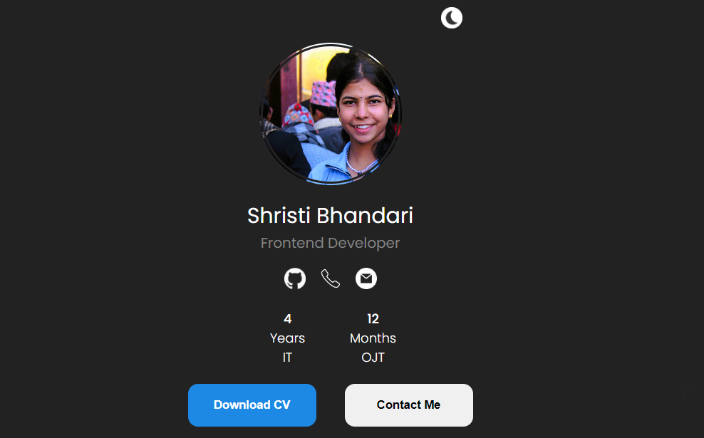

Figure 6.1 Home/Intro Page


Figure 6.2 Project Page

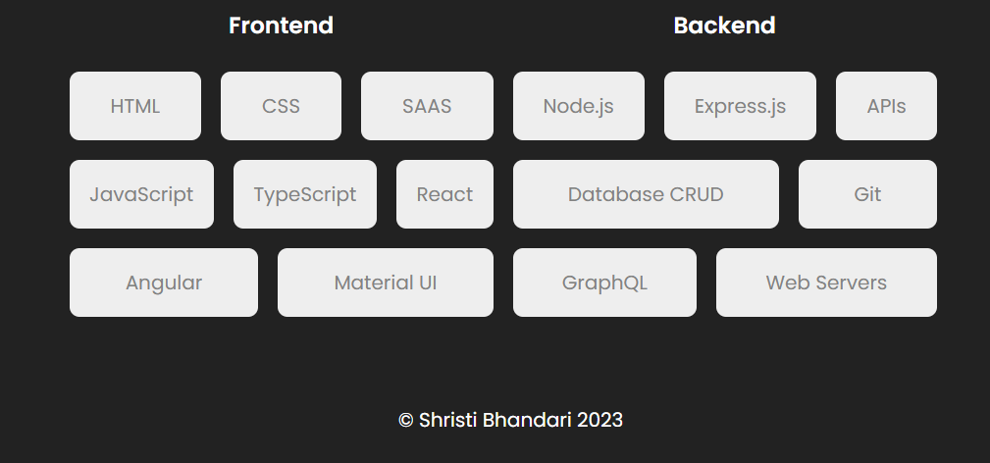

Figure 6.3 Skill Page

REFRENCES

- https://github.com/sanjit333/TransportManagementSystem
- https://www.w3schools.com/cs/index.php
- https://dotnet.microsoft.com/enus/languages/csharp#:~:text=C%23%2 0is%20a%20modern%2C%20innovative,5%20programming%20lang uages%20on%20G
- https://www.hostinger.com/tutorials/portfolio-website-example
- https://www.cloudflare.com/

