**Kathmandu University**

**Department of Computer Science and Engineering**

**Dhulikhel, Kavre**



**A Project Report on**

**“CHUTTI”**

**[COMP 206]**

*(For partial fulfillment of 2nd1st Year/Semester in Computer Science/Engineering)*

**Submitted by**:

Bibek Palanchoke(61)

Bipan Neupane(29)

Birat Shankar Shrestha(45)

Dikesh Shrestha(46)

Saharsha Ojha(30)

**Submitted to**:

Mr. Nabin Ghimire

Department of Computer Science and Engineering

*Submission Date: 12/03/2020*

**Bonafide Certificate**

This project work titled as

“PHARMACY MANAGEMENT SYSTEM”

has been submitted to the Department of Computer Science and Engineering

for the partial fulfillment of ENGG 102 as a 1st year 2nd semester project.

This project work is the bonafide work of

“BIBEK PALANCHOKE, BIPAN NEUPANE, BIRAT SHANKAR SHRESTHA, DIKESH SHRESTHA, SAHARSHA OJHA”

who carried out the project work under my supervision.

Project Supervisor

________________________

Name: Deni Shahi

Academic Designation:

Project Coordinator

_________________________

Name: Nabin Ghimire

Academic Designation: Lecturer

Project Evaluators

**________________________ ____________________****_**

# Acknowledgement

We would like to express our sincere gratitude to our supervisor Ms. Deni Shahi & our friends for providing their invaluable guidance, comments and suggestions throughout the course of the project. We would specially thank Ms. Deni Shahi for constantly motivating us to work harder and stimulating suggestions and encouragement which helped us to coordinate my project especially in writing this report.

We have to appreciate the guidance given by other supervisor as well as the panels especially in our project presentation that has improved our presentation skills thanks to their comment and advices.

Many people, especially our classmates and team members itself, have made valuable comment suggestions on this proposal which gave us an inspiration to improve our assignment. We thank all the people for their help directly and indirectly to complete our assignment.

# Abstract

This project presents a theoretical framework of hotel online reservation system, the aim of this project to develop an online booking system for customers to make reservation at their convenient time because currently, a lot of hotels uses a manual based system to keep record of customer’s reservation and make new bookings. This project discusses the tool and technology used in developing the proposed system (the system has a front end by using HTML, CSS, JavaScript to display the content structure and a back end of database using MySQL and PHP). The objects-oriented analysis and design methodology was used. Demonstration of different webpages available on the website was discussed and then an evaluation was conducted using the methods to evaluate the website. The use of online view of room rates and uploading of available rooms and facilities are used for the new system so that the customer can view and make his choice before arrival, and also in the case of emergency travelling. This system assists the hotel owners in managing their hotels and also increases the efficiency of the hotel managers and also their profit margin, once they have a better and good facilities.

**Contents**

Acknowledgement i

Abstract ii

List of figures v

List of Tables vi

Acronyms/Abbreviations vii

Chapter 1: Introduction 1

1.1. Background 1

1.2. Objectives 2

1.3. Motivation and Significance 3

1.4 Application 4

Chapter 2: Related Works 5

Chapter 3: Design and Implementation 6

3.1. System Requirement Specification 6

3.1.1. Functional Requirements 6

3.1.2. Non-Functional Requirements 7

3.1.3. Software Specification 7

3.2 System Analysis 9

3.3. System Flowchart 9

3.4. Sequence Diagram. 9

3.5. Webpage Sitemap 10

3.5.1. Homepage 10

3.5.2. Accommodation 11

3.5.3. Gallery 11

3.5.4. Services 11

3.5.5. Contact us 11

3.5.6. Making Reservation 11

3.5.7. Login 11

3.5.8. Sign Up 11

3.6. System Deployment Diagram 12

3.7. Database Design 12

3.7.1. Table: user-comment 12

3.7.2. Table: Users 12

3.7.3. Table: Contact 13

3.7.4. Table: Reservation 13

3.8. Implementation and Testing 14

3.8.1. Functional Testing 14

3.8.2. Usability Testing 15

Chapter 4: Discussion on the Achievements 16

4.1. Website Demonstration 16

4.1.1. Home Page 16

4.1.2. Accommodation Page 16

4.1.3. Gallery Page 17

4.1.4. Services Page 17

4.1.5. Contact Us Page 17

4.1.6. Register (Sign Up) Page 17

4.1.7. Login Page 18

4.1.8. Booking Page 18

4.2. Summary on the achievement 19

Chapter 5: Conclusion and Recommendation 20

5.1. Limitation 20

Reference 21

APPENDICES 22

GANTT chart 22

# List of figures

Figure 1. CHUTTI System Flowchart 13

Figure 2 Online Hotel Reservation System Sequence Diagram 14

Figure 3. CHUTTI Website map 15

Figure 4 Deployment Diagram 17

Figure 5: System Evaluation Process 20

Figure 6. CHUTTI Homepage 21

Figure 7. CHUTTI Gallery page 22

Figure 8. CHUTTI Register page 23

Figure 9. CHUTTI Admin Login page 23

Figure 10. CHUTTI Booking page 24

# 

# List of Tables

Table 1: Database Design Table 1 12

Table 2: Database Design Table 2 13

Table 3: Database Design Table 3 13

Table 4: Database Design Table 4 14

# Acronyms/Abbreviations

|  |  |
| --- | --- |
| HTML | * HyperText Markup Language |
| CSS | * Cascading Style Sheets |
| PHP | * Hypertext Preprocessor |
| MySQL | * My Structured Query Language |
|  |  |

# Chapter 1: Introduction

The hotel industry is a business venture for the owner and a solace for the traveler and/or tourist. A customer can get stranded in the quest to secure a hotel room to pass the night if s/he has not made adequate plans by the existing system. The project “Chutti” is a system based on accessing the internet to book for rooms in a hotel. The purpose of this study is to develop and implement an online hotel reservation system for hotels that will replace the manual method of booking for hotel rooms. The previous system for booking rooms were faced with so many problems like, delay in processing the customer booking or paying for rooms that is below or beyond his standard, causes difficulty for emergency booking. To address this issue, a proposed solution is implemented where an online reservation system is developed and deployed to customers to make their reservation at a convenient time and place and the reservation is immediately confirmed by the hotel.

## 1.1. Background

“Chutti” is a web application for Online Hotel Booking system. The aim of this project is to develop a system for hotel customers to make a successful reservation online and immediately get reservation confirmation about their booking. This system is designed in an appropriate and flexible way that test and validate any input provided by customers earlier. A database is created to record each customer details and any transaction. It also brings convenience to the users by saving their time and effort. In this project, the system development is used to capture data and manage all reservation process, it will display room availability, store confirmed booking in the database, customers can leave a feedback which is stored in a table in the database, a contact us form is available for customers to make any enquiry or complains. For the project limitations, the system can also store the type of payment made but payments will not be done online. Customers will have to be in person to make any transaction.

## 1.2. Objectives

The main aim & objective of this “**Chutti”** is to give simple application which provides all facilities like room booking, room class type, hall booking, hotel booking, etc.…

Some of the objectives are listed below:

* To enable online booking via the internet.
* To enable automated data entry methods.
* Ensure efficient and reliable communication within the hotel.
* Avoid data entry errors by use of input masks.
* Enable easy authorized modification of data.
* Enforce security measures to avoid unauthorized access to guest records.
* Overall system quality should be good and it should be a smooth experience for both customers and administrators.

## 1.3. Motivation and Significance

Small hotel managers and owners recognize that technology is key to growing their business and increasing their bookings overtime. To sell rooms to capacity and to appeal to a global audience, a hotel reservation system is required. This project is an interest in taking up a challenging work in this particular area of research to test our capability and knowledge, so as to provide a platform to manage online reservations and bookings and also display organized information of hotel, prices and pictures. This work will help in a good number of ways to ease the delay in manual system of booking. The website developed will help many hotels and its guest to achieve efficient information management system.

## 1.4 Application

A hotel reservation system works by processing secure online reservations made through a hotel’s website. The data is then passed onto a backend system which can be accessed by hotels to manage bookings. Other features come with it as well some of them are:

* Secure Admin Login
* Hotel contact information (address, telephone, fax, email, and internet), Hotel class (stars), full description, extra services, full room and room pricing information, review on hotel by registered users, time-sensitive availability and pricing.
* Powerful administration system.
* Booking History and Management.
* Easy to administrate
* Hotel details, description, map, facilities, photo gallery more in details.
* Guest Login/Register

# Chapter 2: Related Works

* **OYO** 

**Oyo Rooms** (stylised as **OYO**), also known as **Oyo Homes & Hotels**, is an Indian hotel chain. It is the world's third-largest and fastest-growing hospitality chain of leased and franchised hotels, homes and living spaces[1]. Oyo was designed as a platform to enable listing and booking of budget accommodation.

* **Agoda** 

Agoda.com is an online [travel agency](https://en.wikipedia.org/wiki/Travel_agency) and [metasearch engine](https://en.wikipedia.org/wiki/Metasearch_engine) for hotels, vacation rentals, flights, and airport transfer. It is owned by Agoda Company Pte. Ltd., headquartered in [Singapore](https://en.wikipedia.org/wiki/Singapore), and a subsidiary of [Booking Holdings](https://en.wikipedia.org/wiki/Booking_Holdings). Agoda operates on the merchant model, acquiring [lodging](https://en.wikipedia.org/wiki/Lodging) nights at wholesale prices from partner properties and then reselling them at a mark-up.[2]

* **Trivago** 

Trivago N.V., marketed with lowercase styling as trivago, is a [German](https://en.wikipedia.org/wiki/Germany) transnational technology company specializing in internet-related services and products in the hotel, lodging and [metasearch](https://en.wikipedia.org/wiki/Metasearch) fields. The [United States](https://en.wikipedia.org/wiki/United_States) travel company [Expedia Group](https://en.wikipedia.org/wiki/Expedia_Group) owns a majority of the company's stock. The company is incorporated in the [Netherlands](https://en.wikipedia.org/wiki/Netherlands). As a hotel price comparison website, Trivago makes money from advertising partners primarily using a [cost-per-click](https://en.wikipedia.org/wiki/Pay-per-click) (CPC) business model. Booking platforms, hoteliers and other providers list rates and advertise on the Trivago site, paying for the clicks received from Trivago users. [3]

# Chapter 3: Design and Implementation

This section shows how the noted complicated human task can be solved by using a database Management System together with scripting and programming languages like HTML and PHP respectively as the key tools in the development of a hotel reservation System. The system was developed using the object-oriented software development approach which includes the use of object-oriented analysis, object- oriented design and object-oriented programming. This was done so that the developed software can be maintainable, reliable and scalable.

## 3.1. System Requirement Specification

A requirement is a ‘statement regarding an intended product that specifies what it should do or how it should perform’. The two types of requirements are:

## 3.1.1. Functional Requirements

**For customer reservation /Booking**

* The system should allow customers to reserve room.
* The system should record customer personal details (for example, first name, last name, passport no).
* The system should display room type availability
* The system should record the room type and numbers of occupants.
* The system should display the room rate by default.
* The system should record expected check-in and check-out dates and time
* The system should generate a unique customer confirmation number
* The system should record any form of payment
* The system should display any amount owned by customers
* The system should allow space for customer feedback

**For Managements**

* The system should allow manager view feedback/review comments
* The systemshould display a specific period of time of guest occupancy.
* The system should allow manager to login and logout from the system
* The system should display any overridden prices of food and rooms.
* The system should allow duty manager generate daily reservation report

**System Administrator**

* The system shouldallow the system administrator to add or delete room
* The system shouldallow the system administrator to login and logout from the system
* The system should allow the system administrator to update hotel information.

## 3.1.2. Non-Functional Requirements

A non-functional requirement specifies the properties of the information system itself. Some of the non-functional requirements for this project are:

**Security:** Manager and customer representative on duty will be able to log into the system (Hotel management system) and have access to the reservation/booking system but access to the various subsystems will be protected by a user login screen that requires a username and password.

**Availability:** The system will be available 24/7.

**Reliability:** The performance of the system is consistent according to its specifications

**Speed:**

* The system should respond to users request within 2-3 seconds
* The system must retrieve information

**Usability:** The system gives direct input on how real users use the system.

**Portability:** The system supports every operating system

**Efficiency:** The system provides appropriate output based on the list of inputs

### 3.1.3. Software Specification

The various tools used in developing the system are PHP (for creating codes that links the webpages to the database), MySQL (for creating database), HTML and CSS (for designing and styling the website). These tools are used to develop an interactive system with users.

**The** **Hypertext Preprocessor** (PHP) is a programming language that allows web developers to create dynamic content that interacts with database. For this project, the PHP Code used is embedded into the HTML source codes which is linked to the database and then interpreted by a web server that generates the page document for proper understanding. PHP is used because; it quickly identifies errors in codes and easier to fix problems, simple and easy to use and it is speedy.

**Structured Query Language** (SQL) is a database programming language designed for managing and retrieving data. It specializes in updating, deleting and requesting information from database. SQL is used in this project to create database that stores user’s information (data). The benefits of SQL to this project are: it is easy to use, an open source and user friendly.

**Hypertext Markup Language** (HTML) and **Cascading Styling sheet** (CSS) are tools used in building Web pages. HTML provides the structure of the web pages (for example headings and paragraphs). CSS is a language created to define and style the appearance of content and other materials of the Web page (for example fonts and size). The advantages of using HTML and CSS are: it has a build in function (easy to use) that allows users specify various format and style properties.

**JavaScript:** This is a dynamic programming language used as a part of web browser which allows client-side script interact with user and server side. It is increasingly considered as an “assembly” language. This scripting language is classified as a prototype-based language with dynamic typing which has a first-class function.

**Notepad++** is used in this project as the main source code editor needed in developing the system. It supports several languages, which makes it suitable for this project.

## 3.2 System Analysis

The proposed system will help the Hotels to operate efficiently by eliminating all the time-consuming procedures and provide a better service to their customers as well as for the employees in the company. It will eliminate the need for members of staff of the hotel to go about some affairs manually and hereby reduces most problem inherent in the existing system.

## 3.3. System Flowchart

Select Choices

If Choice=Gallery

Display Gallery

If Choice=Our Hotels

Display Our Hotels

If Choice=About Us

Display About us

If Choice=Contact Us

Display Contact Details

If Choice=log in

Display Login page

If Choice=Register

Display Register page

Display Hotel Details

Select Hotel

Return Home

Book Rooms

Have an Account

Register Account

Log in

Enter User Name

Enter Password

Valid?

Valid?

Log out

Book Rooms

Enter First Name

Enter Last Name

Enter Email Address

Enter Password

Re-enter Password

Is email address Valid?

Does Password match?

Enter City

Enter Country

Enter Phone No.

Enter Payment Type

Confirm Register

Admin Login

Customer Login

Enter Password

Enter User Name

Valid?

Valid?

Log out

Admin Information

Figure 1. CHUTTI System Flowchart

## 3.4. Sequence Diagram.

A sequence diagram [4] is the interaction between objects in a sequential order that those interactions occur. In sequence diagram, each role is shown as lifeline and messages are shown as arrows between lifelines. Below is the sequence diagram of this project Hotel reservation system.

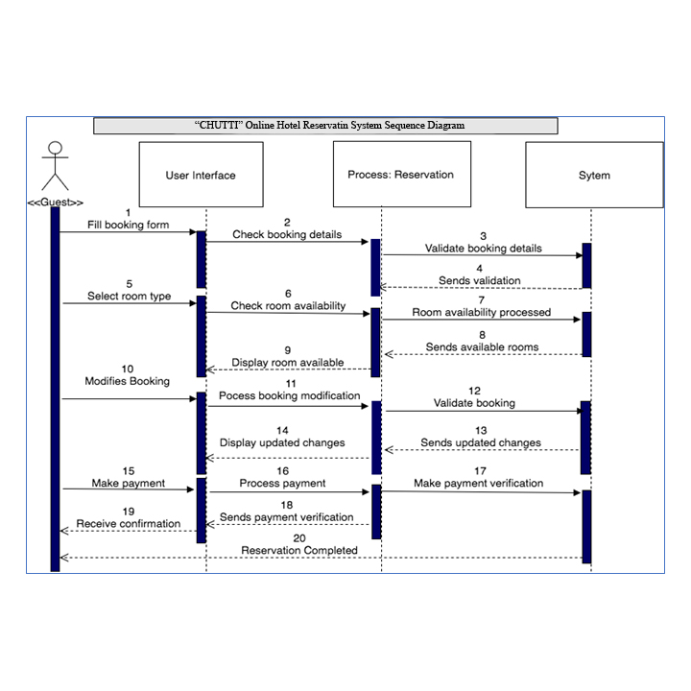

Figure 2 Online Hotel Reservation System Sequence Diagram

## 3.5. Webpage Sitemap

A site map is a visual or textually organized model of a website content designed to help users and search engine to navigate through a site to find information available in the sites. Below is a hierarchical representation of this project site map of “CHUTTI” hotel website with a booking system.

Figure 3. CHUTTI Website map

## 3.5.1. Homepage

This page is also known as the index page (The main page on the website). It consists of the navigation bar through all pages on the website, images, sign in and sign up, and the booking section to check for availability and make reservation.

## 3.5.2. Accommodation

In this page on the website, different types of rooms and suite available in the hotel are displayed here with descriptive explanation of every suite. This page helps customers or guest have an idea of the type of room/suite they want for reservation.

## 3.5.3. Gallery

This page comprises of mostly images of the hotel. It shows the facilities and equipment’s available at the hotel. Images shown on this page help prospective guests have ideas of what the hotel looks like and it environment.

## 3.5.4. Services

In this page, the website shows all services provided by the hotel which include business meetings, events (such as weddings, birthdays and party), the gym and the swimming pool area.

## 3.5.5. Contact us

This page is for making enquiries about the hotel or related services, it also shows the location of the hotel and how customers can reach through the hotel.

## 3.5.6. Making Reservation

On this page, customer who will like to stay at the hotel can make their reservation here by providing their name, email, contact, address, check in and check out dates with the number of rooms, adults and children expected. After filling the booking form customers are then asked to process to payment using the credit or debit master card.

## 3.5.7. Login

This is the login page; guests are required to log into this page before they can comment or give feedback regarding their stay in the hotel. The page also keeps track of guest’s visits.

## 3.5.8. Sign Up

This is the sign-up page were unregistered guests are required to create an account in order to give their feedback and also enable them track their stay at the hotel.

## 3.6. System Deployment Diagram

A deployment diagram is used to visualize the physical component of a system which consists of nodes and their relationship. Below is the hotel reservation system deployment diagram. This diagram shows how users can access the website by using different web browsers as listed below, Apache will serve as the web server and MySQL will be used to store customer and hotel information in categorized tables in the database.



Figure 4 Deployment Diagram

## 3.7. Database Design

## 3.7.1. Table: user-comment

This table is used to store review messages provided by users on the website

|  |  |  |  |
| --- | --- | --- | --- |
| Field Name | Data Type | Length | Description |
| Id | Int (Auto Increment) | 11 | users id |
| username | Varchar | (50) | username |

Table 1: Database Design Table 1

## 

## 3.7.2. Table: Users

This table is used to store user’s information when the register their details on the website. It will also be used to retrieve information when users try to login.

|  |  |  |  |
| --- | --- | --- | --- |
| Field Name | Data Type | Length | Description |
| id | Int (Auto Increment) | 11 | users id |
| username | Varchar | (50) | username |
| email | Varchar | (50) | Users email address |
| password | Varchar | (20) | password |
| Confirm password | Varchar | (20) | Verification of the first password |

Table 2: Database Design Table 2

## 3.7.3. Table: Contact

This table is used to store information about users who make complains or want to make an enquiry about the hotel or their reservation.

|  |  |  |  |
| --- | --- | --- | --- |
| Field Name | Data Type | Length | Description |
| id | int | 11 | Users id |
| email | Varchar | 50 | Email address |
| message | Varchar | 50 | Enquiry message |

Table 3: Database Design Table 3

## 3.7.4. Table: Reservation

This table is used to store customer’s reservation details.

|  |  |  |  |
| --- | --- | --- | --- |
| Field Name | Data Type | Length | Description |
| id | int | 11 | Users id |
| title | Varchar | 5 | Gender title |
| username | Varchar | 20 | username |
| email | Varchar | 20 | email |
| contact number | int | 20 | contact number |
| check-in | Date | 10 | check-in |
| checkout | Date | 10 | checkout |
| address | Varchar | 30 | address |
| states | Varchar | 20 | states |
| city | Varchar | 10 | city |
| payment type | Varchar | 10 | payment type |

Table 4: Database Design Table 4

## 3.8. Implementation and Testing

Series of testings’ and evaluation was used on the developed system in order to avoid system errors and also make sure every functional requirement gathered from the requirement stage had been implemented in the system.

## 3.8.1. Functional Testing

Functional testing is done to verify that each function in the system software operates with the requirements specifications. Functional testing involves checking client/server application (This project uses apache webserver), user interface, database and the system functionality which is tested by providing required input and then verify the output and compare the results with the expected result. The functions that are tested in the section are [5]:

* Mainline functions: This is the testing of the system main functions.
* Basic Usability: basic usability is usability testing of the system to check whether a user can easily navigate through the webpages without any difficulties.
* Error Condition: This is to check or errors and whether error messages are displayed. Since the system will be developed using PHP codes it is easier to identify an error once the developer runs the page.

## 3.8.2. Usability Testing

This testing technique is used to determine whether the developed system is accessible, findable, useful and easy for end users to achieve the tasks for which it was designed. The goal of using this technique is to know the effectiveness of the system, user friendliness, accuracy and efficiency. Usability testing process will be used to develop the system evaluation results, analysis and any findings. The usability testing processes consist of:

Figure 5: System Evaluation Process

# Chapter 4: Discussion on the Achievements

## 4.1. Website Demonstration

## 4.1.1. Home Page

This is the first page users will interact with on the website. It provides a detail description about the hotel, a booking form for customers to check room availability within selected date. The home page also has a Review form for users to leave a feedback about their experience in the hotel. Users can register and the login on this page in order to have full access of the website.

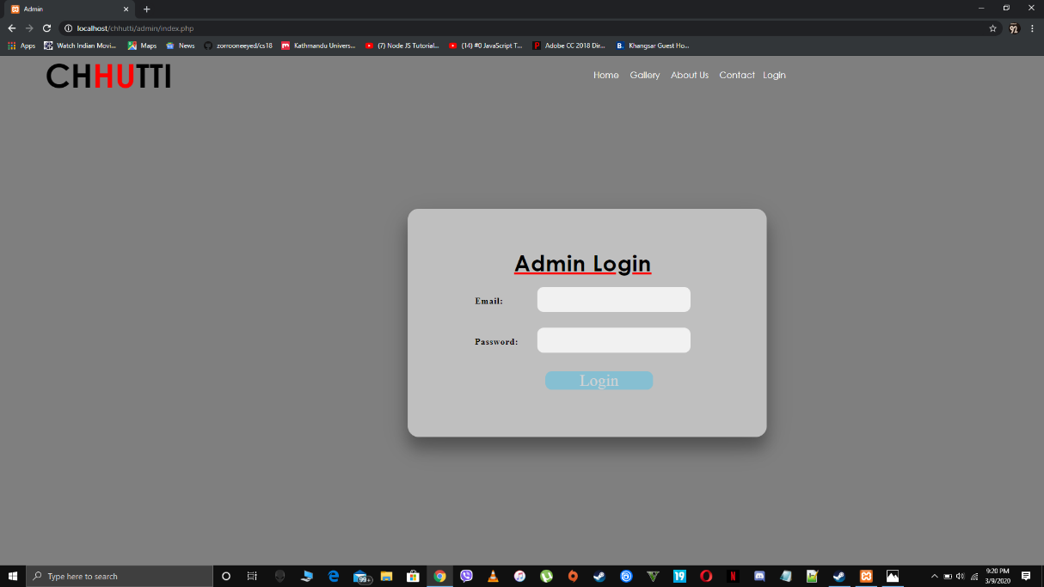

Figure 6. CHUTTI Homepage

## 4.1.2. Accommodation Page

In this web page, users can view the types of accommodation available in the hotels on the website, they can also click on these room types to have an idea or know more information about the room. It also has the reservation form for users to book or check rooms’ availability on all pages of room types.

## 4.1.3. Gallery Page

The image gallery is one of the attractive pages on the website. In this page, users can view different type images of the hotels to have an idea of what the hotel looks like.

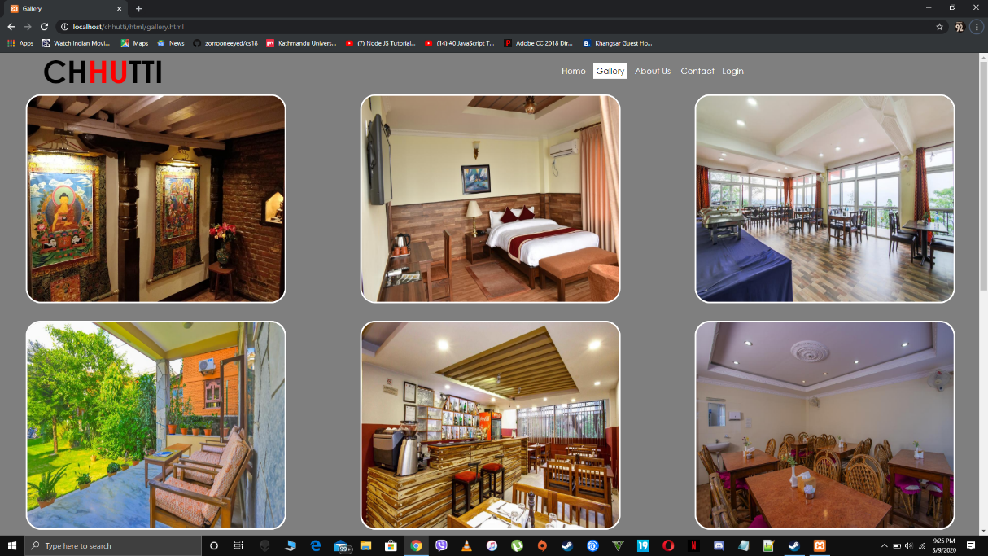

Figure 7. CHUTTI Gallery page

## 4.1.4. Services Page

This page allows users to view the services rendered by the hotel. It also has a number of links that links users to the type of services on different pages.

## 4.1.5. Contact Us Page

On this page, users can leave an enquire message or any complains, which will be immediately directed to the hotel and will be replied within twenty-four hours. This page also has the hotel’s address (location map), contact number and all social media’s the hotel operates with.

## 4.1.6. Register (Sign Up) Page

This page allows new users to register their details into the hotel database. Without the sign-up function, users will not be able to make reservations in the hotel but can view other webpages available. Once users are registered to the website, the login function allows the system to recover their details.

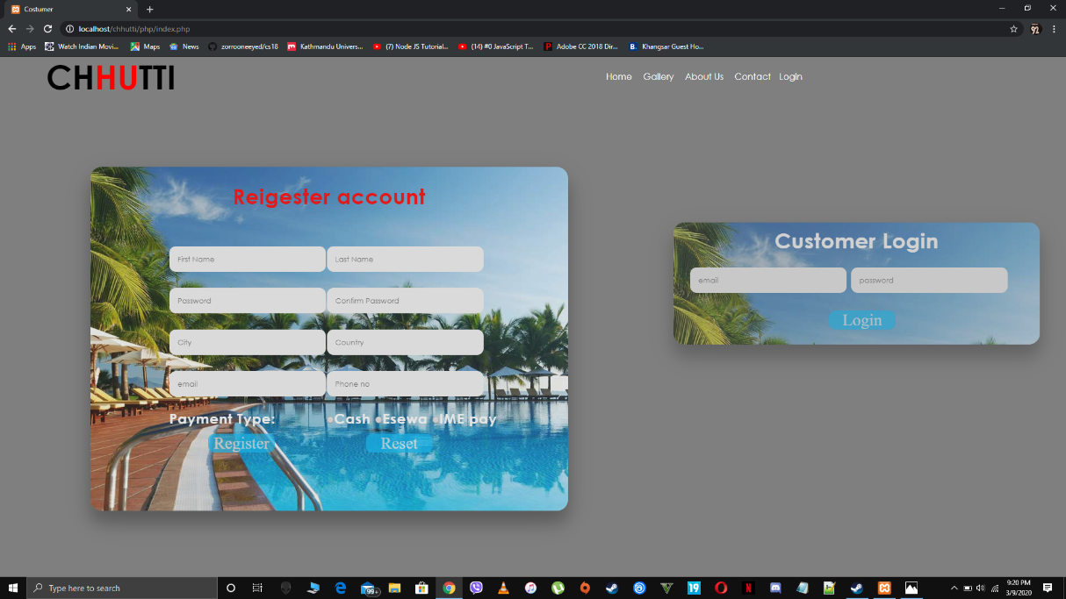

Figure 8. CHUTTI Register page

## 

## 4.1.7. Login Page

This page allows admin to log in to the website in order have full access to the website. Admin can view customer details from this page.



Figure 9. CHUTTI Admin Login page

## 

## 4.1.8. Booking Page

This page is for users who may wish to make a reservation with the hotel online, users are supposed to fill in this form and click the submit button to confirm their reservation. After this a unique id is generated as a confirmation number for customers who have confirmed their booking.

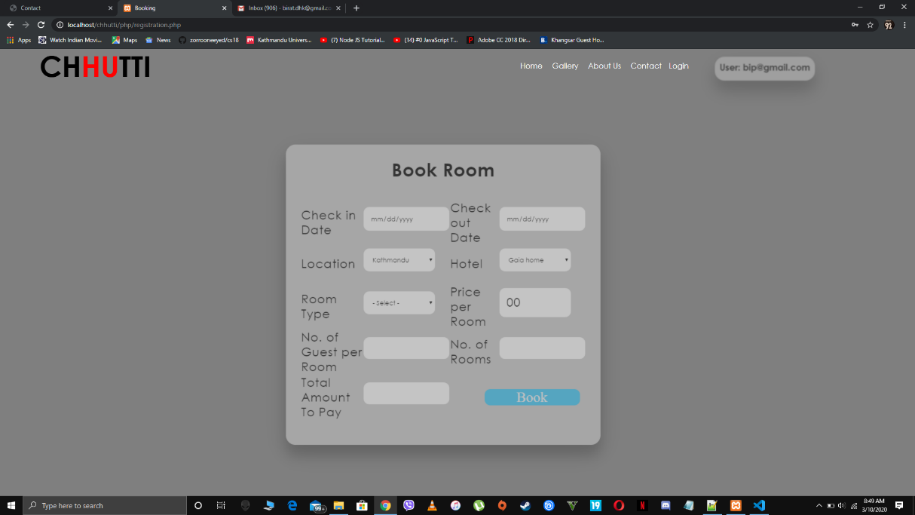

Figure 10. CHUTTI Booking page

## 4.2. Summary on the achievement

Having come to completion of this project work a lot of achievement was made and they include;

* The replacement of error prone manual system with new online Hotel management system.
* Data can now be processed with great speed and efficiency.
* Direct capture and storing of data.
* The security of data is to some extent ensured. 5. The use of database server was implemented.

# Chapter 5: Conclusion and Recommendation

In conclusion, this report has been able to address the issues customers and hotels face when making a reservation using a manual booking system by developing an online booking system for clients to make reservation at their own comfort. It has also discussed on the past studies of online booking and the integration of the internet by hotels to connect more to their customers. It has discussed on the types of development methodology selected for the research. A detailed description of pages on the website was discussed and the types of evaluation used to evaluate the website. All processing of hotel information with regards to reservation, evaluation of hotel activities can be carried out online.

## 5.1. Limitation

In the course of this research project, a few limitations were face and they are;

* In the website, customers can reservations but are unable to make online payments.
* In case of enquiry when customers send their feedback through the system, it will go directly to the staff mailbox. It means the system don’t have the separate web page for checking all the customers enquiry and send reply promptly.
* This project work has one semester time limit, it would have been desirable for a longer period of time, for the development of a software for hotels.

.

# Reference

[1] Oyo Rooms. (2020). Retrieved 8 March 2020, from https://en.wikipedia.org/wiki/Oyo_Rooms [2] Assist, C. and Software, R. (2019). *Compound Assist Reviews and Pricing - 2019*. [online] Capterra.com. Available at: https://www.capterra.com/p/92554/Compound-Assist/ [Accessed 24 Jul. 2019].

[2] Agoda. (2020). Retrieved 10 March 2020, from https://en.wikipedia.org/wiki/Agoda

[3]Trivago.(2020).Retrieved 10 March 2020, from https://en.wikipedia.org/wiki/Trivago

[4] The sequence diagram. (2020). Retrieved 9 March 2020, from http://www.ibm.com/developerworks/rational/library/3101.html

[5] What is Functional Testing? Types & Examples (Complete Tutorial). (2020). Retrieved 9 March 2020, from http://www.guru99.com/functional-testing.html

# APPENDICES

## GANTT Chart

|  |  |  |  |  |  |  |  |  |
| --- | --- | --- | --- | --- | --- | --- | --- | --- |
| **Week Work** | **1** | **2** | **3** | **4** | **5** | **6** | **7** | **8** |
| Program analysis and design |  |  |  |  |  |  |  |  |
| File handling |  |  |  |  |  |  |  |  |
| Database |  |  |  |  |  |  |  |  |
| Program Testing |  |  |  |  |  |  |  |  |
| Documentation |  |  |  |  |  |  |  |  |

Figure 11: GANTT Chart