**SUSHMA GODAWARI ENTRANCE EXAMINATION-2081 (20224)**

**Time: 1.5 hours F. M.: 70**

**DIPLOMA IN COMPUTER / CIVIL ENGINEERING 2081**

Attempt **all** the questions

**Objective Answer Questions: (70x 1= 70)**

Rewrite the correct option of each quest in your answer sheet.

1. Ball pen functions on the principle of

a. Viscosity b. Boyle’s law

c. Gravitational force d. Surface tension

1. Which of the following diseases results from endocrine disorder?

a. Pneumonia b. Goitre

c. Typhoid d. Jaundice

1. Which of the following is called a positive electron?

a. Proton b. Positron

c. Protium d. Protonium

1. The value of g at the pole is

a. 9.78 m/s2 b. 9.83 m/s2

c. 10 m/s2 d. 9.8 m/s2

1. Which organic acid is found in an apple?

a. Tannic acid b. Lactic acid

c. Malic acid d. Citric acid

1. The full form of TNT is

a. Tri Nitro Toluene b. Triple Nitrogen Tablet

c. Tetra Nitro Titanium d. None of above

1. The atomic theory was given by

a. Chadwick b. J.J Thomson

c. John Dalton d. E. Rutherford

1. A 200 kg car traveling at 10 m/s hits a tree and is brought to rest in 0.10s. What is its acceleration before comes to rest?

a. 100 m/sec2 b. 120 m/sec2

c. 10 m/sec2 d. 200 m/sec2

1. Sound energy is converted into electrical energy in a:

a. loudspeaker b. microphone

c. sonometer d. earphone

1. Which of the alkalis have no metal?

a. Sodium hydroxide b. Ammonium hydroxide

c. Magnesium hydroxide d. Calcium hydroxide

1. What is the main principle of an electric bell?

a. to ring the bell b. electromagnet

c. magnet d. pole energy

1. Estimate the height of a hanging bridge over the tamor river; if a stone drops freely takes 4 seconds to touch the water surface.

a. 78 m b. 78.2 m

c. 78.4 m d. 78.6 m

1. What is the molecular formula of laughing gas?

a. N2O3 b.N2O5

c. N2O d. N2O4

1. In the photosynthesis process, which of the following is not an essential factor?

a. sunlight b. carbon dioxide

c. chlorophyll d. acid

1. What is the pH value of pure water?

a. 6 b. 5.5

c. 7.5 d.7.0

1. A fruit develops from the part of a plant called

a. embryo sac b. ovary

c. egg d. pollen tube

1. Nitrogen compounds in the nitrogen cycle are broken down by decomposers to release

a. methane b. ammonia

c. urea d. nitrogen gas

1. The molecule that does not obey the octet rule is

| a. MgO | b. NaCl |
| --- | --- |
| c. BeCl2 | d. NH3 |

1. At what temperature the density of water is maximum?

a. $0^{0}$ c b. $4^{0}$ c

c. $3^{0}$ c d. ${100}^{0}$ c

1. The chemical formula of calcium hydrogen carbonate is…….

a. Ca(OH)2 b. CaCO3

c. Ca(HCO3)2 d. Na2CO3

1. The Latin name of mercury is………..

a. Argentum’s b. kalium

c. natrium d. hydrargyrum

1. Pneumatic bone is found in

a. shark b. Rana

c. pigeon d. whale

1. The first metal used by the man was

a. Iron b.Copper

c.Silver d. Gold

1. Which is the Largest Ethnic group in Nepal?

a. Brahmin b. Tharu

c. Tamang d. Chhettri

1. In cricket the length of pitch between the two wickets is
2. 24 yards b. 23 yards
3. 22 yards d. 21 yards
4. Which is the uppermost part of the atmosphere?

a. Troposphere b. Exposphere

c. Stratosphere d. Mesosphere

1. What is the last letter of Greek alphabet?

a. Pi (π) b. Alpha (α)

c. Beta (β) d. Omega (ω)

1. Paramecium is…………

a. herbivorous b. carnivorous

c. insectivorous d. omnivorous

1. The full form of LED is

a. Light emission device. b. Laser emitting device.

c. Light emitting diode. d. Laser emitting diode.

1. What does CPU stands for?

a. Computer Peripheral Unit b. Central Processing Unit

c. Central Processor Unit d. Computer Processor Unit

1. The process of decomposing soil nitrogen into atmospheric nitrogen is called

a. nitrogen fixation b. ammonification

c. nitrification d. denitrification

1. A man does 6000J work in 10 sec. His power is….

a.700 W b.500W

c.800W d. 600W

1. Which gas is used to produce blueprint?

a. carbon dioxide b. nitrogen

c. ammonia d. helium

1. Which form of energy is stored in the nucleus of an atom?

a. chemical b. light

c. sound d.nuclear

1. Which element makes blood red?

a.Fibrinogen b.Platelets

c.WBC d.Hemoglobin

1. Which of the following pairs of substances on reaction will not evolve H2 gas?

| a. Iron and H2SO4(aq.) | b.Iron and steam |
| --- | --- |
| c. Copper and HCl(aq.) | d. Sodium and ethanol |

1. T.llest Building of the world is

a. shanghai tower b. lotte world tower

c. wills tower d. Burzkhalifa

1. The percentage of nitrogen gas in atmosphere is…………

a.21% b.78%

c.70% d.1%

1. Nowadays, Harry is …………. busy taking care of her health.

a) Very b. too

c) So, d extremely

1. Would you mind……………on the light?

a) to switch b. switching

c) to switching d. to be switching

1. Before the Angles and the Saxons …………to England, the Iberians had lived there.

a. Coming b. Come

c. Came d. did come

1. You must dispense ….. his service.

a. in b. at

c. with d. of

1. The principal and secretary _______were highly impressed with the overall progress of the students.

a. were b. was

c. are d. is

1. He walked as if he ……. lame.

a. is b. was

c. had been d. is being

1. The bed and breakfast — nice. We had fun.

a. is b. are

c. was d. is/was

1. I have received no invitation ……….

a. either from A or from B. b. either from A or from B.

c. neither from A nor from B. d. neither from A or from B.

1. "Mind your own business," he said ………...

a. heavily b. hardly

c. harshly d. rudely

1. Which word is incorrectly spelled?
   1. preferable b. nuptial

c. nuisance d. hygiene

1. Upper quartile of the continuous series is….

a. $L+\frac{\frac{N}{2}-c.f.}{f}xh$ b. $L+\frac{\frac{N}{4}-c.f.}{f}xh$

c. $L+\frac{\frac{3N}{2}-c.f.}{f}xh$ d.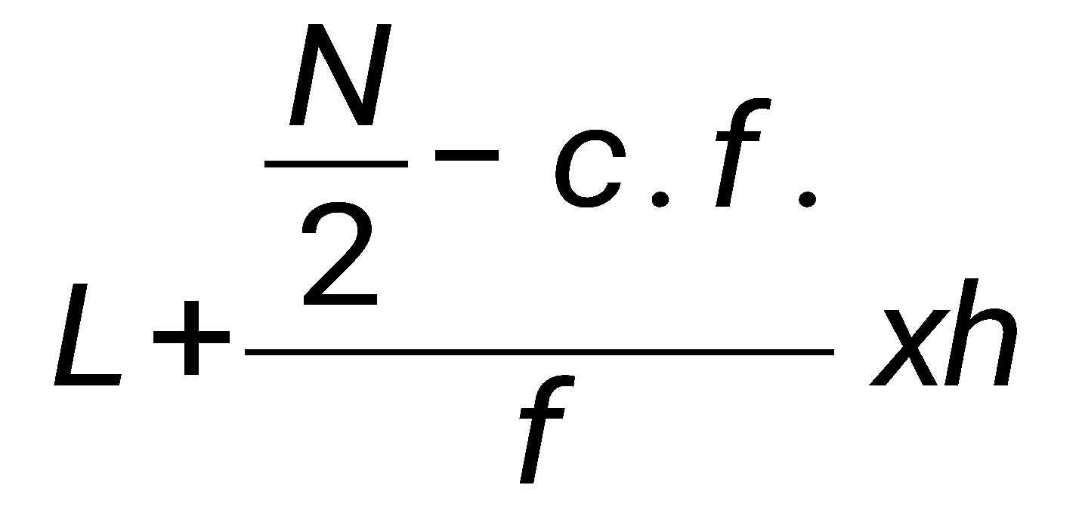

1. A dealer mixes 120 liters of milk containing 5% water with 80 liters of milk containing 10% water. What is the percentage of water in the mixture?

a.5% b.7%

c.9% d.11%

1. If f(x) = (10 – x)2 and m = f (6), then which one of the following equal to 4m?

a. f (12) b. f (18)

c. f (24) d. f (8)

1. For what value of k one root of 2x2 – (6 + k) x + (2 + k) = 0 is zero?

a. 0 b. 6

c. 2 d. -2

1. For what value of K will the points (1, 4), (-3, 16) and (K, -2) are collinear?

a. 1 b. 3

c. 6 d. 10

1. If the amount of a sum of money is 5/4 of the principal in 2.5 years, then the rate of interest is

a. 5% b. 10%

c. 15% d. 25%

1. The marks of 10 students of a class are 46, 51, 62, 70, 35, 36, x, 83, 65, 52, If the average mark is 55, then the value of x is

a. 52 b. 51

c. 50 d. 53

1. If x+y=10 and x-y=11, what is the value of x2 -y 2?

a. 100 b. 110

c. 121 d. 21

1. Find the value of x, if 2x+1 -2 x - 8=0

a. 3 b. 2

c. 3/ 2 d. 2/ 3

1. What is the average of 4y+3 and 2y-1?

a. 3y+2 b. 3y+1

c. 3y+4 d. y+1

1. If the diameter of a semi-circular protractor is 14 cm, then its perimeter is….

a.22cm b. 33cm

c). 36cm d. 42cm

1. There are n arithmetic means between 3 and 17. The ratio of the last mean to the first mean is 3:1, then the value of n is

a.6 b.7

c.8 d.9

1. After paying an income tax of 5%, a man has Rs.7600 left. What is his income?

a.Rs. 8000 b.Rs. 6000

c.Rs. 4000 d.Rs.16000

1. A boy is three years older than his sister. Two years ago, the sum of their ages was 19. How old is the boy now?

a.11years b.12Years

c.13Years d.10Years

1. If P= then P3 is …

a. b.

c. d. $\left(27 3 3 27 \right)$

1. What is the sub-triplicate ratio of 27:64?

a. 9:16 b. 9:27

c.3:5 d.3:4

1. Angles of a triangle are in the ratio 3:5:7, then the triangle is;

a.acute angled b.obtuse angled

c.right angled d.none

1. If f(x)=3x+b and fof (2) =12,then the value of b is

a. $\frac{3}{2}$ b. $\frac{-3}{2}$

c. $\frac{-1}{3}$ d. $\frac{1}{3}$

1. If 10 cows eat as much as 6 oxen, how many oxen will eat as much as 15 cows?

a. 10 b. 6

c. 9 d.15

1. If a dice is thrown two time, find the probability of the outcomes being 5 in the first throw and an odd number In the second row ?

a. 1/ 12 b 2 /3

c. 5 /6 d 2/ 9

1. The product of two consecutive natural numbers is…..

a.even b. prime

c.odd d.none

1. The solution region of inequalities 𝑥 $≤$ 0 and 𝑦 ≤ 0 lies in

a. 1st quadrant b. 2nd quadrant

c. 3rd quadrant d.4th quadrant