Asian School of Management And

Technology

Gongabu, Kathmandu

Tribhuvan University



**Compiler Design and Construction**

**Submitted By**

Name: Rabin Neupane

Roll No: 24109/076

6th Semester Bsc.Csit

**Submitted To**

Name: Mr. Bikash Balami

1. Design a DFA to simulate the following machines.

a. Accepting binary string that start with 0 and ends with 1.

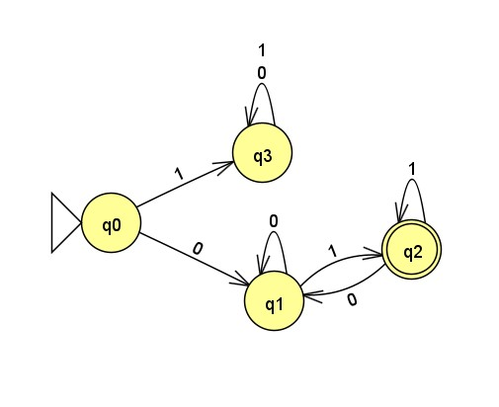

# b. Accepting the valid variable names in C program

#include<stdio.h>

#include<stdlib.h> #include<string.h>

int main()

{

char string[50];

int count=0,i;

printf("Enter the String: ");

gets(string);

if((string[0]>='a'&&string[0]<='z') || (string[0]>='A'&&string[0]<='Z') || (string[0]=='_'))

{

for(i=1;i<=strlen(string);i++)

{

if((string[i]>='a'&& string[i]<='z') || (string[i]>='A' && string[i]<='Z') || (string[i]>='0'&& string[i]<='9') || (string[i]=='_'))

{

count++;

}

}

}

if(count==(strlen(string)-1))

{

printf("Input string is a valid variable");

}

else

{

printf("Input string is not a valid variable");

}

return 0;

}

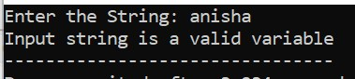 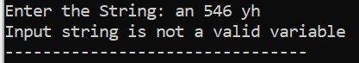

c. Accepting the valid gmail ID.

<!DOCTYPE html>

<html lang="en">

<head>

<meta charset="UTF-8" />

<meta http-equiv="X-UA-Compatible" content="IE=edge" />

<meta name="viewport" content="width=device-width, initial-scale=1.0" />

<title>Document</title>

</head>

<body>

<label>Email:</label>

<input type="text" id="emailId" /><br />

<button onclick="validateGmail()">Submit</button>

<script> function validateGmail() { var email = document.getElementById("emailId").value; regex =

/^[a-zA-Z0-9.!#$%&'*+/=?^_`{|}~-]+@[a-zA-Z0-9-]+(?:\.[a-zA-Z0-9]+)+$/;

if (email.match(regex)) { alert("Valid Gmail");

} else { alert("Invalid Gmail");

}

}

</script>

</body>

</html>

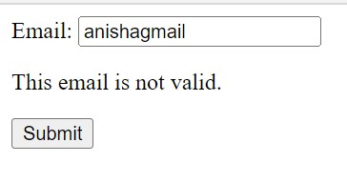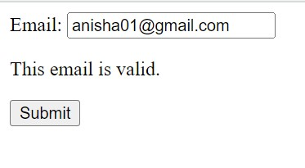

# Accepting the prepaid NTC number

<!DOCTYPE html>

<html lang="en">

<head>

<meta charset="UTF-8" />

<meta http-equiv="X-UA-Compatible" content="IE=edge" />

<meta name="viewport" content="width=device-width, initial-scale=1.0" />

<title>Document</title>

</head>

<body>

<label>Phone number:</label>

<input type="text" id="num" /><br />

<button onclick="validateNumber()">Submit</button>

<script>

function validateNumber() {

var num = document.getElementById("num").value; regex = /^984\d{7}$/;

if (num.match(regex)) { alert("Valid Ntc Prepaid number");

} else {

alert("Invalid Ntc Prepaid number");

}

}

</script>

</body>

</html>

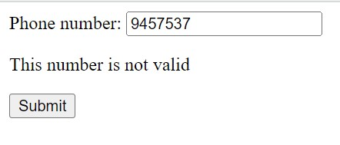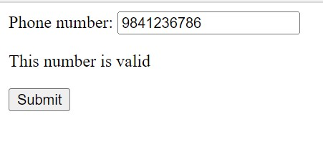

**2. Design a NFA to simulate the following machine**

# a. Accepting RE (a + b)*a over = {a,b}

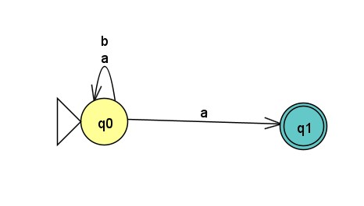

b. Accepting RE (a+b)(a+b) over = {a,b}.

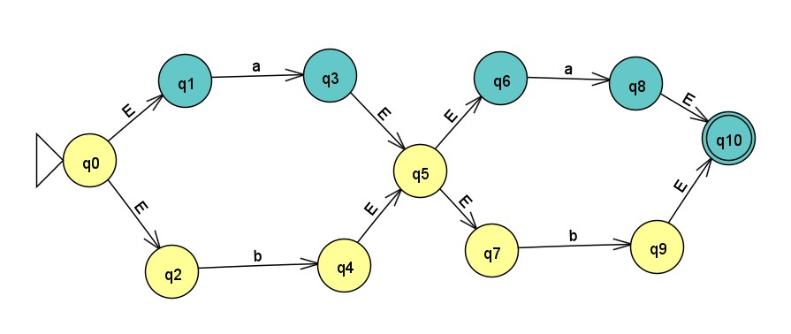

**3. Write a program to remove left recursion from the following grammar.**

# a. S ->Sab | ab | a | b (Grammar 1) b. A ->A0 | A1 | 0 (Grammar 2)

gram = {}

def add(str): #to rules together str = str.replace(" ", "").replace(" ", "").replace("\n", "") x = str.split("->") y = x[1]

x.pop() z = y.split("|")

x.append(z) gram[x[0]]=x[1]

def removeDirectLR(gramA, A):

"""gramA is dictonary""" temp = gramA[A] tempCr = [] tempInCr = [] for i in temp: if i[0] == A:

#tempInCr.append(i[1:]) tempInCr.append(i[1:]+[A+"'"]) else:

#tempCr.append(i) tempCr.append(i+[A+"'"])

tempInCr.append(["|e"]) gramA[A] = tempCr gramA[A+"'"] = tempInCr

return gramA

def checkForIndirect(gramA, a, ai): if ai not in gramA:

return False if a == ai:

return True for i in gramA[ai]: if i[0] == ai:

return False if i[0] in gramA:

return checkForIndirect(gramA, a, i[0]) return False

def rep(gramA, A):

temp = gramA[A] newTemp = [] for i in temp:

if checkForIndirect(gramA, A, i[0]): t = []

for k in gramA[i[0]]:

t=[]

t+=k

t+=i[1:]

newTemp.append(t) else:

newTemp.append(i)

gramA[A] = newTemp return gramA

def rem(gram):

c = 1 conv = {} gramA = {} revconv = {} for j in gram:

conv[j] = "A"+str(c) gramA["A"+str(c)] = []

c+=1 for i in gram: for j in gram[i]:

temp = [] for k in j: if k in conv:

temp.append(conv[k]) else:

temp.append(k) gramA[conv[i]].append(temp)

#print(gramA) for i in range(c-1,0,-1): ai = "A"+str(i) for j in range(0,i):

aj = gramA[ai][0][0] if ai!=aj :

if aj in gramA and checkForIndirect(gramA,ai,aj):

gramA = rep(gramA, ai)

for i in range(1,c):

ai = "A"+str(i) for j in gramA[ai]: if ai==j[0]:

gramA = removeDirectLR(gramA, ai)

break

op = {} for i in gramA:

a = str(i) for j in conv: a = a.replace(conv[j],j) revconv[i] = a

for i in gramA:

l = [] for j in gramA[i]:

k = [] for m in j: if m in revconv:

k.append(m.replace(m,revconv[m]))

else:

k.append(m)

l.append(k)

op[revconv[i]] = l

return op

n = int(input("Enter No of Production: ")) for i in range(n): txt=input() add(txt)

result = rem(gram) for x,y in result.items(): print(f'{x} -> ', end="") for index, i in enumerate(y): for j in i:

print(j, end="") if (index != len(y) - 1): print("", end="") print()

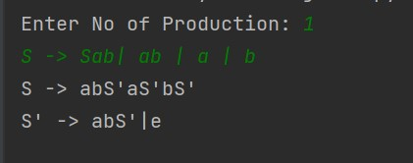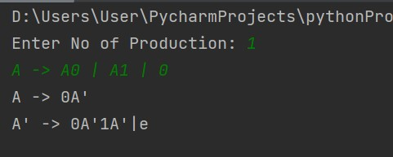

**4. Write a program to create a symbol table for the variables (for data types only)**

# program.txt

int a = 9 ; float b = 6.79 ;

# Python code

tokens=[' '] ids = []

key_words = ['int','string','char','float','double'] operators = ['+','-','*','/','=','<'] punct = ['(',')', '{', '}' , '[' ,']',','] with open("program.txt") as t:

a=t.readlines() for t in a:

tokens=tokens + (t.split(" ")) print("id\t\t\tdata_types\t\tvalue") for pos, t in enumerate(tokens):

for k in key_words: if(t==k):

ids.append(tokens[pos + 1]) if(tokens[pos + 2 ] == ','):

print(tokens[pos + 1] + " " + tokens[pos] + " " + "NULL") tokens.insert(pos + 3, tokens[pos]) elif (tokens[pos + 2] =='('): end=tokens.index(')') para = tokens[pos + 3:end]

kc=0 pt=[] for key in key_words:

kc = kc + para.count(key)

i=0 while(i < para.count(key)):

pt.append(key) i = i + 1

print(tokens[pos + 1] + "\t\t\t" + tokens[pos] + "\t\t\t" + str(kc) +

"\t\t\t" + str(pt)) elif (tokens[pos + 1] == '('):

continue Else:

print(tokens[pos + 1] + "\t\t\t" + tokens[pos] + "\t\t\t" + tokens[pos + 3])

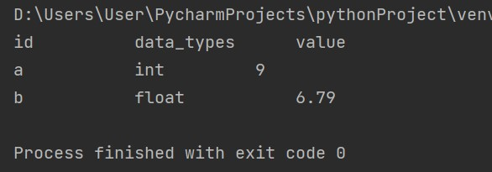

**5. Write a program to find set of non-terminals, set of terminals, set of productions and starting symbol. Here you have to take the CFG as input in file.**

**grammar.txt**

A->Axy|xy|x|y

# Python code

import re tokens=[] with open("grammar.txt") as t:

a=t.readlines() for t in a:

tokens=tokens + (t.split("->"))

r = re.findall('([A-Z])', tokens[1]) #get all capital letters from rhs rSmall = re.findall('([a-z])', tokens[1]) #get all small letters from rhs rSmallUpdated = list(dict.fromkeys(rSmall)) #remove duplicates

productions = tokens[1].split("|") print("Set of starting symbol = {"+tokens[0]+"}") print("Set of non-terminals:") print(r,sep=",") print("Set of terminals:") print(rSmallUpdated,sep=',') print("Set of productions:") for item in productions:

print(tokens[0]+"->"+item)

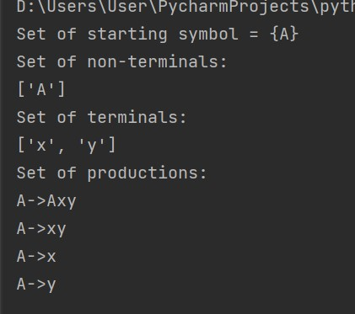

6. Write a program to realize the concept of loop optimization in compiler optimization in following cases, with respect to running time only.

a. Code Motion

#include<stdio.h> #include <time.h> void program1(){

int a,b,c,d,e,f,g,h =0; for(int i=0; i<1000000000; i++) { c = d + e; f = g + h; a = b + i ;

}

}

int main(){ clock_t t; t = clock(); program1();

t = clock() - t;

double time_taken = ((double)t)/CLOCKS_PER_SEC; // in seconds

printf("program1() took %f seconds to execute \n", time_taken);

}

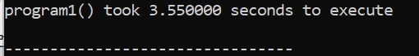

# Program 2(After reducing frequency) void program2(){

int a,b,c,d,e,f,g,h =0; c = d + e; f = g + h;

for(int i=0; i<1000000000; i++) {

a = b + i ;

}

}

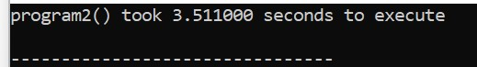

## b. Loop Jamming

Loop jamming or loop fusion is a technique for combining two similar loops into

one, thus reducing loop overhead by a factor of 2. For example, the following C code:

for (i=1;i<=100;i++) x[i]=y[i]*8;

for (i=1;i<=100;i++) z[i]=x[i]*y[i];

can be replaced by

for (i=1;i<=100;i++)

{ x[i]=y[i]*8; z[i]=x[i]*y[i];

};

**Code:**

#include<stdio.h>

#include <time.h>

void loopJam(){

int a =1; int b= 5; for(int i =0;i<1000000000;i++){ a = a + i;

}

for(int j =0;j<1000000000;j++){

b = b + j;

}

} int main(){ clock_t t; t = clock(); loopJam(); t = clock() - t;

double time_taken = ((double)t)/CLOCKS_PER_SEC; // in seconds

printf("loopJam() took %f seconds to execute \n", time_taken);

}

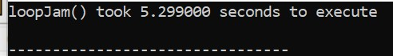

**After reducing:**

#include<stdio.h> #include <time.h> void loopJam(){

int a =1; int b= 5; for(int i =0;i<1000000000;i++){

a = a + i; b = b + i;

}

}

int main(){ clock_t t; t = clock(); loopJam(); t = clock() - t;

double time_taken = ((double)t)/CLOCKS_PER_SEC; // in seconds printf("loopJam() took %f seconds to execute \n", time_taken); }

