**Matrix Multiplication:**

Write a Java program to perform matrix multiplication.

package matrix;

public class MatrixMultiplication {

public static void main(String[] args) {

int[][] num1 = { { 3, 4, 5 }, { 8, 6, 7 } };

int[][] num2 = { { 3, 4 }, { 8, 6 }, { 7, 5 } };

int result[][] = new int[num1.length][num2[0].length];

for (int i = 0; i < num1.length; i++) {

for (int j = 0; j < num2[0].length; j++) {

for (int k = 0; k < num1[0].length; k++) {

result[i][j] += num1[i][k] * num2[k][j];

}

}

}

// Print the result

for (int i = 0; i < result.length; i++) {

for (int j = 0; j < result[0].length; j++) {

System.out.print(result[i][j] + " ");

}

System.out.println();

}

}

}

**OUTPUT**:

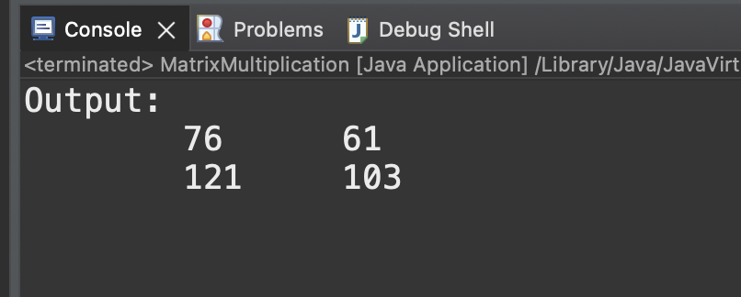

**Swing GUI:**

Create a Java Swing GUI application that allows users to input their name and displays a personalized greeting message using JLabel and JTextField.

package Swing;

// imports

import javax.swing.JFrame;

import javax.swing.JLabel;

import javax.swing.JTextField;

import java.awt.event.ActionEvent;

import java.awt.event.ActionListener;

public class JavaGui {

public static void main(String[] args) {

JFrame frame = new JFrame("Greeting Application");

JLabel label = new JLabel(" Name:");

// create objects

final JTextField textField = new JTextField();

final JLabel resultLabel = new JLabel();

// position set Display

label.setBounds(10, 20, 150, 30);

textField.setBounds(170, 20, 100, 30);

resultLabel.setBounds(10, 70, 300, 30);

textField.addActionListener(new ActionListener() {

public void actionPerformed(ActionEvent e) {

String name = textField.getText();

resultLabel.setText("Hello, " + name + "!");

}

});

// add to frames

frame.add(label);

frame.add(textField);

frame.add(resultLabel);

frame.setLayout(null);

frame.setDefaultCloseOperation(JFrame.EXIT_ON_CLOSE);

frame.setSize(300, 150);

frame.setVisible(true);

}

}

**Output**:

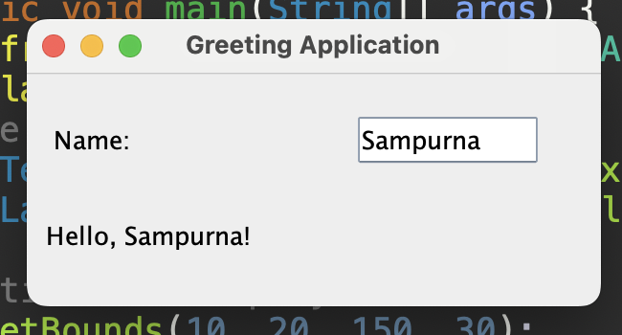

**Java Applet:**

Develop a simple Java applet program

Interface:

Define an interface named Shape with methods calculateArea() and calculatePerimeter(). Implement this interface in two classes: Circle and Rectangle. Write a program to demonstrate the use of the interface.

// interface class

package interfaces;

public interface Shape {

double calculateArea();

double calculatePerimeter();

}

package interfaces;

public class Circle implements Shape{

private double radius;

public Circle(double radi) {

this.radius= radi;

}

public double calculateArea() {

return Math.PI * radius * radius;

}

public double calculatePerimeter() {

return 2 * Math.PI * radius;

}

}

package interfaces;

class Rectangle implements Shape {

private double length;

private double width;

public Rectangle(double length, double width) {

this.length = length;

this.width = width;

}

public double calculateArea() {

return length * width;

}

public double calculatePerimeter() {

return 2 * (length + width);

}

}

package interfaces;

public class Main {

public static void main(String[] args) {

Circle circle = new Circle(5.0);

Rectangle rectangle = new Rectangle(7.0, 6.0);

System.out.println("\nCircle Area: "+ circle.calculateArea());

System.out.println("Circle Perimeter: " + circle.calculatePerimeter());

System.out.println("\nRectangle Area: " + rectangle.calculateArea());

System.out.println("Rectangle Perimeter: " + rectangle.calculatePerimeter());

}

}

**OUTPUT:**

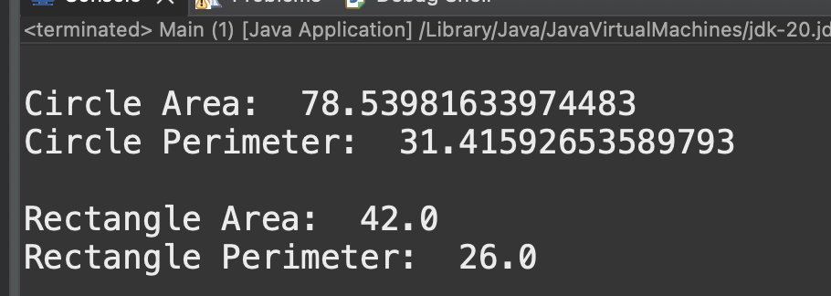

**Abstract Class:**

Create an abstract class called Vehicle with abstract methods start() and stop(). Implement this abstract class in two concrete classes: Car and Motorcycle. Demonstrate the use of abstract classes and their methods.

package abstracts;

abstract class Vehicle {

public abstract void start();

public abstract void stop();

}

package abstracts;

public class Car extends Vehicle {

public void start() {

System.out.println("\nRabin Car Enginee start");

}

public void stop() {

System.out.println("Rabin Car Enginee stop");

}

}

package abstracts;

public class Motorcycle extends Vehicle {

public void start() {

System.out.println("\nDuke 200 Enginee start");

}

public void stop() {

System.out.println("Duke 200 Enginee stop");

}

}

package abstracts;

public class Vehicle_Main {

public static void main(String[] args) {

// create an objects

Motorcycle bike = new Motorcycle();

Car car = new Car();

// call methods

bike.start();

bike.stop();

car.start();

car.stop();

}

}

**OUTPUT:**

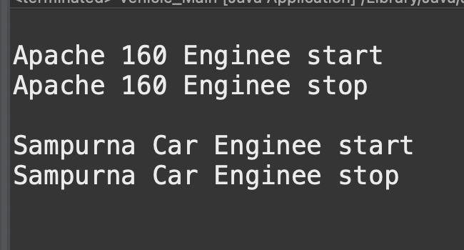

**Super Class / Inheritance:**

Design a class hierarchy representing different types of animals. Include a superclass Animal with subclasses such as Mammal, Bird, and Fish. Implement the concept of inheritance and demonstrate it through a program.

package inheritance;

//Animal.java

public class Animal {

//common attributes of all animals

protected String name;

//constructor

public Animal(String name) {

this.name = name;

}

//common behaviors of all animals

public void eat() {

System.out.println(name + " is eating.");

}

public void sleep() {

System.out.println(name + " is sleeping.");

}

}

public class Birds extends Animal {

public Birds(String name) {

super(name); // call the constructor of the superclass

}

public void fly() {

System.out.println(name + " is flying. \n");

}

}

public class Fish extends Animal {

// constructor

public Fish(String name) {

super(name);

}

// specific behavior of fish

public void breathe() {

System.out.println(name + " is breathing with gills.\n");

}

}

public class Mammal extends Animal {

//constructor

public Mammal(String name) {

super(name);

}

//specific behavior of mammals

public void breathe() {

System.out.println(name + " is breathing with lungs.\n");

}

}

public class Main {

public static void main(String[] args) {

// Creating objects

Mammal mam = new Mammal("Human");

Birds sparrow = new Birds("Sparrow");

Fish goldfish = new Fish("gold fish");

mam.eat();

mam.sleep();

mam.breathe();

sparrow.eat();

sparrow.sleep();

sparrow.fly();

goldfish.eat();

goldfish.sleep();

goldfish.breathe();

}

}

**OUTPUT:**

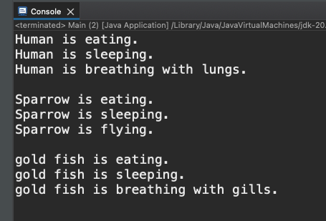

**Constructors**:

Create a class called Book with attributes title, author, and price. Include a default constructor and a parameterized constructor. Write a program that creates instances of the Book class using both constructors.

package constructor;

public class Book {

String name;

String author;

double price;

// Default constructor

Book(){

name= "Seto Dharti";

author = "Baburam Neupane";

price = 345.00;

System.out.println("Default Constructor: ");

}

// Parameterized Constructor

public Book(String nam, String auth, double paisa) {

this.name = nam;

this.author = auth;

this.price = paisa;

System.out.println("\nParameterized Construcor: ");

}

// display

void show() {

System.out.println(" Name: " + name + "\n Author: " + author + "\n Price: " + price);

}

}

public class Book_Main {

public static void main(String[] args) {

Book bok = new Book();

bok.show();

Book book = new Book("11 Minutes", "Paulo ", 800.00);

book.show();

}

}

**OUTPUT:**

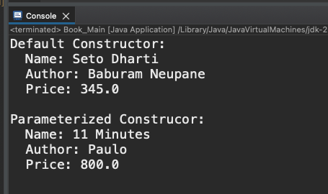

**Error Handling:**

Write a Java program that reads an integer from the user. Handle the possibility of the user entering a non-integer value and provide appropriate error messages. Ensure the program does not crash due to invalid input.

package error_Handling;

import java.util.Scanner;

public class IntegerErrors {

public static void main(String[] args) {

Scanner sc = new Scanner(System.in); // Scanner input

int num2 = 12;

System.out.println("Enter integer value: ");

try {

int num = sc.nextInt();

int result = num2 / num;

System.out.println(result);

} catch (ArithmeticException ex) {

System.out.println("Arithmetic Exception: " + ex);

} catch (Exception ex) {

System.out.println("Error: ");

}

}

}

**OUTPUT:**

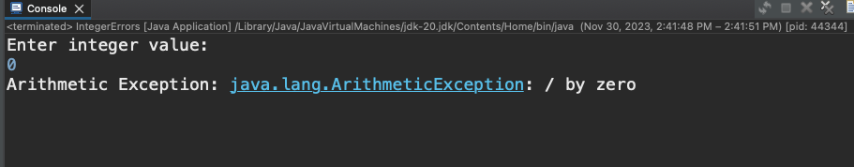

**GUI-Based Functional Calculator:**

Design a GUI-based functional calculator using Java Swing. Include basic arithmetic operations (addition, subtraction, multiplication, division). Implement error handling for division by zero and invalid input.

package calculator_app;

public class Calculator {

public static void main(String[] args) {

new Calculation();

}

}

package calculator_app;

import java.awt.Color;

import java.awt.Font;

import java.awt.GridLayout;

import java.awt.event.ActionEvent;

import java.awt.event.ActionListener;

import javax.swing.JFrame;

import javax.swing.JPanel;

import javax.swing.JTextField;

import javax.swing.JButton;

// create class and implements the actionListener

public class Calculation implements ActionListener {

// create objects of the different frame

JFrame frame;

JTextField textfield;

JButton[] numberButtons = new JButton[10];

JButton[] functionButtons = new JButton[8];

JButton addButton, subButton, mulButton, divButton;

JButton decButton, equButton, delButton, clrButton;

JPanel panel;

Font myFont = new Font("Ink Free", Font.BOLD, 30);

double num1 = 0, num2 = 0, result = 0;

char operator;

Calculation() {

frame = new JFrame("Calculator");

frame.setDefaultCloseOperation(JFrame.EXIT_ON_CLOSE);

frame.setSize(420, 550);

frame.setLayout(null);

textfield = new JTextField();

textfield.setBounds(50, 25, 300, 50);

textfield.setFont(myFont);

textfield.setEditable(false);

addButton = new JButton("+");

subButton = new JButton("-");

mulButton = new JButton("*");

divButton = new JButton("/");

decButton = new JButton(".");

equButton = new JButton("=");

delButton = new JButton("Delete");

clrButton = new JButton("clear");

functionButtons[0] = addButton;

functionButtons[1] = subButton;

functionButtons[2] = mulButton;

functionButtons[3] = divButton;

functionButtons[4] = decButton;

functionButtons[5] = equButton;

functionButtons[6] = delButton;

functionButtons[7] = clrButton;

for (int i = 0; i < 8; i++) {

functionButtons[i].addActionListener(this);

functionButtons[i].setFont(myFont);

functionButtons[i].setFocusable(false);

}

for (int i = 0; i < 10; i++) {

numberButtons[i] = new JButton(String.valueOf(i));

numberButtons[i].addActionListener(this);

numberButtons[i].setFont(myFont);

numberButtons[i].setFocusable(false);

}

// Buttons positioned

delButton.setBounds(50, 430, 145, 50); // delete button position

clrButton.setBounds(205, 430, 145, 50); // clear button position

panel = new JPanel();

panel.setBounds(50, 100, 300, 300);

panel.setLayout(new GridLayout(4, 4, 10, 10));

panel.setBackground(Color.gray);

panel.add(numberButtons[1]);

panel.add(numberButtons[2]);

panel.add(numberButtons[3]);

panel.add(addButton);

panel.add(numberButtons[4]);

panel.add(numberButtons[5]);

panel.add(numberButtons[6]);

panel.add(subButton);

panel.add(numberButtons[7]);

panel.add(numberButtons[8]);

panel.add(numberButtons[9]);

panel.add(mulButton);

panel.add(decButton);

panel.add(numberButtons[0]);

panel.add(equButton);

panel.add(divButton);

// Buttons add to the frame

frame.add(textfield);

frame.add(delButton);

frame.add(clrButton);

frame.add(panel);

frame.setVisible(true);

}

@Override

public void actionPerformed(ActionEvent e) {

for(int i=0; i<10; i++) {

if(e.getSource() == numberButtons[i]) {

textfield.setText(textfield.getText().concat(String.valueOf(i)));

}

}

if(e.getSource() == decButton) {

textfield.setText(textfield.getText().concat("."));

}

if(e.getSource() == addButton) {

num1 = Double.parseDouble(textfield.getText());

operator = '+';

textfield.setText("");

}

if(e.getSource() ==subButton) {

num1 = Double.parseDouble(textfield.getText());

operator = '-';

textfield.setText("");

}

if(e.getSource() == mulButton) {

num1 = Double.parseDouble(textfield.getText());

operator = '*';

textfield.setText("");

}

if(e.getSource() == divButton) {

num1 = Double.parseDouble(textfield.getText());

operator = '/';

textfield.setText("");

}

if(e.getSource()==equButton) {

num2 = Double.parseDouble(textfield.getText());

switch(operator) {

case '+':

result = num1 + num2;

break;

case '-':

result = num1 - num2;

break;

case '*':

result = num1 * num2;

break;

case '/':

result = num1 / num2;

break;

}

textfield.setText(String.valueOf(result));

num1 =result;

}

if(e.getSource()==clrButton) {

textfield.setText("");

}

if(e.getSource()==delButton) {

String string = textfield.getText();

textfield.setText("");

for(int i=0; i<string.length()-1;i++) {

textfield.setText(textfield.getText()+string.charAt(i));

}

}

}

}

**OUTPUT:**

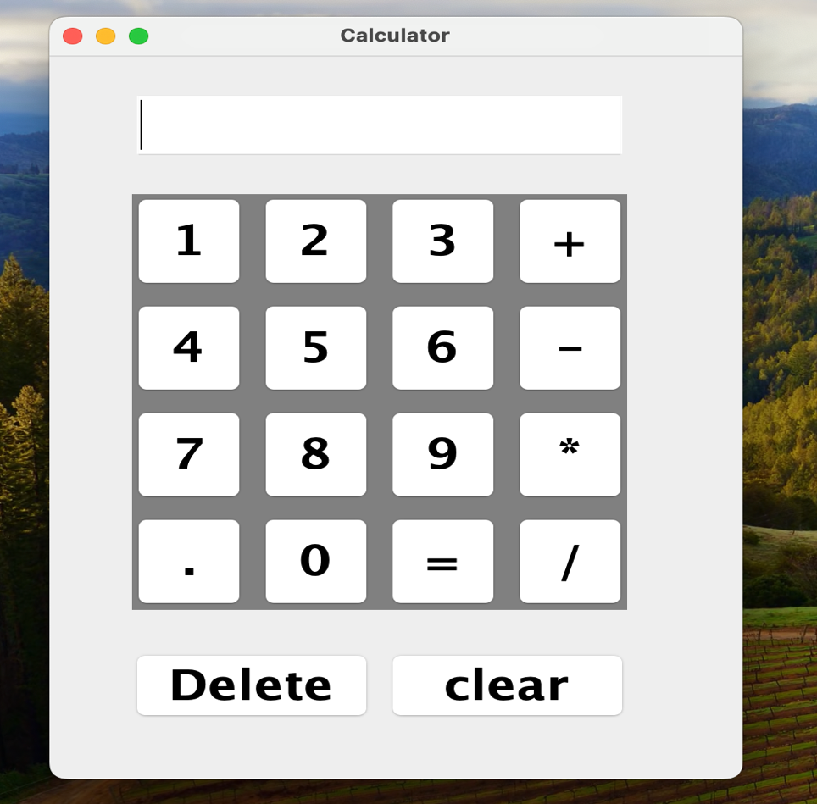

**- Implement a Java program that creates two threads. One thread should print even numbers, and the other should print odd numbers from 1 to 10.**

**- Create a Java program with two threads sharing a common resource (e.g., a counter). Implement synchronization to ensure that the threads alternate incrementing the counter.**

**- Develop a Java program that creates three threads with different priorities.**

**- Create a Java program that reads data from a text file and displays it on the console. Ensure proper exception handling.**

**- Write a Java program to copy the contents of one text file to another new file.**

**- Design a simple login form using Java Swing components. Include JTextField for username, JPasswordField for password, and a JButton to submit the login. Display a message in a JLabel based on whether the login is successful or not.**