# Lab1: Getting familiarized with SQL Join

1. Find all employees who work on IT department and have salary>2000.

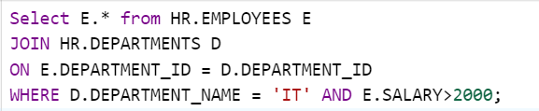

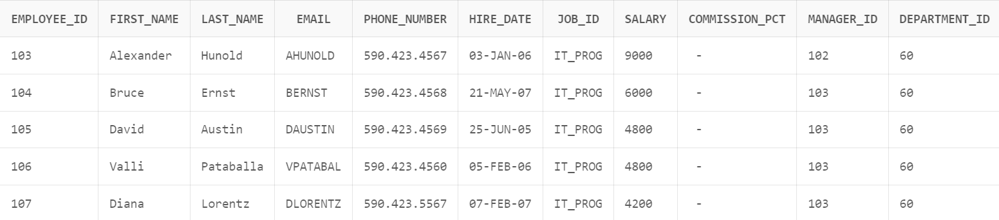

1. Find all employees who works on department located at country 'United States of America' and have salary>4000.

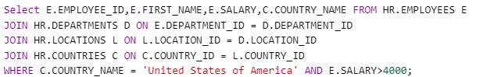

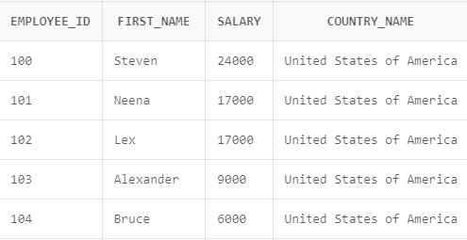

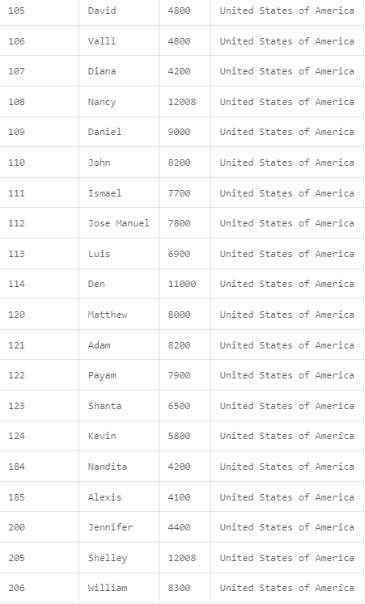

# Lab2:  Getting familiarized with Horizontal Fragmentation

1. **Primary Horizontal Fragmentation**  
   - Divide Employees table with IT and Sales department in different fragments

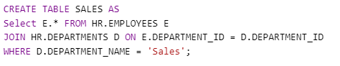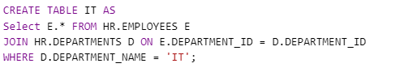

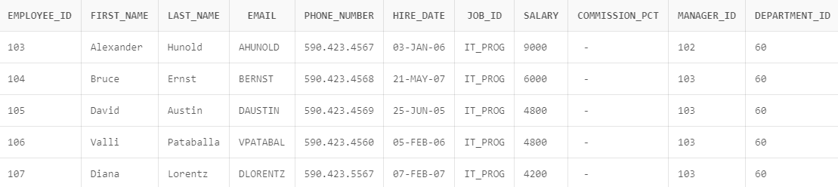IT

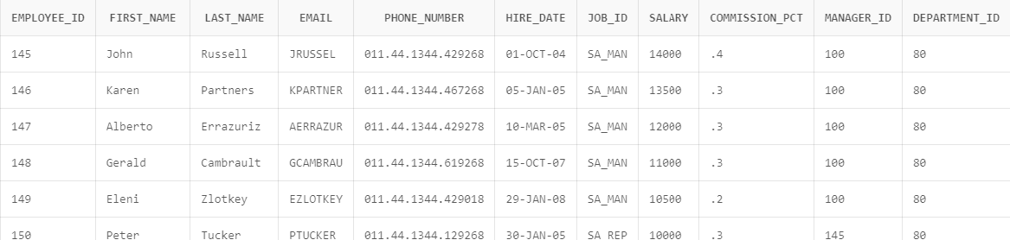SALES

1. **Derived Horizontal Fragmentation**  
   - Create a different fragment for all employees who works on department located at country 'United States of America' and have salary>4000

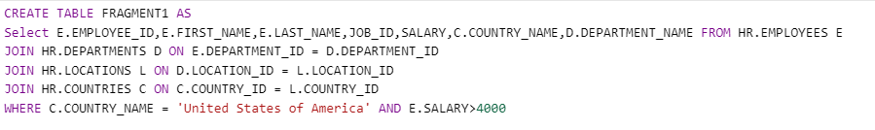

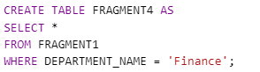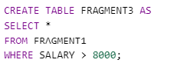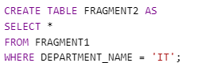

1. **Reconstruction from fragmented DB**  
   - Fetch all employees who work on IT department and Sales department from fragments created on section 1.  
   - Select all employees who are in IT and Sales department

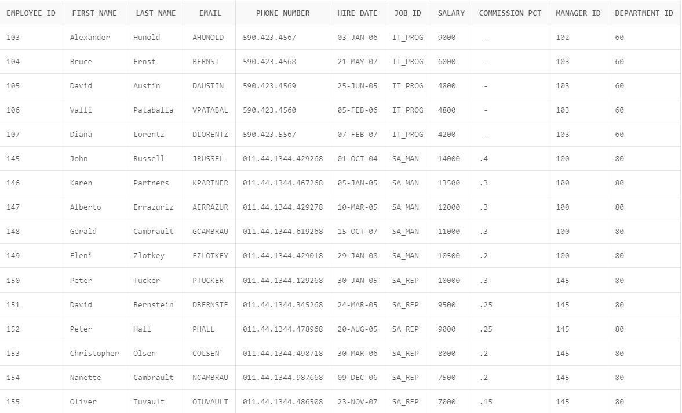

# Lab 4: Getting familiarized with Vertical Fragmentation

1. Divide HR. EMPLOYEES table to hold employees related information in different fragment and JOB description (all related columns) in different fragment.



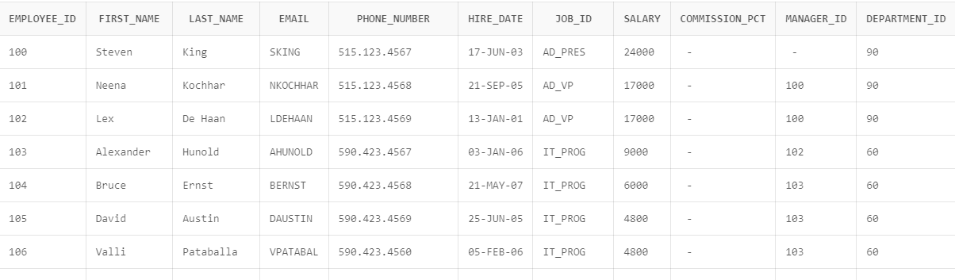

1. employee information must hold EMPLOYEE_ID, FIRST_NAME, LAST_NAME, EMAIL, PHONE_NUMBER, HIRE_DATE  
   job description fragment must hold EMPLOYEE_ID, JOB, SALARY, DEPARTMENT_ID, DEPARTMENT_NAME, JOB_TITLE

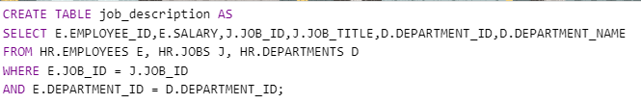

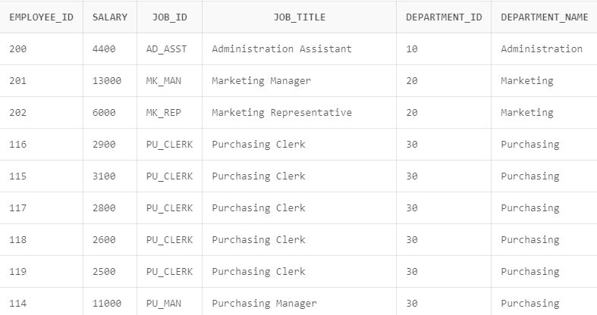

1. Reconstruct all employees and job information from fragment tables in part 1.

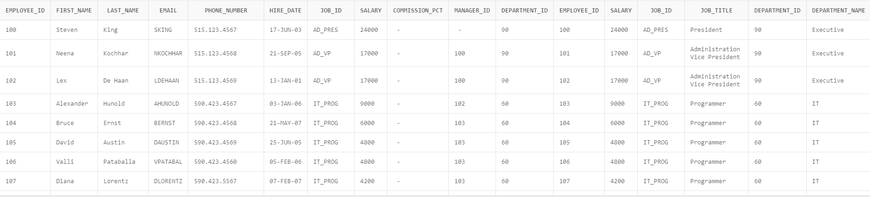

# Lab 4: Getting familiarized with DB-LINK.

Syntax to create the DB-link:

CREATE DATABASE LINK dbLink

CONNECT TO remote_user

IDENTIFIED BY password

USING ‘remote-database’:

Step 1:

SALES =

( DESCRIPTION=

ADDRESS =(PROTOCOL = TCP)

//(HOST = 10.50.100.143)

(PORT =1521)

(CONNECT_DATA =

(SERVER= DEDICATED)

(SERVICE_NAME = SALES_PRD)

)

)

Step 2:

CREATE DATABASE LINK sales

CONNECT TO bob IDENTIFIED BY 'password'

USING 'SALES';

Step 3:

Insert data

INSERT INTO customer@sales customer_id, name, email)

VALUES (4, 'ABC', 'contact@outlook.com');

Select data:

select * from customers@sales;

Update the data:

Update customer@sales

set name = ‘User User’ where customer_id = 17;

Delete the data:

delete from customer@saleswhere customer_id = 17;