JasperServer User's Guide

Version 3.7

© 2010 Jaspersoft Corporation. All rights reserved. Printed in the U.S.A. Jaspersoft, the Jaspersoft logo, JasperAnalysis, JasperServer, JasperETL, JasperReports, JasperStudio, iReport, and Jasper4 products are trademarks and/or registered trademarks of Japsersoft Corporation in the United States and in jurisdictions throughout the world. All other company and product names are or may be trade names or trademarks of their respective owners.
Table of Contents
1 Introduction 1
1.1 What is JasperServer? 1
1.2 Who is this guide for? 1
1.3 Related documents 1
2 Terms and concepts 1
2.1 JasperServer Report 1
2.2 JRXML 1
2.3 Resource 2
2.4 Data source 2
2.5 Query 2
2.6 Image 2
2.7 Input control 2
2.8 Data type 3
2.9 Analysis view 3
2.10 OLAP client connection 3
2.11 Mondrian connection 3
2.12 XML/A connection 4
2.13 Mondrian XML/A source 4
2.14 Analysis schema 4
2.15 MDX query 4
3 Accessing Reports and Analytics 5
3.1 Running a report 5
3.1.1 Running a report from the repository browser 5
3.1.2 Running a report with cascading input controls 7
3.1.3 Running a report through direct URL 8
3.2 Using Report Scheduler 10
3.2.1 Report browser 10
3.2.2 Report jobs list 10
3.2.3 Report job details 11
3.2.4 Quick background execution 17
3.2.5 Built-in report parameters 17
4 JasperServer Administration 18
4.1 Creating a folder 18
4.2 Creating a simple report 19
4.2.1 Naming the new report 19
4.2.2 Add the JRXML file, logo, and data source 20
4.3 Creating a complex report 25
4.3.1 Naming the new report 25
4.3.2 Add the JRXML file, logo, and data source 26
4.3.3 Adding input controls 26
4.3.4 Adding external resources 31
4.3.5 Adding a datasource 32
4.3.6 More on data types 33
4.4 Creating reports using the iReport plugin 33
4.4.1 Plugin features 34
4.4.2 Making connection to JasperServer 35
4.4.3 Using the plugin 37
4.4.4 Folders 37
4.4.5 Importing JDBC connections into iReport 38
4.4.6 Creating a JasperServer Report from iReport 39
4.4.7 Edit a JRXML 40
4.4.8 Running a JasperServer Report from iReport 40
4.4.9 Adding an image to a report 41
4.4.10 Adding an subreport to a report 43
4.4.11 Resources, input controls, data types, lists of values and data sources 44
4.4.12 Repository resource chooser 44
4.5 Adding resources directly to the repository 45
4.6 Move/Copy resources in the repository 46
4.6.1 Copying resources 46
4.6.2 Moving a folder 47
4.7 Searching the repository 48
4.7.1 Searching by name 49
4.7.2 Navigating the folder tree 50
4.7.3 Refining with filters 51
4.7.4 Changing the search expression 52
4.7.5 Interacting with the list of resources 52
4.8 Security Maintenance 53
4.8.1 Overview 53
4.8.1.1 Authentication 53
4.8.1.2 Authorization 54
4.8.2 Creating a role 54
4.8.3 Creating a user 55
4.8.3.1 Changing role assignments for existing users 57
4.8.4 Configuring Password Options 58
4.8.4.1 Changing Password Encryption Settings 58
4.8.4.2 Allowing Users to Change Their Passwords 59
4.8.4.3 Enabling Password Expiration 60
4.8.5 Setting Permissions 60
5 Utilities 60
5.1 Import/Export 60
5.1.1 Import Resources 60
5.1.2 Export Resources 61
5.2 Message viewer 62
5.2.1 Messages list 62
5.2.2 Message details 63
5.3 iReport Plugin installation and configuration 63
5.3.1 Requirements 63
5.3.2 Plugin installation 64
5.3.3 Configuring the plugin 65
5.3.4 Troubleshooting 67
6 Advanced configuration 67
6.1 Custom Data Sources 67
6.1.1 Background on data sources in JasperServer and JasperReports 67
6.1.1.1 Query executers 68
6.1.2 Custom Data Source Examples 68
6.1.2.1 Custom Bean Data Source 69
6.1.2.2 Webscraper Custom Data Source 69
6.1.3 Creating a Custom Data Source 70
6.1.3.1 Files used by a custom data source implementation 70
6.1.3.2 Implementing the ReportDataSourceService Interface 70
6.1.3.3 Defining Custom Data Source Properties 70
6.1.3.4 Implementing Optional Interfaces 70
6.1.3.5 Creating the Message Catalog 71
6.1.3.6 Defining the Custom Data Source in Spring 71
6.1.3.7 Configuring the Message Catalog 72
6.1.4 Installing a Custom Data Source 72
6.1.5 Using a Custom Data Source 73
6.2 Report output channels 73
6.2.1 Excel output 73
6.2.2 CSV output 74
6.3 Configuring Login Page 74
7 Integrating JasperServer and Liferay Portal 74
7.1 Changing Liferay’s Port Numbers 74
7.2 Configuring JasperServer to Accept Web Services Calls 75
7.3 Configuring Liferay to Access JasperServer 75
7.4 Testing Liferay 76
7.5 Deploying the JasperServer Portlet WAR File 76
7.6 Configuring a Default Report to Display 77
7.7 Testing the JasperServer Portlet 78
7.8 JasperServer Portlet Configuration Options 78
7.8.1 Portlet Parameters 78
7.8.1.1 image_servlet_ssl_enabled 78
7.8.1.2 portal_server 78
7.8.1.3 show_logo 78
7.8.1.4 show_return_to_report_list_icon 78
7.8.1.5 show_return_to_parameter_icon 79
7.8.1.6 company_logo 79
7.8.1.7 company_logo_hyper_link 79
7.8.1.8 report_directory 79
7.8.1.9 number_of_reports_per_page 79
7.8.2 Example Server and Browser Configuration 79
7.8.2.1 applicationContext-security 80
7.8.2.2 portlet.xml 80
7.8.2.3 Browser URL 80
7.9 Setting up JasperReports Hyperlinks for Use in a Portlet Environment 80

Introduction

What is JasperServer?
JasperServer is a framework that lets you build a Web application around JasperReports and use JasperAnalysis, an implementation of Online Analytical Processing or OLAP, to perform on-line analytical tasks. Using JasperReports, it lets you create, schedule and run reports, and manage resources, roles, and permissions. It also provides a sample Web-based user interface that lets you create and manage reports and other resources. Using JasperAnalysis, it lets you interact with analysis views to perform operations such as slice/dice, drill down/drill through, etc. It also lets you create new analysis views with OLAP schemas and various data sources.

Who is this guide for?
This guide is for users of the sample user interface provided with JasperServer.
With respect to JasperReports, in the current release, you must use iReport, or write JRXML code, to create the JRXML file that is the basis of the report. The sample JasperReports UI only assembles the JRXML file and other resources into a report that you can run. This UI cannot create a JRXML file.
Note: To use this user interface, you must be very familiar with the JasperReport (.jrxml) files that are the basis of the JasperServer report. It is assumed that you understand JRXML and you are very familiar with all the resources that a JRXML file refers to.
With respect to JasperAnalysis, in the current release, you must supply OLAP schemas in XML format, corresponding data sources as JDBC or JNDI, and MDX queries. The sample JasperAnalysis UI only assembles the schemas, data source and MDX queries into analysis views that you can interact. This UI cannot create schemas or MDX queries. For more information, refer to the JasperAnalysis User's Guide.

Related documents
- JasperServer Installation Guide
- JasperAnalysis User's Guide
- JasperServer Developer’s Guide
- JasperServer Web Services Client Install Guide
- JasperServer Database Scripts install Guide
- The Definitive Guide to JasperReports
- iReport manual

Terms and concepts

JasperServer Report
A JasperServer report is what you actually run to generate output. A report consists of a set of resources. (See the Resource section.)
A JasperServer report may contain resources in either the file system or the repository.

JRXML
JRXML is JasperReport's XML-based report definition language. Every JasperServer report must contain one main JRXML file and one for each subreport it might contain.

Resource
A resource is one of the following elements of a report:
- a JRXML file (see the JRXML section)
- a data source (JNDI or JDBC)
- a query
- fonts
- images
- data types (see the Data type section)
- JAR files for JasperReports scriptlets
- resource bundles for localization and internationalization
- subreports
Every JasperServer report must contain a JRXML file and a data source. The other resources may or may not be required, depending on the contents of the JRXML file. Therefore, to create a report, you must know the resources required by the JRXML file.
You can retrieve resources from the file system or the repository.

Data source
The three supported data source types are JDBC, JNDI and Bean.
For reports with MDX queries in their main JRXMLs, OLAP client connections are used as data sources. Such reports use the Mondrian and XML/A query executers included in JasperReports when launched.

Query
Instead of the query stored inside the JRXML file, a report can make use of a reusable query from the repository.

Image
You can point to an image in one of the following three ways:
- using a URL
- using the classpath
- using the "repository" syntax (i.e., repo:/image/logo.jpg)

Input control
Input controls are values that can be mapped to JasperReports parameters. Depending on their various data type, input controls can be visualized as:
- Single value input control – a text box containing the input control's value. It may contain some text value, or a number or a date.
- Boolean input control – a check box which can be either checked (usually corresponding to a boolean true) or unchecked (equivalent of a boolean false).
- Static list input control – a single selection list box mapping key/value pairs on the list entries.
- Single query-backed input control – a single selection list box where any entry should correspond to the query key/value column.
- Multi-valued or multiple query input control – a multiple selection list box where multiple values can be assigned to the same URL parameter
(e.g. parameter=value1&parameter=value2&parameter=value3).
Note that all list input control types are based on key/value pairs. It is essential that keys are unique in a given list of items. Below are some reasons for requiring keys in list input controls to be unique:
- If the user selects one of several different items having the same key/value in a combo box type of input control, there is no way to know which of those different items was selected. This means that when returning to the input control form, for running the report again, one cannot reselect the exact same item in the list that they have picked. At best, the first item matching the memorized key can be highlighted.

- Same issue with identifying items in list when input control values are saved for the scheduler (saved options). The user returning to a saved options form will not see the original items selected in a list box, because it is impossible to distinguish between several items having the same key, while only keys are saved.

- One idea is to memorize the index in the list, not the key of the value. But this poses a potential problem because items in a list can change over time (see query backed input controls) and the index that are memorized will not match the selection made when the saved options were saved. Over time, scheduled reports might end up running with different values that the user creating them intended.

- Same problem with identifying the original user selection in the case of multi-select list input controls backed by sets (unique values collection). If the user selects two items having the same key, when going back to the input control form they will see only one item being selected, probably not even one of those who they actually selected in the first place.

- Default values defined in JRXML for report parameters, show up as preselected values in list input controls. But the exact item meant by the specified key returned as default value cannot be determined. The only possibility is to select the first match in the list.

Same problem with reports that are ran by direct URL in which the parameters are encoded in the URL itself. When the input control will pop-up, the list input controls might not highlight the exact items they wanted.

Data type
In JasperServer, a data type is a set of constraints on the value of an input control. It contains more information (for example, maximum and minimum values) than a data type in most programming languages.

Analysis view
An analysis view consists of an OLAP client connection and a MDX query for providing an entry point to OLAP operations, such as slice/dice, drill down and drill through.

OLAP client connection
An olap client connection contains the connection definitions for retrieving an analysis view. The two types of OLAP client connection are Mondrian connection and XML/A connection.

Mondrian connection
A Mondrian connection is a type of OLAP client connection, which consists of an OLAP schema and a data source used to access an analysis view.

XML/A connection
An XML/A connection is a type of OLAP client connection, which consists of SOAP definitions used to access an analysis view on a remote XML/A Provider.

Mondrian XML/A source
A Mondrian XML/A source is a server-side XML/A source definition for defining how XML/A connections will be processed from remote clients to access an analysis view via a Mondrian connection on this server.

Analysis schema
An analysis schema is a file resource for defining and documenting the structure of OLAP cubes, dimensions and measures in XML format.

MDX query
MDX query is a language for querying multidimensional objects, such as cubes, and return cube data for analytical processing.

Accessing Reports and Analytics
The user interface features four menu buttons:
Menu name | Function
Home | Describes JasperServer.
View | Shows metadata for, and lets you run, reports in the repository. All reports for which you have read permission appear regardless of which folder they're in.
Manage | Contains the Repository, Roles, and Users submenus. It appears only if you have administration privilege.
Logout | Logs you out of JasperServer.

Running a report
First, you'll run the sample SalesByMonth report. This report contains four input controls: a text input control, a Boolean checkbox, a list input control, and a date input control.

Running a report from the repository browser
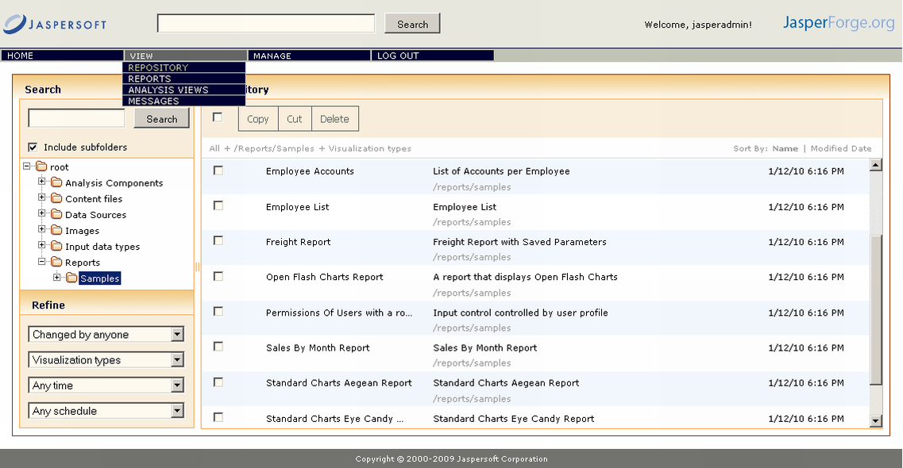
- Mouse on the VIEW menu.
- Click the REPOSITORY menu item.
- Click the samples folder
- Click the SalesByMonth sample. Then click on the Report Options button in the left upper corner. A list of controls appears.
- For the Text Input Control, enter 999.
- Check the Checkbox Input Control.
- In the List Input Control dropdown list, select Yet Another Item.
- In the Date Input Control, click the calendar icon (on the right).
- Choose a date.
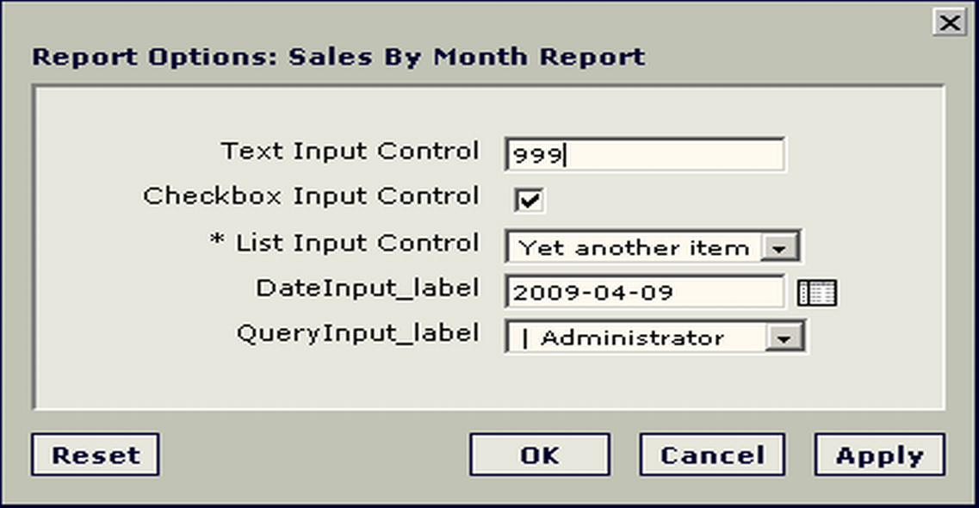

- Click OK and wait for the report to run. Notice the values in the report title. These are derived from the values you gave for the input controls. Navigate through the report using the left- and right-arrow controls at the top of the report.
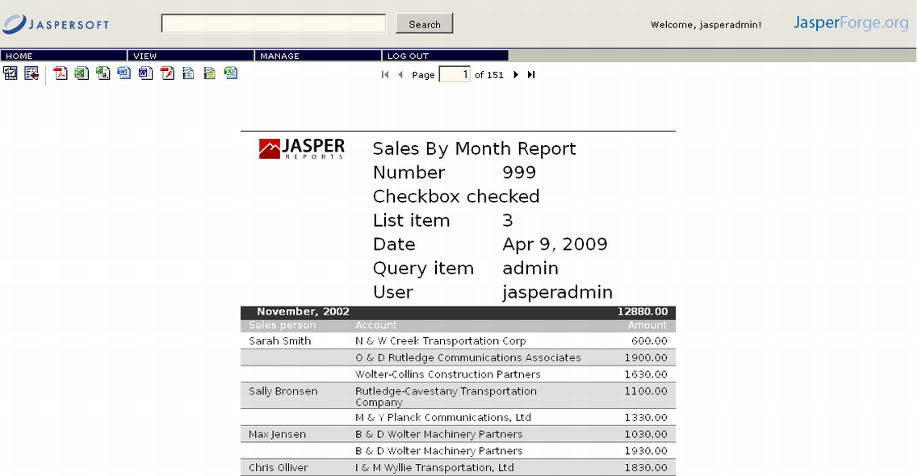

- Click the PDF icon. The report appears in a separate browser in PDF format.
- Click the Close icon () to close the report.
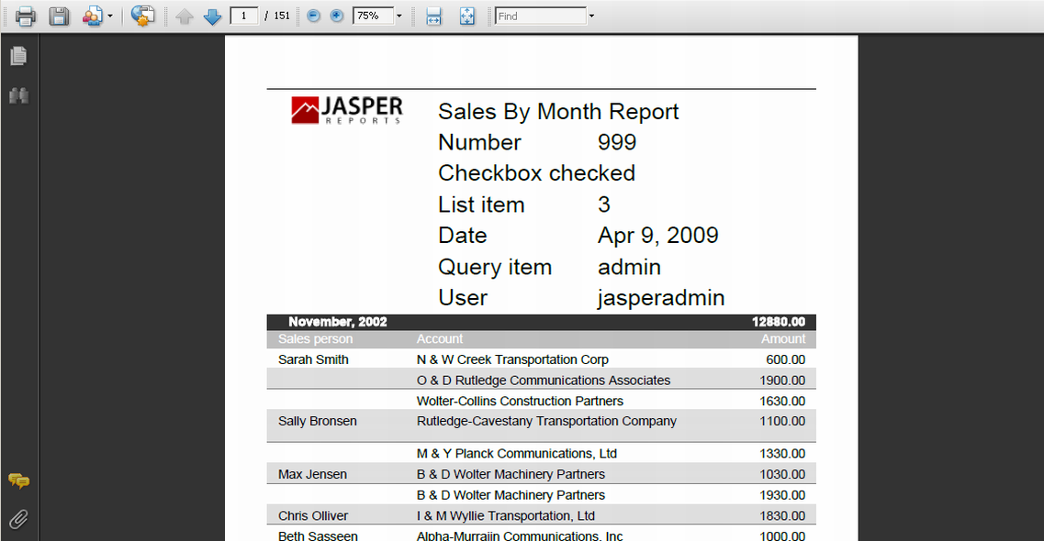

Running a report with cascading input controls
With simple input controls, every value chosen is independent of the others. Reports can also be designed with cascading input controls, where the choice for one input determines the choices for the other input. For example, the choice of a country determines which states or regions are available to choose from.
The following example also demonstrates required inputs, in which case you must enter values before running the report.
To run a report with cascading input controls:
- Mouse on the VIEW menu.
- Click the REPOSITORY menu item.
- Click the samples folder
- Click the Cascading multi select example report in the list of results. Instead of running the report, you are prompted to enter new values for them.
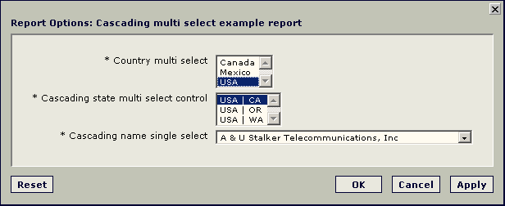
- Select a different country in the first field, in this example, Mexico. The other fields are automatically updated to reflect the state and names associated with Mexico in your data. Cascading input controls are implemented as queries that access your database to retrieve the new values. JasperServer displays an activity monitor while the query is running, and in the case of long queries, you can click Cancel and select different values.
- Select a different state, for example Guerrero. The names field updates to reflect the choice of state. The country and state inputs are defined as multi-select; use control-click to select multiple values in each lists. The other values are updated to reflect your choices.
- Click OK to run the report with your chosen values. The report creates a list of all account names in the chosen states of the chosen countries. The chosen name is listed at the top of the report.

Running a report through direct URL
Reports stored in JasperServer can be executed via direct URLs that can be used or embedded into external applications. All the information required to execute a JasperServer report can be passed as URL parameters.
A report execution URL has the following syntax:
<JS deployment context>/flow.html?_flowId=viewReportFlow&<report execution parameters>
The first part is the base URL of the JasperServer deployment, for instance
http://server:8080/jasperserver
if JasperServer is deployed as jasperserver on the server machine on port 8080.
The report execution parameters can be either reserved parameters used by JasperServer to determine general attributes of the report execution, or arbitrary parameters that correspond to the report input controls/parameters. The parameters are specified as standard HTTP GET parameters, i.e. in the form of name=value and separated by & characters.
The following general parameters are recognized by JasperServer:
- reportUnit is the URI of the report unit resource in the JasperServer repository.
- output (optional) specifies the desired report output format.
If it is not present or html is used as value for the parameter, the default JasperServer report viewer is used as output.
Other values for this parameter are given by the report exporters configured in JasperServer. By default, JasperServer recognizes the following output types: pdf for PDF, xls for Excel, rtf for RTF, csv for CSV and swf for the JasperServer Flash report viewer.
- reportLocale is used to pass the locale in which the report is to be executed. A locale is passed as code consisting of a lower-case two letter ISO-639 language code, followed by optional upper-case two letter ISO-3166 country code and a locale variant, separated bu underscore (the format is identical to the standard Java locale programmatic names).
- j_username and j_password can be used to pass the credentials to be used to authenticate a user with JasperServer. The username should correspond to a valid JasperServer user, and password should be the user password (in clear text).
If such credential parameters are not present, and no authenticated JasperServer session exists, and JasperServer is not configured to use automatic authentication mechanisms (such as Single sign-on), the user accessing a report execution URL will be first required to provide a username and a password on the login screen, and then redirected to the actual report execution screen. The two authentication parameters can be used to skip the login screen and have the user directly presented with the report execution screen.
Note that these two parameters are not specific to report execution URLs, they can be used for any URLs that point to a JasperServer web page.
Apart from these standard parameters, report execution URLs can contain parameters that provide values for the report input controls/parameters. The URL parameter names must match the name of the corresponding report input control. The URL parameter values are specified depending on the input control type:
- For simple single value input controls, the desired value is used as URL parameter value:
  - If the type of the input control is text, the URL parameter value is directly used as input control value.
  - If the type of the input control is numeric, the URL parameter value is the numerical value formatted according to standard rules, using a dot as decimal separator.
  - If the type of the input control is date or date/time, the URL parameter value is the date/time value formatted according to the yyyyMMddHHmmss format (e.g. 20090621054500 for June 21st 2009, 05:45). The formatted value is interpreted according to JasperServer's default timezone.
- For boolean/checkbox input controls, the URL parameter value can be either true of false.
- For input controls backed by static list of values, the URL parameter value should be the key/value of the list entry.
- For query-backed input controls, the URL parameter value should correspond to the query key/value column.
- For multi-valued input controls, multiple occurrences of the same URL parameter can be used (e.g. parameter=value1&parameter=value2&parameter=value3).
A special marker URL parameter can be used for multi-valued input controls to specify that an empty list should be used as input control value; the marker URL parameter uses as name the name of the input control prefixed by an underscore and doesn't require any value. This is useful when a multi-valued input control has a non-empty list as default value, and the user wants to override the default value with an empty list.
If the report parameter values included in a report execution URL are not valid (i.e. if a required parameter is missing or a parameter value is not valid), the report input controls are displayed to the user so that they can be corrected.

Using Report Scheduler
The report scheduler runs report execution jobs in the background and saves the execution result in the repository. Users can define such jobs and schedule them to run at specific moments in the future and find the resulting reports in the repository or receive the results by email.

Report browser
In the report browser, there are context menu options that provide access to the report scheduling functionality, on right-click mouse on a selected report unit.
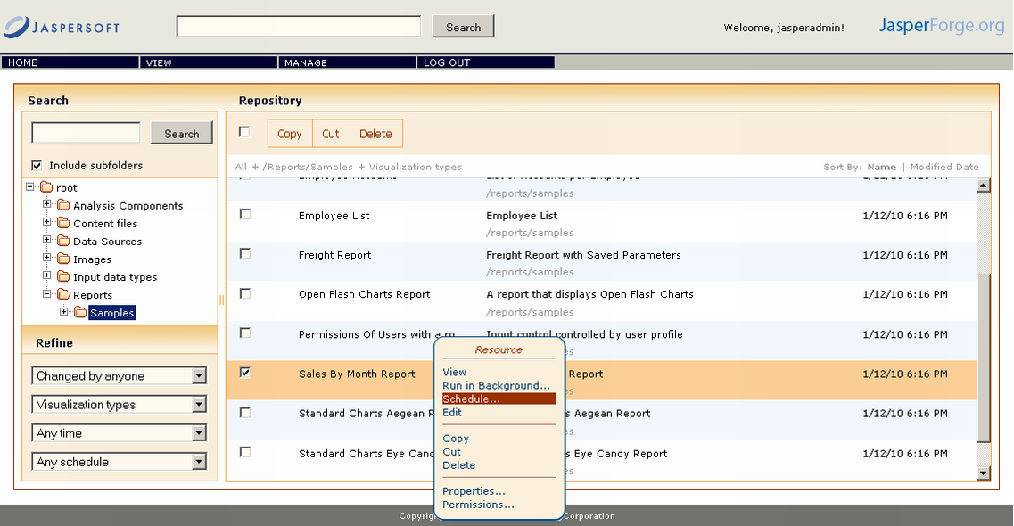
The two menu options have the following purposes:
- The "Schedule..." context menu open the list of jobs defined for the report.
- The "Run in Background..." provides a quick way to run a report in background (asynchronously), i.e. to schedule a report execution job that would get executed immediately. More about this here.

Report jobs list
When the "Schedule..." menu option is used, the list of report jobs opens.
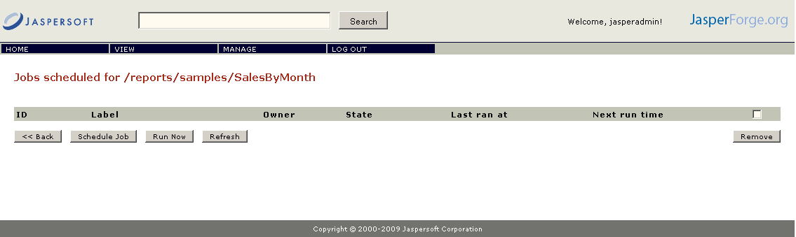
Each regular user only sees his own jobs, while administrative users will see all the report jobs.

The following information is displayed in the jobs list:
- the job ID, accompanied by a link that opens the job for editing.
- the job label, which is a short description provided while creating the job
- the job owner, i.e. the user that created the job

- the job state, which is one of:
  - Normal: the job is scheduled
  - Running: the job is currently running
  - Complete: the job has completed all its executions.
  - Error: the scheduler encountered an error while scheduling or triggering the job. This does not include the cases when the job is successful triggered, but some error occurs during execution.
- the last time the job was fired
- the next time the job will get fired
Several controls are placed on the report jobs list:
- The "Back" button is used to return to the report browser screen.
- The "Schedule Job" button is used to create a new job for the report. Clicking it opens the job details screen.
- The "Run Now" has the same purpose as the "Run in background" icon on the report browser screen (more details here).
- The "Refresh" button is used to refetch from the server an updated jobs list.
- The "Remove" button is used to delete the selected jobs. Jobs are selected via the checkboxes placed on all rows; the checkbox placed on the list header can be used to select/unselect all the jobs.
When a jobs gets deleted, it will be unscheduled but if the job is currently running the execution will not be stopped. Completed report jobs, i.e. jobs that will not be fired again, will be automatically deleted from the scheduler.

Report job details
The report job details consist of information required to schedule a report execution:
- schedule information: when should the report be executed
- report parameters
- output: where should the resulting report be sent
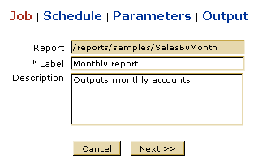
The job details screens are used both for scheduling a new job and for viewing/updating an existing one.
The first screen contains general job description attributes:
- The job label is a short description that will get displayed in the jobs list.
- The job description (optional) is a long job description.
The second screen is used to define job scheduling information. This information consists of job start and end times and from optional recurrence information. The user can set the following scheduling attributes:
- A time zone to use for the scheduling dates. By default, the scheduling dates and times are interpreted in the server time zone, but the user has the option to specify the dates in another time zone and the scheduler will take this into account when firing the job.
- A start date to indicate when the job should become effective. The user has the option of instructing the job to start immediately or at a specific date and time in the future. The start date has slightly different meaning depending on the recurrence type. If no recurrence is defined, the start date will be the date the job is going to be executed at.
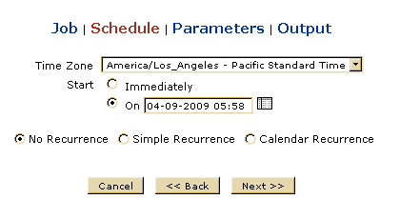
Apart from this attributes, the user can optionally specify a recurrence scheme for the job. There are two types of recurrence mechanisms that can be used: simple recurrence and calendar recurrence.
The simple recurrence mechanism allows the user to schedule the job to recur at fixed time intervals.
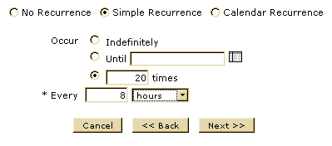
The user can set the following attributes:
- Maximum number of occurrences is optional and specifies the maximum number a job can occur. The job would occur until either the occurrence count reaches this value or the end date (if defined) is reached. The user can also choose not to specify a maximum number of occurrences and let the job recur indefinitely or until the end date.
- The fixed recurrence interval, composed of a numerical value and a unit of measure. The user can specify the interval in minutes, hours, days or weeks.
In case of simple recurrence, the job start date will be the date the job is going to be first fire at and the next occurrences will be computed based on the start date and the recurrence interval.
The calendar recurrence mechanism allows users to define jobs that recur at specific calendar moments.
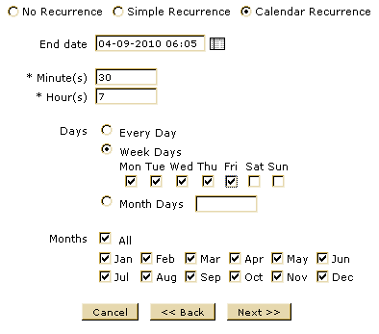
The End date field specifies the date limit until the job will be performed. If it is not specified, the job will run indefinitely.
The user needs to specify the minutes, hours, days and months the job should occur at:
- One can specify one or more minutes the job should be executed at. The accepted values are in the 0 to 59 range. In the most common scenarios, only one value would be set for the minutes. If the report needs to be executed multiple times per hour, the minutes can be specified using the following syntax:
- X,Y,Z,... – the job will be executed at minutes X, Y, Z, ..
- X-Y – the job will be executed every minute from X to Y
- * - the job will be executed every minute
- The hour(s) field is similar to the minutes, with the difference that the accepted values are in the 0 to 23 range.
- To select the days the job should run on, the user has three options:
- Set the job to run every day.
- Set the job to run on specific week days.
- Set the job to run on specific month days. The month days field is similar to the minutes field, with accepted values in the 1 to 31 range.
- The months the job should be executed on are selected individually. A checkbox to select/deselect all months is available for convenience.
If the user chooses calendar recurrence, the job will first be executed at the first moment after the start date that matches all the defined date and time values. The job would then recur at each matching date and time until the end date is reached or indefinitely if an end date is not set.
If the report has input controls, the job details will contain a set of input values which will be used when executing the report. A separate screen, identical to the one used when directly executing the report, will allow the user to input value for the report parameters.
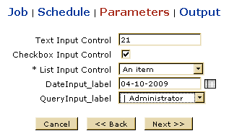
Finally, the user has to define the job output attributes. Each time the job runs, the results are saved into the content repository. Optionally, the result can also be distributed by email to one or more recipients.
The following attributes can be set in the job output screen:
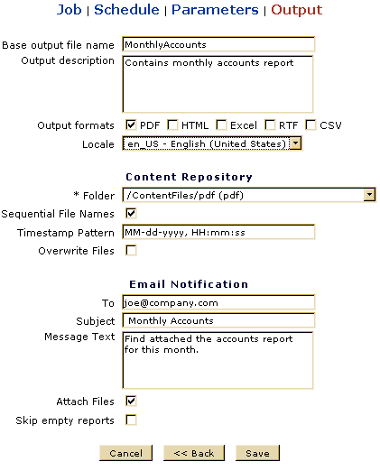
- The base output filename is used to derive all output filenames by appending an optional timestamp and a format extension.
- The user needs to choose at least one output format. The available list includes PDF, HTML, Microsoft Excel, RTF and CSV.
- The user can choose a locale that should be used when filling the report. If no specific locale is selected, the server will use the default locale.
- The content repository folder where all the resulting files should be saved has to be selected.
- The user can choose to include a timestamp in the file names used to save the job results. This is useful for recurring jobs when multiple results need to be kept.
- The user can instruct the scheduler whether overwriting existing content files is allowed. If the scheduler wants to save a report and another saved report having the same name already exists, it will either overwrite it or generate an error, depending on this flag.
- In addition to saving the result in the content repository, the job creator can choose to enable an email notification for the job. Each time the job would get executed, an email would be sent to one or more recipients that would optionally include the job results as attachments.
A user needs to specify the following attributes for the email notification:
- One or more recipient addresses, separated by comma.
- The message subject.
- The message body.
- Whether the job results should be attached to the message.
- Whether the mail should not be sent when the generated is empty.
As we mentioned before, the report job details screens are used for both creating a new job and for updating an existing job. The users should note that if the scheduling attributes of a job are updated, the scheduler will recreate the trigger that fires the job execution. This might have unexpected results if the job start date is in the past and should generally be avoided. If other job attributes are updated, they will take effect from the next job execution.

Quick background execution
The "Run in background" report execution allows users to define a report job that would get fired immediately without manually entering all the job attributes. This functionality can be used to launch asynchronously long report executions and save the results in the repository (and optionally receive the results via email).
If the user wants to quickly launch a report execution in background, he will only be required to enter the report parameters if the report has input controls and to define the job output. The screens used for these tasks are the same as the ones used when scheduling a new report job.

Built-in report parameters
When a report is executed by the report scheduler, a built-in parameter named "_ScheduledTime" is used to pass to the report the date and time the report was scheduled at. The parameter needs to be declared in the JRXML in order to be used:
<parameter name="_ScheduledTime" class="java.util.Date"/>
The value can be used to filter the reported date or for displaying purposes.

JasperServer Administration
The Manage menu appears only if you have administrator privileges. It consists of the following submenus:
Repository | Displays the repository browser, which contains data sources, images, reports, and other user-created folders.
Roles | Lets you manage roles that you assign to users.
Users | Lets you see and administer users.
Analysis Properties | Displays current Mondrian properties
Flush OLAP Cache | Clears cache used by OLAP operations

Creating a folder
If you have administrator privileges, JasperServer lets you create a tree of folders in which to put your reports and resources. To do this:
- Click the REPOSITORY submenu of the VIEW menu.
- Choose or create the repository folder in which you want to create your new report. For this example, click reports. The path should display as follows:
root/Reports

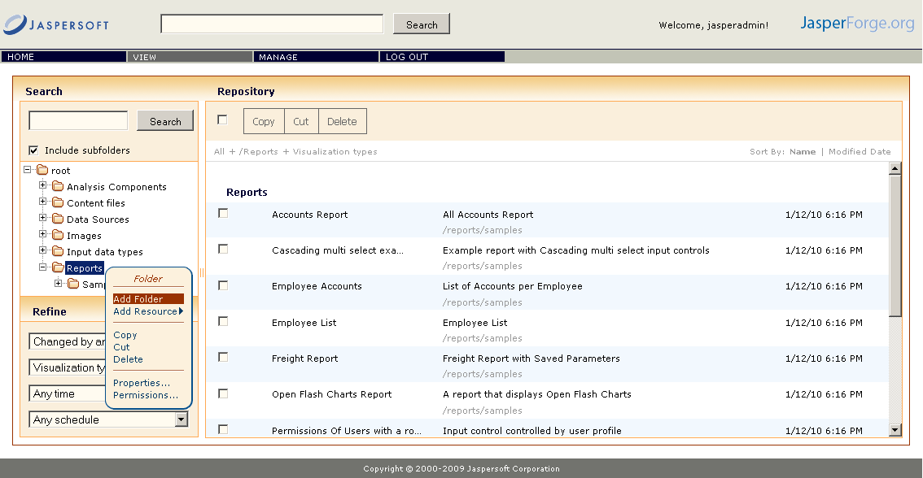
- Right-click the folder in the repository tree view and then select the Add Folder option in the context menu. The Edit Folder screen appears.
- Enter the name of the new folder you want to create. In this case, enter MyReports.
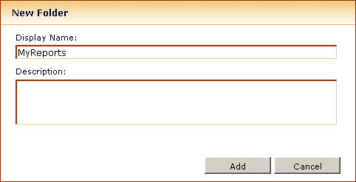

- Click Add. The folder appears in the repository.

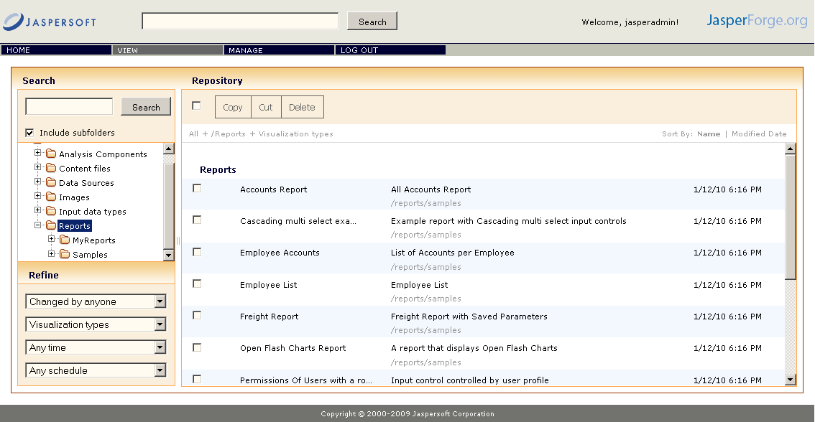

Creating a simple report
In this example, you'll create a report to run the AllAccounts.jrxml file. This is a simple report that takes no input parameters. To create the report, you must have access to the samples/reports/AllAccounts.jrxml and the samples/image/logo.jpg. Both of these resources can be found in the samples directory at the root of the JasperServer installation directory.

Naming the new report
- In the REPOSITORY browser, select the MyReports folder that you have created.
- Right-click the folder in the repository tree and then select the Add Resource/JasperServer Report option in the pop-up menu that opens.
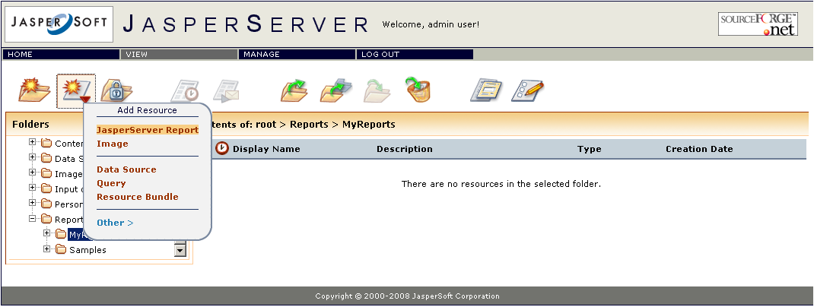
- The Create Report Wizard appears.
- For Name, enter new_simple_report.
- For Label, enter New Simple Report.
- For Description, enter This is a simple test.

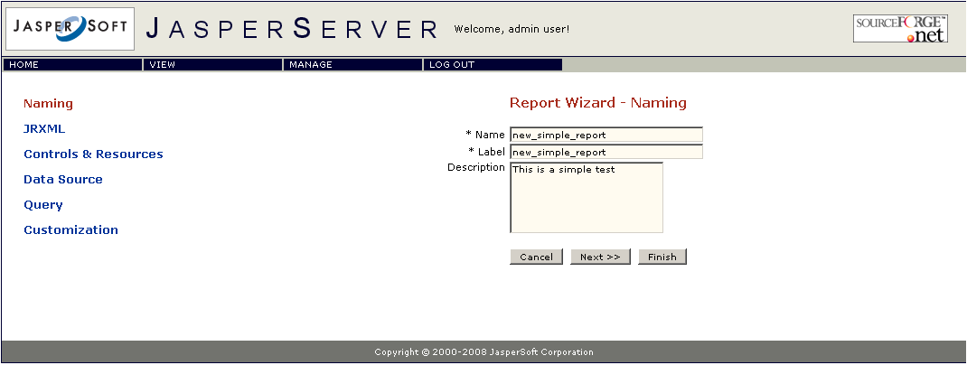

- Click Next.

Add the JRXML file, logo, and data source
- Now that you've named the report, you'll add the resources you need to run it. Under Locate main JRXML File:, click the From file System radio button.
- Click the Browse button. Locate samples/reports/AllAccounts.jrxml. (You should find it in the <JasperServer-install-dir>/samples/reports directory). Select the AllAccounts.jrxml file.
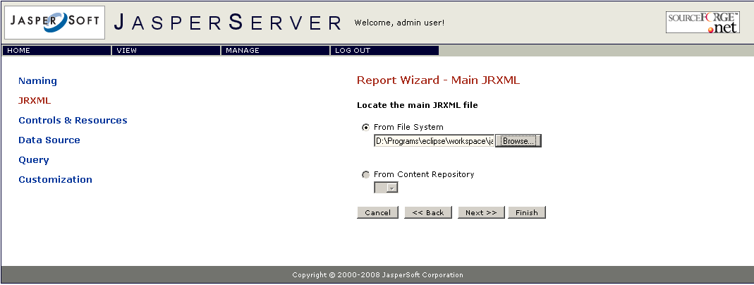
- Click Next.
- The Resource List screen shows you need the LogoLink resource.

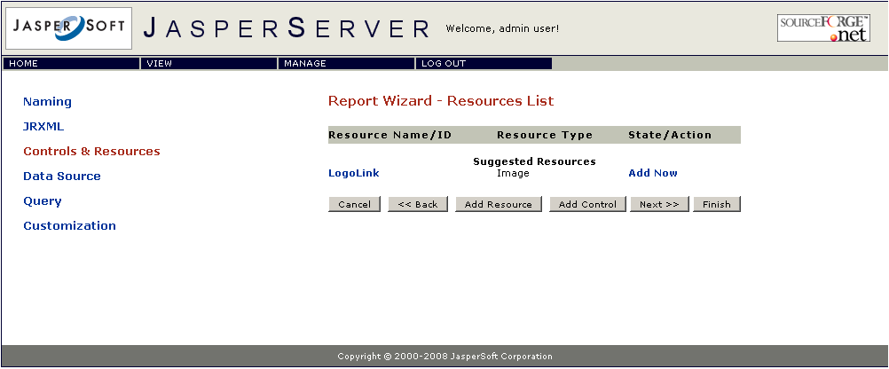
- On the right side of the LogoLink line click Add Now.
- Click the From the Repository radio button and select /images/JRLogo.

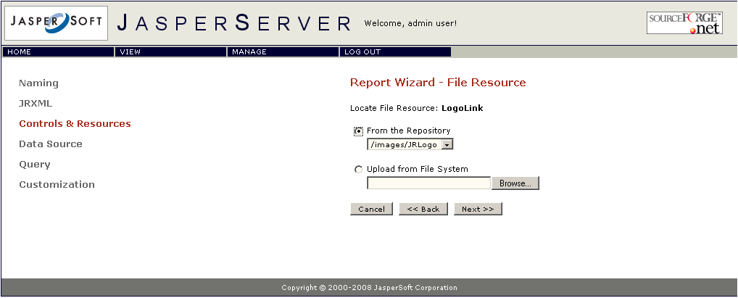
- Click Next.
- Accept the default naming of the image in the Repository. Click Next.
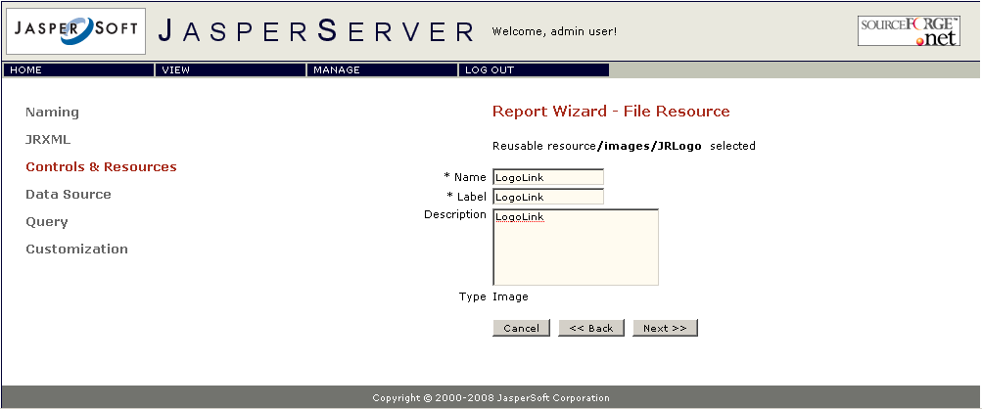
- You should now back on the Resource List screen. Click Next.
- On the Locate Data Source screen, click the From the Repository radio button.
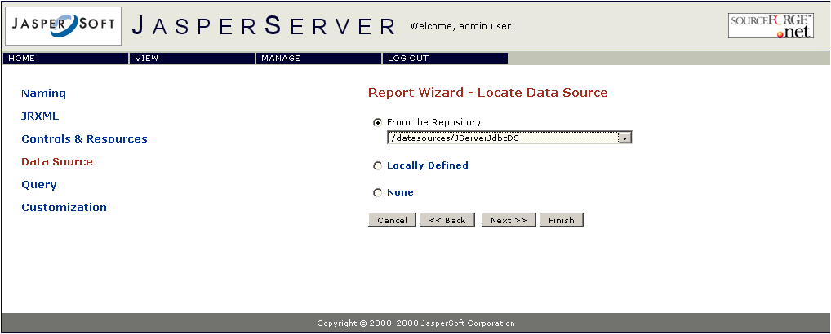

- Accept the default data source. Click Next.
- Our JRXML file already has a query inside, but are going to override it by creating local query resource; pick Locally Defined in the Locate Query page. None is for using the JRXML query, if present.
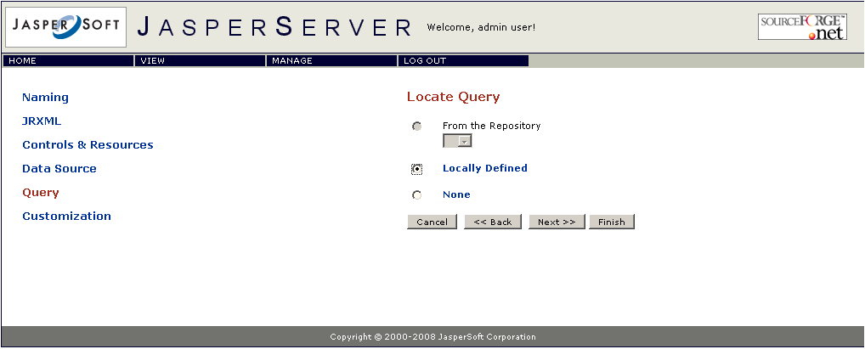
- Name they local query CanadaAccounts and use the same for label.
- Click Next.
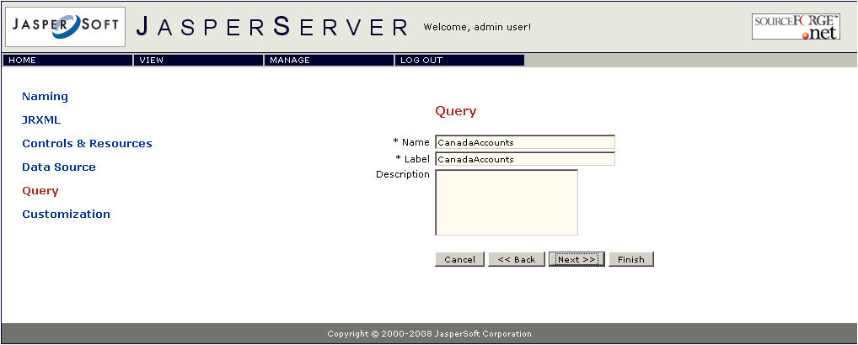
- The query itself can point to a different data source. But we want to use the data source that was already picked for the report and thus pick None.
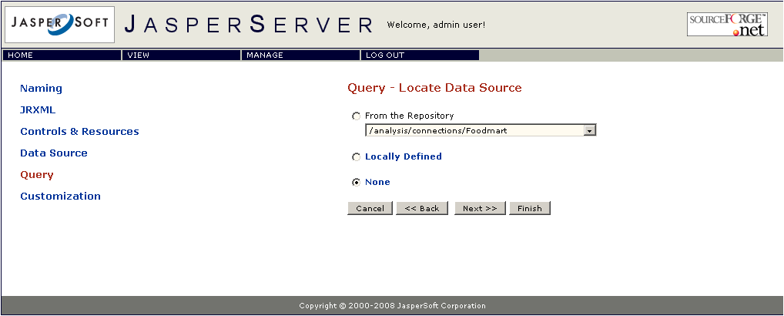
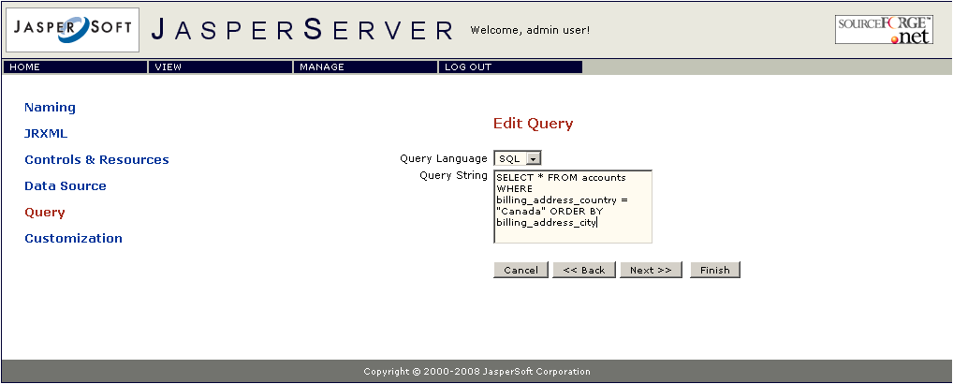
- Use SQL as query language and the following query text: SELECT * FROM accounts WHERE billing_address_country = "Canada" ORDER BY billing_address_city

- Skip the Custom Report View page by clicking Next.
- The report should be successfully validated. Click Save. You have now created your first report!
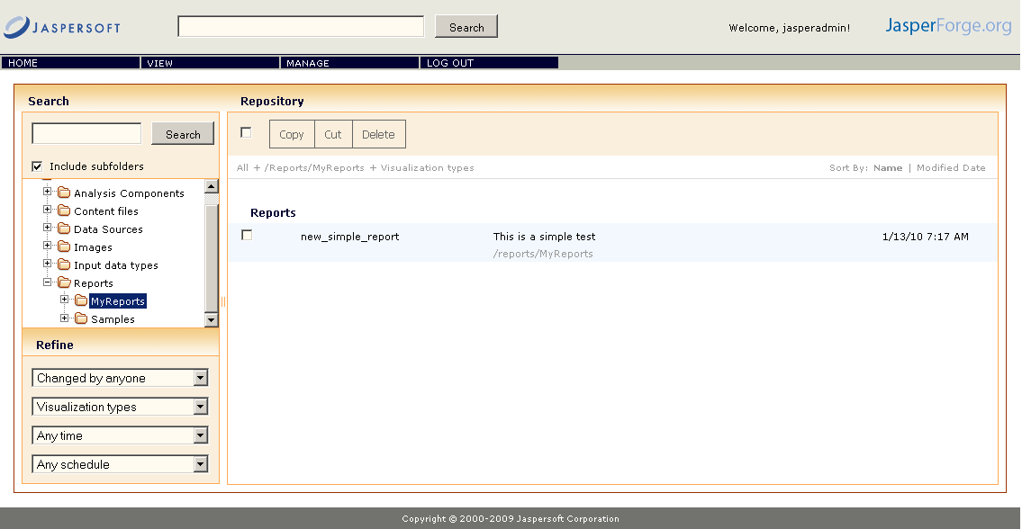
- Now, you should see your new JasperServer Report within the Repository Browser screen. Click on the new_simple_report to view the report.
The next section shows how to create a more complex report that has a full set of input controls as well as scriptlet class JAR file dependencies.

Creating a complex report
You will now create a more complex report that contains several input parameters. To create the report, you must have access to all resources, including the SalesByMonth.jrxml file, the SalesByMonthDetail.jrxml file (the subreport), a data type, and an image for the logo.
Note: It is assumed you are very familiar with the SalesByMonth.jrxml file and the resources it requires.
SalesByMonth.jrxml and the resources it needs can be found in the samples directory included in the JasperServer Installers. After installation, the samples directory is located in the root of the installation directory. Additionally, a samples.zip is available for download from the jasperintel.sourceforge.net site.
Now, you'll use the available resources to create a report that behaves just like SalesByMonth.

Naming the new report
- In the repository browser, select the MyReports folder that you have created.
- Click the Add Resource button in the toolbar and select JasperServer Report.
- The Create Report Wizard appears.
- For Name, enter new_report.
- For Label, enter New Report.
- For Description, enter This is a test report.
- Click Next.

Add the JRXML file, logo, and data source
- Now that you've named the report, you'll add the resources you need to run it. Under Locate JRXML File:, click From file System.
- Search on your file system for the SalesByMonth.jrxml file. (You should find it in the <install-dir>/samples/reports directory if you used the JasperServer installer. Otherwise, you can go to the jasperintel.sourceforge.net site and download the samples.zip file.)
- Click Next.
- The next screen shows you that you need the following resources: a subreport (the SalesByMonthDetail .jrxml file) and an image (a logo).
- Click Add Now to the right of the SalesByMonthDetail resource name.
- Click Upload From File System and browse for the SalesByMonthDetail.jrxml file.
- Click Next.
- Leave the name as SalesByMonthDetail. (Note that spaces are not allowed in the name field.)
- For the Label, enter Sales By Month Detail.
- Click Next. You'll see that you still have to locate the image for the logo.
- Click Add Now to the right of the Logo resource name.
- Click the From Content Repository radio button.
- Use repository file URI /images/JRLogo.
- Click Next.
- Leave the name Logo for name, label, and description.
- Click Next. You'll see that you've successfully located all necessary resources.

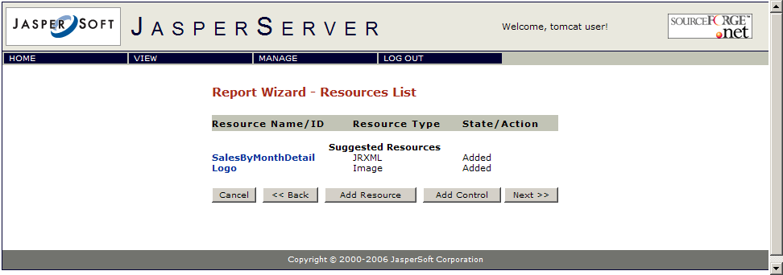

Adding input controls
Now, continuing with the same report, you'll add the input controls.
The SalesByMonth.jrxml file has four input controls: TextInput (an integer), CheckboxInput (a Boolean), ListInput (a single-select list), and DateInput (a date). You must use these exact names when creating the input controls.
- Click Add Control.
- Click the Locally Defined.
- Click Next.
- For Name, enter TextInput.
- For Label, enter Text Input Control.
- For Type, select Single Value.
- Click Next.
- Now you must define the data type (validation criteria) for the input control. Click Locally Defined.
- Click Next.
- For Name, enter integer_type.
- For Label, enter Integer Control.
- For Type, select Number.
Note: In this example, you will not fill in most of the values on this screen. See More on Datatypes below for more information on this screen.
- Click Save. You are sent back to the Resources List Screen in the report wizard. You should see TextInput in the list of resources.
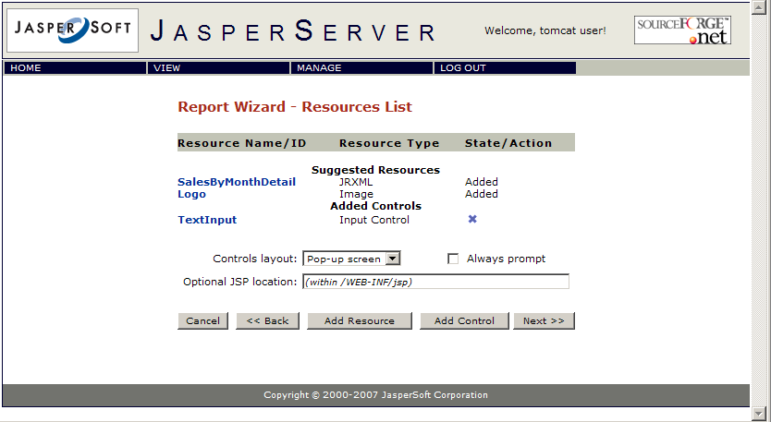
- Click Add Control.
- Click the Locally Defined.
- Click Next.
- For Name, enter CheckboxInput.
- For Label, enter Checkbox Input Control.
- For Type, select Boolean.
- Click Next. You should see the CheckboxInput in the list of resources.
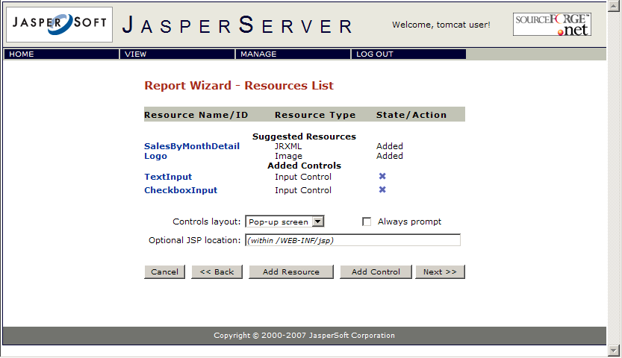
- Click Add Control.
- Click the Locally Defined.
- Click Next.
- For Name, enter ListInput.
- For Label, enter List Input Control.
- For Type, select Single Select List of Values.
- Click Next.
- Click Locally Defined.
- Click Next.
- For Name, enter list_type.
- For Value, enter List Type.
- Click Next.
- Under Label, enter First Item, under Value, enter 1. Click the plus button (+).
- You are presented with a new row for Label and Values. Enter Second Item and 2 and click the plus button (+).
- Lastly, add Third Item and 3 and click the plus button (+).
- Click Save. ListInput appears in your list of resources.
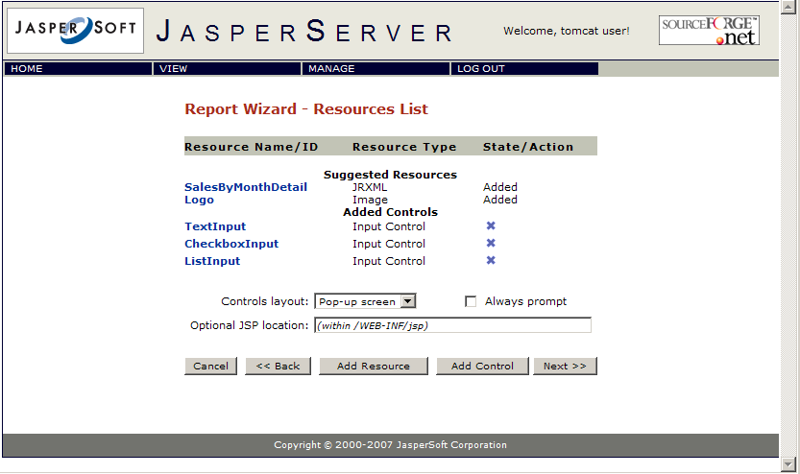
- Click Add Control.
- Click the Locally Defined.
- Click Next.
- For Name enter DateInput.
- For Label, enter Date Input Control.
- For Type, select Single Value.
- Click Next.
- Click the From the Repository radio button.
- From the drop down list, select /datatypes/date.
- Click Next.
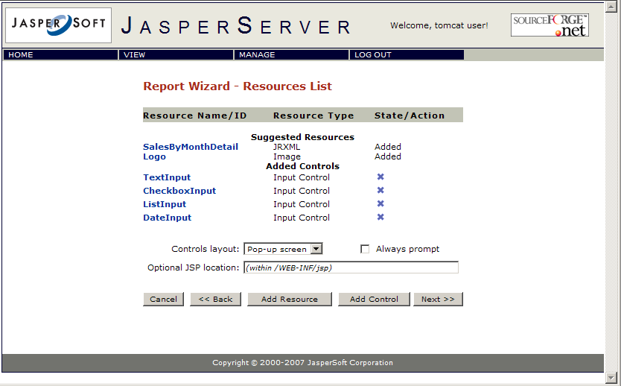
- Click Add Control.
- Click the Locally Defined.
- Click Next.
- For Name enter QueryInput.
- For Label, enter Query Input Control.
- For Type, select Single Select Query.
- Click Next.
- Click Locally Defined for the location of the query.
- For query name and for label enter testQuery
- Click Next.
- Click None for the query data source and then Next.
- For Query language leave the default SQL and for the query text enter the following: SELECT user_name, first_name, last_name FROM users
- Click Next.
- For Value column enter user_name
- Add first_name and last_name for Visible columns using the + button.
- Click Save.
- You are now done with input controls! Begin adding external resources below.
In the same screen, one can choose whether the report input controls are to be displayed in a pop-up screen on the "View Report" page or in a separate page. A custom JSP page to be used for displaying the input controls can also be specified here; the JSP file needs to already be present on the server.

Adding external resources
The JRXML file contains two external resources: a JAR file scriptlet and a resource bundle for localization. This section shows how to include them in the report.
- Click Add Resource.
- Choose From File System and browse for the scriptlet.jar file (samples/jars). Click Next. A screen appears saying the scriptlet was successfully loaded.
- For Name, enter Scriptlet. (This name is specified in the .jrxml file, so you must use this name.)
- For Label, enter Scriptlet JAR.
- Click Next.
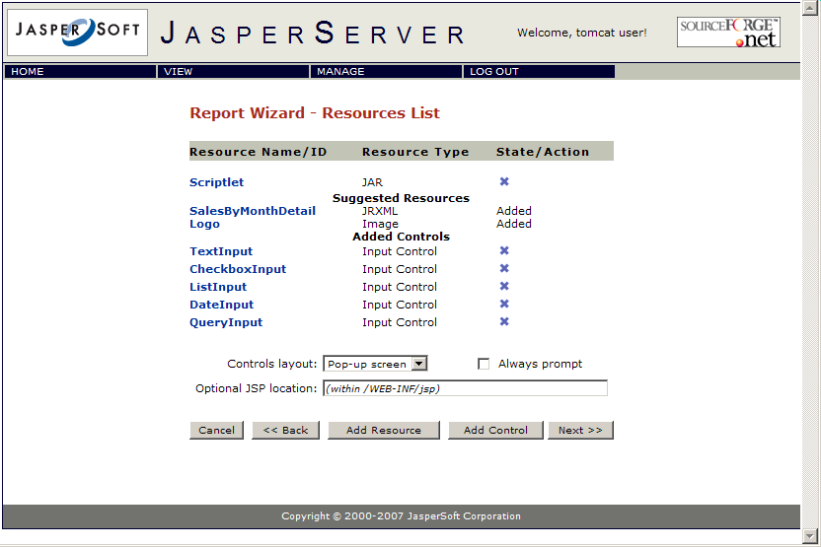
- Now you'll upload the resource bundle. Click Add Resource.
- From the file system, browse for sales.properties (samples/resource_bundles) and click Next. A screen appears saying sales.properties was successfully loaded.
- For Name, enter sales.properties. (You must use the same name as the file specified in the SalesByMonth.jrxml file.)
- For Label, enter Sales Properties.
- Click Next.
- You have returned to the Resource List screen. Continue to the next section to complete your report.
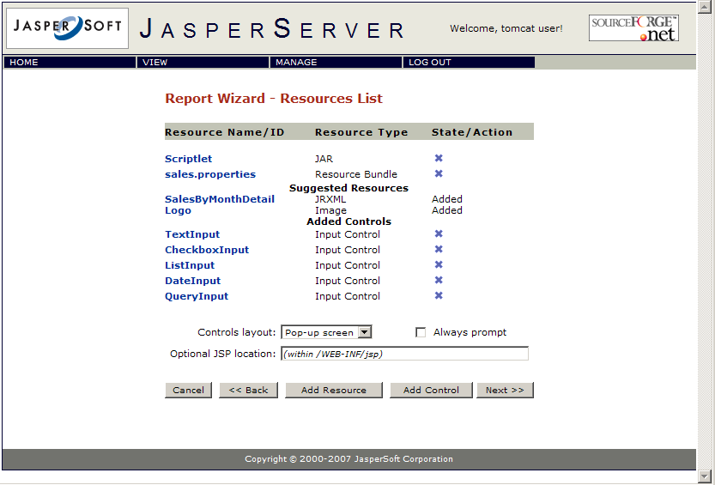

Adding a datasource
You have now finished adding all the report's resources. Now you'll add a datasource and validate the report.
- On the Resources List screen, click Next.
- Click the From the Repository radio button.
- From the drop-down list, choose /datasources/JServerJdbcDS (default selection).
- Click Next. A screen appears to say the report was successfully validated.
- Click Save. The report appears as published in the repository.

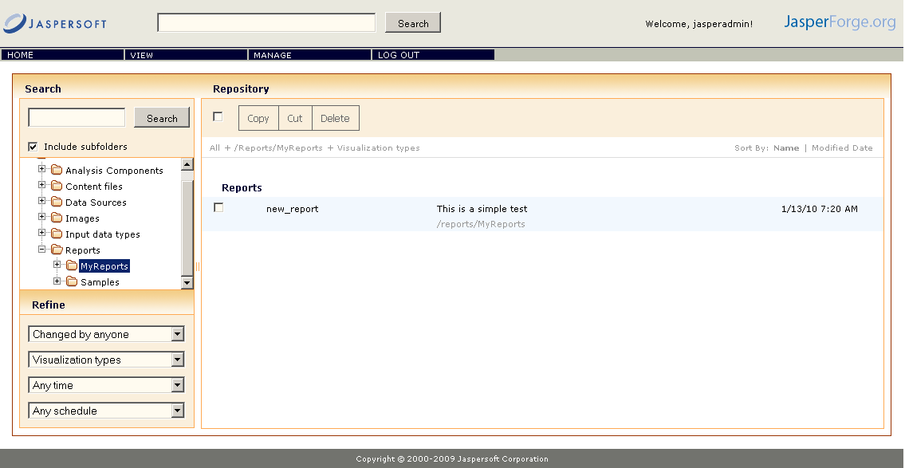
You can now click on your new report to view it. When you enter values in the the input control fields, these values appear toward the top of the report. Input Controls are typically used to modify runtime selections such as WHERE clauses in SQL queries.

More on data types
A data type in JasperServer is more than just a classification of the data. It also includes validation criteria. The data type description page contains the following fields:
Field name | Description
Name | A name of your choosing for the data type.
Label | A label of your choosing for the data type.
Description | Any additional information you want to provide about the data type.
Type | The data type, in a stricter sense. Possible values are Text, Number, Date, or Date-Time.
Max length | The maximum number of characters in the field.
Decimals | The number of decimal places in the field.
Pattern | A regular expression that restricts the possible values of the field.
Minimum value | The lowest permitted value of the field.
Is strict minimum | If checked, the minimum value itself is not permitted; only values greater than the minimum value are permitted.
Maximum value | The highest permitted value of the field.
Is strict maximum | If checked, the maximum value itself is not permitted; only values less than the maximum value are permitted.

Creating reports using the iReport plugin
The JasperServer plugin for iReport provides an easy and quick way to manage JasperServer Reports inside the JasperServer repository. The plugin uses a set of web services to interact with the server, and it is able no handle more than one server at the same time.

Plugin features
- Repository browsing
- Create / modify / delete folders
- Create / modify / delete generic resources (images, fonts, jrxml files, jars, property files, ...)
- Create/Modify/import datasources (JDBC, JNDI, JavaBean)
- Create / modify / delete JasperServer Reports
- Create/modify/delete datatypes
- Create/modify/delete List of values
- Create/modify/delete controls
- Add/remove/link controls to/from JasperServer Reports
- Drag and drop of images and subreports into the design window
- Repository resource chooser dialog

Making connection to JasperServer
For Windows platform, select the Start/All Programs/JasperSoft/iReport-1.3.x/iReport-1.3.x menu item to start iReport. (See 5.3 for a detailed description of installing and configuring the iReport plugin.)
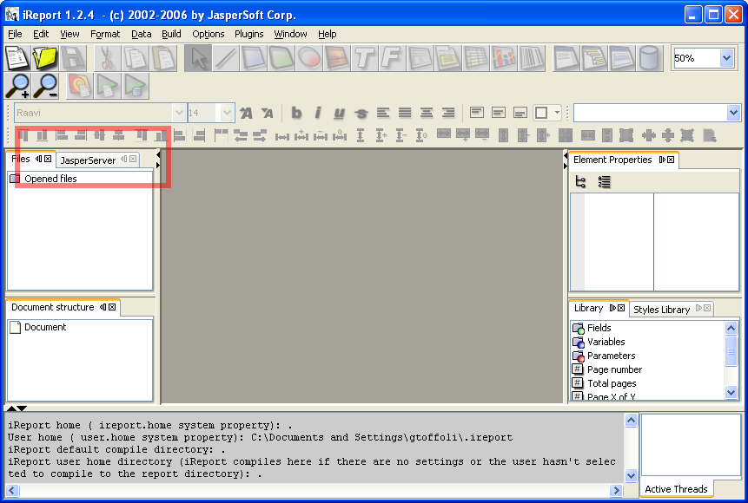
When the plugin is started for the first time, no servers are yet configured. To add a server, press the first button in the plugin toolbar.
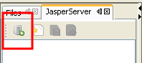
You get a dialog box titled"JasperServer Plugin" that allows for JasperServer access configuration. In this dialog box, you will enter the information that will enable you to connect to your JasperServer Web Services application.
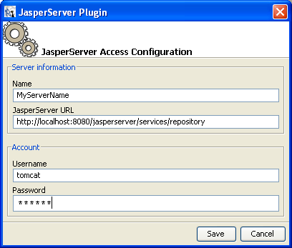
For instance:
Name: MyServerName
JasperServer URL: <you should only need to change the hostname>
Username: <jasperadmin>
Password: <password>
A server entry should now appear in this pane.

Using the plugin
Double-click on the server entry to see a list of Resources at the root of the JasperServer repository. You may view the property information on the Resources in the repository. You may download, edit and upload jrxml files. You may download images and other files (using right-click "export file").
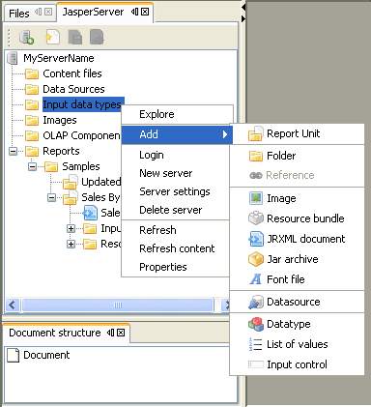
You can browse the repository double-clicking the server and folder icons.

Folders
When a folder is selected, you can add one of the following objects into a folder:
- another folder
- a brand new JasperServer Report
- a generic resource (like an image or a JRXML file)
- a datasource definition
- a datatype
- a list of values (used inside a control)
- an input control
To create a folder, select the parent folder (or the server entry to create a folder in the root), and click Add / Folder.
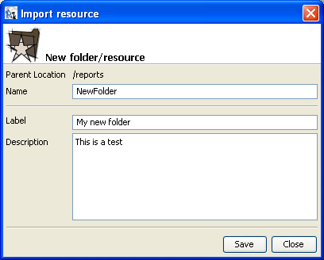
Only the name and the label are mandatory fields. To delete a folder select the “Delete” from the popup menu.

Importing JDBC connections into iReport
You can import a JDBC datasource from the server into iReport selecting the JDBC datasource from the repository tree. Right-click on the datasource, and select the item Import JDBC connection definition.
The new connection will stored in the iReport datasources/connections list. Now you can use this new connection with the iReport wizard to create your reports.
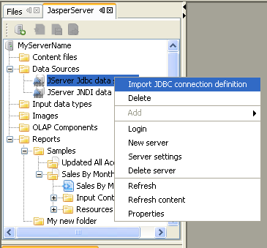

Creating a JasperServer Report from iReport
JasperServer Reports are displayed as special folders with the following icon:
To create a brand new JasperServer Report, you need at least a JRXML file (it will become the main JRXML for the JasperServer Report.
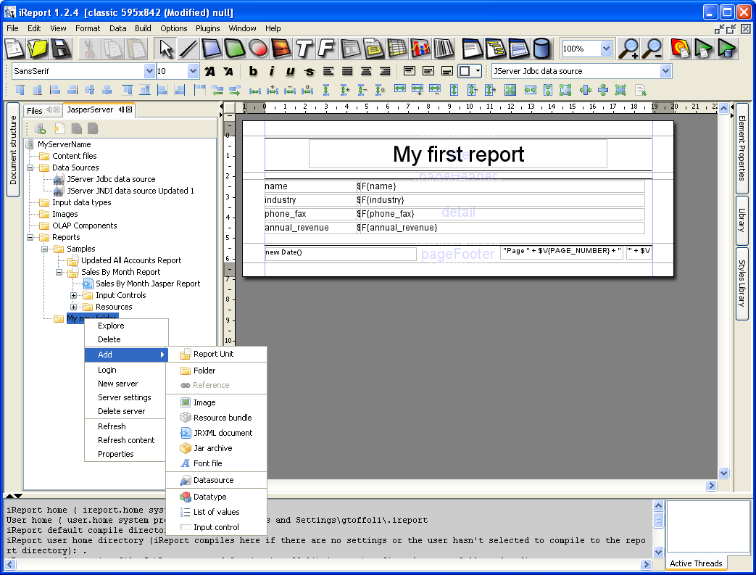
Choose the parent folder for the new JasperServer Report, select Add / JasperServer Report. You'll get the JasperServer Report dialog.
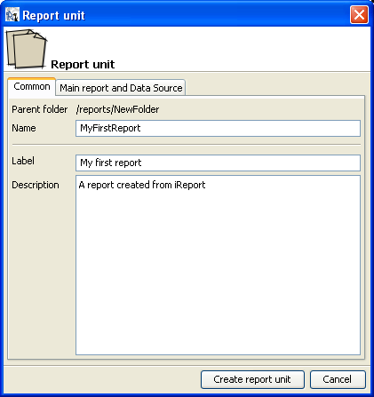
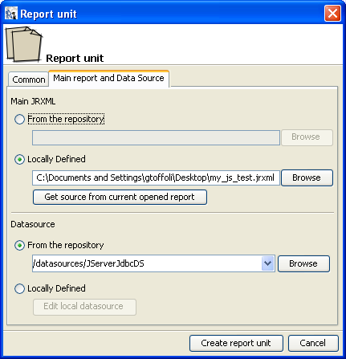
The dialog is composed by two tabs: “Common” and “Main Report and Datasource”. All fields, except Description, are mandatory.
If you want import the current opened file, save it before creating the report, and press the button “Get source from current opened report”.
If you want, you can pick an existing JRXML file from the repository, and/or define a local datasource (that is belonging to the JasperServer Report).
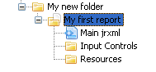
In any given JasperServer Report, there is always a main jrxml file, a set of input controls (zero or more) and a set of resources (zero or more).

Edit a JRXML
To edit a JRXML, double click on the JRXML file entry in the repository tree. If you have created a JasperServer Report from the current opened report, close this report, because this IS NOT the report present now on the server.
When you double click on the JRXML file, the JRXML is extracted from the repository and stored in a local copy into the directory <USER_HOME>/.ireport/jstmp. This directory is never clean.
The JRXML source is automatically opened in iReport.
To restore the modified file on the server, save it, then select the file entry in the repository tree, and click the button on the plugin toolbar.
A message will confirm that the operation was completed successful.
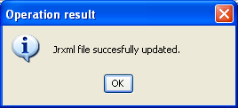

Running a JasperServer Report from iReport
To run a JasperServer Report on the server from iReport using all export options set in iReport, select a JasperServer Report from the repository tree, and click the button on the plugin toolbar.
If the JasperServer Report has input controls, the report parameters window will ask for values.
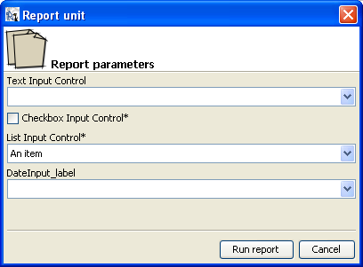
All messages coming from the server will be displayed on the iReport log pane.
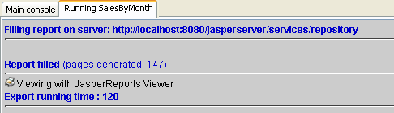

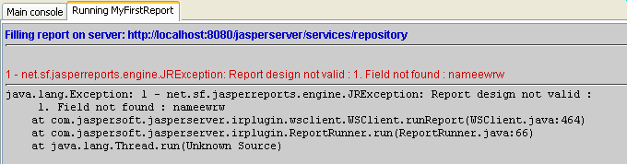

Adding an image to a report
If you want add an image stored in your repository into a report, you can drag the image into the design window. The plugin will add the image element for you, setting the right expression to refer the image into the server repository.
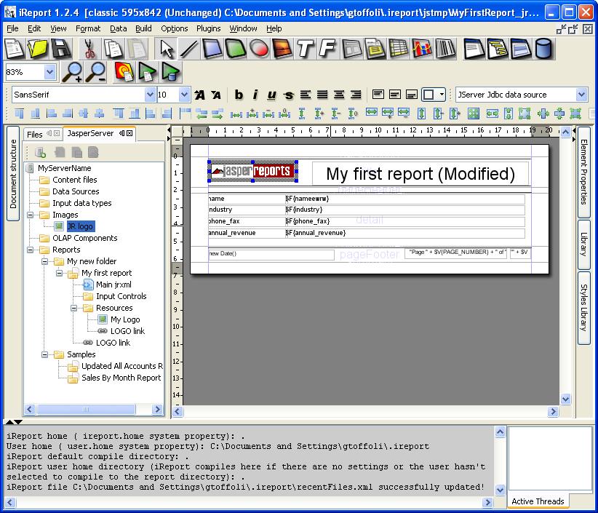74
Save and run the report as described in the previous paragraph to see the result.
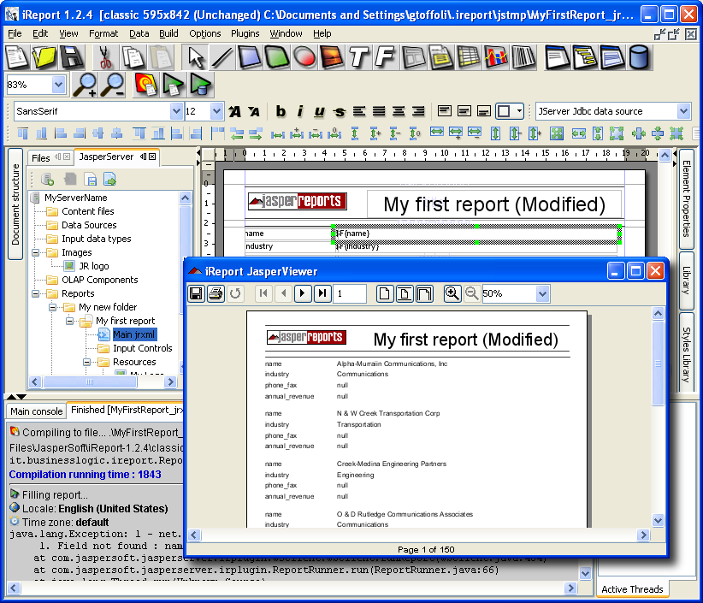

Adding an subreport to a report
Similarly to what we have done to add an image, we can add a subreport to a report. First of all we have to create the JRXML that will be used as subreport, then we will add the new JRXML as resource to the repository, or to the JasperServer Report.
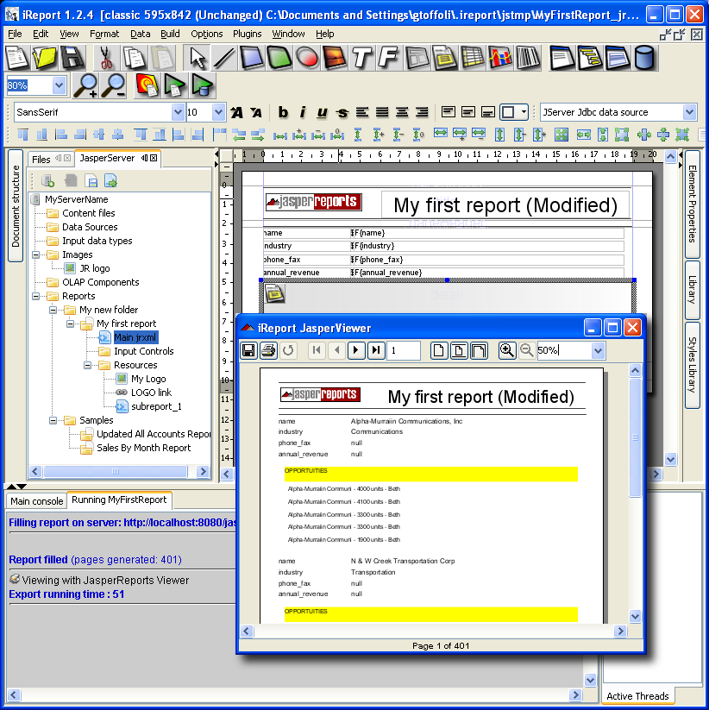
There is no way to try a subreport on the server, you can only try the whole report.
Edit the main jrxml and drag into the detail band the subreport jrxml entry. A subreport element will be created. The main report uses a JDBC connection so you have to set the connection expression of the subreport to $P{REPORT_CONNECTION} in the element properties dialog, subreport tab.

Resources, input controls, data types, lists of values and data sources
The plugin provides a way to manage resources like images, jars, jrxml files, properties file for localizable reports, etc..., input controls, data types, lists of values and data sources. The user interface provided by iReport to deal with these objects is similar to the one provided by the web UI. Refer to the sections below for the meaning of each field requested creating or managing a specific resource.

Repository resource chooser
To locate a resource in the repository (i.e. defining a JasperServer Report that uses a JRXML already stored on the repository), the plugin provides a special component similar to a file chooser dialog.
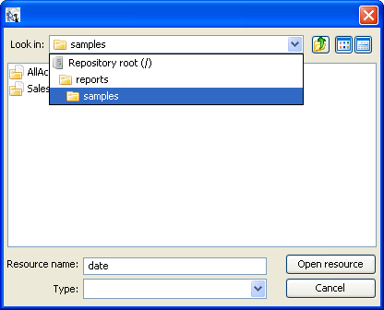
Use it to easily navigate the repository and pick the resource your want.

Adding resources directly to the repository
The example in this document shows how to create a complete report and place it into the repository. You can also use the Add Resource button in the repository browser to configure the following individual resources and add them to the repository for future use:
- Data Source
- Query
- Input Control
- Data Type
- JRXML
- Image
- Font
- JAR
- Resource Bundle
To add any of these resources to the repository:
- Navigate to the folder where you want to put the resource.
- Choose the resource type from the drop down list next to the Add button.
- Click Add
- Follow the steps in the resulting screen(s).
- When you complete the screen(s), click Save. The resource is added to the repository.

Move/Copy resources in the repository
The repository browser UI (and the JasperServer API in general) allows moving and copying folders and resources within the repository.

Copying resources
In the following example we are going to see how to copy an existing report into a destination folder:
- Navigate to the folder where the source report definition is found.
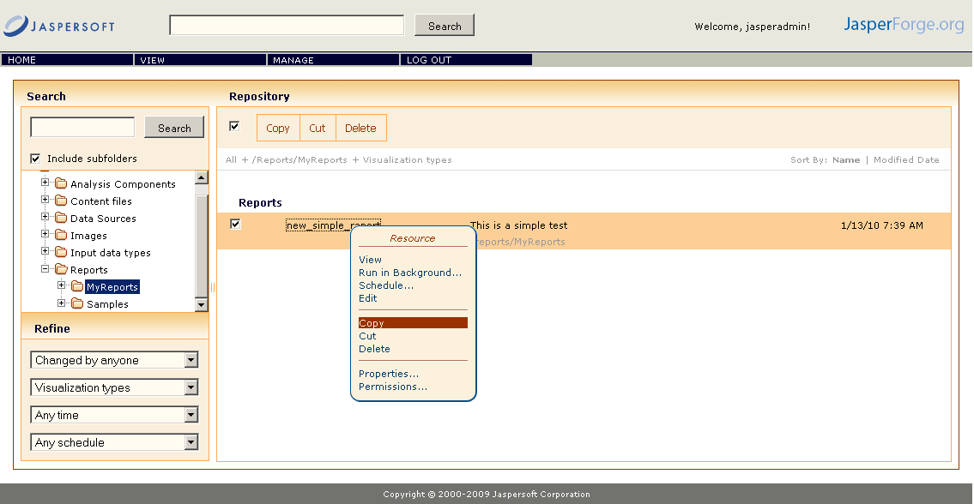
- Select the report definition (and the other resources in that folder that you want to copy at the same time). In our case, the resource to copy is the new_simple_report created earlier in this chapter.
- Select the Copy option on the right click of the mouse on the chosen resource.
- The mouse pointer changes to reflect we are during a copy operation.
- Navigate to the destination folder (the Samples folder in our example).
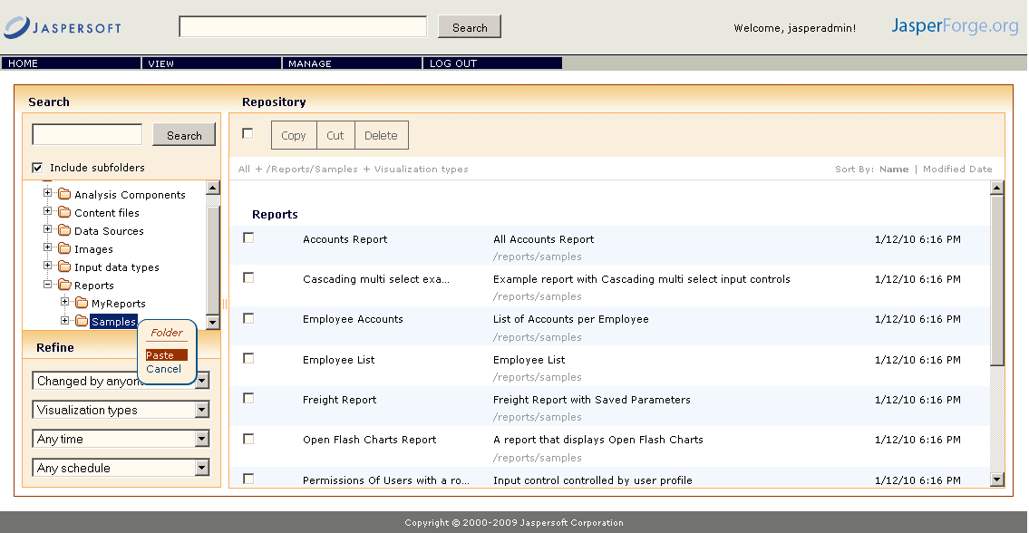
- Select the Paste option on the right click of the mouse on the destination folder in the report browser tree view.
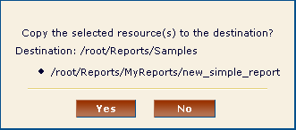
- Confirm the copy operation by clicking OK in the pop-up dialog that appears.
- The report copy should appear in the destination folder.

Moving a folder
Moving content is very similar to copy, and we are going to see now how we can move a folder and its content to another location within the repository:
- Navigate to the folder that you want to move, in our case the MyReports folder created earlier in this chapter.
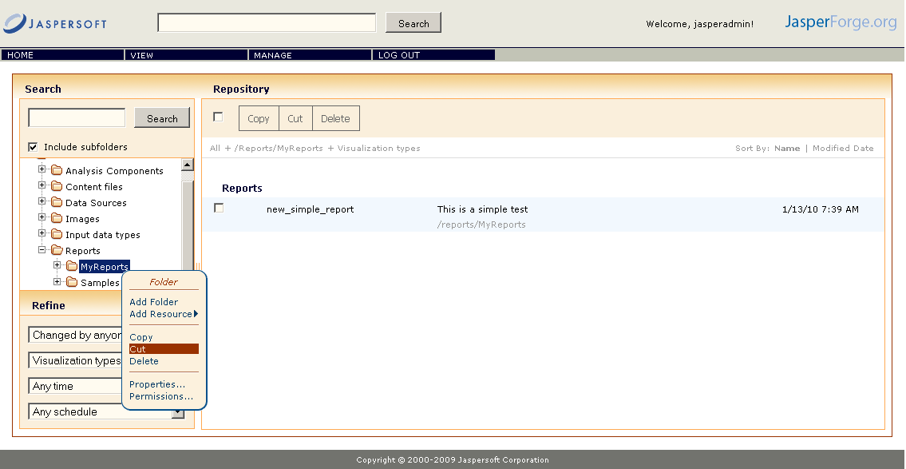
- Select the Cut option in the pop-up menu.
- Navigate to the destination folder.
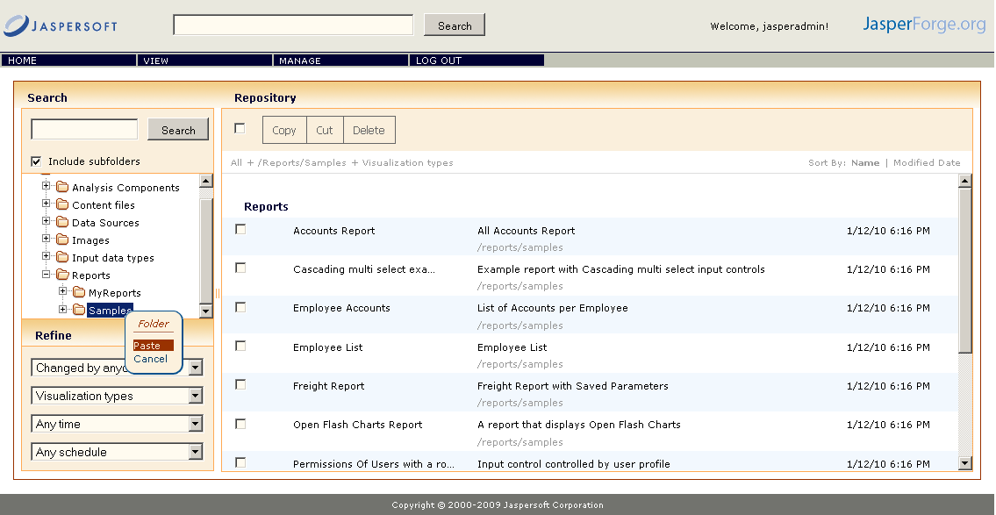
- Select the Paste option from the right mouse click on the destination folder.
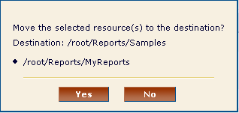
- Confirm the move operation by clicking OK in the pop-up dialog.
- The folder should appear in the destination folder and should have disappeared from its former parent folder.

Searching the repository
The repository is JasperServer’s internal storage for all reports, dashboards, analysis views and related files. The repository is organized as a tree structure of folders containing resources, much like a file system. However, JasperServer stores all objects and files in a private database that is otherwise inaccessible, except to administrators. This release of JasperServer introduces a search interface for the repository.
To access the repository, select View > Repository from any page of JasperServer.
The repository page is also where search results are displayed, as well as lists of reports and analysis views. As shown in the figure above, the repository page has the following features:
- Search controls – Let you find resources by searching for text in their names or descriptions.
- Folder tree – Lets you restrict search results to branches of the tree, or if Include subfolders is cleared, lets you browse individual folder contents.
- Filters for refining results – Provide a quick way to find resources based on other criteria such as type or access time.
- Bulk operation controls – For selecting and copying, cutting (moving), or deleting multiple resources at once.
- Search expression and sorting – An interactive status bar showing the search criteria, folders, filters, and sorting criteria.
- List of resources – The resources in the repository that meet the search criteria, grouped by resource type when appropriate. Click or right-click a resource in the list to view it or see what actions are available.
The new repository interface is designed to help you find resources faster by using intuitive search criteria. Instead of viewing resources by folder alone, the repository now provides many other filters such as who modified the resource and when. By clearing the check box to Include subfolders, you can still browse folder by folder, but once you are familiar with the search interface, you can often find resources with fewer clicks.
All of the controls on the repository page make it easy to refine or enlarge your set of results. In addition, JasperServer remembers your settings so that your most commonly needed resources stay visible when you return to the repository page.
The following sections explain how to use the search features of the repository page.

Searching by name
Use the search field at the top of every JasperServer page to begin a search at any time. Search terms are not case-sensitive. When you click Search, it opens the repository page with the same search term and displays the results.

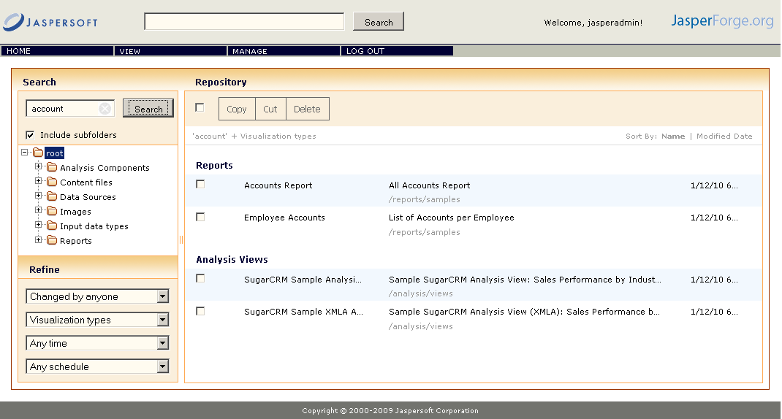
JasperServer matches the search term, even word fragments, anywhere it appears in the display name or description string of a resource. JasperServer does not match folder names or display folders in the results. If you enter multiple words, JasperServer searches for resources that match all words, but not necessarily in order. Do not enter quotes around terms or any symbols between terms. Figure above shows the results of a search for the term “account” in the sample data.
If you enter a search term and click Search on the repository page, the search uses the current settings on the page. If you enter a search term and click Search at the top of any other page, the search uses the default settings:
- Include subfolders
- Start at the top-most folder visible to your user
- Filter for visualization types only
- Sort alphabetically by name
To refine the search, select a folder or filter as explained in the following sections. To cancel search by name, click the icon in the search field to clear the search term and update the search results according to the remaining settings.

Navigating the folder tree
The folder tree shows the folders in the repository that your user has permission to view. Use the icons to expand the tree and view all nested folders. Click a folder name to select it.
There are two ways to navigate the folder tree:
- Search – When Include subfolders is checked, selecting a folder searches the entire branch of the tree starting at that folder. This mode is most useful in combination with other search settings, allowing you to search by name or by resource type across the entire repository or a specific branch of it. By default, Include subfolders is checked.
- Browse – Clear the box next to Include subfolders to restrict the scope of any search to the resources directly contained in the selected folder. This mode mimics a file system browser, letting you explore folder by folder. This mode works best when you clear the search term and select All types so that the results are exactly the contents of the selected folder.

Refining with filters
The filters below the folder tree let you refine your search using several other resource attributes. For example, these filters can help you find your most recently viewed reports. You can set each filter independently of the others.
The user filter has the following settings:
Filter Setting | Description
Changed by anyone (default) | Does not take into account user access to the resource.
Changed by me | Selects only resources that have been last modified by the currently logged in user.
Viewed by me | Selects only resources that have been run and viewed by the currently logged in user. This filter not only applies to visualization types, but also to resources that are included in reports such as images.

The resource type filter has the following settings:
Filter Setting | Description
All types | Does not take into account the resource type; as a result, every type is displayed.
Visualization types (default) | The default filter that includes reports, dashboards, and analysis views. These are the resources that can be viewed by anyone who has read access.
Reports | Displays only reports, both JRXML reports and Ad Hoc reports.
Report outputs | Displays only the output from reports that were scheduled or run in the background. Report output can be any of the supported export types (HTML, PDF, etc).
Dashboards | Displays only dashboards.
Analysis views | Displays only analysis views (if you implement JasperAnalysis).
Domains | Displays only Domains.
Data sources | Displays only data sources.
Other types | Displays all types except reports, report output, dashboards, views, Domains, and data sources. This includes input controls, data types, images, and other files that only administrators may add to the repository.

The access time filter has the following settings. All times are relative the user’s effective timezone:
Filter Setting | Description
Any time (default) | Does not take into account the last modification time of a resource.
Today | Resources viewed or modified since the previous midnight.
Yesterday | Resources viewed or modified during the previous day ending at midnight.
Past week | Resources viewed or modified during the past 7 days, including today.
Past month | Resources viewed or modified during the past 30 days, including today.

The scheduled report filter has the following settings:
Filter Setting | Description
Any schedule (default) | Does not take into account the existence of scheduled jobs.
Scheduled | Only reports that have scheduled jobs.
Scheduled by me | Only reports that have jobs scheduled by the currently logged in user.
Not scheduled | Only reports that do not have scheduled jobs, and all other resource types.

Changing the search expression
Above the list of resources, the search expression shows you all of the criteria that contribute to the search. It contains the following elements, always in this order from left to right:
- The search term, if any, or the word All.
- The folder selected, if any.
- Any and all filter settings.
The search expression provides a quick visual summary of the search criteria for the list of results that appear right below it.
The search expression is also interactive, allowing you to easily remove some of the filters. It supports the following actions:
- If there is more than one filter, clicking any one of them removes all those to the right of it.
- If there is a folder selected that is nested more than one level, you can click any parent folder to select it instead.
- You can click the search term or the word All to remove any and all folders and filters to the right of it.
To remove the search term, click the icon in the search field. The search expression then displays All.
After any one of these actions, the search controls displayed on the left are refreshed, and the results are updated.
To the right of the search expression, the sort criteria let change the order of the results. The following sorting is supported:
- Click Name to sort alphabetically (A at the top). This is the default sort order.
- Click Modified Date to sort by the latest modified time and date (most recent at the top).

Interacting with the list of resources
The list of resources is always the set of results determined by the current search criteria. Because search results can be quite large, the list of resources has two modes:
- Multiple Types Condensed – When there are more than two types of resources listed, the number of resources of each type is limited to a certain number, by default 5. When there are more resources of that type, there is a link to see all of that type. You can quickly scroll through the condensed results and find the type of resource you want. Click the See all... link to display the results of that type.
- Single Type Expanded – When there is a single type of resource in the results, either by circumstance, by clicking a See all... link, or because a single-type filter is selected, all resources are listed, with a scroll bar if necessary. If the list of results is still too long, enter or refine the search term, or select additional filters.
When you click See all... for a type that has a single-type filter, for example Domains, that filter is automatically applied. The filter display and the search expression refresh to reflect this. Use the search expression to remove the filter if necessary. When no filter exists for that type, for example input controls, the filter display and search expression are not updated. Use the type filter drop-down to change the types displayed.
Once the resource or resources you want are displayed, there are several ways to interact with them:
- Click the name of a report or analysis view to run and view it.
- Right-click the name of a resource to access other operations on the context menu, for example Run in Background... Items appear on the context menu according to the permissions granted to your user.
- Check the box beside the resource name or click anywhere in the row to select it. Check several boxes or Control-click anywhere in the rows to select multiple resources. You can drag and drop selected items to move them or press Control while you drag and drop items to copy them. When you have multiple resources selected, you can also used the bulk operation buttons above the results list: Copy, Cut (move), or Delete. You must have the appropriate permissions on the selected items and the target folder to move, copy, or delete resources.
There are two icons that may appear between a report name and its check box:
- + indicates that the report has saved options for its input controls. Click the + icon to list the saved options below the report.
- indicates that the report has been scheduled to run or that it is currently running in the background. Click this icon to view the list of jobs scheduled for the report.

Security Maintenance

Overview
JasperServer has an integrated security framework that operates on several levels, namely:
- Authentication: identifying users
- Authorization
  - Access to screens
  - Menu options
  - Objects in the metadata repository

Authentication
In order to customize the user experience and restrict access to resources in the system, users need to be authenticated to identify them and their user profiles, including their roles within the system. JasperServer tracks users with its metadata repository. The metadata repository can be the authentication source, i.e., Definition and management of user passwords, or we can also authenticate against a variety of authentication services, such as LDAP (i.e., Microsoft Active Directory, Novell eDirectory). The open source Acegi security framework that is used has many configurable options for:
- Single sign-on: JA-SIG's Central Authentication Service (CAS)
- Java Authentication and Authorization Service (JAAS)
- Container security – Tomcat, Jetty
- SiteMinder
Encryption and authentication standards are also supported.
- HTTPS: including requiring HTTPS
- HTTP Basic
- HTTP Digest
- X509
The Acegi framework is readily extensible to integrate with custom and commercial authentication services and transports.
Authentication occurs by default through the Web user interface, forcing login, and also through HTTP Basic authentication for Web Services, such as iReport and for XML/A traffic. JasperServer will synchronize automatically with an external authentication service without the external users needing to be created in JasperServer first. Roles passed in with the externally authenticated user are included in the JasperServer metadata.

Authorization
With the user's identity and roles established, JasperServer controls what the user can do and see in a variety of ways.
- Menu options
Menu options appear depending on the user's roles. Normal users do not have access to administrative functions. This can be modified through reconfiguration. See the Developer's Guide for details.
- Screen access
Individual screens can be blocked for access by people with given roles. For example, the default security framework only allows administrators access to repository maintenance screens. This configuration of what screens are available for what roles is done in configuration files. Assigning appropriate roles to individual users through the administrative user interface configures the precise screen access for users.
- Object level security
Objects in the repository and folders can have permissions set on them so that users without sufficient rights cannot see and access those resources. For example, you may have management reports that are not for all users. Permissions can be set to block access for only users with a management role. This filtering capability is used regardless of whether the user is going through the Web user interface or Web Services. See Setting Permissions below.

Creating a role
Roles are sets of permissions that you can assign to users.
To create a role:
- Click the Role menu.
- Click Add Role.
- Type the name of the role in the Role Name field.
- Click Submit.
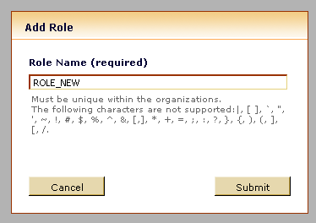

Creating a user
To create a user:
- Click the Users menu.
- Click Add User.
- Fill in the User ID, Full Name, Email Address, Password, and Confirm Password fields.
- Click Enable this user to allow this user to log in.
- Click Submit.
- Edit the user to select the roles that you want to assign to this user (ROLE_USER will be assigned by default). If you want to assign other roles, click on the edit roles link. In the Edit Roles dialog select the desired roles from the Available list and click on the right arrow in order to assign them to the user.
- If you want to remove some assigned roles, select them from the Assigned list and click on the left arrow to remove them
- Click Done.

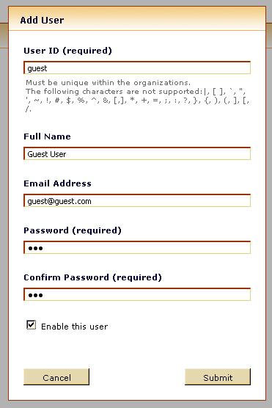
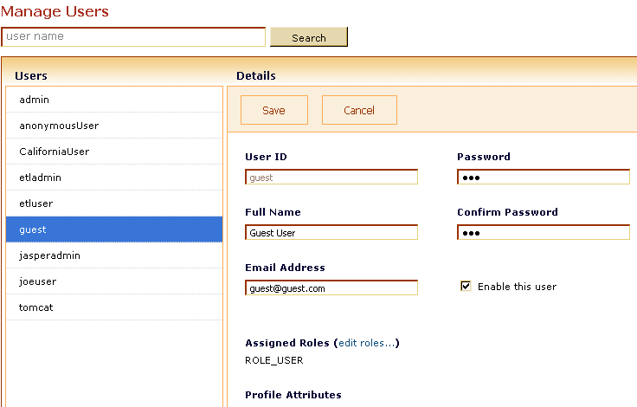

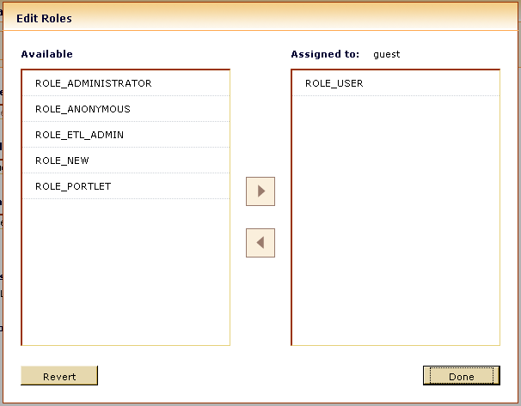

Changing role assignments for existing users
- Click the Roles menu.
- Select the role that you want to apply to an existing user and click Edit.
- For users that you want to add to this this role, click the arrow and move them from the Available list into the Assigned list.
- For users that you want to delete from this role, click the arrow and move them from the Assigned list into the Available list.
- Click Done.
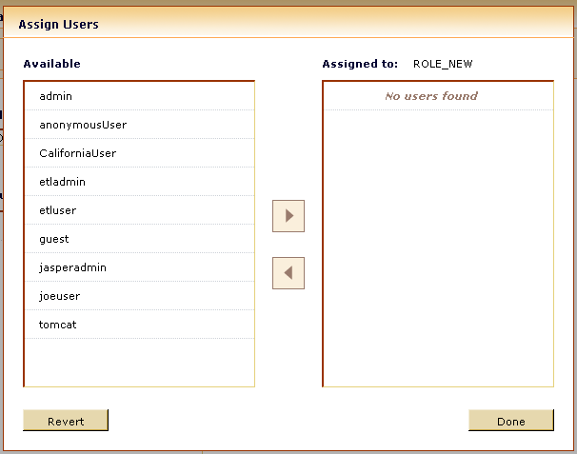

Configuring Password Options
JasperServer includes several password configuration options, described in the following sections.

Changing Password Encryption Settings
By default, the passwords JasperServer stores in the database are not encrypted. If your security standards require you to encrypt passwords, you can configure JasperServer to handle encrypted passwords. These passwords include:
- JasperServer user passwords
- JDBC data source admin passwords
- XML/A connection admin passwords
Since JasperServer always includes at least one user (admin), you can’t simply configure JasperServer to use encrypted passwords. To change the existing users, you must also use the import/export utility to extract them from the repository, then change the configuration, and finally re-import the users back into the repository. The import/export steps ensure that your users’ passwords are properly encrypted.

This section describes the available password encryption configuration options:
Password Configuration Options
Configuration File
...\WEB-INF\applicationContext-security.xml
Property | Bean | Description
passwordEncoder | daoAuthenticationProvider | Uncomment this property to enable the encryption of passwords.
allowEncoding | passwordEncoder | Determines whether JasperServer should encrypt the passwords it writes to the database. Set it to TRUE to use encrypted passwords
secretKey | passwordEncoder | The “salt” key to use as a pass phrase when encrypting passwords. This string is used to encrypt passwords. This value can be a simple string or a numeric representation that can be parsed by Integer.decode(). For example:  String:  This is my secret key  Numeric representation:  0xC8 0x43 0x29 0x49 0xAE 0x25 0x2F 0xA1 0xC1
keyInPlainText | passwordEncoder | Determines whether the secret key is a simple string or a numeric representation. Set this parameter to TRUE if the secretKey is a string; set it to FALSE if the key is a numeric representation.
secretKeyAlgorithm | passwordEncoder | The name of the algorithm to use, such as DESede.
cipherTransformation | passwordEncoder | The name of the transformation, such as DES/CBC/PKCS5Padding.

JasperSoft recommends that you change the salt key in your production environment. This ensures that your encryption is unique to that environment.
The secretKey, secretKeyAlgorithm, and cipherTransformation must be consistent with each other. For example, if the secretKeyAlgorithm is DESede, the secretKey must be 24 bytes long. For more information about secretKey, secretKeyAlgorithm, and cipherTransformation, see Sun’s javax.crypto documentation.

Allowing Users to Change Their Passwords
In order to change their passwords, users click the Change Password link appears on the Login page. Enable this link only if JasperServer authenticates your users. If your users are externally-authenticated, do not enable the option. To allow users to change their passwords, you must edit a configuration file. Note that enabling the password expiration option (described in the following section) automatically enables the ability of end users to change their passwords.
Password Administration Option
Configuration File
...\WEB-INF\jasperserver-servlet.xml
Property | Value | Description
allowUserPasswordChange | TRUE  <any other value> | Set the value to TRUE to enable the Change Password link. Any other value disables it.

Enabling Password Expiration
If your security policies require your users to change their passwords at regular intervals, you can enable password expiration. In this case, JasperServer prompts users to change their passwords at the interval you specify. For example, if you set the password expiry to 90 days, JasperServer prompts your users to change their passwords every three months. When a user’s password expires, the user cannot log into JasperServer until she changes her password. The default value is 0; in this case, passwords don’t expire.
When this option is enabled, JasperServer automatically enables the user password change options on the login page, even if allowUserPasswordChange is set to false.
Password Administration Option
Configuration File
...\WEB-INF\jasperserver-servlet.xml (controls the Login page)
...\WEB-INF\applicationContext-security.xml (controls web services)
Property | Value | Description
passwordExpirationInDays | TRUE  <any other value> | Set the value to any positive, non-zero value to specify the number of days after which a password will expire.

Setting Permissions
In the repository browser for administrators, the "assign" permissions link is available for resources and users. Selecting this link takes you to:
Role Permissions Screen
Here you can set the level of permissions for the resource or folder for individual roles.
- None set: permissions have not been set for this resource or folder for the role. The permissions in effect for the role will be for the parent folder.
- No access: users with this role will not be able to access this resource or folder
- Read: Users with the role can read but not update the resource
- Administration: Users with the role can read, update and delete the resource
Select the level of permission and Update.
From the Role Permissions screen, the administrator can opt to set permissions at the user level for the resource.

Utilities

Import/Export
The import and export utilities let you extract resources from or add resources to a JasperServer repository. Import and export can be helpful when migrating between versions of JasperServer, or when moving between test and production environments.

Import Resources
usage: ji-import [OPTIONS]
Reads a repository catalog from the disk (created using the ji-export command) and creates the named resources in the current JasperServer application repository.
Options:
--prepend-path | string to prepend to a URI path for all imported resources
--update | specifies that existing repository resources should be updated by catalog resources
--input-dir | path for import catalog directory
--input-zip | path for import catalog zip file
--help | print usage message

Examples:
- Import the myDir catalog folder, prepending /importDir to all repository URIs:
ji-import --input-dir myDir --prepend-path /importDir
- Import the myExport.zip catalog archive file:
ji-import --input-zip myExport.zip

Notes:
The prepend-path option is handy for avoiding URI path conflicts during import. For example, if the resource in the catalog file is /images/JRLogo and you set a prepend-path of myNewDir, then the resource is imported and created under the URI path /myNewDir/images/JRLogo. So, if you are importing a set of resources into a repository, and the URI naming conflicts with objects already in the repository, adding a prepend-path allows you to import the resources to a different location. However, this does not affect repository URIs in JRXML reports (for example, if a report image has <imageExpression>repo:/images/JRLogo</imageExpression>, that URI is not prepended during import).
During import, if a resource is found in the target repository that has the same URI as the resource that you are attempting to create and the “update” option was not used, the create operation is skipped, and the existing resource is left unchanged (no overwrite occurs); if the “update” option was specified and the type of the repository resource matches the type of the catalog resource, then the repository resource is overwritten by the catalog resource. Note that the “update” option results in all catalog resource indiscriminately overwriting repository resource, but it does not apply to other catalog objects such as users, permissions or report jobs.

Export Resources
usage: ji-export [OPTIONS]
Specifies repository resources such as reports, images, folders, users, roles, and scheduled jobs to export to a folder structure on disk.
The export output is known as a repository catalog.
Options:
--uris | Comma separated list of repository folder/resource URI paths
--repository-permissions | When this option is present, repository permissions are exported along with each exported folder and resource.  This option should only be used in conjunction with --uris
--report-jobs | Comma separated list of repository report unit and folder URIs for which report unit jobs should be exported.  If a folder URI is specified, the folder is recursively traversed and each report unit found has its jobs exported.
--users | Comma separated list of users to export; if no users are specified, all users are exported
--roles | Comma separated list of roles to export; if no roles are specified, all roles are exported
--role-users | When this option is present, each role export triggers the export of all users belonging to the role. This option should only be used in conjunction with --roles
--everything | Export everything: all repository resources, permissions, report jobs, users and roles.  Equivalent to --uris / --repository-permissions --report-jobs / --users --roles
--output-dir | Output catalog folder
--output-zip | Output catalog zip file
--help | Print usage message

Examples:
- Export the /reports/samples/AllAccounts resource to a catalog folder:
ji-export --uris /reports/samples/AllAccounts --output-dir myExport
- Export the /images and /fonts folders:
ji-export --uris /images,/fonts --output-dir myExport
- Export all the resources with permissions to a zip catalog:
ji-export --uris / --repository-permissions --output-zip myExport.zip
- Export all the resource and all the report jobs:
ji-export --uris / --report-jobs / --output-dir myExport
- Export the report jobs of the /reports/samples/AllAccounts report unit
ji-export --report-jobs /reports/samples/AllAccounts --output-dir myExport
- Export all the roles and users:
ji-export --roles --users --output-dir myExport
- Export the ROLE_USER and ROLE_ADMINISTRATOR roles along with all users belonging to one of these roles:
ji-export --roles ROLE_USER, ROLE_ADMINISTRATOR --role-users --output-dir myExport
- Export two users:
ji-export --users jasperadmin,joeuser--output-dir myExport

Notes:
- The --uris option allows you to specify one or more resources or folder URIs. A URI can specify a resource such as a report. In this case, all associated resources such as images, subreports, data sources, resource bundles, and classfiles are exported. A URI can also specify a folder. If a folder is specified, the export operation exports all files and folders contained in the folder. In addition, it recurses through all its subfolders.
- When you export a user, in addition to the user information, the user’s roles are also exported. When you import a user, if its roles exist in the repository, the user is given these roles.

Message viewer
The message viewer screens allows users to browse the server event log. This log is meant to be used by server component to log messages for events that require user notification. Currently the event log is exclusively used by the report scheduling module to log report execution errors.

Messages list
The messages list screen displays the list of events logged for the current user.
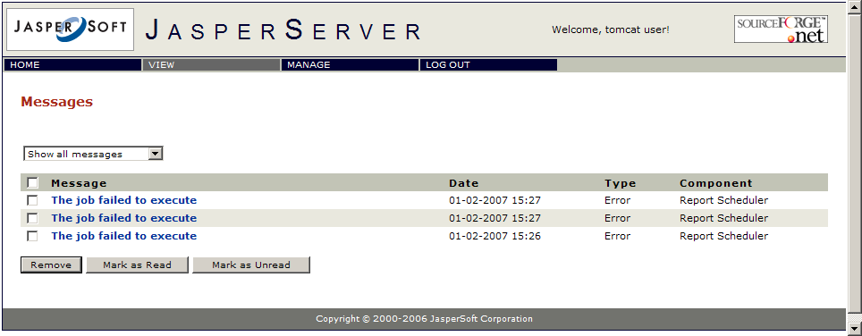

Message details
The full message details can be opened by clicking the event message.
The user can choose to browse all the messages or to see only the unread messages.
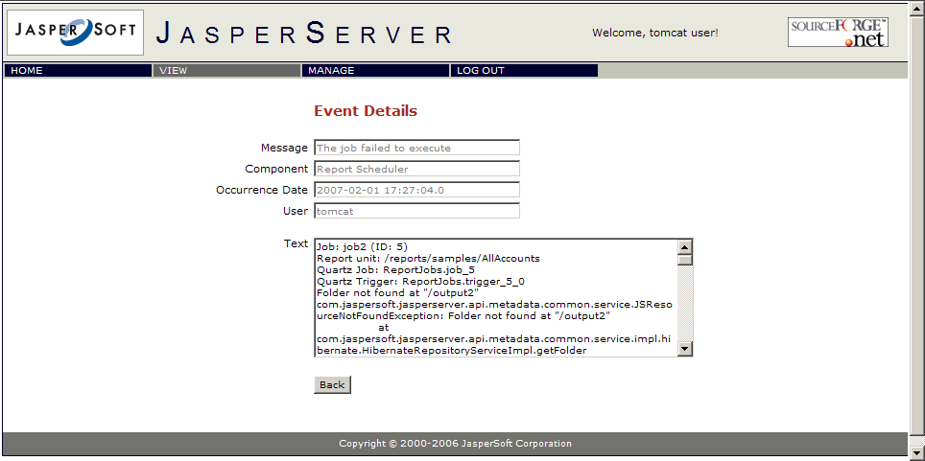

iReport Plugin installation and configuration

Requirements
- IReport 1.3.1 or greater
- Java Sun JDK 1.5 or greater (not mandatory but strongly suggested)
- JasperServer with enabled Web Services

Plugin installation
To install the plugin you have to drop into the lib directory of iReport the following jars:
jasperserver-ireport-plugin-1.1.0.jar
XmlSchema-1.0.2.jar
activation-1.1.jar
axiom-api-1.0.jar
axiom-impl-1.0.jar
axis2-1.0.jar
castor-1.0-xml.jar
commons-codec-1.3.jar
commons-httpclient-3.0.jar
mail-1.4.jar
neethi-1.0.1.jar
stax-api-1.0.jar
wsdl4j-1.5.2.jar
wstx-asl-2.8.2.jar
xbean-2.1.0.jar
All this jars are already in place if iReport is shipped in bundle with the JasperServer. iReport will load the plugin automatically when started. To lunch iReport on the Windows platform, you may use the Start/All Programs/JasperServer/iReport menu item. On Linux simply type:
./ iReport.sh
from the iReport home directory. You will see a JasperServer pane in the upper left hand side of your iReport workspace.

Configuring the plugin
When the plugin is started for the first time, no servers are yet configured. To add a server, press the first button in the plugin toolbar.

You get a dialog box titled"JasperServer Plugin" that allows for JasperServer access configuration. In this dialog box, you will enter the information that will enable you to connect to your JasperServer Web Services application.

For instance:
Name: MyServerName
JasperServer URL: <you should only need to change the hostname>
Username: <jasperadmin>
Password: <password>

A server entry should now appear in this pane.
Double-click on the server entry to see a list of Resources at the root of the JasperServer repository. You may view the property information on the Resources in the repository. You may download, edit and upload jrxml files. You may download images and other files (using right-click "export file").

Troubleshooting
If the connection fails, you can get a message similar to the following:
Check the login and password and be sure that the URL set for the server is exact. If needed, you can modify the server settings selecting it in the JasperServer pane and choosing the properties menu item from the popup menu.
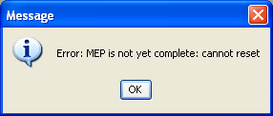

Advanced configuration
This chapter presents some of the most common extension points that can be used to enrich or customize the JasperServer functionality and achieve the desired level of integration with the environment where it is deployed.

Custom Data Sources
JasperServer provides built-in support for many commonly used data sources, such as JDBC, Java beans, Mondrian, and XML/A. However, not all JasperReports data sources have corresponding JasperServer data sources, and you may have written your own custom JasperReports data source that you want to use within JasperServer. In either case, you will need to extend JasperServer to support additional data sources. Fortunately, the current version of JasperServer has a framework which makes it possible to add a new data source by adding just a few files to your JasperServer configuration.
This section will cover the following subjects:
- Instructions for installing examples of custom data sources in your JasperServer web application
- A description of JasperServer data sources and how they interact with JasperReports data sources
- Descriptions of all the components required to implement a new JasperServer data source
- Instructions on how to deploy your new JasperServer data source

Background on data sources in JasperServer and JasperReports
A JasperServer data source is not the same thing as a JasperReports data source, but they work together closely. A JasperReports data source is an implementation of the JRDataSource interface which provides data organized in rows and columns to the JasperReports filler, which is responsible for producing a JasperPrint object. Each field declared in the JRXML corresponds to a column in the JRDataSource output.
A JasperServer data source is a persistent object in the JasperServer repository which stores properties which tell JasperServer how to create a JRDataSource (possibly in collaboration with a JRQueryExecuter, see below). These properties vary by the type of data source; for example, a JDBC data source will have a JDBC driver, URL, user, and password. A data source, like other repository objects such as data types and input controls, can be defined as a “public” repository object which can be used by any report unit (for example, /datasources/JserverJdbcDS), or as a “local” object used by a specific report unit. Public and local data sources can be created and edited with the JasperServer web interface.
When JasperServer receives a request to run a report unit, it looks up the the report unit’s data source, and maps that to an implementation of ReportDataSourceService, which is in turn responsible for handing back a JRDataSource based on the data source’s persistent properties. The JRDataSource is used to fill the report and produce a JasperPrint object, which can be turned into HTML or any other supported output format.
Each JasperServer data source implementation has to do the following:
- Read and write persistent properties in the JasperServer repository
- Provide a user interface for creating and editing instances which is integrated in the JasperServer web interface
- Create a JRDataSource using the property values for a specific data source instance, or pass parameters to a JRQueryExecuter which produces the JRDataSource.
The existing data sources each require about a half dozen Java classes, along with many changes to Spring bean files, WebFlow configurations, message files, and JSP files. The custom data source framework described here provides the same functionality using a Spring bean file, a message catalog, and a minimum of one Java file (more for optional features).

Query executers
Query executers are implementations of the JasperReports interface called JRQueryExecuter. They are responsible for interpreting the queryString inside the JRXML and producing a JRDataSource. Some JasperServer data sources don’t need queryStrings and will produce a JRDataSource which is passed directly to the filler with no query executer involved. However, the ability to pass a queryString gives the data source a lot more flexibility. In this case, the data source will put implementation-specific objects in the report parameter map that get passed down to the JRQueryExecuter, which uses them to produce the JRDataSource. The prime example of this is the JDBC data source, which puts a JDBC Connection object in the parameter map. The JRJdbcQueryExecuter then uses the connection to create a JDBC Statement using the queryString, run it on the connection, and generate a JRDataSource with the result set.
The webscraper example below shows examples of both approaches—it can be used either with or without a queryString in the JRXML.

Custom Data Source Examples
The examples are found in <js-install>/samples/customDataSource. Once you have deployed a JasperServer web application to your application server, you can use Ant to build and deploy the examples.
If you used an installer to install JasperServer version 2.1 or later, you will have Ant installed already. Ant may be run with the following command:
<js-install>/ant/bin/ant <ant-arguments>(for Linux/Unix)
<js-install>\ant\bin\ant <ant-arguments> (for Windows)
If you installed JasperServer manually with a WAR file, you will need to download Ant from http://ant.apache.org. Ant 1.6.2 was used for testing, but earlier versions should also work.
The JVM used for installing the examples needs to be a full Java Development Kit, because it needs to compile Java source files. Ensure that the JAVA_HOME environment variable points to a JDK installation.
The sample directory includes the following files and directories:
build.xml: The Ant build file
src: Java source directory
webapp: A directory containing other files required by the examples, such as JSPs and Spring configuration files, which are copied directly to the JasperServer web application directory
reports: A directory containing example JRXML files that use the sample custom data sources
Take the following steps to install the samples in your JasperServer web application (this can be built from the source code or the delivered version of JasperServer):
At the command line, change directories to the custom data source sample directory (<js-install>/samples/customDataSource)
Edit build.xml and set the webAppDir property to the root of the JasperServer web application.
Run the Ant command (see above) with no arguments, which will execute the default target, which is named deploy. The deploy target will run the following tasks:
Compile the Java source under the src directory
Deploy the compiled Java class files to the JasperServer web application
Deploy files under the webapp directory to the the JasperServer web application
Restart the application server

Custom Bean Data Source
The custom bean data source implementation creates a data source from a collection of Java beans declared in the source code. Its Spring bean definition file is located in <js-install>/samples/customDataSource/webapp/WEB-INF/applicationContext-sampleCDS.xml. It An example of a report using this data source is located in <js-install>/samples/customDataSource/reports/simpleCDS.jrxml.

Webscraper Custom Data Source
The webscraper custom data source implementation can fetch a web page, decode the HTML, and extract selected data which is turned into field values in the data source. Its Spring bean definition file is located in <js-install>/samples/customDataSource/webapp/WEB-INF/applicationContext-webscraperDS.xml.
These are the configuration items for the datasource:
URL: An HTTP URL which refers to the HTML page containing the desired content
DOM path: An XPath expression which locates HTML elements to be turned into rows in the data source
Field paths: XPath expressions for each field defined in the JRXML which are used to locate the field value within each row selected by the DOM path
The implementation creates a data source by taking the following steps:
Uses the URL to issue a GET request for an HTML page.
Converts the HTML response into XML using JTidy (http://jtidy.sourceforge.net).
Uses the DOM path to select XML elements from the converted response.
Create a new data source row for each selected element
For each field, use the field path to determine the content for each field
The data source has two parameters: the URL of the web page, and the XPath which determines that elements in the HTML page become rows in the data source. The parameters can be specified either by a data source definition in the repository or by a query string in the JRXML.
The example reports for this data source read a web page from http://www.craigslist.org and extract a list of items for sale. The report reports/webscrapertest.jrxml has no query defined. Instead, it relies on an instance of the custom data source that has been created in the repository. Typical parameters to use with this data source are:
URL: http://sfbay.craigslist.org/sfc/cta/
DOM Path: /html/body/blockquote[2]/p
The reports/webscraperQEtest.jrxml example contains a queryString element which specifies the URL and the DOM path. It should be used without defining a data source instance, because JasperServer will not run the query executer for this particular implementation if a data source is defined for the report unit.

Creating a Custom Data Source
A custom data source consists of Java code, a message catalog, and a Spring bean definition file that configures all the parts of the implementation with JasperServer. This section defines the steps for implementing a custom data source.

Files used by a custom data source implementation
Type of files | Path (relative to web application directory) | Description
Spring bean definition | WEB-INF/applicationContext-name.xml | Defines Spring beans needed to configure the data source. Choose a unique name starting with “applicationContext-“ and ending with “.xml”
Message catalog | WEB-INF/bundles/xyz.properties | Defines messages used by the data source implementation (this path is referenced in the Spring bean definition file).
Implementation classes | WEB-INF/lib or WEB-INF/classes | Any Java code required by the implementation.

Implementing the ReportDataSourceService Interface
A custom data source requires an implementation of the ReportDataSourceService interface, which is responsible for setting up and tearing down data source connections in JasperServer. It relies on:
void setReportParameterValues(Map parameterValues): called before running a report - creates resources needed by JasperReports to obtain a JRDataSource and adds them to the parameter map
void closeConnection(): clean up any resources allocated in setReportParameterValues()

Defining Custom Data Source Properties
A custom data source can define properties that can be used to configure each data source instance differently, in the same way that a JDBC datasource has properties for JDBC driver class, URL, user name, and password. The definition of properties is covered later (refer to section Error: Reference source not found “Error: Reference source not found” on page Error: Reference source not found), but you will need to consider what properties you want to use while implementing your ReportDataSourceService.
There are two kinds of properties:
- Editable properties are string values. When you use the JasperServer data source wizard to create an instance of your custom data source, you can enter values for the editable properties using a text field. These values are persisted when you save the data source.
- Hidden properties can be of any type, but their values are determined by the Spring configuration file, so they are not persisted, and are not visible in the data source wizard. They can be used to give your ReportDataSourceService implementation access to a Spring bean instance. For an example of a hidden property, see the repository property in the custom bean data source definition below.
These property values are set by the custom data source framework after it instantiates your ReportDataSourceService implementation. You need property setters and getters corresponding to the property name; for example, if you defined a property with the name foo you will need getFoo() and setFoo() methods.

Implementing Optional Interfaces
If you wish to use the value of the queryString in the JRXML to obtain your data source, you need to create implementations of the JRQueryExecuter and JRQueryExecuterFactory interfaces.
JRQueryExecuterFactory has this method:
- JRQueryExecuter createQueryExecuter(JRDataset dataset, Map parameters): return a JRQueryExecuter for the given dataset and parameter map.
- JRQueryExecuter has these methods:
- JRDataSource createDatasource(): returns the actual data source based on the parameter map that was passed to the JRQueryExecuterFactory above; most likely, you will create a JRDataSource implementation suitable for your data source.
- close(): called when report filling process is done with the data source.
- cancelQuery(): called to clean up resources if the report filling process is interrupted.
- If you wish to provide validation in the user interface for creating and editing custom data source instances, you need to create an implementation of CustomDataSourceValidator. It has the following method:
- validatePropertyValues(CustomReportDataSource ds, Errors errors): check parameters and call errors.rejectValue() with the appropriate property name and error code (defined in a message catalog, refer to section 6.1.3.5 "Creating the Message Catalog,” next).

Creating the Message Catalog
The message catalog contains messages displayed by the data source wizard when creating and editing custom data source instances. The various types of messages are shown in the table below, along with conventions for choosing message names:
Message Type | Naming Convention
Name of custom data source type | Cdsname.name (where cdsname is the value of the name property of the custom data source).
Name of custom data source property | Cdsname.properties.propname (where propname is the value of the property name).
Validation messages | Cdsname.any.message.code (there is no convention enforced, but JasperSoft recommends starting with cdsname for consistency).
For example, the webscraper message catalog contains the following:
webScraperDataSource.name=Web Scraper Data Source
webScraperDataSource.properties.url=URL
webScraperDataSource.properties.path=DOM Path
webScraperDataSource.url.required=A value is required for the URL
webScraperDataSource.path.required=A value is required for the DOM path

Defining the Custom Data Source in Spring
To configure the data source, you must add an instance of CustomDataSourceDefinition to the Spring bean definition file. This class has the following properties:
Name | Required | Value
factory | ▲ | (Fixed value) ref="customDataSourceFactory" (this is the bean that manages all the custom data sources).
name | ▲ | Unique name used to refer to custom data source in messages, etc.
serviceClassName | ▲ | A class name for your ReportDataSourceService implementation.
validator |  | An instance of your CustomDataSourceValidator implementation.
propertyDefinitions |  | A list containing a map of information about each property used by the custom data source (details on map entries are listed in the table below).
queryExecuterMap |  | Map with query languages (uses language attribute of JRXML queryString element) as keys, and JRQueryExecuterFactory class names as values.
The propertyDefinitions property is a list of maps, each one describing a property of the custom data source implementation. These are the entry keys used currently:
Name | Required | Value
name | ▲ | Name of property, which matches a JavaBean property in the ReportDataSourceService implementation, and is also used in message catalog keys
default |  | A default value for the property
hidden |  | Properties with hidden set to true are set to fixed values using the "default" entry. They are not be editable in the UI or persisted. This is handy for making Spring beans accessible to ReportDataSourceService implementations
The following XML creates a CustomDataSourceDefinition bean for the custom bean data source example:
<bean id="myCustomDataSource" class="com.jaspersoft.jasperserver.api.engine.jasperreports.util.CustomDataSourceDefinition">
<property name="factory" ref="customDataSourceServiceFactory"/>
<property name="name" value="myCustomDataSource"/>
<property name="serviceClassName" value="example.cds.CustomSimplifiedDataSourceService"/>
<property name="validator">
<bean class="example.cds.CustomTestValidator"/>
</property>
<property name="propertyDefinitions">
<list>
<map>
<entry key="name" value="foo"/>
</map>
<map>
<entry key="name" value="bar"/>
<entry key="default" value="b"/>
</map>
<map>
<entry key="name" value="repository"/>
<entry key="hidden" value="true"/>
<entry key="default" value-ref="repositoryService"/>
</map>
</list>
</property>
</bean>

Configuring the Message Catalog
To configure your message catalog with JasperServer, add a bean definition similar to the following to the Spring definition file that you created above. For the value of the value property, substitute the location of your message catalog file, omitting the .properties extension. It is not necessary to edit the messageSource bean definition in applicationContext.xml.
<bean class="com.jaspersoft.jasperserver.api.common.util.spring.GenericBeanUpdater">
<property name="definition" ref="addMessageCatalog"/>
<property name="value" value="WEB-INF/bundles/cdstest"/>
</bean>

Installing a Custom Data Source
Add all the files required by the custom data source implementation to the JasperServer web application and restart the application server.
The new custom data source type appears in the list of choices for data source type when you create a new data source in JasperServer. If the new type is selected, JasperServer displays a form containing the list of properties you configured.
When the form is submitted, the parameter values are validated with the CustomDataSourceValidator implementation and appropriate validation messages are displayed.

Using a Custom Data Source
When defining <queryString> in JRXML, use a language setting that your custom data source supports.
When you create a report and are prompted for the data source to use, any custom data sources created by the administrator are displayed.
If you select a locally defined data source, you can choose the new custom data source type and edit it, just as if you were creating a data source in a folder (see section 6.1.4 “Installing a Custom Data Source” on page 72).

Report output channels
When running a report in JasperServer, the result can be delivered in several supported formats such as HTML, PDF, RTF, XLS and CSV. The report viewer page, where reports are viewed initially in HTML format, has a toolbar on top with buttons for exporting the current report to the above mentioned formats. A similar document export process occurs when reports are scheduled and the output is delivered in one of these formats.
The document export process is controlled using the WEB-INF/applicationContext.xml file where for each of the supported export formats there is a bean with properties that help fine-tune the export.

Excel output
The Excel output channel is controlled by the xlsExportParameters bean inside the WEB-INF/applicationContext.xml file. JasperServer is shipped with a default configuration that produces a data-centric Excel output where graphic elements are ignored, spacer cells are removed and the data type of cells is preserved.
The following properties can be set for the Excel exporter:
Property Name | Default | Description
detectCellType | true | Preserve the type of the original text field expressions and use it for the cell data type
onePagePerSheet | false | Each report page should be written in a different XLS sheet
removeEmptySpaceBetweenRows | true | Empty spaces that could appear between rows should be removed or not.
whitePageBackground | false | Force cell white background
ignoreGraphics | true | Export text elements only
collapseRowSpan | true | Collapse row span and avoid merging cells across rows
ignoreCellBorder | true | Do not draw the cell border
fontSizeFixEnabled | true | Decrease font size so that texts fit into the specified cell height
maximumRowsPerSheet | 0 | Maximum number of rows allowed before continuing on a new sheet

In report templates, Java specific format patterns are used to format dates and numbers (see JasperReports documentation for details). But these patterns might not work inside the Excel document viewer program, as their syntax might not be fully supported there.
In such cases, the Java format patterns have to be converted to equivalent proprietary format patterns using the formatPatternsMap bean inside the WEB-IN/applicationContext.xml file, where pairs of equivalent patterns can be added.

CSV output
The CVS export options can be changed by modifying the csvExportParameters bean configuration inside the WEB-INF/applicationContext.xml file.
For the moment, only the field delimiter can be configured for the CSV output channel.

Configuring Login Page
Starting with version 2.1, JasperServer comes with a new login page which displays welcome information about the product. If you want to switch to the simpler login page that was shipped prior to version 2.1, you can alter the paramResolver bean inside the WEB-INF/applicationContext.xml file by changing the line:
<prop key="/login.html">login_welcome</prop>
into
<prop key="/login.html">login</prop>

Integrating JasperServer and Liferay Portal
These instructions assume that both JasperServer and Liferay have been installed properly. For instructions about installing Liferay, refer to its documentation. For instructions about installing JasperServer, refer to the JasperServer Professional Installation Guide. This chapter also assumes:
- You are using Liferay 5.0 Final Release, bundled with Tomcat 5.5 for JDK5.0, which can be downloaded from:
http://sourceforge.net/projects/lportal/
- <js-install> is the root of your JasperServer installation.
- <liferay-install> is the root of your Liferay installation. This path cannot contain any spaces.
These instructions describe how to deploy the portlet WAR that is included in the JasperServer Professional distribution. If you are implementing the JasperServer portlet from a different distribution, refer to the instructions provided in that distribution.
If you are upgrading from a previous version of JasperServer in which you deployed the Liferay portal, you must take additional steps; pay careful attention when following the instructions in this chapter.

Changing Liferay’s Port Numbers
By default, both Liferay and JasperServer run on port 8080. You must change Liferay’s listening port to avoid this conflict. For example, you can change Liferay’s listening port to 7080. You must also update a number of other Liferay ports.
To configure Liferay’s port numbers:
- In the server.xml file (found at <liferay-install>\conf\), change all the occurrences of port numbers. For example:

Port | Default | Suggested
Server Port | 8005 | 7005
Non-SSL Connector Port | 8080 | 7080
AGP 1.3 Connector Port | 8009 | 7009
Proxy Connector Port | 8082 | 7082

- In the server-minimal.xml file (found at <liferay-install>\conf\), change all the occurrences of port numbers. For example:
Port | Default Value | Suggested Value
Server Port | 8005 | 7005
Catalina Connector Port | 8080 | 7080
AGP 1.3 Connector Port | 8009 | 7009

- Start the Liferay Portal by entering the following at the command prompt:
Linux | <liferay-install>/bin/startup.sh
Windows | <liferay-install>\bin\startup.bat

Configuring JasperServer to Accept Web Services Calls
Configure JasperServer to accept web service calls from Liferay by updating
<js-install>/webapps/jasperserver-pro/WEB-INF/applicationContext-security.xmli.
To configure JasperServer to accept web services from trusted hosts:
- Start JasperServer.
- Locate the trustedIpAddress property in the applicationContext-security.xmli file found at <js-install>/webapps/jasperserver-pro/WEB-INF.
- Add the IP address of your Liferay Portal host. For example, if Liferay is running on a computer with the IP address 172.17.3.171, the trustedIpAddress property would be:
<property name="trustedIpAddress">
<list>
<value>172.17.3.171</value>
</list>
</property>
Jaspersoft strongly recommends using a static IP for this host. Do not use the value localhost or 127.0.0.1 for this property.
- Restart JasperServer.

Configuring Liferay to Access JasperServer
The JasperServer portlet uses web services to retrieve information from JasperServer. This parameter specifies the JasperServer repository web service URL. It’s normally of the form:
http://<host:port>/jasperserver-pro/services/repository
or
https://<host:port>/jasperserver-pro/services/repository

For example:

http://172.17.3.171:7080/jasperserver-pro/services/repository

To configure Liferay to access JasperServer:

- Locate the jasperserver_repository_ws_url parameter of the portlet.xml file found at
<liferay-install>/webapps/<context_name>/WEB-INF.
- Set its value to the URL of the JasperServer repository web service. For example:
<init-param>
<name>jasperserver_repository_ws_url</name>
<value>
http://172.17.3.171:8080/jasperserver-pro/services/repository
</value>
</init-param>

- Restart Liferay.

Testing Liferay
To test Liferay:
- Enter your Liferay Portal URL in your browser’s address bar. For example:
http://<liferay host>:7080/c/portal
- Login to Liferay; by default Liferay includes a default Admin user with these credentials:
- User name: test@liferay.com
- Password: test
If the portal appears, Liferay is properly installed.

Deploying the JasperServer Portlet WAR File
If you are upgrading from a previous version of JasperServer in which you deployed the portlet WAR file, you must delete the webapps/Jaspersoft folder of the application server hosting Liferay. This deletes libraries used in older versions that conflict with libraries in the latest version. Once this folder is deleted, you can deploy the new portlet WAR.
To deploy the portlet WAR file:
- Login on the Liferay Portal as a user with administrative privileges. For example, test@liferay.com. The default password is test.
- Add the Admin portlet to your current dashboard by clicking Add Content > Admin > Admin portlet.
- Click the Plugins tab in the Admin portlet.
- Click Install More Portlets.
- Click the Upload File tab.
- Locate and add the JasperServerPortlet WAR file
- Select an optional context.
- Click Install.
Liferay Portal attempts to deploy the WAR file (this step may take several moments, depending on your environment).
- When Liferay finishes the deployment, click Add Content > Jaspersoft. The JasperServer Portlet appears.
The JasperServer portlet is deployed.
Note that you can run multiple instances of the portlet at once.

Configuring a Default Report to Display
By default, the portlet displays all the reports that the current user is allowed to view. You can configure the portlet to display a specific report, instead.
In the portlet.xml file, add the following entries to specify a default report:
- full_resource_path: This parameter specifies the full report Path.
- resource_type: The only supported value is report
- number_of_parameters: This specifies the number of parameters the report requires, including optional and required parameters.
- js_resource_parameter_<parameter>: For each parameter of the report, append prefix js_resource_parameter_ to the name. In this example, the report /reports/samples/EmployeeAccounts takes a parameter named EmployeeID; it is defined as js_resource_parameter_EmployeeID.
- modifiable: This value has to be 1 [one] so end users can choose different reports at run time. 1 is the only supported value. For details of this parameter, please refer to the JSR-168 specification.
For example, the portlet configuration section of the portlet.xml file might be similar to the following:
<portlet-preferences>
<preference>
<name>full_resource_path</name>
<value>/reports/samples/EmployeeAccounts</value>
<modifiable>1</modifiable>
</preference>

<preference>
<name>resource_type</name>
<value>report</value>
<modifiable>1</modifiable>
</preference>

<preference>
<name>number_of_parameters</name>
<value>1</value>
<modifiable>1</modifiable>
</preference>

<preference>
<name>js_resource_parameter_EmployeeID</name>
<value>beth_id</value>
<modifiable>1</modifiable>
</preference>
<portlet-preferences>

If you remove this section, the JasperServer Portlet displays a list of reports that the current user can access.

Testing the JasperServer Portlet
You can configure several parameters that control the JasperServer portlet. They are located in the <liferay-install>/webapps/<context_name>/WEB-INF/portlet.xml file. You must restart Liferay for these changes to take effect.
Note: The values described in this section are case sensitive.

JasperServer Portlet Configuration Options
You can configure several parameters that control the JasperServer portlet. They are located in the <liferay-install>/webapps/<context_name>/WEB-INF/portlet.xml file. You must restart Liferay for these changes to take effect.
Note: The values described in this section are case sensitive.

Portlet Parameters

image_servlet_ssl_enabled
An image servlet is used to serve images including pictures and charts. If the servlet is configured to use regular HTTP, this value should be false. If HTTPS is used, the value should be set to true. For example:

<init-param>
<name>image_servlet_ssl_enabled</name>
<value>false</value>
</init-param>

portal_server
The only supported value for this parameter is liferay. For example:
<init-param>
<name>portal_server</name>
<value>liferay</value>
</init-param>

show_logo
This parameter indicates whether the company logo (at the top right-hand corner of the portlet) is displayed. Any value other than true hides the logo. For example:
<init-param>
<name>show_logo</name>
<value>true</value>
</init-param>

show_return_to_report_list_icon
The parameter indicates whether the Return to Report List icon is displayed. Any value other than true hides the icon. For example:
<init-param>
<name>show_return_to_report_list_icon</name>
<value>true</value>
</init-param>

show_return_to_parameter_icon
The parameter indicates whether the Report Options icon should be shown. Any value other than true hides the icon. For example:
<init-param>
<name>show_return_to_parameter_icon</name>
<value>true</value>
</init-param>

company_logo
This parameter specifies the image to use when show_logo is set to true. The picture must be located under <liferay-install>/webapps/<portlet_context_name>/WEB-INF/images/. For example:
<init-param>
<name>company_logo</name>
<value>jaspersoft-logo.png</value>
</init-param>

company_logo_hyper_link
This parameter specifies the hyperlink URL to request when a user clicks the company logo. For example:
<init-param>
<name>company_logo_hyper_link</name>
<value>http://www.jaspersoft.com</value>
</init-param>

report_directory
This parameter specifies a folder in the JasperServer repository that should be used to populate the Report List page in the portlet. For example:
<init-param>
<name>report_directory</name>
<value>/</value>
</init-param>

number_of_reports_per_page
This parameter specifies the pagination limit for the Report List page. The value specifies how many reports to display on each page. When there are more reports than the number specified for this parameter, end users must click a link to go to next page. For example:
<init-param>
<name>number_of_reports_per_page</name>
<value>5</value>
</init-param>

Example Server and Browser Configuration
This section shows examples of the updated files that must be edited to enable Liferay integration with JasperServer.
Note: Do not specify localhost or 127.0.0.1 for any of the following settings. Otherwise, pictures and charts may not be displayed.

applicationContext-security
Default Location: <js-install>/webapps/jasperserver-pro/WEB-INF/
<property name="trustedIpAddress">
<list>
<value>172.17.3.171</value>
</list>
</property>

portlet.xml
Default Location: <liferay-install>/webapps/<context_name>/WEB-INF/
<init-param>
<name>jasperserver_repository_ws_url</name>
<value>
http://172.17.3.171:8080/jasperserver-pro/services/repository
</value>
</init-param>

Browser URL
Users point their browsers to: http://Liferay_host:7080/c/portal

Setting up JasperReports Hyperlinks for Use in a Portlet Environment
Because the portal environment is different than that of JasperServer when runs stand-alone, the behavior of links in reports is also different. Although any valid JasperReports link is rendered within the portal environment, the hyperlinks behave differently than if the report is run directly in JasperServer. For example, some hyperlinks might become static text when running within a portal server.
The JasperServer portlet supports these types of links:
Hyperlink | Reference Tab | Link Parameters Tab | ToolTip Tab
Points to an external URL when the Hyperlink Type is CUSTOM or Reference | Hyperlink Reference Expression value must start with http:// or https://.  When users click the link within a portlet, the current browser window displays the new web page. The user leaves the portal environment.  If Hyperlink is invalid, static text is rendered without links. | Parameters and values that the target web site receives. | Tooltip for the hyperlink.
Points to a particular page of the same report when the Hyperlink Type is LocalPage. | Hyperlink Reference Expression value specifies the target page number of the current report. | Parameters and values that the target web site receives. For multiple-valued parameters, use the same parameter name for each parameter value. | Tooltip for the hyperlink.
Points to a particular page of a different report when the Hyperlink Type is RemotePage. | Hyperlink Reference Expression is used in specification of the target page URI. | Hyperlink Page Expression value specifies the target page number of the target report. | Tooltip for the hyperlink.

Notes:
- This section assumes you are using iReport 3.1.0 to set up the hyperlinks.
- If type None is chosen, no hyperlink is rendered.
- For both Hyperlink Target values Self and Blank, the target report is displayed in the same portlet window.
- For Hyperlink Type RemoteAnchor and LocalAnchor, no links are rendered.

