Apache – JMeter

Introduction :

Apache – JMeter is a Java desktop application designed to load test client-server applications. It can be used to test performance both on static and dynamic resources such as static files, Java Servlets, CGI scripts, Java objects, databases, FTP servers, and more. JMeter can be used to simulate a heavy load on a server, network or object to test its strength or to analyze overall performance under different load types.

Steps to Create a Load Testing Script :

Creation of a Test Plan :

Create a Thread Group :

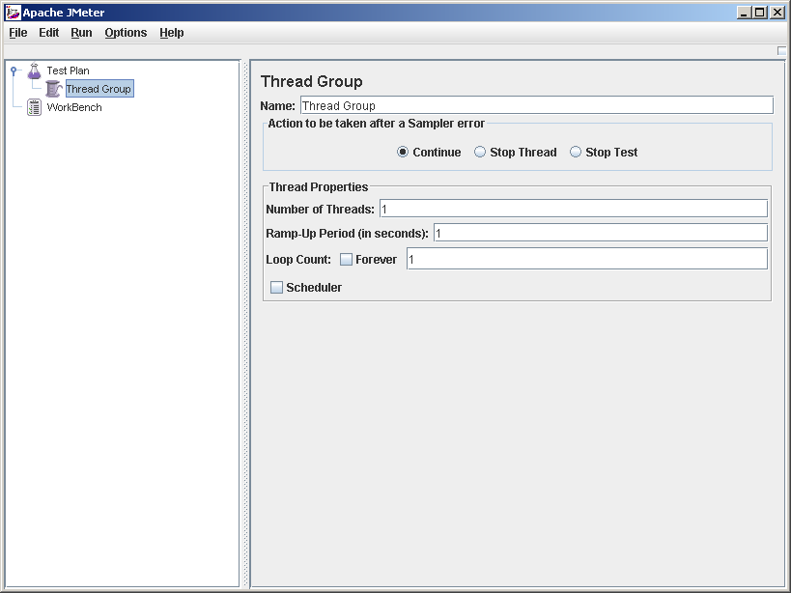

In this screen, along with the Thread Group, properties for simulating the number of users should be entered :

Number of Threads : This field denotes the number of virtual users (or threads) need to be created.

Ramp-Up Period : This field denotes (in Seconds) how much time should JMeter take to load all the required users. For e.g. : If the Number of Threads is 10, and the Ramp-Up Period is 5, then it means that JMeter will load 10 users in 5 seconds.

Loop Count : The Loop Count, is the number of times the loading of users will take place, for e.g. : If the Loop Count is 3, then the same operation of loading the number of threads in an allocated period of time will take place 3 times.
Note : If “Forever” checkbox is selected, then the process of loading the users will continue till the user terminates the process.

Describe the HTTP request

Select the Thread Group node, right click on the same and select the Add ---> Sampler ---> HTTP Request.

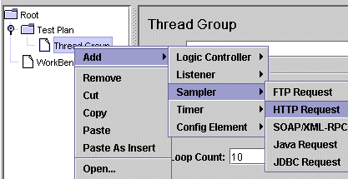

After selecting this option, the following window will be displayed :

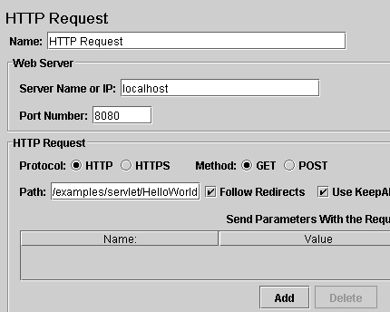

In this screen, enter the necessary parameters for Name, the IP or the Server Name value, Port Number and the path to the application, as shown in the above screenshot.

Select the Result Display Format :

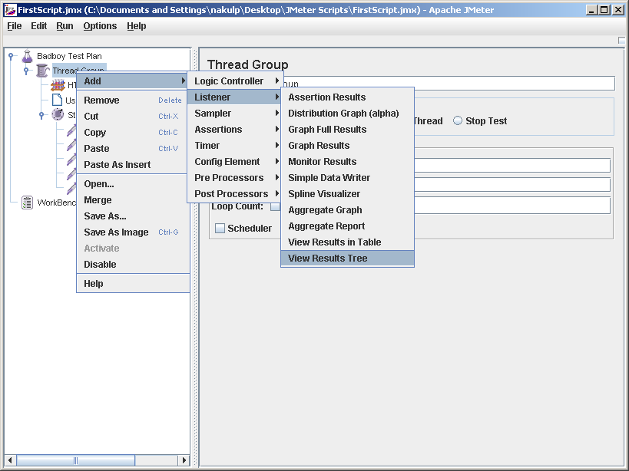

The results of the load test, can be displayed in a variety of formats.

Run the Created Test Plan :

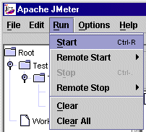

Once the Run ----> Start option is selected as shown above, the created test will run according to the number of threads selected in the Thread Group options window.

Viewing of the results

When the run has completed the results can be seen in the Results Tree:
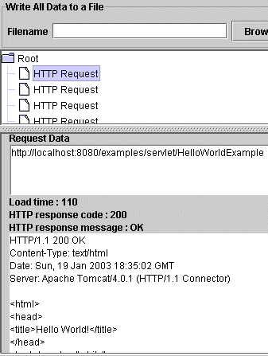
These are the basic steps to create and Run a Test Script using Apache’s JMeter.

Creation of JMeter compatible scripts using BADBOY tool :

- Download and Install BadBoy software. (http://www.badboy.com.au/)

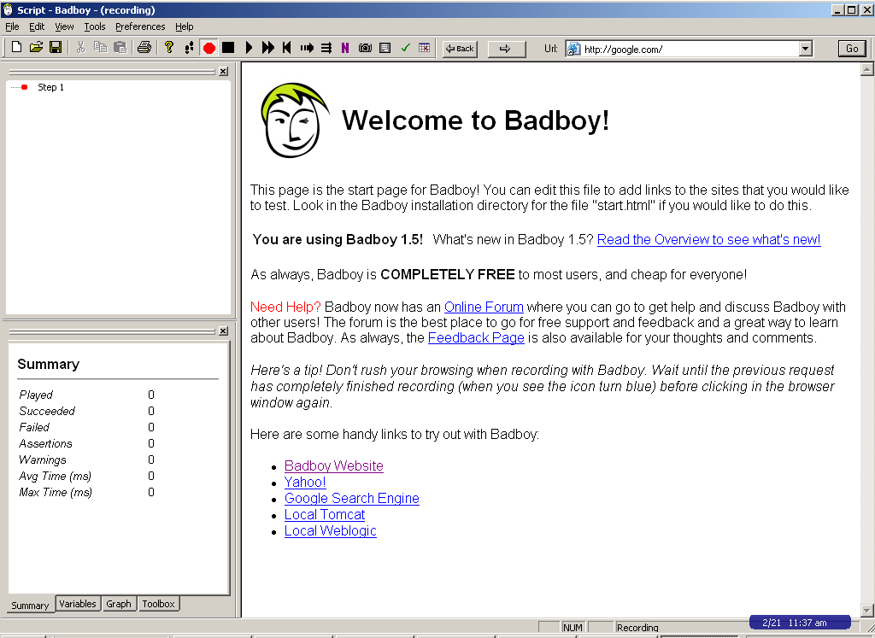

- In Badboy’s window, enter the applications URL/IP address that is to be tested.

- The Selected application will open in the space inside Badboy application. ( e.g. google)
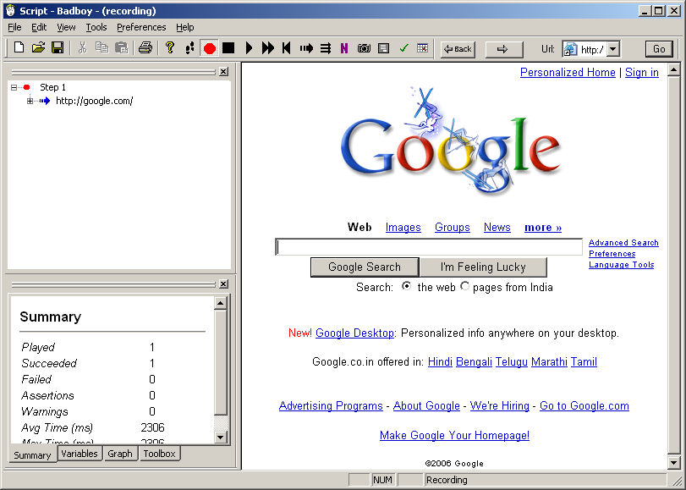
- Perform operations that need to be captured and tested for Load Testing.
For e.g. : Enter some string to be searched by google and click on the Google Search button.

There operations will be recorded and captured by Badboy application.

- After performing the required operations in the application (google in this
example), export the Badboy created script to JMeter, using the Export to JMeter option.

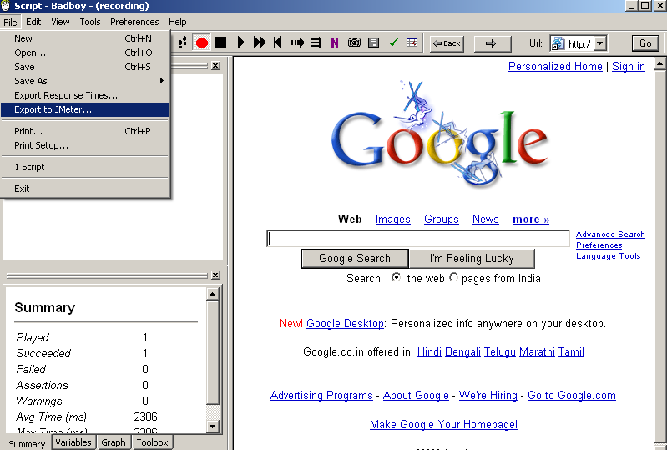

- Return back to JMeter console, open the script created and exported from Badboy application.

- Add a Listener in order to view the results and Run the saved test.

In this way, the load testing scripts can be easily created by Badboy and exported to be run from JMeter.

Useful Links :

There is a very nice tutorial at the following site that can be referred :
http://javaboutique.internet.com/tutorials/JMeter/

Also : The JMeter User Manual is located at :
D:\JMeter\jakarta-jmeter-2.1.1\docs\usermanual folder

Note : To access this, JMeter should have been installed.
(Please change the ‘Drive’ alphabet if JMeter is installed on some other drive in the hard disk.)

