**Ambidexterity**

Let’s say A & B represent one hemisphere, while C & D represent the other.

Let’s say B & C represent corticocortical neurons, while A & D are local.

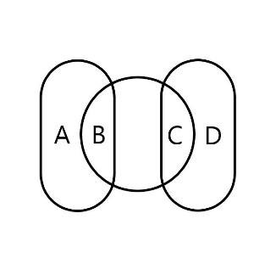

The center section between B & C represents the Corpus Callosum, consisting of 200–300 million *axonal projections1*, compared to the 100 billion2 *neurons*, interconnected via the number of synapses they share between hemisphere. That is to say, that the number of cells which make axonal projections across hemispheres is relatively small compared to the number which those cells themselves communicate with, and generally serve higher functions.

The relative higher importance of corticocortical neurons can be gestured towards by calculating the global maximum connection count for a set given those relationships, which is all the neurons of A, times all the neurons of B, times all the neurons of C, times all the neurons of D. Learning to use both hands equally can increase the CC by as much as 10%3, effectively raising throughput across a bottleneck. This is why putting the effort in to learn to engage fine motor skills and linguistics with both hands is valuable for time spent doing so.

Granted, these proportions and relationships are rudimentary and need to be completely refitted and scaled, but the general idea is that although a 10% increase from B1 and C1 (10 to 11) represents the same global increase as a 10% increase in A2 and D2 (50 to 55), the proportional growth is less in terms of neurons by count it took to make the increase, which means higher return for cost of growth, theoretically.

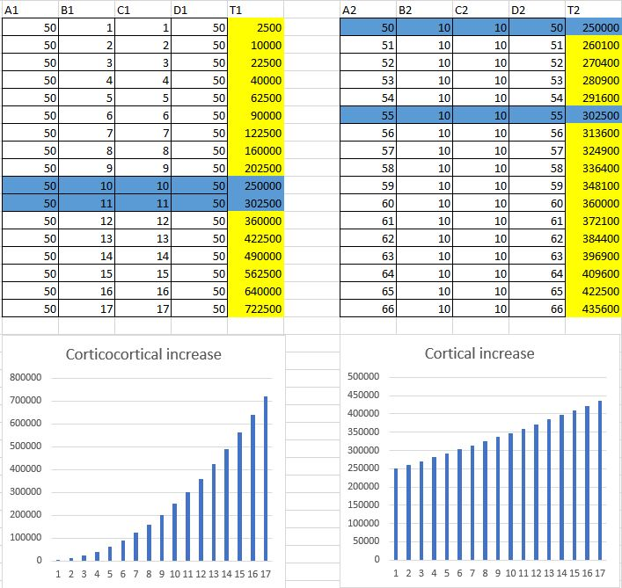

1. <https://en.wikipedia.org/wiki/Corpus_callosum>
2. <https://www.ncbi.nlm.nih.gov/pmc/articles/PMC2776484/>
3. <https://pubmed.ncbi.nlm.nAih.gov/4023705/>

09MAR2024 EDIT:

Perhaps being ambidextrous isn’t as important as forcing the corpus callosum to be used by using motor control to express what originates from the other hemisphere, regardless of side. This combines the advantage of hand specialization with gains in corpus callosum.

Consider the split‐brain studies of the 1960s. These studies were based on patients who had undergone section of corpus callosum and in some cases other forebrain commissures, for the relief of intractable epilepsy. The operation was largely successful in reducing seizures, but effectively disconnected the two sides of the brain, at least with respect to cognitive function. This enabled researchers to test the mental capacities of each side of the brain more or less independently of activity in the other side. The results quickly confirmed that the left side of the brain in these patients was indeed dominant for speech, while in most cases the right side of the brain was essentially mute.

As a Bilateria species, the human brain is a balance of symmetrical and asymmetrical functions.

There really are no left or right brained people, really, we all use both hemispheres for their unique and shared functions, their lateral and bilateral ones respectively. Asymmetry in handedness can increase efficiency by reducing duplication of functions and increasing specialization. There are certainly advantages to being single handed, it’s less redundant, reduces training time, and min maxes training time to a single recipient.

It is true that Broca’s area isn’t always on the left side of the brain, but usually it is. It’s also true, that like Ambidextrous people left handers also have a CC expanded by ten percent. Could the reason why left-handed people have a 10% larger CC on average than right-handed people, be because of the majority of people, weather left or right-handed, having language vocalization localized to the left hemisphere, which requires transmission across hemispheres to the right for motor control of the left hand at the same time? Or in short on opposites sides which forces relatively higher transhemispheric activity. If Broca’s area was on the right, would right handers using the left motor cortex have a ten percent larger cc because of it, where lefties would have the disadvantage in that case?