**VHP Female Computational Phantom version 2.0**

Body parts (soft and hard tissues) as of Dec. 30th 2014.

NEVA Electromagnetics, LLC and ECE Dept., Worcester Polytechnic Institute

*Intended for electromagnetic and mechanical full-body analysis including different overweight or obese conditions (variable fat volume), and for different tissue compositions.*

*Source*

* Image dataset from National Library of Medicine’s Visible Human Project (VHP)- **Female**. Body donated by husband
* Age: ~60
* BMI ~0.36
* Known pathologies: heart

*Triangular surface meshes (Fig. 1 and Table 1)*

* Surface deviation of less than 3 mm
* All individual meshes are strict 2 manifolds with only one closed surface
* All meshes have neither coincident nor intersecting faces, and do not have joint vertices
* All meshes are physically separated from each other by a gap of 0.6 mm or wider
* The fully enclosed meshes are allowed
* Triangle quality is defined as twice the ratio of incircle radius to circumcircle radius
* All individual meshes are available for export in ASCII NASTRAN format

*Body shells*

* The model includes three body shells: Skin (outermost), Fat (second outermost, separated from skin by 1.5 mm everywhere except eyes), and Average body (separated from fat by a variable distance of 0.6-150 mm) – see Fig. 2a.
* The volume between Skin and Fat shells is skin
* The volume between Fat and Average body shells is fat
* All other tissues are enclosed into the Average body shell container

*Anatomical features of version 2.0*

* 113 individual parts
* Separation of individual muscles (16)
* Superior resolution in the cranium – see Fig. 3.
* Eyes are closed by a 0.6 mm skin shell and 0.6 mm fat shell, respectively
* CSF ventricles are fully enclosed into the grey matter shell
* White matter is fully enclosed into the grey matter shell
* The Average body shell has two other variations: for a medium and low BMI, respectively – see Fig. 2b, c

*Simplifications of version 2.0*

* Small and large intestines are combined
* Left and right lungs and trachea are combined
* Ribs 1-9(left, right) and cartilage are combined
* In the vertebrate spinal column, individual vertebrae are combined
* Nervous system is not present
* Cardiovascular system is not developed (except superior vena cava and aorta)

*Computational performance of the full phantom version 2.0 (export to ANSYS HFSS, a 2.2 GHz server)*

* The phantom is to be used with the classic FEM mesher only
* Mesh intersection check and mesh analysis check run in less than 3 min each
* Initial mesh generation (FEM meshing) of the complete plain model (without extra features) runs in less than 30 min
* Typical run time at plane wave incidence with five adaptive passes at 300 MHz is less than 9 hours

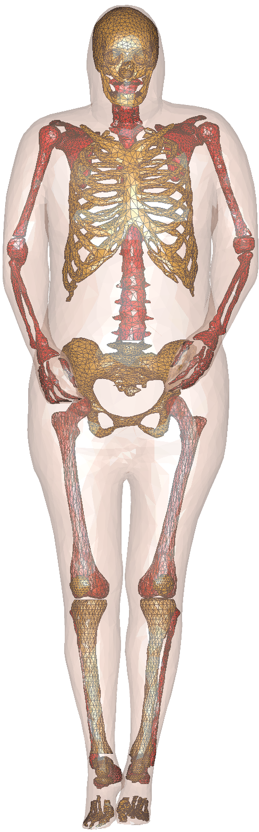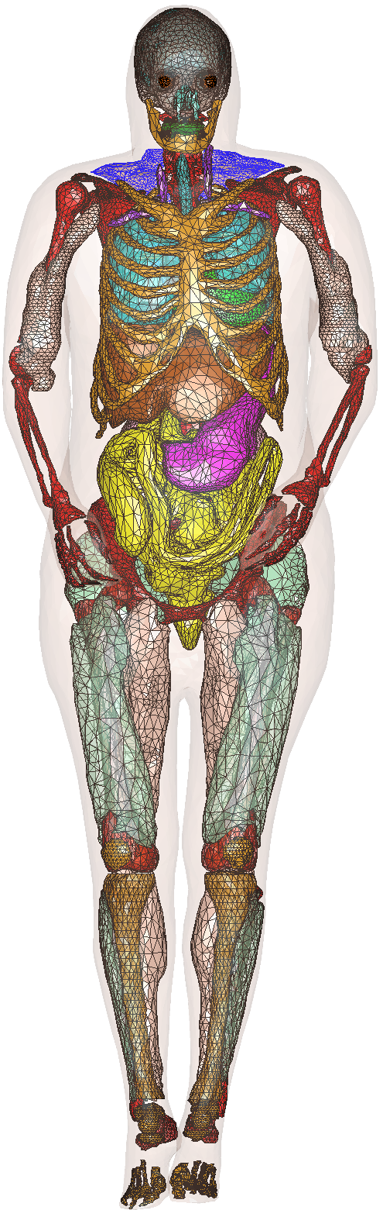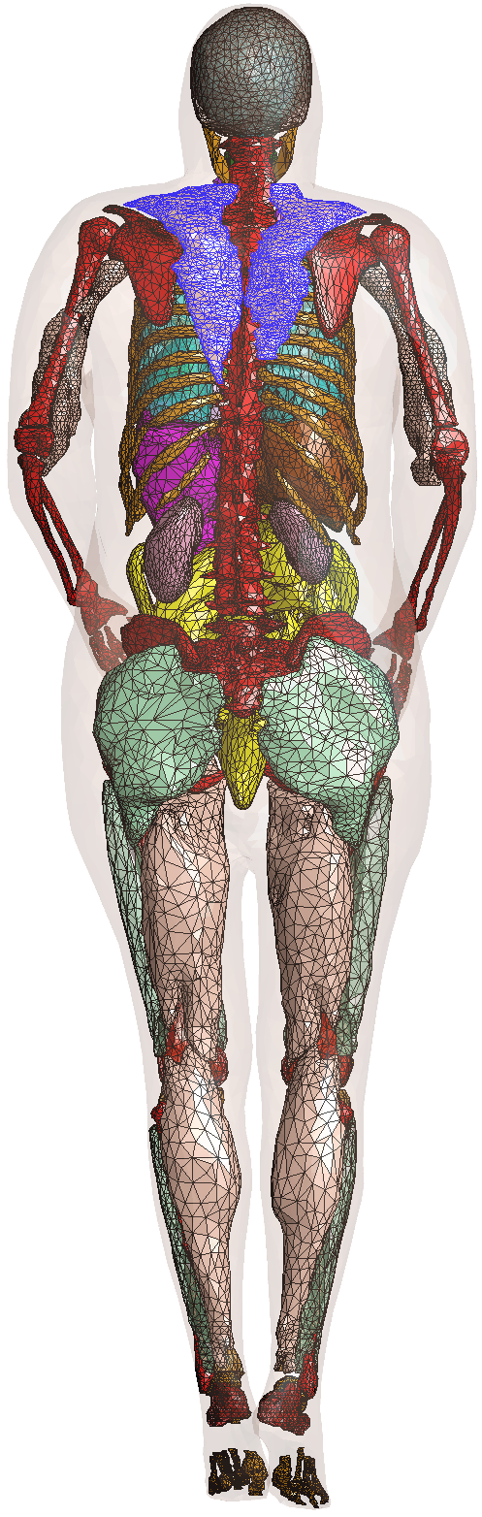

c)

a)

b)

**Fig. 1.** Partial VHP-Female model of NEVA EM: a) – skeleton Bones, b) – anterior view of organs and muscles, c) – posterior view of organs and muscles. Some muscles are made transparent.

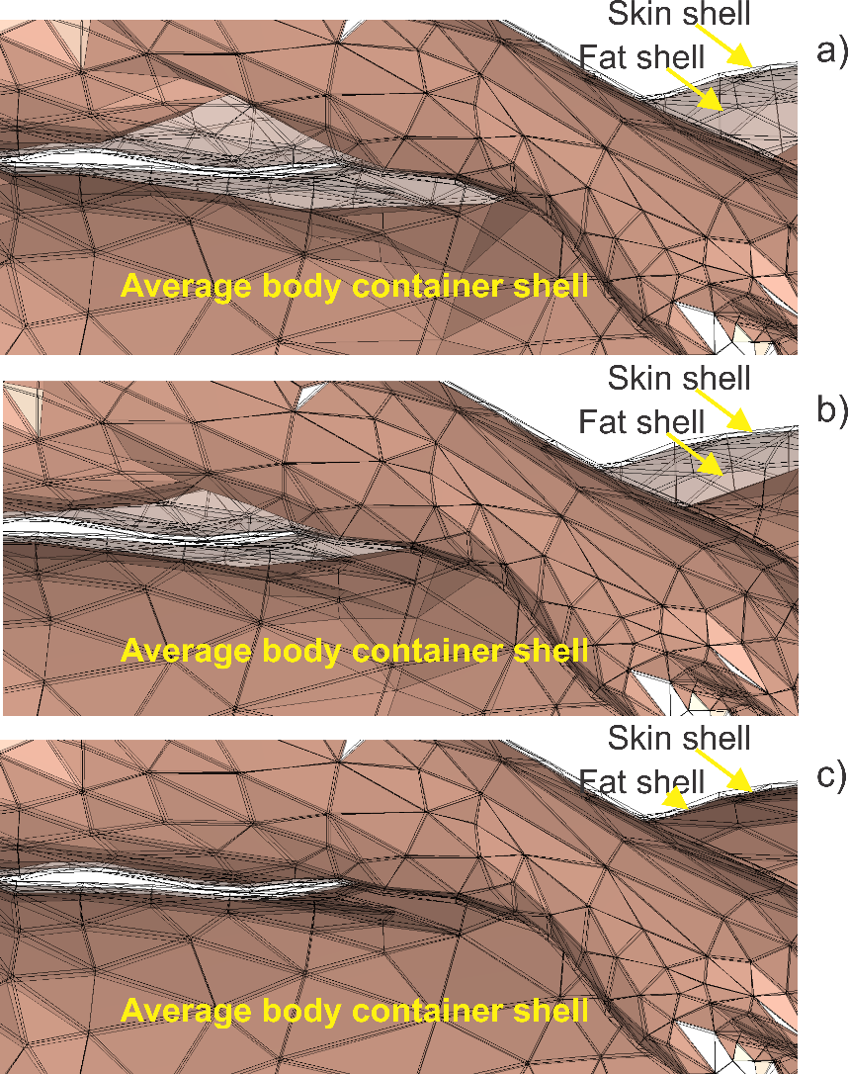

**Fig. 2** Three body shells and deformable average container shell for the VHP-Female computational model. ©NEVA EM.

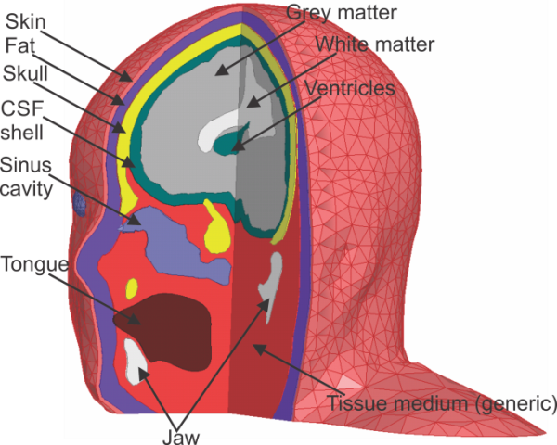

**Fig. 3.** Cranium model of the VHP-Female phantom. Cross-sections of triangulated surfaces are shown. The CSF is marked green.

*Table 1. List of triangular surface meshes – version 2.0*

*Legend:*

|  |  |  |
| --- | --- | --- |
| Hard tissues | Soft tissues | Individual muscles |

|  |  |  |  |  |  |  |
| --- | --- | --- | --- | --- | --- | --- |
| # | Mesh name (alphabetical) | Number of triangles | Min. triangle quality | Min. edge length, mm | Tissue (IT’IS database) | Min Dist (mm) |
| 1 | VHP_Aorta_M.mat | 910 | 0.0097 | 1.7166 | Blood | 0.00673 |
| 2 | VHP_Average_body.mat | 6702 | 0.0102 | 0.5564 | Muscle* | 0.00118 |
| 3 | VHP_Bicep_left_M.mat | 980 | 0.0970 | 2.1773 | Muscle | 0.0174 |
| 4 | VHP_Bicep_right_M.mat | 990 | 0.0206 | 2.6506 | Muscle | 0.0902 |
| 5 | VHP_Calcaneous_left_M.mat | 500 | 0.2087 | 2.4465 | Bone | 0.72755 |
| 6 | VHP_Calcaneous_right_M.mat | 500 | 0.2007 | 2.7420 | Bone | 0.27569 |
| 7 | VHP_Calf_left_M.mat | 760 | 0.1667 | 3.2296 | Muscle | 0.17081 |
| 8 | VHP_Calf_right_M.mat | 800 | 0.0175 | 1.6501 | Muscle | 0.00743 |
| 9 | VHP_Cava_M.mat | 598 | 0.0119 | 1.6433 | Blood | 0.08266 |
| 10 | VHP_Cerebellum_M.mat | 516 | 0.0615 | 1.2714 | Cerebellum | 0.4319 |
| 11 | VHP_CSF_Ventricles_M.mat | 834 | 0.0077 | 0.6398 | Cerebrospinal Fluid | 0.35787 |
| 12 | VHP_Eye_left_M.mat | 216 | 0.2286 | 2.0269 | Eye (Vitrous Humor) | 0.67187 |
| 13 | VHP_Eye_right_M.mat | 204 | 0.5260 | 2.2577 | Eye (Vitrous Humor) | 0.66112 |
| 14 | VHP_Fat.mat | 6676 | 0.0138 | 0.6332 | Fat (Average Infiltrated) | 0.00117 |
| 15 | VHP_Feet1Phalange_left_M.mat | 350 | 0.0095 | 1.5006 | Bone | 0.25276 |
| 16 | VHP_Feet1Phalange_right_M.mat | 350 | 0.2860 | 1.6478 | Bone | 1.3431 |
| 17 | VHP_Feet2Phalange_left_M.mat | 350 | 0.1473 | 1.3619 | Bone | 0.31477 |
| 18 | VHP_Feet2Phalange_right_M.mat | 350 | 0.2953 | 0.7860 | Bone | 1.12785 |
| 19 | VHP_Feet3Phalange_left_M.mat | 350 | 0.3110 | 1.0856 | Bone | 1.03919 |
| 20 | VHP_Feet3Phalange_right_M.mat | 350 | 0.1519 | 1.0440 | Bone | 1.54441 |
| 21 | VHP_Feet4Phalange_left_M.mat | 350 | 0.0825 | 1.7637 | Bone | 0.60097 |
| 22 | VHP_Feet4Phalange_right_M.mat | 350 | 0.1589 | 1.1114 | Bone | 0.62106 |
| 23 | VHP_Feet5Phalange_left_M.mat | 350 | 0.2330 | 0.8687 | Bone | 1.49644 |
| 24 | VHP_Feet5Phalange_right_M.mat | 350 | 0.1315 | 1.3508 | Bone | 0.81978 |
| 25 | VHP_Femur_left_M.mat | 1000 | 0.0118 | 3.1569 | Bone | 0.10362 |
| 26 | VHP_Femur_right_M.mat | 1000 | 0.0274 | 2.9429 | Bone | 0.00938 |
| 27 | VHP_Fibula_left_M.mat | 910 | 0.0502 | 2.0500 | Bone | 0.32108 |
| 28 | VHP_Fibula_right_M.mat | 910 | 0.0773 | 0.5525 | Bone | 0.27379 |
| 29 | VHP_Gluteus_left_M.mat | 1160 | 0.0346 | 3.7871 | Muscle | 1.46494 |
| 30 | VHP_Gluteus_right_M.mat | 1100 | 0.0230 | 4.0281 | Muscle | 0.93578 |
| 31 | VHP_GreyMatter_M.mat | 2942 | 0.1486 | 2.1400 | Brain (Grey Matter) | 0.19367 |
| 32 | VHP_Hamstring_left_M.mat | 1200 | 0.0821 | 3.7279 | Muscle | 0.46614 |
| 33 | VHP_Hamstring_right_M.mat | 1200 | 0.1109 | 2.8981 | Muscle | 1.33276 |
| 34 | VHP_Hands1Phalange_left_M.mat | 290 | 0.2893 | 1.2541 | Bone | 0.06475 |
| 35 | VHP_Hands1Phalange_right_M.mat | 290 | 0.1434 | 0.8342 | Bone | 0.50185 |
| 36 | VHP_Hands2Phalange_left_M.mat | 300 | 0.2564 | 2.1443 | Bone | 1.30544 |
| 37 | VHP_Hands2Phalange_right_M.mat | 290 | 0.0984 | 0.8971 | Bone | 0.40424 |
| 38 | VHP_Hands3Phalange_left_M.mat | 290 | 0.1487 | 1.2750 | Bone | 0.6023 |
| 39 | VHP_Hands3Phalange_right_M.mat | 286 | 0.0711 | 1.0278 | Bone | 0.15952 |
| 40 | VHP_Hands4Phalange_left_M.mat | 286 | 0.1555 | 1.0998 | Bone | 0.82038 |
| 41 | VHP_Hands4Phalange_right_M.mat | 290 | 0.1200 | 0.5133 | Bone | 0.63332 |
| 42 | VHP_Hands5Phalange_left_M.mat | 290 | 0.0736 | 1.2552 | Bone | 0.27049 |
| 43 | VHP_Hands5Phalange_right_M.mat | 290 | 0.1998 | 0.9490 | Bone | 0.55705 |
| 44 | VHP_Heart_M.mat | 1900 | 0.0027 | 2.4284 | Heart Muscle | 0.05038 |
| 45 | VHP_Humerus_left_M.mat | 882 | 0.4101 | 2.0717 | Bone | 0.60268 |
| 46 | VHP_Humerus_right_M.mat | 798 | 0.1902 | 1.7055 | Bone | 0.32904 |
| 47 | VHP_Intestine_M.mat | 5500 | 0.0153 | 1.1024 | Large Intestine | 0.16493 |
| 48 | VHP_Jaw_M.mat | 210 | 0.0398 | 4.6205 | Bone | 0.47522 |
| 49 | VHP_Kidney_left_M.mat | 1500 | 0.0088 | 1.2448 | Kidney | 1.40841 |
| 50 | VHP_Kidney_right_M.mat | 1500 | 0.0383 | 0.9471 | Kidney | 0.27341 |
| 51 | VHP_LatissimusDorsi_left_M.mat | 980 | 0.0235 | 2.5872 | Muscle | 1.12744 |
| 52 | VHP_LatissimusDorsi_right_M.mat | 996 | 0.1111 | 2.2136 | Muscle | 0.17698 |
| 53 | VHP_Liver_M.mat | 2498 | 0.0150 | 1.1619 | Liver | 0.00686 |
| 54 | VHP_Lungs_M.mat | 4998 | 0.0025 | 1.3235 | Lung | 0.02937 |
| 55 | VHP_Navicular_left_M.mat | 198 | 0.3619 | 2.2289 | Bone | 1.71138 |
| 56 | VHP_Navicular_right_M.mat | 214 | 0.2936 | 1.7489 | Bone | 0.22832 |
| 57 | VHP_Patella_left_M.mat | 300 | 0.2659 | 1.3477 | Patella | 0.66582 |
| 58 | VHP_Patella_right_M.mat | 280 | 0.6478 | 2.3964 | Patella | 2.29755 |
| 59 | VHP_Pelvic_Girdle_M.mat | 6000 | 0.0111 | 0.7167 | Bone | 0.85736 |
| 60 | VHP_Quadriceps_left_M.mat | 1000 | 0.0216 | 1.9319 | Muscle | 0.01821 |
| 61 | VHP_Quadriceps_right_M.mat | 982 | 0.0312 | 0.6741 | Muscle | 0.98327 |
| 62 | VHP_Ribs_Cartilage_M.mat | 8680 | 0.0501 | 1.9425 | Bone | 0.04384 |
| 63 | VHP_Ribs_left11_M.mat | 296 | 0.0966 | 3.4912 | Bone | 2.18678 |
| 64 | VHP_Ribs_left12_M.mat | 116 | 0.2628 | 2.9755 | Bone | 10.7535 |
| 65 | VHP_Ribs_right10_M.mat | 434 | 0.1461 | 3.7586 | Bone | 0.2103 |
| 66 | VHP_Ribs_right11_M.mat | 308 | 0.1450 | 3.1846 | Bone | 0.18708 |
| 67 | VHP_Ribs_right12_M.mat | 150 | 0.1451 | 1.5159 | Bone | 0.05676 |
| 68 | VHP_Scapula_left_M.mat | 1500 | 0.0834 | 1.1141 | Bone | 0.5995 |
| 69 | VHP_Scapula_right_M.mat | 1500 | 0.0088 | 0.8392 | Bone | 0.48408 |
| 70 | VHP_Shin_left_M.mat | 1160 | 0.0738 | 2.2049 | Muscle | 0.00144 |
| 71 | VHP_Shin_right_M.mat | 1154 | 0.0187 | 2.0897 | Muscle | 0.26053 |
| 72 | VHP_Sinus_M.mat | 400 | 0.0090 | 0.6892 | Air | 0.39309 |
| 73 | VHP_Skin.mat | 6646 | 0.0100 | 0.5989 | Skin | 0.33733 |
| 74 | VHP_Skull_M.mat | 3976 | 0.0235 | 1.8129 | Skull | 0.08698 |
| 75 | VHP_Spine_M.mat | 2500 | 0.0272 | 1.9978 | Spinal Cord | 0.04745 |
| 76 | VHP_Stomach_M.mat | 1998 | 0.0540 | 1.5316 | Stomach | 0.25571 |
| 77 | VHP_Talus_left_M.mat | 720 | 0.3037 | 1.7856 | Bone | 0.13048 |
| 78 | VHP_Talus_right_M.mat | 754 | 0.3192 | 1.2847 | Bone | 1.51879 |
| 79 | VHP_Teeth_lower17_M.mat | 78 | 0.0396 | 0.8380 | Tooth | 0.8123 |
| 80 | VHP_Teeth_lower18_M.mat | 64 | 0.1455 | 1.1039 | Tooth | 1.51127 |
| 81 | VHP_Teeth_lower19_M.mat | 54 | 0.1999 | 0.9156 | Tooth | 2.26438 |
| 82 | VHP_Teeth_lower28_M.mat | 60 | 0.2943 | 1.0345 | Tooth | 2.76053 |
| 83 | VHP_Teeth_lower29_M.mat | 58 | 0.1995 | 0.8014 | Tooth | 0.70717 |
| 84 | VHP_Teeth_lower30_M.mat | 64 | 0.1690 | 1.0328 | Tooth | 0.21209 |
| 85 | VHP_Teeth_lower31_M.mat | 72 | 0.0067 | 0.6292 | Tooth | 0.59207 |
| 86 | VHP_Teeth_upper11_M.mat | 38 | 0.3055 | 0.8348 | Tooth | 0.96629 |
| 87 | VHP_Teeth_upper12_M.mat | 36 | 0.3236 | 0.9483 | Tooth | 0.60495 |
| 88 | VHP_Teeth_upper13_M.mat | 40 | 0.3960 | 0.9526 | Tooth | 1.07703 |
| 89 | VHP_Teeth_upper14_M.mat | 38 | 0.2216 | 1.3158 | Tooth | 1.20412 |
| 90 | VHP_Teeth_upper15_M.mat | 46 | 0.4536 | 1.0626 | Tooth | 0.89538 |
| 91 | VHP_Teeth_upper16_M.mat | 42 | 0.5181 | 1.3653 | Tooth | 1.74019 |
| 92 | VHP_Teeth_upper2_M.mat | 46 | 0.3361 | 1.0350 | Tooth | 0.48052 |
| 93 | VHP_Teeth_upper3_M.mat | 44 | 0.5622 | 1.2812 | Tooth | 0.58665 |
| 94 | VHP_Teeth_upper4_M.mat | 44 | 0.5553 | 1.1748 | Tooth | 0.57725 |
| 95 | VHP_Teeth_upper5_6_M.mat | 26 | 0.2226 | 0.9234 | Tooth | 0.9071 |
| 96 | VHP_Teeth_upper7_8_M.mat | 42 | 0.2519 | 1.0636 | Tooth | 0.7183 |
| 97 | VHP_Teeth_upper9_10_M.mat | 44 | 0.3170 | 0.6744 | Tooth | 0.82433 |
| 98 | VHP_Tibia_left_M.mat | 1248 | 0.4153 | 1.9274 | Bone | 0.10174 |
| 99 | VHP_Tibia_right_M.mat | 1040 | 0.2091 | 2.6007 | Bone | 0.57274 |
| 100 | VHP_Tongue_M.mat | 480 | 0.0202 | 0.8674 | Tongue | 0.04283 |
| 101 | VHP_Trabecular_lower_left_M | 500 | 0.0825 | 1.6093 | Bone (Cancellous) | 3.30386 |
| 102 | VHP_Trabecular_lower_right_M | 508 | 0.0363 | 1.3147 | Bone (Cancellous) | 0.41805 |
| 103 | VHP_Trabecular_upper_left_M.mat | 498 | 0.0746 | 1.5324 | Bone (Cancellous) | 0.8021 |
| 104 | VHP_Trabecular_upper_right_M.mat | 498 | 0.0172 | 1.7749 | Bone (Cancellous) | 0.28853 |
| 105 | VHP_Trapezious_left_M.mat | 2000 | 0.0068 | 1.1799 | Muscle | 1.3157 |
| 106 | VHP_Trapezious_right_M.mat | 2000 | 0.0374 | 0.9741 | Muscle | 1.12069 |
| 107 | VHP_Ulna_Radius_left_M.mat | 1178 | 0.0115 | 1.0765 | Bone | 0.78115 |
| 108 | VHP_Ulna_Radius_right_M.mat | 1200 | 0.0610 | 2.4306 | Bone | 0.61203 |
| 109 | VHP_WhiteMatter_M.mat | 2450 | 0.0051 | 0.4220 | Brain (White Matter) | 0.04073 |
| Deformed meshes | | | | | |  |
| 110 | VHP_Average_body_lowfat.mat | 6732 | 0.0131 | 0.4375 | Non-model or  Fat (Average Infiltrated) | 0.00118 |
| 111 | VHP_Average_body_mediumfat.mat | 6732 | 0.0193 | 0.4375 | Non-model or  Fat (Average Infiltrated) | 0.00118 |
| CSF shells | | | | | |  |
| 112 | VHP_CSF_ShellInner.mat  (0.3 mm thick shell fully enclosing grey matter) | 2942 | 0.2378 | 2.4021 | Cerebrospinal Fluid | 0.10292 |
| 113 | VHP_CSF_ShellOuter.mat  (outer CSF shell distanced by 0.3mm from the skull) | 2990 | 0.0053 | 0.5124 | Cerebrospinal Fluid | 0.02309 |

*CSF shell assembly*

* Fig. 4 shows one possible scenario with two intermediate subshells having average-body properties
* Other scenarios are possible by removing one of the shells (inner or outer) and/or changing material properties

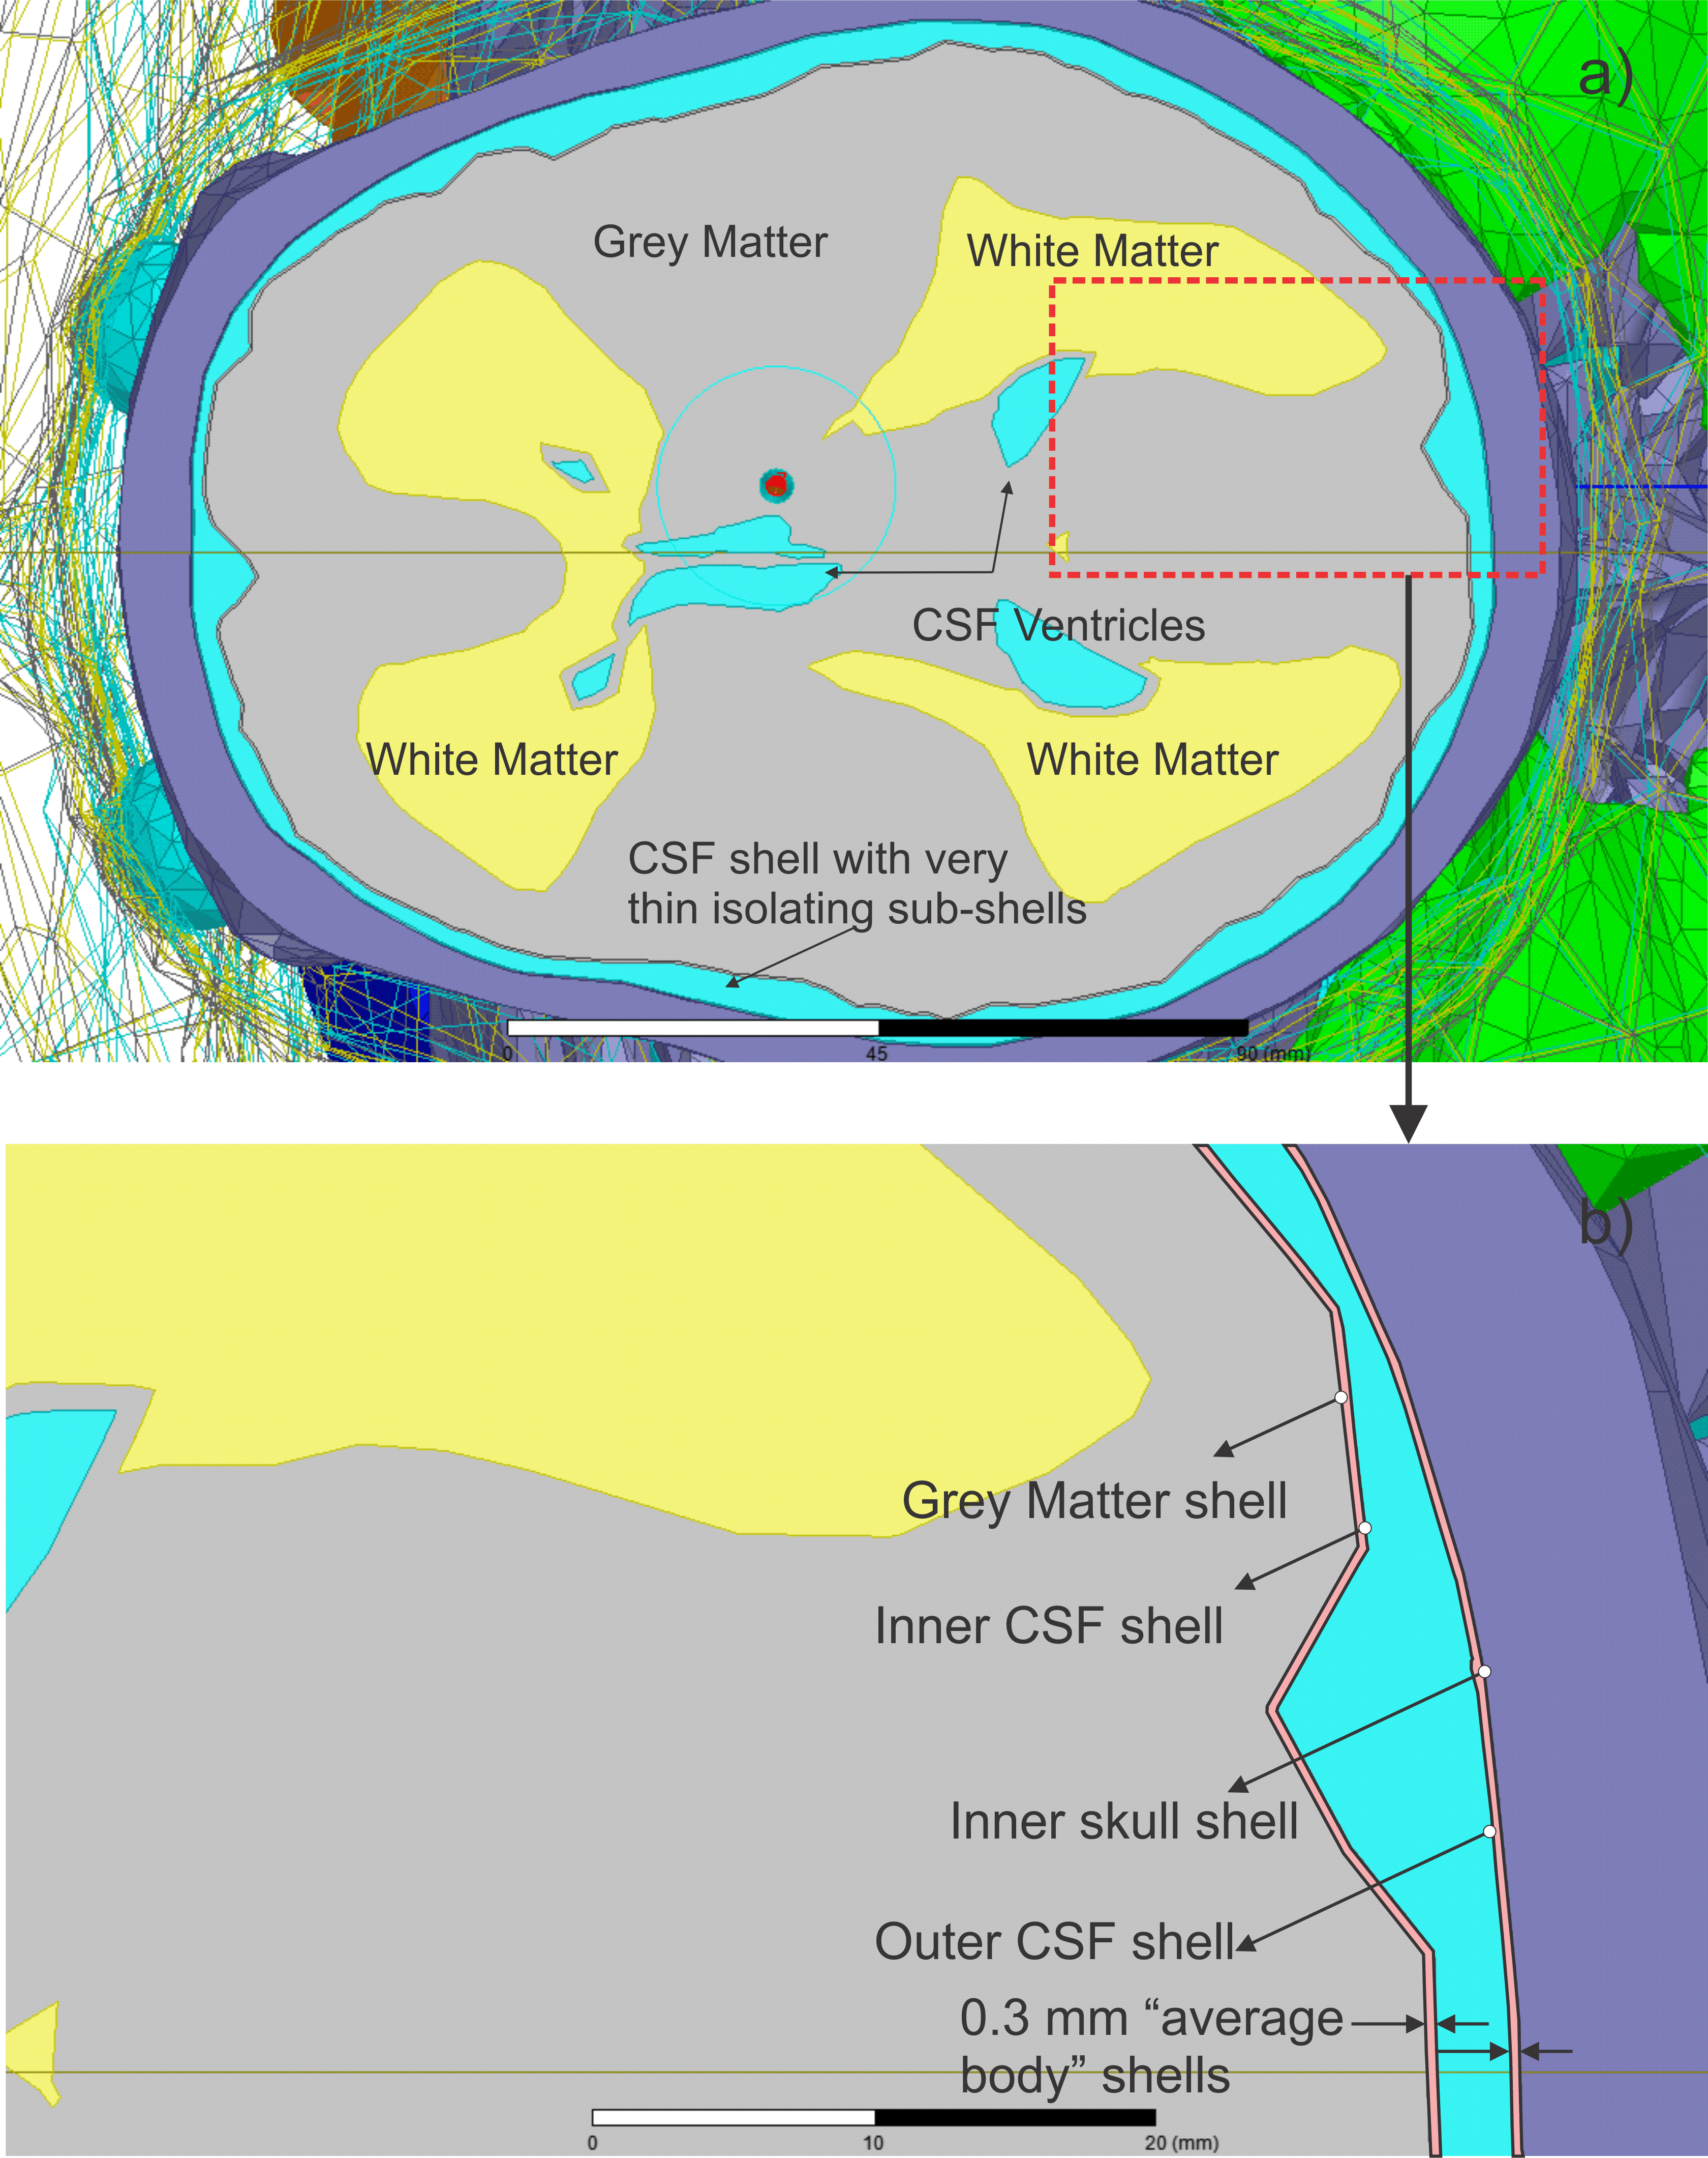

**Fig. 4.** One scenario for the CSF shell assembly.