NRU HSE, Institute for Cognitive Neuroscience, International Laboratory of Social Neurobiology
Moscow school on South-West № 1543

Auditory attention to unknown words of different length: an EEG study

K. S. Fedorov*
- A. Medvedev*
V. A. Klucharev
A. N. Morozova

Moscow, 2024
*These authors equally contributed to this work.
Introduction
Whether some event or fact is going to be preserved in our memory Is defined by the level of given attention (Chun et al., 2007). Several types of attention could be distinguished: spatial attention, temporal attention (to an event happening continuously or at a particular moment of time (Henry and Herrmann, 2014)), selective attention and internal attention (to the memory operations and other cognitive processes) (Frey et al., 2015). Attention can also be divided by auditory and visual – after the perception system it is engaged by. This study investigates the auditory attention paradigm.

During communicating people sometimes encounter unfamiliar words, and although in a simple conversation it may not happen very often, the studying process produces such situations much more frequently. However, it worth noticing that there is a plethora of features to define the memorizing success. For example, Baddeley et al. (1975) showed that word’s storage capacity in the short-term memory (and thus, potentially, in the long term one (Squire, 2009)) is dependent on the length of the word. And the way a word length can determine its memory storage capacity, it is believed to be among the most important aspects to determine the level of attention given. Several studies which examined this characteristic visually (the words were presented on the screen) were conducted (Hauk et al., 2004; Juphard et al., 2011). However, most of the auditory attention studies investigated the effect of the length of meaningful parts, such as syllables, on the level of attention given to a separate word or collocation, without analyzing it in the context of continuous speech (Baddeley et al., 1975).

We decided to clarify the impact of the word’s length on auditory attention to it in the context of continuous speech. By the length of the word this study refers to its number of sounds. In order to see the difference between the auditory attention to the words of different length we introduced mathematical tasks to our participants. The brain rhythms’ absolute power (here and after AP) which appears while performing math is expected to change at the time, when the attention is switched onto the presented stimuli (a word), thus by observing the difference in rhythms’ amplitude before and after the stimuli presentation the extent to which the attention is shifted could be deciphered (is further discussed in the next paragraph). Afterwards, by comparing the results between different groups of stimuli (words of different length) we will be able to understand the difference in attention to them. Additionally, by the means of mathematical tasks we wanted to make sure, whether participant is engaged in the experiment. What is more, the attention is also going to be measured by the amplitude of several evoked components (N1/P300/N400) (Bentin, 1985; Kutas, 1985; Bentin, 1987; Näätänen and Picton, 1987; Luck et al., 1990; Näätänen, 1990; Alcaini et al., 1994; Kutas, 2000; Federmeier, 2007; Polich, 2007; Kutas and Federmeier, 2011; Luck, 2014; Bachiller et al., 2015).

Mathematics, speech and oscillations

Neural activity while performing mathematical tasks is taking place at frontoparietal network and mostly generating theta and beta rhythmic bands (Palva et al., 2005; Friedrich and Friederici, 2013; Lin et al., 2015; Rio et al., 2019; Bonança et al., 2024), while the auditory tasks, especially ones involving the memory retrieval of the words, are taking place at temporal and frontal lobes and mostly generating only theta bands (Scott and Johnsrude, 2003; Hugdahl et al., 2003; Peele and Davis, 2012; Morillon and Baillet, 2017; Peña and Melloni, 2017).

Even though auditory reaction to unknown words has not been studied precisely, the same thing about unknown language cannot be said. Peña and Melloni (2017) conducted their study on the two groups of participants: Spanish and Italian native speakers. Each group was presented a set of audios in three different languages: Spanish, Italian and Japanese. The only audio, which evoked the middle gamma band activity (in parietal lobes) was the one with the native language of this person, despite the fact that Spanish and Italian are quite close phonetically. This study hypothesizes that middle gamma band reflects the words’ integration, as it appears 1 second after the sentence onset and decreases 1 second after the sentence is finished. Peña and Melloni (2017) suggest that 1 second is the time need for at least 2 words to be heard to create a sufficient context. So, we decided to compare the level of middle gamma band activity after familiar and unfamiliar words’ presentation. As unknown words in the native language are also phonetically familiar, even though not recognized lexically and may be analyzed by the brain the way unfamiliar language is (both stimuli possibly induce an unsuccessful memory retrieval process, thus N400 potential in the centrotemporal area (Lau et al., 2008) that represents it could be evoked (Bentin et al., 1985; Bentin, 1987; Kutas and Federmeier, 2000; Kutas and Federmeier, 2011)).

H1: A noticeable decrease in beta activity at frontal and parietal lobes after the stimuli presentation is going to occur due to the attention switch (gradually larger for unfamiliar and longer words).
H2: An increase in theta activity at temporal lobes after the stimuli presentation is going to occur due to the attention switch (gradually larger for unfamiliar and longer words).
H3: An increase in middle gamma band activity at parietal lobes for familiar stimuli is going to occur along with N400 evoked for unfamiliar stimuli, hypothetically, due to unsuccessful memory retrieval.

Visual attention to unknown words of different length

Research carried out by Hauk et al. (2004) showed that longer words elicit a higher early response, while shorter ones induce greater ERP amplitude between 150 and 400 ms (including N1). Moreover, this study showed that pseudowords (a set of syllables put together that does not have any lexical meaning) induce a higher N400 amplitude than the familiar words. The same effect was obtained comparing the monolingual and bilingual participants (Lehtonen et al., 2012). The other study conducted by Juphard et al. (2011) on epileptic participants using the electrode injection technique examined both the word’s length and familiarity effect on the ERP amplitude; and did not find any correlation between the word’s length and the response, while pseudowords evoked a much higher ERP amplitude. Comparing these conditions in the paradigm of auditory study would be fascinating.

What is more, we expect to obtain a P3a component in the frontal lobe (Strobel et al., 2008; Wronka et al., 2012; Bachiller et al., 2015; Fonken, Kam, Knight, 2020), which is directly related to surprisal that might occur during an unfamiliar word presentation (Polich, 2007).

H4: Unknown words are going to induce higher ERPs (N1, P3a, N400).
H5: Shorter words are going to evoke higher ERPs (N1, P3a, N400) amplitude (Hauk et al., 2004), alternatively, no effect of the word’s length is going to be revealed (Juphard et al., 2011).

Materials and methods

Participants

21 mentally healthy participants were taken, no one among which reported hearing malfunction. All of them were the Russian language native speakers 18 to 26 years old with the age standard deviation of 2.28 (average age = 20.7). Both right (19 people) and left (2 people) handed participants attended our experiment, however, the lefthanded ones were excluded from ERP analysis, as the ERP localization may differ depending on the handiness of the person (Alexander et al., 1995; Polich et al., 1997).

Mathematical tasks

During the experiment participants were asked to perform mathematical tasks, which were automatically generated using a Python based program. Each task contained a simple additive or deductive problem with the number ranged from 1 to 200, no negative solutions could be obtained. The task was presented on the tablet screen with all possible signals switched off; the participant needed to type the answer on the electronic keyboard and press the ‘Enter’ button for the next task to be generated.

Stimuli and experimental design

As the stimuli 160 words (148 nouns, 10 adjectives, 2 adverbs) of different length were used (Appendix 1). All of them were incorporated in the meaningful text, which consisted of 2596 words and 298 sentences, written and then vocalized in Russian language. The stimuli words were always placed at the end of 7-to-8-words sentence. 138 of the text’s sentences did not contain the stimulus word and tended to be more that 8 words-long. The stimuli were divided by two groups: experimental stimuli (unfamiliar terms related to plant’s anatomy, physiology and morphology, organic and bio chemistry, algology, mycology and lichenology (120 words)) were situated at the first part of the text and control stimuli (simple and common words that are often used in regular conversations (40 words)), which were situated in the end of the text. Considering that clean ERP data requires at least 300 stimuli, this number of experimental and control words was taken. Each of the groups listed above was further split into four smaller sub-groups based on the word’s length (i.e. the number of sounds) (Hauk et al., 2006). The following sub-groups were formed: words of 5-6, 7-8, 9-10, 11-12 sounds. Each experimental sub-group contained 30 words, while each control consisted of 10.

Before the experiment, for simplicity of understanding participants were told ‘a story’: that they will attend a biological lecture during which, to complete their homework assignment, as many mathematical tasks as possible must be accomplished. Consequently, participant was motivated to pay attention to both the audio and the mathematical tasks. The audio sampling rate was 150 Hz.

The overall duration of the experiment resulted approximately in 32-36 minutes. After the main part finished participant needed to fill the form, where each stimulus-word was marked by one out of three conditions: ‘Did not hear this word before the experiment’, ‘Heard this word before the experiment, but did not know its meaning’ or ‘Heard the word before the experiment and knew the meaning’. According to the obtained answers we excluded the words that the person knew or heard before from the unfamiliar stimuli group and the words that he did not from the control stimuli group.

EEG recording

The EEG was recorded using a 64-electrode cap ‘Brain Products easyCAP’. The ground electrode was placed into the Fpz position, while for reference electrodes the FT9 and FT10 were chosen, because the data that we could have gotten using these electrodes would be less valuable in comparison to the data obtained from the other ones that are usually used for a reference. BrainVision actiCHamp Plus (Brain Products) amplifier with the discretization rate of 500 Hz was used for the signal recording.

The data analysis

The data analysis was performed in the Python programming medium with the usage of MNE-Python library (Gramfort et al., 2013). The frequency filter was applied to the EEG signal: 1-45 Hz for the ERP analysis and 1-80 Hz for the oscillatory analysis. Artifacts created by the eye and head movements so as blinks were excluded using the independent component analysis (ICA); from 2 to 7 components were marked as bad in every participant’s recording. The time period from -200 ms to 0 was taken as a baseline for the epochs’ creation; epochs, where post-stimulus signal differed more than ±10 μV relatively to the baseline were also excluded. Consequently, approximately 25 epochs out of 160 were marked as bad in each recording (~16%) and every control group eventually consisted of ~8 and experimental of ~24-25 epochs.

ERPs

Epochs were average both across participants and stimuli groups. Afterwards, the ERP analysis was realized using a cluster method, that was detecting a time period, when the difference between two groups appeared to be significant (p < 0.05); these regions were highlighted on the graphs with red color. N1 component was considered to be the highest peak on the 50-150 ms time period; similar approach was applied to distinct the P300 and N400 components but on the 250-450 and 300-500 ms time periods respectively.

Results

Behavioral results

The number of mathematical tasks completed correctly by the participant was not taken into account, as people of both humanitarian and mathematical/engineering profiles attended our experiment and the comparison would be inhomogeneous. However, we checked whether the person was fully involved into the experiment by comparing the number of exercises he completed to the average. All of the participants completed more than 150 tasks, moreover, two of them reached 400 corrected answers (they both had a degree in physics). The average number of accomplished exercises by one participant is approximately 200. What is more, every participant made at least 5 mistakes (~9 average) during the experiment. One of our participants stopped doing mathematics, when the audio began, thus, he was later excluded from the frequency analyses. Notably, after the experiment finished participants tended to share that there were lots of unfamiliar words present in the audio, which indirectly demonstrates the presence of passive attention to these words.

According to the form filled by every subject. Each participant new ~15 experimental words out of 120 and all of words from the control group.

ERPs

General comparison

Picture 4 represents the ERPs, which are elicited by unfamiliar (1: blue line) and familiar (2: orange line) words; the data is averaged across all participants, all sub-groups and all electrodes. These sets were compared on the 100 ms intervals throughout the whole post stimulus period using the Wilcoxon test and Bonferroni correction for multiple comparison. No significant difference was obtained.
Picture 4. ERP graph for unfamiliar (1: blue line) and familiar (2: orange line) words; the data is averaged across all participants, all sub-groups and all electrodes. The X-line represents the time scale (in ms), while the Y-line Voltage (in μV). The 0 point on the time scale represents the onset of the stimulus.
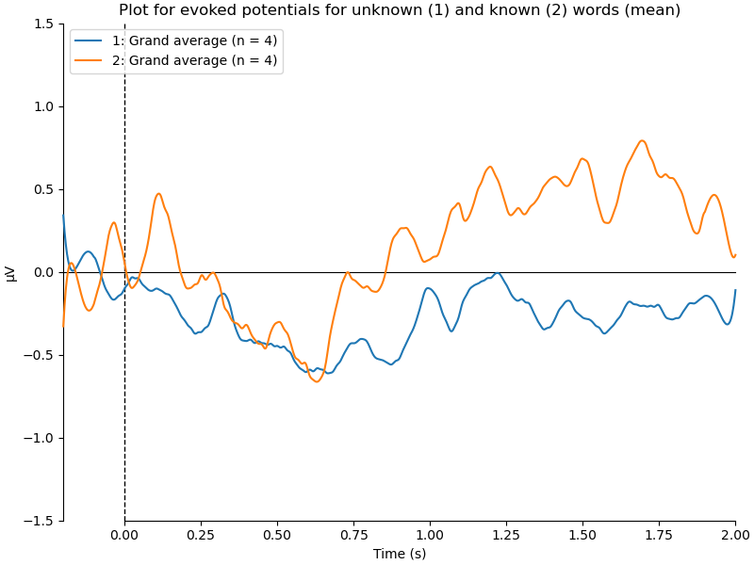

For each of 8 our sub-groups we performed the t-test with Bonferroni and FDR (False Discovery Rate) correction for multiple comparisons, to establish whether the ERPs at the particular time point are different from 0. The data was averaged across all participants and electrodes. No significant difference from 0 was found in any of the sub-groups (Pictures 5-6).

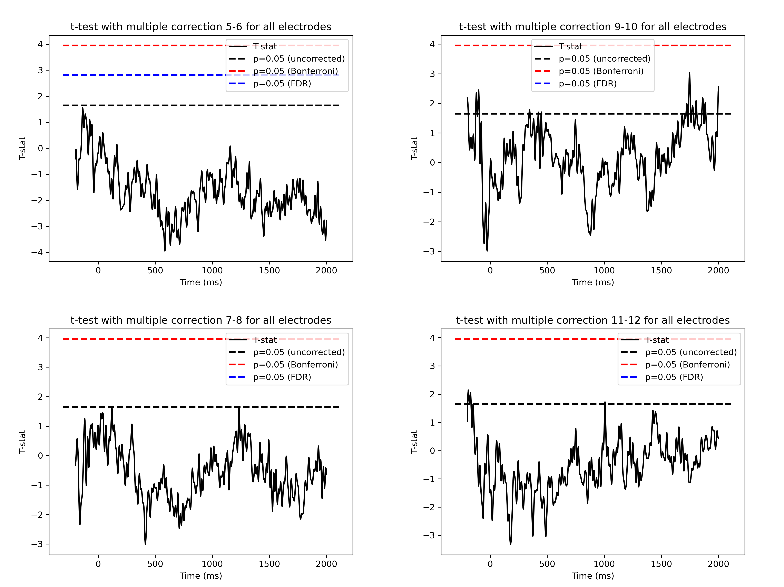
Picture 5. The graphs represent whether the ERPs are significantly different from 0 at a particular moment of time; averaged across all electrodes and participants with the multiple comparison correction applied for four experimental sub-groups. If at any point the graph crosses the blue (FDR correction) or red (Bonferroni correction) line, the ERPs there are significantly different from 0. In case the blue line is missing from the graph, then for this sub-group the FDR correction has a zero cluster (no point on the graph is different from 0).
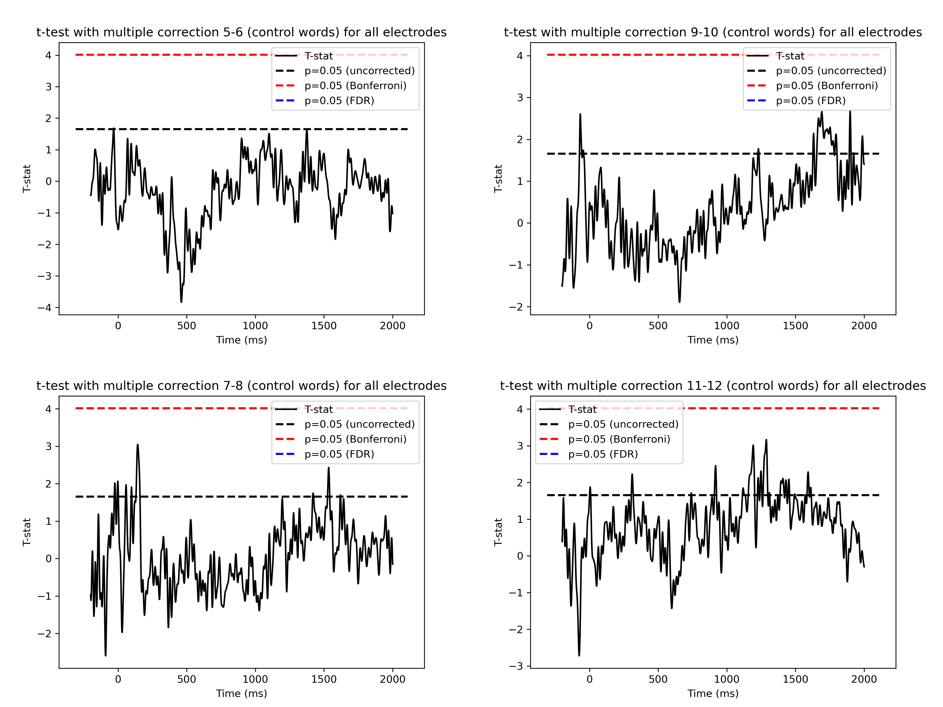
Picture 6. The graphs represent whether the ERPs are significantly different from 0 at a particular moment of time; averaged across all electrodes and participants with the multiple comparison correction applied for four control sub-groups. If at any point the graph crosses the blue (FDR correction) or red (Bonferroni correction) line, the ERPs there are significantly different from 0. In case the blue line is missing from the graph, then for this sub-group the FDR correction has a zero cluster (no point on the graph is different from 0).

Comparison between sub-groups

The Pairwise cluster T-test analysis was used for ERP sub-groups comparison (averaged across all electrodes) for both familiar and unfamiliar words (Pictures 7-8). No significant difference was obtained.
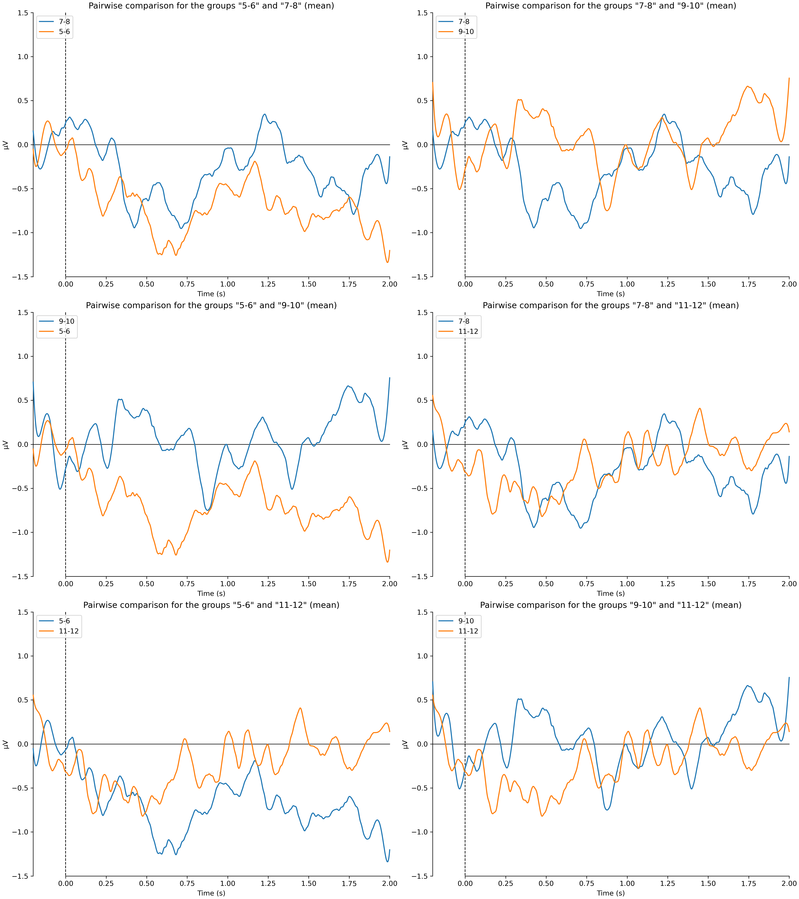
Picture 7. The Pairwise comparison ERP graphs for experimental sub-groups (6 comparison graphs for four groups) averaged across all participants and electrodes. The X-line represents the time scale (in ms), while the Y-line Voltage (in μV). The 0 point on the time scale represents the onset of the stimulus.
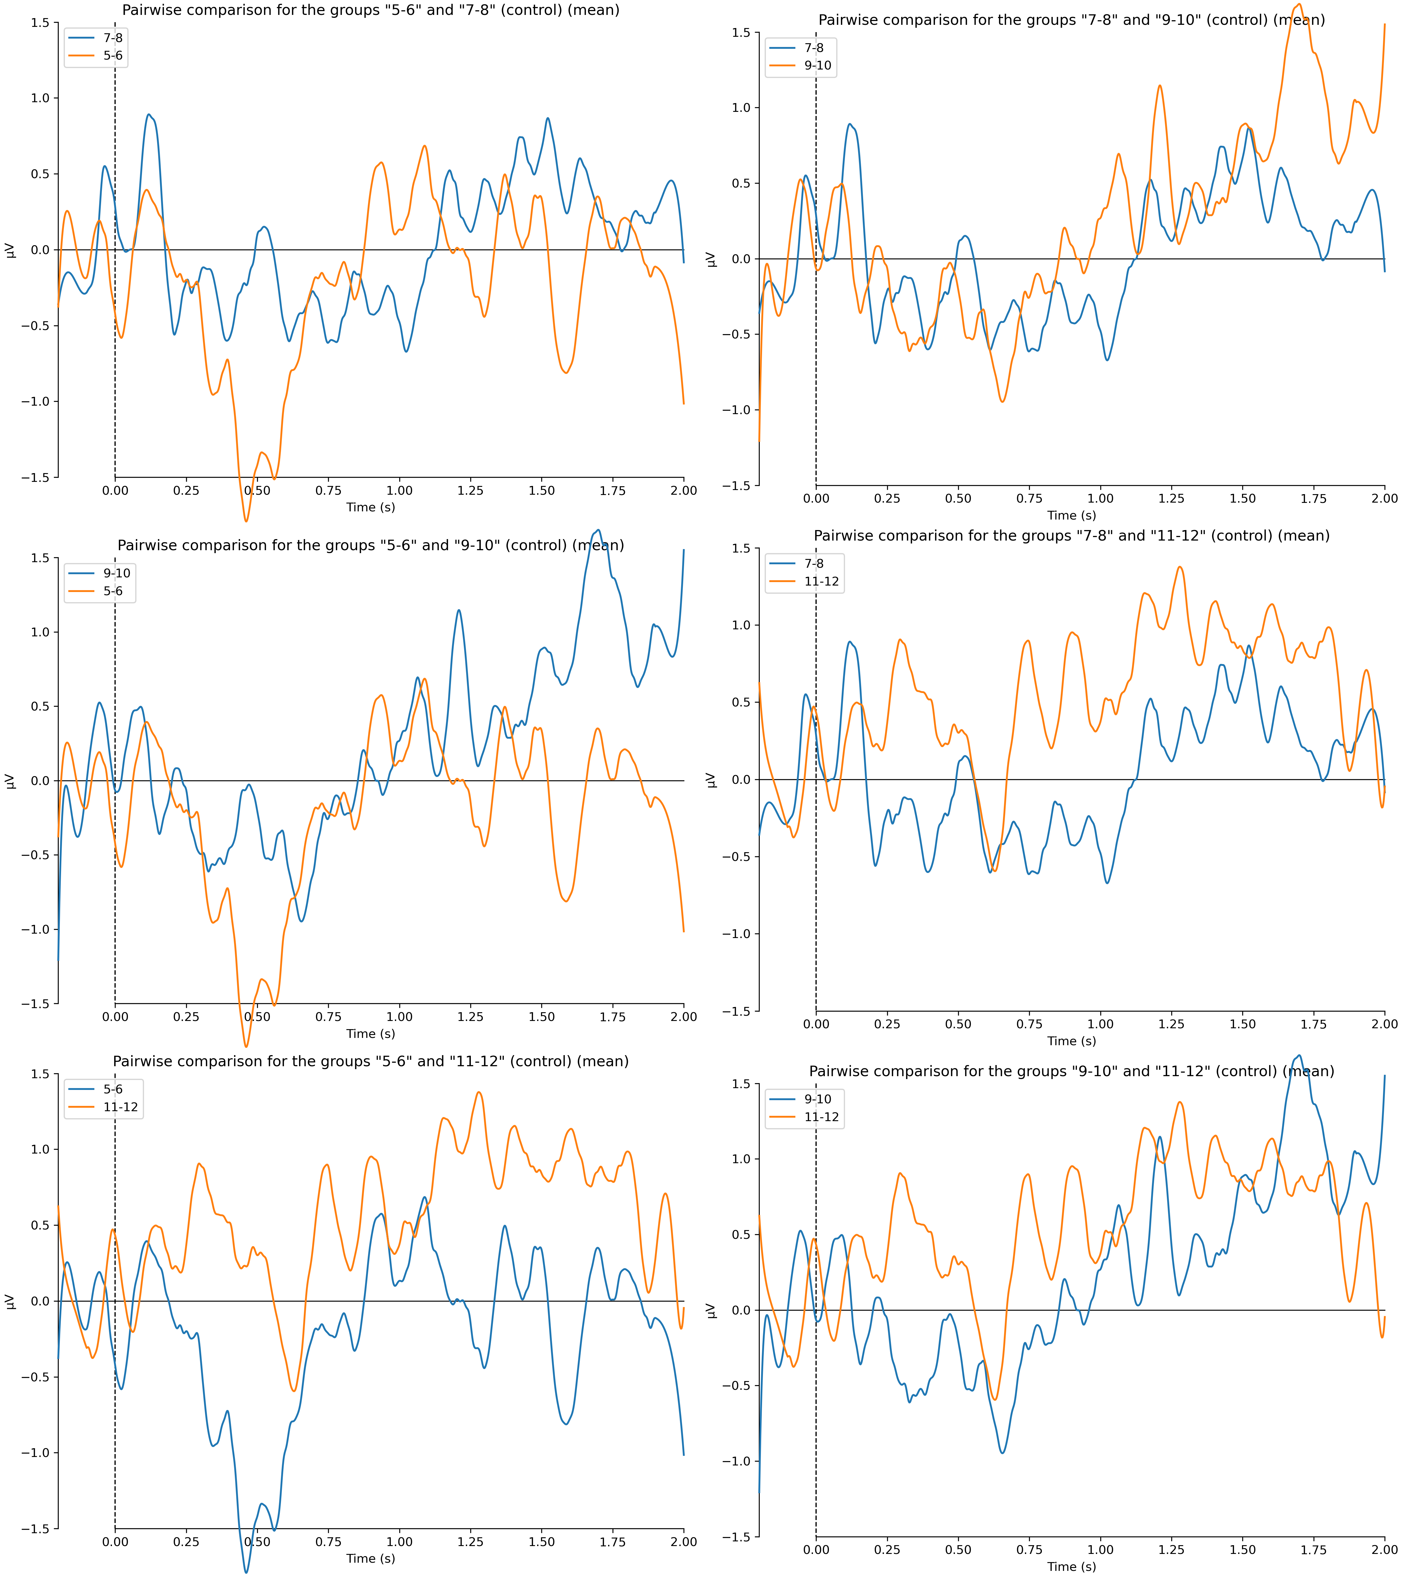
Picture 8. The Pairwise comparison ERP graphs of different experimental sub-groups (4 groups, thus 6 comparison graphs) averaged across all participants and electrodes. The X-line represents the time scale (in ms), while the Y-line Voltage (in μV). The 0 point on the time scale represents the onset of the stimulus.

Comparison across control and experimental sub-groups

The same way as written above the experimental and control sub-groups with words of similar length were compared. No significant difference was found (Picture 9).

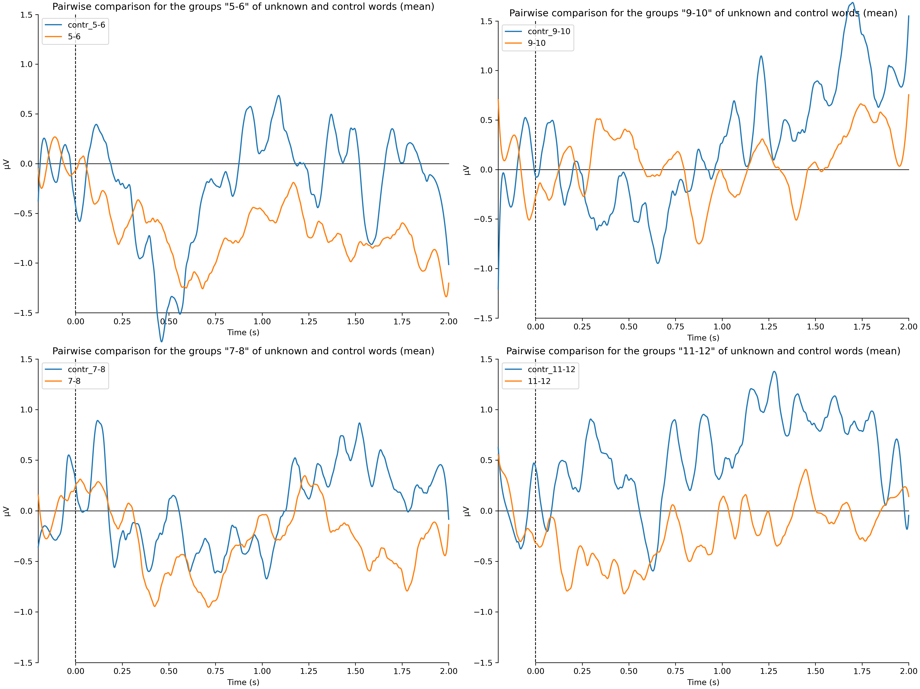
Picture 9. The Pairwise comparison ERP graphs between experimental and control sub-groups with words of similar length averaged across all participants and electrodes. The X-line represents the time scale (in ms), while the Y-line Voltage (in μV). The 0 point on the time scale represents the onset of the stimulus.

Brain rhythms analysis

Additionally, we performed the frequency analysis of our data during and after the stimulus presentation using the ERDS method, averaged across all subjects, but not electrodes of interest. The graphs for some of the electrodes of temporal and frontal lobes of both hemispheres for all the sub-groups are presented in the Appendix 2. Only one representative electrode is going to be reviewed here (Picture 10).

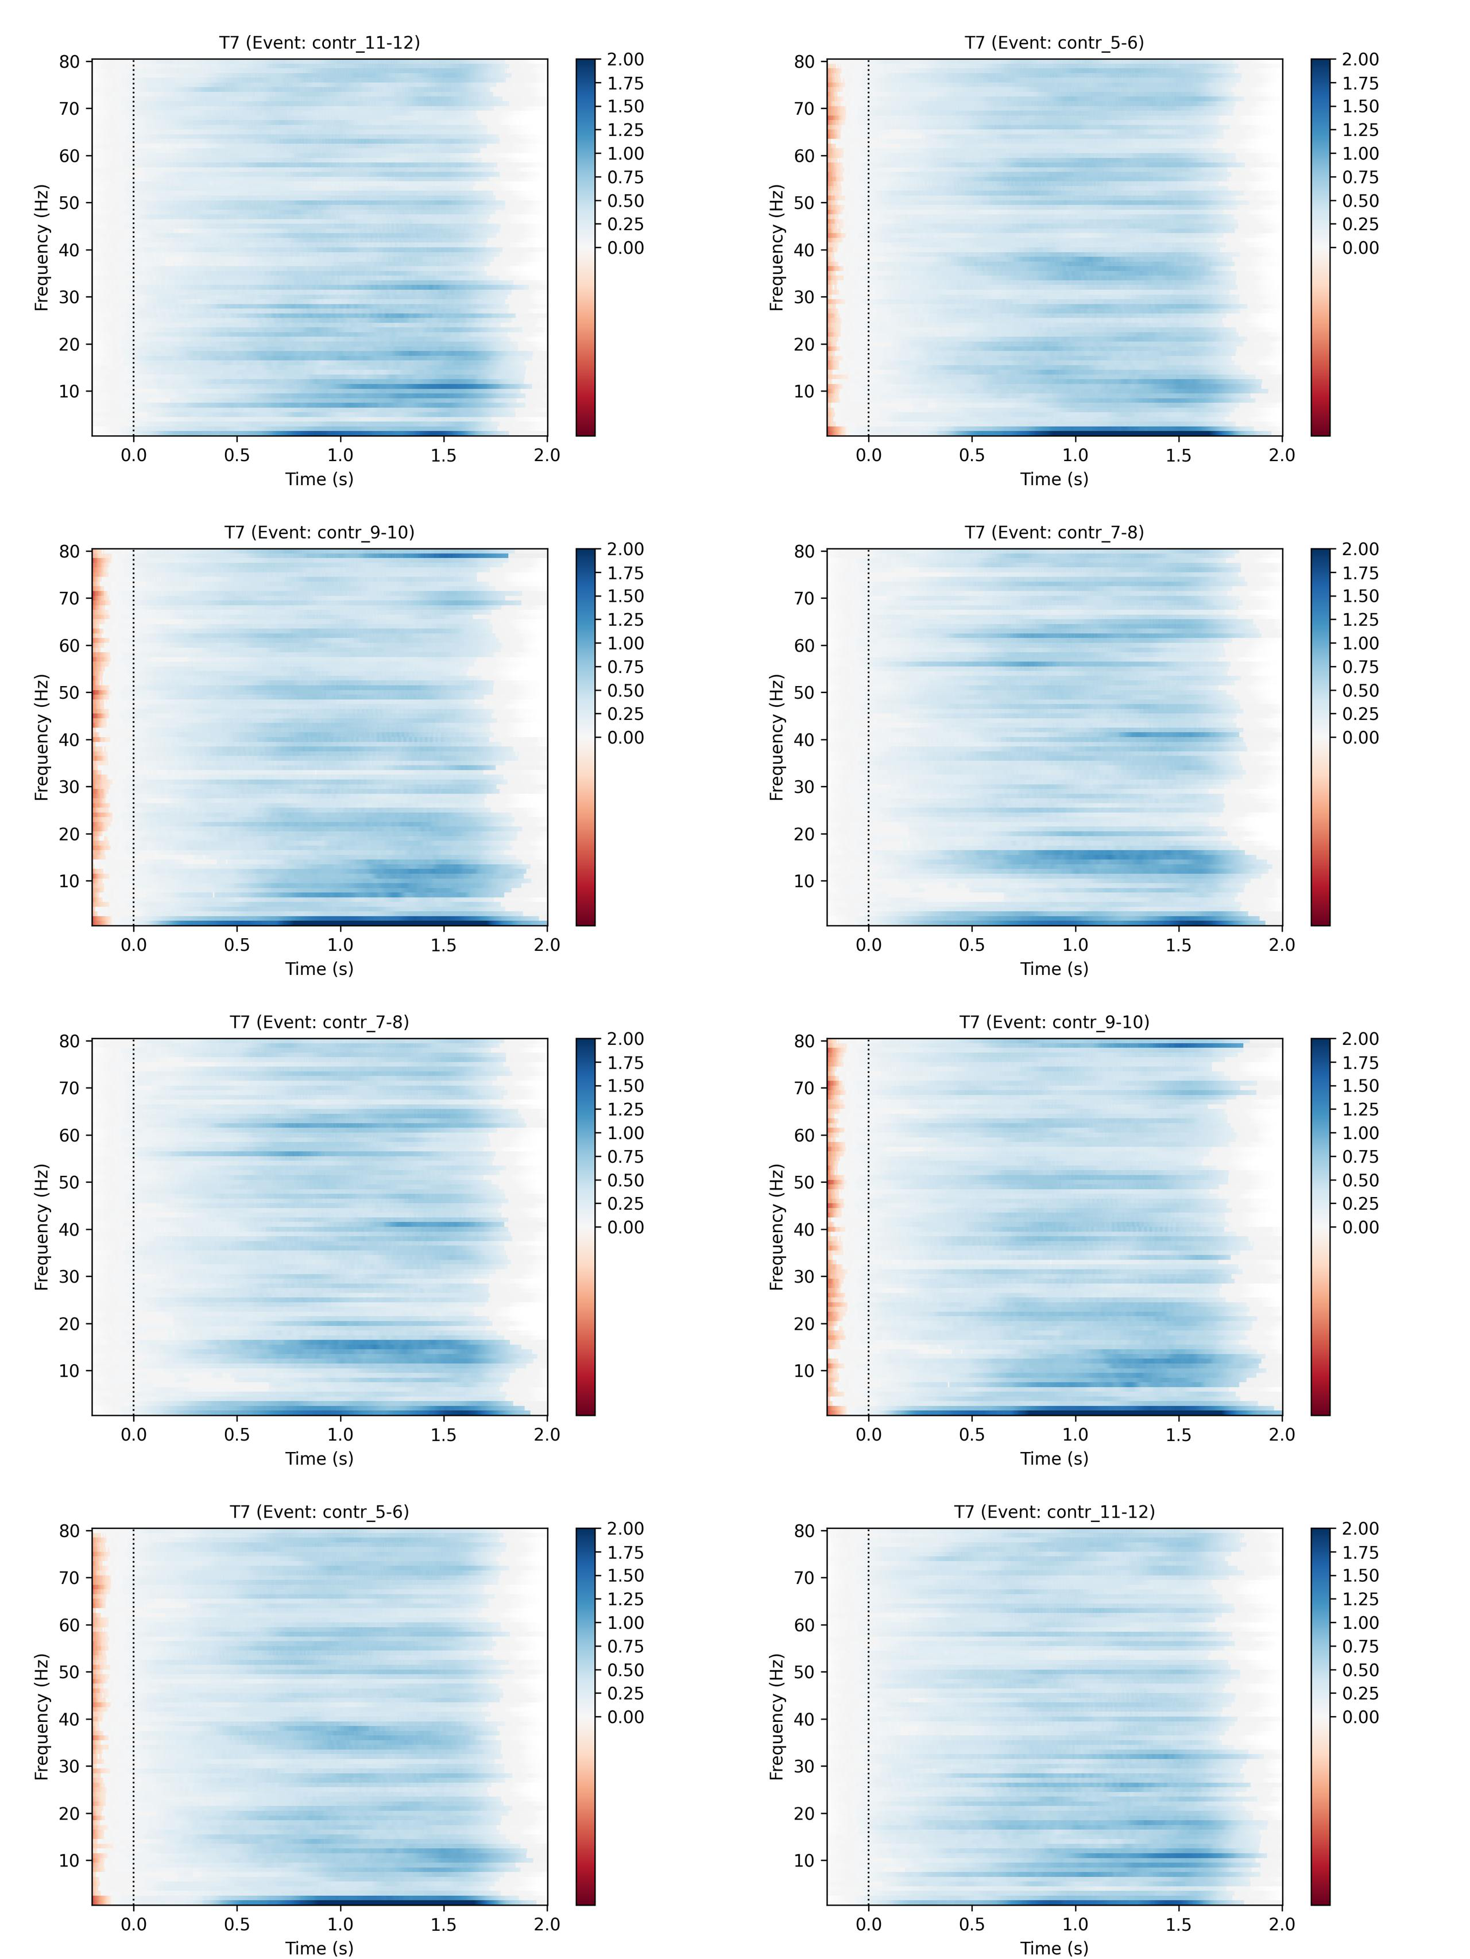
Picture 10. Eight graphs (one for each control and experimental sub-group) of averaged across all participants frequency ERDS data for T7 electrode (temporal lobe of left hemisphere) are presented. An increase in brain rhythms’ absolute power (here and after, AP) compared to the baseline interval (-0.2, 0) is marked with blue color, while a decrease with red.

No visible difference between any of control or experimental groups was detected. However, a certain increase in delta (1-4 Hz) and low-middle-beta (12-18 Hz) rhythms were detected across all of our conditions.

Discussion

Primarily, our experiment was determined to compare the difference in auditory attention to the words of different length. Considering that average length of the word In Russian language is 5.28 letters (Sharov, 2011), we hypothesized (H1) that higher ERP amplitude (and thus attention) is going to be elicited by longer words, as their presence would be less anticipated by the subject.

However, we did not find any ERPs in response to any of experimental or control words. While the latter partially corresponds to our hypothesis (H2), as familiar words are expected to be heard in the right context and thus do not elicit the ERPs; the former seems rather surpring. We assume that mathematical tasks required more attention resources than we thought, which was the reason for lack of attention switch on the presented stimulus, alternatively, the number of stimuli that we averaged is not sufficient (even though 300-400 stimuli for each experimental group usually can provide with a strong pattern). Nevertheless, it may also be possible that the lack of ERPs to unfamiliar words is truthful. The same assumptions can be made relative to the control group. As was already said above, our behavioral data indirectly contradicts the ERP results. Neglecting possible issues with experimental paradigm and the number of collected data, it would be logical to draw the conclusion that the reaction to unfamiliar words does not evoke any ERPs and thus disproves our hypothesis (H1). These results are not coherent with the results obtained in visual paradigm (Juphard, 2011), where ERPs of different amplitude are elicited by familiar and pseudowords, even though no correlation between the ERP amplitude and word’s length was found either; however, for the pseudowords of different length the difference in latency of ERPs was found. The difference in the results for visual and auditory paradigm can cause a hypothesis that different pathways are involved in the auditory and visual word perception, e.g. the processing of unfamiliar words heard may be taking place in the hippocampus (Fonken, Kam, Knight, 2020), which activation is nearly impossible to record using the EEG method.

Interestingly, no difference was detected between control and experimental sub-groups, moreover, the pattern of reaction for control and experimental sub-groups with words of 5-6 and 7-8 sounds long is similar to each other (Picture 9). This may also be interpreted as evidence for lack of difference in auditory attention between familiar and unfamiliar words.

The frequency analysis results did not correspond to our hypothesis too. We observed a sharp increase in delta rhythms’ absolute power after the presentation of any type of stimuli, despite the fact that human speech perception is mostly linked with theta and alpha bands. However, some of the previous studies also observed an increase in delta band activity and assumed that theta and alpha are mostly active during syllabus processing, while delta indicates the cognitive processing of longer parts of speech (Mai et. al., 2016). Thus, the presence of similar delta rhythms activity both in control and experimental groups of stimuli contradicts our hypothesis of higher attention to unfamiliar words (H5).

Beta band’s activity is also atypical for the studies in auditory perception paradigm. Nevertheless, several papers reviewed and hypothesized its possible causes, for example, Haarmann et. al., 2002 outlines that an increase in beta rhythm absolute power can indicate the cognitive processing of the full sentence and memory work. Alternatively, Röhm et. al., 2001 links it to the words’ decoding process. The latter would explain our results, in case we obtained a higher beta rhythms activity to unfamiliar words relative to familiar once. Therefore, we suppose that sentence’s semantic processing is taking place.

We did not observe a higher middle-gamma (50-80 Hz) rhythms activity on the control group stimuli relative to the experimental. Thus, we can conclude that neural mechanism for processing unfamiliar words in the native language is different from an unknown language perception. We also did not register a decrease in theta or alpha rhythms absolute power after any stimulus presentation. It disproves our hypothesis (H4 и H5) about different levels of attention to words of different length and familiarity. It may also justify our concern about lack of attention resources distributed on the auditory task and simultaneously lack of attention shift from mathematical exercises to the stimuli.

Limitations of the experiment

One of the most severe limitations, we assume, is the mathematical tasks’ introduction, as they could affect the auditory perception by drawing the vast majority of the participant’s attention resources. The next limitation is connected to insufficient number of control stimuli (130-150), which can be not enough for the ERP detection. Furthermore, the number of participants can also be an obstacle that complicates the ERP detection: with the larger number of participants ERPs can emerge. Moreover, two lefthanded participants are present in the experimental data, due to laboratorial conditions. Even though they were excluded from ERP analysis, we suppose that they should also be excluded from the frequency analysis, however, it worth noting that the majority of brain rhythms studies do not emphasize the importance of participants’ handiness.

Due to technical difficulties, we could not perform the parametric tests for our frequency data, and therefore evaluated only observable differences. We aim to conduct the Student’s t-test for this data in the nearest future.

Peelle and Davis, 2012 highlight that frequently the results of brain rhythms’ analysis averaged across one single electrode are not representative and cannot provide with sufficient picture of observable phenomena. While by averaging across several electrodes a much more detailed view could be obtained. However, due to technical difficulties we could not perform the ERDS analysis averaging by a cluster of electrodes. We will try to remediate this deficiency in the upcoming future.

Future directions for research

More detailed analyses of our data are going to be performed further. It is particularly interesting to compare the ERPs elicited in different electrode clusters. Furthermore, we are looking forward to enlarge our participants’ number up to 30-40 subjects for a cleaner ERP response for the control stimuli. It is also possible to conduct a similar experiment without introducing the mathematical tasks, as it may result in higher auditory attention to the stimuli. However, by the means of mathematical tasks we were verifying whether the participant was involved into the experiment and not fallen asleep, which may become an obstacle with their elimination. Conclusively, the auditory attention to the words of different length requires further research.

Acknowledgements

We acknowledge the administration of Institute for Cognitive Neuroscience the department of Higher School of Economics National Research University and particularly the Director of the laboratory Klucharev Vasiliy Andreevich for giving us an opportunity to conduct our experiment and further in its development. What is more, we acknowledge the researches of the Centre for Cognition & Decision Making for their help with teaching us the work with EEG equipment and data analyses.

References:

- Sharov, S.A. (2011). Russian language words’ statistics. URL: http://www.lingvisto.org/artikoloj/ru_stat.html
- Abhang, P.A., Gawali, B.W., Mehrotra, S.C. (2016). Introduction to EEG-and speech-based emotion recognition. Amsterdam: Academic Press.
- Alcaini, M., Giard, M.H., Thévenet, M., and Pernier, J. (1994). Two separate frontal components in the N1 wave of the human auditory evoked response. Psychophysiology. 31(6), 611-615.
- Alexander, J.E., Porjesz, B., Bauer, L.O., Kuperman, S., Morzorati, S., O’Connor, S.J., Rohrbaugh, J., Begleiter, H., Polich, J. (1995). P300 hemispheric amplitude asymmetries from a visual oddball task. Psychophysiology. 32(5). 467-475.
- Bachiller, A., Romero, S., Molina, V., Alonso, J.F., Mañanas, M.A., Poza, J., Hornero, R. (2015). Auditory P3a and P3b neural generators in schizophrenia: An adaptive sLORETA P300 localization approach. Schizophrenia Research. 169. 318-325.
- Baddeley, A.D., Thomson, N., Buchanan, M. (1975). Word length and the structure of short-term memory. Journal of Verbal Learning and Verbal Behavior. 14(6). 575-589.
- Bentin, S., McCarthy, G., Wood, C.C. (1985). Event-related potentials, lexical decision and semantic priming. Electroencephalography and clinical Neurophysiology. 60(4). 343-355.
- Bentin, S. (1987). Event-related potentials, semantic processes, and expectancy factors in word recognition. Brain and language. 31(2). 308-327.
- Bonança, G.M., Gerhardt, G.J.L., Molan, A.L., Oliveira L.M.A., Jarola G.M., Schönwald S.V., Rybarczyk-Filho J.L. (2024). EEG alpha and theta time-frequency structure during a written mathematical task. Medical & biological engineering & computing. 62. 1869-1885.
- Buzsáki, G. (2006). Rhythms of the Brain. New York: Oxford University Press.
- Chun, M.M., Turk-Browne, N.B. (2007). Interactions between attention and memory. Current opinion in neurobiology. 17(2). 177-184.
- Federmeier, K.D. (2007). Thinking ahead: the role and roots of prediction in language comprehension. Psychophysiology. 44(4). 491-505.
- Fonken, Y.M., Kam, J.W.Y., Knight, R.T. (2020). A differential role for human hippocampus in novelty and contextual processing: Implications for P300. Psychophysiology, 57(7). e13400.
- Frey, J.N., Ruhnau, P., Weisz, N. (2015). Not so different after all: The same oscillatory processes support different types of attention. Brain Research. 1626. 183-197.
- Friedrich, R.M., Friederici, A.D. (2013). Mathematical logic in the human brain: Semantics. PLOS ONE. 8(1).
- Gramfort, A., Luessi, M., Larson, E., Engemann, D.A., Strohmeier, D., Brodbeck, C., Goj, R., Jas, M., Brooks, T., Parkkonen, L., and Hämäläinen, M.S. (2013). MEG and EEG data analysis with MNE-Python. Frontiers in Neuroscience. 7(262). 1-13.
- Haarmann, H.J., Cameron, K.A., Ruchkin, D.S. (2002). Neural synchronization mediates on-line sentence processing: EEG coherence evidence from filler-gap constructions. Psychophysiology. 39(6). 820-825.
- Hauk, O., Pulvermuller, F. (2004). Effects of word length and frequency on the human event-related potential. Clinical Neurophysiology, 115. 1090-1103.
- Hauk, O., Davis, M.H., Ford, M., Pulvermuller, F., and Marslen-Wilson, W.D. (2006). The time course of visual word recognition as revealed by linear regression analysis of ERP data. Neuroimage. 30(4). 1383-1400.
- Henry, M.J., Herrmann B. (2014). Low-frequency neural oscillations support dynamic attending in temporal cortex. Brill. 2(1). 62-86.
- Hugdahl, K., Thomsen, T., Ersland, L., Rimol, L.M., and Niemi, J. (2003). The effects of attention on speech perception: An fMRI study. Brain and Language. 85. 37-48.
- Jones, S.R. (2016). When brain rhythms aren’t ‘rhythmic’: implication for their mechanism and meaning. Current opinion in neurobiology. 40. 72-80.
- Juphard, A., Vidal, J.R., Perrone-Bertolotti, M., Miotti, L., Kahane, P., Lachaux, J.-P., Baciu, M. (2011). Direct evidence for two different neural mechanisms for reading familiar and unfamiliar words: an intra-cerebral EEG study. Frontiers in human neuroscience. 5(101).
- Kutas, M., Federmeier, K.D. (2000). Electrophysiology reveals semantic memory use in language comprehension. Trends in cognitive sciences. 4(12). 463-470.
- Kutas, M., Federmeier, K.D. (2011). Thirty Years and Counting: Finding Meaning in the N400 Component of the Event-Related Brain Potential (ERP). 62. 621-647.
- Lau, E.F., Phillips, C., Poeppel, D. (2008). A cortical network for semantics: (de)constructing the N400. Nature reviews neuroscience. 9. 920-933.
- Lehtonen, M., Hultén, A., Rodríguez-Fornells, A., Cunnilera, T., Tuomainen, J., Laine, M. (2012). Differences in word recognition between early bilinguals and monolinguals: Behavioral and ERP evidence. Neuropsychologia. 50. 1362-1371.
- Lin, C.L., Jung, M., Wu, Y.C., She, H.C., Jung, T.P. (2015). Neural Correlates of Mathematical Problem Solving. International Journal of Neural Systems. 25. 1550004.
- Luck, S.J. (2014). An Introduction to the Event-Related Potential Technique. Cambridge: MIT Press.
- Mai, G., Minett, J.W., Wang, W.S.-Y. (2016). Delta, theta, beta, and gamma brain oscillations index levels of auditory sentence processing. NeuroImagine. 133. 516-528.
- Morillon, B., Baillet, S. (2017). Motor origins of temporal predictions in auditory attention. PNAS. 114(2).
- Miller, G.A. (1956). The magical number seven, plus or minus two: Some limits on our capacity for processing information. Psychological Review. 63(2). 81-97.
- Näätänen, R., Picton, T. (1987). The N1 Wave of the Human Electric and Magnetic Response to Sound: A Review and an Analysis of the Component Structure. Psychophysiology. 24(4). 375-425.
- Näätänen, R. (1990). The role of attention in auditory information processing as revealed by event-related potentials and other brain measures of cognitive function. Behavioral and brain sciences. 13. 201-288.
- Orquin, J.L., Loose S.M. (2013). Attention and choice: A review on eye movements in decision making. Acta Psychologica. 144(1). 190-206.
- Palva, J.M., Palva, S., Kaila, K. (2005). Phase Synchrony among Neuronal Oscillations in the Human Cortex. The Journal of Neuroscience. 25(15). 3962-3972.
- Peelle, J.E., Davis, M.H. (2012). Neural oscillations carry speech rhythm through to comprehension. Frontiers in psychology. 3. 320.
- Peña, M., Melloni, L. (2012). Brain oscillations during spoken sentence processing. Journal of cognitive neuroscience. 24(5). 1149-1164.
- Polich, J., Alexander, J.E., Bauer, L.O., Kuperman, S., Morzorati, S., O’Connor, S.J., Porjesz, B., Rohrbaugh, J., Begleiter, H. (1997). P300 topography of amplitude/latency correlations. Brain Topography. 9. 275-282.
- Polich, J. (2007). Updating P300: An integrative theory of P3a and P3b. Clinical Neurophysiology. 118. 2128-2148.
- Rio, J.M., Guevara, M.A., González, M.H., Aguirre, R.M.H., Aguilar, M.A.C. (2019). EEG correlation during the solving of simple and complex logical–mathematical problems. Cognitive, Affective, & Behavioral Neuroscience. 19. 1036-1046.
- Röhm, D., Klimesch, W., Haider, H., Doppelmayr, M. (2001). The role of theta and alpha oscillations for language comprehension in the human electroencephalogram. Neuroscience Letters. 310(2-3). 137-140.
- Steriade, M. (2006). Grouping of brain rhythms in corticothalamic systems. Neuroscience. 137. 1087-1106.
- Scott, S.K., Johnsrude, I.S. (2003). The neuroanatomical and functional organization of speech perception. Trends in Neuroscience. 26(2). 100-107.
- Squire, L.R. (2009). Memory and brain systems: 1969-2009. The journal of neuroscience. 29(41). 12711-12761.
- Strobel, A., Debener, S., Sorger, B., Peters, J.C., Kranczioch, C., Hoechstetter, K., Engel, A.K., Brocke, B., Goebel, R. (2008). Novelty and target processing during an auditory novelty oddball: A simultaneous event-related potential and functional magnetic resonance imaging study. NeuroImage. 40(2). 869-883.
- Wronka, E.A., Kaiser, J., Coenen, A.M.L. (2012). Neural generators of the auditory evoked potential components P3a and P3b. Acta Neurobiologiae Experimentalis. 72. 51-64.

Appendix 1

Sub-group 5-6 | Sub-group 7-8 | Sub-group 9-10 | Sub-group 11-12
апекс | плерома | эмергенцы | калиптроген
кристы | гонофор | колумелла | гиалоплазма
строма | ламеллы | тилакоиды | фрагмопласт
настии | тропизм | мацерация | паранектрозе
висцин | нутации | десмосомы | плазмодесмы
галлы | ценоцит | элиситоры | схизогенные
каллус | цистолит | капсидиол | рексигенные
гумми | веламен | медикарпин | гиперплазия
камеди | гуттация | фурановым | умбеллиферон
терпен | эпитема | гаустории | анастемозах
камбий | заболонь | эндархным | васкулатура
лептом | феллема | диссолюции | атрихобласты
лизис | мицелла | гидропота | гетерофилия
энации | ритидом | катафиллы | склеренхима
тиллы | мезофилл | пластохрон | ксилоглюканы
фитол | антохлор | либриформ | каринальный
хлороз | тирозин | периблемы | каротиноиды
малат | цитохром | артростела | ксантофиллы
друзы | РУБИСКО | синглентны | элайопласты
кутин | суберин | хромопласт | транспирация
лигнин | трахеиды | трабекулы | фитохелатин
торус | крассулы | гиподерма | пневматофоры
ацидоз | нуцеллус | мугеневая | брассинолида
зеатин | флаведо | цитокинины | кампестерол
бакане | трихомы | гибберлины | алейроновые
рафиды | альбедо | апокарпий | соленостелия
гомфом | марсилия | саркотесты | антоцианидид
ризаны | гаптеры | миксотеста | филлокладии
сцифы | стереом | мутуализм | гомеомерный
изидии | подеции | цефалодии | гимениальный
работа | рассказ | календаре | содержанием
тесте | практике | аттестацию | факультетов
хорошо | палатке | микроскоп | эксперименты
ночью | организм | коллекцию | лаборатории
прудах | ловушки | стаканчик | определитель
сачок | бабочку | признаком | расправилка
кальки | ботаники | помещение | особенностей
стебель | гербарий | оберточку | преподаватель
цветом | спальник | босоножки | фотоаппараты
поход | вопросы | комфортно | рекомендации
Table 1. The table of stimulus-words distribution across sub-groups. The control words are marked with red color.

The order, in which the words are presented in the text | Sub-group
апекс | 5
калиптроген | 11
плерома | 7
эмергенцы | 9
колумелла | 9
гиалоплазма | 11
фрагмопласт | 11
кристы | 5
гонофор | 7
строма | 5
тилакоиды | 9
ламеллы | 7
настии | 5
тропизм | 7
паранекроз | 9
нутации | 7
висцин | 5
мацерация | 9
плазмодесмы | 11
десмосомы | 9
ценоцит | 7
схизогенные | 11
рексигенные | 11
галлы | 5
гиперплазия | 11
каллус | 5
гумми | 5
цистолит | 7
элиситоры | 9
камеди | 5
капсидиол | 9
медикарпин | 9
терпен | 5
умбеллиферон | 11
фурановым | 9
гаустории | 9
камбий | 5
эндархным | 9
анастемозах | 11
лептом | 5
васкулатура | 11
диссолюции | 9
веламен | 7
атрихобласты | 11
лизис | 5
гидропота | 9
катафиллы | 9
энации | 5
гетерофилия | 11
гуттация | 7
эпитема | 7
пластохрон | 9
либриформ | 9
периблемы | 9
склеренхима | 11
заболонь | 7
тиллы | 5
феллема | 7
мицелла | 7
ксилоглюканы | 11
артростела | 9
каринальный | 11
ритидом | 7
мезофилл | 7
фитол | 5
синглентны | 9
хлороз | 5
каротиноиды | 11
антохлор | 7
хромопласт | 9
ксантофиллы | 11
тирозин | 7
цитохром | 7
малат | 5
друзы | 5
элайопласты | 11
трабекулы | 9
РУБИСКО | 7
транспирация | 11
кутин | 5
суберин | 7
лигнин | 5
торус | 5
трахеиды | 7
крассулы | 7
гиподерма | 9
фитохелатин | 11
мугеневая | 9
пневматофоры | 11
ацидоз | 5
брассинолида | 11
кампестерол | 11
цитокинины | 9
зеатин | 5
гибберлины | 9
бакане | 5
апокарпий | 9
нуцеллус | 7
алейроновые | 11
флаведо | 7
трихомы | 7
альбедо | 7
саркотесты | 9
рафиды | 5
миксотеста | 9
марсилия | 7
соленостелия | 11
мутуализм | 9
гомфом | 5
гаптеры | 7
ризаны | 5
стереом | 7
подеции | 7
сцифы | 5
антоцианидид | 11
филлокладии | 11
изидии | 5
цефалодии | 9
гомеомерный | 11
гимениальный | 11
рассказ | 7
работа | 5
содержанием | 11
тесте | 5
календаре | 9
хорошо | 5
аттестацию | 9
практике | 7
факультетов | 11
эксперименты | 11
палатке | 7
ночью | 5
лаборатории | 11
микроскоп | 9
организм | 7
прудах | 5
определитель | 11
коллекцию | 9
сачок | 5
ловушки | 7
стаканчик | 9
признаком | 9
бабочку | 7
расправилка | 11
кальки | 5
ботаники | 7
особенностей | 11
стебель | 5
помещение | 9
гербарий | 7
цветом | 5
оберточку | 9
преподаватель | 11
поход | 5
спальник | 7
босоножки | 9
фотоаппараты | 11
вопросы | 7
рекомендации | 11
комфортно | 9
Table 2. The order, in which the words are presented in the text. The words are written from the first to the last line in the directly same order, which they were presented with to the participant. The control words are marked with red color.

Appendix 2

