**Validation of the block inclined_surface   
with Meteonorm data**

Table of contents

1 Data used for validation 1

2 Description of the model 2

2.1 Block 2

2.2 Model File 2

3 Results 2

4 Literature 2

**Author**

Bernd Hafner, Viessmann Werke, Germany

**Version of Model, Carnot, Matlab and Operation system**

surfrad.c (V 5.1.0), Carnot 5.2, Matlab R2010b, Windows XP

**Complete path of the block in the Carnot Library**

Carnot/weather/inclined_surface

# Data used for validation

Meteonorm Version 6.1



# Description of the model

## Block

Detailed description of the equations is given by Duffie (2006).

Model for the comparison:

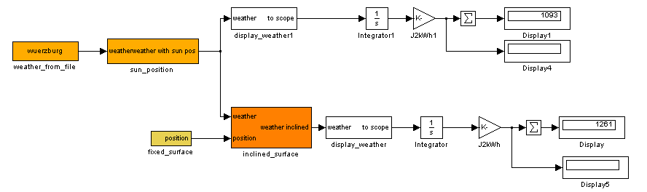

“Look under Mask” of the Block:

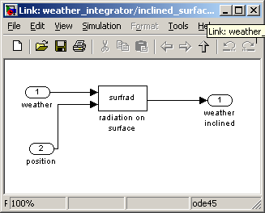

Block parameters:

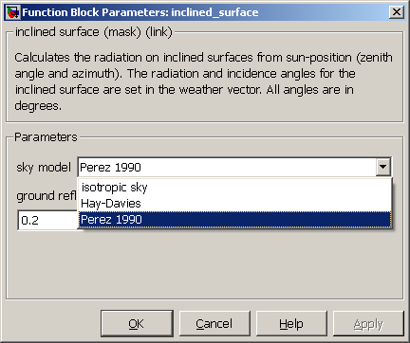

The Position is varied:

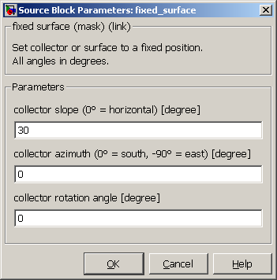

## Model File

Comparison of horizontal and inclined solar radiation for the location Wuerzburg (Germany), results of Meteonorm and Carnot are compard. The input for Carnot is the Meteonorm weather data file generated for the same location using the 5.x Carnot weather data format (including direct normal radiation).

Solver parameters:

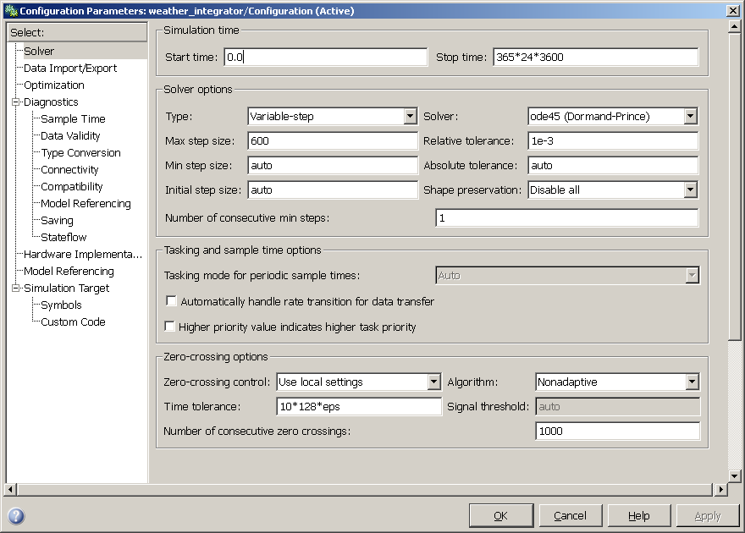

# Results

Annual sum of solar radiation in kWh/m²

Perez Sky Model, ground reflectance 0.2

|  |  |  |  |  |  |
| --- | --- | --- | --- | --- | --- |
| Azimut | Inclination | **Meteonorm**  **Global** | CARNOT  Global | **Meteonorm**  **Diffuse** | CARNOT  Diffuse |
| 0 | 0 | **1093** | 1092 | **594** | 593 |
| 0 | 30 | **1257** | 1255 | **628** | 629 |
| 0 | 60 | **1178** | 1178 | **583** | 585 |
| 0 | 90 | **882** | 883 | **471** | 474 |
| 45 | 30 | **1192** | 1190 | **614** | 614 |
| 45 | 60 | **1102** | 1101 | **565** | 567 |
| 45 | 90 | **846** | 846 | **461** | 464 |
| -90 | 30 | **1041** | 1044 | **574** | 576 |
| -90 | 60 | **906** | 912 | **511** | 516 |
| -90 | 90 | **699** | 707 | **421** | 427 |
| 120 | 30 | **903** | 901 | **545** | 544 |
| 120 | 60 | **715** | 715 | **470** | 471 |
| 120 | 90 | **547** | 548 | **388** | 391 |
| -180 | 30 | **775** | 774 | **512** | 512 |
| -180 | 60 | **484** | 486 | **414** | 415 |
| -180 | 90 | **373** | 376 | **350** | 351 |

# Literature

Duffie, J., Beckman, W.: Solar Engineering of thermal processes, John Wiley & Sons Inc, 2006