Test of working cells
This test is used to determine the number of working cells in the studied crossbar array of memristive devices. It is recommended to be performed at the initial stages of getting acquainted with the studied crossbar array of memristive devices. For its execution, an experimental plan has been created (file “writable.json” which is contained in the tickets folder) in the MemriBoard program, consisting of three tickets with the following parameters (Figures 1.1 – 1.3).

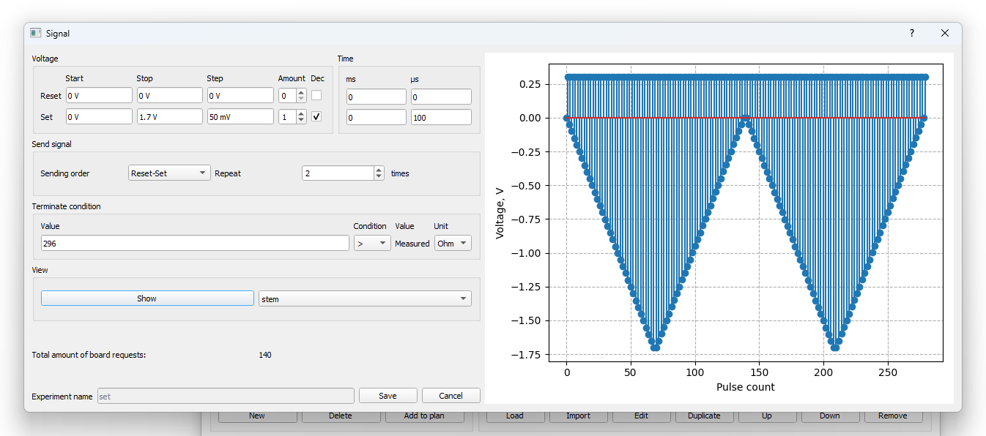
Figure 1.1 – SET procedure with stop condition upon reaching memristor resistance of 296 Ohms or less.

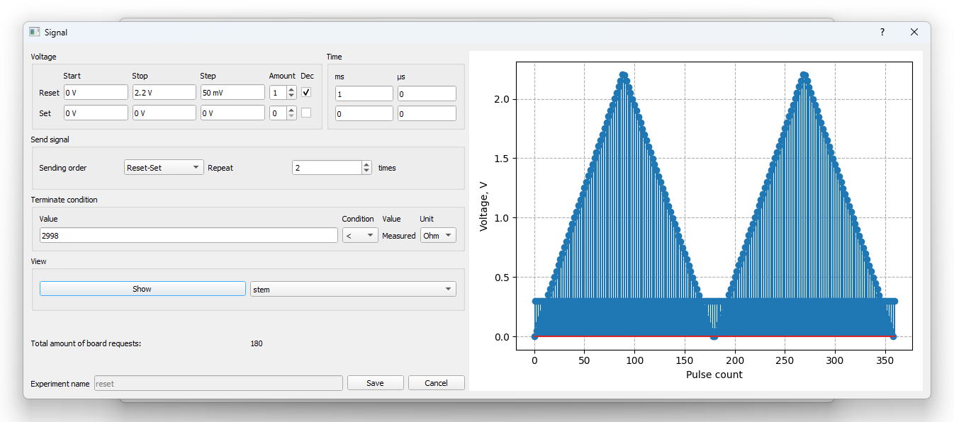
Figure 1.2 – RESET procedure with stop condition upon reaching memristor resistance of 2998 Ohms or more.
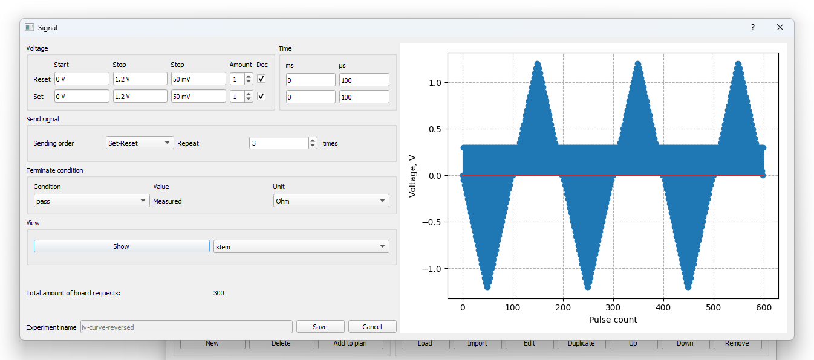
Figure 1.3 – Measurement of current-voltage characteristic 3 times.

Next, a condition is applied to the cells – if the minimum resistance is greater than 100 Ohms and the ratio of maximum resistance to minimum resistance is greater than 2, then the cell is considered working.

To perform it, the following sequence of actions must be carried out:
1. Perform it first for any single cell of the crossbar.
2. After that, open the “Testing” window.
3. Select or create a folder for this experiment (it is advisable to use an empty folder).
4. Select the “writable” experiment for all cells of the crossbar.
5. After successful execution, go to the “Result analysis” tab in the same “Testing” window and click “Calculate”.
6. As a result, the percentage of working cells will be displayed.

