Writing with tuning
For writing resistances, a special experiment is used, which consists of 32 tickets. The first ticket performs the resistance writing procedure with stopping upon hitting the specified range (Figure 2.1). The second ticket performs ten readings at a voltage of 0.3 V (Figure 2.2).
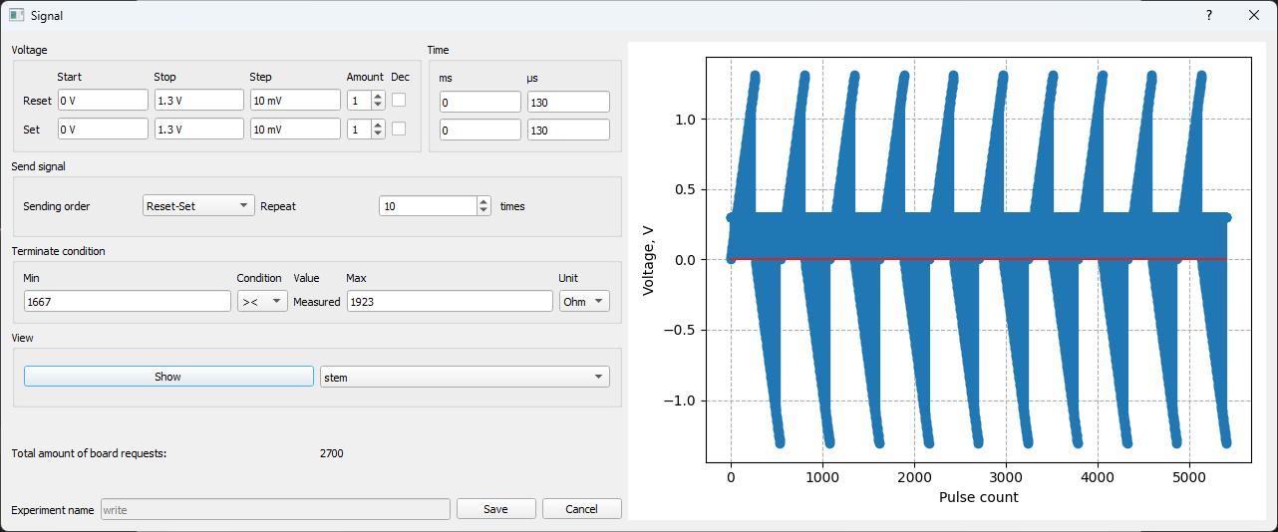
Figure 2.1 – Procedure for writing the range 1667 – 1923 Ohms. For other ranges, the parameters are identical.

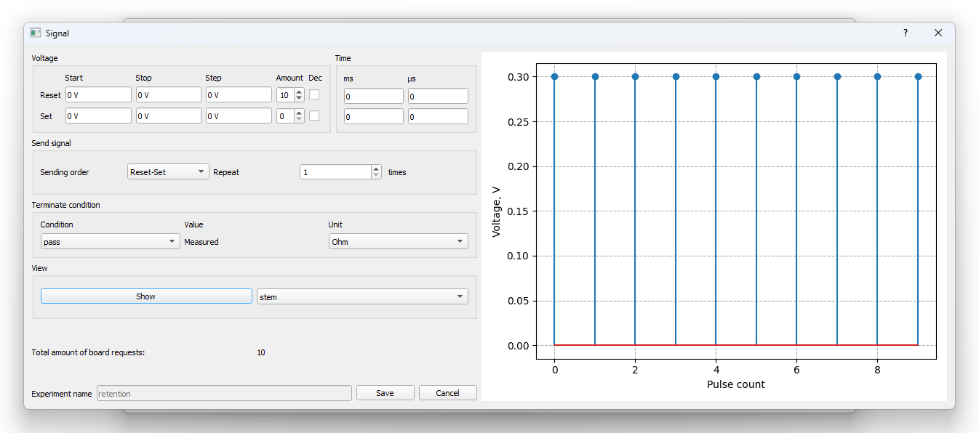
Figure 2.2 – Ten readings at a voltage of 0.3 V.

The remaining 30 tickets consist of a tenfold repetition of automatic resistance tuning to the middle of the range. This is performed by three tickets, two of which are shown in Figures 2.3, 2.4, and the third in Figure 2.2.
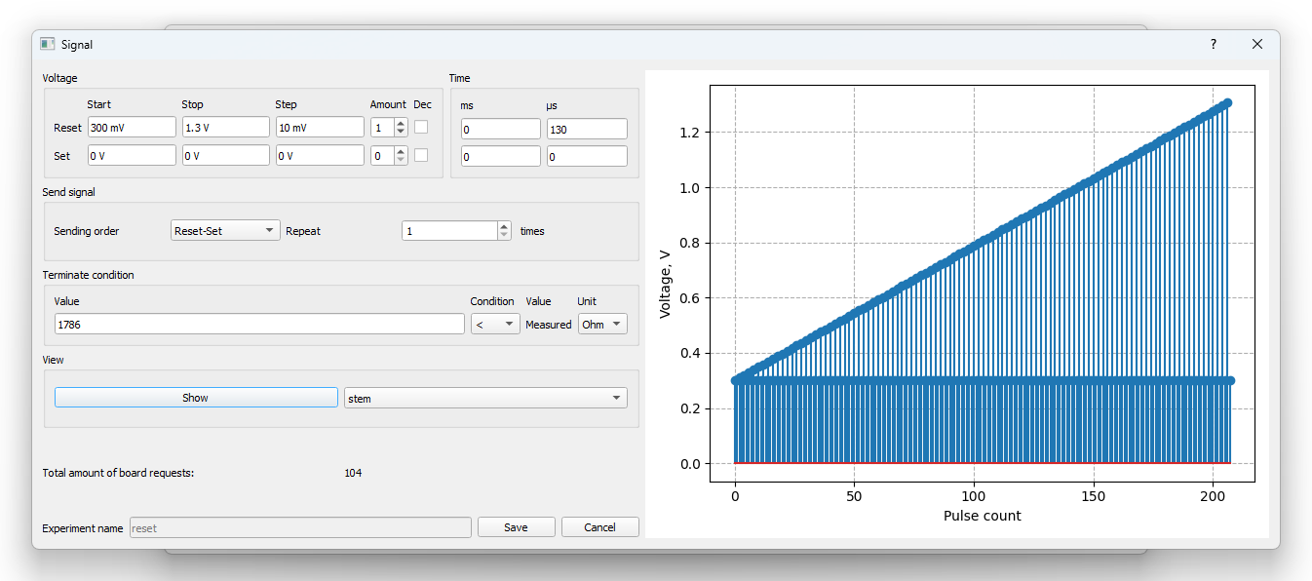
Figure 2.3 – Attempt to perform RESET. It is interrupted upon reaching a resistance greater than the middle of the range.

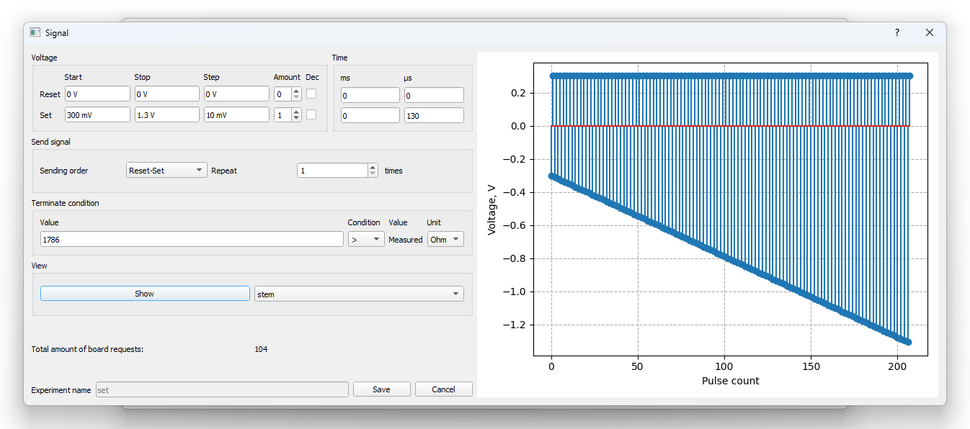
Figure 2.4 – Attempt to perform SET. It is interrupted upon reaching a resistance less than the middle of the range.

An illustration of the operation of such an experimental plan is shown in Figure 2.5.

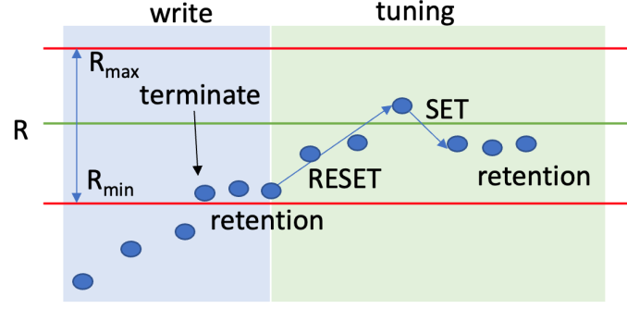
Figure 2.5 – Procedure for writing a resistance level.

To create such experiments for writing the desired resistance in a specific range, there is a special script ‘gen_write.py’ in the program folder. In it, you need to fill in 2 lists, namely “min_res” (list of minimum resistances for the writing and tuning experiment) and “max_res” (list of maximum resistances for the writing and tuning experiment). After running this script, you will have files “min_res”_“max_res”_tuning_10.json created, which can then be used in the MemriBoard program.

