**Imasonic R100**

Results based on artificially created profile:

Crosshair at NBM’s center

**Imasonic R75**

shallower artificial profile, else errors during fitting procedure

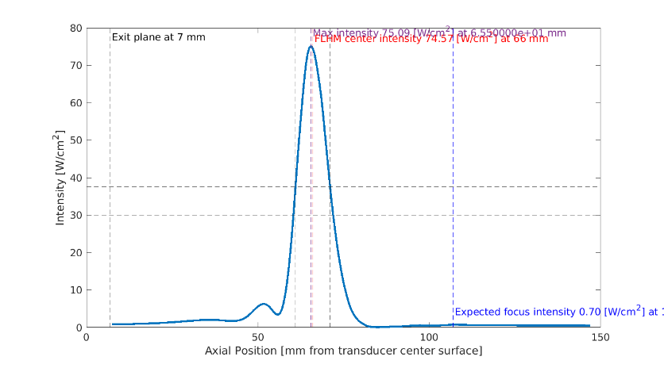

Crosshair at NBM’s center

Crosshair at max intensity

