**LAB WORK - ELECTROENCEPHALOGRAPHY**

Groups of 3 max – 1 acquisition system per group – 1 computer each. **SAVE ALL FIGURES**

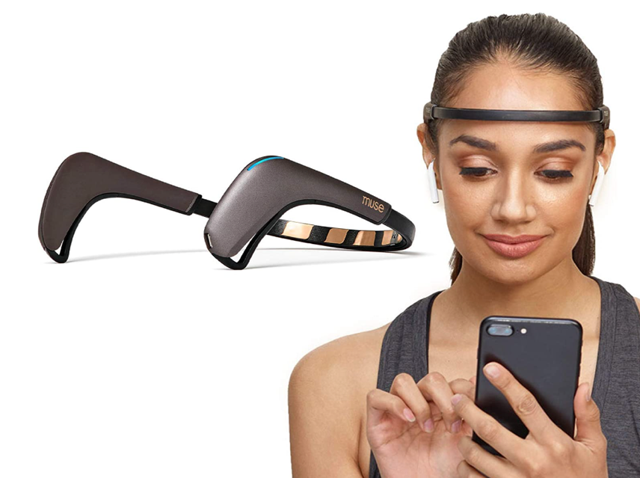

# Materials

**Device:**

EEG acquisition: MUSE 2 dry electrode EEG system (InterXon ®), 4 channels, wireless (Bluetooth) communication.

**N.B. HANDLE WITH CARE!!**

**Software:**

EEG acquisition: Muselsl and LabRecorder

EEG analysis : Matlab and EEGLab

--------------------------------------------------------------------------------------------------------------------------------------

# INSTALLATION

Before playing with the MUSE 2 system, you’ll need to install some python library and dedicated software – This will be done from the **Anaconda Terminal**

* CREATE A VIRTUAL ENVIRONMENT « muse » :

conda create -n muse  
conda activate muse

* INSTALL MUSELSL TO STREAM MUSE 2 DATA

conda install pip

pip install muselsl --proxy <http://proxy.isae.fr:3128>

conda install -c conda-forge liblsl

* INSTALL THE MUSE DATA VIEWER

pip install vispy

pip install mne

pip install pyqt5

* INSTALL LABRECORDER (TO RECORDE MUSE2 DATA)

https://github.com/labstreaminglayer/App-LabRecorder/releases/tag/v1.16.2

choose LabRecorder-1.16.2-Win_i386.zip

* BUG CORRECTIONS:

**Modify backends.py** **file** (C:\Users\Public\Programs\mblock\resources\app\mlink-v2\exec\python-env\win\Lib\asyncio\backends.py)

*Change lines 62 et 63 to:*

def wrap(gatt_characteristics, data):

value_handle = gatt_characteristics.handle + 1

**Modify Stream.py  file** (C:\Users\Public\Programs\mblock\resources\app\mlink-v2\exec\python-env\win\Lib\asyncio\streams.py)

*Change line 211 to :*

outlet.push_sample(data[:, ii])

# INSTALLATION

Open the MUSE 2 box . **HANDLE WITH CARE!!**

Plug the Bluetooth dongle and turn on the MUSE 2 by pressing the power button for 2 seconds.

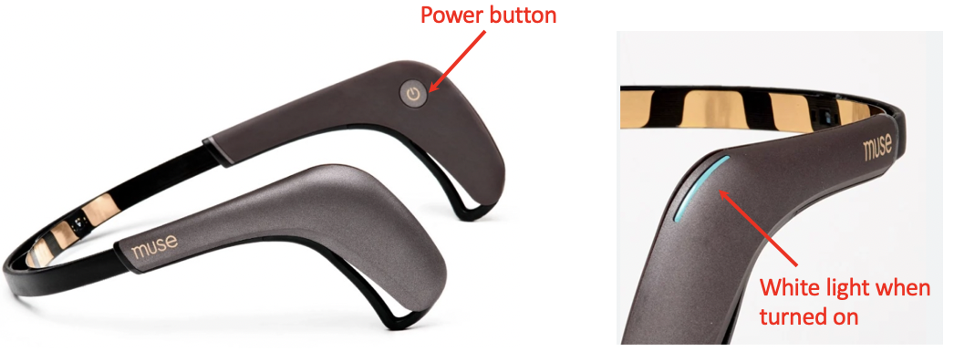

The MUSE 2 system has 4 electrodes: TP9, TP10, AF7 and AF8 + auxiliary channel (will not be used today)

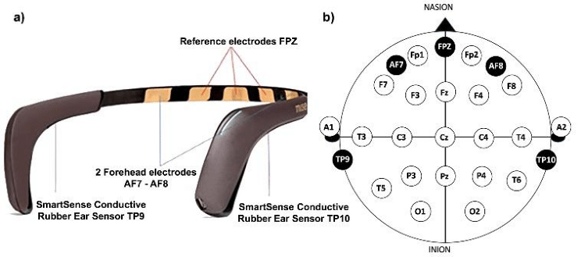

**Adjust the MUSE 2 system on your forehead and make sur that the rubber electrodes (TP9 and TP10) are clear from any hairs over your hears.**

It is important to **drop a bit of water** with your finger on all the electrodes (including the rubber one TP9 and TP10) – it will ensure optimal signal quality

[**https://www.youtube.com/shorts/7UOlDKQPu8c?feature=share**](https://www.youtube.com/shorts/7UOlDKQPu8c?feature=share)

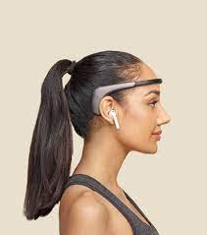

**Have the setup checked by a supervisor.**

--------------------------------------------------------------------------------------------------------------------------------------

# Data streaming

# Start a new Anaconda Terminal and type:

**To activate the muse environment, type:**

$ conda activate muse

**Find the name of your muse device**

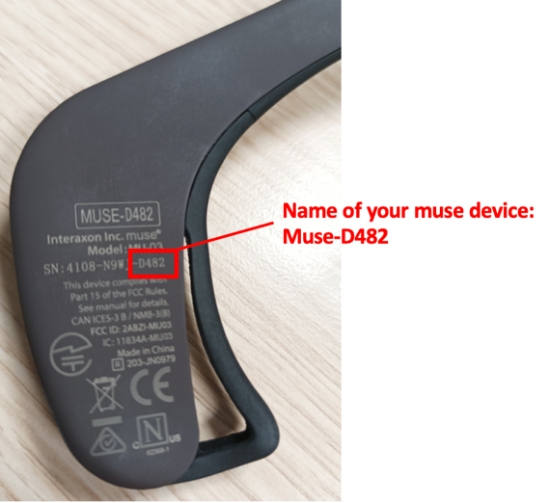

$ muselsl stream - -name name_of_your_device (eg: muselsl stream - - name Muse-D482)

**To visualize the data, type:**

$ muselsl view - -version 2

the mean values for each electrode should be between 10 and 20 (see figure below)

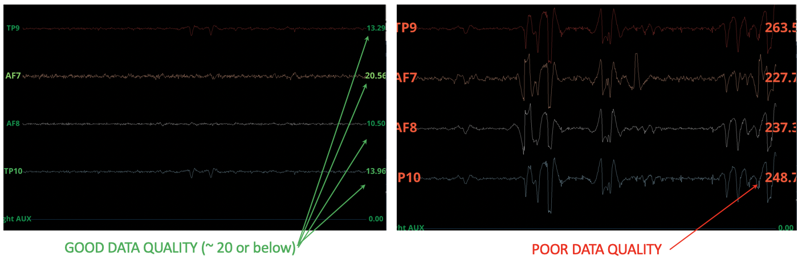

------------------------------------------------------------------------------------————————————————

# Visualization of artifacts

* While streaming, perform the following activities to generate artifacts on the EEG signal (save screen captures) :

1. Blink repeatedly
2. Clench your teeth several times
3. Move on your chair
4. Close you eyes and relax

------------------------------------------------------------------------------------------------—————————————

# A small experiment: Count down vs Relaxation

***Evaluation:*** cognitive workload (on-task vs off-task)

***Task:*** perform a rest session (eyes closed, no movements) followed by a mental count down.

***To record your data use Labrecorder (you can find it via Windows search) – please make sure to check the Muse stream and the Marker(MyMarkStream) and then press the Start button***

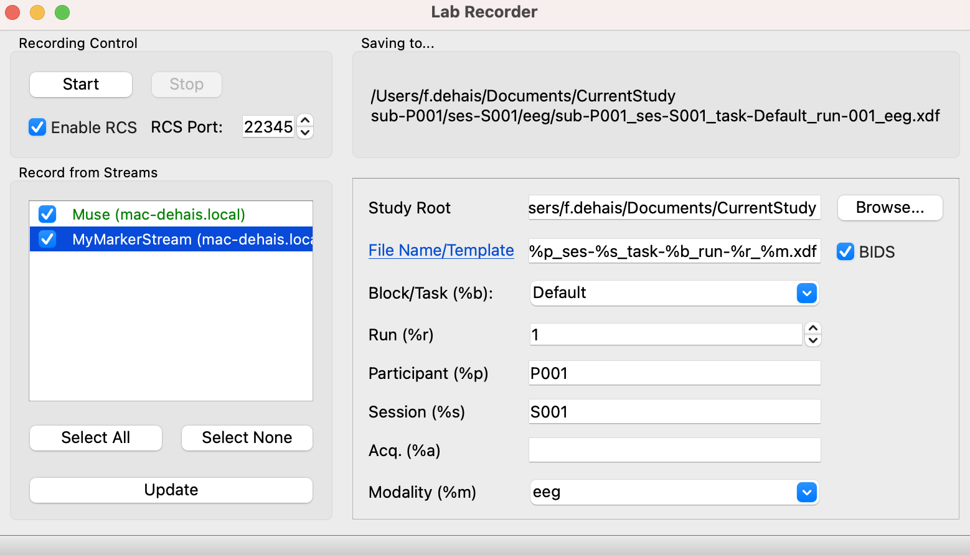

* After the first beep (see console “RELAX”) : 60 seconds of resting state eyes closed —> Firstname_relax
* After the second beep (see console “Do the Maths”): 60 seconds of the count down session —> Firstname_math

Have the subject perform a mental count down 7 by 7 starting from 700 during one minute. **Eyes open & avoid motion!**

# Visual Oddball experiment

***Evaluation of:*** attentional orientation

***Task:*** count the rare auditory stimuli

Run…

Blabal…

##### -----------------------------------------------------------------------------------------------------------------

# End of use & cleaning

* Make sure your recorded files are on your computer.
* Stop the recording & streaming.
* Close the software.
* Disconnect the **Bluetooth dongle** and put it back in its appropriate place in the box.
* Remove the headset and turn the interface off by pressing the button for 2 seconds.
* Clean the electrodes: use a soft cloth and 70 % isopropyl alcohol or disinfection wipes. Clean the pins of all Unicorn Hybrid EEG Electrodes by wiping from different directions over the tips of the pins.
* Put the headset back in its box (with electrodes still on).
* Make sure all equipement is back in the boxes and close them all and put them back in the main box.

--------------------------------------------------------------------------------------------------------------------------------------

# Analyses & Results - using EEGlab

* On the LMS download the folder ‘Practical-EEG’ in which you have the EEGlab toolboxand two P300 files (fdt and set).
* Unzip this folder and put it in your D.
* In Matlab, add the path to the eeglab folder.
* Launch EEGlab: type *eeglab* and wait for the GUI to appear.

## Rest vs Count down experiment: Spectral analysis

-Load the data of the **1st condition** (rest): File, import data, using EEGlab functions and plugins, From Unicorn Hybrid Black

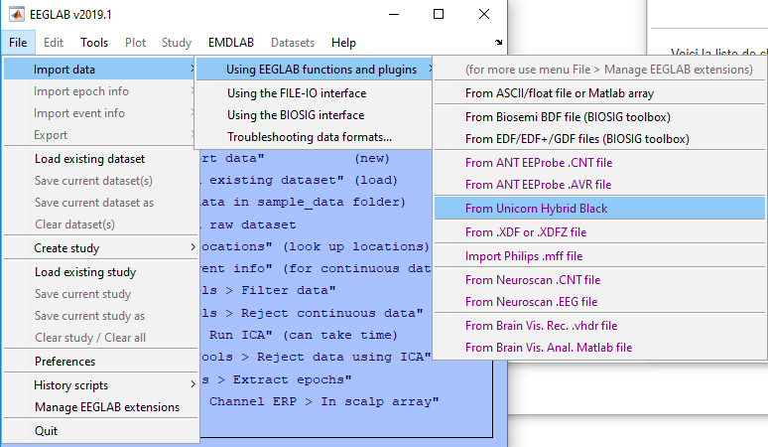

- Select the .csv file of the resting state, then check OK. A new pop-up appears, to rename your file “MyName_rest”.

- Import the channel spherical coordinates: Edit, Dataset info, Channel location file or info

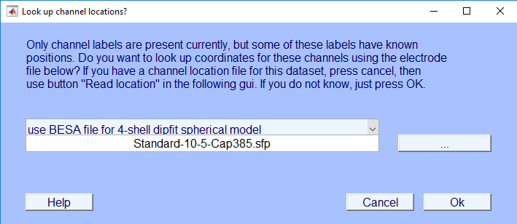

Leave everything as default and click OK

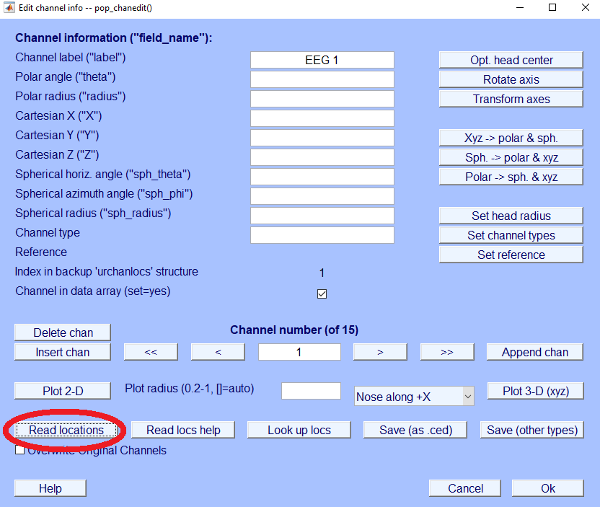

Click on Read locations and select the ‘unicorn_electrodeloc.ced’

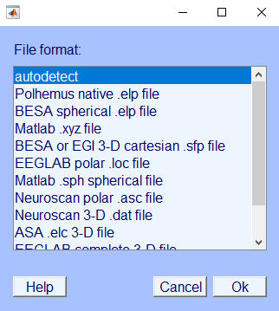

Select autodetect to retrieve spherical information based on electrode labels

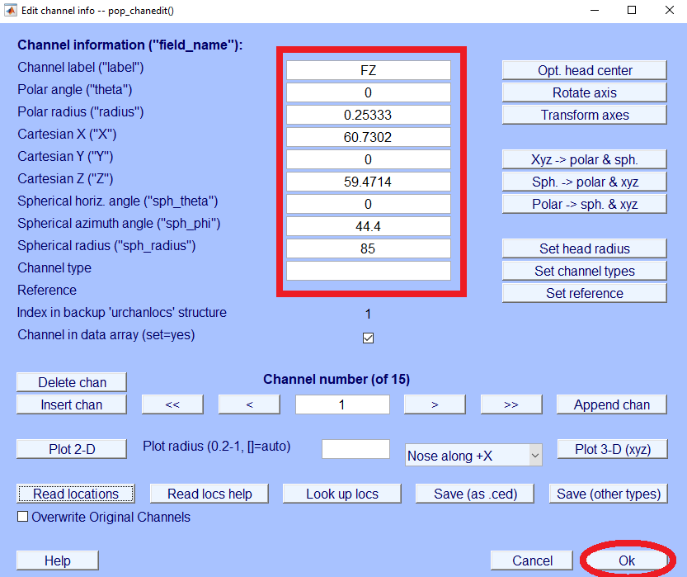

Correct labels for EEG channels and location coordinates are now imported.

* Now we will discard auxiliary EEG channels: EDIT > Select Data

Click on the box on the right side of the Channel range row. In the pop-up window select the 8 Right auxiliary channels as indicated on the figure. Channel range: click OK on “On->remove these”. Then click “OK” on both windows to close them all.

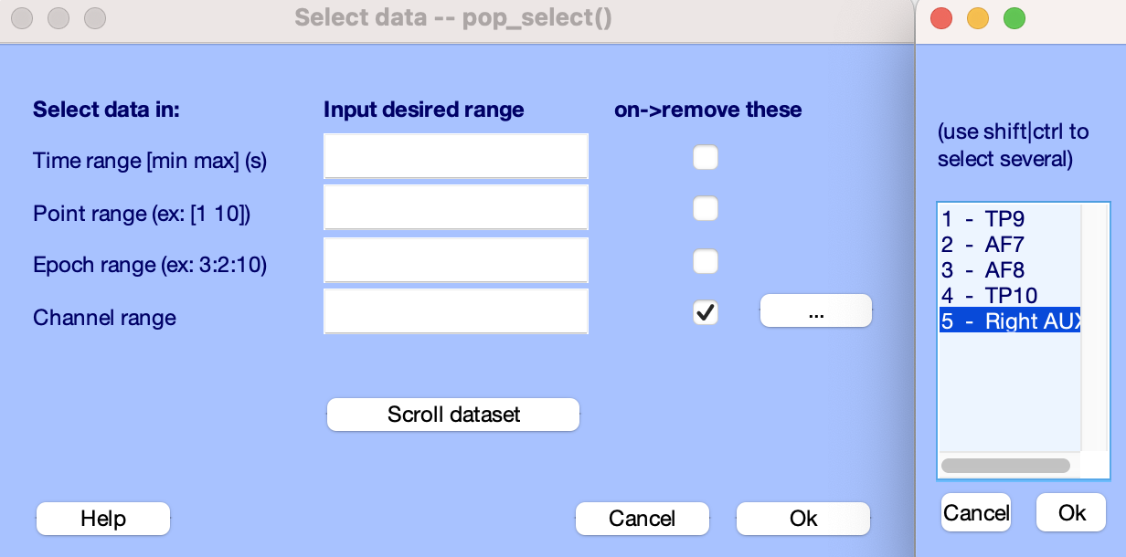

- Verify the information displayed on the GUI (e.g. number of channel, sampling frequency, number of events).

### Frequency filtering

* Tools, Filter the data, Basic FIR filter, [1 40] Hz, order by default. Rename your file: MyName_ _filtered
* Look at your data: Plot > Channel data (scroll)

### Re-referencin the data (mastoid re-referecing TP9 and TP10)

* Tools >Re-reference the data. Rename your file: MyName_Relax_Rereferenced

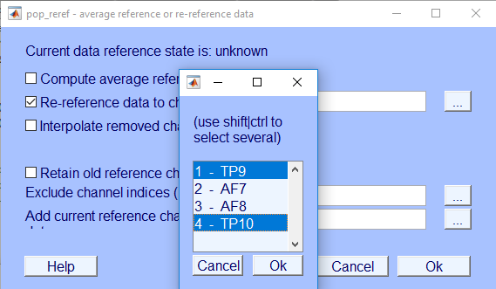

### 3.Spectral analysis

* Plot —> Channel spectra & maps, remove «Frequencies to plot as scalp maps », OK
* Save figure.

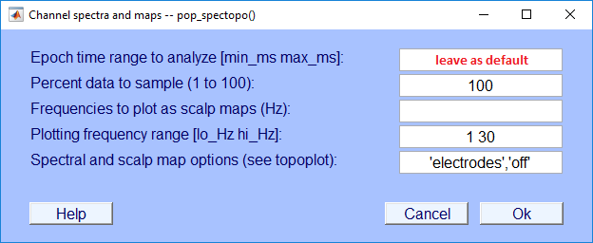

### Comparison

* Repeat the whole procedure for the **2nd condition** (count down) and save all figures.
* Open the spectra of the 1st and the 2nd condition, adjust the parameters to enable direct comparison (axes).

*Remarks on the most appropriate frequency band:*

*Comparison between the conditions:*

————————————————————————————————————————————

## Oddball task: Event-Related Potential analysis

* Load the data: File, import data, oddball_ctrl.set file
* Verify the information displayed on the GUI (e.g. number of channel, sampling frequency, number of events).
* Repeat the same procedure as previously done:
  + Remove auxiliary channel
  + Re-reference the data on TP9 and TP10

### Frequency filtering

* Tools, Filter the data, Basic FIR filter, [1 40] Hz, order by default. Rename your file: Oddball_filtered
* Look at your data: Plot —> Channel data (scroll)

### Epoching

This step allows you to extract epochs of signal synchronized on the markers sent by Matlab and that correspond to the occurrence of a stimulation (100: rare/target sound, 200: standard/distractor sound).

* Tools, extract epochs, in Time-locking event types select the markers 100. Epoch limits: -0.2 1 (seconds), rename your file: Oddball_epochs_100
* Pop-up baseline (sort of normalization): -200 0; rename with same name.

### Artifact rejection

In order to remove noisy epochs you need to visually inspect the signal and select the epochs to be discarded:

* Plot, Channel data scroll, scroll using the bottom cursor, select the eventual noisy epochs by clicking on the epoch. **When all noisy epochs are selected**, click on REJECT and rename your file: Oddball_epochs10_cleaned

**Perform the whole procedure twice, once for each marker (100 and 200)!**

### Event-Related Potentials Visualization:

* Plot, sum/compare ERPs, select the dataset that corresponds to the marker 200 (1st line), then that of the marker 100 (2nd line); select plot difference; plottopo options remove the “-“ sign.

*OR* type **pop_comperp(ALLEEG);**

* Click on the graph that corresponds to the Pz electrode.

*What do you observe? At which time point is the amplitude maximal?*

* Click on the graph that corresponds to the Cz electrode.

*What do you observe? Is there a negative peak earlier than the maximal peak you found before?*

### Topographical representations

* Plot, Channel ERPs, with scalp maps for each marker type.

*What do you observe? Specifically for the max amplitude of the ERP ?*