ModelNgspicer
User Guide

Version 1.0

Developed by ペE

Introduction
ModelNgspicer is a GUI application built on top of ngspice, designed to enhance workflow efficiency in circuit design optimization and device modeling. The graphical interface is developed using Python’s Qt library (PySide6), allowing users to adjust model parameters via mouse wheel or numeric input and instantly visualize changes through real-time plotting.

Ngspice is an open-source SPICE-based circuit simulator that supports a wide range of analysis types, including DC, AC, transient, noise, and S-parameter analysis. It also accommodates industry-standard models such as Verilog-A and BSIM, enabling high-precision device modeling. Since it operates via command line, ngspice is well-suited for complex scripted computations and automated analysis workflows.

Ngspice official website:
https://ngspice.sourceforge.io

Installation

System Requirements
ModelNgspicer has been tested under the following environment:
- Operating System: Windows 10 or later (64-bit)
- Python: Version 3.13 or later
- Required packages: PySide6, PyQtGraph, numpy
- Ngspice: Version 43 or later is recommended

Installation Guide (Windows)
This section outlines the installation procedure for Windows environments. We recommend using Chocolatey, a package manager for Windows, to streamline the setup process. Alternatively, you can download and install manually from the official website.

1. Installing Chocolatey
Open PowerShell with administrator privileges and run the following command:
For more details, visit Chocolatey’s official installation page (https://chocolatey.org/install).

Powershell
Set-ExecutionPolicy Bypass -Scope Process -Force; [System.Net.ServicePointManager]::SecurityProtocol = [System.Net.ServicePointManager]::SecurityProtocol -bor 3072; iex ((New-Object System.Net.WebClient).DownloadString('https://community.chocolatey.org/install.ps1'))

2. Installing Python
To install Python using Chocolatey, run the following command in an administrator PowerShell or Command Prompt. After installation, verify that both python and pip commands are available.

Powershell
choco install python

3. Installing ngspice
Ngspice can also be installed via Chocolatey. Run the following command in an administrator PowerShell or Command Prompt. After installation, ensure that ngspice and ngspice_con commands are available.

Powershell
choco install ngspice

4. Installing Required Libraries
Run the following command to install the required Python libraries.

Powershell
pip install pyside6 pyqtgraph numpy

Once the setup is complete, you can launch ModelNgspicer by executing run.vbs located in the project folder.

GUI and Basic Operations

Overview of the Interface
The following figure illustrates the GUI layout of ModelNgspicer:

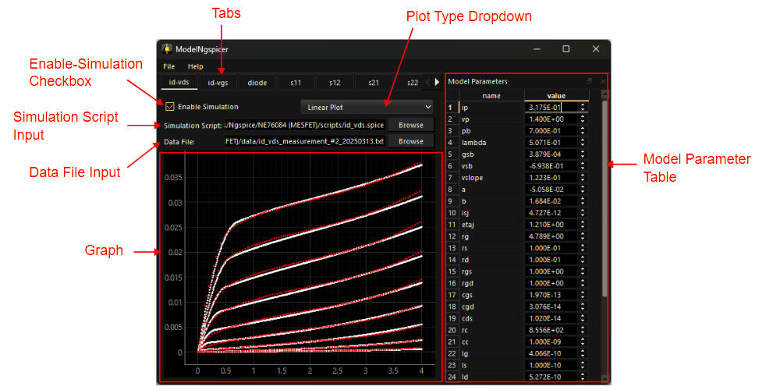
Fig. 3-1 Graphical interface

- Tabs
At the top of the interface, there are 10 tab panels, each allowing for different simulation configurations. You can rename a tab by double-clicking its title. Right-clicking a tab and selecting Pop Out opens its contents in a separate window. When the pop-out window is closed, it returns to its original tab position. Multiple pop-out windows can be displayed simultaneously, enabling parallel parameter adjustments.
- Model Parameter Table
This section displays a list of model parameters. You can load a parameter definition file via the menu bar: File > Load Parameters... . Each parameter value is shown in a spin box, which can be adjusted using the mouse wheel. Holding the Ctrl key while scrolling allows for coarse adjustments.
- Enable-Simulation Checkbox
This checkbox toggles simulation on or off for the currently active tab. When enabled, simulations are automatically executed whenever model parameters are modified. Disabling simulations for unused tabs may help reduce execution time.
- Simulation Script Input
This field allows you to select a simulation script for ngspice. Clicking the Browse button opens a file dialog. The selected script file (.spice, .sp, or .cir) is executed via the ngspice_con command from Python. The results are automatically plotted on the graph below by outputting a .txt file with the same name as the script.
- Data File Input
You can select a data file for comparison with simulation results. The loaded data is plotted on the same graph as the simulation output. This feature is useful for overlaying measurement results, datasheet values, or target specifications.
- Plot Type Dropdown
This dropdown menu lets you choose the graph type: Linear Plot, Log-Log, Semi-Log X, Semi-Log Y, or Smith Chart.
- Graph
Simulation results are plotted as white dots, while data file points appear in red.

Basic Operation Flow
To use ModelNgspicer, the user needs to prepare at least the following two files. The formats of these files are explained in the next section.
- Parameter definition file (.txt)
- Ngspice simulation script (.spice, .sp, or .cir)

The basic workflow for using ModelNgspicer is outlined below.
- Load Model Parameters
Click File > Load Parameters... from the menu bar and select a parameter definition file (.txt). The loaded parameters will apear in the Model Parameter Table.
- Specify Simulation Script
In the Simulation Script Input section, click the Browse button and select the desired ngspice script (.spice, .sp, or .cir).
- Enable Simulation
Turn on the Enable-Simulation Checkbox to activate simulation for the selected tab.
- Adjust Parameters
Use the spin boxes to modify model parameter values:
- Scroll the mouse wheel for fine adjustments
- Hold the Ctrl key while scrolling for coarse adjustments
- Load Comparison Data (Optional)
In the Data File Input section, you can specify an external data file (e.g., measurement results or target values).
- Select Plot Type
Use the Plot Type Dropdown to choose a display format: Linear, Log-Log, Semi-Log X, Semi-Log Y, or Smith Chart.
- Review Results
In the graph area, white dots represent simulation results, and red dots indicate external data. The graph updates in real time as parameters are adjusted.
- Save Model Parameters
To save the adjusted model parameters, go to File > Save Parameters... in the menu bar.

File Formats

Parameter Definition File
In ModelNgspicer, model parameters are defined using a plain text file (.txt). Each line in the file begins with a + symbol, as shown below:

Plain Text
+ is = 1e-14
+ n = 1.5
+ rs = 0.5
+ …

The + symbol is part of SPICE syntax and indicates a continuation from the previous line. By using this format, the parameter file can be seamlessly expanded into .param or .model statements within ngspice scripts.

Example 1: Expansion into a .param statement

Ngspice Script
.param
.include model.txt

When an .include statement is placed directly below a .param block as shown in the script above, Ngspice internally expands it as follows. As a result, the contents of the parameter file model.txt are interpreted as .param arguments, enabling concise integration into simulation script.

Ngspice Script
.param
+ is = 1e-14
+ n = 1.5
+ rs = 0.5
+ …

Example 2: Expansion into a .model statement

Ngspice Script
.model DIODE1 D (
.include model.txt
+ )

In the example above, the contents of the parameter file model.txt are applied as model parameters for DIODE1. With this approach, you can define custom device models.

Simulation Result and Data Files
ModelNgspicer uses a common plain text format (.txt) for both simulation results and external data files. The file structure is as follows:
- No header row
- First column: X-axis data
- Second and subsequent columns: Y-axis data
- Delimiters: Space or tab

Example:
Plain Text
1e6 -3.2 -1.1
2e6 -3.5 -1.3
3e6 -3.8 -1.6
…

To export simulation results, use the wrdata command in your ngspice script. The output file must have the same name as script file, with a .txt extension. This naming rule enables ModelNgspicer to automatically identify the result file and display it the graph view.

Example (ngspice script):
Ngspice Script
set wr_singlescale
wrdata iv.txt i(v1) i(v2)

In this example, running iv.spice will produce iv.txt, containing the current values of i(v1) and i(v2).

Notes:
- The result file must have the same base name as the script file; otherwise, it will not be automatically plotted.
- Data integrity is necessay. If the file contains inconsistent or malformed data, plotting may fail or produce incorrect results.

Use Cases

Designing an LC Bandpass Filter
This section introduces an example of designing an LC bandpass filter using ModelNgspicer.

Fig. 5-1 shows the schematic diagram, with nodes labeled from n01 to n05. The model parameters used are Cval1, Lval2, Cval3, and Lval4. In this example, we aim to design the bandpass filter so that its center frequency is 100 MHz.

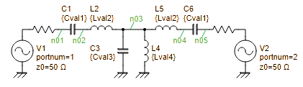
Fig. 5-1 Schematic of the LC bandpass filter

We create a parameter definition file (model_initial.txt) and an ngspice script (bpf1.spice), as shown below.

File: model_initial.txt
+ Cval1=10p
+ Lval2=300n
+ Cval3=253p
+ Lval4=10n

File: bpf1.spice
1  2  3  4  5  6  7  8  9  10  11  12  13  14  15  16  17  18  19  20  21  22 | bpf1.spice  .param  .include model.txt  V1 n01 0 dc 0 portnum 1 z0 50  V2 n05 0 dc 0 portnum 2 z0 50  C1 n01 n02 {Cval1}  L2 n02 n03 {Lval2}  C3 n03 0 {Cval3}  L4 n03 0 {Lval4}  L5 n03 n04 {Lval2}  C6 n04 n05 {Cval1}  .control  sp lin 200 50Meg 150Meg  set wr_singlescale  wrdata bpf1.txt db(s_2_1) db(s_1_1)  .endc  .end

Explanation of the script:
Line 1: Treated as a comment in ngspice Here, the filename is noted.
Line 3: Begins the .param statement.
Line 4: The .include directive expands model parameters as arguments for .param.
Line 6-13: Describes the test circuit using a netlist. Voltage sources V1 and V2 are treated as RF ports by specifying portnum, and the reference impedance is set to 50 Ω using z0.
Line 15: .control starts the control section for batch processing.
Line 16: sp lin 200 50Meg 150Meg performs an S-parameter sweep from 50 MHz to 150 MHz with 200 linear points.
Line 18: Specifies the output format for wrdata: the first column is X-axis data, and subsequent columns are Y-axis data.
Line 19: Writes the S21 and S11 results to bpf1.txt. The filename must match the script name for automatic recognition.
Line 21: .endc ends the control section.
Line 22: .end marks the end of the script.

Now that setup for using ModelNgspicer is complete, let’s run the application. Go to File > Load Parameters... and load model_initial.txt. Then, use the Browse button to select bpf1.spice.

After loading, the screen will appear as shown in Fig. 5-2. The graph area displays the frequency response of S11 and S21. At this point, the model parameters remain at their initial values, so the filter response appears slightly distorted. To improve this, try adjusting the value of Cval1 to bring the center frequency closer to 100 MHz.

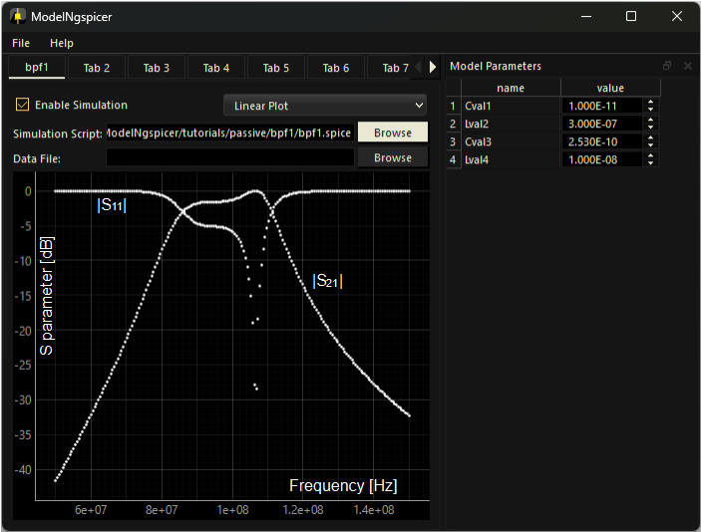
Fig. 5-2 LC bandpass filter design (Before adjustment)

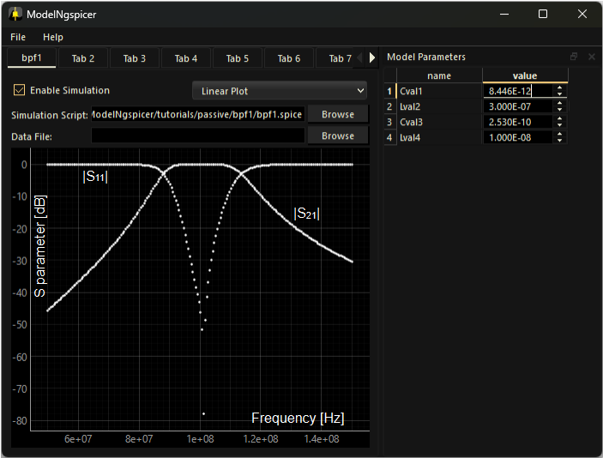
Fig. 5-3 LC bandpass filter design (After adjustment)

Fig. 5-3 shows the screen after adjustment. The response within the passband has become smoother, and the maximum gain is obtained at the center frequency.

Finally, save the adjusted parameters by selecting File > Save Parameters... from the menu bar. This will export the current parameter values to a text file for future use.

Diode Modeling
This section presents an example of diode modeling using ModelNgspicer. We will adjust the model parameters based on the datasheet of the Onsemi 1N4148 diode. In this example, we focus on the following characteristics for modeling.
- Forward and reverse current–voltage characteristics (I_{F}–V_{F}, I_{R}–V_{R})
- Junction capacitance vs. reverse voltage (C_{T}–V_{R})
- Reverse recovery time (t_{rr})

Onsemi, 1N4148 datasheet:
https://www.onsemi.com/products/discrete-power-modules/small-signal-switching-diodes/1n4148

Model Parameters
Below is a list of SPICE model parameters targeted for adjustment, along with the parameter definition file (model_final.txt).

Junction DC parameters
Name | Parameter | Units | Default | Final value
IS | Saturation current | A | 1.0e-14 | 4.277E-09
JSW | Sidewall saturation current | A | 0.0 | 0.000E+00
N | Emission coefficient | - | 1.0 | 1.912E+00
RS | Ohmic resistance | Ω | 0.0 | 7.416E-01
BV | Reverse breakdown voltage | V | infinity | 1.42E+02
IBV | Current at breakdown voltage | A | 1.0e-3 | 1.000E-03
NBV | Breakdown Emission Coefficient | - | N | 4.784E+01
IKF | Forward knee current | A | 0.0 | 0.000E+00
IKR | Reverse knee current | A | 0.0 | 5.000E-07
JTUN | Tunneling saturation current | A | 0.0 | 3.987E-11
JTUNSW | Tunneling sidewall saturation current | A | 0.0 | 0.000E+00
NTUN | Tunneling emission coefficient | - | 30 | 4.914E+02
XTITUN | Tunneling saturation current exponential | - | 3 | 3.000E+00
KEG | EG correction factor for tunneling | - | 1.0 | 1.000E+00
ISR | Recombination saturation current | A | 1.0e-14 | 1.000E-14
NR | Recombination current emission coefficient | - | 2.0 | 2.000E+00

Junction capacitance parameters
Name | Parameter | Units | Default | Final value
CJO | Zero-bias junction bottom-wall capacitance | F | 0.0 | 8.695E-13
CJP | Zero-bias junction sidewall capacitance | F | 0.0 | 0.000E+00
FC | Coefficient for forward-bias depletion bottom-wall capacitance formula | - | 0.5 | 5.000E-01
FCS | Coefficient for forward-bias depletion sidewall capacitance formula | - | 0.5 | 5.000E-01
M | Area junction grading coefficient | - | 0.5 | 2.266E-02
MJSW | Periphery junction grading coefficient | - | 0.33 | 3.300E-01
VJ | Junction potential | V | 1.0 | 7.000E-01
PHP | Periphery junction potential | V | 1.0 | 1.000E+00
TT | Transit-time | sec | 0.0 | 4.121E-09

Temperature effects
Name | Parameter | Units | Default | Final value
EG | Activation energy | eV | 1.11 (Si)  0.69 (SBD)  0.67 (Ge) | 1.110E+00
XTI | Saturation current temperature exponent | - | 3.0 (pn)  2.0 (SBD) | 3.000E+00
TNOM | Parameter measurement temperature | °C | 27 | 2.700E+01

Noise parameters
Name | Parameter | Units | Default | Final value
KF | Flicker noise coefficient | - | 0 | 0.000E+00
AF | Flicker noise exponent | - | 1 | 1.000E+00

Scaling factors
Name | Parameter | Units | Default | Final value
area | Scaling factor for area | - | 1 | 1.000E+00
pj | Scaling factor for perimeter | - | 1 | 1.000E+00

File: model_final.txt
+ is=4.277E-09
+ jsw=0.000E+00
+ n=1.912E+00
+ rs=7.416E-01
+ bv=1.270E+02
+ ibv=0.000E+00
+ nbv=4.784E+01
+ ikf=0.000E+00
+ ikr=5.000E-07
+ jtun=3.987E-11
+ jtunsw=0.000E+00
+ ntun=4.914E+02
+ xtitun=3.000E+00
+ keg=1.000E+00
+ isr=1.000E-14
+ nr=2.000E+00
+ cjo=8.695E-13
+ cjp=0.000E+00
+ fc=5.000E-01
+ fcs=5.000E-01
+ m=2.266E-02
+ mjsw=3.300E-01
+ vj=7.000E-01
+ php=1.000E+00
+ tt=4.121E-09
+ eg=1.110E+00
+ xti=3.000E+00
+ tnom=2.700E+01
+ kf=0.000E+00
+ af=1.000E+00
+ area=1.000E+00
+ pj=1.000E+00

Forward Current–Voltage Characteristics
We begin by adjusting the model parameters based on the forward current–voltage (I_{F}–V_{F}) characteristics. The test circuit used for this simulation is shown in Fig. 5-4, with the corresponding ngspice script (if-vf.spice).

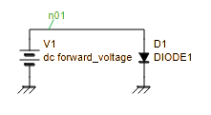
Fig. 5-4 Test circuit for forward current–voltage characteristics

File: if-vf.spice
1  2  3  4  5  6  7  8  9  10  11  12  13  14  15  16  17 | if-vf.spice  .model DIODE1 D (  .include model.txt  + )  V1 n01 0 dc 0  D1 n01 0 DIODE1  .control  option TEMP=25  dc V1 0.3 1.5 0.01  set wr_singlescale  wrdata if-vf.txt -i(V1)  .endc  .end

Explanation of the script:
Line 1: Treated as a comment in ngspice Here, the filename is noted.
Line 3-5: Defines the diode model DIODE1 usgin .model statement. The .include directive expands the model parameters as arguments.
Line 7-8: Describes the test circuit using a netlist.
Line 10: .control starts the control section for batch processing.
Line 11: Sets the ambient temperature TEMP to 25°C using the option command.
Line 12: dc V1 0.3 1.5 0.01 performs a DC sweep on voltage source V1 from 0.3 V to 1.5 V in 0.01 V increments.
Line 14: Specifies the output format for wrdata: the first column is X-axis data, and subsequent columns are Y-axis data.
Line 15: Outputs the simulation results to if-vf.txt.
Line 16: .endc ends the control section.
Line 17: .end marks the end of the script.

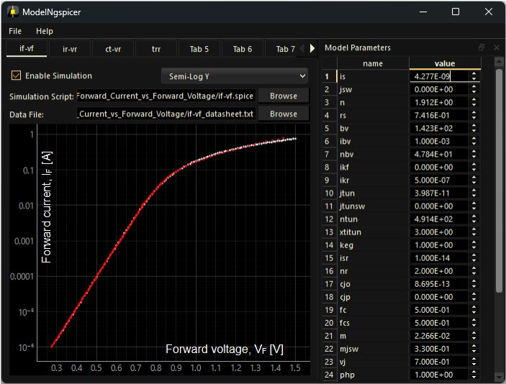
Fig. 5-5 Parameter tuning for forward I–V characteristics
(Red dots: datasheet values, white dots: simulation results)

Parameter tuning:
Here, we adjust the model parameters: IS (saturation current), N (emission coefficient), and RS (ohmic resistance). In the low-current region, IS and N affect the graph’s intercept and slope, respectively. In the high-current region, RS becomes the dominant factor.

Fig. 5-5 shows the adjusted forward I–V characteristics. Red dots represent values extracted from the datasheet, while white dots show the simulation results. The two sets of data are in good agreement.

Reverse Current–Voltage Characteristics
Next, we adjust the model parameters based on the reverse current–voltage characteristics (I_{R}–V_{R}). The test circuit used for this simulation is shown in Fig. 5-6, with the corresponding ngspice script (ir-vr.spice).

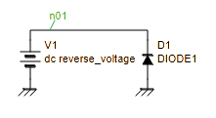
Fig. 5-6 Test circuit for reverse current–voltage characteristics

File: ir-vr.spice
1  2  3  4  5  6  7  8  9  10  11  12  13  14  15  16  17 | ir-vr.spice  .model DIODE1 D (  .include model.txt  + )  V1 n01 0 dc 0  D1 0 n01 DIODE1  .control  option TEMP=25 GMIN=4e-10  dc V1 10 146 1  set wr_singlescale  wrdata ir-vr.txt -i(V1)  .endc  .end

Explanation of the script:
Line 1: Treated as a comment in ngspice Here, the filename is noted.
Line 3-5: Defines the diode model DIODE1 usgin .model statement. The .include directive expands the model parameters as arguments.
Line 7-8: Describes the test circuit using a netlist.
Line 10: .control starts the control section for batch processing.
Line 11: Sets the ambient temperature TEMP to 25°C and the minimum conductance GMIN to 4e-10 Ω⁻¹. GMIN helps reproduce the diode’s leakage current and is tuned to match the datasheet characteristics.
Line 12: dc V1 10 146 1 performs a DC sweep on voltage source V1 from 10 V to 146 V in 1 V increments.
Line 14: Specifies the output format for wrdata: the first column is X-axis data, and subsequent columns are Y-axis data.
Line 15: Outputs the simulation results to ir-vr.txt.
Line 16: .endc ends the control section.
Line 17: .end marks the end of the script.

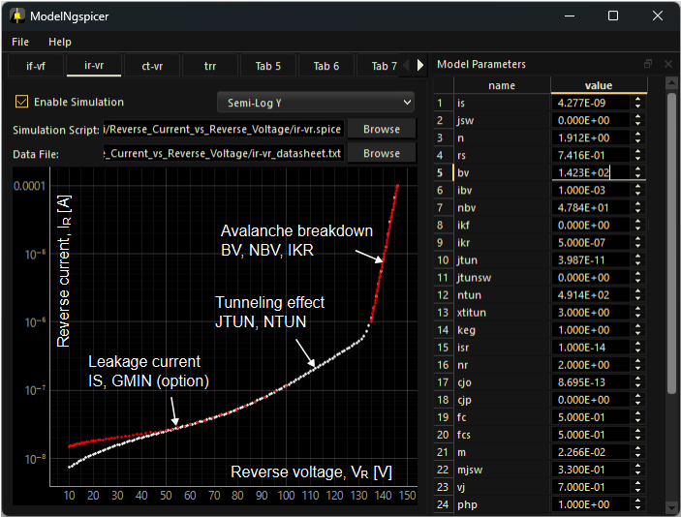
Fig. 5-7 Parameter tuning for reverse I–V characteristics
(Red dots: datasheet values, white dots: simulation results)

Parameter tuning:
Here, we adjust the model parameters: JTUN (tunneling saturation current), NTUN (tunneling emission coefficient), BV (reverse breakdown voltage), NBV (breakdown emission coefficient), IKR (reverse knee current), and the environment variable GMIN (minimum conductance).
- Low-voltage region (～70 V):
Leakage current in this region is primarily determined by IS and GMIN. Since IS has already been tuned based on the forward I–V characteristics, only GMIN is adjusted here.
- Mid-voltage region (70–130 V):
The current slope increases in this region. To reproduce this behavior, we adjust JTUN and NTUN, which are related to tunneling current.
- High-voltage region (above 130 V):
Avalanche breakdown dominates in this region. We adjust the breakdown voltage BV and the emission coefficient NBV. Additionally, IKR is set to the onset of avalanche breakdown (approximately 0.5 μA)

Fig. 5-7 shows the adjusted reverse I–V characteristics. Red dots represent values extracted from the datasheet, while white dots show the simulation results. The two sets of data are in good agreement.

Junction Capacitance–Reverse Voltage
Next, we adjust the model parameters based on the junction capacitance–reverse voltage characteristics (C_{T}–V_{R}). The test circuit used for this simulation is shown in Fig. 5-8, with the corresponding ngspice script (ct-vr.spice). A series resistor R1 is inserted to pick up the current value during AC analysis.

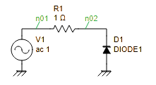
Fig. 5-8 Test circuit for C_{T}–V_{R} characteristics

File: ct-vr.spice
1  2  3  4  5  6  7  8  9  10  11  12  13  14  15  16  17  18  19  20  21  22  23  24  25  26  27  28  29  30  31  32  33  34  35 | ct-vr.spice  .model DIODE1 D (  .include model.txt  + )  V1 n01 0 dc 0 ac 1  R1 n01 n02 1  D1 0 n02 DIODE1  .control  * Reverse voltage sweep settings  let st = 0  let sp = 15  let step = 0.1  let loop_index = 0  let loop_count = (sp-st)/step  let capacitance = vector(loop_count)  let reverse_voltage = st+step*vector(loop_count)  while loop_index lt loop_count  alter V1 dc reverse_voltage[loop_index]  ac lin 1 1Meg 1Meg  $ Calculate capacitance from admittance  let Y11 = v(n01,n02)/v(n02)  let capacitance[loop_index] = abs(imag(Y11)/(2*pi*frequency))/1e-12  let loop_index = loop_index + 1  end  setscale capacitance reverse_voltage  wrdata ct-vr.txt capacitance  .endc  .end

Explanation of the script:
Line 1: Treated as a comment in ngspice Here, the filename is noted.
Line 3-5: Defines the diode model DIODE1 usgin .model statement. The .include directive expands the model parameters as arguments.
Line 7-9: Describes the test circuit using a netlist.
Line 11: .control starts the control section for batch processing.
Line 13-15: Voltage sweep settings are defined using st (start), sp (stop), and step.
Line 17-18: Variables loop_index and loop_count are defined for loop control.
Line 19-20: Vector variables capacitance and reverse_voltage are initialized to store output results.
Line 22: while loop is used to perform repeated processing.
Line 23: alter overwrites the value of the voltage source V1.
Line 24: ac lin 1 1Meg 1Meg performs AC analysis at a single frequency point of 1 MHz.
Line 27-28: Capacitance is calculated from admittance and stored in the capacitance vector.
Line 29: loop_index is incremented.
Line 30: marks the end of the while loop.
Line 32: Associates the capacitance and reverse_voltage vectors.
Line 33: Outputs the results to ct-vr.txt.
Line 34: .endc ends the control section.
Line 35: .end marks the end of the script.

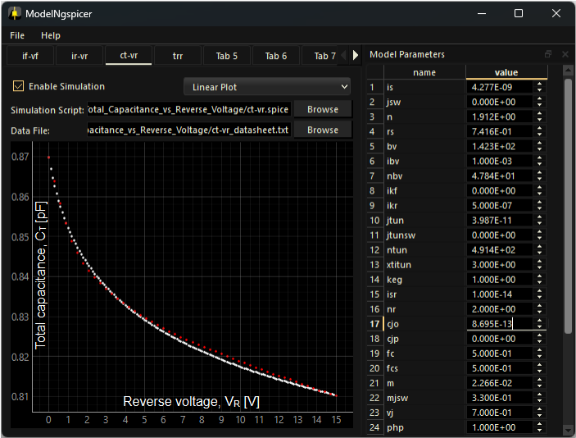
Fig. 5-9 Parameter tuning for C_{T}–V_{R} characteristics
(Red dots: datasheet values, white dots: simulation results)

Parameter tuning:
Here, we adjust the model parameters: CJO (zero-bias junction bottom-wall capacitance), M (area junction grading coefficient), and VJ (junction potential).

Fig. 5-9 shows the adjusted C_{T}–V_{R} characteristics. Red dots represent values extracted from the datasheet, while white dots show the simulation results. The two sets of data are in good agreement.

Reverse Recovery Time
Finally, we adjust the model parameters based on the reverse recovery time (t_{rr}). Reverse recovery time refers to the delay between switching from forward bias to reverse bias, during which excess carriers (electrons and holes) stored in the junction are swept out before the diode fully blocks current.

Typically, a measurement circuit like Fig. 5-10 is used. In this setup, a forward current I_{F} (~10 mA) is applied via voltage source V2. Then, a negative pulse is applied from the pulse generator V1, and the time response of the reverse current is observed until it settles.

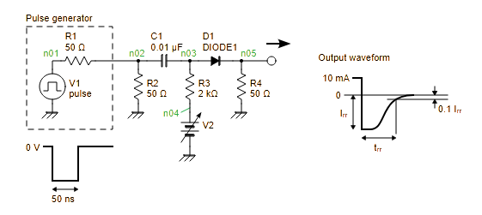
Fig. 5-10 Test circuit for reverse recovery time (t_{rr})

File: trr.spice
1  2  3  4  5  6  7  8  9  10  11  12  13  14  15  16  17  18  19  20 | trr.spice  .model DIODE1 D (  .include model.txt  + )  V1 n01 0 dc 0 pulse(0 -3 10n 0.1n 0.1n 50n 100n 1)  V2 n04 0 dc 21.2  R1 n01 n02 50  R2 n02 0 50  R3 n03 n04 2k  R4 n05 0 50  C1 n02 n03 0.01u  D1 n03 n05 DIODE1  .control  tran 10p 20n  wrdata trr.txt v(n05)  .endc  .end

Explanation of the script:
Line 1: Treated as a comment in ngspice Here, the filename is noted.
Line 3-5: Defines the diode model DIODE1 usgin .model statement. The .include directive expands the model parameters as arguments.
Line 7-14: Describes the test circuit using a netlist.
Line 16: .control starts the control section for batch processing.
Line 17: tran 10p 20n performs transient analysis, simulating the time response up to 20 ns with a time step of 10 ps.
Line 18: Outputs the results to trr.txt.
Line 19: .endc ends the control section.
Line 20: .end marks the end of the script.

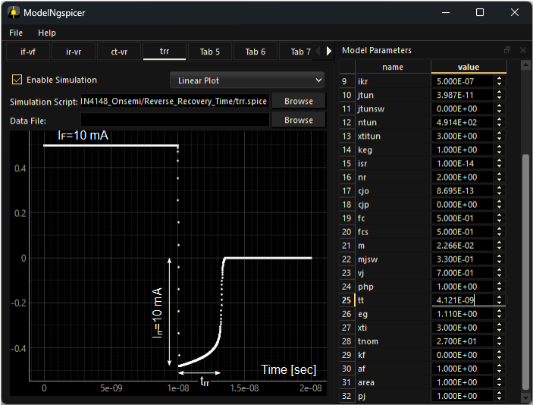
Fig. 5-11 Parameter Tuning for Reverse Recovery Time

Parameter tuning:
According to the datasheet for the 1N4148 diode, the reverse recovery time is specified as t_{rr}=3.2 ns under the condition of I_{F}=10 mA and I_{rr}=10 mA. To match this characteristics, the model parameter TT (transit time) is adjusted accordingly.

Fig. 5-11 shows the time-domain waveform of the reverse recovery response. It confirms that t_{rr}≃3.2 ns has been achieved.

