MODELngspicer
User Guide

Version 2.2

Developed by ペE

Introduction
MODELngspicer is a GUI application built on top of ngspice, designed to enhance workflow efficiency in circuit design optimization and device modeling. The graphical interface is developed using Python’s Qt library (PySide6), allowing users to adjust model parameters via mouse wheel or numeric input and instantly visualize changes through real-time plotting.

Ngspice is an open-source SPICE-based circuit simulator that supports a wide range of analysis types, including DC, AC, transient, noise, and S-parameter analysis. It also accommodates industry-standard models such as Verilog-A and BSIM, enabling high-precision device modeling. Since it operates via command line, ngspice is well-suited for complex scripted computations and automated analysis workflows.

Ngspice official website:
https://ngspice.sourceforge.io

Installation

System Requirements
MODELngspicer has been tested under the following environment:
- Operating System: Windows 10 or later (64-bit)
- Python: Version 3.13 or later
- Required packages: PySide6, PyQtGraph, NumPy
- Ngspice: Version 43 or later is recommended

Installation Guide (Windows)
This section outlines the installation procedure for Windows environments. We recommend using Chocolatey, a package manager for Windows, to streamline the setup process. Alternatively, you can download and install manually from the official website.

1. Installing Chocolatey
Open PowerShell with administrator privileges and run the following command. For more details, visit Chocolatey’s official installation page (https://chocolatey.org/install).

Powershell
Set-ExecutionPolicy Bypass -Scope Process -Force; [System.Net.ServicePointManager]::SecurityProtocol = [System.Net.ServicePointManager]::SecurityProtocol -bor 3072; iex ((New-Object System.Net.WebClient).DownloadString('https://community.chocolatey.org/install.ps1'))

2. Installing Python and Ngspice
To install Python and Ngspice using Chocolatey, run the following commands in an administrator PowerShell or Command Prompt. After installation, verify that python, pip, ngspice, and ngspice_con commands are available.

Powershell
choco install python
choco install ngspice

3. Installing Required Libraries
Run the following command to install the required Python libraries.

Powershell
pip install pyside6 pyqtgraph numpy

Once the setup is complete, you can launch MODELngspicer by executing run.vbs located in the project folder.

GUI and Basic Operations

Overview of the Interface
The following figure illustrates the GUI layout of MODELngspicer:

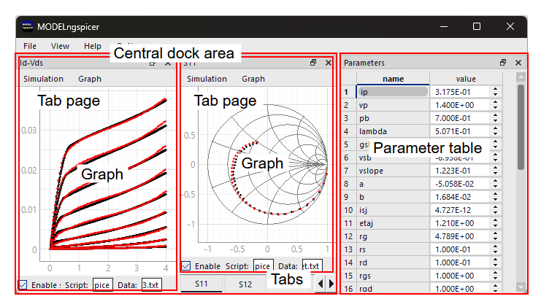
Fig. 3-1 Graphical interface

- Central dock area
The area where tab pages are hosted.

- Tab pages
Up to 10 tab pages may be added, each maintaining its own simulation settings. Visibility can be toggled via the View menu, and tab names can be edited via Simulation > Rename title.

- Tabs
Tab pages are stacked within the central dock area to form tabs.

- Graph
Simulation results and external data are plotted. Simulation results appear as black dots (white in dark mode), while external data is shown as red dots.

- Parameter table
A list of parameters is displayed. When a parameter file is loaded via File > Load params..., the table is updated accordingly. Each parameter value is shown in a spin box and can be adjusted using the mouse wheel. Holding down the Ctrl key while scrolling enables coarse adjustments.

Basic Operation Flow
To use MODELngspicer, the user needs to prepare at least the following two files. The formats of these files are explained in the next section.
- Parameter definition file (.txt)
- ngspice simulation script (.spice, .sp, or .cir)

The basic workflow for using MODELngspicer is outlined below.
- Load parameters
Select a parameter file via File > Load params... . The loaded parameters will be displayed in the parameter table.
- Select ngspice script
Choose an ngspice script (.spice, .sp, or .cir) via Simulation > Select ngspice script... .
- Select external data (optional)
To load external data such as measurement results or target values, use Simulation > Select data file... .
- Enable/disable simulation
Simulation can be toggled via Simulation > Enable/disable simulation or the checkbox at the bottom left. Disabling simulation for unused tabs may reduce execution time.
- Configure graph display
Adjust graph settings via the Graph menu. Logarithmic axes, Smith charts, and polar plots are supported.
- Adjust parameters
Modify parameter values using the spin boxes in the parameter table:
- Mouse wheel → fine adjustment
- Ctrl + mouse wheel → coarse adjustment
- Review results
Simulation results (black dots) and external data (red dots) are displayed in the graph area.
- Save Model Parameters
Save the adjusted parameters via File > Save params... .

File Formats

Parameter File
In MODELngspicer, parameters are defined using a plain text file (.txt). Each line begins with a + symbol, as shown below:

Plain Text
+ is = 1e-14
+ n = 1.5
+ rs = 0.5
+ …

The + symbol is part of SPICE syntax and indicates a continuation from the previous line. By using this format, the parameter file can be seamlessly expanded into .param or .model statements within ngspice scripts.

Example 1: Expansion into a .param statement

Ngspice Script
.param
.include model.txt

When an .include statement is placed directly below a .param as shown in the script above, ngspice internally expands it as follows. As a result, the contents of the parameter file model.txt are interpreted as .param arguments, enabling concise integration into simulation script.

Ngspice Script
.param
+ is = 1e-14
+ n = 1.5
+ rs = 0.5
+ …

Example 2: Expansion into a .model statement

Ngspice Script
.model DIODE1 D (
.include model.txt
+ )

In the example above, the contents of model.txt are applied as model parameters for DIODE1. With this approach, you can define custom device models.

Simulation Result and Data Files
MODELngspicer uses a common plain text format (.txt) for both simulation results and external data files. The file structure is as follows:
- No header
- First column: X-axis data
- Second and subsequent columns: Y-axis data
- Delimiters: Space or tab

Example:
Plain Text
1e6 -3.2 -1.1
2e6 -3.5 -1.3
3e6 -3.8 -1.6
…

To export simulation results, use the wrdata command in your ngspice script. The output file must have the same name as the script, with a .txt extension. This naming rule enables MODELngspicer to automatically identify the result file and plot it on the graph.

Example (ngspice script):
Ngspice Script
set wr_singlescale
wrdata iv.txt i(v1) i(v2)

In this example, running iv.spice will produce iv.txt, containing the current values of i(v1) and i(v2).

Notes:
- The result file must have the same base name as the script file; otherwise, it will not be automatically plotted.
- Data integrity is necessay. If the file contains inconsistent or malformed data, plotting may fail or produce incorrect results.

Use Cases

Designing an LC Bandpass Filter
This section introduces an example of designing an LC bandpass filter using MODELngspicer.

Fig. 5-1 shows the schematic diagram, with nodes labeled from n01 to n05. The parameters used are Cval1, Lval2, Cval3, and Lval4. In this example, we aim to design the bandpass filter so that its center frequency is 100 MHz.

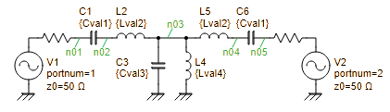
Fig. 5-1 Schematic of the LC bandpass filter

We create a parameter file (model_initial.txt) and an ngspice script (bpf1.spice), as shown below.

File: model_initial.txt
+ Cval1=10p
+ Lval2=300n
+ Cval3=253p
+ Lval4=10n

File: bpf1.spice
1  2  3  4  5  6  7  8  9  10  11  12  13  14  15  16  17  18  19  20  21  22 | bpf1.spice  .param  .include model.txt  V1 n01 0 dc 0 portnum 1 z0 50  V2 n05 0 dc 0 portnum 2 z0 50  C1 n01 n02 {Cval1}  L2 n02 n03 {Lval2}  C3 n03 0 {Cval3}  L4 n03 0 {Lval4}  L5 n03 n04 {Lval2}  C6 n04 n05 {Cval1}  .control  sp lin 200 50Meg 150Meg  set wr_singlescale  wrdata bpf1.txt db(s_2_1) db(s_1_1)  .endc  .end

Explanation of the script:
Line 1: Treated as a comment in ngspice Here, the filename is noted.
Line 3: Begins the .param statement.
Line 4: The .include directive expands parameters as arguments for .param.
Line 6-13: Describes the test circuit using a netlist. Voltage sources V1 and V2 are treated as RF ports by specifying portnum, and the reference impedance is set to 50 Ω using z0.
Line 15: .control starts the control section for batch processing.
Line 16: sp lin 200 50Meg 150Meg performs an S-parameter sweep from 50 MHz to 150 MHz with 200 linear points.
Line 18: Specifies the output format for wrdata: the first column is X-axis data, and subsequent columns are Y-axis data.
Line 19: Writes the S21 and S11 results to bpf1.txt. The filename must match the script name for automatic recognition.
Line 21: .endc ends the control section.
Line 22: .end marks the end of the script.

Launch MODELngspicer, then select File > Load params... and choose model_initial.txt. Next, go to Simulation > Select ngspice script... and select bpf1.spice.

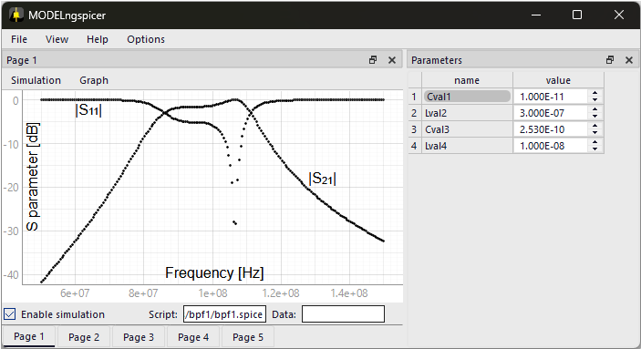
Fig. 5-2 LC bandpass filter design (Before adjustment)

After loading, the screen will appear as shown in Fig. 5-2. The graph displays the frequency response of S11 and S21. At this point, the parameters remain at their initial values, so the filter response appears slightly distorted. To improve this, try adjusting the value of Cval1 to bring the center frequency closer to 100 MHz.

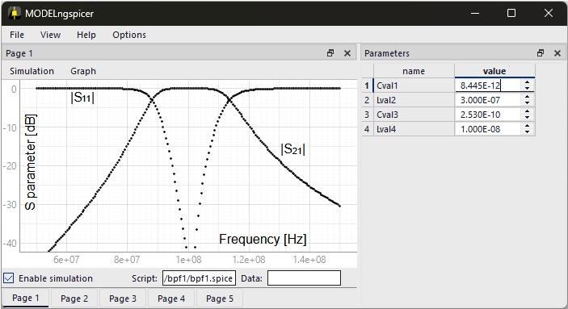
Fig. 5-3 LC bandpass filter design (After adjustment)

Fig. 5-3 shows the screen after adjustment. The response within the passband has become smoother, and the maximum gain is obtained at the center frequency. Finally, save the adjusted parameters by selecting File > Save params... from the menu bar.

Diode Modeling
This section presents an example of diode modeling using MODELngspicer. We will adjust the model parameters based on the datasheet of the Onsemi 1N4148 diode. In this example, we focus on the following characteristics for modeling.
- Forward and reverse current–voltage characteristics (I_{F}–V_{F}, I_{R}–V_{R})
- Junction capacitance vs. reverse voltage (C_{T}–V_{R})
- Reverse recovery time (t_{rr})

Onsemi, 1N4148 datasheet:
https://www.onsemi.com/products/discrete-power-modules/small-signal-switching-diodes/1n4148

Model Parameters
Below is a list of SPICE model parameters targeted for adjustment, along with the parameter definition file (model_final.txt).

Junction DC parameters
Name | Parameter | Units | Default | Final value
IS | Saturation current | A | 1.0e-14 | 4.277E-09
JSW | Sidewall saturation current | A | 0.0 | 0.000E+00
N | Emission coefficient | - | 1.0 | 1.912E+00
RS | Ohmic resistance | Ω | 0.0 | 7.416E-01
BV | Reverse breakdown voltage | V | infinity | 1.42E+02
IBV | Current at breakdown voltage | A | 1.0e-3 | 1.000E-03
NBV | Breakdown Emission Coefficient | - | N | 4.784E+01
IKF | Forward knee current | A | 0.0 | 0.000E+00
IKR | Reverse knee current | A | 0.0 | 5.000E-07
JTUN | Tunneling saturation current | A | 0.0 | 3.987E-11
JTUNSW | Tunneling sidewall saturation current | A | 0.0 | 0.000E+00
NTUN | Tunneling emission coefficient | - | 30 | 4.914E+02
XTITUN | Tunneling saturation current exponential | - | 3 | 3.000E+00
KEG | EG correction factor for tunneling | - | 1.0 | 1.000E+00
ISR | Recombination saturation current | A | 1.0e-14 | 1.000E-14
NR | Recombination current emission coefficient | - | 2.0 | 2.000E+00

Junction capacitance parameters
Name | Parameter | Units | Default | Final value
CJO | Zero-bias junction bottom-wall capacitance | F | 0.0 | 8.695E-13
CJP | Zero-bias junction sidewall capacitance | F | 0.0 | 0.000E+00
FC | Coefficient for forward-bias depletion bottom-wall capacitance formula | - | 0.5 | 5.000E-01
FCS | Coefficient for forward-bias depletion sidewall capacitance formula | - | 0.5 | 5.000E-01
M | Area junction grading coefficient | - | 0.5 | 2.266E-02
MJSW | Periphery junction grading coefficient | - | 0.33 | 3.300E-01
VJ | Junction potential | V | 1.0 | 7.000E-01
PHP | Periphery junction potential | V | 1.0 | 1.000E+00
TT | Transit-time | sec | 0.0 | 4.121E-09

Temperature effects
Name | Parameter | Units | Default | Final value
EG | Activation energy | eV | 1.11 (Si)  0.69 (SBD)  0.67 (Ge) | 1.110E+00
XTI | Saturation current temperature exponent | - | 3.0 (pn)  2.0 (SBD) | 3.000E+00
TNOM | Parameter measurement temperature | °C | 27 | 2.700E+01

Noise parameters
Name | Parameter | Units | Default | Final value
KF | Flicker noise coefficient | - | 0 | 0.000E+00
AF | Flicker noise exponent | - | 1 | 1.000E+00

Scaling factors
Name | Parameter | Units | Default | Final value
area | Scaling factor for area | - | 1 | 1.000E+00
pj | Scaling factor for perimeter | - | 1 | 1.000E+00

File: model_final.txt
+ is=4.277E-09
+ jsw=0.000E+00
+ n=1.912E+00
+ rs=7.416E-01
+ bv=1.270E+02
+ ibv=0.000E+00
+ nbv=4.784E+01
+ ikf=0.000E+00
+ ikr=5.000E-07
+ jtun=3.987E-11
+ jtunsw=0.000E+00
+ ntun=4.914E+02
+ xtitun=3.000E+00
+ keg=1.000E+00
+ isr=1.000E-14
+ nr=2.000E+00
+ cjo=8.695E-13
+ cjp=0.000E+00
+ fc=5.000E-01
+ fcs=5.000E-01
+ m=2.266E-02
+ mjsw=3.300E-01
+ vj=7.000E-01
+ php=1.000E+00
+ tt=4.121E-09
+ eg=1.110E+00
+ xti=3.000E+00
+ tnom=2.700E+01
+ kf=0.000E+00
+ af=1.000E+00
+ area=1.000E+00
+ pj=1.000E+00

Forward Current–Voltage Characteristics
We begin by adjusting the model parameters based on the forward current–voltage (I_{F}–V_{F}) characteristics. The test circuit used for this simulation is shown in Fig. 5-4, with the corresponding ngspice script (if-vf.spice).

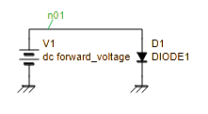
Fig. 5-4 Test circuit for forward current–voltage characteristics

File: if-vf.spice
1  2  3  4  5  6  7  8  9  10  11  12  13  14  15  16  17 | if-vf.spice  .model DIODE1 D (  .include model.txt  + )  V1 n01 0 dc 0  D1 n01 0 DIODE1  .control  option TEMP=25  dc V1 0.3 1.5 0.01  set wr_singlescale  wrdata if-vf.txt -i(V1)  .endc  .end

Explanation of the script:
Line 1: Treated as a comment in ngspice Here, the filename is noted.
Line 3-5: Defines the diode model DIODE1 usgin .model statement. The .include directive expands the model parameters as arguments.
Line 7-8: Describes the test circuit using a netlist.
Line 10: .control starts the control section for batch processing.
Line 11: Sets the ambient temperature TEMP to 25°C using the option command.
Line 12: dc V1 0.3 1.5 0.01 performs a DC sweep on voltage source V1 from 0.3 V to 1.5 V in 0.01 V increments.
Line 14: Specifies the output format for wrdata: the first column is X-axis data, and subsequent columns are Y-axis data.
Line 15: Outputs the simulation results to if-vf.txt.
Line 16: .endc ends the control section.
Line 17: .end marks the end of the script.

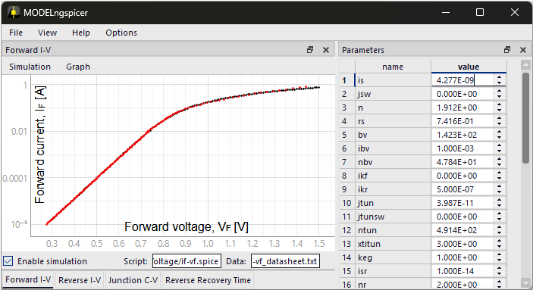
Fig. 5-5 Parameter tuning for forward I–V characteristics
(Red dots: datasheet values, black dots: simulation results)

Parameter tuning:
Here, we adjust the model parameters: IS (saturation current), N (emission coefficient), and RS (ohmic resistance). In the low-current region, IS and N affect the graph’s intercept and slope, respectively. In the high-current region, RS becomes the dominant factor.

Fig. 5-5 shows the adjusted forward I–V characteristics. Red dots represent values extracted from the datasheet, while white dots show the simulation results. The two sets of data are in good agreement.

Reverse Current–Voltage Characteristics
Next, we adjust the model parameters based on the reverse current–voltage characteristics (I_{R}–V_{R}). The test circuit used for this simulation is shown in Fig. 5-6, with the corresponding ngspice script (ir-vr.spice).

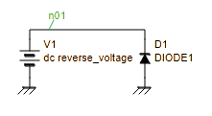
Fig. 5-6 Test circuit for reverse current–voltage characteristics

File: ir-vr.spice
1  2  3  4  5  6  7  8  9  10  11  12  13  14  15  16  17 | ir-vr.spice  .model DIODE1 D (  .include model.txt  + )  V1 n01 0 dc 0  D1 0 n01 DIODE1  .control  option TEMP=25 GMIN=4e-10  dc V1 10 146 1  set wr_singlescale  wrdata ir-vr.txt -i(V1)  .endc  .end

Explanation of the script:
Line 1: Treated as a comment in ngspice Here, the filename is noted.
Line 3-5: Defines the diode model DIODE1 usgin .model statement. The .include directive expands the model parameters as arguments.
Line 7-8: Describes the test circuit using a netlist.
Line 10: .control starts the control section for batch processing.
Line 11: Sets the ambient temperature TEMP to 25°C and the minimum conductance GMIN to 4e-10 Ω⁻¹. GMIN helps reproduce the diode’s leakage current and is tuned to match the datasheet characteristics.
Line 12: dc V1 10 146 1 performs a DC sweep on voltage source V1 from 10 V to 146 V in 1 V increments.
Line 14: Specifies the output format for wrdata: the first column is X-axis data, and subsequent columns are Y-axis data.
Line 15: Outputs the simulation results to ir-vr.txt.
Line 16: .endc ends the control section.
Line 17: .end marks the end of the script.

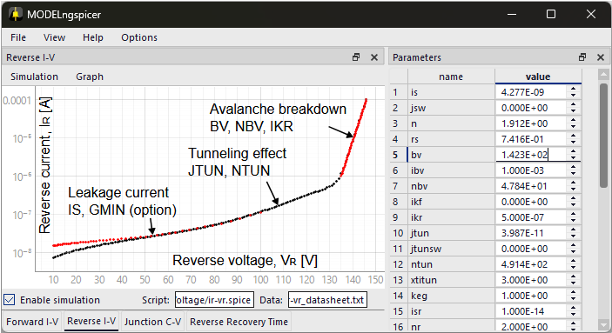
Fig. 5-7 Parameter tuning for reverse I–V characteristics
(Red dots: datasheet values, black dots: simulation results)

Parameter tuning:
Here, we adjust the model parameters: JTUN (tunneling saturation current), NTUN (tunneling emission coefficient), BV (reverse breakdown voltage), NBV (breakdown emission coefficient), IKR (reverse knee current), and the environment variable GMIN (minimum conductance).
- Low-voltage region (～70 V):
Leakage current in this region is primarily determined by IS and GMIN. Since IS has already been tuned based on the forward I–V characteristics, only GMIN is adjusted here.
- Mid-voltage region (70–130 V):
The current slope increases in this region. To reproduce this behavior, we adjust JTUN and NTUN, which are related to tunneling current.
- High-voltage region (above 130 V):
Avalanche breakdown dominates in this region. We adjust the breakdown voltage BV and the emission coefficient NBV. Additionally, IKR is set to the onset of avalanche breakdown (approximately 0.5 μA)

Fig. 5-7 shows the adjusted reverse I–V characteristics. Red dots represent values extracted from the datasheet, while white dots show the simulation results. The two sets of data are in good agreement.

Junction Capacitance–Reverse Voltage
Next, we adjust the model parameters based on the junction capacitance–reverse voltage characteristics (C_{T}–V_{R}). The test circuit used for this simulation is shown in Fig. 5-8, with the corresponding ngspice script (ct-vr.spice). A series resistor R1 is inserted to pick up the current value during AC analysis.

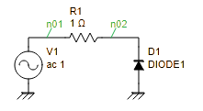
Fig. 5-8 Test circuit for C_{T}–V_{R} characteristics

File: ct-vr.spice
1  2  3  4  5  6  7  8  9  10  11  12  13  14  15  16  17  18  19  20  21  22  23  24  25  26  27  28  29  30  31  32  33  34  35 | ct-vr.spice  .model DIODE1 D (  .include model.txt  + )  V1 n01 0 dc 0 ac 1  R1 n01 n02 1  D1 0 n02 DIODE1  .control  * Reverse voltage sweep settings  let st = 0  let sp = 15  let step = 0.1  let loop_index = 0  let loop_count = (sp-st)/step  let capacitance = vector(loop_count)  let reverse_voltage = st+step*vector(loop_count)  while loop_index lt loop_count  alter V1 dc reverse_voltage[loop_index]  ac lin 1 1Meg 1Meg  $ Calculate capacitance from admittance  let Y11 = v(n01,n02)/v(n02)  let capacitance[loop_index] = abs(imag(Y11)/(2*pi*frequency))/1e-12  let loop_index = loop_index + 1  end  setscale capacitance reverse_voltage  wrdata ct-vr.txt capacitance  .endc  .end

Explanation of the script:
Line 1: Treated as a comment in ngspice Here, the filename is noted.
Line 3-5: Defines the diode model DIODE1 usgin .model statement. The .include directive expands the model parameters as arguments.
Line 7-9: Describes the test circuit using a netlist.
Line 11: .control starts the control section for batch processing.
Line 13-15: Voltage sweep settings are defined using st (start), sp (stop), and step.
Line 17-18: Variables loop_index and loop_count are defined for loop control.
Line 19-20: Vector variables capacitance and reverse_voltage are initialized to store output results.
Line 22: while loop is used to perform repeated processing.
Line 23: alter overwrites the value of the voltage source V1.
Line 24: ac lin 1 1Meg 1Meg performs AC analysis at a single frequency point of 1 MHz.
Line 27-28: Capacitance is calculated from admittance and stored in the capacitance vector.
Line 29: loop_index is incremented.
Line 30: marks the end of the while loop.
Line 32: Associates the capacitance and reverse_voltage vectors.
Line 33: Outputs the results to ct-vr.txt.
Line 34: .endc ends the control section.
Line 35: .end marks the end of the script.

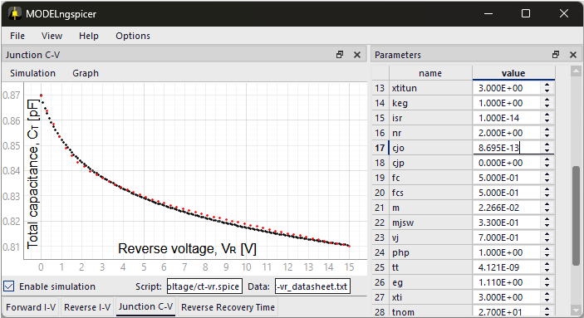
Fig. 5-9 Parameter tuning for C_{T}–V_{R} characteristics
(Red dots: datasheet values, white dots: simulation results)

Parameter tuning:
Here, we adjust the model parameters: CJO (zero-bias junction bottom-wall capacitance), M (area junction grading coefficient), and VJ (junction potential).

Fig. 5-9 shows the adjusted C_{T}–V_{R} characteristics. Red dots represent values extracted from the datasheet, while white dots show the simulation results. The two sets of data are in good agreement.

Reverse Recovery Time
Finally, we adjust the model parameters based on the reverse recovery time (t_{rr}). Reverse recovery time refers to the delay between switching from forward bias to reverse bias, during which excess carriers (electrons and holes) stored in the junction are swept out before the diode fully blocks current.

Typically, a measurement circuit like Fig. 5-10 is used. In this setup, a forward current I_{F} (~10 mA) is applied via voltage source V2. Then, a negative pulse is applied from the pulse generator V1, and the time response of the reverse current is observed until it settles.

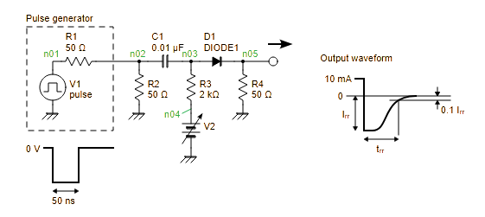
Fig. 5-10 Test circuit for reverse recovery time (t_{rr})

File: trr.spice
1  2  3  4  5  6  7  8  9  10  11  12  13  14  15  16  17  18  19  20 | trr.spice  .model DIODE1 D (  .include model.txt  + )  V1 n01 0 dc 0 pulse(0 -3 10n 0.1n 0.1n 50n 100n 1)  V2 n04 0 dc 21.2  R1 n01 n02 50  R2 n02 0 50  R3 n03 n04 2k  R4 n05 0 50  C1 n02 n03 0.01u  D1 n03 n05 DIODE1  .control  tran 10p 20n  wrdata trr.txt v(n05)  .endc  .end

Explanation of the script:
Line 1: Treated as a comment in ngspice Here, the filename is noted.
Line 3-5: Defines the diode model DIODE1 usgin .model statement. The .include directive expands the model parameters as arguments.
Line 7-14: Describes the test circuit using a netlist.
Line 16: .control starts the control section for batch processing.
Line 17: tran 10p 20n performs transient analysis, simulating the time response up to 20 ns with a time step of 10 ps.
Line 18: Outputs the results to trr.txt.
Line 19: .endc ends the control section.
Line 20: .end marks the end of the script.

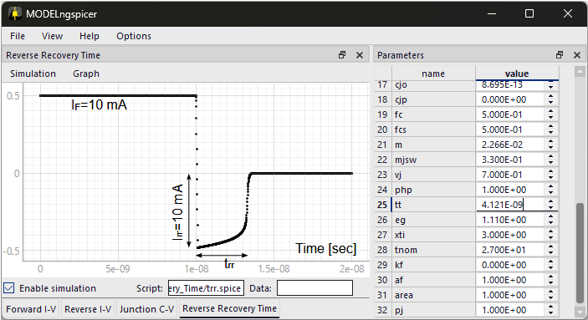
Fig. 5-11 Parameter tuning for reverse recovery time

Parameter tuning:
According to the datasheet for the 1N4148 diode, the reverse recovery time is specified as t_{rr}=3.2 ns under the condition of I_{F}=10 mA and I_{rr}=10 mA. To match this characteristics, the model parameter TT (transit time) is adjusted accordingly.

Fig. 5-11 shows the time-domain waveform of the reverse recovery response. It confirms that t_{rr}≃3.2 ns has been achieved.

