Normalization for clinical data

Christopher Rorden, Leonardo Bonilha, Julius Fridriksson, Benjamin Bender, Hans-Otto Karnath (2012) Age-specific CT and MRI templates for spatial normalization. NeuroImage
https://www.nitrc.org/projects/clinicaltbx/
http://www.ncbi.nlm.nih.gov/pubmed/22440645

Version 7/7/2016
7/7/2016 supports SPM12

Introduction
Normalization warps brain scans from different people to a common stereotaxic space. This allows us to conduct group analyses (comparing brain activity for a fMRI study or extent of brain injury for a lesion mapping study). The typical templates used in neuroimaging are optimized for fMRI studies with healthy young adults. This toolbox provides tools for normalizing datasets for clinical purposes. Specifically, we provide tools to help normalize CT scans, MRI scans from elderly and those with brain injury, and a segmentation routine designed to help source localization for ERP, EEG and tDCS studies. This package includes the following files:
- toolbox: This folder the ‘Clinical’ folder. This file must be placed in SPM8’s “toolbox” folder. The default SPM installation will have the folder ‘SPM8\toolbox\Seg’, and your goal is to have a folder ‘SPM8\toolbox\Clinical’
- optional_place_in_spm8_folder: Optional. You can replace the original spm_image.m file with this file. This file provides a handy way to set the origin prior to normalization. It is based on version 3691, you may want to check with a text editor to ensure that you are not replacing a newer version that might work differently.
- tutorial: Optional. Sample images for testing the functions.
- high_res: Optional. This folder contains unsmoothed images. These are optional, and are not used for normalization. These may be useful if you want to show results overlayed on an image that shows probabilistic location of landmarks.
- Manual.doc: Optional. The file you are currently reading.

CT Normalization
- With SPM open, choose ‘Batch’, a new window named ‘Batch editor’ appears. Select SPM/Tools/Clinical/CTnormalization
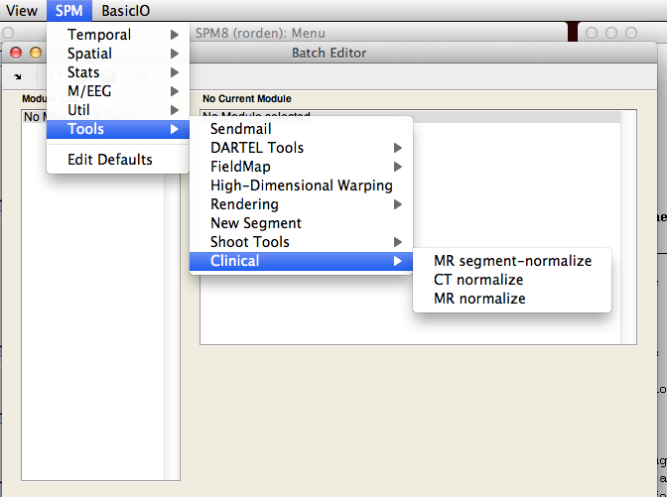
- Make sure your images have a fairly accurate origin (see the ‘Setting the starting estimate’ section).
- Select the ‘Input images’ option and then press ‘Select files’. Select the CT scans you want to normalize. Note you can select multiple images. E.G. the tutorial folder contains the image ‘ctnolesion.nii’.
- If you have any lesion maps drawn on the CT scans, you can select them by pressing ‘Input lesions’ and selecting the images. If you have multiple CT scans, you must enter the lesions in the same order as you entered the scans in the previous step. Note the tutorial does not include a lesion map for this CT scan, so leave this blank.
- Press the green arrow, or choose File/RunBatch
- Note: the process will create images with the prefix ‘w’ images. This is because it ‘W’arps the image to the template.
- Note: By default, images are normalized to 1x1x1mm resolution, but you can edit ‘Bounding box’ and ‘Voxel sizes’ options if you wish (e.g. 2x2x2mm will reduce number of tests). Troubleshootings: Manually setting the starting estimate

MR Segment-Normalization  The toolbox will normalize a MRI scan (and optionally a lesion map) to standard space (using SPM’s unified normalization and segmentation). Regions of brain injury can disrupt this automated process. Therefore, if you provide a lesion the software will either mask the lesioned region (www.pubmed.com/20542122; www.pubmed.com/11467921) or substitute tissue from the healthy hemisphere's homologue (www.ncbi.nlm.nih.gov/pubmed/18023365). We will use a T1-weighted image (which has good gray-white matter contrast, which helps the algorithm) for the normalization. However, we can often best see brain injury on other scan modalities (e.g. T2, DWI, FLAIR – for brevity henceforth referred to as T2). However, these T2 images do not have as sharp gray-white contrast and typically do not have the same spatial resolution. Therefore, the script allows you to enter three types of data: | 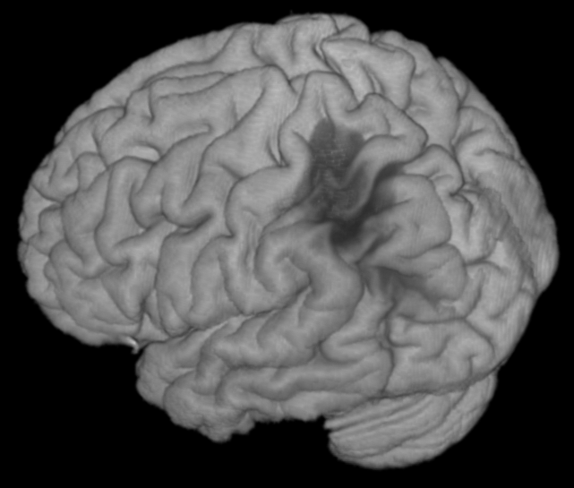  Volume rendering of individual with brain injury. This scalp stripped image is generated by this toolbox

- T1 scans only: e.g. elderly adults (as our stroke template is based on people ~70 years old), or stroke patients (as lesion masking has less of an influence with SPM8 versus older versions, see Crinion et al. www.pubmed.com/17616402).
- T1 scan with lesion map. Here the lesion is drawn directly on the T1 image.
- T1 scan, lesion map, and T2 scan. Here the lesion is drawn on the T2 image. Therefore, the lesion must first be coregistered to the T1 scan, and then the T1 and lesion will be normalized.

- With Matlab open, press the ‘Batch’ button to show the Batch editor window. Then select SPM/Tools/Clinical/MRsegment-normalize (see the CT Normalization section for a picture).
- Click on ‘Anatomicals’ and press ‘Select files’ – choose your T1-weighted image(s). Note you can select multiple files. For the tutorial, select ‘T1.nii’
- Optional: if you have lesion maps, click on the ‘Lesion Maps’ item and press ‘Select files’. If you are processing multiple files, they must be entered in the same order as the T1 scans. For the tutorial, select the image ‘lesionT2.nii’.
- Optional: if you included lesion maps in step 4, but they were not drawn on the T1 scan (step 3), then you will want to load the images that the lesions were drawn on (this could be FLAIR, DWI or T2 images). Click on the ‘Pathological scans’ item and press ‘Select files’. If you are processing multiple files, they must be entered in the same order as the T1 scans. For the tutorial, select the image ‘T2.nii’.
- Optional: By default the images will be normalized to a template from older people, matching the average age of people with stroke (and the CT template). You can choose the ‘younger brain’ (the MNI 152 series used for many imaging studies.
- Optional: By default, images are normalized to 1x1x1mm resolution, but you can edit ‘Bounding box’ and ‘Voxel sizes’ options if you wish.
- Optional: By default this toolbox will generate a scalp stripped image, where tissue only tissue estimated to have at least a 10% probability of being gray or white matter is preserved. At low resolutions, this is useful for visually inspecting the quality of the normalization (if a lot of scalp is visible in this image, the normalization has not been successful). At high resolutions (e.g. set the voxel size to 1mm), you can generate nice renderings using MRIcroGL or other volume rendering tools. You can adjust the probability threshold, or set the threshold to 0 (in which case no brain-extracted image is generated).
- Optional: Decide if you want to use enantiomorphic normalization or not. If you choose 'Enantiomorphic normalization' the lesion will be replaced by tissue from the intact hemisphere, if you set this to false a traditional lesion-masked normalization will occur. In general enantiomorphic is better for large unilateral lesions, lesion masking is required for bilateral lesions and these methods perform similarly for smaller lesions.
- SPM will create a normalized bias corrected anatomical image (e.g. ‘wmT1.nii’) and a binarized, warped, smoothed lesion map (‘bwsLesionT2.nii’). It will also convert the lesion map to MRIcron’s VOI format (just a gzipped NII file). You can use the VOI file with MRIcron or NPM. Troubleshootings: Manually setting the starting estimate

MRI Normalization
The previously described unified segmentation normalization can provide excellent registration, but it does require a high quality T1 scan (though anecdotally it can also work with good T2 scans or DWI B0 scans). In some clinical situations there are no T1 scans available (as DWI, PWI, FLAIR, T2 images are typically more clinically relevant). In these cases, you can try to normalize your MRI scans using the MRI normalization function.
- With Matlab open, press the ‘Batch’ button to show the Batch editor window. Then select SPM/Tools/Clinical/MRnormalize (see the CT Normalization section for a picture).
- Make sure your images have a fairly accurate origin (see the ‘Setting the starting estimate’ section).
- Click on ‘Anatomicals’ and press ‘Select files’ – choose your MRI (DWI, T2, FLAIR) image(s). Note you can select multiple files. For the tutorial, select ‘T2nii’
- Optional: if you have lesion maps, click on the ‘Lesions’ item and press ‘Select files’. If you are processing multiple files, they must be entered in the same order as the images from the previous step. For the tutorial, select the image ‘lesionT2.nii’
- Optional: if the lesion maps are drawn on a different scan than selected for step 3, select the pathological scans used for lesion mapping.
- Optional: The modality option lets you select the modality of your anatomical scans. The choices are T1, T2, FLAIR, and Other. Select the appropriate modality. For T1-weighted images, select T1. For B0 DWI images, and T2-weighted images, choose T2. For fluid-attenuated T2 scans, select FLAIR. Alternatively, you can try ‘Other’ which attempts to use both the T1 and T2 templates. Note that this procedure always uses the default SPM templates, and therefore the brains will be aligned to the size and shape estimated from healthy young adults. The exception is the FLAIR option, which uses the images from the Glahn team based on 181 individuals (Mean age: 39.9y, std dev: 9.3y, range: 26-76y, 102 females, http://www.glahngroup.org/Members/anderson/flair-templates).
- Optional: By default this toolbox will not apply a template mask. If you select to use a brain mask the initial coarse normalization will get the image to be roughly aligned to the template, and then a brain mask will be applied so that regions outside the brain do not influence the normalization. This can help ensure that features like nose and bone shape do not influence the final normalization. However, the MR normalization option is often used for images with poor contrast and resolution, where the coarse fitting is not very accurate.
- Optional: By default, images are normalized to 1x1x1mm resolution, but you can edit ‘Bounding box’ and ‘Voxel sizes’ options if you wish.
- SPM will create a normalized bias corrected anatomical image (e.g. ‘wT1.nii’) and a binarized, warped, smoothed lesion map (‘bwsLesionT2.nii’). It will also convert the lesion map to MRIcron’s VOI format (just a gzipped NII file). You can use the VOI file with MRIcron or NPM. If this fails, see the "Troubleshootings: Manually setting the starting estimate" section.

Troubleshootings: Manually setting the starting estimate
Each of the normalization methods described above will default to automatically attempting to set the origin for a scan. If this fails, you should try manually setting the origin for your input data and re-running the normalization with the "Automatically Set Origin" option to false. This section describes how to manually set the origin. It is critical that normalization has a good starting estimate, otherwise the routines will get trapped in a local minimum resulting in a poor solution. For SPM, the starting estimate should point to the anterior commissure. We need to set this, because for most MRI scanners the starting estimate is the magnet isocenter, whereas for most CT scans it is the table center. This procedure is also described in http://www.fil.ion.ucl.ac.uk/~john/misc/VBMclass10.pdf
- Start SPM8 (e.g. ‘spm fmri’ from the Matlab command line).
- Press the ‘Display’ button in SPM’s command window and select your CT scan (e.g. ‘yourCT.nii’).
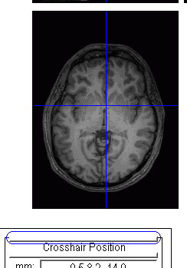
- Put ‘0 0 0’ into the ‘mm’ edit and press enter (alternatively, click the horizontal bar between “Crosshair Position” and the ‘mm’ edit). Blue crosshairs should appear (though you may not see them if your starting estimate is off).
- Adjust the ‘right {mm}’, ‘forward {mm}’ and ‘up {mm}’ so that the blue crosshairs are centered on the anterior commissure. After entering a new number, press return to see the adjustment. For CT scans, you may have to shift the image by 100s of mms, as the image center is usually way off.
- Press ‘reorient images’ and select your CT scan (e.g. ‘yourCT.nii’). Note: if you have multiple scans from the same individual during the same session, reorient all of them with this single set of parameters (so they stay aligned with each other).
- Put ‘0 0 0’ into the ‘mm’ edit and press enter. Blue crosshairs should appear.
- Adjust the ‘pitch {rad}’, ‘roll {rad}’ and ‘yaw {rad}’ so that the image is roughly aligned to stereotaxic space (e.g. the brain is not rotated relative to the blue crosshairs). Note these values are in Radians, so small values (e.g. 0.2) induce a large rotation..
- Press ‘reorient images’ and select your CT scan (e.g. ‘yourCT.nii’). Note: if you have multiple scans from the same individual during the same session, reorient all of them with this single set of parameters (so they stay aligned with each other).
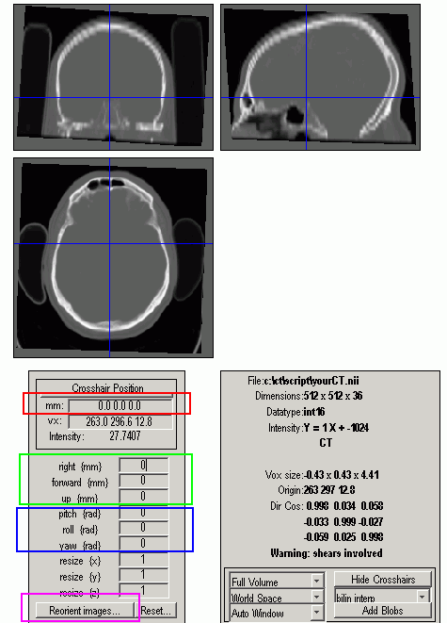

New features
Version 8/8/2015 includes the following features
- By default each normalization routine automatically attempts to set the origin for each image. This reduces the tedious process of manually setting the origin. The automated process works by initially assuming the origin is located at the image's center of brightness. A linear coregisteration is then performed to approximately align the image to its template. This tends to be more robust than directly normalizing the images (as the normalization routines can get trapped in local minima).
- Some General Electric CT scanners fill portions outside the imaging circle with artificially dark pixels (-3024 Hounsfield units), which can disrupt normalization. The new version automatically detects these images and resets these regions to match air (-1024 Hounsfield).
- The MRI segmentation-normalization routine adds the option for enantiomorphic normalization, instead of the traditional lesion masked normalization. If you use enantiomorphic normalization you should cite the seminal work by Nachev et al., for example "Images were normalized to an age-appropriate template brain using the Clinical Toolbox for SPM (Rorden et al., 2012) using enantiomorphic normalization (Nachev et al., 2008)." If you use the traditional lesion masked normalization you should cite the seminal work by Brett et al. "Images were normalized to an age-appropriate template brain using the Clinical Toolbox for SPM (Rorden et al., 2012) using lesion-masked normalization (Brett et al., 2001).". The appropriate papers are http://www.ncbi.nlm.nih.gov/pubmed/11467921, http://www.ncbi.nlm.nih.gov/pubmed/18023365, http://www.ncbi.nlm.nih.gov/pubmed/22440645. Note that Nachev et al. do not provide routines for their process, and used several tools. Therefore, this toolbox attempts to mimic their effects. For our toolbox the anatomical scan's mirror is coregistered to the native anatomical scan. We then slightly dilate the lesion and apply a Gaussian blur. This blurred, dilated image is used to create a feathered mask for inserting tissue from the injured brain into the healthy brain. The images below show this effect with the sample T1 image provided in the tutorial. The left image shows the lesioned brain, the right image shows the same brain after the enantiomorphic fill.
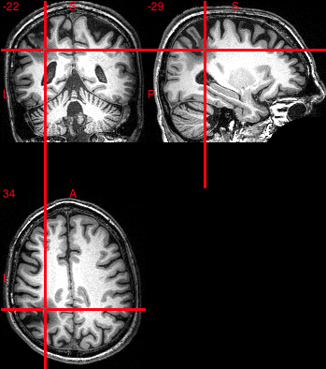 | 