Chapter 1 study guide.

“Allegory in the cave”- Plato’s cave. Prisoners could only learn about their world from shadows on the wall. Therefore, this was their perceived reality. It basically states that our “reality” is limited.

Panpsychism and psychophysics

* What is the mind?
  + Two basic ideas
    - The mind is your consciousness and the brain is the physical organ
    - The brain and the mind are synonymous
* Gustav Fechner- set the stage for thinking about the mind v. the physical environment.
  + Fechner believed that human consciousness was present within all matter, this is called panpsychism and it gave rise to the idea of psychophysics.
  + Psychophysics- We are talking about the relationship between the mind, and the word we use when talking about the mind is psycho, and a physical stimulus, or matter, thus the physics. So a good way to remember it is a mind-matter relationship.
  + Founded the idea of the two-point touch threshold-using a device with two fine points like needles he could touch a persons skin and ask that person to discern whether both points were touching them or only one. Essentially, his goal was to measure the smallest distance between these points required for a person to feel both points, before they blended together. This idea comes from Weber’s experiments
  + Expanded on Weber’s law to create Fechner’s law:
    - * Where S is the psychological sensation, equal to the log of the physical stimulus level, R, multiplied by constant K.
      * This essentially means that as the intensity of a stimulus increases, you need larger changes for a perceiver to detect some change.

Ernst Weber- studied anatomy and physiology

* Just noticeable difference threshold- the difference required for detecting a change in weight. For example for weight the change that could be detected was one fourtieth of the standard weight.
  + Weber fractions- 1:40 for weight, so 1 gram change could be detected if the standard was 40, or 10 to 400, etc. 1:100 for sight, thus sight is more adept at noticing differences between two stimuli.
* Difference threshold- the smallest change in a stimulus that can be detected. This is just another more general term for just noticeable difference.
* Weber’s law- The mathematical representation of Weber’s ideas:

Absolute threshold- the minimum intensity of a stimulus that can be detected.

* How do we measure this?
  + Method of constant stimuli- Creating many stimuli with different intensities, to find the tiniest that can be detected. This is like a hearing test, raising your hand when you hear the tone.
  + Method of limits- Start with the same tones that vary in intensity as in the above example. Then, the tones will be played from highest to lowest intensities, to see when the subject can no longer hear the tone, or lowest to highest, to determine when the subject is first able to hear the tone.
  + Method of adjustment- Same as the method of limits, except the subject increases or decreases the intensity on their own.

Signal Detection Theory- detection of signals (which bear the information we are interested in) in noise (random patterns that will distract from the signal).

* Signal to noise ratio and examples-
  + phone in the shower. If phone volume is turned low or it is far away from you, it will decrease your confidence that you heard it due to the noise of the shower.
  + Astronaut in space, blurry to clear picture.
  + Car radios have a clear signal near the radio tower and a bad signal the further away you drive.
  + Photography in dark room v. in a light room
* Criterion-
  + Guilty-guilty=hit
  + Guilty-innocent=false alarm
  + Innocent-guilty=miss
  + Innocent-innocent= correct rejection
* cross modal matching- allows you to get a measure of the strength of the stimulus. You take two different stimuli from different modalities (ex. sight and hearing) and have a subject try to match their magnitudes. For example, the subject may be asked to adjust a lights brightness to match a sounds loudness.
* magnitude estimation- the participant here will assign values according to the subjective magnitude of the stimulus. For example, a tone may be played at different volumes and the subject may be asked to assign a number 1-100 to each volume.
* ROC curve- receiver operating curve. Plotting of the criterion and how easily the signal is to discern from the noise (discriminability). If you want to manipulate discriminability you just manipulate the signal to noise ratio. Direct correlation. If you want to manipulate the criterion you just change the consequences.
* Stevens’ power law- the introspective sensation (S) is related to the stimulus intensity (I) by an exponent (b) where a is a constant for the modality being used.
  + different depending on the modality.
    - Linear: lines of different lengths
    - Saturate: two lights, where one is twice as bright as the other, are perceived as being only slightly different
    - Exponential: electric shock

spatial frequency- level of detail present in a stimulus per visual angle. High-small details, sharp edges.

[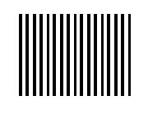](NULL)

Higher spatial frequency grating

[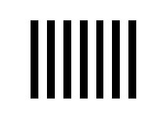](NULL)

Lower spatial frequency grating

(images from http://www.ucalgary.ca/pip369/mod4/spatial/frequency1)

* Anatomy of a neuron (neurotransmitters, neuron, axon, dendrites, receptor, myelin, ect) and basic structure (layers) of the cortex.
  + neuron

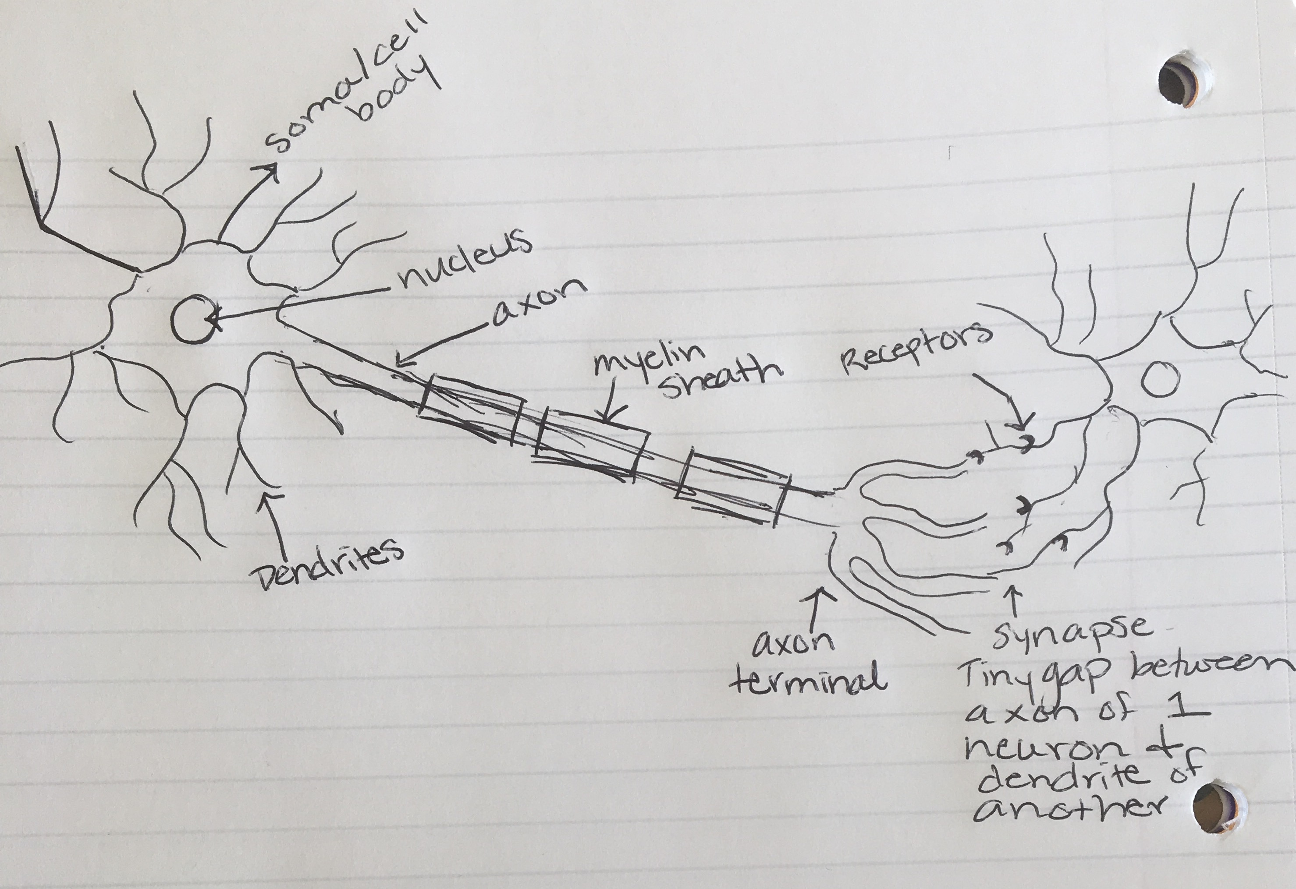

* + Cortex
  + 
    - * + insula which is buried in the lateral fissure
      * sulci- valleys
      * gyri-ridges
    - sensory cortex
      * parietal lobe- polysensory – more than one sense is being combined in some manner
      * orbital frontal cortex- olfactory bulb (smell, temporal lobe)
      * somatosensory cortex- touch and posture (parietal lobe)
      * auditory cortex- hearing (temporal lobe)
      * visual and occipital cortex- vision (occipital lobe)
* Types of nerve cells- can be located in the central or the peripheral nervous system. 3 types:
  + Afferent nerves- these are sensory neurons which detect stimulus in the environment and transmit these signals to the central nervous system
  + Interneurons- these can transmit signals and process them. Their main function is to transmit impulses between other neurons in order to either inhibit or facilitate these neurons to fire.
  + Efferent neurons- these are motor neurons which transmit signals from the central nervous system to the muscles and glands for movement.
* Joseph Fourier- determined that signals can all be transformed into sine waves. This is important when talking about sensation because all of our senses are tuned for specific frequencies. Used in MRI scans, music, and movies.
* Neuroimaging techniques
  + fMRI (functional magnetic resonance imaging)- sensitive to oxygen. Detects changes associated with blood flow in the brain.
  + MEG (Magnetoencephalography)- measures magnetic changes that can be induced by magnetic firing.
  + EEG- (electroencephalogram) measures brain rhythms by detecting electrical activity by attaching electrodes to the scalp.
  + CT (computerized tomography) – a combination of x-rays taken at different angles to create cross-sectional images. Uses radiation
  + PET (positron emission tomography)- uses a dye that has radioactive tracers. Allows doctors to detect diseases in the body.