RITHI

 | Function | Name | Date | Signature
Written by | Service Co-Ordinator | Devika.M | 28.02.2023
Checked by | National Service Manager | Sundari.M | 28.02.2023
Checked by | Engineer R&D and QMS | Vijay.R | 01.03.2023
Approved by | VP-Technical | Chandrakumar.N.R | 01.03.2023

CHANGE HISTORY
Revision | Date | Change | Author
00 | 01.06.2022 | Initial | Devika
01 | 01.03.2023 | Revision for “Daily Call Review” Validation | Devika

TABLE OF CONTENTS
1 Description of the Software 3
1.1 Intended Use 3
1.2 Scope 3
1.3 References 3
1.4 Definitions and acronyms 3
2 Process Definition 4
2.1 Process needs to be followed as per International Standards 4
2.2 Software Tool(s) usage in the Process 4
2.2.1 Assumptions and dependencies of software tool 4
2.2.2 Risks associated with each activity 5
2.2.3 Storage of data 6
3 Validation Planning 6
3.1 Type 1 - In-house Developed software 7
3.2 Type 2- OFF The Shelf (OTS) Software 7
3.3 Type 3 – Disposal 7
4 Risk Analysis and Control Measures 7
5 Validation Tasks 9
6 CONCLUSION 10

Description of the Software
RITHI software is an internally developed solution for service process of customer related activities of installing, maintaining and complaint handling of all our ventilators in field till its life cycle.

Intended Use
Service operation and administration as follows:
- Sale entry
- Complaints handling and feedback
- Installation and preventive maintenance
- Contract management
- Spare management

Scope
All ALMS supplied Products (Imported and Indigenous)
- Order processing - Spare request
- Stock Maintenance for service spare parts
- Sales - Warranty and Non-Warranty sale entry
- Annual Maintenance contracts
- Complaint handling –Registration, Daily Review and reporting
- Installation and Preventive Maintenance
- Customer feedback

References
Reference documents:
[1] IEC/TR 80002-2:2017 -
[2] Service Procedure QSP-05, Customer feedback-QSP-08.

Definitions and acronyms
Initials and acronyms | Meaning
MD | Medical Device
RM | Risk Management
PRM | Preliminary Risk Management

Process Definition
All process as per Service Procedure QSP-05, Customer feedback-QSP-08.
Such as
- Complaints registration, Daily review and solution reporting
- Preventive maintenance activities
- Customer feedback collection
- Installation activities
Software tool RITHI covers all above process mentioned in QSP-05 and QSP-08.

Process needs to be followed as per International Standards
Refer QSP-05 and QSP-08

Software Tool(s) usage in the Process
BREAKDOWN CALL

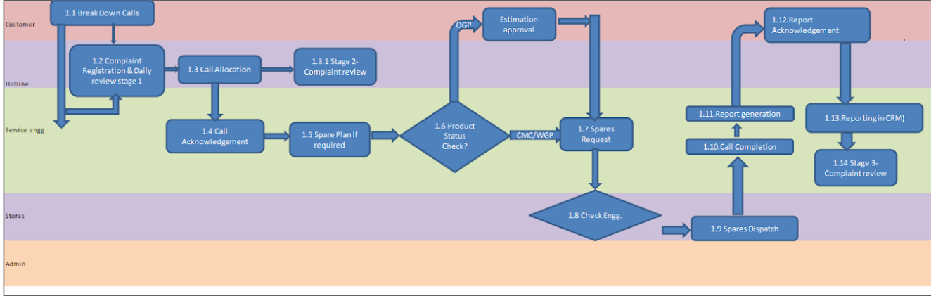

Assumptions and dependencies of software tool
Assumptions:
User should have computer knowledge and training in RITHI
Dependencies:
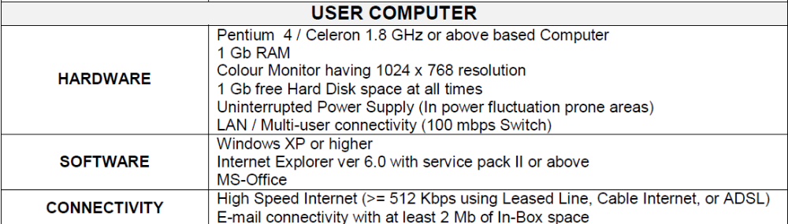

Risks associated with each activity
Process ID | Process | Risk Identified
1.1 | Breakdown calls | -
1.2 | Call registration & Daily call review stage 1 | Wrong customer ID entry during call registration  In complete data/ missing information related to public health threat, Death, Serious incident
1.3 | Call allocation | Wrong Engineer entry
1.4 | Call Acknowledgement | -
1.5 | Spare Plan | NA
1.6 | Product status check (CMC/WGP) | -
1.7 | Spares request | Wrong spare request
1.8 | Check stock | -
1.9 | Spares Dispatch | Spare dispatch to different engineer
1.10 | Call completion | NA
1.11 | Report generation | -
1.12 | Report Acknowledgement | -
2.1 | PM Schedules/Startup Report Monthly List & individual call allocation in RITHI | -
2.2 | Data Storage | Data Stored in Air liquide kite cloud (google) – google outage leads to non-functioning of RITHI
1.13 | Daily complaint review process stage 2 | In-complete Data/missing information related to complaints for potential failures.
1.14 | Daily complaint review process stage 3 | In-complete Data/Missing information related to complaints for product failure analysis

- NA – Not handled by RITHI

Storage of data
All data stored in clouds
- Complaints history
- Customer feedback
- Product sold
- Warranty and contract info
- Spare dispatches and Consumption
- Installation and maintenance records ( manual uploads)

Validation Planning

 | Module | Check plan | Responsibility
1 | Order processing -Contract and Spare purchase | - Ability to place request for spare from engineers. | - Service engineer
2 | Stock Maintenance for service spare parts | - Stock out by stores to corresponding engineers | - Service Stores
3 | Sales – Warranty and Non warranty | - Product sale entry | - Service admin
4 | Annual Maintenance contracts | - Contract entry | - Service admin
5 | Complaint handling | - Breakdown call registration  - Daily complaint review process stage 1  - Call allocation  - Daily complaint review stage 2  - Visit work details entry  - Service report entry with spares used  - Service Manual Report Upload  - Daily complaint review stage 3 | - Hotline  - Hotline  - Hotline  - Customer support manager  - Service engineer  - Service engineer  - Service engineer  - Customer support manager
6 | Installation & Preventive maintenance | - Installation call generation  - PM call generation  - Installation & PM call visit details and closure report | - Service admin  - Hotline  - Service engineer
7 | Customer feedback | - Collection of feedback | - Service engineer

Type 1 - In-house Developed software
YES

Type 2- OFF The Shelf (OTS) Software
NA

Type 3 – Disposal
Every six-month Data are export from RITHI to google drive.

The following template is used for validation of software before implementing and periodic validation of every year and as and when required.

Risk Analysis and Control Measures

Refer 2.2

Process ID | Process | Risk Identified | Mitigation | Validated By | Status
1.1 | Breakdown calls
1.2 | - Call registration  - Daily complaint review stage 1 | - Wrong customer ID entry  - Not capturing relevant information like public health threat, death, serious incident | - Linked with customer vs Product model/Sl no  - Mandatory field to capture all the three parameters during complaint registration process completion.
1.3 | Call allocation | Wrong Engineer entry | Engineers linked with customers/Engineers not accept the calls
1.4 | Call Acknowledgement | - | -
1.5 | Spare Plan | NA
1.6 | Product status check (CMC/WGP) | -
1.7 | Spares request | Wrong spare request | Approval by managers
1.8 | Check stock | -
1.9 | Spares Dispatch | Spare dispatch to different engineer | Spares request linked with engineer name.
1.10 | Call completion | NA
1.11 | Report generation | - | -
1.12 | Report Acknowledgement | - | -
2.1 | PM Schedules/Startup Report Monthly List & individual call allocation in RITHI | Pm schedules wrongly allocated by Hotline Engineer | PM schedule automatically allocated by engineer’s
2.2 | Data Storage | Data Stored in Air liquide kite cloud (google) – google outage leads to non-functioning of RITHI | No data loss, only delay in Operations. It’s automatically retrieves.
1.13 | Daily complaint review stage 2 | Not capturing relevant information like Warranty failure, clinical impact, frequent failure | Mandatory field to capture all the three parameters during daily customer complaint review stage 2
1.14 | Daily complaint review stage 3 | Not capturing relevant information like complaint grouping, root cause key word | Mandatory field to capture all the two parameters during daily customer complaint review stage 3

Validation Tasks

 | Module | Check plan | Responsibility | Validated by | Verification Status
1 | Order processing -Contract and Spare purchase) | - Ability to place request for spare from engineers. | - Service engineer
2 | Stock Maintenance for service spare parts | - Stock out by stores to corresponding engineers | - Service Stores
3 | Sales – Warranty and Non warranty | - Product sale entry | - Service admin
4 | Annual Maintenance contracts | - Contract entry | - Service admin
5 | Complaint handling | - Breakdown call registration | - Hotline
5 | Complaint handling | - Daily complaint review process stage 1 | - Hotline
5 | Complaint handling | - Call allocation | - Hotline
5 | Complaint handling | - Daily complaint review stage 2 | - Customer Support Manager
5 | Complaint handling | - Visit work details entry | - Service engineer
5 | Complaint handling | - Service report entry with spares used | - Service engineer
5 | Complaint handling | - Service manual report upload. | - Service engineer
5 | Complaint handling | - Daily complaint review stage 3 | - Customer Support Manager
6 | Installation & Preventive maintenance | - Installation call generation | - Service admin
6 | Installation & Preventive maintenance | - PM call generation | - Hotline
6 | Installation & Preventive maintenance | - Installation & PM call visit details and closure report | - Service engineer
7 | Customer feedback | - Collection of feedback | - Service engineer

CONCLUSION
RITHI is validated for its suitability and all mitigation measures have been implemented
and followed.

Verified by the responsible persons

Validation Date: Validated by:

END OF DOCUMENT

