# **Instructions „GMT“**

This task consists of several trials. In each trial you will have to decide whether to perform a **simple detection task** or not. The detection task goes as follows: A **circle** will appear on either side of the screen display (left or right). You can indicate by pressing the **arrow keys** whether you think the circle appeared on the left or right side. Just before you will see the circle on the screen, you will be shown a **picture**. This picture gives you two information:

1. Whether you should do the detection task – and hence, indicate your answer by pressing the correct button – or not.
2. Whether you can win or lose money on this trial (per trial 5 Cent)

There will be **four different pictures**. Through trial and error, you have to find the **best strategy** on how to react when you see the circle: Doing the detection tasks and pressing the key accordingly or not doing the detection task and not pressing any key! The goal is to win as much money as possible and to lose as little money as possible.

Some of the pictures indicate that you can win money. However, the information on whether you can win or not is **probabilistic** (i.e., tied to probabilities). Through finding the best strategy you can maximize the likelihood that you win 5 Cents in a trial. The same goes for pictures that indicate that you can lose money. Whether you lose money or not is probabilistic, but though finding the best strategy you can minimize the likelihood to lose money on a trial. The best strategy for a given picture could be to do the detection tasks and press the right key or to not do the detection task and not press any keys.

**Attention: The meaning of each picture is the same throughout the experiment. However, the task is not easy, so try to explore all options!**

# **The task in more detail:**

(1) Each trial starts with one of the four pictures. Here, you do not have to press any buttons just yet.

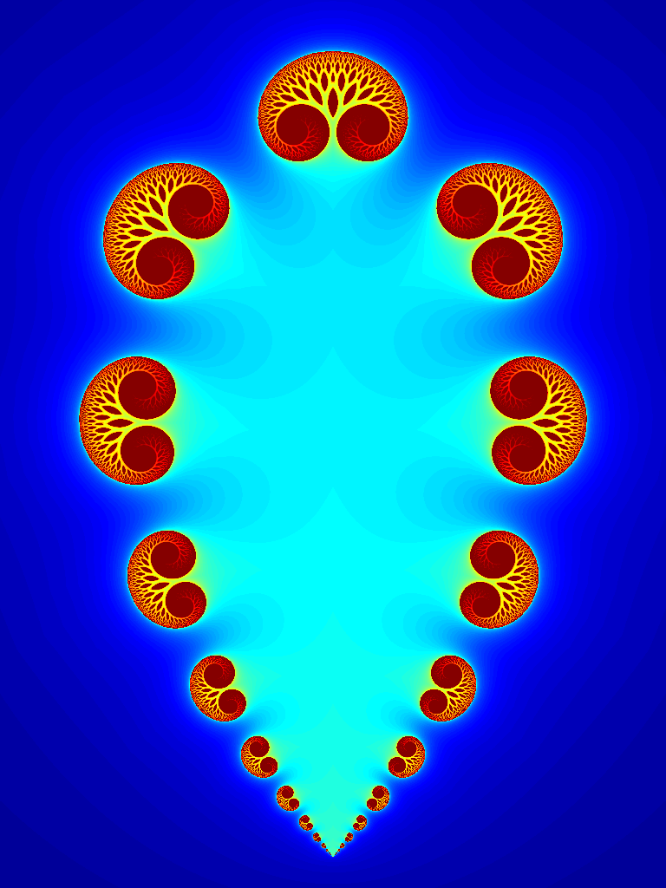

**Example picture**. A picture gives probabilistic information on whether a detection task should be performed or not, and whether you can win or lose money.

(2) After a short moment, you will see a circle on the screen, and have to decide on which side of the screen the circle was presented. If you decide to do the detection task, you have to press the left or right key accordingly.

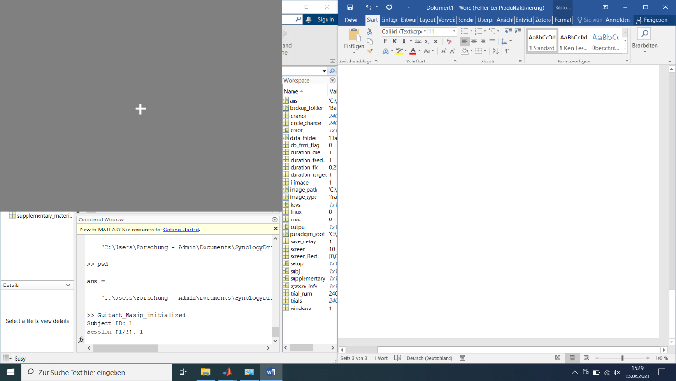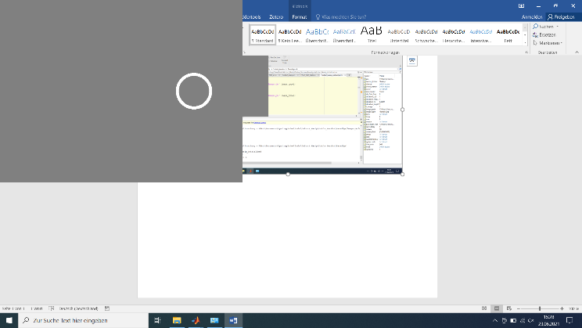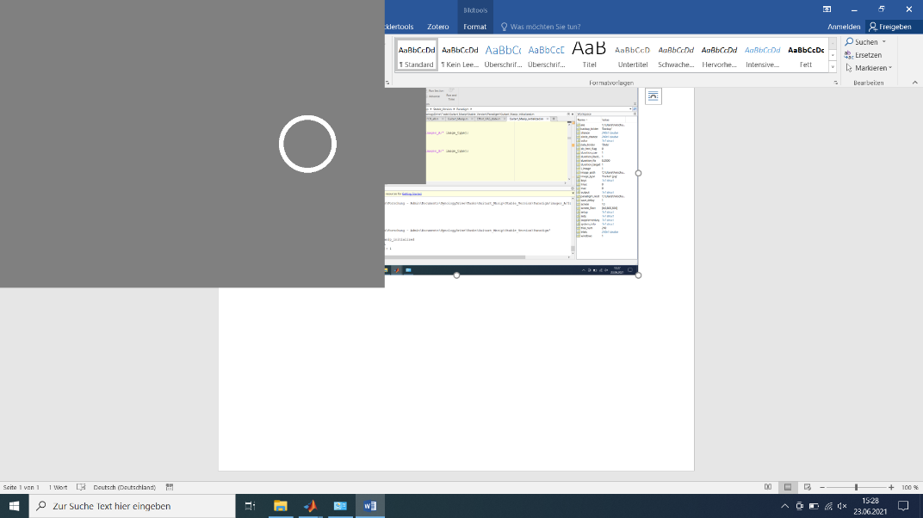

**Detection trial**. Left: Start of the detection trial. Middle: A circle appears for a short amount of time. Right: Time for you answer.

(3) After another short moment you will receive feedback on the trial. You will see on of the following symbols:

* A green arrow that points upwards, indicating, that you won 5 Cents.
* A red arrow that points downwards, indicating, that you lost 5 Cents.
* A yellow horizontal line, indicating, that you neither lost nor won anything.

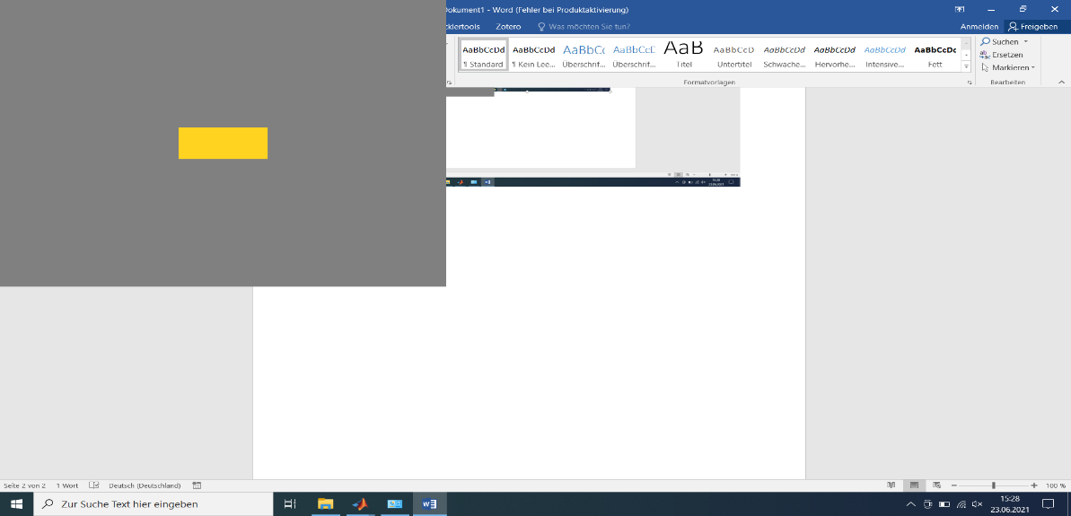

**Feedback**. These are the possible feedback symbols that you can receive   
after the detection trial.

**Pay attention**: It can happen, that you do not win, even though you reacted correctly, and that you do not lose, even though you reacted wrongly. It can also happen that you will lose money, even though you reacted correctly, or that you win, even though you reacted wrongly. Nevertheless, there is one strategy for each picture, that leads over the course of the whole task to a better outcome than other strategies. Also, if you do press a wrong arrow, it counts as if you did not do the detection task.

In the **winning condition** your feedback could be either the upwards arrow or the horizontal line. In the **losing condition** your feedback could be either the downwards arrow or the horizontal line. By deciding correctly whether to do the detection task or not, you can make the desired outcome more likely.

If you do not have any further questions, we will start the task. Your final outcome will be calculated over all trials and given to you in the end of today’s session.