**Instructions Motivational Task**

**Training**

The Training for the Motivation Task has **three phases**. In order for you to become familiar and comfortable with the task, you will begin by practicing outside of the scanner.

To begin, take a hold of the grip force device with your **right hand** and hold your fingers loosely around it. Once you have done this, please place your hand next to the laptop on the table.

1. **Phase: Getting to know the Grip Force Device.**

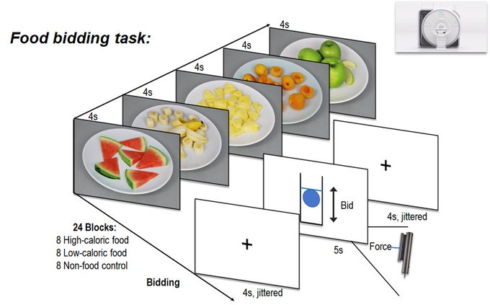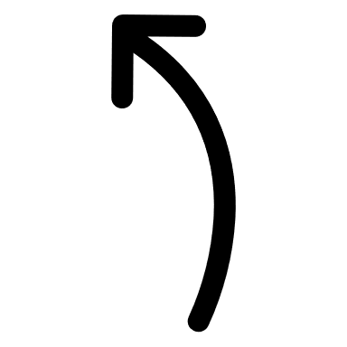On the screen in front of you, you will see a tube with a blue ball inside. The more effort you exert on the grip force, the stronger the effect will be and the higher the ball will rise. A blue line will indicate the highest point the ball has reached so far during your trial.

Please follow the instructions on the screen to complete the task.

1. **Phase: Getting to know the different reward conditions.**

When you have completed the training and are performing the task in the scanner, each trial will allow you to collect points. Some trials will allow you to collect **money points,** where (after completion of the task) you will receive a corresponding cash reward. In other trials you can collect **food points**. In these trials (following completion of the task) you will be given a food reward in the form of snacks corresponding to the collected calories.

There are four different conditions:

= 1 money point per force-unit = 1 food point per force-unit

= 10 money points per force-unit = 10 food points per force-unit

In the scanner you will not have a screen. Therefore, in this section of the training phase, you will learn to associate **auditory cues** with different reward conditions.

To this end, you will hear the different auditory cues in several training trials. Each trial will begin with an auditory cue and is shortly followed by a visual depiction of the associated reward. During these cue-learning trials you will simply listen and watch.

**2.1 Learning to associate auditory cues with reward:**

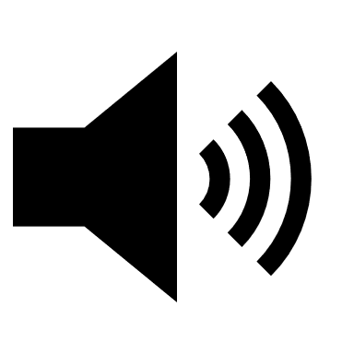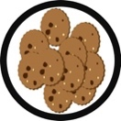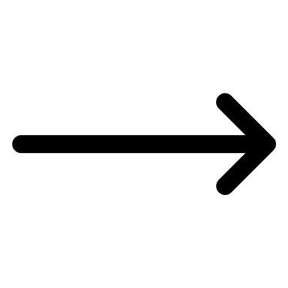

Picture: You will hear a tone for 3 seconds. Shortly after the onset of the tone you will also see the associated reward on the screen.

**2.2 Testing the learned cue-reward association:**

In some trials you will be tested on the cue learning („Test“). During these trials, you will only hear the auditory cue but it will not be followed by the associated visual depiction of the reward.

After hearing the tone, you will be asked to use the **arrows on the keyboard** to indicate which reward is associated with this tone. Sometimes you will be asked to indicate whether it was a **food (left arrow)** or **money (right arrow)** reward. Sometimes you will be asked whether it was a **1x (downward arrow)** or a **10x (upward arrow)** reward. You be asked to follow the instructions on the screen to complete this task and the instructions will reiterate which arrows you should press for different tests.

It is totally normal to make many mistakes early on in the training. The aim of the training is to ensure that you are able to confidently associate the various auditory cues with the different rewards. You will be asked to enter your response (using the keys) within a few seconds after hearing the auditory cue. If you do not respond **within a few seconds**, your ‘non-response’ will be evaluated as incorrect. **Thus, the goal is to enter the correct answer and as fast as possible.**

**Test:   
Food or money?**

Food or Money?

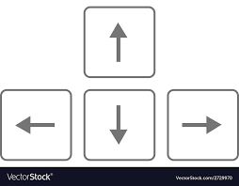



Picture: You will hear a tone for 3 seconds. After that you are asked to indicate – using the arrows on the keyboard - either which reward type or which reward magnitude the tone was indicating.

1. **Phase: Practice of the full task (as it will be during the scan)**

In the last phase of the training, you will have the opportunity to play a few rounds of the tasks in the same format as you will experience in the scanner.

It is important to remember that no screen will be present in the scanner, so these tasks will also have no visual aid – the screen in front of you will remain white for the duration of the trial.

Each trail starts with a tone – that you have now learned to associate with a reward. After the tone, the bidding phase starts. This is signaled with a short **signal tone**. After the signal tone, you have **3 seconds** to exert effort, using the **grip force device** to indicate **how much effort you are willing to exert in order to receive the given reward**. The **stronger and longer** you press the device during the 3 seconds, the more points you collect. **Attention**: **The bidding phase starts after the end of the signal tone! Squeezing the device before the end of the signal tone leads to a reduction in points at the end of the experiment!** During the training, you will be informed when a trial is counted as **invalid** due to squeezing before the end of the signal tone. After the bidding phase you will receive feedback on how many points you won during the trial and a new trial will start.

**Full task, an example:**

|  |  |  |  |
| --- | --- | --- | --- |
| Tone: Announcement of the reward of the current trial. | Short signal tone that the bidding phase is about to start. | Bidding: Exert Force using the device to win points according to the current reward condition. | Feedback: You will be informed how many points you won during this trial. |
| Musiknote mit einfarbiger Füllung | Volumen mit einfarbiger Füllung |  | Chatblase Silhouette    You won **34 kcal-points**. |

**Task in the scanner**

The task will be longer during the scan than in the training rounds (~ 20 min). Therefore, it will not always be possible to exert maximum force during each trial. With this in mind, one strategy could be to take breaks during a trial in order to exert more force and effort in a later trial. There will also be a short break after half of the trials.

During the task you will lie in the scanner and hold the grip force device loosely on your lap. It is important that you will try to **keep your hand as steady as possible**, so as to minimize motion artifacts.

You will be told when the task is about to start. You will be reminded that you should **only press the grip force device after the signal tone! Otherwise, you will be deduced points at the end of the experiment. You will also hear the signal tone once before the task starts.** In contrast to the training, you will **not** be informed when a trial will be counted as **invalid** due to squeezing the device before the end of the signal tone.

You will then also receive a reminder of which tone is associated with which condition.

The points you have collected during the experiment will be paid to you in cash and snack rewards at the end of the task.