Motivational Task Instructions
You will first practice the motivational task on the laptop, later it will be performed in the MRI. The difference between now and in the MRI is, that you are currently using a controller where you need to press the button on the front-right as quickly as possible, instead of pressing a grip force device as hard as possible (like in the MRI). Additionally, we will now ask after each trial how much you wanted the reward and how hard you tried.
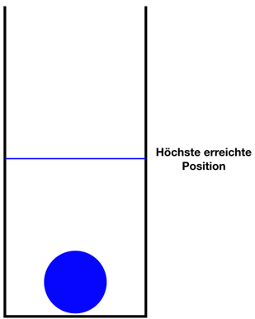
First, you will see an open container with a blue ball inside. When you press the button on the controller, the ball moves upwards. The faster you press, the higher the ball goes. The highest position reached will be marked with a blue line during the calibration process.

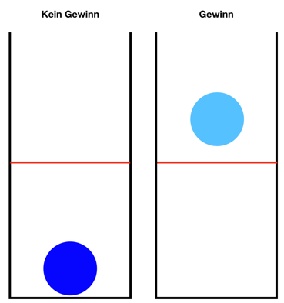

Training
Next, you will practice the actual task: The line will no longer move with the ball. Try to move the ball over the red line by pressing the button. You can win points for every full second the ball is over the red line. You can tell when you are collecting points when the ball changes its color to light blue.
Task
After the training, the actual task begins. During the experiment there will be different levels of difficulty. It will not always be possible to keep the ball the whole time over the red line. One way of dealing with this is to take breaks during a trial so that you can press faster again afterwards.
You can receive different types of reward in the individual trials. You will play for money as well as for calories. After the task, you will be paid the corresponding amount of money and you can exchange the calories for a snack.



The following conditions apply:
= 1 money point per second = 1 food point per second



= 10 money points per second = 10 food points per second

What the current reward is remains constant for one trial. After each trial, you will see how many points you have won.
Do you have any questions?

In the MRI:
Instead of frequency, you press a grip force device. The harder you press, the higher the ball rises.
Note for the training in MRI:
Try to keep the ball above the line as often and as long as possible.

