Bug report

Comment: resolved

When in multi-group mode, external validation does not work. I thought it was because the labels weren’t given (i.e., because of indG(1)), but I tested this with dummy labels and it still didn’t work. This is important because of PsyCourse.

Path: /volume/PsyCourse/NMF_method/NMF_sparse_hpc_repeat_1000iters/NM_multigroup_top5fromfactors/NM_struct_external_added.mat

Analysis number 2.

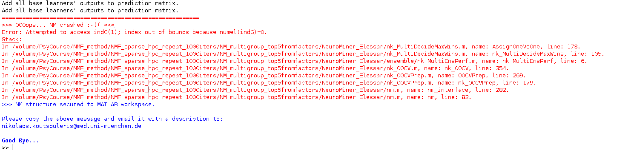

Bug report

Comment: This bug is independent of multi-mode and has been resolved now.

In multigroup mode, even when original variables are in the workspace it does not seem to work and errors due to a lack of entry for s_featnames. When debugging you can manually add this in to get it to progress. See next page for picture.

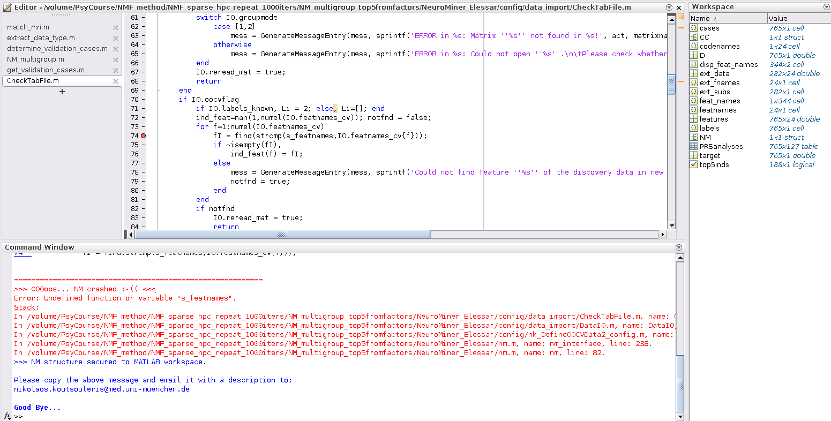

Bug report

Comment: This is not a bug but a compilation problem concerning Linux/MacOS. I had not problems in running the analysis on my computer.

When logistic regression used in discovery analysis, the external validation does not work in multi-group mode.

Path: /volume/PsyCourse/NMF_method/NMF_sparse_hpc_repeat_1000iters/NM_multigroup_top5fromfactors/NM_struct_external_added.mat

Analysis number 1.

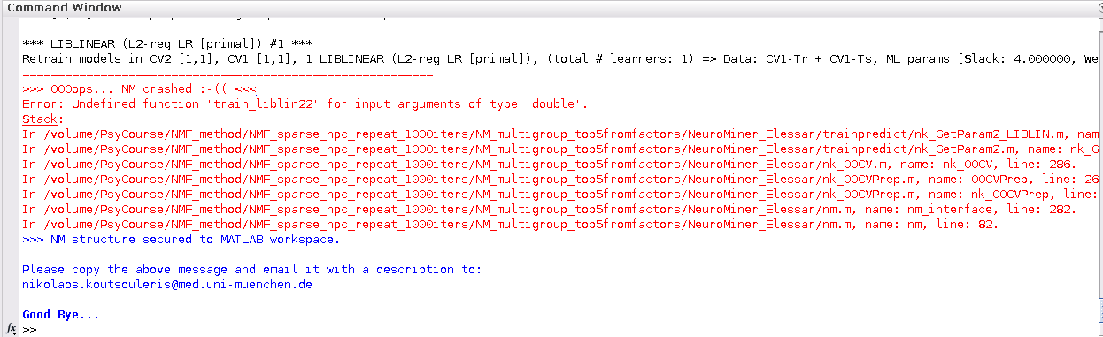

Bug report

Comment: Cannot do anything about it. Please check with MATLAB 2017a

Path

/volume/PsyCourse/NMF_method/NMF_sparse_hpc_repeat_1000iters/NM_multigroup_wrapper/NM_ID737320_55154_A3_CV2eq20_liblinear_wrapper/NM_struct.mat

Black box on right when initialized. Can be resolved by going to a different analysis comparison and then back to the original comparison.

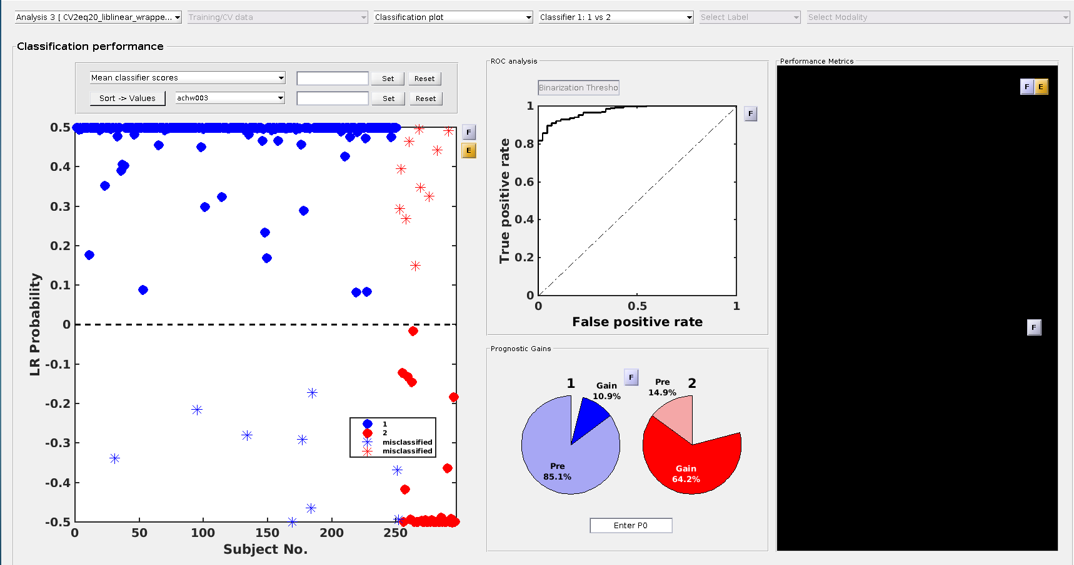

In the results viewer, it crashes when you go to the 'model complexity' disaply. When the window is closed then it errors with this report. If the user navigates to model complexity at all during exploration of the results then when the window is closed it will issue the error.

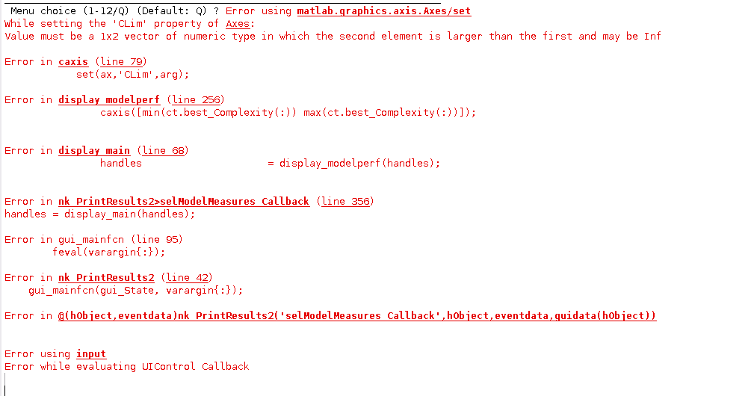

Bug report

Comment: No idea why this happens. I would suggest you use the scripts created for the batch processing and run nk_VisModels_batch from the MATLAB command line. The critical point in the code may be in nk_VisModelsPrep.m (line 256)

inp2 = nk_SetFusionMode2(dat, analysis, F, nF, i);

inp = catstruct(inp1,inp2); clear inp2;

I would set a breakpoint at the first line and explore if nk_SetFusionMode2 populates inp2 with a field named ‘analysis’. Let me know if this helps isolating the bug.

Bug when visualising using the HPC. It works when running MATLAB using the GUI. I’ve re-compiled NM and it doesn’t seem to be associated with this.

Loading NM structure: /volume/PsyCourse/NMF_method/NMF_sparse_hpc_repeat_1000iters/NM_multigroup_wrapper/NM_struct.mat[H[2J>>> Initializing NeuroMiner

Root path is /home/dominic/.mcrCache8.5/NeuroM0/NeuroMiner_Release.

Warning: Can't obtain SPM Revision information.

[> In spm_spm_version (line 1312)

  In spm (line 901)

  In nk_CheckSPMver (line 4)

  In nk_SetupGlobVars2 (line 108)

  In nk_VisModelsPrep (line 39)

  In nk_VisModels_batch (line 85)

  In NeuroMinerMCCMain (line 14)]

[H[2J ~~~~~~~~~~~~~~~~~~~~~~~

  N e u r o M i n e r

~~~~~~~~~~~~~~~~~~~~~~~

version 0.999 | aragorn

(c) Nikolaos Koutsouleris & PRONIA-WP2 team, 04/2018

[nikolaos.koutsouleris@med.uni-muenchen.de](mailto:nikolaos.koutsouleris@med.uni-muenchen.de)

You are here: NM:HPC:VISMODELS >>>Warning: Directory already exists.

[> In nk_VisModelsPrep>VisModelsPrep (line 243)

  In nk_VisModelsPrep (line 197)

  In nk_VisModels_batch (line 85)

  In NeuroMinerMCCMain (line 14)]

PROCESSING OF MODALITY #1Reference to non-existent field 'analysis'.

Error in nk_VisModels (line 24)

Error in nk_VisModelsPrep>VisModelsPrep (line 253)

Error in nk_VisModelsPrep (line 197)

Error in nk_VisModels_batch (line 85)

Error in NeuroMinerMCCMain (line 14)

MATLAB:nonExistentField​

Bug report

The default values change based on prior user input. This has resulted in confusion in the past.

e.g.​



Bug report

Text is cut off for option 3.

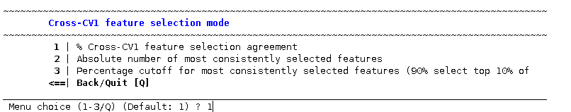

Bug report

Text was going to be changed for the wrappers --- 90% of most consistently related items or 10%? Also for the cross-CV1 selection.

​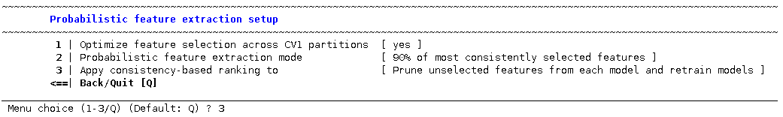

Bug report

Possible bug in visualisation when you select “M” option to view the parameters.

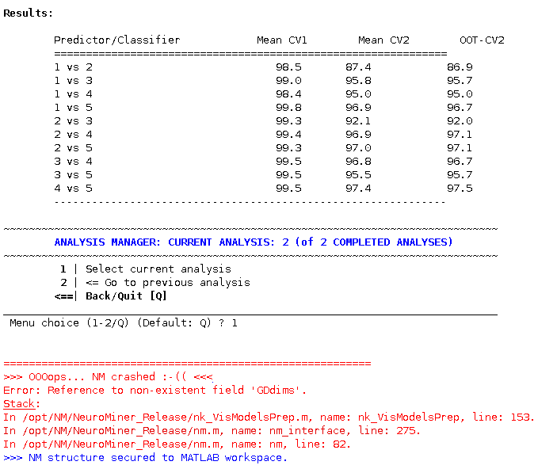

Bug report

Multi-group results display does not work with more than 7 groups because there are only 7 colour options.

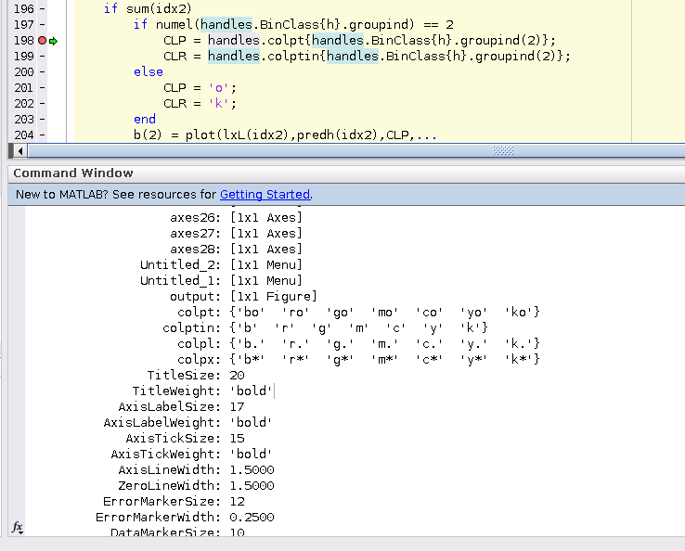

Bug report

I’ve had a number of situations where people have not had their globals and covariates in the same order as their images. This is especially the case when using the SPM GUI file selector. It would be good to make them re-enter the IDs when the globals and the covars (and any other data) is entered and then check the order against what is recorded for the images so that we know that they match.

Bug report’s for OOCV data

OOCV general point for matrix data. At the moment, when you enter new data you had to first load the participant IDs otherwise you can’t load the predictor data.

Julian W reports that when you have two modalities and you are entering the second, you first have to load the feature names.

You can’t apply models that were created on another computer because the paths don’t match. This is a current limitation for Julian and was a limitation last year for the Autumn school. I’m not sure if this has been updated in the newest version.