Risks in signal processing pipelines influencing the estimation of phase-dependency for EEG-TMS
Running title: Gain modulation of corticospinal excitability

Robert Guggenberger, Maximilian Scherer, Alireza Gharabaghi*
Division of Functional and Restorative Neurosurgery, and Tuebingen Neuro Campus, Eberhard Karls University Tuebingen, Tuebingen, Germany
*To whom correspondence should be addressed
Professor Alireza Gharabaghi, Division of Functional and Restorative Neurosurgery, Eberhard Karls University Tuebingen, Otfried-Mueller-Str.45, 72076 Tuebingen, Germany. Email address: alireza.gharabaghi@uni-tuebingen.de

Acknowledgments
A.G. was supported by grants from the German Federal Ministry of Education and Research [BMBF 13GW0119B, IMONAS; 13GW0214B, INSPIRATION; 13GW0270B, INAUDITAS] and the Baden-Wuerttemberg Foundation [NEU005, NemoPlast]. The authors declare no competing financial interests.

Abstract

Keywords: phase-dependency, transcranial magnetic stimulation, motor evoked potential, digital signal processing, brain-state-dependent stimulation
Introduction
The excitability of neuronal populations depends on their current state (Izhikevich, 2007). Using non-invasive measurements to monitor a populations current state is an import step towards implementing brain-state-dependent transcranial stimulation for research and treatment. This is generally feasible. For example, desynchronization of sensorimotor power as picked up by electroencephalography (EEG) increases cortico-spinal excitability (CSE) as measured by the motor evoked potential (MEP) in response to transcranial magnetic stimulation (TMS) (Takahashi et al., 2018; Takemi et al., 2013). Similarily, transcranial alternating current stimulation (tACS), which is assumed to synchronize neuronal populations (Zaehle et al., 2010), is able to increase CSE, depending on the frequency of stimulation.
Most TMS devices can be triggered with short latencies, and can apply short-lasting single pulses. Such high temporal precision allows to probe the current CSE not only in regard to a rather slow-changing measure of power, but also to the relatively fast-changing phase of an oscillation. Research has suggested that applying TMS at different phases of sinusoidal signal applied via transcranial alternating current stimulation (tACS) discloses such phase-dependency of CSE (Fehér et al., 2017; Raco et al., 2016; Zrenner et al., 2017).
The step from exogenous entrainment of oscillations via tACS to reading the endogenous current phase of an oscillation from EEG or EMG recording offers several challenges. Compared to a tACS signal, the signal-to-noise ratio of non-invasive electrophysiological recordings is low. The amplitude and phase of an oscillations is non-stationary, and might be sinusoidal only in approximation(Cole and Voytek, 2017). In an attempt to beat the non-stationarity, the construction of dedicated hardware might become necessary for fast processing. But even with dedicated hardware, and even if performed only when an oscillations amplitude is high, real-time estimation of an oscillations phase might fall below a standard deviation of 50° (Zrenner et al., 2017).
Therefore, post-hoc analysis of TMS applied initially at random and subsequently probed for possible phase-dependencies stays an important research method (Keil et al., 2013; Khademi et al., 2018; van Elswijk et al., 2010; Zrenner et al., 2017). Yet, this still requires the stringent design of the signal processing pipeline, and especially the filter design. For example, non-causal filters can smear the TMS-artifact and distort the phase of an oscillation prior to the TMS pulse. In this manuscript, we show how methodological differences in filter design influence estimation of the phase dependency. For example, it is under discussion, whether there is only a single maximum of CSE, found in the rising phase of the oscillation (Khademi et al., 2018; van Elswijk et al., 2010), or whether there are two maxima of CSE, at the peak and trough of the oscillation (Keil et al., 2013). Using simulated data, we compare how two different approaches to phase estimation on identical data can result in such conflicting findings. Subsequently, we explore the general influence of filter order and filter bandwidth on recovering the phase of maximal CSE. Finally, we discuss policies to minimize risks in the design and implementation of signal processing pipelines for estimation of phase-dependency.

Material and Method
All simulations were performed with Anaconda Python 3.6.3 on Linux Mint 18.2, employing SciPy, NumPy, Seaborn and Matplotlib. The script is available online (https://github.com/translationalneurosurgery/2018_filtersimulation_tmseeg).
Simulation 1
We simulated data with two known dependencies between oscillatory phase and MEP amplitude (peak and trough versus rising flank) and processed following the methods as reported by two previous studies (Keil et al., 2013; van Elswijk et al., 2010).
Data processing
In the dependency models, data was simulated as an 18 Hz cosine signal, and subsequent analyses were performed in accordance with two previous reports. For estimating the phase in analogy to Elswijk and colleagues (van Elswijk et al., 2010) on the basis of a discrete Fourier transformation, we simulated the data with a 10 kHz sampling rate and duration of ± 1.1 s, and included two cycles before the TMS pulse. To estimate the phase in analogy to Keil and colleagues (Keil et al., 2013) on the basis of a Hilbert transformation, we simulated the data with a 2 kHz sampling rate and duration of ± 1.5 s, and included three cycles, terminating 5 ms before the TMS pulse.
MEP dependency
On the basis of previous findings, we simulated two different dependencies between the oscillatory phase and MEP amplitude: maximum MEP amplitude (i) with a unimodal pattern, i.e., at the rising phase of 18 Hz oscillations, (ii) with a bimodal pattern, i.e., at the peak and trough of 18 Hz oscillations. We simulated a log-linear relationship with base 50 to account for the log-normal distribution of MEPs. The two dependency models are visualized in Figure 1A and 1B.
Filter Order
Simulated data epochs were bandpass filtered forward in time with a Butterworth filter with orders from 3 to 8, and for two different frequency bands, i.e., 1-400 Hz and 17-19 Hz.
Assessment
We visualized the simulation results as polar-linear and linear-linear scatter plots between oscillatory phase and MEP amplitude. To achieve a well-resolved and uniform sampling across the unit circle, the relationship for each integer phase was sampled from 0 to 360°. For the simulation, we added a small white noise term (with 0.05 standard deviation) to prevent points from overlaying and to reduce any possible bias due to numerical errors.
Simulation 2
We simulated data as above, but with only one dependency mode, i.e. peak of CSE would be at the rising flank of an oscillation at 18 Hz. Signals were simulated with a sampling rate of 1000 Hz, a duration of ± 1.5 s around the TMS for filtering, and included three cycles for subsequent phase estimation. The signal was simulated without noise.
Data processing
We filtered the data exploring the influence of four parameters, i.e. estimation method, filter order, filter bandwidth, and filter center. This means the phase was estimated using either Hilbert or Fourier transformation, similar to above. Additionally, we systematically increased filter order up to an order of 8, and decreased the filter bandwidth. This was done in two ways, one time with the bandwidth centered on the frequency of interest, and another time unevenly anchored.
Assessment
We visualized the simulation results as heat maps, showing the phase which was estimated to exhibit a maximal MEP after filtering.
Results
Simulation study 1
Our simulation suggested that filtering a signal using a narrow-band Butterworth filter of high order followed by Hilbert transformation (rather than a broad-band filter of lower order followed by Fourier transformation) did not detect a unimodal phase-dependency of MEP amplitudes (Figure 1C). Furthermore, when the narrow-band filter was decreased, it was able to distinguish between uni- and bimodal phase dependencies (Figures 1E and 1F).
Simulation study 2
Our simulation suggested that
Discussion
To assess the influence of different signal processing pipelines on the estimation of phase-dependency of CSE, we conducted a simulation and applied two approaches as used in earlier research (Keil et al., 2013; van Elswijk et al., 2010). The goal was to investigate whether methodological differences of data processing and phase estimation could explain apparently contradictory findings.
Our simulation study indicated that a data processing approach with a sufficiently low filter order was able to recover both uni- and bimodal phase-dependency patterns, whereas higher filter orders distorted the signal. We found that the filter order has a strong influence on the estimated phase-dependency.
Methodological considerations
Phase estimation of neuronal gain modulation is prone to artifacts that are related to data processing and filtering. Broad-band Fourier as well as narrow-band Hilbert transformation were both able to recover the original phase-dependent relationship, as long as the filter order was sufficiently low. Only when higher filter orders were applied, both approaches returned a bimodal dependency. Considering that too high filter orders can corrupt the phase spectrum of a signal (Oppenheim et al., 2014)., this appears to be mainly an artifact of the filtering. To prevent corruption of the phase spectrum, lower filter orders are preferable. If Hilbert-transformation is used for phase-estimation, this can conflict with the goal to estimate the phase for a narrow frequency band of interest. Phase estimation using Fourier transformation after broad-band low-order filtering might in such cases present a more suitable approach.
Toolbox selection
Implementations of the same filter in different environments, e.g. by using different toolboxes or programming languages, can influence the results (Widmann et al., 2015). Notably, the more recent version of a commonly used data analysis software (Fieldtrip, (Oostenveld et al., 2011) supports an automatic filter instability correction and interrupt the computation (e.g., “fail with an exception”), if the filter order is too high. However, before this default behavior was introduced (git log–grep “instability”, 914d6ab/2013), https://github.com/fieldtrip/fieldtrip/), analyses performed with this software might not have experienced any error warning if the filter orders applied were too high.
Conclusions
On a more general account, these observation proposes two policies: First, using up-to-date toolboxes and re-running scripts after software updates (Kitzes et al., 2018). Second, running simulation studies in parallel to the actual data processing to safeguard the analysis pipeline against potential pitfalls (Haufe, 2015)
References
Cole, S.R., Voytek, B., 2017. Brain Oscillations and the Importance of Waveform Shape. Trends Cogn. Sci. 21, 137–149. https://doi.org/10.1016/j.tics.2016.12.008
Fehér, K.D., Nakataki, M., Morishima, Y., 2017. Phase-Dependent Modulation of Signal Transmission in Cortical Networks through tACS-Induced Neural Oscillations. Front. Hum. Neurosci. 11. https://doi.org/10.3389/fnhum.2017.00471
Haufe, S., 2015. An extendable simulation framework for benchmarking EEG-based brain connectivity estimation methodologies. IEEE, pp. 7562–7565. https://doi.org/10.1109/EMBC.2015.7320142
Izhikevich, E.M., 2007. Dynamical systems in neuroscience: the geometry of excitability and bursting, Computational neuroscience. MIT Press, Cambridge, Mass.
Keil, J., Timm, J., Sanmiguel, I., Schulz, H., Obleser, J., Schoenwiesner, M., 2013. Cortical Brain States and Corticospinal Synchronization Influence TMS-evoked motor potentials. J. Neurophysiol. https://doi.org/10.1152/jn.00387.2013
Khademi, F., Royter, V., Gharabaghi, A., 2018. Distinct Beta-band Oscillatory Circuits Underlie Corticospinal Gain Modulation. Cereb. Cortex 28, 1502–1515. https://doi.org/10.1093/cercor/bhy016
Kitzes, J., Turek, D., Deniz, F. (Eds.), 2018. The practice of reproducible research: case studies and lessons from the data-intensive sciences. University of California Press, Oakland, California.
Oostenveld, R., Fries, P., Maris, E., Schoffelen, J.-M., 2011. FieldTrip: Open Source Software for Advanced Analysis of MEG, EEG, and Invasive Electrophysiological Data. Comput. Intell. Neurosci. 2011, 1–9. https://doi.org/10.1155/2011/156869
Oppenheim, A.V., Willsky, A.S., Nawab, S.H., 2014. Signals & Systems.
Raco, V., Bauer, R., Tharsan, S., Gharabaghi, A., 2016. Combining TMS and tACS for closed-loop phase-dependent modulation of corticospinal excitability: A feasibility study. Front. Cell. Neurosci. 10. https://doi.org/10.3389/fncel.2016.00143
Takahashi, K., Kato, K., Mizuguchi, N., Ushiba, J., 2018. Precise estimation of human corticospinal excitability associated with the levels of motor imagery-related EEG desynchronization extracted by a locked-in amplifier algorithm. J. NeuroEngineering Rehabil. 15. https://doi.org/10.1186/s12984-018-0440-5
Takemi, M., Masakado, Y., Liu, M., Ushiba, J., 2013. Event-related desynchronization reflects downregulation of intracortical inhibition in human primary motor cortex 110, 1158–1166. https://doi.org/10.1152/jn.01092.2012
van Elswijk, G., Maij, F., Schoffelen, J.-M., Overeem, S., Stegeman, D.F., Fries, P., 2010. Corticospinal beta-band synchronization entails rhythmic gain modulation. J. Neurosci. Off. J. Soc. Neurosci. 30, 4481–4488. https://doi.org/10.1523/JNEUROSCI.2794-09.2010
Widmann, A., Schröger, E., Maess, B., 2015. Digital filter design for electrophysiological data--a practical approach. J. Neurosci. Methods 250, 34–46. https://doi.org/10.1016/j.jneumeth.2014.08.002
Zaehle, T., Rach, S., Herrmann, C.S., 2010. Transcranial alternating current stimulation enhances individual alpha activity in human EEG. PloS One 5, e13766. https://doi.org/10.1371/journal.pone.0013766
Zrenner, C., Desideri, D., Belardinelli, P., Ziemann, U., 2017. Real-time EEG-defined excitability states determine efficacy of TMS-induced plasticity in human motor cortex. Brain Stimulat. https://doi.org/10.1016/j.brs.2017.11.016

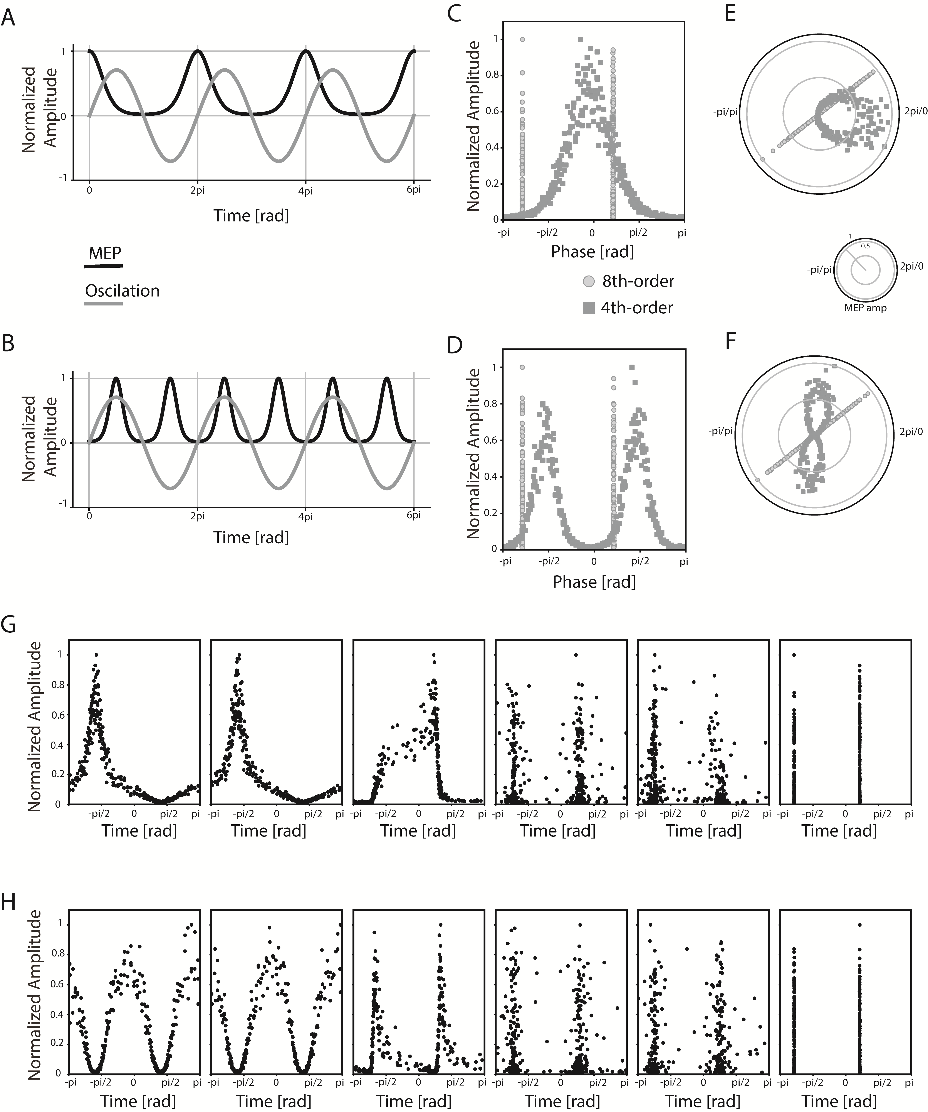

Figure 1 Uni- and bimodal models with amplitudes shown in normalized units.
A, Unimodal phase-dependency with maximum MEP amplitude (black line) at the rising flank of oscillatory activity (gray line).
B, Bimodal phase-dependency with maximum MEP amplitude (black line) at the peak and trough of oscillatory activity (gray line).
C Unimodal phase-dependency which is detected by broad-band filtering followed by discrete Fourier transformation (dark dots) according to van Elswijk and colleagues (dark dots) but not narrow-band filtering followed by Hilbert transformation according to Keil and colleagues (light dots).
D, Same as in C but for bimodal phase-dependency which is detected by broad-band filtering followed by discrete Fourier transformation according to van Elswijk and colleagues (dark dots) while narrow-band filtering followed by Hilbert transformation according to Keil and colleagues distorts the phase-spectrum (light dots).
E/F, same as C/D but visualized as polar plot with the scale shown as a small inlet.
G, Narrow-band (17-19 Hz) filtering followed by Hilbert transformation with different filter orders (from 3rd to 8th) for the unimodal model. Lower filter orders can distinguish between bimodal and unimodal dependencies of MEP amplitudes.
H, same as G but for the bimodal model.

