**Potter’s Original Text**

**1.** A newspaper is better than a magazine. A seashore is a better place than the street. At first, it is better to run than to walk. You may have to try several times. It takes some skill but it’s easy to learn. Even young children can enjoy it. Once successful, problems are minimal. * Birds seldom get too close. Rain, however, soaks in very fast. Too many people doing the same thing can also cause problems. One needs lots of room. If there are no complications, it can be very peaceful. A rock will serve as an anchor. If things break loose, however, you will not get a second chance. There are just these few simple things to remember when [making and flying your own kite/ doing this activity. (129 words; 15 sentences)

*Related Target:*

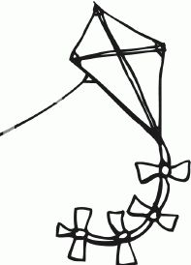

*Related Foils:*

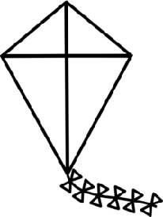

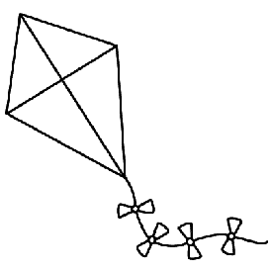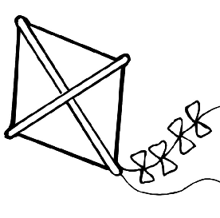

*Unrelated Target:*

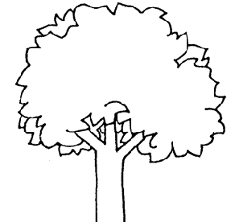

*Unrelated Foils:*

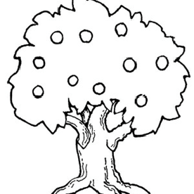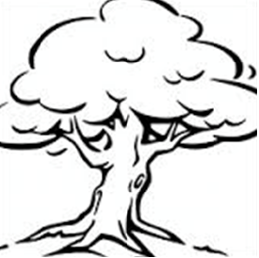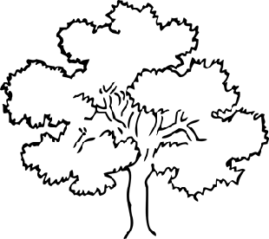

**2.** With pawned jewels financing him, our hero bravely defied the scornful laughter of people who tried to prevent his scheme. “Your eyes deceive,” he had said. “An egg, not a table, correctly typifies this unexplored region.” * Now with three sturdy sisters he sought proof, forgoing along sometimes through calm vastness, yet more often over turbulent peaks and valleys. Days became weeks, as many doubters spread fearful rumors about the edge. At last, from nowhere, welcome winged messengers appeared, signifying momentous success. [Christopher Columbus/He knew he was right.] (89 words; 7 sentences)

*Related Target:*

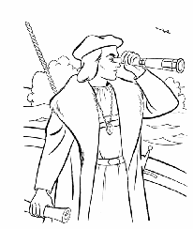

*Related Foils:*

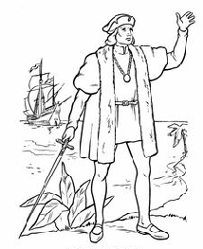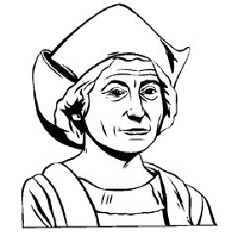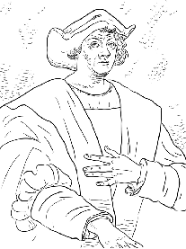

*Unrelated Target:*

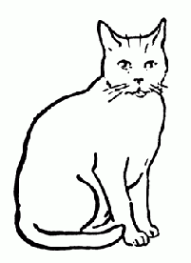

*Unrelated Foils:*

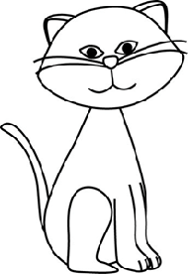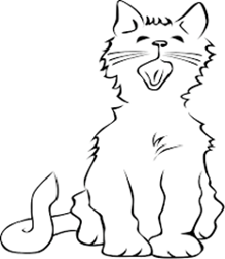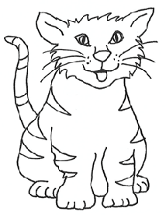

**3.** The procedure was quite simple. First you arrange everything into different groups. One pile is enough if you don’t have much to do. Then you have to go somewhere else if you don’t have a machine. You put them in the machine and turn it on. It is better not to put too many in at once. Then you sit and wait. * you have to stay in there in case anything goes wrong. Then you put everything in another machine and watch it go around. When it stops, you take the things home and arrange them again. Then they can be put away in their usual places. Soon they will all be used again and you will have to do it all over. [Doing your laundry/The whole thing can be a pain. (133 words; 13 sentences)

*Related Target:*

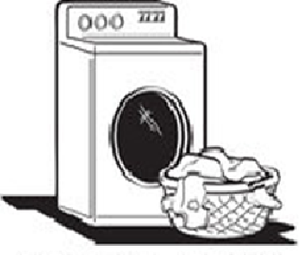

*Related Foils:*

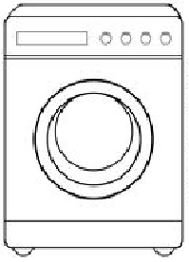

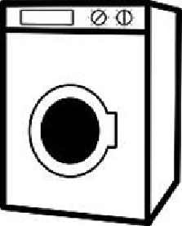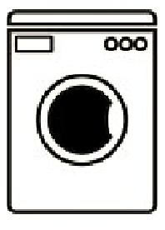

*Unrelated Target:*

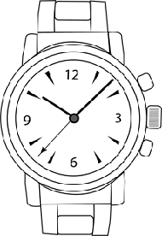

*Unrelated Foils:*

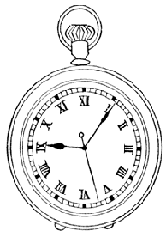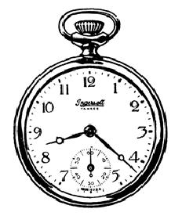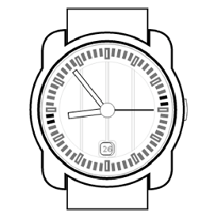

**4.** It seemed like hours since I had called. Finally it arrived, richly colored but a little thin. I wondered if it was too hot to touch. The smell was so strong that I couldn’t help but try *. I pulled at one section, but it was difficult to remove, so I tried another. Elastic fibers developed, attaching it to the rest. I exerted more force. As I pulled, however, droplets of hot oil splashed one side, burning my hand. I dropped it. Perhaps I could last a couple more minutes. I was impatient, but [the pizza/it] was very hot. (100 words; 10 sentences)

*Related Target:*

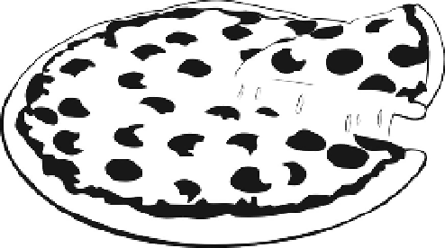

*Related Foils:*

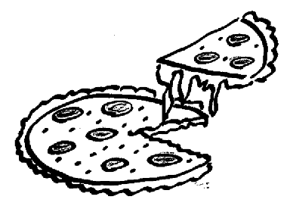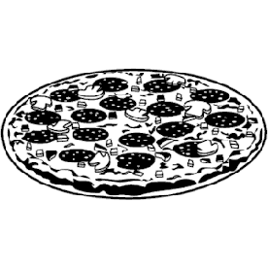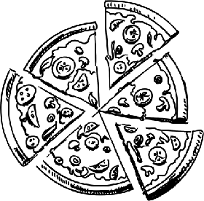

*Unrelated Target:*

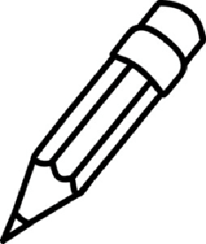

*Unrelated Foils:*

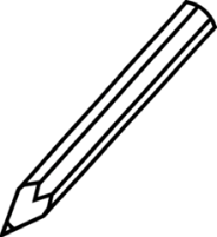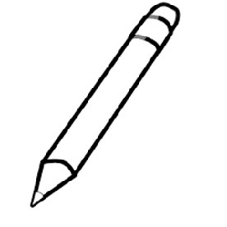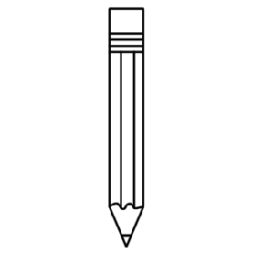

**Ritchey Texts**

**Procedural**

You will probably want to be outdoors. A sunny, dry day makes it easier than a windy or wet day. Beginners prefer a smooth surface. Straight ways are easier than curvy or crooked ways. If you don’t have your own, you could borrow a friend’s. * You would want to make sure the size suits your needs. You can add a mirror for more visibility if you want. Any moving parts need to be in good working condition. Moving quickly or slowly is up to you. Protecting your head is a good idea. With practice, [riding a bike/using this method] can be an efficient way to move around. (104 words; 11 sentences)

*Related Target:*

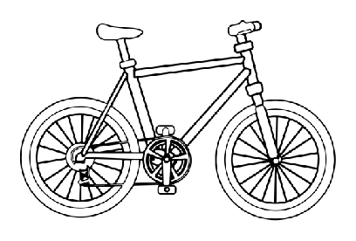

*Related Foils:*

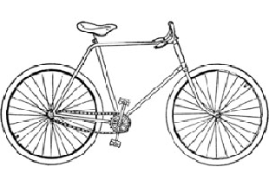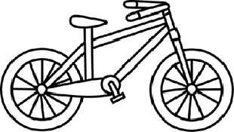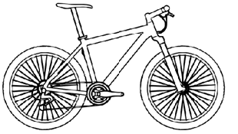

*Unrelated Target:*

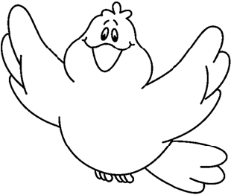

*Unrelated Foils:*

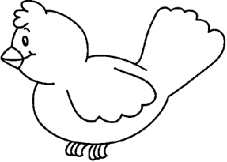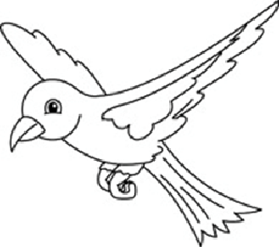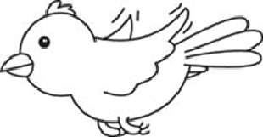

**Procedural/Narrative**

The newness of it was intimidating. Opening it seemed to almost break it in half, but the top and bottom held together. Pushing one black square caused a light to flash. I could hear a humming sound. Colors and images appeared on top half. * I waited for the chance to tell it what to do. It seemed to understand the message I conveyed with the black squares. Moving my hands over the bottom half caused the images on the top half to change. I was getting the hang of my new [laptop/machine.] (91 words; 9 sentences)

*Related Target:*



*Related Foils:*

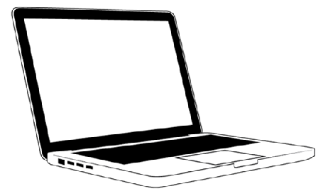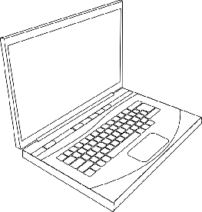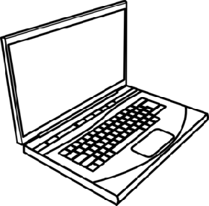

*Unrelated Target:*

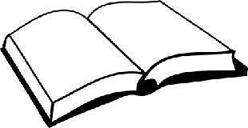

Unrelated Foils:

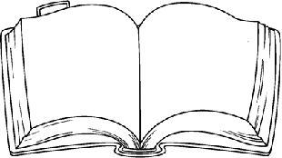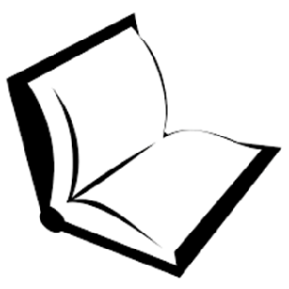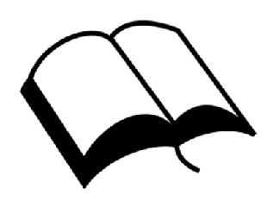

I knew it had been a while since I had done this task and was guessing it was time to do it again. After removing the used one, I threw it away. Using a soft, damp towel I cleaned up any mess. I took a clean one off the top of the stack and unfolded it to lay flat. * I slid it under the bottom and folded the extra material over. I secured the tabs around the middle. It looked snug but not too tight. I was hoping [the diaper/the cloth] would not leak. (92 words; 8 sentences)

*Related Target:*

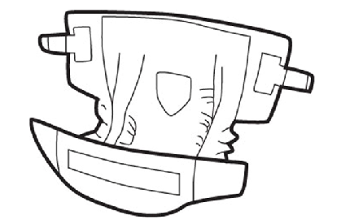

*Related Foils:*

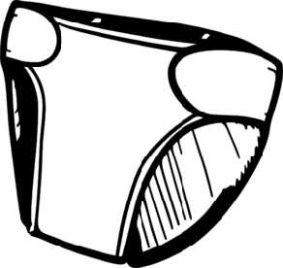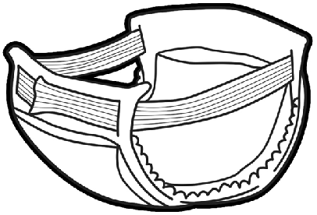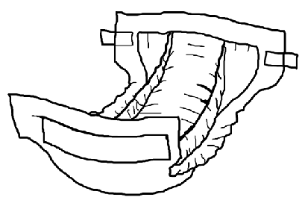

*Unrelated Target:*

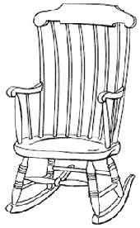

*Unrelated Foils:*

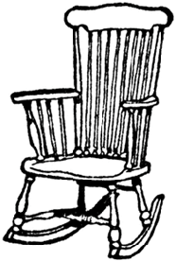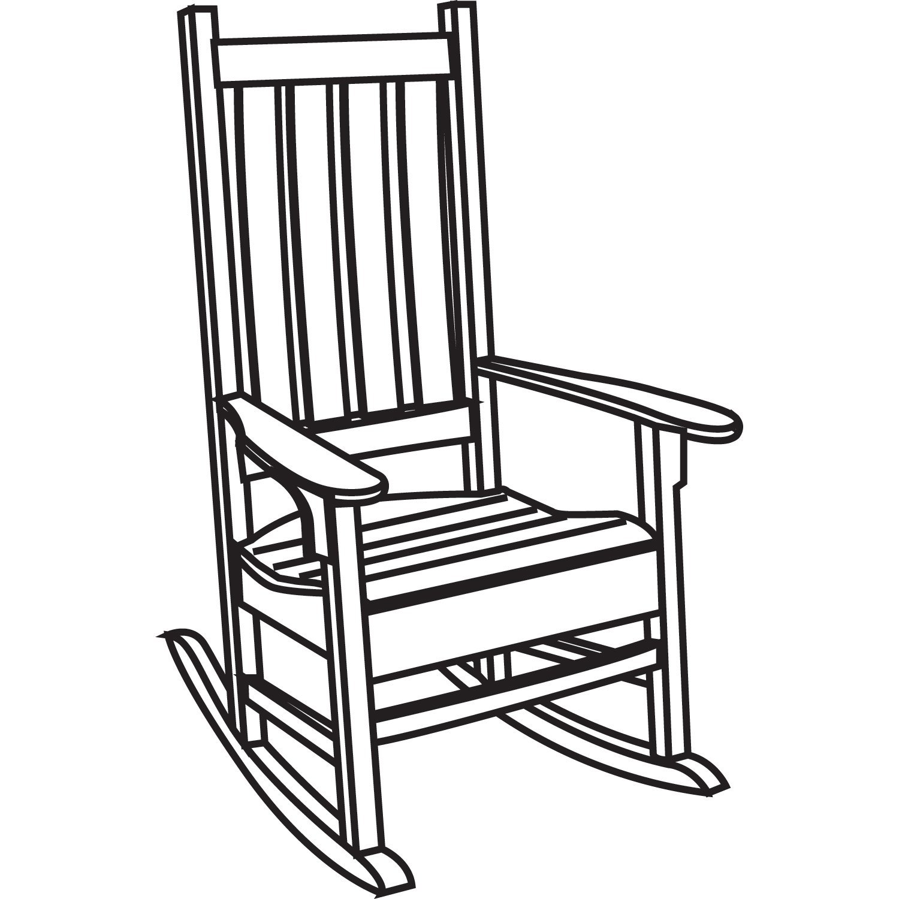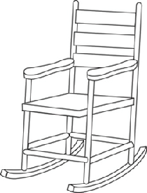

**Narrative**

He was aware of the fact that people were either on his side or against him. He felt a sense of responsibility to get everyone on his side. As a boy he had no money. As a man he towered over others, in stature, in learning, and in power. * Now he had a tremendous task in front of him. Bridging differences of morals and locations, he wrote and spoke, trying to persuade. He believed the cause was just. Descendants following in his footsteps reap the benefits of (Abraham Lincoln’s/ this man’s] vision. (92 words/8 sentences)

*Related Target:*

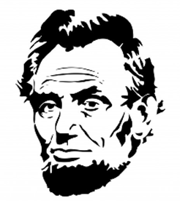

*Related Foils:*

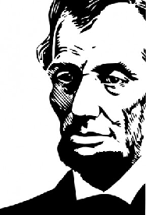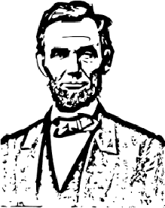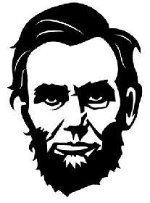

*Unrelated Target:*

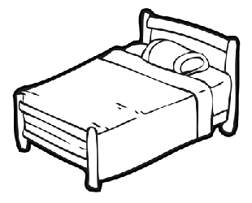

*Unrelated Foils:*

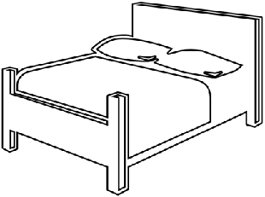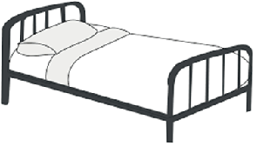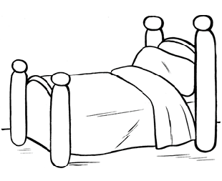

I could see that the conditions were right. I had looked forward to this for a couple seasons. The outdoors seemed bright compared to indoors. At first nothing would stay together, but with some work the first shape began to take form. I repeated the same process a couple times. * More of the matter arrived which helped. Parts stuck to my clothes and hands. When the pieces were assembled I surveyed my work. I added some details with sticks and rocks. Now [my snowman/my creation] looked complete. (86 words; 10 sentences)

*Related Target:*

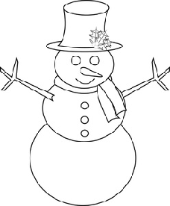

*Related Foils:*

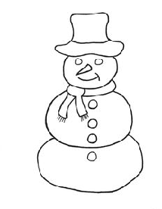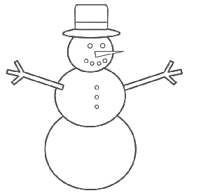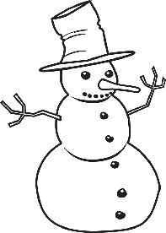

*Unrelated Target:*

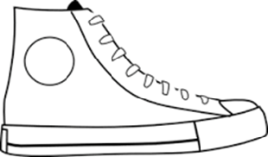

*Unrelated Foils:*

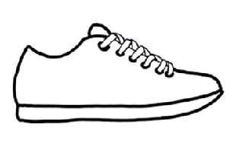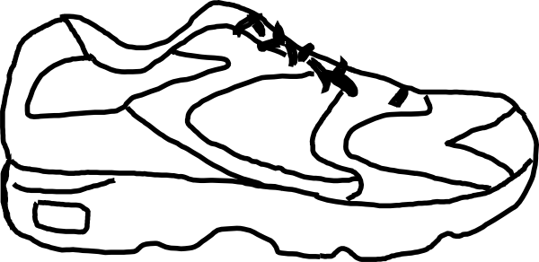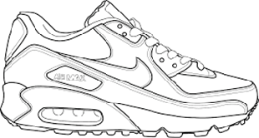

**NOT USED**

