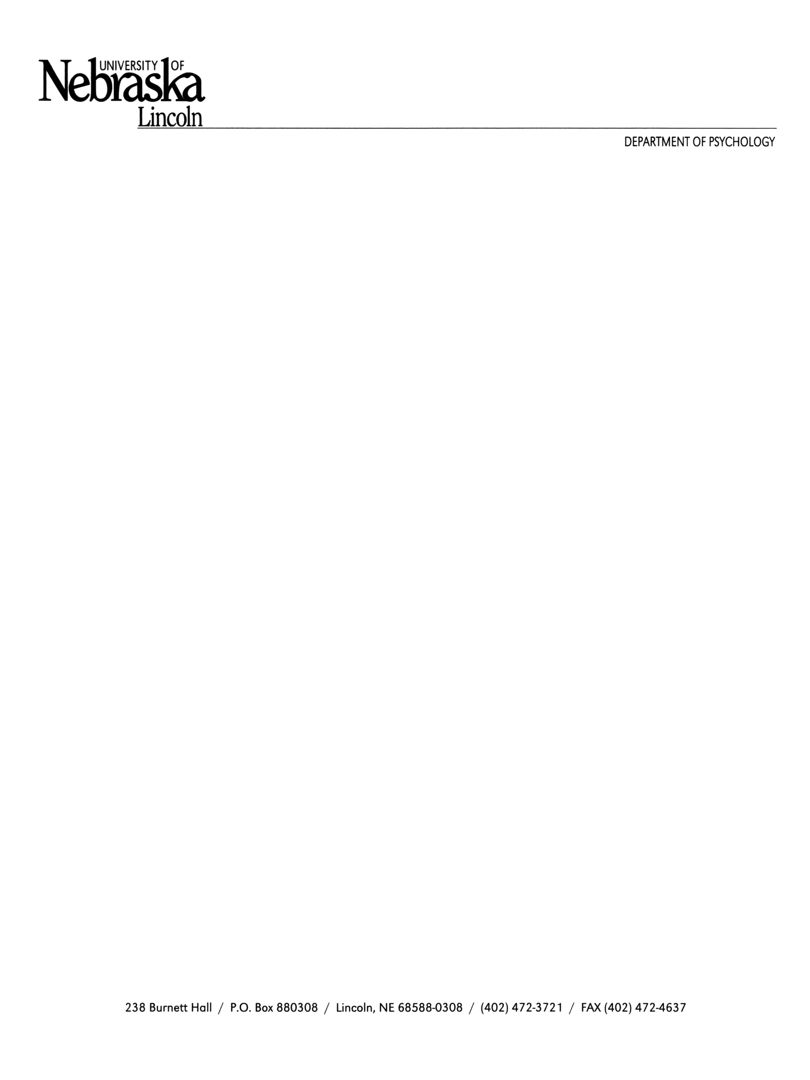

9 September 2020

Editorial Office, *Journal of Vision*

Dear members of the editorial board:

We have enclosed a submission of original research for the *Journal of Vision* entitled, “Convolutional neural networks can decode eye movement data: A black box approach to predicting task from eye movements.”

The enclosed manuscript presents a novel approach to classifying task from minimally processed eye movement data. Previous attempts to classify eye movements have focused on processing data and developing models designed to emulate cognitive and neural component processes. Our approach used a convolutional neural network (CNN) framework unconstrained by such theoretical assumptions. This “black box” CNN successfully decoded two eye movement datasets, each of which was processed into timeline and image formats, with accuracy comparable to that of previous studies with more theoretical assumptions and more heavily pre-processed datasets. Additional analyses were conducted to further understand the effect of task set, feature set, and data format. To our knowledge, this study was the first to use a deep learning approach to decode eye movement data in these minimally processed formats. Our manuscript demonstrates the potential to implement a practical and reliable black box approach to decoding eye movement data. We believe that the findings presented in this manuscript will help substantially to advance the state of the art in classifying task from eye movement data.

**Suggested Reviewers:**

Taylor Hayes, Ph.D., University of California, Davis (taylor.r.hayes@gmail.com)

Monica Castelhano, Ph.D., Queen’s University (monica.castelhano@queensu.ca)

Neil Bruce, Ph.D., Ryerson University (bruce@ryerson.ca)

Laurent Itti, Ph.D., University of Southern California (itti@pollux.usc.edu)

Thank you for taking the time to consider this manuscript for publication. Please feel free to contact us if you have any questions or concerns, or if you require additional reviewer suggestions.

Best Regards,

**Corresponding Author:**

Zachary J. Cole, M.A.

Department of Psychology

University of Nebraska-Lincoln

Lincoln, NE 68588-0308

Email: zachary.cole@huskers.unl.edu

Phone: (765) 609-1813

**Co-Authors:**

Karl M. Kuntzelman, Ph.D.

Michael D. Dodd, Ph.D.

Matthew R. Johnson, Ph.D.