rrp4 is a model of the depletion of the RRP (defined as the initial population of docked vesicles in a resting terminal, and equal to the number of release sites) and its replenishment by recruitment. It seeks to replicate observed behavior of quantal release during repetitive stimulation. The default program tries to predict, for example, quantum content and its variance during the plateau of a stimulus train (100 Hz for 1 s). (copy rrp4.m and rrp4.fig from the server to the 'work' directory)

What are the values observed during electrophysiological recordings, which we seek to replicate? There are two of particular interest: first, quantum content (m) averages 30-50 during the plateau phase of a 1 s, 100 Hz train. Second, the variance in m is low, suggesting that n is small. The resulting value of calculated release probability (p = 1-var(m)/m) is greater than 0.5. I have been unable to replicate this high value of p with this program (load 'bills_best.mat' to see my results).

When you run rrp4, a window opens, like the one below (left side). The 3 graphs at the top are empty. The graph at the bottom shows the resting distribution of release probabilities of the release sites. Below the graphs are various buttons and sliders used to set values of variables.
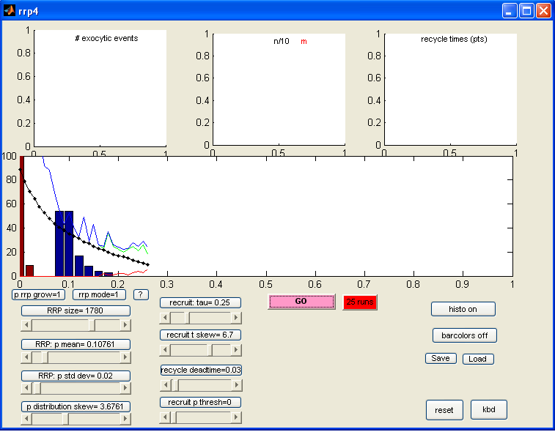
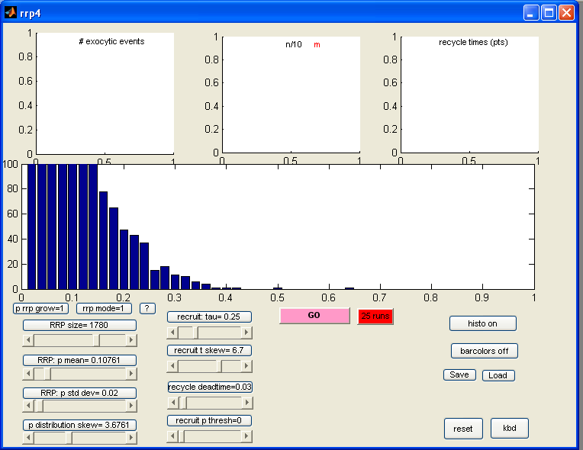

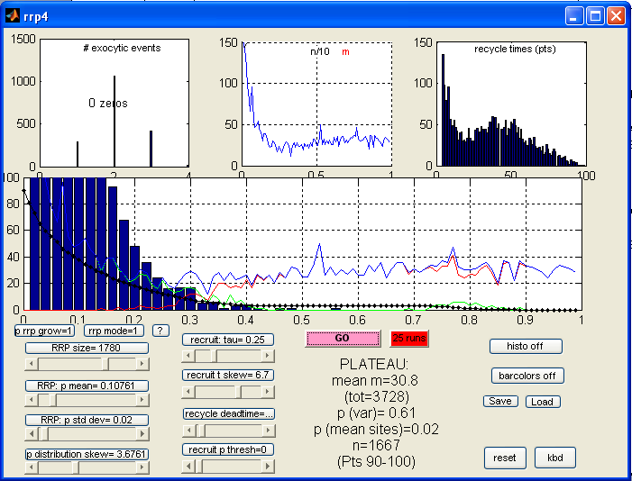
When you click the pink button (Run), the program starts, and several values are plotted (above, right side). The plot is updated after each shock in the train. The blue bars show the updated distribution of release probabilities. After several shocks, brown bars begin to appear. These represent the distribution of release probabilities for vesicles recruited to sites of previous exocytosis.
Four lines also are plotted as the iterations continue. The black line with small points shows the depletion of the RRP (it is normalized to the y axis, so it always begins at 100%). The blue line plots quantum content (m). The green and red lines show the contributions to m from RRP vesicles and from recruited vesicles, respectively.
After the last shock in the train, the top 3 graphs are plotted, and some text appears below the graphs (see figure to the left).

The top 3 graphs are as follows: left: distribution of number of exocytic events. The number of release sites with zero exocytic events (i.e., remaining RRP) is also printed. middle: the blue line shows m (same as blue line in bottom graph), and the black line shows n (value divided by 10). right: distribution of recycle times (times between consecutive exocytic events).
The text shows certain values during the plateau phase, namely average m, total m for entire train, two measures of p, n, and the points used to determine the plateau.

Changing values of variables: The values of the variables are controlled by the sliders and buttons below the graphs. If you change a slider the resting state is recalculated and displayed. If you click a button above a slider, the complete array of variables is displayed, and you can change any or all of them.
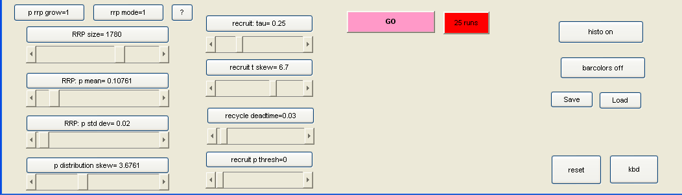
There are two sets of variables. One set determines the initial properties (setup) of the RRP - size, mean release probability (p), etc. The second set of variables determines the rate of recruitment of new vesicles after exocytosis. These are described below.

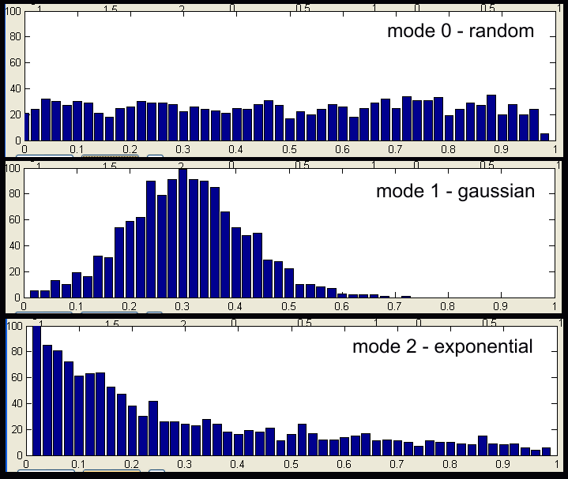
Initial RRP properties
Two buttons:
1. Mode button: There are 3 ways to distribute the initial p values at release sites: random (mode 0), gaussian (mode 1), or exponential (mode 2). See examples at right.

2. p0 grow button determines if p values can increase above their original (p0) values. 0 = no grow; 1 = RRP only can grow; 2 = RRP and recruited vesicle p values can grow (to 1.0).
(The help button marked "?" describes these two buttons)

Four sliders (left side) determine other initial RRP values:
3. RRP size
4. RRP mean release probability (p; no effect if mode is 'random')
5. RRP distribution standard deviation (no effect if mode is 'random')
6. RRP skew factor causes p values to be skewed towards extreme values (near 0 or 1)

Four sliders (right side) determine recruitment rates
7. Recruit tau: After exocytosis, p is set to zero, and it then increases exponentially to its original value. The slider sets the approximate time constant of p increase after exocytosis
8. Recruit time skew: This raises the exponential function to a power, making the recovery of p become sigmoidal instead of exponential for large values of skew.
9. Recycle dead time: after exocytosis, no further exocytosis allowed until deadtime has passed
10. Recruitment p threshold: no exocytosis allowed if p is less than this threshold

Other buttons:
Go: This button causes one run (one stimulus train) to be started.

25 runs: This will cause 25 runs to be done. To make the program run fast, the display in the bottom graph is turned off, until the end. The results printed below the graphs are the averages of the 25 runs. The number of runs can be changed by clicking on any button above any slider.

histo on/off: this toggles the plot during a run on and off (the plot at the end of the train is always shown). The runs go much faster with plotting is turned off.

save and load: you can save variables to a file, and reload them later

Other variables can be set by clicking the button above any slider. These are the number of points (stimuli) per run (default=100), the number of runs when the red button ("25 runs") is clicked (default is 25), and the noise added to results (noise is added by making two random arrays, and adding results from one and subtracting results from the other to each data point).

How it works:
An array is generated with the same number of rows as the RRP size. So each row of the array tracks a single release site. Each release site (row) has 4 values: time of last exocytosis, total number of exocytic events this run, initial p, and current p.
For each shock, the 'eligible' release sites are determined. Sites with p less than the recruitment p threshold (variable #10 above) are not eligible, as are those whose last exocytosis was less than the deadtime previously (variable #9 above).
Next, the eligible sites that undergo exocytosis are determined. A vector of random numbers is generated, and if p of an eligible release site exceeds the associated random value, exocytosis occurs.
After exocytosis, the p values of those release sites are set to zero (or a minimum close to zero). Then, with each subsequent shock, p increases exponentially towards its initial value.

