Analyse

Makowski, D. & École de Neuropsychologie

Table of Contents

This report contains the full statistical analysis.

# Descriptive Statistics

library(knitr)  
library(neuropsychology)  
library(tidyverse)  
library(plotly)  
  
df <- read.csv("df.csv")

L'échantillon se compose de 34 étudiants.

# Global Satisfaction

library(broom)  
  
vars <- df %>%   
 select(starts_with("Q"))  
  
fit <- lm(Q13_Satisfaction ~ ., data=vars)  
  
summary(fit)

##   
## Call:  
## lm(formula = Q13_Satisfaction ~ ., data = vars)  
##   
## Residuals:  
## Min 1Q Median 3Q Max   
## -1.17857 -0.24811 0.07223 0.25658 1.05433   
##   
## Coefficients:  
## Estimate Std. Error t value Pr(>|t|)   
## (Intercept) -0.44809 2.00625 -0.223 0.826   
## Q1_Difficulty 0.29920 0.18205 1.644 0.116   
## Q2_Interest 0.27698 0.17173 1.613 0.122   
## Q3_Teaching 0.71529 0.34447 2.077 0.051 .  
## Q4_Interest_Generation -0.04100 0.30156 -0.136 0.893   
## Q5_Speech_Unclarity -0.03344 0.12728 -0.263 0.795   
## Q6_Adaptation 0.22987 0.18776 1.224 0.235   
## Q7_Examination 0.10200 0.19457 0.524 0.606   
## Q8_Mastery -0.12257 0.26773 -0.458 0.652   
## Q9_Motivation -0.02662 0.22447 -0.119 0.907   
## Q10_Methods -0.36966 0.27904 -1.325 0.200   
## Q11_Interactivity -0.06935 0.20123 -0.345 0.734   
## Q12_Availability 0.34848 0.27598 1.263 0.221   
## ---  
## Signif. codes: 0 '***' 0.001 '**' 0.01 '*' 0.05 '.' 0.1 ' ' 1  
##   
## Residual standard error: 0.608 on 20 degrees of freedom  
## (1 observation deleted due to missingness)  
## Multiple R-squared: 0.5934, Adjusted R-squared: 0.3495   
## F-statistic: 2.432 on 12 and 20 DF, p-value: 0.03806

plot <- df %>%   
 ggplot(aes(y=Q13_Satisfaction, x=Q3_Teaching)) +  
 geom_jitter(width=0.05, height=0.05, size=4, shape="+") +  
 geom_smooth(method="lm", fullrange=T) +  
 theme_neuropsychology() +  
 xlab("\nQ3. The teacher explained well") +  
 ylab("Q13. I'm generally satisfied\n")  
ggplotly(plot)

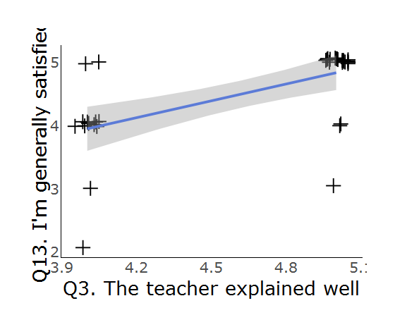

# Factor Analysis

library(FactoMineR)  
library(factoextra)  
  
# vars <- df %>%   
# select(starts_with("Q")) %>%   
# select(-starts_with("Q13"))  
#   
# pca <- PCA(df)  
# get_eig(res.pca)  
# fviz_screeplot(res.pca, addlabels = TRUE, ylim = c(0, 50))